St. Paul’s Anglican Church
Visalia, California
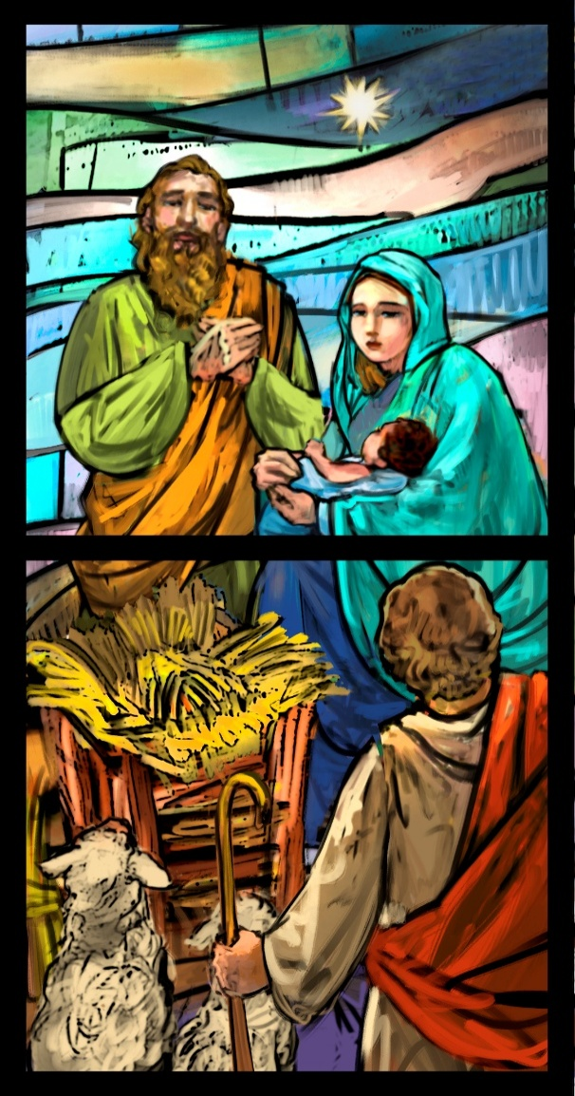

Second Sunday of Christmas
January 4, 2026
10:30 AM

Welcome!

St. Paul’s Anglican Church extends a warm welcome to all visitors and newcomers, whether worshiping in person or at home via livestream.

Visitors’ Guide

St. Paul’s Church is a parish in the Diocese of San Joaquin of the Anglican Church in North America, which includes both Catholic and Protestant traditions. We accept Jesus Christ as Savior, and we promise to follow him as Lord. We believe in One God,

- the Father who created us and all things,
- the Son who redeems us from sin and death,
- the Holy Spirit who renews and sanctifies us.

We believe the Holy Scriptures to be the Word of God and to contain all things necessary for salvation, and we accept the Apostles’ and Nicene Creeds as essential beliefs of the Christian faith.

Holy Communion is open to all baptized Christians who have examined their lives, repented of their sins, and desire to live
in love and charity with all people.

Those not desiring to receive Holy Communion, and those who have not been baptized into the Christian faith, are invited to cross their arms across their chest, and a blessing will be given instead.

Visitors are invited to sign the guest book at the entrance table and introduce themselves to the clergy following the service.

The Holy Eucharist

Prelude: “We Three Kings of Orient” Are Young
Opening Hymn: #93 –” Angels, from the Realms of Glory” p. 4
Acclamation p. 5
The Collect for Purity p. 5
Summary of the Law p. 5
Kyrie p. 5
Gloria p. 6
Collect of the Day p. 7
Lesson: Jeremiah 31:7-14 p. 7
Gradual: Psalm 84 p. 8
Epistle: Ephesians 1:3-14 p. 9
Sequence Hymn: #128 “We Three Kings” p. 10
Gospel: Matthew 2:1-12 p. 11
Sermon: The Rev. John Iseman
Nicene Creed p. 12
Prayers of the People p. 13
Confession and Absolution p. 14
The Comfortable Words p. 15
The Peace p. 15
Offertory Organ: “From Heaven Above to Earth I Come” Zachau
The Offertory p. 15
The Eucharistic Liturgy p. 15
Sanctus p. 16
The Lord’s Prayer p. 18
The Fraction p. 19
Prayer for Humble Access p. 19
Agnus Dei p. 19
Communion Hymn: #82 – “Of the Father’s Love Begotten” p. 20
Post Communion Prayer p. 21
Blessing p. 21
Closing Hymn #450 – “All Hail the Power of Jesus’ Name!” p. 22
Dismissal p. 23
Postlude: “The Hallelujah Chorus” Handel

Opening Hymn: Angels, from the Realms of Glory

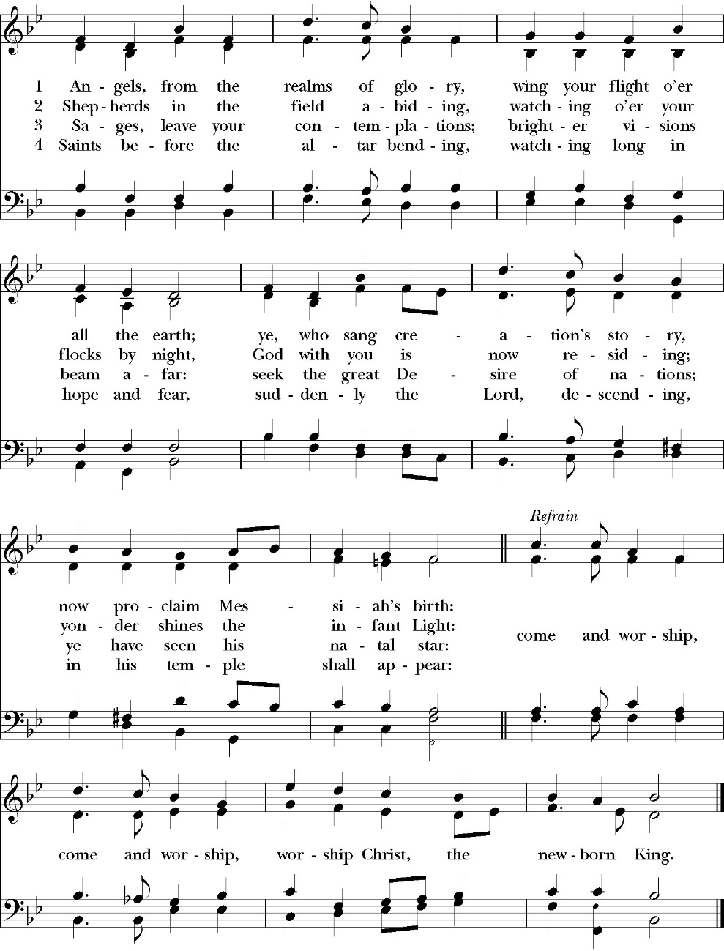

The Acclamation

Celebrant For unto us a child is born,
People Unto us a son is given.

The Collect for Purity

Almighty God, to you all hearts are open, all desires
known, and from you no secrets are hid: Cleanse the thoughts
of our hearts by the inspiration of your Holy Spirit, that we
may perfectly love you, and worthily magnify your holy Name.
through Christ our Lord. Amen.

The Summary of the law

Hear what our Lord Jesus Christ says: You shall love the Lord your God with all your heart and with all your soul and with all your mind. This is the first and great commandment. And the second is like it: You shall love your neighbor as yourself. On these two commandments depend all the Law and the Prophets.

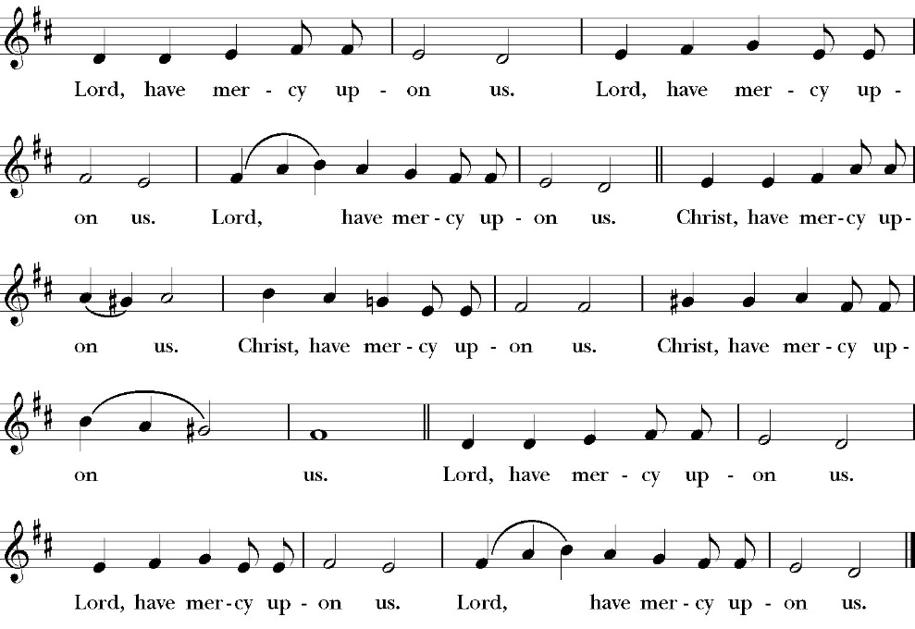
The Kyrie
Gloria

Officiant The Lord be with You.
People And with your spirit.
Officiant Let us pray:

The Collect of the Day

O God, who wonderfully created, and yet more wonderfully restored, the dignity of human nature: Grant that we may share the divine life of him who humbled himself to share our humanity, your Son Jesus Christ our Lord; who lives and reigns with you, in the unity of the Holy Spirit, one God, for ever and ever. Amen.

Lesson Jeremiah 31:7-14
For thus says the LORD: “Sing aloud with gladness for Jacob, and raise shouts for the chief of the nations; proclaim, give praise, and say, ‘O LORD, save your people, the remnant of Israel.’ 8 Behold, I will bring them from the north country and gather them from the farthest parts of the earth, among them the blind and the lame, the pregnant woman and she who is in labor, together; a great company, they shall return here. 9 With weeping they shall come, and with pleas for mercy I will lead them back, I will make them walk by brooks of water, in a straight path in which they shall not stumble, for I am a father to Israel, and Ephraim is my firstborn.

10 “Hear the word of the LORD, O nations, and declare it in the coastlands far away; say, ‘He who scattered Israel will gather him, and will keep him as a shepherd keeps his flock.’ 11 For the LORD has ransomed Jacob and has redeemed him from hands too strong for him. 12 They shall come and sing aloud on the height of Zion, and they shall be radiant over the goodness of the LORD, over the grain, the wine, and the oil, and over the young of the flock and the herd; their life shall be like a watered garden, and they shall languish no more. 13 Then shall the young women rejoice in the dance, and the young men and the old shall be merry. I will turn their mourning into joy; I will comfort them, and give them gladness for sorrow.

14 I will feast the soul of the priests with abundance, and my people shall be satisf ied with my goodness, declares the LORD.”

Reader The Word of the Lord
People Thanks be to God
Gradual: Psalm 84
1 How lovely are your dwellings, *
O LORD God of hosts!
2 My soul has a desire and longing to enter into the courts of the LORD; *
my heart and my flesh rejoice in the living God.
3 Indeed, the sparrow has found her a house, and the swallow a nest where she may lay her young, *
even your altars, O LORD of hosts, my King and my God.
4 Blessed are they who dwell in your house; *
they will be always praising you.
5 Blessed is the one whose strength is in you, *
in whose heart are your ways,
6 Who going through the valley of misery uses it for a well; *
indeed, the early rains fill the pools with water.
7 They will go from strength to strength, *
and the God of gods shall be seen by them in Zion.
8 O LORD God of hosts, hear my prayer; *
hearken, O God of Jacob.
9 Behold, O God, our defender, *
and look upon the face of your Anointed.
10 For one day in your courts *
is better than a thousand;
11 I would rather be a door-keeper in the house of my God *
than dwell in the tents of ungodliness.
12 For the LORD God is a light and defense; *
the LORD will give grace and honor, and no good thing shall he withhold from those who live a godly life.
13 O LORD God of hosts, *
blessed is the one who puts his trust in you.

Glory be to the Father, and to the Son, and to the Holy Spirit;
as it was in the beginning, is now, and ever shall be, world without end. Amen

Epistle: Ephesians 1:3-14
Blessed be the God and Father of our Lord Jesus Christ, who has blessed us in Christ with every spiritual blessing in the heavenly places, 4 even as he chose us in him before the foundation of the world, that we should be holy and blameless before him. In love 5 he predestined us for adoption to himself as sons through Jesus Christ, according to the purpose of his will, 6 to the praise of his glorious grace, with which he has blessed us in the Beloved. 7 In him we have redemption through his blood, the forgiveness of our trespasses, according to the riches of his grace, 8 which he lavished upon us, in all wisdom and insight 9making known to us the mystery of his will, according to his purpose, which he set forth in Christ 10 as a plan for the fullness of time, to unite all things in him, things in heaven and things on earth.

11 In him we have obtained an inheritance, having been predestined according to the purpose of him who works all things according to the counsel of his will, 12 so that we who were the first to hope in Christ might be to the praise of his glory. 13 In him you also, when you heard the word of truth, the gospel of your salvation, and believed in him, were sealed with the promised Holy Spirit, 14 who is the guarantee of our inheritance until we acquire possession of it, to the praise of his glory.

Reader The Word of the Lord
People Thanks be to God

Sequence Hymn: We Three Kings
(verses 1-2 before gospel, verse 3 after)
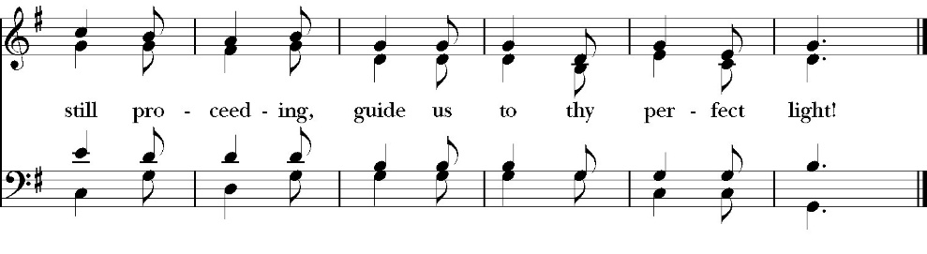
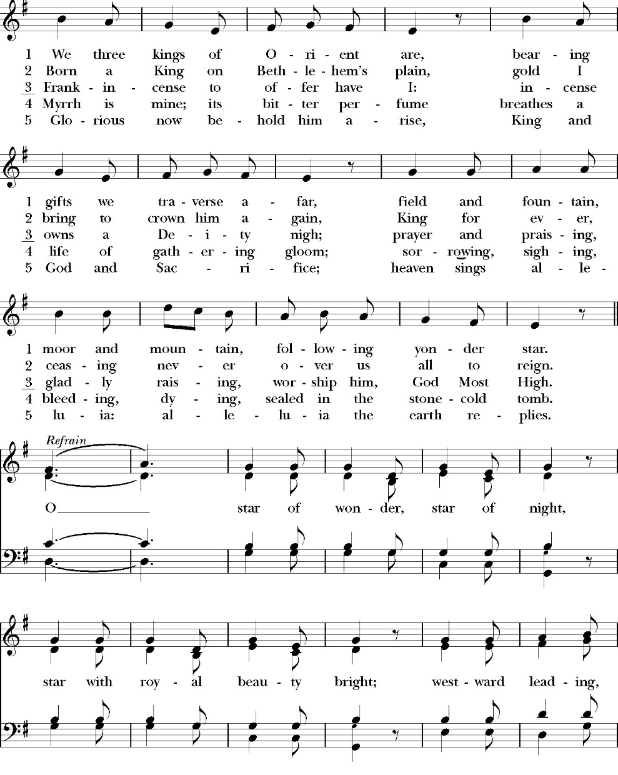

Clergy: The Holy Gospel of Our Lord Jesus Christ, according to
Matthew
People Praise to you, Lord Christ.

Gospel: Matthew 2:1-12
Now after Jesus was born in Bethlehem of Judea in the days of Herod the king, behold, wise men from the east came to Jerusalem, 2 saying, “Where is he who has been born king of the Jews? For we saw his star when it rose and have come to worship him.” 3 When Herod the king heard this, he was troubled, and all Jerusalem with him; 4 and assembling all the chief priests and scribes of the people, he inquired of them where the Christ was to be born. 5 They told him, “In Bethlehem of Judea, for so it is written by the prophet: 6 “‘And you, O Bethlehem, in the land of Judah, are by no means least among the rulers of Judah; for from you shall come a ruler who will shepherd my people Israel.’”

7 Then Herod summoned the wise men secretly and ascertained from them what time the star had appeared. 8 And he sent them to Bethlehem, saying, “Go and search diligently for the child, and when you have found him, bring me word, that I too may come and worship him.” 9 After listening to the king, they went on their way. And behold, the star that they had seen when it rose went before them until it came to rest over the place where the child was. 10 When they saw the star, they rejoiced exceedingly with great joy. 11 And going into the house, they saw the child with Mary his mother, and they fell down and worshiped him. Then, opening their treasures, they offered him gifts, gold and frankincense and myrrh. 12 And being warned in a dream not to return to Herod, they departed to their own country by another way.

Clergy The Gospel of the Lord
People Praise to you Lord Christ

Sermon
The Rev. John Iseman

The Nicene Creed

We believe in one God,
the Father, the Almighty,
maker of heaven and earth,
of all that is, visible and invisible.

We believe in one Lord, Jesus Christ,
the only-begotten Son of God,
eternally begotten of the Father,
God from God, Light from Light,
true God from true God,
begotten, not made,
of one Being with the Father.
through him all things were made.
For us and for our salvation he came down from heaven:
was incarnate from the Holy Spirit and the Virgin Mary,
and was made man.
For our sake he was crucified under Pontius Pilate;
he suffered death and was buried.
On the third day he rose again in accordance with the
Scriptures;
he ascended into heaven
and is seated at the right hand of the Father.
He will come again in glory to judge the living and the dead,
and his kingdom will have no end.

We believe in the Holy Spirit, the Lord, the giver of life,
who proceeds from the Father [and the Son],
who with the Father and the Son is worshiped and glorified.
who has spoken through the Prophets.
We believe in one holy catholic and apostolic Church.
We acknowledge one Baptism for the forgiveness of sins.
We look for the resurrection of the dead,
and the life of the world to come. Amen.

The Prayers of the People

Leader Let us pray for the Church and for the world, saying, “hear our prayer.”
For the peace of the whole world, and for the well-being and unity of the people of God.
Lord, in your mercy:
People Hear our prayer.

Leader For Stephen our archbishop and Eric, our Bishop. For Fr. Rob, Deacon John, Deacon Kashy, and for all the clergy and people of our Diocese and Congregation and for the worldwide Anglican Communion.
Lord, in your mercy:
People Hear our prayer.

Leader For all those who proclaim the Gospel at home and abroad; and for all who teach and disciple others.
Lord, in your mercy:
People Hear our prayer.
Leader For our brothers and sisters in Christ who are persecuted for their faith.
Lord, in your mercy:
People Hear our prayer.

Leader For our nation, for those in authority, and for all in public service especially Donald our president and Gavin our Governor.
Lord, in your mercy:
People Hear our prayer.

Leader: In the St. Paul’s cycle of prayer, we pray for all ministries of Christian education, discipleship and bible study. We pray that through word and deed we might grow closer to the heart and life of Jesus through our study, prayer, fellowship and mission.
Lord, in your mercy:
People Hear our prayer.

Leader: In the ACNA Cycle of Prayer, today we pray for the
Anglican Province of Southeast Asia, The Rt. Rev. Dr.
Titus Chung, Primate, and his wife, Connie.
Lord, in your mercy:
People Hear our prayer.

Leader For all those who are in trouble, sorrow, need, sickness, or any other adversity [especially _____________]. We also pray for all who are currently serving in our armed forces and serving as first responders.
Lord, in your mercy:
People Hear our prayer.

Leader For all those who have departed this life in the certain hope of the resurrection, (we pray especially for ____________), in thanksgiving let us pray.
Lord, in your mercy:
People Hear our prayer.

Celebrant will add a concluding prayer

The Confession and Absolution

Celebrant Let us humbly confess our sins to Almighty God.

Most merciful God,
we confess that we have sinned against you
in thought, word and deed,
by what we have done, and by what we have left undone.
We have not loved you with our whole heart;
we have not loved our neighbors as ourselves.
We are truly sorry and we humbly repent.
For the sake of your Son Jesus Christ,
have mercy on us and forgive us;
that we may delight in your will, and walk in your ways,
to the glory of your Name. Amen.

Celebrant

Almighty God, our heavenly Father, who in his great mercy has
promised forgiveness of sins to all those who sincerely repent and
with true faith turn to him, have mercy upon you, pardon and deliver
you from all your sins, confirm and strengthen you in all goodness,
and bring you to everlasting life; through Jesus Christ our Lord.
Amen.

The Comfortable Words

God so loved the world, that he gave his only-begotten Son, that
whoever believes in him should not perish but have eternal life.
-John 3:16t

Celebrant The Peace of the Lord be always with you.
People And with your spirit.

Offertory anthem
From Heaven Above to Earth I Come, Organ

The Offertory

Celebrant All things come from you, O Lord,
People And of your own have we given you.

The Eucharistic Liturgy

Celebrant The Lord be with you.
People And with your spirit.
Celebrant Lift up your hearts.
People We lift them up to the Lord.
Celebrant Let us give thanks to the Lord our God.
People It is right to give him thanks and praise.

It is right, our duty and our joy, always and everywhere to give thanks to you, Father Almighty, Creator of heaven and earth.
Because you gave Jesus Christ, your only Son, to be born for us; who,
by the Holy Spirit and the Virgin Mary his mother, was made truly
man, yet without the stain of sin, that we might be cleansed from sin
and given the right to become your children.
Therefore we praise you, joining our voices with angels and archangels and with all the company of heaven, who forever sing this hymn to proclaim the glory of your Name:

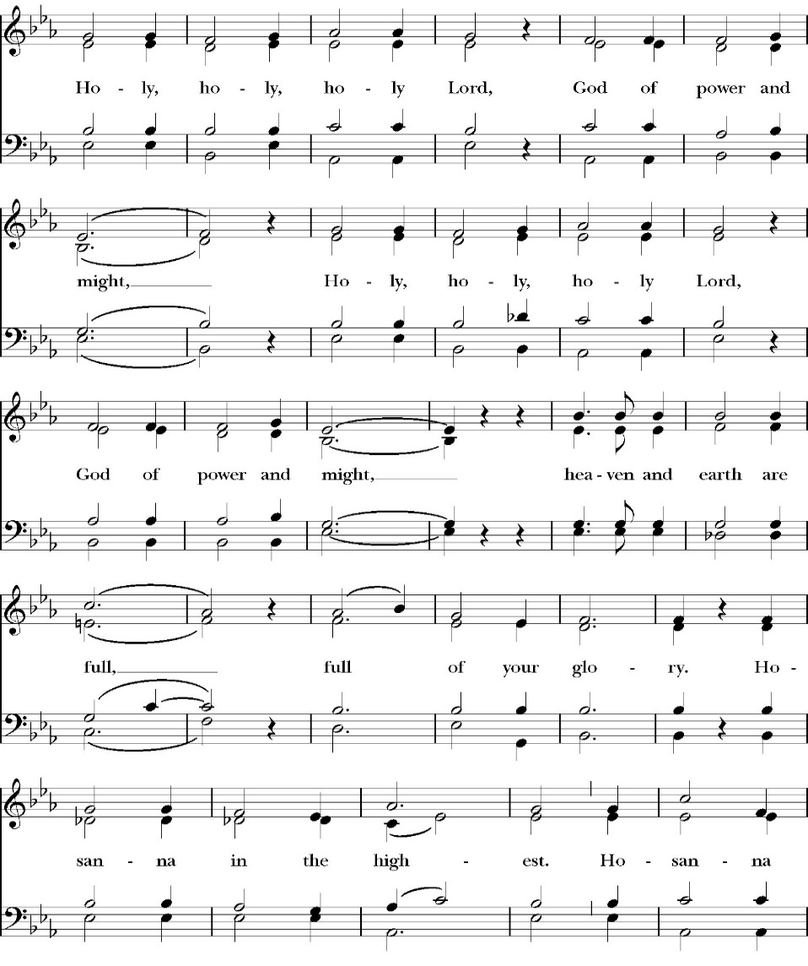
The Sanctus

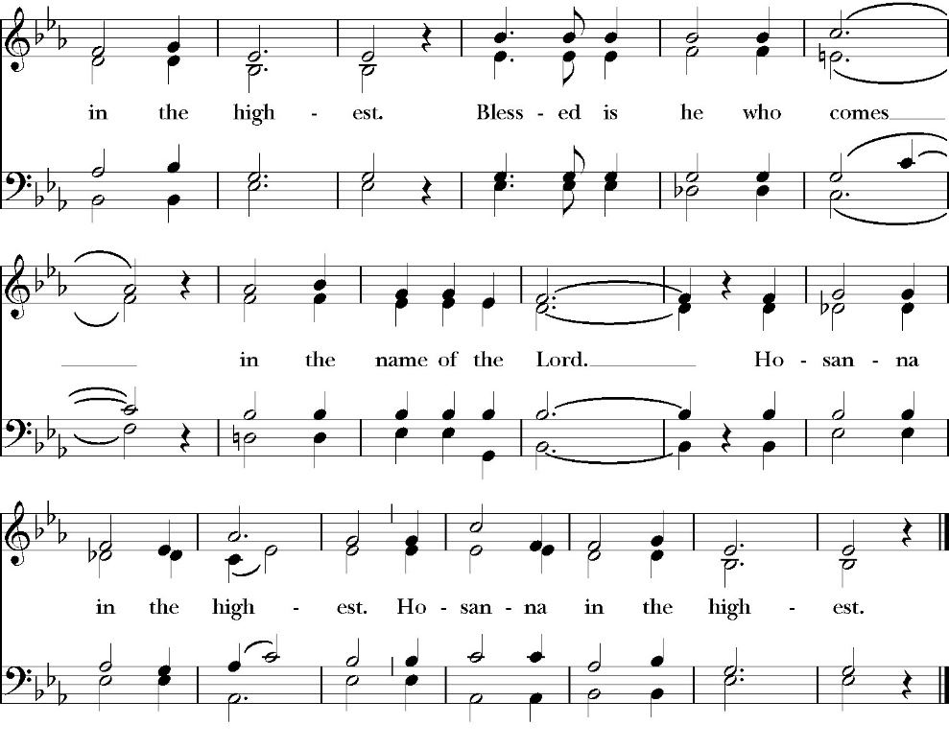
Holy and gracious Father: In your infinite love you made us for yourself; and when we had sinned against you and became subject to evil and death, you, in your mercy, sent your only Son Jesus Christ into the world for our salvation. By the Holy Spirit and the Virgin Mary he became flesh and dwelt among us. In obedience to your will, he stretched out his arms upon the Cross and offered himself once for all, that by his suffering and death we might be saved. By his resurrection he broke the bonds of death, trampling Hell and Satan under his feet. As our great high priest, he ascended to your right hand in glory, that we might come with confidence before the throne of grace.

On the night that he was betrayed, our Lord Jesus Christ took bread; and when he had given thanks, he broke it, * and gave it to his disciples, saying, “Take, eat; this is my Body, which is given for you: Do this in remembrance of me.”

Likewise, after supper, Jesus took the cup, and when he had given thanks, he gave it to them, saying, “Drink this, all of you; for this is my Blood of the New Covenant, which is shed for you, and for many, for the forgiveness of sins: Whenever you drink it, do this in remembrance of me.”

Therefore we proclaim the mystery of faith:

Christ has died.
Christ is risen.
Christ will come again.

We celebrate the memorial of our redemption, O Father, in this sacrifice of praise and thanksgiving, and we offer you these gifts.

Sanctify them by your Word and Holy Spirit to be for your people the Body and Blood of your Son Jesus Christ. Sanctify us also, that we may worthily receive this holy Sacrament, and be made one body with him, that he may dwell in us and we in him. In the fullness of time, put all things in subjection under your Christ, and bring us with all your saints into the joy of your heavenly kingdom, where we shall see our Lord face to face.

All this we ask through your Son Jesus Christ: By him, and with him, and in him, in the unity of the Holy Spirit, all honor and glory is yours, Almighty Father, now and for ever. Amen.

And now, as our Savior Christ has taught us, we are bold to pray,

Our Father, who art in heaven,
hallowed be thy Name,
thy kingdom come,
thy will be done,
on earth as it is in heaven.
Give us this day our daily bread.
And forgive us our trespasses,
as we forgive those
who trespass against us.
And lead us not into temptation,
but deliver us from evil.
For thine is the kingdom,
and the power, and the glory,
for ever and ever. Amen.

The Fraction

Celebrant Alleluia! Christ our Passover is sacrificed for us.
People Therefore let us keep the feast. Alleluia!

The Prayer for Humble Access

We do not presume to come to this your table, O merciful Lord,
trusting in our own righteousness,
but in your abundant and great mercies.
We are not worthy so much as to gather up
the crumbs under your table;
but you are the same Lord
whose character is always to have mercy.
Grant us, therefore, gracious Lord,
so to eat the flesh of your dear Son Jesus Christ,
and to drink his blood,
that our sinful bodies may be made clean by his body,
and our souls washed through his most precious blood,
and that we may evermore dwell in him, and he in us.
Amen.

Agnus Dei
The Ministration of Communion

The gifts of God for the People of God. Take them in remembrance that Christ died for you and feed on him in your hearts by faith, with thanksgiving.

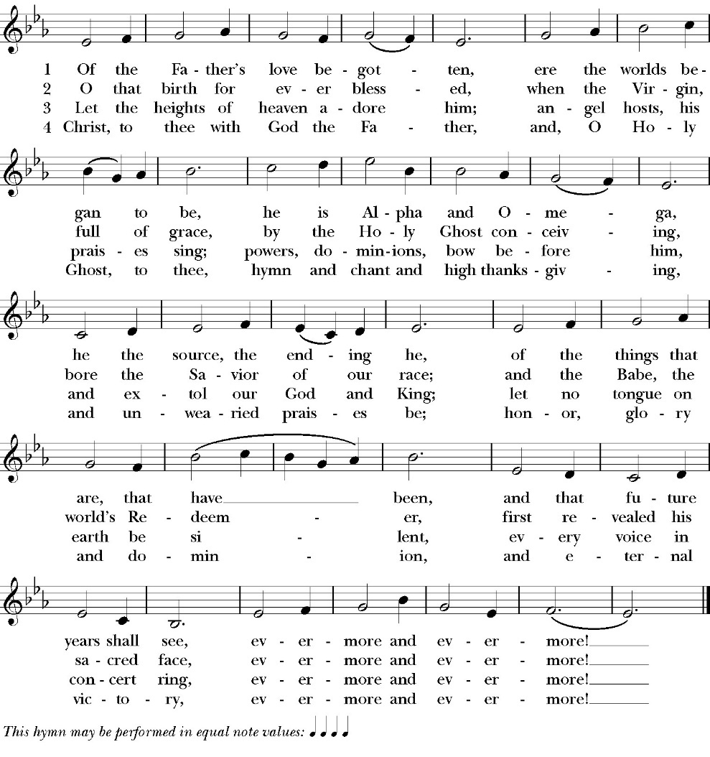
Communion Hymn: Of the Father’s Love Begotten

The Post Communion Prayer

Let us pray.

Heavenly Father,
We thank you for feeding us with the spiritual food
of the most precious Body and Blood
of your Son our Savior Jesus Christ;
and for assuring us in these holy mysteries
that we are living members of the body of your Son,
and heirs of your eternal Kingdom.
And now, Father, send us out to do the work you have
given us to do,
to love and serve you as faithful witnesses of Christ our
Lord.
To him, to you, and to the Holy Spirit,
be honor and glory, now and for ever. Amen.

The Blessing
The peace of God, which passes all understanding, keep your heart and minds in the knowledge and love of God, and his Son Jesus Christ our Lord; and the blessing of God Almighty, the Father, the Son, and the Holy Spirit, be among you, and remain with you always. Amen.

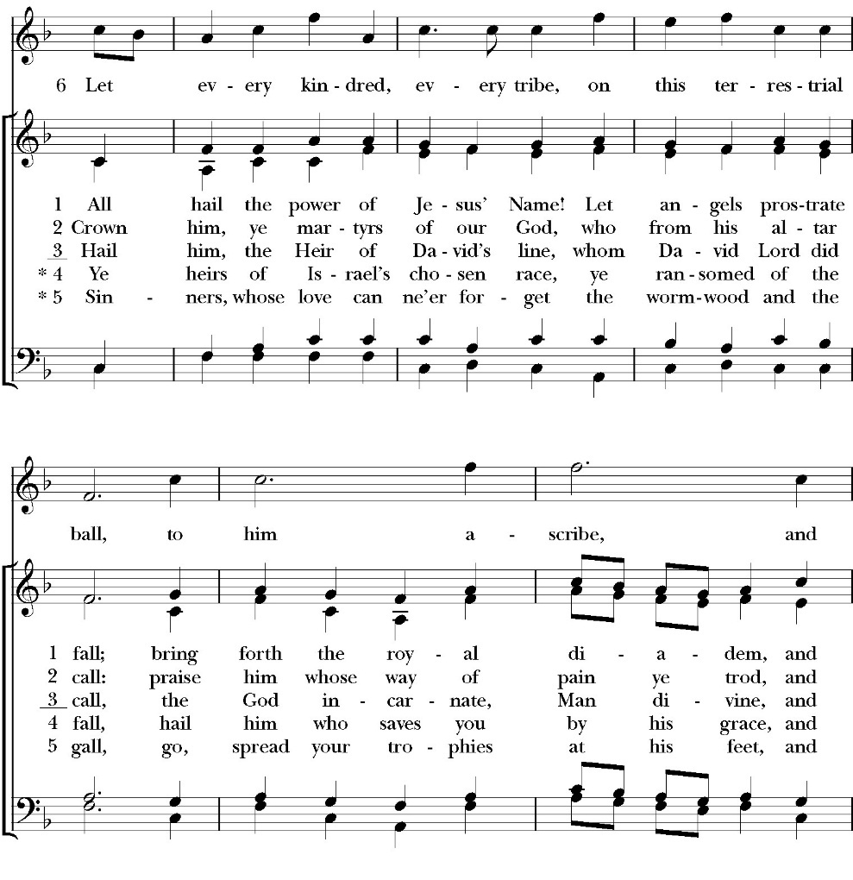
Closing Hymn: All Hail the Power of Jesus’ Name!

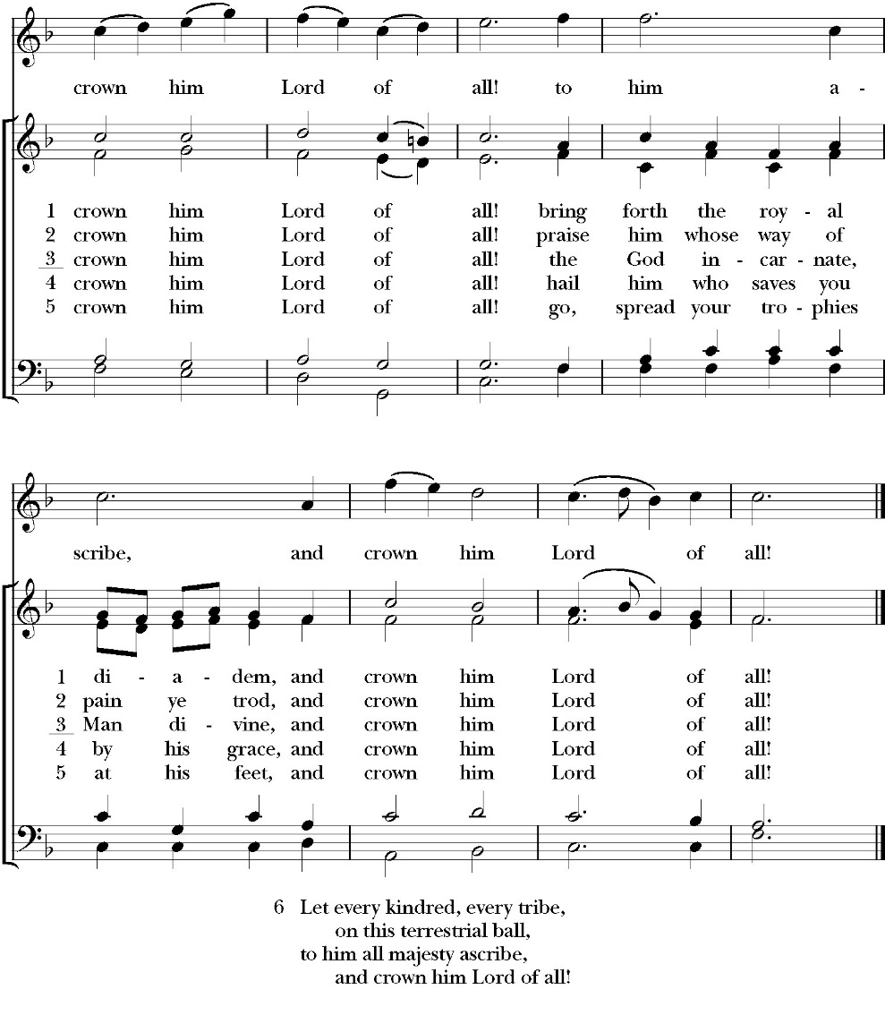

Celebrant Alleluia! Alleluia! Let us go forth in the Name of Christ.
People Thanks be to God. Alleluia! Alleluia!

St. Paul’s Parish Calendar
Sunday January 4 – Sunday January 11

SUNDAY, January 4 – Second Sunday of Christmas
10:30 AM Children’s Sunday School, Chapel
10:30 AM Holy Eucharist, Church

MONDAY, January 5

TUESDAY, January 6
6:00 PM Bell Choir Practice, Music Room

WEDNESDAY, January 7
9:30 AM Holy Eucharist with healing prayer, Chapel
10:15 AM Bible Study, Conference Room
7:00 PM Vocal Choir Rehearsal, Church

THURSDAY, January 8

FRIDAY, January 9
6:30 AM Men’s Bible Study, Valhalla Restaurant

SATURDAY, January 10

SUNDAY, January 11 – First Sunday of Epiphany
9:30 AM Anglican Catechism Class, Conference room
9:30 AM Vocal Choir rehearsal, Chapel
10:30 AM Children’s Sunday School, Chapel
10:30 AM Holy Eucharist, Church

Church Office Hours
Monday-Thursday 8:00 AM-4:00 PM

Announcements

Catechism class, Becoming Like Christ: The Ten
Commandments, Justification and Sanctification
Sundays, 9:15am-10:00 January 11-February 15
The Anglican Catechism invites us to explore how we can connect
the Authority of God’s word to our everyday Christian walk. This is
the final section of our Anglican catechism class, but does not require
previous attendance. We will explore how to live more fully
according to the law of God while also living according to the person
and teachings of Jesus.

Child Safety Training on Wednesday January 21st
In order to be in compliance with our Diocesan Child Safety Guidelines we will host a child safety training on Wednesday January 21, 2026. We will have dinner in James Hall from 6:00pm-7:00pm and then the training will be held in the church from 7:00pm-8:00pm. This training is mandatory for all of the following groups, regardless of whether or not you have completed this training in the past as the Diocesan Guidelines call for all of these groups to meet together for training every 3 years: (1) Family Ministry Volunteers (2) Vestry Members (3) Staff (4) Pastoral Care Team. In addition to those who are required to attend, all members of the church are invited and encouraged to attend so we can all work together to keep our church safe for all! If you have any questions or concerns, please reach out to Deacon John Iseman at family@spvisalia.com or on his cell at (518) 222-6722.

Special January Wonderful Wednesday Dinner Menu
Spaghetti & Sweet Basil Italian Meat Sauce
Green Mix Salad with Parmesan Cheese, Sweet Tomato Basil Croutons & Italian Dressing
Manny's Special Cheese Garlic Sour Dough Bread
Dessert: Toffee Bars

Please RSVP by calling the Church Office

Rt. Rev. Eric Menees to visit Sunday, January 25th
Bisho Eric Menees will be making his official visit to St. Paul’s on Sunday, January 25th. This year Bishop Menees will be sharing about the Diocesan Capital Campaign called Laying a Firm Foundation at a Forum after the worship service. More information will be coming soon.

Annual Meeting of St. Paul’s Anglican Church
Sunday, February 1, after the worship service
The annual meeting of St. Paul’s Anglican Church is an opportunity
to celebrate the ministries of the church, present the year end budget
for 2025 and the budget approved by the Vestry of the church for
2026 and elect new vestry members and delegates to the 2026
convention of the Anglican Diocese of San Joaquin. A Sandwich
Lunch and childcare will be provided.

Spring Rummage Sale 2026
We will be collecting gently used items on Wednesday, March 4, and Thursday, March 5, from 9 AM to 4 PM. The actual sale begins on Friday, March 6, from 8 AM to 4 PM concluding on Saturday, March 7, from 8 AM to 2 PM. If you have any questions, please call Mary Murray 559-799-6973.

St. Paul’s Anglican Church
Parish Office
6436 W. Hurley Ave
Visalia, California 93291
559-732-4821
Office Hours: 8:00 – 4:00
Monday – Thursday

Worship: Sundays at 10:30AM
Livestream: Link at spvisalia.com
and on our Facebook page
Please be advised that this service is being recorded for broadcast
and/or archival purposes. By attending, you consent
to the inclusion of your likeness in these recordings.

St. Paul’s Clergy and Staff
The Rev. Robert Longbottom, Rector
rector@spvisalia.com
(559)802-2928
The Rev. John Iseman, Pastoral Associate for Family Ministries
family@spvisalia.com
The Rev. Kashy Rowland-Smith, Deacon
kashyrs@aol.com
Antoinette Horsting, Parish Administrator
bookkeeper@spvisalia.com
Marguerite Crownover, Organist and Accompanist
Cynthia Culp, Choral Director
Jackie Iseman, Nursery Coordinator
Shane Motl, Sexton

St. Paul’s is a member church of the
Anglican Diocese of San Joaquin
The Rt. Rev. Eric V. Menees, Bishop

Next Week’s Lessons
Isaiah 42:1-9
Psalm 89:1-29
Acts 10:34-38
Matthews 3:13-17

