St. Paul’s Anglican Church
Visalia, California
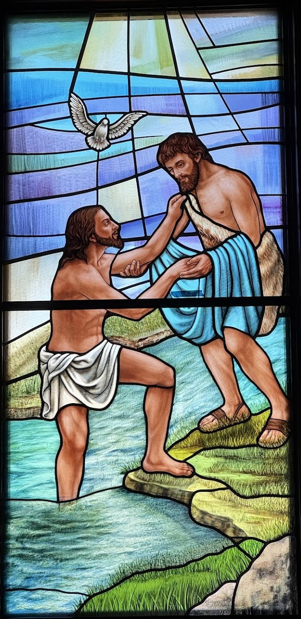

Second Sunday of Epiphany
January 18, 2026
10:30 AM

Welcome!
St. Paul’s Anglican Church extends a warm welcome to all visitors and newcomers, whether worshiping in person or at home via livestream.

Visitors’ Guide

St. Paul’s Church is a parish in the Diocese of San Joaquin of the Anglican Church in North America, which includes both Catholic and Protestant traditions. We accept Jesus Christ as Savior, and we promise to follow him as Lord. We believe in One God,

- the Father who created us and all things,
- the Son who redeems us from sin and death,
- the Holy Spirit who renews and sanctifies us.

We believe the Holy Scriptures to be the Word of God and to contain all things necessary for salvation, and we accept the Apostles’ and Nicene Creeds as essential beliefs of the Christian faith.

All followers of Jesus who are baptized in the name of the Trinity are invited to receive Holy Communion. If for whatever reason you feel you cannot receive communion, we invite you to come forward to receive a blessing. Please indicate you’d like a blessing by crossing your arms. All people are welcome at the Altar of the Lord.

Visitors are invited to sign the guest book at the entrance table and introduce themselves to the clergy following the service.

The Holy Eucharist

Prelude: “When I Can Read My Title Clear” by Dale Wood
Opening Hymn: #616 – “Hail to the Lord’s Anointed” p. 4
Acclamation p. 5
The Collect for Purity p. 5
Summary of the Law p. 5
Kyrie p. 5
Gloria p. 6
Collect of the Day p. 7
Lesson: Exodus 12:21-28 p. 7
Gradual: Psalm 40:1-11 p. 8
Epistle: 1 Corinthians 1:1-9 p. 8
Sequence Hymn: #384 – “Fairest Lord Jesus” p. 9
Gospel: John 1:29-42 p. 10
Sermon: Rev. Robert Longbottom
Nicene Creed p. 11
Prayers of the People p. 12
Confession and Absolution p. 13
The Peace
Offertory Anthem- Bells Choir - “Hearth and Home” by Jason W. Krug
The Offertory p. 14
Sanctus p. 15
The Lord’s Prayer p. 17
Prayer for Humble Access p. 17
Agnus Dei p. 18
Communion Hymn: #339 – “Deck Thyself My Soul, with Gladness” p. 19
Post communion Prayer p. 20
Blessing p. 20
Closing Hymn: #448 – “O Love, How Deep” p. 21
Dismissal p. 21
Postlude: “Praise Ye the Lord of Hosts” By Camille Saint-Saens

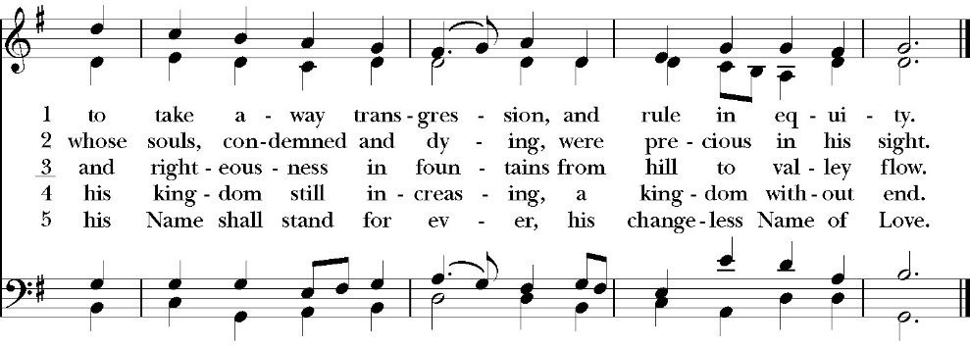
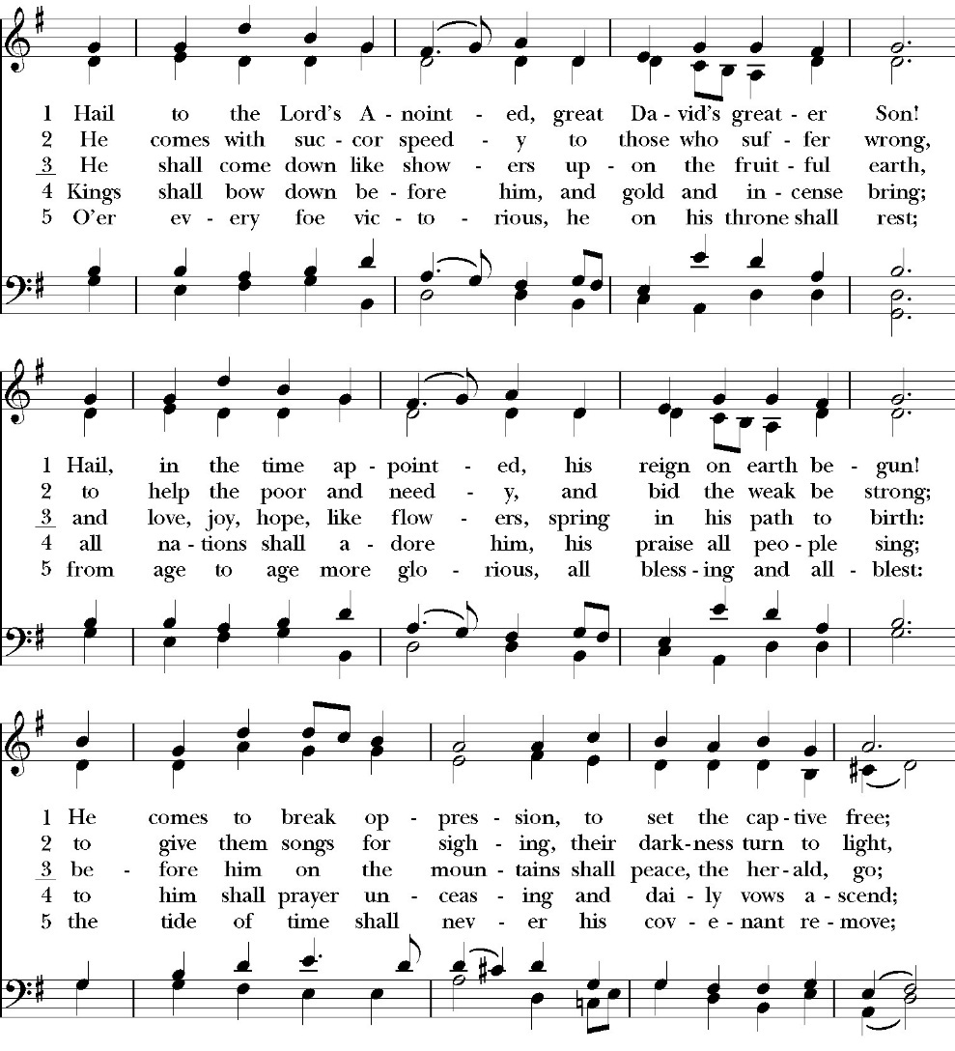
Opening Hymn: Hail to the Lord’s Anointed

The Acclamation

Celebrant I will make you as a light for the nations,
People That my salvation may reach to the end of the earth.

The Collect for Purity

Almighty God, to you all hearts are open, all desires known, and from you no secrets are hid: Cleanse the thoughts of our hearts by the inspiration of your Holy Spirit, that we may perfectly love you, and worthily magnify your holy Name through Christ our Lord. Amen.

The Summary of the law

Hear what our Lord Jesus Christ says: You shall love the Lord your God with all your heart and with all your soul and with all your mind. This is the first and great commandment. And the second is like it: You shall love your neighbor as yourself. On these two commandments depend all the Law and the Prophets.

The Kyrie
The Gloria

Officiant The Lord be with You.
People And with your spirit.
Officiant Let us pray:

The Collect of the Day

Almighty God, whose Son our Savior Jesus Christ is the light of the
world: Grant that your people, illumined by your Word and Sacraments, may shine with the radiance of Christ’s glory, that he may be known, worshiped, and obeyed to the ends of the earth; through Jesus Christ our Lord, who with you and the Holy Spirit lives and reigns, one God, now and for ever. Amen.

Lesson: Exodus 12:21-28
²¹ Then Moses called all the elders of Israel and said to them, “Go and select lambs for yourselves according to your clans, and kill the Passover lamb. ²² Take a bunch of hyssop and dip it in the blood that is in the basin, and touch the lintel and the two doorposts with the blood that is in the basin. None of you shall go out of the door of his house until the morning. ²³ For the Lord will pass through to strike the Egyptians, and when he sees the blood on the lintel and on the two doorposts, the Lord will pass over the door and will not allow the destroyer to enter your houses to strike you. ²⁴ You shall observe this rite as a statute for you and for your sons forever. ²⁵ And when you come to the land that the Lord will give you, as he has promised, you shall keep this service. ²⁶ And when your children say to you, ‘What do you mean by this service?’ ²⁷ you shall say, ‘It is the sacrifice of the Lord's Passover, for he passed over the houses of the people of Israel in Egypt, when he struck the Egyptians but spared our houses.’” And the people bowed their heads and worshiped.
²⁸ Then the people of Israel went and did so; as the Lord had commanded Moses and Aaron, so they did.
Reader The Word of the Lord
People Thanks be to God

Gradual: Psalm 40:1-11
1 I waited patiently for the Lord, *
and he inclined to me, and heard my call.
2 He brought me out of the horrible pit, out of the mire and clay; *
he set my feet upon the rock, and secured my footing.
3 He has put a new song in my mouth, *
a song of thanksgiving unto our God.
4 Many shall see and fear, *
and shall put their trust in the Lord.
5 Blessed is the man who has set his hope in the Lord, *
and has not turned to the proud, or to those who go about
lying.
6 O Lord my God, great are the wondrous works which you have
done, and also your thoughts toward us; *
there is none who can be compared with you.
7 If I should declare them and speak of them, *
they would be more than I am able to express.
8 Sacrifice and offering you do not desire, *
but my ears you have opened.
9 Burnt offerings and sin offerings you have not required, *
and so I said, “Behold, I come;
10 In the volume of the book it is written of me, that I delight to do
your will, O my God; *
indeed, your law is within my heart.”
11 I have declared your righteousness in the great congregation; *
behold, I will not restrain my lips, O Lord, and that you know.
Glory be to the Father, and to the Son, and to the Holy Spirit;
as it was in the beginning, is now, and ever shall be, world without end. Amen
Epistle: 1 Corinthians 1:1-9
Paul, called by the will of God to be an apostle of Christ Jesus, and our brother Sosthenes,
² To the church of God that is in Corinth, to those sanctified in Christ Jesus, called to be saints together with all those who in every place call upon the name of our Lord Jesus Christ, both their Lord and ours:
³ Grace to you and peace from God our Father and the Lord Jesus Christ.
⁴ I give thanks to my God always for you because of the grace of God that was given you in Christ Jesus, ⁵ that in every way you were enriched in him in all speech and all knowledge— ⁶ even as the testimony about Christ was confirmed among you— ⁷ so that you are not lacking in any gift, as you wait for the revealing of our Lord Jesus Christ, ⁸ who will sustain you to the end, guiltless in the day of our Lord Jesus Christ. ⁹ God is faithful, by whom you were called into the fellowship of his Son, Jesus Christ our Lord.

Reader The Word of the Lord
People Thanks be to God

Sequence Hymn: Fairest Lord Jesus
(vs.1-2 before the Gospel, vs.3 after)
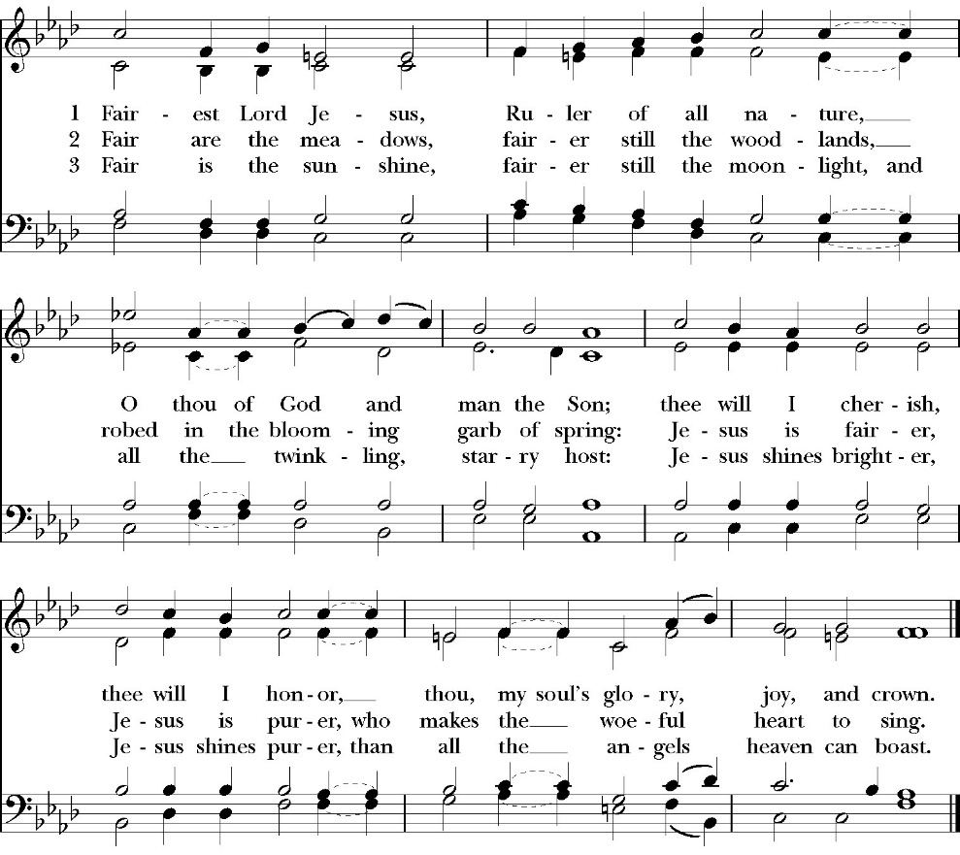

Clergy The Holy Gospel of Our Lord Jesus Christ, according to
St. John.
People Glory to you, Lord Christ.

Gospel: John 1:29-42
²⁹ The next day he saw Jesus coming toward him, and said, “Behold, the Lamb of God, who takes away the sin of the world! ³⁰ This is he of whom I said, ‘After me comes a man who ranks before me, because he was before me.’ ³¹ I myself did not know him, but for this purpose I came baptizing with water, that he might be revealed to Israel.” ³² And John bore witness: “I saw the Spirit descend from heaven like a dove, and it remained on him. ³³ I myself did not know him, but he who sent me to baptize with water said to me, ‘He on whom you see the Spirit descend and remain, this is he who baptizes with the Holy Spirit.’ ³⁴ And I have seen and have borne witness that this is the Son of God.”
³⁵ The next day again John was standing with two of his disciples, ³⁶ and he looked at Jesus as he walked by and said, “Behold, the Lamb of God!” ³⁷ The two disciples heard him say this, and they followed Jesus. ³⁸ Jesus turned and saw them following and said to them, “What are you seeking?” And they said to him, “Rabbi” (which means Teacher), “where are you staying?” ³⁹ He said to them, “Come and you will see.” So they came and saw where he was staying, and they stayed with him that day, for it was about the tenth hour. ⁴⁰ One of the two who heard John speak and followed Jesus was Andrew, Simon Peter's brother. ⁴¹ He first found his own brother Simon and said to him, “We have found the Messiah” (which means Christ). ⁴² He brought him to Jesus. Jesus looked at him and said, “You are Simon the son of John. You shall be called Cephas” (which means Peter).

Clergy The Gospel of the Lord
People Praise to you, Lord Christ.

Sermon
The Rev. Robert Longbottom

The Nicene Creed

We believe in one God,
the Father, the Almighty,
maker of heaven and earth,
of all that is, visible and invisible.

We believe in one Lord, Jesus Christ,
the only-begotten Son of God,
eternally begotten of the Father,
God from God, Light from Light,
true God from true God,
begotten, not made,
of one Being with the Father.
through him all things were made.
For us and for our salvation he came down from heaven:
was incarnate from the Holy Spirit and the Virgin Mary,
and was made man.
For our sake he was crucified under Pontius Pilate;
he suffered death and was buried.
On the third day he rose again in accordance with the
Scriptures;
he ascended into heaven
and is seated at the right hand of the Father.
He will come again in glory to judge the living and the dead,
and his kingdom will have no end.

We believe in the Holy Spirit, the Lord, the giver of life,
who proceeds from the Father [and the Son],
who with the Father and the Son is worshiped and glorified.
who has spoken through the Prophets.
We believe in one holy catholic and apostolic Church.
We acknowledge one Baptism for the forgiveness of sins.
We look for the resurrection of the dead,
and the life of the world to come. Amen.

The Prayers of the People

Leader Let us pray for the Church and for the world, saying, “hear our prayer.”
For the peace of the whole world, and for the well-being and unity of the people of God.
Lord, in your mercy:
People Hear our prayer.

Leader For Stephen our archbishop and Eric, our Bishop. For Fr. Rob, Deacon John, Deacon Kashy, and for all the clergy and people of our Diocese and Congregation and for the worldwide Anglican Communion.
Lord, in your mercy:
People Hear our prayer.

Leader For all those who proclaim the Gospel at home and abroad; and for all who teach and disciple others.
Lord, in your mercy:
People Hear our prayer.

Leader For our brothers and sisters in Christ who are persecuted for their faith.
Lord, in your mercy:
People Hear our prayer.

Leader For our nation, for those in authority, and for all in public service especially Donald our president and Gavin our Governor.
Lord, in your mercy:
People Hear our prayer.

Leader: In the St. Paul’s cycle of prayer will pray for all ministries of mission and outreach to our community and in the world. We pray specifically for the medical mission to Honduras, St. Paul’s School, Visalia Senior Housing, Turning Point ministries and all ministries which, we support as a parish. We pray for Fr. Frank and Ann Bernardi and Millagro Menees.
Lord, in your mercy:
People Hear our prayer.

Leader In the ACNA Cycle of Prayer, today we pray for the Diocese of Christ our Hope, Bishop Alan Hawkins, and his wife, Angela; Bishop Quigg Lawrence, and his wife, Annette; and Bishop Steven Breedlove, his wife, Sally.
Lord, in your mercy:
People Hear our prayer.

Leader For all those who are in trouble, sorrow, need, sickness, or any other adversity [especially _____________]. We also pray for all who are currently serving in our armed forces and serving as first responders.
Lord, in your mercy:
People Hear our prayer.

Leader For all those who have departed this life in the certain hope of the resurrection, (we pray especially for ____________), in thanksgiving let us pray.
Lord, in your mercy:
People Hear our prayer.

Celebrant will add a concluding prayer

The Confession and Absolution

Celebrant Let us humbly confess our sins to Almighty God.

Most merciful God,
we confess that we have sinned against you
in thought, word and deed,
by what we have done, and by what we have left undone.
We have not loved you with our whole heart;
we have not loved our neighbors as ourselves.
We are truly sorry and we humbly repent.
For the sake of your Son Jesus Christ,
have mercy on us and forgive us;
that we may delight in your will, and walk in your ways,
to the glory of your Name. Amen.
Almighty God, our heavenly Father, who in his great mercy has
promised forgiveness of sins to all those who sincerely repent and
with true faith turn to him, have mercy upon you, pardon and deliver
you from all your sins, confirm and strengthen you in all goodness,
and bring you to everlasting life; through Jesus Christ our Lord.
Amen.

The saying is trustworthy and deserving of full acceptance, that
Christ Jesus came into the world to save sinners.
1 Timothy 1:15
Celebrant The Peace of the Lord be always with you.
People And with your spirit.

Offertory anthem
Bells Choir - “Hearth and Home” by Jason W. Krug

The Offertory

Celebrant All things come from you, O Lord,
People And of your own have we given you.

The Eucharistic Liturgy

Celebrant The Lord be with you.
People And with your spirit.
Celebrant Lift up your hearts.
People We lift them up to the Lord.
Celebrant Let us give thanks to the Lord our God.
People It is right to give him thanks and praise.

It is right, our duty and our joy, always and everywhere to give thanks to you, Father Almighty, Creator of heaven and earth.

Through Jesus Christ our Lord, who took on our mortal flesh to reveal his glory; that he might bring us out of darkness and into his own glorious light.

Therefore we praise you, joining our voices with angels and archangels and with all the company of heaven, who forever sing this hymn to proclaim the glory of your Name:
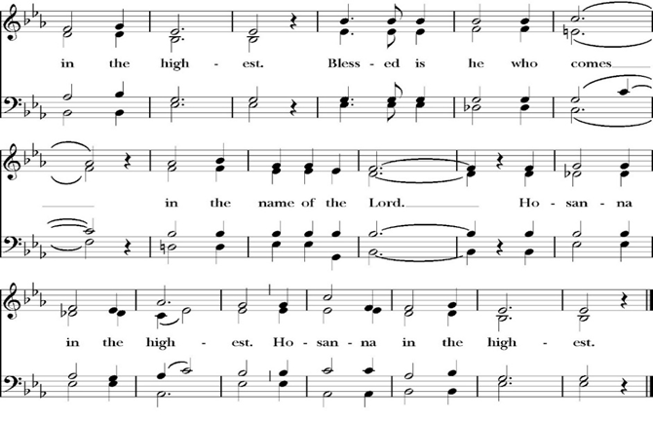
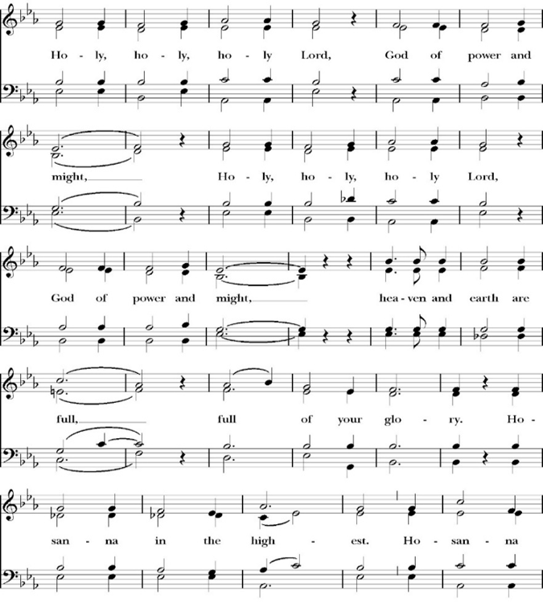
The Sanctus
Holy and gracious Father: In your infinite love you made us for yourself; and when we had sinned against you and become subject to evil and death, you, in your mercy, sent your only Son Jesus Christ into the world for our salvation. By the Holy Spirit and the Virgin Mary he became flesh and dwelt among us. In obedience to your will, he stretched out his arms upon the Cross and offered himself once for all, that by his suffering and death we might be saved. By his resurrection he broke the bonds of death, trampling Hell and Satan under his feet. As our great high priest, he ascended to your right hand in glory, that we might come with confidence before the throne of grace.

On the night that he was betrayed, our Lord Jesus Christ took bread; and when he had given thanks, he broke it, * and gave it to his disciples, saying, “Take, eat; this is my Body, which is given for you: Do this in remembrance of me.”

Likewise, after supper, Jesus took the cup, and when he had given thanks, he gave it to them, saying, “Drink this, all of you; for this is my Blood of the New Covenant, which is shed for you, and for many, for the forgiveness of sins: Whenever you drink it, do this in remembrance of me.”

Therefore we proclaim the mystery of faith:

Christ has died.
Christ is risen.
Christ will come again.

We celebrate the memorial of our redemption, O Father, in this sacrifice of praise and thanksgiving, and we offer you these gifts.

Sanctify them by your Word and Holy Spirit to be for your people the Body and Blood of your Son Jesus Christ. Sanctify us also, that we may worthily receive this holy Sacrament, and be made one body with him, that he may dwell in us and we in him. In the fullness of time, put all things in subjection under your Christ, and bring us with all your saints into the joy of your heavenly kingdom, where we shall see our Lord face to face.

All this we ask through your Son Jesus Christ: By him, and with him, and in him, in the unity of the Holy Spirit, all honor and glory is yours, Almighty Father, now and for ever. Amen.

And now, as our Savior Christ has taught us, we are bold to pray,

Our Father, who art in heaven,
hallowed be thy Name,
thy kingdom come,
thy will be done,
on earth as it is in heaven.
Give us this day our daily bread.
And forgive us our trespasses,
as we forgive those
who trespass against us.
And lead us not into temptation,
but deliver us from evil.
For thine is the kingdom,
and the power, and the glory,
for ever and ever. Amen.

Celebrant Alleluia! Christ our Passover is sacrificed for us.
People Therefore let us keep the feast. Alleluia!

We do not presume to come to this your table, O merciful Lord,
trusting in our own righteousness,
but in your abundant and great mercies.
We are not worthy so much as to gather up
the crumbs under your table;
but you are the same Lord
whose character is always to have mercy.
Grant us, therefore, gracious Lord,
so to eat the flesh of your dear Son Jesus Christ,
and to drink his blood,
that our sinful bodies may be made clean by his body,
and our souls washed through his most precious blood,
and that we may evermore dwell in him, and he in us.
Amen.
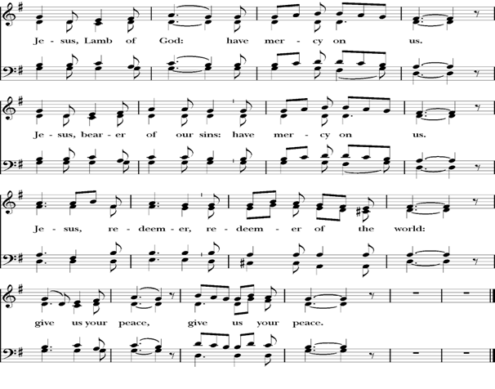
Agnus Dei

The Ministration of Communion

The gifts of God for the People of God. Take them in remembrance that Christ died for you and feed on him in your hearts by faith, with thanksgiving.

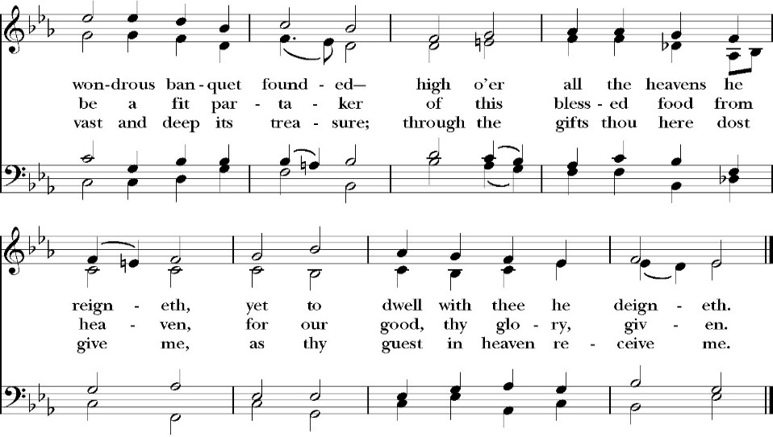
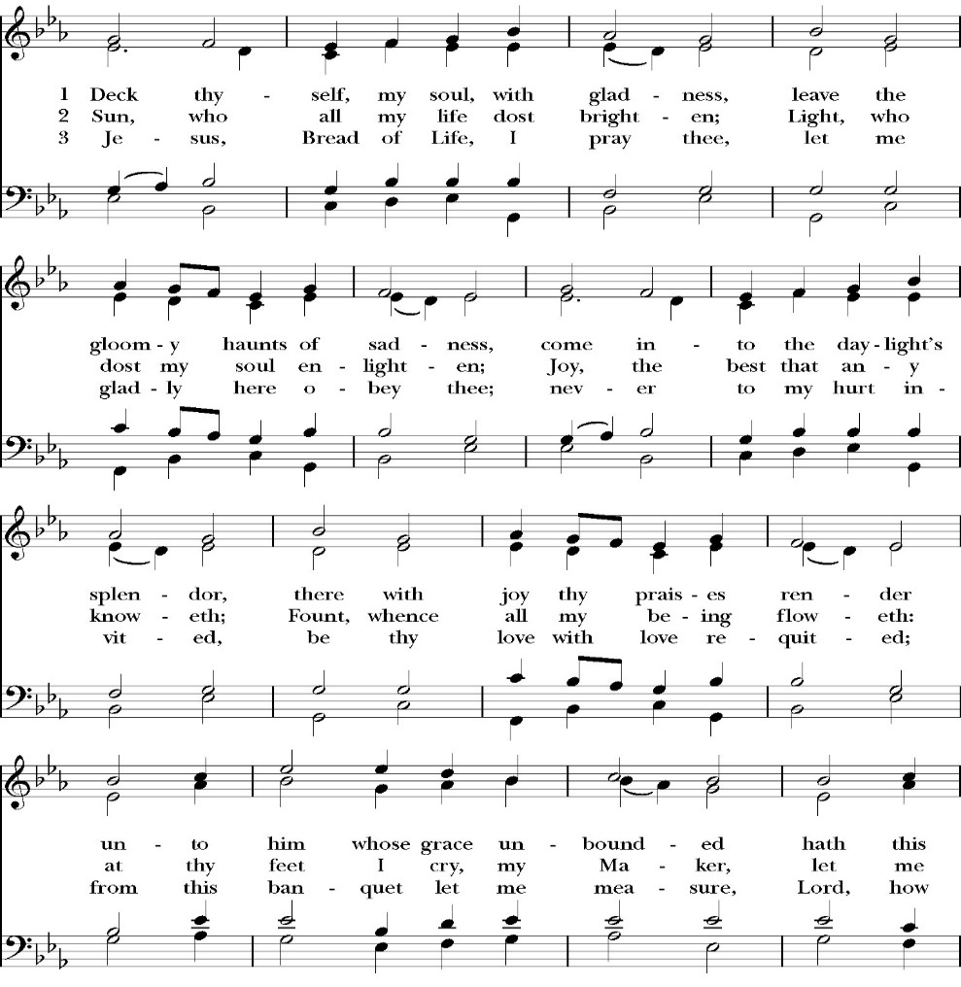
Communion Hymn: Deck Thyself My Soul, with Gladness
The Post Communion Prayer
Let us pray.

Heavenly Father,
We thank you for feeding us with the spiritual food
of the most precious Body and Blood
of your Son our Savior Jesus Christ;
and for assuring us in these holy mysteries
that we are living members of the body of your Son,
and heirs of your eternal Kingdom.
And now, Father, send us out to do the work you have
given us to do,
to love and serve you as faithful witnesses of Christ our
Lord.
To him, to you, and to the Holy Spirit,
be honor and glory, now and for ever. Amen.

The Blessing

The peace of God, which passes all understanding, keep your hearts
and minds in the knowledge and love of God, and of his Son Jesus
Christ our Lord; and the blessing of God Almighty, the Father, the
Son, and the Holy Spirit, be among you, and remain with you always.
Amen.

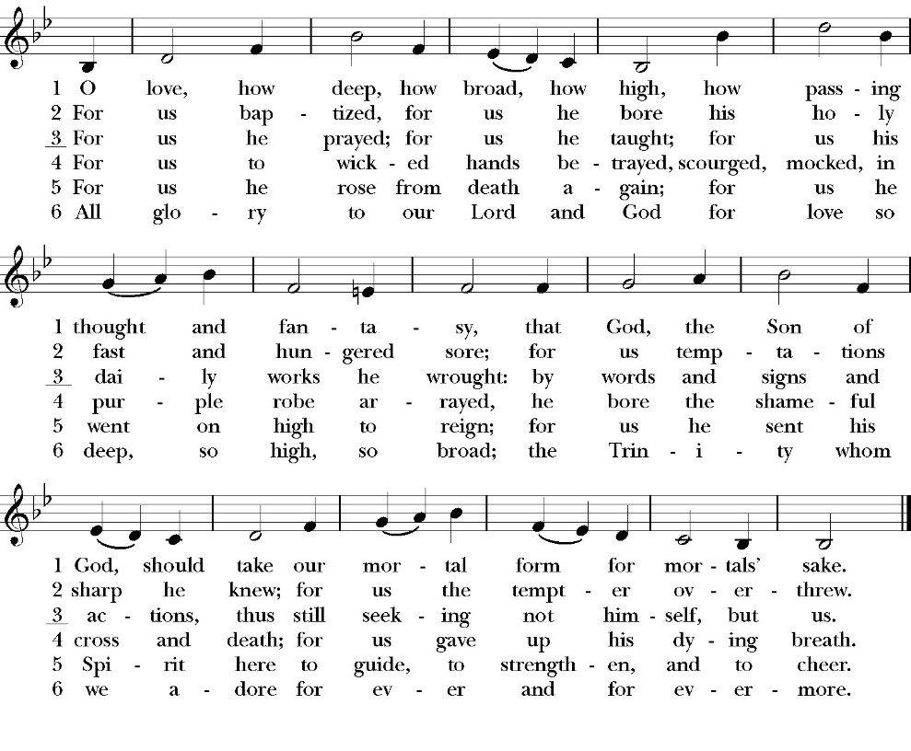
Closing Hymn: O Love, How Deep

Celebrant Alleluia! Go in peace to love and serve the Lord.
People Thanks be to God. Alleluia! Alleluia!
St. Paul’s Parish Calendar
Sunday January 18 – Sunday January 25

SUNDAY, January 18 – Second Sunday of Epiphany
9:15 AM Sunday Funday, Youth Room
9:15 AM Anglican Catechism Class, Conference room
10:30 AM Children’s Sunday School,
Pre-K –2nd Grade, Sunday School Room.
3rd -5th Grade, Youth Room
10:30 AM Holy Eucharist, Church

MONDAY, January 19 – Office Closed for Martin Luther King’s Day

TUESDAY, January 20
6:00 PM Bell Choir Practice, Music Room

WEDNESDAY, January 21
9:30 AM Holy Eucharist with healing prayer, Chapel
10:15 AM Bible Study, Conference Room
2:30 to 3:30 PM Neighborhood Market, Church Parking Lot
6:00 PM Dinner, James Hall
7:00 to 8:00 PM Child Safety Training, Church
7:00 PM No Vocal Choir Rehearsal, Church

THURSDAY, January 22

FRIDAY, January 23
6:30 AM Men’s Bible Study, Valhalla Restaurant

SATURDAY, January 24

SUNDAY, January 25 – Third Sunday of Epiphany
9:15 AM Sunday Funday, Youth Room
9:15 AM Anglican Catechism Class, Conference room
9:30 AM Vocal Choir rehearsal, Chapel
10:30 AM Children’s Sunday School, Chapel
Pre-K –2nd Grade, Sunday School Room.
3rd -5th Grade, Youth Room
10:30 AM Holy Eucharist, Church

Church Office Hours
Monday-Thursday 8:00 AM-4:00 PM

Office will be closed for Martin Luther King’s Day Monday January 19

Announcements

Nominations for Vestry and Delegates for 2026 Convention of
the Anglican Diocese of San Joaquin
The nominations committee (a subcommittee of the vestry) put
forward a slate of nominees to the Vestry at the January 13th meeting.
The following were approved by vestry to stand for election for
vestry and delegates to the 2026 Convention of the Anglican Diocese
of San Joaquin.

Vestry class of 2029 (Four vestry seats open)

Don Fowler
Joey Haas
Wendy Johns
Justin Qualls

Delegates to 2026 Convention of the Anglican Diocese of San
Joaquin (Three delegates and one alternate to be elected)

David Francis (Delegate)
Janet Robinson (Delegate)
Kim Robinson (Delegate)
Jim Doe (Alternate)

Additional nominations may be presented by confirmed voting members the
congregation on the floor of the annual meeting on Sunday, February 1

Rt. Rev. Eric Menees to visit Sunday, January 25
Bishop Eric Menees will be making his official visit to St. Paul’s on Sunday, January 25. This year, Bishop Menees will be sharing about the Diocesan Capital Campaign called “Laying a Firm Foundation” at a forum after the worship service. More information will be coming soon.

Annual Meeting of St. Paul’s Anglican Church
Sunday, February 1, after the Worship Service
The annual meeting of St. Paul’s Anglican Church is an opportunity
to celebrate the ministries of the church, present the year-end budget
for 2025 and the budget approved by the Vestry of the church for
2026, and elect new vestry members and delegates to the 2026
convention of the Anglican Diocese of San Joaquin. A sandwich
lunch and childcare will be provided.

Catechism Class, Becoming Like Christ: The Ten Commandments, Justification and Sanctification
Sundays, 9:15AM-10:00 January 11-February 15
The Anglican Catechism invites us to explore how we can connect
the authority of God’s word to our everyday Christian walk. This is
the final section of our Anglican catechism class, but does not require
previous attendance. We will explore how to live more fully
according to the law of God while also living according to the person
and teachings of Jesus.

January 18 Commandments 1 & 2
January 25 Commandments 3 & 4
February 1 Commandments 5 & 6
February 8 Commandments 7 & 8
February 15 Commandments 9 & 10 and Summary

The schedule may be modified based on weekly progress. No matter how far we get, the class will finish on Sunday, February 15.

So…. This Is the Bible” Program
Wednesdays January 28, February 4, and
February 11

Potluck, 6PM
Attendees are encouraged to bring a casserole, salad or side to share. No RSVP required.

"So...This is the Bible": A four week overview of the Bible
6:30-7:30PM
Have you ever read the Bible and found yourself to be very confused because you have no idea what is going on in the scripture you’re reading?

Have you ever been asked questions about the Bible by a non-Christian friend and found yourself grasping at straws and wishing you could give a better answer?
Is growing in your knowledge of the Bible and in your faith a consistent goal in your life that seems to fall to the bottom of your priority list year after year?

If the answer to these questions is yes, then you are in good company. So many people, even devoted Christians, struggle to read the Bible and know less about the Bible than they might want to admit. If you would like to make 2026 the year that you learn more about the Bible for personal study, spiritual growth, and so you can more effectively share your faith - then this is the class for you!

In four sessions we will cover a number of topics including how the Bible was formed, how we can be sure the Bible is reliable, the overarching storyline of the Bible, how to study the Bible, and more! We hope that you will consider coming out and joining us! Children’s programming and nursery care will be available at the same time as this class. Our first session dates are all on Wednesday evenings on 1/28, 2/4, and 2/11. Stay tuned for exact timing and details.

Child Safety Training on Wednesday, January 21
In order to be in compliance with our Diocesan Child Safety Guidelines, we will host a child safety training on Wednesday, January 21, 2026. We will have dinner in James Hall from 6:00PM-7:00PM and then the training will be held in the church from 7:00PM-8:00PM. This training is mandatory for all of the following groups, regardless of whether or not you have completed this training in the past as our Diocesan Guidelines call for all of these groups to meet together for training every 3 years: (1) Family Ministry Volunteers (2) Vestry Members (3) Staff (4) Pastoral Care Team. In addition to those who are required to attend, all members of the church are invited and encouraged to attend so we can all work together to keep our church safe for all! If you have any questions or concerns, please reach out to Deacon John Iseman at family@spvisalia.com or on his cell at (518) 222-6722.

Special January Wonderful Wednesday Dinner Menu
Spaghetti & Sweet Basil Italian Meat Sauce
Green Mixed Salad with Parmesan Cheese, Sweet Tomato Basil Croutons & Italian Dressing
Manny's Special Cheese Garlic Sourdough Bread
Dessert: Toffee Bars

Please RSVP for dinner by calling the Church Office
A Food Bank for Hurley Families
The next Neighborhood Market to benefit students at Hurley School will be Wednesday, January 21, from 2:30 PM to 3:30 PM at St Paul’s Church parking lot. If you are interested in helping that day, please contact Sue Nyberg. My home phone number is 559-733-8244.

PROVIDED BY VISALIA EMERGENCY AID
AND ST. PAUL’S CHURCH
Wednesday, January 21, 2026
From 2:30 PM to 3:30 PM
LOCATION:
ST. PAUL'S CHURCH PARKING LOT
ACROSS THE STREET FROM HURLEY




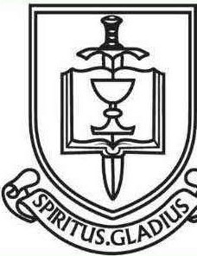

ST. PAUL'S ANGLICAN CHURCH
"WHERE GOD BUILDS THINGS"
-

St. Paul’ Anglican Church
6436 W Hurley Ave

Visalia, CA

Friday March 6, 8:00 AM to 4:00 PM
Saturday March 7, 8:00 AM to 2:00 PM
Drop Off Donated Items in James Hall on:
Wednesday March 4 and Thursday March 5
Between 9:00 AM – 4:00 PM
Items need to be in Good Condition, Clean, gently worn clothing, household items, toys in working order gladly accepted!

Volunteers Needed for Set Up
Wednesday, March 4 and Thursday March 5
Between 9:00 AM – 4:00 PM
Proceeds will Go Toward the New Gate Project and
To Support our Medical Student in Honduras
If you have any questions,
Contact: Mary Murray at 799-6973

St. Paul’s Anglican Church
Parish Office
6436 W. Hurley Ave
Visalia, California 93291
559-732-4821
Office Hours: 8:00 – 4:00
Monday – Thursday

Worship: Sundays at 10:30AM
Livestream: Link at spvisalia.com
and on our Facebook page
Please be advised that this service is being recorded for broadcast
and/or archival purposes. By attending, you consent
to the inclusion of your likeness in these recordings.

St. Paul’s Clergy and Staff
The Rev. Robert Longbottom, Rector
rector@spvisalia.com
(559)802-2928
The Rev. John Iseman, Pastoral Associate for Family Ministries
family@spvisalia.com
The Rev. Kashy Rowland-Smith, Deacon
kashyrs@aol.com
Antoinette Horsting, Parish Administrator
bookkeeper@spvisalia.com
Marguerite Crownover, Organist and Accompanist
Cynthia Culp, Choral Director
Jackie Iseman, Nursery Coordinator
Shane Motl, Sexton

St. Paul’s is a member church of the
Anglican Diocese of San Joaquin
The Rt. Rev. Eric V. Menees, Bishop

Next Week’s Lessons
Amos 3:1-11
Psalm 139-1-18
1 Corinthians 1:10-17
Matthew 4:12-22

