St. Paul’s Anglican Church
Visalia, California

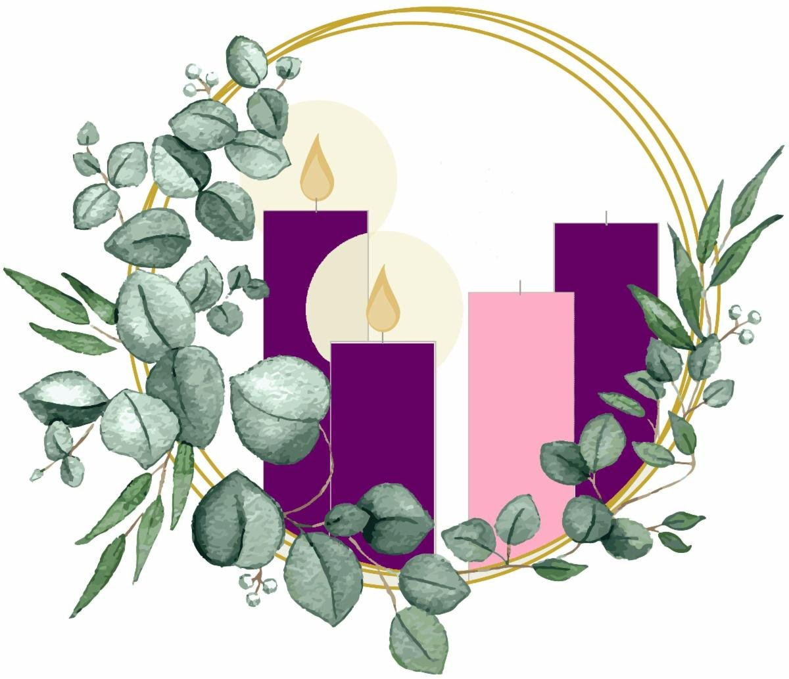

Second Sunday in Advent
December 7, 2025
10:30 A.M

Welcome!

St. Paul’s Anglican Church extends a warm welcome to all visitors and newcomers, whether worshiping in person or at home via livestream.

Visitors’ Guide

St. Paul’s Church is a parish in the Diocese of San Joaquin of the Anglican Church in North America, which includes both Catholic and Protestant traditions. We accept Jesus Christ as Savior, and we promise to follow him as Lord. We believe in One God,

- the Father who created us and all things,
- the Son who redeems us from sin and death,
- the Holy Spirit who renews and sanctifies us.

We believe the Holy Scriptures to be the Word of God and to contain all things necessary for salvation, and we accept the Apostles’ and Nicene Creeds as essential beliefs of the Christian faith.

Holy Communion is open to all baptized Christians who have examined their lives, repented of their sins, and desire to live
in love and charity with all people.

Those not desiring to receive Holy Communion, and those who have not been baptized into the Christian faith, are invited to cross their arms across their chest, and a blessing will be given instead.

Visitors are invited to sign the guest book at the entrance table and introduce themselves to the clergy following the service.

The Holy Eucharist

Prelude: “Comfort, Comfort These My People” Burkhardt
Hymn: #56 – “O Come, O Come Emmauel” (verse 3&4)
The Lighting of the Advent Candle Liturgy p. 4
Opening Hymn: #65 – “Prepare the Way O Zion” p. 5
Acclamation p. 5
The Collect for Purity p. 5
Summary of the Law p. 6
Trisagion p. 6
Gloria p. 7
Collect of the Day p. 8
Lesson: Isaiah11:1-10 p. 8
Gradual: Psalm 72 p. 9
Epistle: Romans 15:1-13 p. 10
Sequence Hymn: #75 – “There’s a Voice in the Wilderness Crying” p. 11
Gospel: Matthew 3:1-12 p. 12
Sermon: Rev Robert Longbottom
Nicene Creed p. 13
Prayers of the People p. 14
Confession and Absolution p. 16
The Comfortable Words p. 17
The Peace p. 17
The Offertory Organ: “Of the Father’s Love Begotten” By Held
The Eucharistic Liturgy Anglican Standard Text p. 18
Sanctus p. 19
The Lord’s Prayer p. 21
The Fraction p. 21
Prayer for Humble Access p. 22
Agnus Dei p. 22
Communion Hymn: #67– “Comfort, Comfort Ye My People” p. 23
Post communion Prayer p. 24
Blessing p. 24
Closing Hymn: #616 – “Hail to the Lord’s Anointed” p. 25
Dismissal p. 25
Postlude: “Awake, Awake for Night is Flying” Burkhardt

LIGHTING THE FIRST CANDLE
THE CANDLE OF HOPE

Hymnal #56: O Come, O Come Emmanuel (verses 3 & 4)

The Patriarchs, Abraham,
the Old Testament Ancestors of Jesus

Leader: Light and peace, in Jesus Christ our Lord.

All: Thanks be to God

Leader: Today is the First Sunday of Advent, in which we recall the hope we have in Christ. God told Abraham that through him all the nations of the world would be blessed, because he trusted and put his hope in God. The Old Testament spoke of the coming of Christ, of how a Savior would be born, a king in the line of King David. He would rule the world wisely and bless all the nations. We, too, believe in God’s promise to send Jesus again to this world to establish his kingdom upon the earth.

The first candle is lit.

Hope is like a light shining in a dark place. As we look at the light of the candle, we celebrate the hope we have in Jesus Christ.

Leader: Let us pray.

God of Abraham and Sarah and all the patriarchs of old, you are our Father, too. Your love is revealed to us in Jesus Christ, Son of God, and Son of David. Help us in preparing to celebrate his birth, to make our hearts ready, and to place our hope in you. Help us today and every day to worship you, to hear your word, and to do your will by sharing your hope with others. We ask it in the name of the one who was born in Bethlehem. Amen.

Opening Hymn: Prepare the Way O Zion
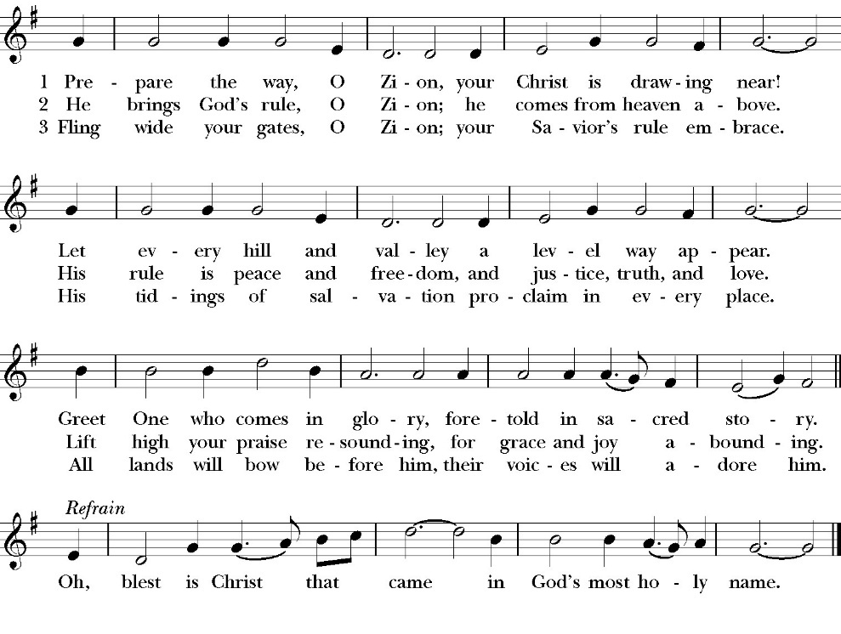

Opening Sentences

Celebrant For unto us a child is born
People Unto us a son is given.

Collect for Purity

Stir up, O Lord, the wills of your faithful people, that bringing
forth in abundance the fruit of good works, they may be
abundantly rewarded when our Savior Jesus Christ comes to
restore all things; who lives and reigns with you and the Holy
Spirit, one God, for ever and ever. Amen.

Summary of the law

Celebrant says
Hear what our Lord Jesus Christ says: You shall love the Lord your
God with all your heart and with all your soul and with all your mind.
This is the first and great commandment. And the second is like it:
You shall love your neighbor as yourself. On these two
commandments depend all the Law and the Prophets.

Trisagion
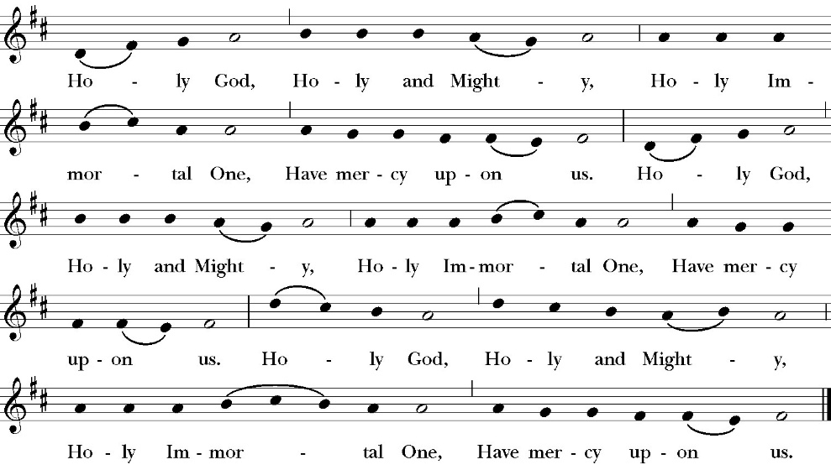

The Gloria

Officiant The Lord be with You.
People And with your spirit.
Officiant Let us pray:

The Collect of the Day

Blessed Lord, who caused all Holy Scriptures to be written for our learning: Grant us so to hear them, read, mark, learn, and inwardly digest them, that by patience and the comfort of your holy Word we may embrace and ever hold fast the blessed hope of everlasting life, which you have given us in our Savior Jesus Christ; who lives and reigns with you and the Holy Spirit, one God, for ever and ever. Amen.

Lesson: Isaiah 11:1-10
There shall come forth a shoot from the stump of Jesse, and a branch from his roots shall bear fruit. 2 And the Spirit of the LORD shall rest upon him, the Spirit of wisdom and understanding, the Spirit of counsel and might, the Spirit of knowledge and the fear of the LORD. 3 And his delight shall be in the fear of the LORD. He shall not judge by what his eyes see, or decide disputes by what his ears hear, 4 but with righteousness he shall judge the poor, and decide with equity for the meek of the earth; and he shall strike the earth with the rod of his mouth, and with the breath of his lips he shall kill the wicked. 5 Righteousness shall be the belt of his waist, and faithfulness the belt of his loins.

6 The wolf shall dwell with the lamb, and the leopard shall lie down with the young goat, and the calf and the lion and the fattened calf together; and a little child shall lead them. 7 The cow and the bear shall graze; their young shall lie down together; and the lion shall eat straw like the ox. 8 The nursing child shall play over the hole of the cobra, and the weaned child shall put his hand on the adder's den. 9 They shall not hurt or destroy in all my holy mountain; for the earth shall be full of the knowledge of the LORD as the waters cover the sea.

10 In that day the root of Jesse, who shall stand as a signal for the peoples—of him shall the nations inquire, and his resting place shall be glorious.

Reader The Word of the Lord
People Thanks be to God

Gradual: Psalm 72
1 Give the King your judgments, O God, *
and your righteousness to the King’s son.
2 Then shall he judge your people with righteousness *
and defend the poor with justice.
3 The mountains also shall bring peace, *
and the little hills righteousness to the people.
4 He shall vindicate the poor among the people, *
defend the children of the poor, and punish the wrongdoer.
5 They shall fear you as long as the sun and moon endure, *
from one generation to another.
6 He shall come down like the rain upon the mown grass, *
even as showers that water the earth.
7 In his time shall the righteous flourish, *
even an abundance of peace, so long as the moon endures.
8 His dominion shall be also from one sea to the other, *
and from the river unto the world’s end.
9 Those who dwell in the wilderness shall kneel before him; *
his enemies shall lick the dust.
10 The kings of Tarshish and of the isles shall give presents; *
the kings of Arabia and Seba shall bring gifts.
11 All kings shall fall down before him; *
all nations shall do him service.
12 For he shall deliver the poor when he cries, *
the needy also, and the one that has no helper.
13 He shall be favorable to the lowly and needy, *
and shall preserve the lives of the poor.
14 He shall deliver them from falsehood and wrong, *
and dear shall their blood be in his sight.
15 Long may he live! And unto him shall be given the gold of
Arabia;*
prayer shall ever be made unto him, and daily shall he be blessed.
16 There shall be an abundance of grain on the earth, thick upon the
hilltops; *
its fruit shall flourish like Lebanon, its grain like the grass upon the earth.
17 His Name shall endure for ever; his Name shall remain as long as
the sun. *
All the nations shall be blessed through him and shall call him blessed.
18 Blessed be the LORD God, even the God of Israel, *
who alone does wondrous things;
19 And blessed be the Name of his majesty for ever; *
and all the earth shall be filled with
his majesty. Amen, Amen.
Glory be to the Father, and to the Son, and to the Holy Spirit;
as it was in the beginning, is now, and ever shall be, world
without end. Amen

Epistle: Romans 15:1-13
We who are strong have an obligation to bear with the failings of the weak, and not to please ourselves. 2 Let each of us please his neighbor for his good, to build him up. 3 For Christ did not please himself, but as it is written, “The reproaches of those who reproached you fell on me.” 4 For whatever was written in former days was written for our instruction, that through endurance and through the encouragement of the Scriptures we might have hope. 5 May the God of endurance and encouragement grant you to live in such harmony with one another, in accord with Christ Jesus, 6 that together you may with one voice glorify the God and Father of our Lord Jesus Christ. 7 Therefore welcome one another as Christ has welcomed you, for the glory of God.

8 For I tell you that Christ became a servant to the circumcised to show God's truthfulness, in order to confirm the promises given to the patriarchs, 9 and in order that the Gentiles might glorify God for his mercy. As it is written, “Therefore I will praise you among the Gentiles, and sing to your name.”

10 And again it is said, “Rejoice, O Gentiles, with his people.”

11 And again, “Praise the Lord, all you Gentiles, and let all the peoples extol him.”

12 And again Isaiah says, “The root of Jesse will come, even he who arises to rule the Gentiles; in him will the Gentiles hope.”

13 May the God of hope fill you with all joy and peace in believing, so that by the power of the Holy Spirit you may abound in hope.

Reader The Word of the Lord
People Thanks be to God

Sequence Hymn: There’s a Voice in the Wilderness Crying
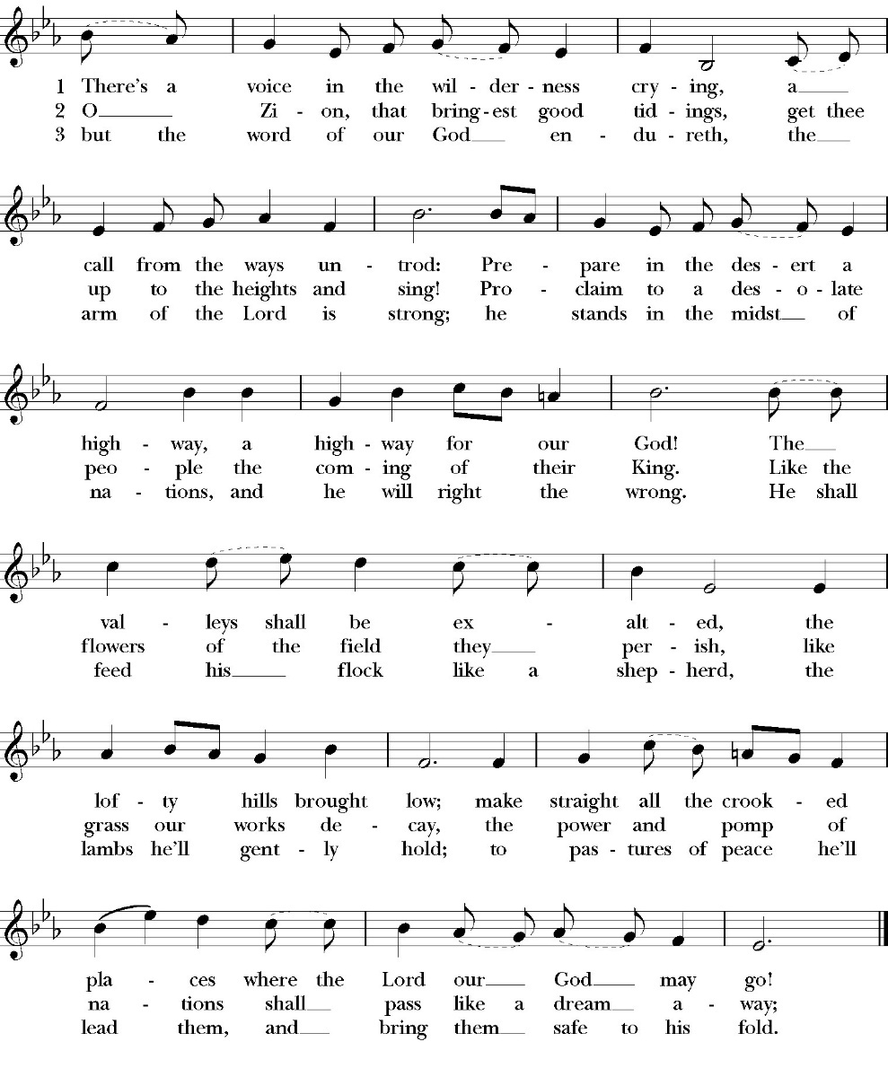
(vs. 1-2 before Gospel, vs. 3 after)

Clergy The Holy Gospel of Our Lord Jesus Christ, according to
St. Matthew
People Glory to you, Lord Christ

Gospel: Matthew 3:1-12
In those days John the Baptist came preaching in the wilderness of Judea, 2 “Repent, for the kingdom of heaven is at hand.” 3 For this is he who was spoken of by the prophet Isaiah when he said, “The voice of one crying in the wilderness: ‘Prepare the way of the Lord; make his paths straight.’”

4 Now John wore a garment of camel's hair and a leather belt around his waist, and his food was locusts and wild honey. 5 Then Jerusalem and all Judea and all the region about the Jordan were going out to him, 6 and they were baptized by him in the river Jordan, confessing their sins.

7 But when he saw many of the Pharisees and Sadducees coming to his baptism, he said to them, “You brood of vipers! Who warned you to flee from the wrath to come? 8 Bear fruit in keeping with repentance. 9 And do not presume to say to yourselves, ‘We have Abraham as our father,’ for I tell you, God is able from these stones to raise up children for Abraham. 10 Even now the axe is laid to the root of the trees. Every tree therefore that does not bear good fruit is cut down and thrown into the fire.

11 “I baptize you with water for repentance, but he who is coming after me is mightier than I, whose sandals I am not worthy to carry. He will baptize you with the Holy Spirit and fire. 12 His winnowing fork is in his hand, and he will clear his threshing floor and gather his wheat into the barn, but the chaff he will burn with unquenchable fire.”

Deacon The Gospel of the Lord
People Glory to you Lord Christ

Sermon
Rev. Robert Longbottom

The Nicene Creed

We believe in one God,
the Father, the Almighty,
maker of heaven and earth,
of all that is, visible and invisible.
We believe in one Lord, Jesus Christ,
the only-begotten Son of God,
eternally begotten of the Father,
God from God, Light from Light,
true God from true God,
begotten, not made,
of one Being with the Father.
through him all things were made.
For us and for our salvation he came down from heaven:
was incarnate from the Holy Spirit and the Virgin Mary,
and was made man.
For our sake he was crucified under Pontius Pilate;
he suffered death and was buried.
On the third day he rose again in accordance with the
Scriptures;
he ascended into heaven
and is seated at the right hand of the Father.
He will come again in glory to judge the living and the dead,
and his kingdom will have no end.
We believe in the Holy Spirit, the Lord, the giver of life,
who proceeds from the Father [and the Son],
who with the Father and the Son is worshiped and glorified.
who has spoken through the Prophets.
We believe in one holy catholic and apostolic Church.
We acknowledge one Baptism for the forgiveness of sins.
We look for the resurrection of the dead,
and the life of the world to come. Amen.

The Prayers of the People

Let us pray for the Church and for the world.

Almighty and everliving God, we are taught by your holy Word to offer prayers and supplications and to give thanks for all people. We humbly ask you mercifully to receive our prayers. Inspire continually the universal Church with the spirit of truth, unity, and concord; and grant that all who confess your holy Name may agree in the truth of your holy Word, and live in unity and godly love.

Silence

Reader Lord, in your mercy:
People Hear our prayer.

We pray that you will lead the nations of the world in the way of righteousness; and so guide and direct their leaders, especially Donald our President and Gavin our Governor, that your people may enjoy the blessings of freedom and peace. Grant that our leaders may impartially administer justice, uphold integrity and truth, restrain wickedness and vice, and protect true religion and virtue.

Silence

Reader Lord, in your mercy:
People Hear our prayer.

For Stephen, our Archbishop, and Eric, our Bishop, and for all the clergy and people of our Diocese and Congregation.

Silence

Reader Lord, in your mercy:
People Hear our prayer.

Prosper, we pray, all those who proclaim the Gospel of your kingdom throughout the world, and strengthen us to fulfill your great commission, making disciples of all nations, baptizing them and teaching them to obey all that you have commanded.

Silence

Reader Lord, in your mercy:
People Hear our prayer.
In the St. Paul’s cycle of prayer will pray for all ministries of mission and outreach to our community and in the world. We pray specifically for the medical mission to Honduras, St. Paul’s School, Visalia Senior Housing, Turning Point ministries and all ministries which, we support as a parish.

Silence

Reader Lord, in your mercy:
People Hear our prayer.

In the ACNA Cycle of Prayer, today we pray for the Provincial office and The Rev. Canon Andrew Gross, acting Chief Operating Officer, and his wife, Summer.

Silence

Reader Lord, in your mercy:
People Hear our prayer.

We ask you in your goodness, O Lord, to comfort and sustain all who in this transitory life are in trouble, sorrow, need, sickness, or any other adversity [especially _____________]. We also pray for all who are currently serving in our armed forces, law enforcement and serving as first responders.

Silence

Reader Lord, in your mercy:
People Hear our prayer.

We remember before you all your servants who have departed this life in your faith and fear, [especially _____________,] that your will for them may be fulfilled; and we ask you to give us grace to follow the good examples of St. Paul and all your saints, that we may share with them in your heavenly kingdom.

Silence

Reader Lord, in your mercy:
People Hear our prayer.

Celebrant:

Heavenly Father, grant these our prayers for the sake of Jesus Christ, our only Mediator and Advocate, who lives and reigns with you in the unity of the Holy Spirit, one God, now and for ever. Amen.

The confession and absolution of sin

The Deacon or other person appointed says the following

All who truly and earnestly repent of your sins, and seek to live in
love and charity with your neighbors, and intend to lead the new life, following the commandments of God, and walking in his holy ways: draw near with faith and make your humble confession to Almighty God.

Almighty God, Father of our Lord Jesus Christ,
maker and judge of us all:
We acknowledge and lament our many sins and offenses,
which we have committed by thought, word, and deed
against your divine majesty,
provoking most justly your righteous anger against us.
We are deeply sorry for these our transgressions;
the burden of them is more than we can bear.
Have mercy upon us,
Have mercy upon us, most merciful Father;
for your Son our Lord Jesus Christ’s sake,
forgive us all that is past;
and grant that we may evermore serve and please you in
newness of life, to the honor and glory of your Name;
through Jesus Christ our Lord. Amen.

A Deacon remains kneeling and prays

Grant to your faithful people, merciful Lord, pardon and peace; that we may be cleansed from all our sins, and serve you with a quiet mind; through Jesus Christ our Lord. Amen.

the comfortable words

The Celebrant may then say one or more of the following sentences, first saying

Hear the Word of God to all who truly turn to him.

The saying is trustworthy and deserving of full acceptance, that Christ Jesus came into the world to save sinners.
-1 Timothy 1:15

the peace

Celebrant The Peace of the Lord be always with you.
People And with your spirit.

Offertory
Organ: “Of the Father’s Love Begotten” By Held
The Doxology
(Verse 3 only)

The Offertory

Celebrant All things come from you, O Lord,
People And of your own have we given you.

The Eucharistic Liturgy

Celebrant The Lord be with you.
People And with your spirit.
Celebrant Lift up your hearts.
People We lift them up to the Lord.
Celebrant Let us give thanks to the Lord our God.
People It is right to give him thanks and praise.

It is right, our duty and our joy, always and everywhere to give thanks to you, Father Almighty, Creator of heaven and earth.

Because you sent your beloved Son to redeem us from sin and death, and to make us heirs in him of everlasting life; that when he shall
come again in power and great glory to judge the world, we may without shame or fear rejoice to behold his appearing.

Therefore, we praise you, joining our voices with angels and archangels and with all the company of heaven, who forever sing this hymn to proclaim the glory of your Name:

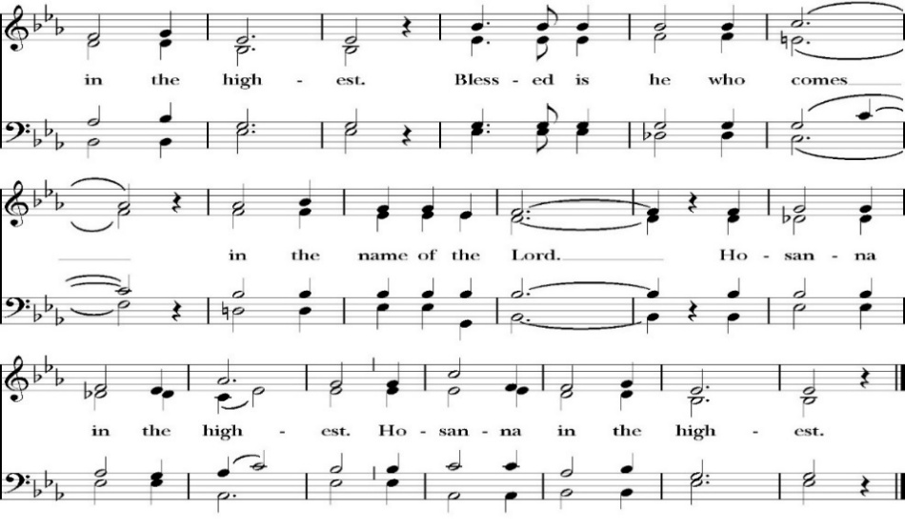
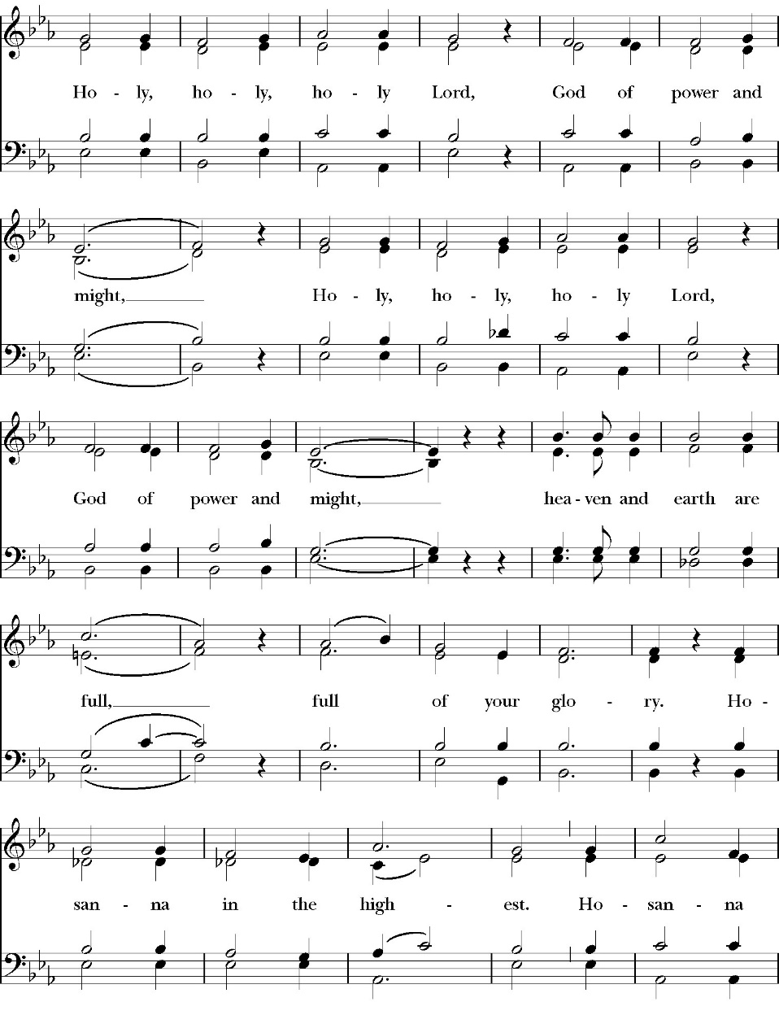
The Sanctus
The People kneel or are seated if unable to kneel

All praise and glory is yours, O God our heavenly Father, for in your tender mercy, you gave your only Son Jesus Christ to suffer death upon the Cross for our redemption. He made there, by his one oblation of himself once offered, a full, perfect, and sufficient sacrifice, oblation, and satisfaction, for the sins of the whole world; and he instituted, and in his Holy Gospel commanded us to continue, a perpetual memory of his precious death and sacrifice, until his coming again.

So now, O merciful Father, in your great goodness, we ask you to bless and sanctify, with your Word and Holy Spirit, these gifts of bread and wine, that we, receiving them according to your Son our Savior Jesus Christ’s holy institution, in remembrance of his death and passion, may be partakers of his most blessed Body and Blood.

For on the night that he was betrayed, our Lord Jesus Christ took bread; and when he had given thanks, he broke it,* and gave it to his disciples, saying, “Take, eat; this is my Body, which is given for you: Do this in remembrance of me.”

Likewise, after supper, Jesus took the cup, and when he had given thanks, he gave it to them, saying, “Drink this, all of you; for this is my Blood of the New Covenant, which is shed for you, and for many, for the forgiveness of sins: Whenever you drink it, do this in remembrance of me.”

Therefore, O Lord and heavenly Father, according to the institution of your dearly beloved Son our Savior Jesus Christ, we your humble servants celebrate and make here before your divine Majesty, with these holy gifts, the memorial your Son commanded us to make; remembering his blessed passion and precious death, his mighty resurrection and glorious ascension, and his promise to come again.

And we earnestly desire your fatherly goodness mercifully to accept this, our sacrifice of praise and thanksgiving; asking you to grant that, by the merits and death of your Son Jesus Christ, and through faith in his Blood, we and your whole Church may obtain forgiveness of our sins, and all other benefits of his passion.
And here we offer and present to you, O Lord, ourselves, our souls and bodies, to be a reasonable, holy, and living sacrifice. We humbly pray that all who partake of this Holy Communion may worthily receive the most precious Body and Blood of your Son Jesus Christ, be filled with your grace and heavenly benediction, and be made one body with him, that he may dwell in us, and we in him.

And although we are unworthy, because of our many sins, to offer you any sacrifice, yet we ask you to accept this duty and service we owe, not weighing our merits, but pardoning our offenses, through Jesus Christ our Lord.

By him, and with him, and in him, in the unity of the Holy Spirit, all honor and glory is yours, Almighty Father, now and for ever. Amen.

And now, as our Savior Christ has taught us, we are bold to pray,

Our Father, who art in heaven,
hallowed be thy Name,
thy kingdom come,
thy will be done,
on earth as it is in heaven.
Give us this day our daily bread.
And forgive us our trespasses,
as we forgive those
who trespass against us.
And lead us not into temptation,
but deliver us from evil.
For thine is the kingdom,
and the power, and the glory,
for ever and ever. Amen.

The Fraction

Celebrant Alleluia. Christ our Passover is sacrificed for us.
People Therefore let us keep the feast. Alleluia.

The Prayer For Humble Access

We do not presume to come to this your table, O merciful Lord,
trusting in our own righteousness,
but in your abundant and great mercies.
We are not worthy so much as to gather up
the crumbs under your table;
but you are the same Lord
whose character is always to have mercy.
Grant us, therefore, gracious Lord,
so to eat the flesh of your dear Son Jesus Christ,
and to drink his blood,
that our sinful bodies may be made clean by his body,
and our souls washed through his most precious blood,
and that we may evermore dwell in him, and he in us.
Amen.

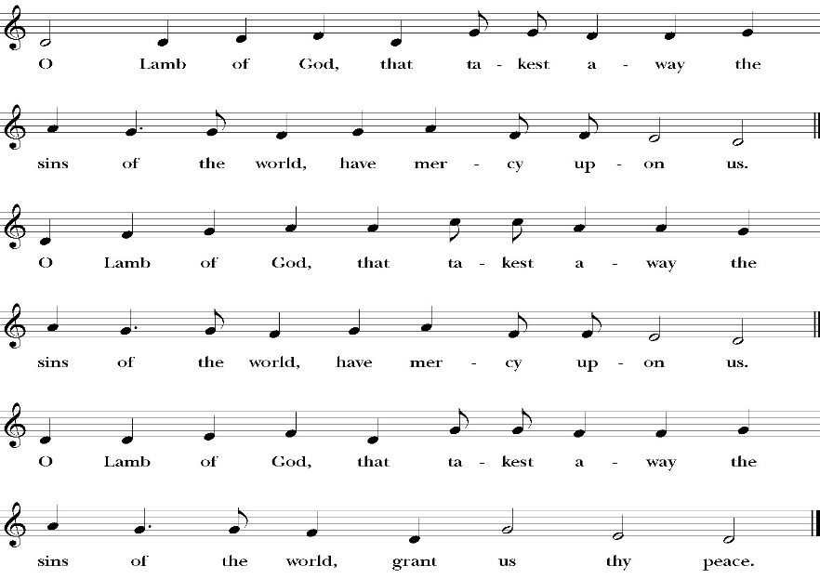
Agnus Dei

Behold the Lamb of God, behold him who takes away the sins of the world. Blessed are those who are invited to the marriage supper of the Lamb.
John 1:29; Revelation 19:9
Communion Hymn: Comfort, Comfort Ye My People

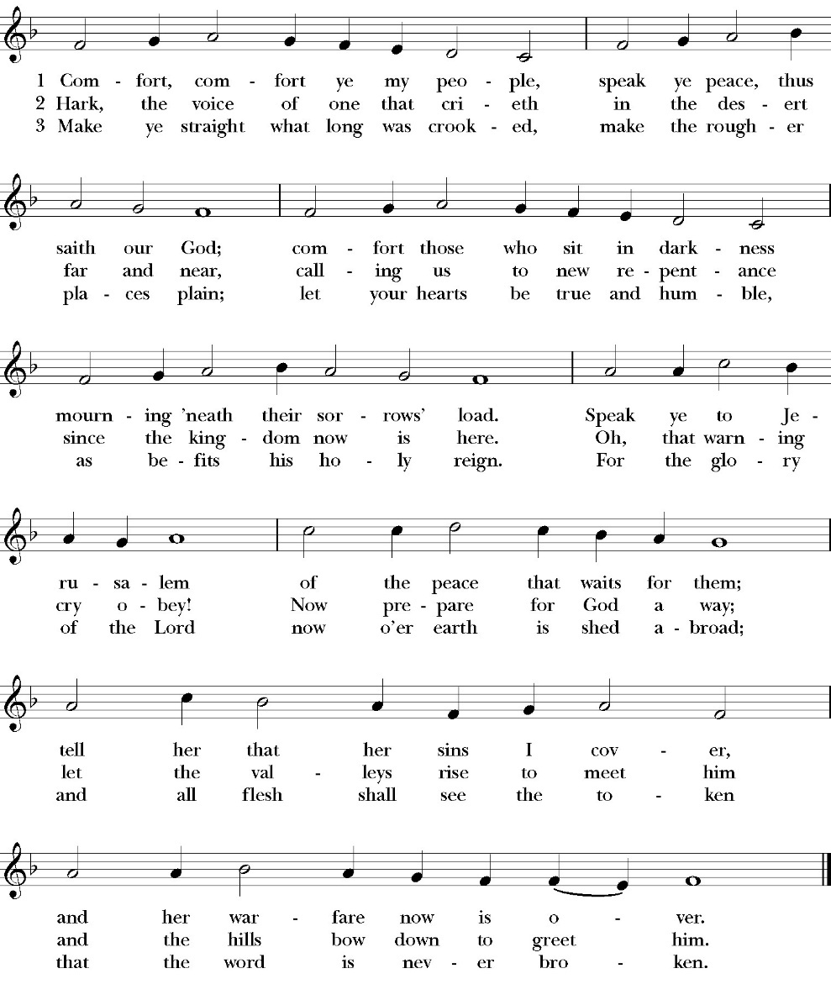

The Post Communion Prayer

Let us pray.

Almighty and everliving God,
we thank you for feeding us, in these holy mysteries,
with the spiritual food of the most precious Body and Blood
of your Son our Savior Jesus Christ;
and for assuring us, through this Sacrament, of your favor and
goodness towards us:
that we are true members of the mystical body of your Son,
the blessed company of all faithful people;
and are also heirs, through hope,
of your everlasting kingdom.
And we humbly ask you, heavenly Father,
to assist us with your grace,
that we may continue in that holy fellowship,
and do all the good works that you have prepared for us to
walk in;
through Jesus Christ our Lord,
to whom, with you and the Holy Spirit,
be all honor and glory, now and for ever. Amen.

The Blessing

The peace of God, which passes all understanding, keep your hearts
and minds in the knowledge and love of God, and of his Son Jesus
Christ our Lord; and the blessing of God Almighty, the Father, the
Son, and the Holy Spirit, be among you, and remain with you always.

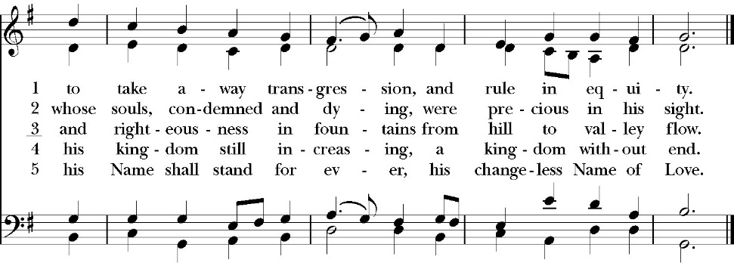
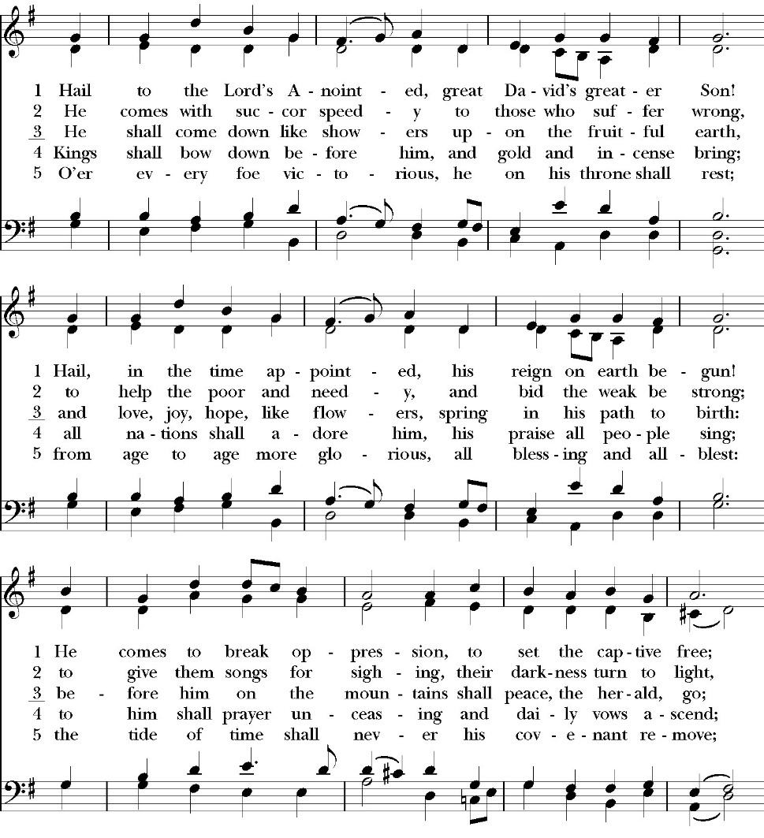
Closing Hymn: Hail to the Lord’s Anointed

Deacon Alleluia, Alleluia. Go in peace to love and serve the Lord.
People Thanks be to God. Alleluia, Alleluia.
St. Paul’s Parish Calendar
Sunday, November 7 – Sunday December 14

SUNDAY, December 7 – Second Sunday in Advent
9:0 AM Choir Practice, Music Room
10:30 AM Children’s Sunday School, Chapel 10:30 AM Holy Eucharist, Church

MONDAY, December 8

TUESDAY, December 9
6:00 PM Vestry Meeting, Conference Room
6:00 PM Bell Choir Rehearsal, Music Room

WEDNESDAY, December 10
9:30 AM Morning Prayer, Chapel
10:15 AM Bible Study, Conference Room
7:00 PM Choir Practice, Chapel

THURSDAY, December 11

FRIDAY, December 12
6:30 AM Men’s Bible Study, Valhalla Restaurant

SATURDAY, December 13
9:00 AM Wreath Across America, Visalia Cemetery
6:00 PM Friendship and Fellowship, Home of Tom and Monica Norton

SUNDAY, December 14 – Third Sunday in Advent
9:20 AM Choir Practice, Music Room
10:30 AM Children’s Sunday School, Chapel
10:30 AM Holy Eucharist, Church

Church Office Hours
Monday-Thursday 8:00 AM-4:00 PM

Announcements

Christmas Pageant Rehearsals every Sunday during church.
Christmas Pageant is Sunday, December 21, during 10:30AM worship service
All children and youth of St. Paul’s are invited to participate in this year’s Christmas pageant. Rehearsals will be on Sunday mornings during Sunday School time. The Christmas pageant will be on Sunday, December 21, during the 10:30 worship service. If you have any questions, please reach out to our pageant director Mrs. Jennifer Hennagin at (661)332-7275.

Christmas Caroling to shut ins
Sunday, December 21, 4:00PM-6:00PM
Every year a group from St. Paul’s travels to the homes or care facilities to sing Christmas carols to four members of our church who are in need of a Christmas blessing. We will gather at the church at 4:00PM, get our itinerary and finish by 6:00PM. All are welcome to join us. Hot cocoa and cookies will be provided for all.

Wreaths Across America, December 13, 9:00 AM
Visalia Cemetery
St. Paul’s will once again be joining the more than two million volunteers and supporters who will gather to remember, honor, and teach at more than 5,200 participating locations in all 50 states, at sea and abroad. It is reported that over 4,000 veterans are buried at just the Visalia cemetery and placing a wreath is a gift of gratitude for someone who served our country so we can be free.

People may sponsor wreaths specific to the Visalia Cemetery by going to the following web site:
https://www.wreathsacrossamerica.org/
Learn about Wreaths Across America's Mission to Remember, Honor and Teach

Visalia Emergency Aid Food Barrel
For many years, St. Paul’s supported the ministry of Visalia Emergency Aid by housing a food barrel. We are renewing this ministry and invite members to bring food on Sunday mornings to place into the food barrel and support the VEA feeding ministries.

Christmas Gifts for St. Jude’s Family
Return by Sunday, December 13
All gifts for the St. Jude’s family are asked to be returned to the church narthex or church office by Wednesday, December 17th. If all the ornaments were gone before you got a chance to select one, gift cards to Galaxy Theatre and Domino’s pizza have been suggested for the children.

Congregational Blessing of Judy Ramirez Niche
in the St. Paul’s Columbarium
Sunday, December 14, after the Sunday morning service.
Judy Ramirez’s ashes have been placed in the St. Paul’s Columbarium. All friends of Judy are invited to gather together after the Sunday morning worship service for a blessing over her niche in the St. Paul’s Columbarium.

Advent Daily Devotions Available at The Prayer Table
Advent is a season of preparation for the return of Jesus in glorious majesty. This year we once again offer the daily Advent devotional produced by Trinity Anglican Seminary. This year the daily devotional focuses on the Psalms from the daily lectionary of the Book of Common Prayer. The devotionals are available on the prayer table in the Narthex of the church.

Nominations for Vestry Class of 2029
The Vestry is the governing board of St. Paul’s Anglican Church. Every year, four confirmed members of the church are elected to serve on the vestry for a three-year term. The vestry has three primary leadership functions. The vestry serves as the fiduciary leaders of the church, ensures that all administrative tasks of the church are functioning well, and assists the rector in leading the spiritual life of the church. If you are interested in serving on the vestry, desire to nominate a confirmed member of the church to serve on the vestry, or just want to learn more, please speak with Fr. Rob Longbottom or the three members of our vestry nominating committee. These people are Mark Morales, Rosemary Reader, and Lydia Castaneda. Election of new vestry members will be held at the Annual Meeting on Sunday, February 1.



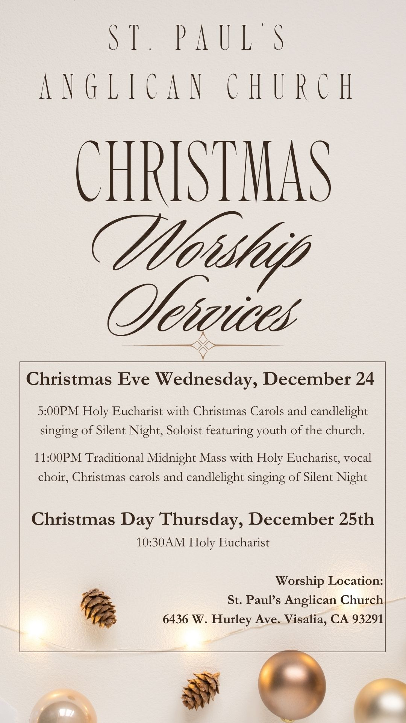

St. Paul’s Anglican Church
Parish Office
6436 W. Hurley Ave
Visalia, California 93291
559-732-4821
Office Hours: 8:00 – 4:00
Monday – Thursday

Worship: Sundays at 10:30AM
Livestream: Link at spvisalia.com
and on our Facebook page
Please be advised that this service is being recorded for broadcast
and/or archival purposes. By attending, you consent
to the inclusion of your likeness in these recordings.

St. Paul’s Clergy and Staff
The Rev. Robert Longbottom, Rector
rector@spvisalia.com
(559)802-2928
The Rev. John Iseman, Pastoral Associate for Family Ministries
family@spvisalia.com
The Rev. Kashy Rowland-Smith, Deacon
kashyrs@aol.com
Antoinette Horsting, Parish Administrator
bookkeeper@spvisalia.com
Marguerite Crownover, Organist and Accompanist
Cynthia Culp, Choral Director
Jackie Iseman, Nursery Coordinator
Shane Motl, Sexton

St. Paul’s is a member of the Anglican Diocese of San Joaquin, The Rt. Rev. Eric V. Menees, Bishop

Next Week’s Lessons
Isaiah 35:1-10
Psalm 146
James 5:7-20
Matthew 11:2-19

