St. Paul’s Anglican Church
Visalia, California
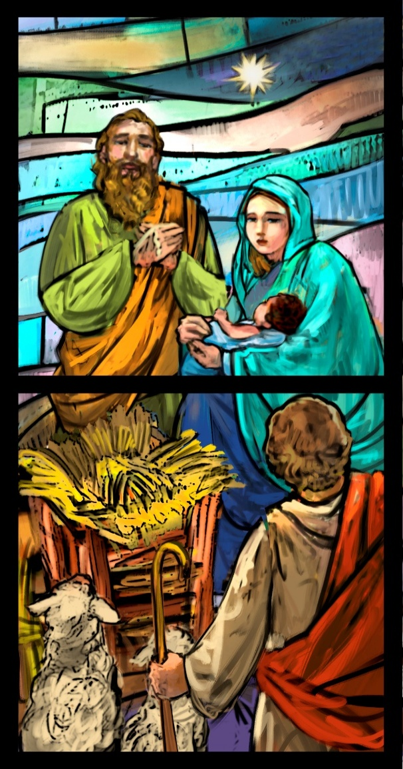

First Sunday of Christmas
December 28, 2025
10:30 AM

Welcome!

St. Paul’s Anglican Church extends a warm welcome to all visitors and newcomers, whether worshiping in person or at home via livestream.

Visitors’ Guide

St. Paul’s Church is a parish in the Diocese of San Joaquin of the Anglican Church in North America, which includes both Catholic and Protestant traditions. We accept Jesus Christ as Savior, and we promise to follow him as Lord. We believe in One God,

- the Father who created us and all things,
- the Son who redeems us from sin and death,
- the Holy Spirit who renews and sanctifies us.

We believe the Holy Scriptures to be the Word of God and to contain all things necessary for salvation, and we accept the Apostles’ and Nicene Creeds as essential beliefs of the Christian faith.

Holy Communion is open to all baptized Christians who have examined their lives, repented of their sins, and desire to live
in love and charity with all people.

Those not desiring to receive Holy Communion, and those who have not been baptized into the Christian faith, are invited to cross their arms across their chest, and a blessing will be given instead.

Visitors are invited to sign the guest book at the entrance table and introduce themselves to the clergy following the service.

The Holy Eucharist

Prelude: “Sussex” Carol Wood
Opening Hymn: #92 –” On this Day” p. 4
Acclamation p. 4
The Collect for Purity p. 4
Summary of the Law p. 5
Kyrie p. 5
Gloria p. 6
Collect of the Day p. 7
Lesson: Isaiah 61:10-62:5 p. 7
Gradual: Psalm 147:12-20 p. 8
Epistle: Galatians 3:23-4:7 p. 8
Sequence Hymn: #107- “Good Christian Friends Rejoice” p. 9
Gospel: John 1:1-18 p. 10
Homily: The Rev. Robert Longbottom p. 10
Special Presentation: Missionary Milagro Menees
Nicene Creed p. 11
Prayers of the People p. 12
Confession and Absolution p. 13
The Comfortable Words p. 14
The Peace p. 14
Offertory Anthem: Jackie Iseman & Jennifer Proch
The Offertory p. 14
The Eucharistic Liturgy p. 14
Sanctus p. 15
The Lord’s Prayer p. 17
The Fraction p. 18
Prayer for Humble Access p. 18
Agnus Dei p. 18
Communion Hymn: #84 – “Love Came Down at Christmas” p. 19
Post Communion Prayer p. 20
Blessing p. 20
Closing Hymn #99 Go Tell It on The Mountain p. 21
Dismissal p. 21
Postlude: “In Dulci Jubilo” Wood

Opening Hymn: On this Day
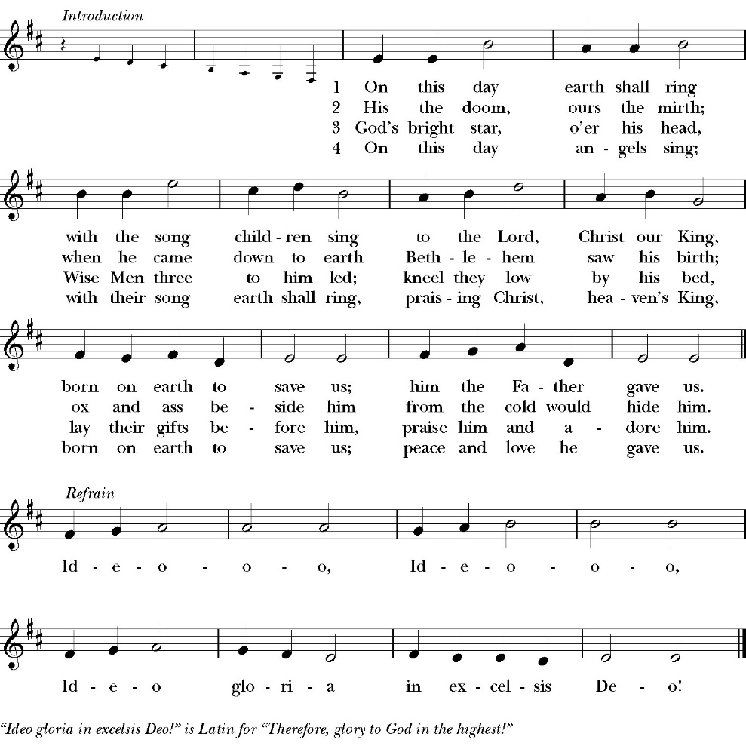

The Acclamation

Celebrant For unto us a child is born,
People Unto us a son is given.

The Collect for Purity

Almighty God, to you all hearts are open, all desires
known, and from you no secrets are hid: Cleanse the thoughts
of our hearts by the inspiration of your Holy Spirit, that we
may perfectly love you, and worthily magnify your holy Name.
through Christ our Lord. Amen.
The Summary of the law

Hear what our Lord Jesus Christ says: You shall love the Lord your God with all your heart and with all your soul and with all your mind. This is the first and great commandment. And the second is like it: You shall love your neighbor as yourself. On these two commandments depend all the Law and the Prophets.

The Kyrie
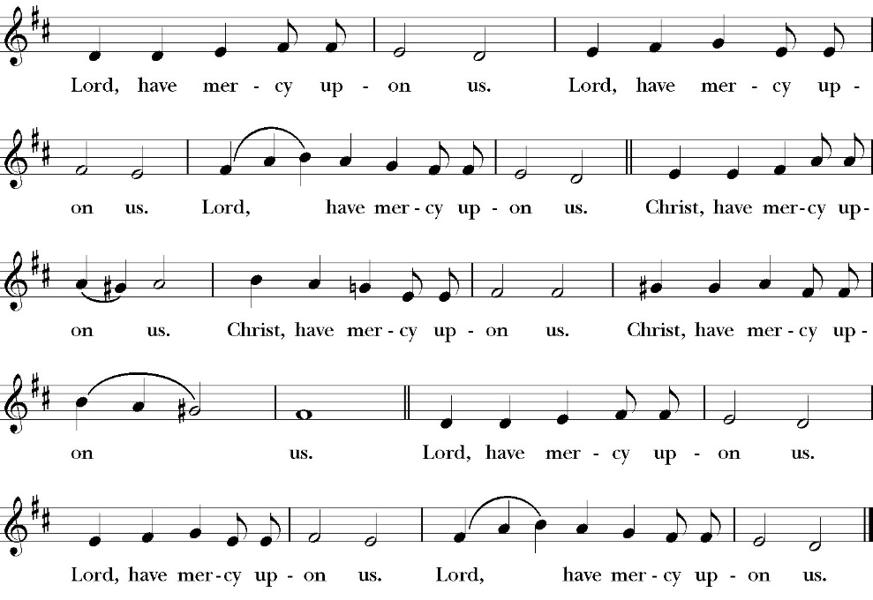

The Gloria

Officiant The Lord be with You.
People And with your spirit.
Officiant Let us pray:

The Collect of the Day

Almighty God, you have poured upon us the new light of your incarnate Word: Grant that this light, kindled in our hearts, may shine forth in our lives; through Jesus Christ our Lord, who lives and reigns with you in the unity of the Holy Spirit, one God, now and for ever. Amen.

Lesson Isaiah 61:10-62:5

I will greatly rejoice in the LORD; my soul shall exult in my God, for he has clothed me with the garments of salvation; he has covered me with the robe of righteousness, as a bridegroom decks himself like a priest with a beautiful headdress, and as a bride adorns herself with her jewels. 11 For as the earth brings forth its sprouts, and as a garden causes what is sown in it to sprout up, so the Lord God will cause righteousness and praise to sprout up before all the nations.

62 For Zion’s sake I will not keep silent, and for Jerusalem’s sake I will not be quiet, until her righteousness goes forth as brightness, and her salvation as a burning torch. 2 The nations shall see your righteousness, and all the kings your glory, and you shall be called by a new name that the mouth of the LORD will give. 3 You shall be a crown of beauty in the hand of the LORD, and a royal diadem in the hand of your God. 4 You shall no more be termed Forsaken, and your land shall no more be termed Desolate, but you shall be called My Delight Is in Her, and your land Married; for the LORD delights in you, and your land shall be married. 5 For as a young man marries a young woman, so shall your sons marry you, and as the bridegroom rejoices over the bride, so shall your God rejoice over you.

Reader The Word of the Lord
People Thanks be to God

Gradual: Psalm 147:12-20

12 Praise the LORD, O Jerusalem; *
praise your God, O Zion.
13 For he has made strong the bars of your gates *
and has blessed your children within you.
14 He makes peace in your borders *
and fills you with the finest of wheat.
15 He sends forth his commandment upon the earth, *
and his word runs very swiftly.
16 He gives snow like wool *
and scatters the white frost like ashes.
17 He casts forth his ice like crumbs; *
who is able to abide his frost?
18 He sends out his word and melts them; *
he blows with his wind, and the waters flow.
19 He declares his word unto Jacob, *
his statutes and ordinances unto Israel.
20 He has not dealt so with other nations; *
neither have they knowledge of his laws. Praise the LORD.

Glory be to the Father, and to the Son, and to the Holy Spirit;
as it was in the beginning, is now, and ever shall be, world without end. Amen
Epistle: Galatians 3:23-4:7

Now before faith came, we were held captive under the law, imprisoned until the coming faith would be revealed. 24 So then, the law was our guardian until Christ came, in order that we might be justified by faith. 25 But now that faith has come, we are no longer under a guardian, 26 for in Christ Jesus you are all sons of God, through faith. 27 For as many of you as were baptized into Christ have put on Christ. 28 There is neither Jew nor Greek, there is neither slave nor free, there is no male and female, for you are all one in Christ Jesus. 29 And if you are Christ’s, then you are Abraham’s offspring, heirs according to promise.

4 I mean that the heir, as long as he is a child, is no different from a slave, though he is the owner of everything, 2 but he is under guardians and managers until the date set by his father. 3 In the same way we also, when we were children, were enslaved to the elementary principles of the world. 4 But when the fullness of time had come, God sent forth his Son, born of woman, born under the law, 5 to redeem those who were under the law, so that we might receive adoption as sons. 6 And because you are sons, God has sent the Spirit of his Son into our hearts, crying, “Abba! Father!” 7 So you are no longer a slave, but a son, and if a son, then an heir through God.

Reader The Word of the Lord
People Thanks be to God

Sequence Hymn: Good Christians Friends Rejoice
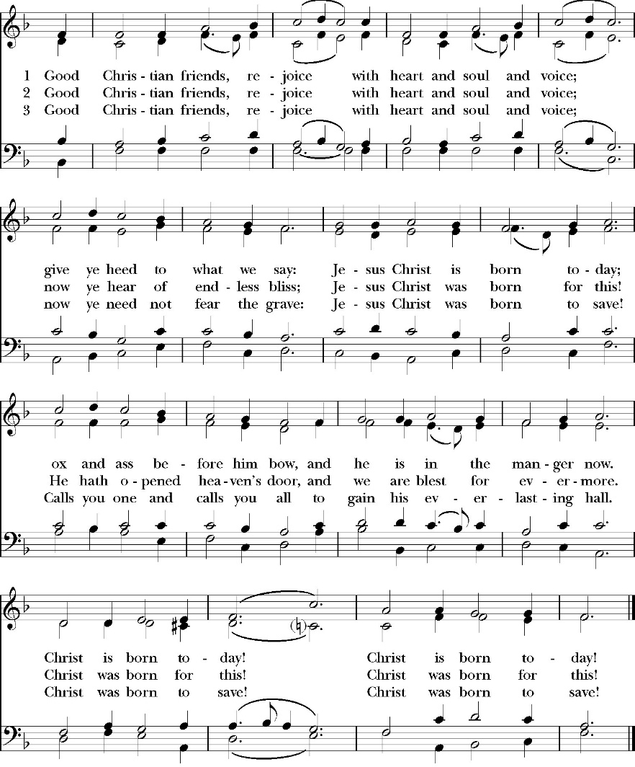
(verses 1-2 before gospel, verse 3 after)
Clergy: The Holy Gospel of Our Lord Jesus Christ, according to
St. John
People Praise to you, Lord Christ.

Gospel: John 1:1-18

In the beginning was the Word, and the Word was with God, and the Word was God. 2 He was in the beginning with God. 3 All things were made through him, and without him was not any thing made that was made. 4 In him was life, and the life was the light of men. 5 The light shines in the darkness, and the darkness has not overcome it.
6 There was a man sent from God, whose name was John. 7 He came as a witness, to bear witness about the light, that all might believe through him. 8 He was not the light, but came to bear witness about the light.
9 The true light, which gives light to everyone, was coming into the world.
10 He was in the world, and the world was made through him, yet the world did not know him. 11 He came to his own, and his own people did not receive him. 12 But to all who did receive him, who believed in his name, he gave the right to become children of God, 13 who were born, not of blood nor of the will of the flesh nor of the will of man, but of God. 14 And the Word became flesh and dwelt among us, and we have seen his glory, glory as of the only Son from the Father, full of grace and truth. (15 John bore witness about him, and cried out, “This was he of whom I said, ‘He who comes after me ranks before me, because he was before me.’”) 16 For from his fullness we have all received, grace upon grace. 17 For the law was given through Moses; grace and truth came through Jesus Christ. 18 No one has ever seen God; the only God, who is at the Father’s side, he has made him known.

Clergy The Gospel of the Lord
People Praise to you Lord Christ

Homily
The Rev. Rob Longbottom

Special message
Milagro Menees

The Nicene Creed

We believe in one God,
the Father, the Almighty,
maker of heaven and earth,
of all that is, visible and invisible.

We believe in one Lord, Jesus Christ,
the only-begotten Son of God,
eternally begotten of the Father,
God from God, Light from Light,
true God from true God,
begotten, not made,
of one Being with the Father.
through him all things were made.
For us and for our salvation he came down from heaven:
was incarnate from the Holy Spirit and the Virgin Mary,
and was made man.
For our sake he was crucified under Pontius Pilate;
he suffered death and was buried.
On the third day he rose again in accordance with the
Scriptures;
he ascended into heaven
and is seated at the right hand of the Father.
He will come again in glory to judge the living and the dead,
and his kingdom will have no end.

We believe in the Holy Spirit, the Lord, the giver of life,
who proceeds from the Father [and the Son],
who with the Father and the Son is worshiped and glorified.
who has spoken through the Prophets.
We believe in one holy catholic and apostolic Church.
We acknowledge one Baptism for the forgiveness of sins.
We look for the resurrection of the dead,
and the life of the world to come. Amen.

The Prayers of the People

Leader Let us pray for the Church and for the world as we celebrate Christ the King Sunday, saying, “hear our prayer.”
For the peace of the whole world, and for the well-being and unity of the people of God.
Lord, in your mercy:
People Hear our prayer.

Leader For Stephen our archbishop and Eric, our Bishop. For Fr. Rob, Deacon John, Kashy our seminarian, and for all the clergy and people of our Diocese and Congregation and for the worldwide Anglican Communion.
Lord, in your mercy:
People Hear our prayer.

Leader For all those who proclaim the Gospel at home and abroad; and for all who teach and disciple others.
Lord, in your mercy:
People Hear our prayer.

Leader For our brothers and sisters in Christ who are persecuted for their faith.
Lord, in your mercy:
People Hear our prayer.

Leader For our nation, for those in authority, and for all in public service especially Donald our president and Gavin our Governor.
Lord, in your mercy:
People Hear our prayer.

Leader: In the St. Paul’s cycle of prayer we lift up the ministries
of pastoral care, all our members who are in the hospital, care facilities or who are shut into their own homes. We pray for those who are recovering from recent surgeries and for those who are in crisis.
Lord, in your mercy:
People Hear our prayer.

Leader: In the ACNA Cycle of Prayer, today we pray for the
College of Bishops Meeting, January 13-17.
Lord, in your mercy:
People Hear our prayer.

Leader For all those who are in trouble, sorrow, need, sickness, or any other adversity [especially _____________]. We also pray for all who are currently serving in our armed forces and serving as first responders.
Lord, in your mercy:
People Hear our prayer.

Leader For all those who have departed this life in the certain hope of the resurrection, (we pray especially for ____________), in thanksgiving let us pray.
Lord, in your mercy:
People Hear our prayer.

Celebrant will add a concluding prayer

The Confession and Absolution

Celebrant Let us humbly confess our sins to Almighty God.

Most merciful God,
we confess that we have sinned against you
in thought, word and deed,
by what we have done, and by what we have left undone.
We have not loved you with our whole heart;
we have not loved our neighbors as ourselves.
We are truly sorry and we humbly repent.
For the sake of your Son Jesus Christ,
have mercy on us and forgive us;
that we may delight in your will, and walk in your ways,
to the glory of your Name. Amen.

Almighty God, our heavenly Father, who in his great mercy has
promised forgiveness of sins to all those who sincerely repent and
with true faith turn to him, have mercy upon you, pardon and deliver
you from all your sins, confirm and strengthen you in all goodness,
and bring you to everlasting life; through Jesus Christ our Lord.
Amen.

The Comfortable Words

Come to me, all who labor and are heavy laden, and I will give you
rest. Matthew 11:28

Celebrant The Peace of the Lord be always with you.
People And with your spirit.

Offertory Anthem

Jackie Iseman & Jennifer Proch

The Offertory

Celebrant All things come from you, O Lord,
People And of your own have we given you.

The Eucharistic Liturgy

Celebrant The Lord be with you.
People And with your spirit.
Celebrant Lift up your hearts.
People We lift them up to the Lord.
Celebrant Let us give thanks to the Lord our God.
People It is right to give him thanks and praise.

It is right, our duty and our joy, always and everywhere to give thanks to you, Father Almighty, Creator of heaven and earth.

Because you gave Jesus Christ, your only Son, to be born for us; who,
by the Holy Spirit and the Virgin Mary his mother, was made truly
man, yet without the stain of sin, that we might be cleansed from sin
and given the right to become your children.
Therefore we praise you, joining our voices with angels and archangels and with all the company of heaven, who forever sing this hymn to proclaim the glory of your Name:

The Sanctus
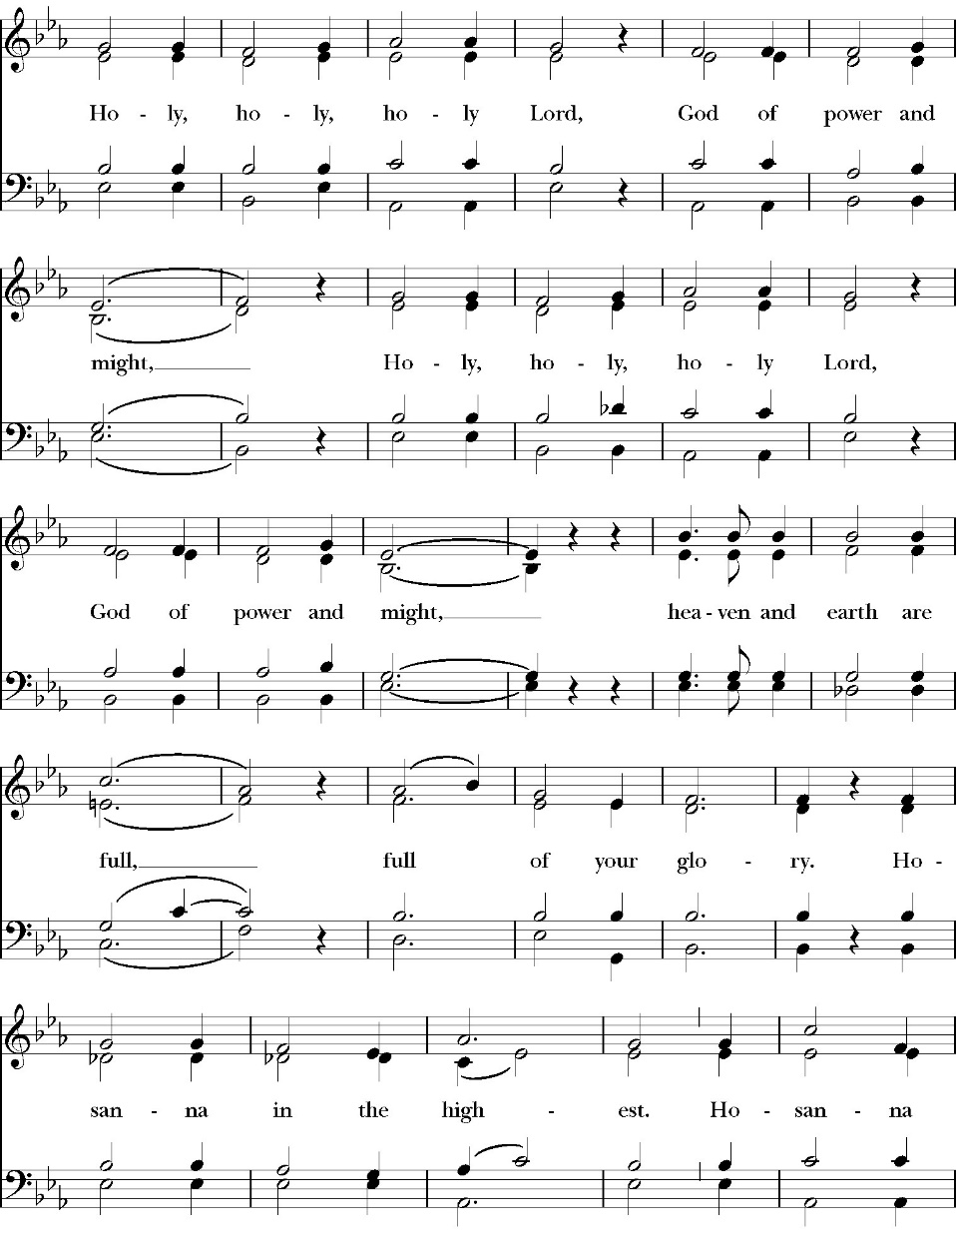

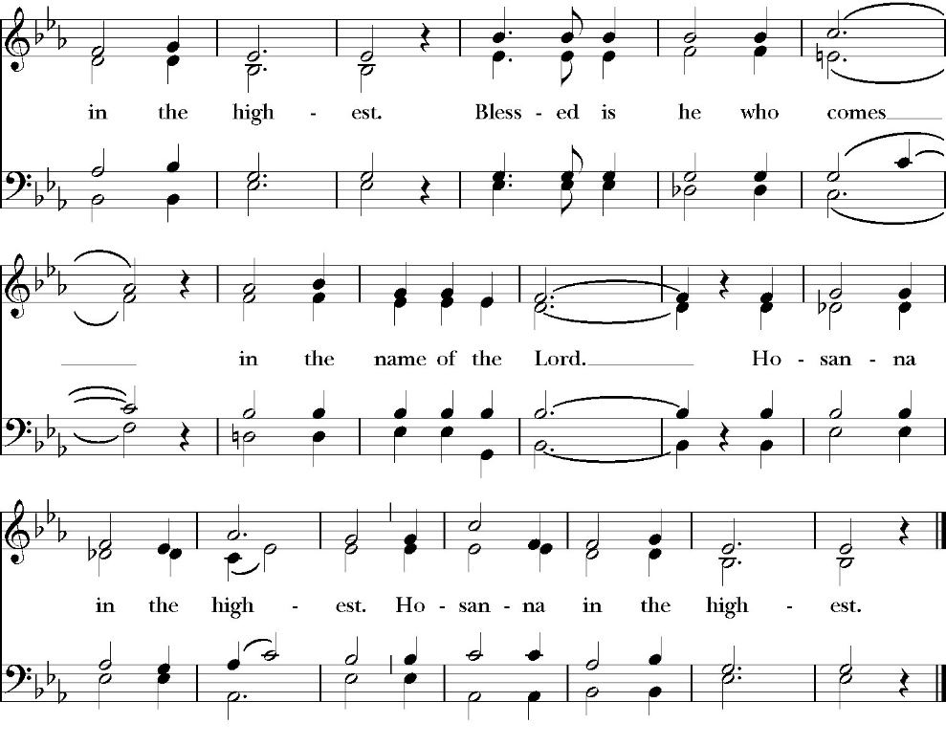
Holy and gracious Father: In your infinite love you made us for yourself; and when we had sinned against you and became subject to evil and death, you, in your mercy, sent your only Son Jesus Christ into the world for our salvation. By the Holy Spirit and the Virgin Mary he became flesh and dwelt among us. In obedience to your will, he stretched out his arms upon the Cross and offered himself once for all, that by his suffering and death we might be saved. By his resurrection he broke the bonds of death, trampling Hell and Satan under his feet. As our great high priest, he ascended to your right hand in glory, that we might come with confidence before the throne of grace.

On the night that he was betrayed, our Lord Jesus Christ took bread; and when he had given thanks, he broke it, * and gave it to his disciples, saying, “Take, eat; this is my Body, which is given for you: Do this in remembrance of me.”

Likewise, after supper, Jesus took the cup, and when he had given thanks, he gave it to them, saying, “Drink this, all of you; for this is my Blood of the New Covenant, which is shed for you, and for many, for the forgiveness of sins: Whenever you drink it, do this in remembrance of me.”

Therefore we proclaim the mystery of faith:

Christ has died.
Christ is risen.
Christ will come again.

We celebrate the memorial of our redemption, O Father, in this sacrifice of praise and thanksgiving, and we offer you these gifts.

Sanctify them by your Word and Holy Spirit to be for your people the Body and Blood of your Son Jesus Christ. Sanctify us also, that we may worthily receive this holy Sacrament, and be made one body with him, that he may dwell in us and we in him. In the fullness of time, put all things in subjection under your Christ, and bring us with all your saints into the joy of your heavenly kingdom, where we shall see our Lord face to face.

All this we ask through your Son Jesus Christ: By him, and with him, and in him, in the unity of the Holy Spirit, all honor and glory is yours, Almighty Father, now and for ever. Amen.

And now, as our Savior Christ has taught us, we are bold to pray,

Our Father, who art in heaven,
hallowed be thy Name,
thy kingdom come,
thy will be done,
on earth as it is in heaven.
Give us this day our daily bread.
And forgive us our trespasses,
as we forgive those
who trespass against us.
And lead us not into temptation,
but deliver us from evil.
For thine is the kingdom,
and the power, and the glory,
for ever and ever. Amen.

The Fraction

Celebrant Alleluia! Christ our Passover is sacrificed for us.
People Therefore let us keep the feast. Alleluia!

The Prayer for Humble Access

We do not presume to come to this your table, O merciful Lord,
trusting in our own righteousness,
but in your abundant and great mercies.
We are not worthy so much as to gather up
the crumbs under your table;
but you are the same Lord
whose character is always to have mercy.
Grant us, therefore, gracious Lord,
so to eat the flesh of your dear Son Jesus Christ,
and to drink his blood,
that our sinful bodies may be made clean by his body,
and our souls washed through his most precious blood,
and that we may evermore dwell in him, and he in us.
Amen.
Agnus Dei

The Ministration of Communion

The gifts of God for the People of God. Take them in remembrance that Christ died for you and feed on him in your hearts by faith, with thanksgiving.

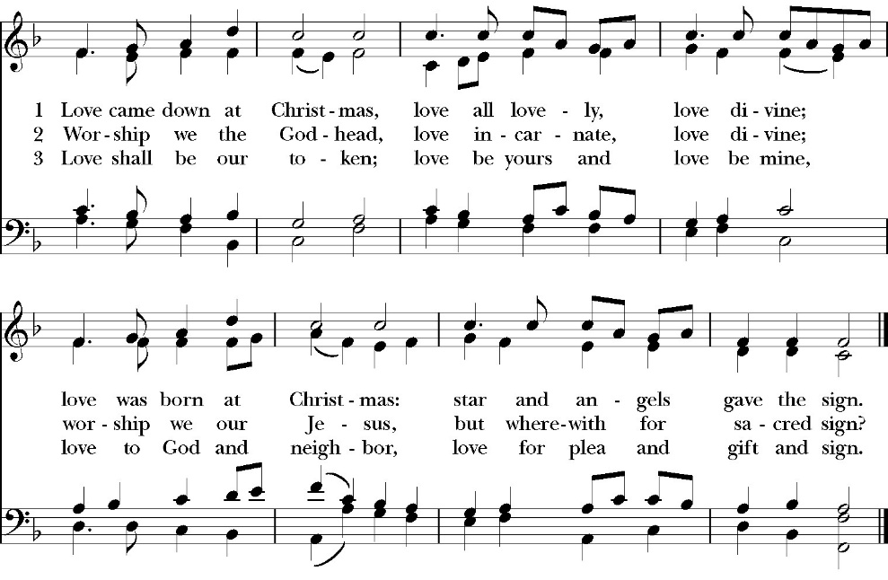
Communion Hymn: Love Came Down at Christmas

The Post Communion Prayer

Let us pray.

Heavenly Father,
We thank you for feeding us with the spiritual food
of the most precious Body and Blood
of your Son our Savior Jesus Christ;
and for assuring us in these holy mysteries
that we are living members of the body of your Son,
and heirs of your eternal Kingdom.
And now, Father, send us out to do the work you have
given us to do,
to love and serve you as faithful witnesses of Christ our
Lord.
To him, to you, and to the Holy Spirit,
be honor and glory, now and for ever. Amen.

The Blessing
The peace of God, which passes all understanding, keep your heart and minds in the knowledge and love of God, and his Son Jesus Christ our Lord; and the blessing of God Almighty, the Father, the Son, and the Holy Spirit, be among you, and remain with you always. Amen.
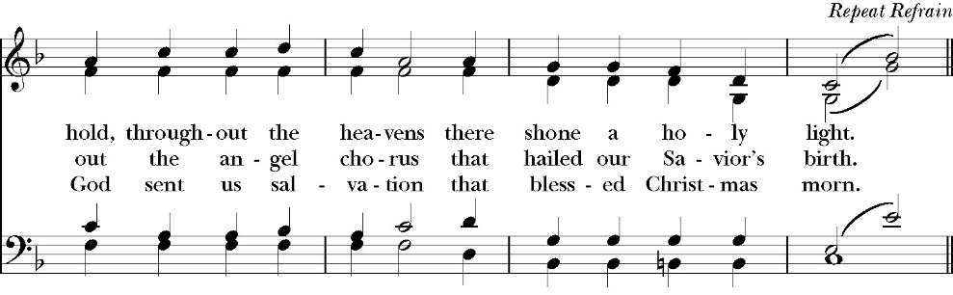
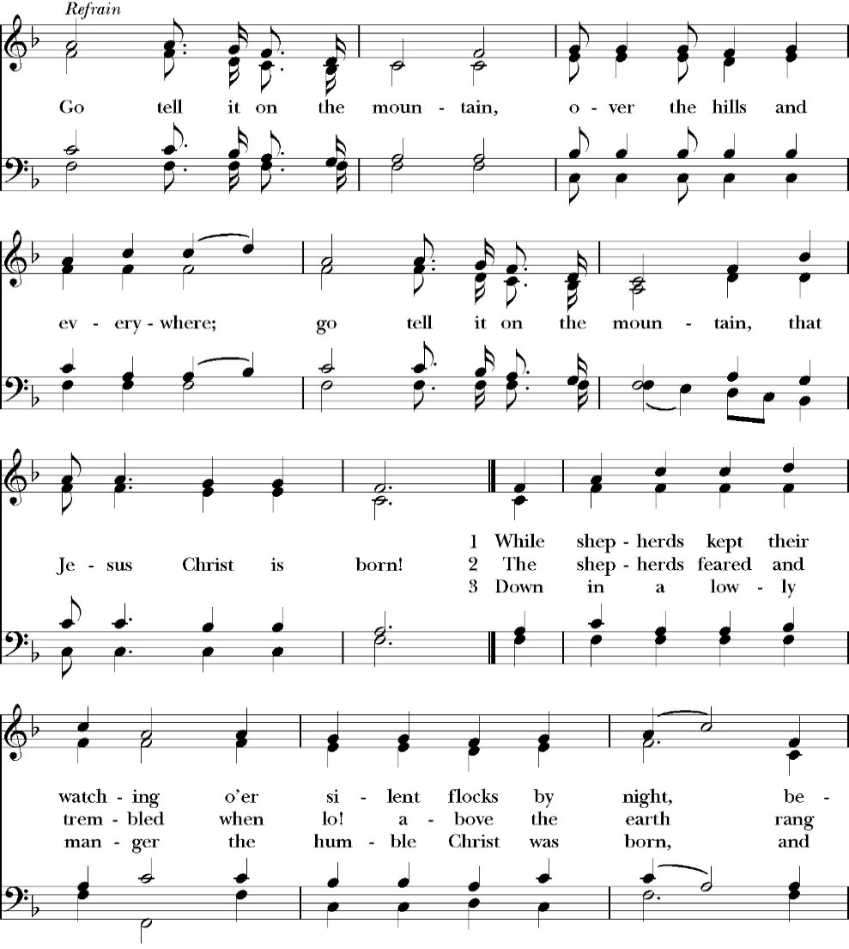
Closing Hymn: Go Tell It on The Mountain

Celebrant Alleluia! Alleluia! Let us go forth in the Name of Christ.
People Thanks be to God. Alleluia! Alleluia!
St. Paul’s Parish Calendar
Sunday December 28 – Sunday January 4

SUNDAY, December 28 – First Sunday of Christmas
10:30 AM Holy Communion

MONDAY, December 29

TUESDAY, December 30

WEDNESDAY, January 31 – New Eve
9:30 AM Holy Eucharist with healing prayer, Chapel
10:15 AM Bible Study, Conference Room
6:45 PM No Vocal Choir Rehearsal, Church

THURSDAY, January1 – New Year’s Day (Office closed)

FRIDAY, January 2
6:30 AM Men’s Bible Study, Valhalla Restaurant

SATURDAY, January 3

SUNDAY, January 4 – Second Sunday of Christmas
10:30 AM Holy Communion

Church Office Hours
Monday-Thursday 8:00 AM-4:00 PM

Special Office Hours for New Years

New Year’s Eve Wednesday, December 31:
Office closes at 12:00PM

New Year’s Day, January 1
Office Closed

Announcements

Year End Giving at St. Paul’s Anglican Church
All financial giving that will be recorded for 2025 must be turned into the church office by Wednesday, December 31. The financial books for 2025 will be closed at 3pm on Monday, January 5.

St. Paul’s welcome’s Missionary Milagro Menees today
Milagro Menees was her a year ago sharing about her calling as a medical missionary to Southeast Asia. Ms. Menees will be embarking soon on her long-term mission and is coming today to St. Paul’s to thank those who are partnering with her and to share again about her mission.

Rt. Rev. Eric Menees to visit Sunday, January 25th
Bisho Eric Menees will be making his official visit to St. Paul’s on Sunday, January 25th. This year Bishop Menees will be sharing about the Diocesan Capital Campaign called Laying a Firm Foundation at a Forum after the worship service. More information will be coming soon.

Annual Meeting of St. Paul’s Anglican Church
Sunday, February 1, after the worship service
The annual meeting of St. Paul’s Anglican Church is an opportunity
to celebrate the ministries of the church, present the year end budget
for 2025 and the budget approved by the Vestry of the church for
2026 and elect new vestry members and delegates to the 2026
convention of the Anglican Diocese of San Joaquin. A Sandwich
Lunch and childcare will be provided.

Catechism class, Becoming Like Christ: The Ten
Commandments, Justification and Sanctification
Sundays, 9:15am-10:00 January 11-February 15
The Anglican Catechism invites us to explore how we can connect
the Authority of God’s word to our everyday Christian walk. This is
the final section of our Anglican catechism class, but does not require
previous attendance. We will explore how to live more fully
according to the law of God while also living according to the person
and teachings of Jesus.
St. Paul’s Anglican Church
Parish Office
6436 W. Hurley Ave
Visalia, California 93291
559-732-4821
Office Hours: 8:00 – 4:00
Monday – Thursday

Worship: Sundays at 10:30AM
Livestream: Link at spvisalia.com
and on our Facebook page
Please be advised that this service is being recorded for broadcast
and/or archival purposes. By attending, you consent
to the inclusion of your likeness in these recordings.

St. Paul’s Clergy and Staff
The Rev. Robert Longbottom, Rector
rector@spvisalia.com
(559)802-2928
The Rev. John Iseman, Pastoral Associate for Family Ministries
family@spvisalia.com
The Rev. Kashy Rowland-Smith, Deacon
kashyrs@aol.com
Antoinette Horsting, Parish Administrator
bookkeeper@spvisalia.com
Marguerite Crownover, Organist and Accompanist
Cynthia Culp, Choral Director
Jackie Iseman, Nursery Coordinator
Shane Motl, Sexton

St. Paul’s is a member church of the
Anglican Diocese of San Joaquin
The Rt. Rev. Eric V. Menees, Bishop

Next Week’s Lessons
Jeremiah 31:7-14
Psalm 84
Ephesians 1:3-14
Luke 2:41-52

