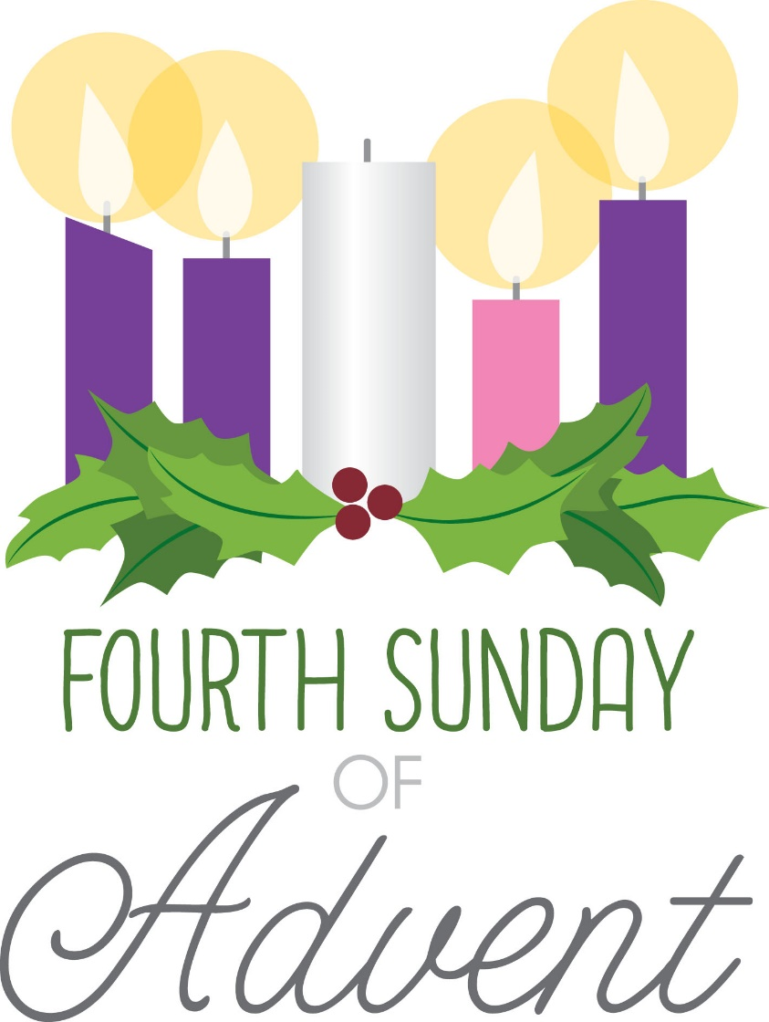
St. Paul’s Anglican Church
Visalia, California

Fourth Sunday in Advent
December 21, 2025
10:30 A.M

Welcome!

St. Paul’s Anglican Church extends a warm welcome to all visitors and newcomers, whether worshiping in person or at home via livestream.

Visitors’ Guide

St. Paul’s Church is a parish in the Diocese of San Joaquin of the Anglican Church in North America, which includes both Catholic and Protestant traditions. We accept Jesus Christ as Savior, and we promise to follow him as Lord. We believe in One God,

- the Father who created us and all things,
- the Son who redeems us from sin and death,
- the Holy Spirit who renews and sanctifies us.

We believe the Holy Scriptures to be the Word of God and to contain all things necessary for salvation, and we accept the Apostles’ and Nicene Creeds as essential beliefs of the Christian faith.

Holy Communion is open to all baptized Christians who have examined their lives, repented of their sins, and desire to live
in love and charity with all people.

Those not desiring to receive Holy Communion, and those who have not been baptized into the Christian faith, are invited to cross their arms across their chest, and a blessing will be given instead.

Visitors are invited to sign the guest book at the entrance table and introduce themselves to the clergy following the service.

The Holy Eucharist

Prelude: “Christmas Pastorale” Stazeski
Hymn: #56 – “O Come, O Come Emmanuel” (verse 7&8)
The Lighting of the Advent Candle Liturgy p. 4
Opening Hymn: #57 – “Lo! He Comes, with Clouds Descending” p. 5
Acclamation p. 6
The Collect for Purity p. 6
Summary of the Law p. 6
Trisagion p. 6
Gloria p. 7
Collect of the Day p. 8
Lesson: Isaiah 7:10-17 p. 8
Gradual: Psalm 24 p. 8
Epistle: Romans 1:1-7 p. 9
Sequence Hymn: #81- Lo, How A Rose E’re Blooming p. 10
Gospel: Matthew 1:18-25 p. 11
Sermon: Rev Robert Longbottom
Nicene Creed p. 11
Prayers of the People p. 12
Confession and Absolution p. 14
The Comfortable Words p. 15
The Peace p. 15
The Offertory Choir: “The Advent of Our God” by John Purifoy
The Eucharistic Liturgy Anglican Standard Text p. 16
Sanctus p. 17
The Lord’s Prayer p. 20
The Fraction p. 20
Prayer for Humble Access p. 20
Agnus Dei p. 21
Communion Hymn: #324 – “Let All Mortal Flesh Keep Silence” p. 22
Post Communion Prayer p. 23
Blessing p. 23
Closing Hymn: #537 - “Christ for the World We Sing!” p. 24
Dismissal p. 24
Postlude: “Shepherd’s Pipe Song” Wood
Hymnal #56: O Come, O Come Emmanuel (verses 7 & 8)

LIGHTING THE FOURTH CANDLE
THE CANDLE OF LOVE

Mary, the Mother of Jesus

Leader: Light and peace, in Jesus Christ our Lord

All: Thanks be to God

Leader: Last Sunday we lit the Candle of Joy. We light it and the Candles of Hope and Peace again as we remember that Jesus, born in Bethlehem, will come again to fulfill all of God’s promises and bring us everlasting peace and joy.

(A person lights the Candles of Hope, Peace and Joy)

Today we light the Fourth Candle of Advent, the Candle of Love. When the angel Gabriel told Mary that a special child would be born to her, she was filled with happiness. She sang a song that began with the words: “My soul magnifies the Lord, my spirit rejoices in God my Savior.” Just as his birth filled her with the deep love of a mother, so shall we experience the love of Jesus in our hearts when we truly become his.

(A person lights the Fourth Candle, the Candle of Love)

Love is like a light shining in a dark place. As we look at this candle we celebrate the love we find in Jesus Christ.

Leader: Let us pray

All: Thank you God for the love that you show to us. We ask that as we wait for all your promises to come true, and for Christ to come again, that you would remain present with us. Help us today, and every day, to worship you, to hear your word, and to do your will by sharing your love with each other. We ask it in the name of the one who was born in Bethlehem. Amen.

Opening Hymn: Lo! He Comes, with Clouds Descending
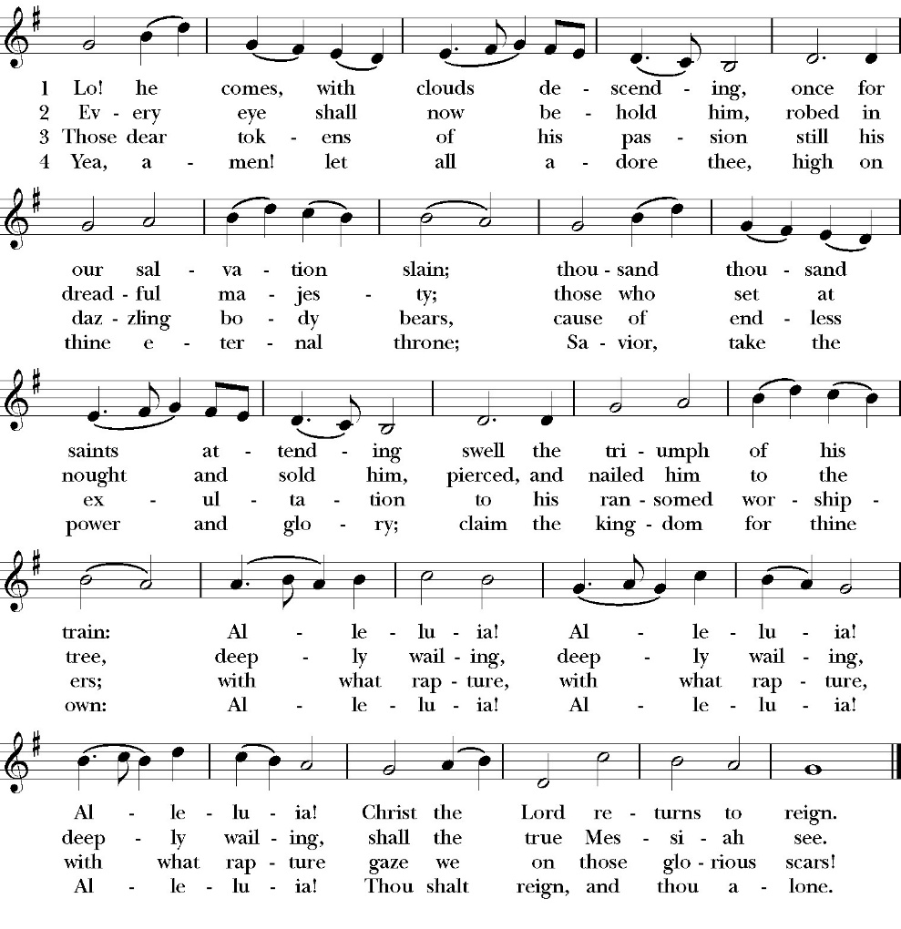

Opening Sentences

Celebrant For unto us a child is born
People Unto us a son is given.

Collect for Purity

Almighty God, to you all hearts are open, all desires known, and from you no secrets are hid: Cleanse the thoughts of our hearts by the inspiration of your Holy Spirit, that we may perfectly love you, and worthily magnify your holy Name; through Christ our Lord. Amen.

Summary of the law

Celebrant says
Hear what our Lord Jesus Christ says: You shall love the Lord your
God with all your heart and with all your soul and with all your mind.
This is the first and great commandment. And the second is like it:
You shall love your neighbor as yourself. On these two
commandments depend all the Law and the Prophets.

Trisagion
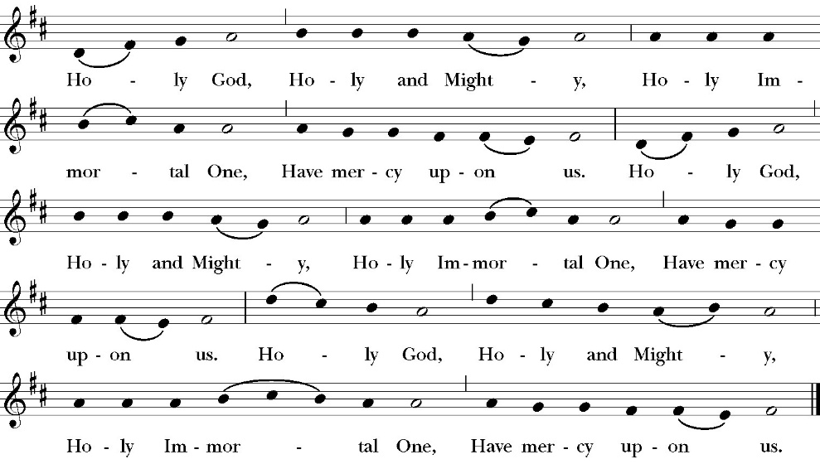

The Gloria

Officiant The Lord be with You.
People And with your spirit.
Officiant Let us pray:

The Collect of the Day

Stir up your power, O Lord, and with great might come among us; and as we are sorely hindered by our sins from running the race that is set before us, let your bountiful grace and mercy speedily help and deliver us; through Jesus Christ our Lord, to whom, with you and the Holy Spirit, be honor and glory, now and for ever. Amen.

Lesson: Isaiah 7:10-17
Again the LORD spoke to Ahaz: 11 “Ask a sign of the LORD your God; let it be deep as Sheol or high as heaven.” 12 But Ahaz said, “I will not ask, and I will not put the LORD to the test.” 13 And he said, “Hear then, O house of David! Is it too little for you to weary men, that you weary my God also?

14 Therefore the Lord himself will give you a sign. Behold, the virgin shall conceive and bear a son, and shall call his name Immanuel. 15 He shall eat curds and honey when he knows how to refuse the evil and choose the good. 16 For before the boy knows how to refuse the evil and choose the good, the land whose two kings you dread will be deserted. 17 The LORD will bring upon you and upon your people and upon your father's house such days as have not come since the day that Ephraim departed from Judah—the king of Assyria!”

Reader The Word of the Lord
People Thanks be to God

Gradual Psalm 24
1The earth is the LORD's and all that is in it, *
the compass of the world and those who dwell therein.
2 For he has founded it upon the seas *
and established it upon the rivers of the deep.
3 Who shall ascend the hill of the LORD? *
Or who shall stand in his holy place?

4 He who has clean hands and a pure heart, *
and who has not set his mind upon vanity, nor sworn to deceive his neighbor.
5 He shall receive blessing from the LORD *
and righteousness from the God of his salvation.
6 This is the generation of those who seek him, *
even of those who seek your face, O God of Jacob.
7 Lift up your heads, O you gates, and be lifted up, you everlasting doors; *
and the King of glory shall come in.
8 “Who is the King of glory?” *
“It is the LORD, strong and mighty, even the LORD, mighty in battle.”
9 Lift up your heads, O you gates, and be lifted up, you ever
lasting doors; *
and the King of glory shall come in.
10 “Who is the King of glory?” * “
The LORD of hosts, he is the King of glory.”

Glory be to the Father, and to the Son, and to the Holy Spirit;
as it was in the beginning, is now, and ever shall be, world
without end. Amen

Epistle: Romans 1:1-7
Paul, a servant of Christ Jesus, called to be an apostle, set apart for the gospel of God, 2 which he promised beforehand through his prophets in the holy Scriptures, 3 concerning his Son, who was descended from David according to the flesh

4 and was declared to be the Son of God in power according to the Spirit of holiness by his resurrection from the dead, Jesus Christ our Lord, 5 through whom we have received grace and apostleship to bring about the obedience of faith for the sake of his name among all the nations, 6 including you who are called to belong to Jesus Christ,

7 To all those in Rome who are loved by God and called to be saints: Grace to you and peace from God our Father and the Lord Jesus Christ.

Reader The Word of the Lord
People Thanks be to God
Sequence Hymn: Lo, How A Rose E’er Blooming
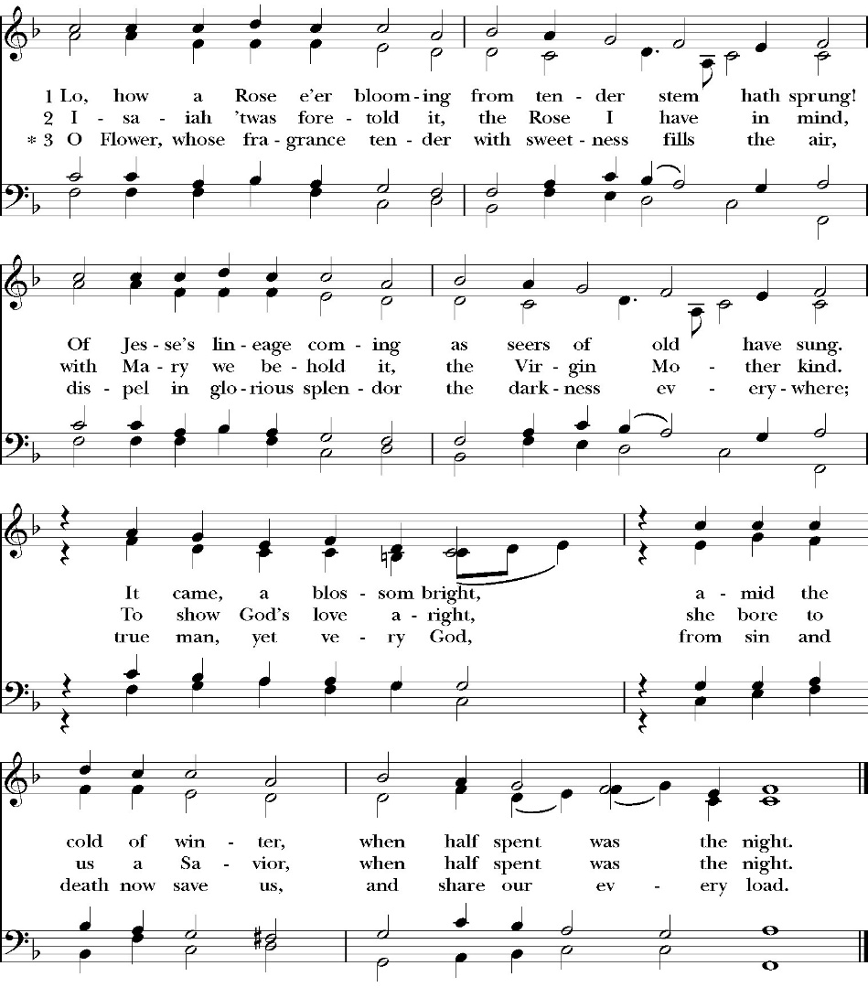
(vs. 1-2 before Gospel, vs. 3 after)

Clergy The Holy Gospel of Our Lord Jesus Christ, according to
St. Matthew
People Glory to you, Lord Christ

Gospel: Matthew 1:18-25
Now the birth of Jesus Christ took place in this way. When his mother Mary had been betrothed to Joseph, before they came together, she was found to be with child from the Holy Spirit.

19 And her husband Joseph, being a just man and unwilling to put her to shame, resolved to divorce her quietly. 20 But as he considered these things, behold, an angel of the Lord appeared to him in a dream, saying, “Joseph, son of David, do not fear to take Mary as your wife, for that which is conceived in her is from the Holy Spirit. 21 She will bear a son, and you shall call his name Jesus, for he will save his people from their sins.”

22 All this took place to fulfill what the Lord had spoken by the prophet:

23 “Behold, the virgin shall conceive and bear a son, and they shall call his name Immanuel” (which means, God with us). 24 When Joseph woke from sleep, he did as the angel of the Lord commanded him: he took his wife, 25 but knew her not until she had given birth to a son. And he called his name Jesus.

Deacon The Gospel of the Lord
People Praise to you, Lord Christ

Sermon
Rev. Robert Longbottom

The Nicene Creed

We believe in one God,
the Father, the Almighty,
maker of heaven and earth,
of all that is, visible and invisible.
We believe in one Lord, Jesus Christ,
the only-begotten Son of God,
eternally begotten of the Father,
God from God, Light from Light,
true God from true God,
begotten, not made,
of one Being with the Father.
through him all things were made.
For us and for our salvation he came down from heaven:
was incarnate from the Holy Spirit and the Virgin Mary,
and was made man.
For our sake he was crucified under Pontius Pilate;
he suffered death and was buried.
On the third day he rose again in accordance with the
Scriptures;
he ascended into heaven
and is seated at the right hand of the Father.
He will come again in glory to judge the living and the dead,
and his kingdom will have no end.
We believe in the Holy Spirit, the Lord, the giver of life,
who proceeds from the Father [and the Son],
who with the Father and the Son is worshiped and glorified.
who has spoken through the Prophets.
We believe in one holy catholic and apostolic Church.
We acknowledge one Baptism for the forgiveness of sins.
We look for the resurrection of the dead,
and the life of the world to come. Amen.

The Prayers of the People

Let us pray for the Church and for the world.

Almighty and everliving God, we are taught by your holy Word to offer prayers and supplications and to give thanks for all people. We humbly ask you mercifully to receive our prayers. Inspire continually the universal Church with the spirit of truth, unity, and concord; and grant that all who confess your holy Name may agree in the truth of your holy Word, and live in unity and godly love.

Silence

Reader Lord, in your mercy:
People Hear our prayer.

We pray that you will lead the nations of the world in the way of righteousness; and so guide and direct their leaders, especially Donald our President and Gavin our Governor, that your people may enjoy the blessings of freedom and peace. Grant that our leaders may impartially administer justice, uphold integrity and truth, restrain wickedness and vice, and protect true religion and virtue.
Silence

Reader Lord, in your mercy:
People Hear our prayer.

For Stephen, our Archbishop, and Eric, our Bishop, and for all the clergy and people of our Diocese and Congregation.

Silence

Reader Lord, in your mercy:
People Hear our prayer.

Prosper, we pray, all those who proclaim the Gospel of your kingdom throughout the world, and strengthen us to fulfill your great commission, making disciples of all nations, baptizing them and teaching them to obey all that you have commanded.

Silence

Reader Lord, in your mercy:
People Hear our prayer.
In the St. Paul’s cycle of prayer, we pray for all ministries to children, youth and families both in our church and through our church into the community around us. We pray for Sunday Funday, Sunday School, and Youth Group. We pray for all of our family ministry volunteers. We pray for the children and youth you have given to our care and for their formation in the Christian faith. We pray for all children and youth to whom we are reaching out with the Good News of Jesus Christ.

Silence

Reader Lord, in your mercy:
People Hear our prayer.

In the ACNA Cycle of Prayer, today we pray for the Special Jurisdiction of the Armed Forces and Chaplaincy, Bishop Derek Jones and his wife, Connie; Bishop Mark Nordstrom and his wife, Christine; and Bishop Michael Williams and his wife, Becky.
Silence

Reader Lord, in your mercy:
People Hear our prayer.

We ask you in your goodness, O Lord, to comfort and sustain all who in this transitory life are in trouble, sorrow, need, sickness, or any other adversity [especially _____________]. We also pray for all who are currently serving in our armed forces, law enforcement and serving as first responders.

Silence

Reader Lord, in your mercy:
People Hear our prayer.

We remember before you all your servants who have departed this life in your faith and fear, [especially _____________,] that your will for them may be fulfilled; and we ask you to give us grace to follow the good examples of St. Paul and all your saints, that we may share with them in your heavenly kingdom.

Silence

Reader Lord, in your mercy:
People Hear our prayer.

Celebrant:

Heavenly Father, grant these our prayers for the sake of Jesus Christ, our only Mediator and Advocate, who lives and reigns with you in the unity of the Holy Spirit, one God, now and for ever. Amen.

The confession and absolution of sin

The Deacon or other person appointed says the following

All who truly and earnestly repent of your sins, and seek to live in
love and charity with your neighbors, and intend to lead the new life, following the commandments of God, and walking in his holy ways: draw near with faith and make your humble confession to Almighty God.

Almighty God, Father of our Lord Jesus Christ,
maker and judge of us all:
We acknowledge and lament our many sins and offenses,
which we have committed by thought, word, and deed
against your divine majesty,
provoking most justly your righteous anger against us.
We are deeply sorry for these our transgressions;
the burden of them is more than we can bear.
Have mercy upon us,
Have mercy upon us, most merciful Father;
for your Son our Lord Jesus Christ’s sake,
forgive us all that is past;
and grant that we may evermore serve and please you in
newness of life, to the honor and glory of your Name;
through Jesus Christ our Lord. Amen.

A Deacon remains kneeling and prays

Grant to your faithful people, merciful Lord, pardon and peace; that we may be cleansed from all our sins, and serve you with a quiet mind; through Jesus Christ our Lord. Amen.

the comfortable words

The Celebrant may then say one or more of the following sentences, first saying

Hear the Word of God to all who truly turn to him.

The saying is trustworthy and deserving of full acceptance, that Christ Jesus came into the world to save sinners.
-1 Timothy 1:15

the peace

Celebrant The Peace of the Lord be always with you.
People And with your spirit.

Offertory
Choir
The Advent of Our God
by John Purifoy

The Doxology (Verse 3 only)

The Offertory

Celebrant All things come from you, O Lord,
People And of your own have we given you.

The Eucharistic Liturgy

Celebrant The Lord be with you.
People And with your spirit.
Celebrant Lift up your hearts.
People We lift them up to the Lord.
Celebrant Let us give thanks to the Lord our God
People It is right to give him thanks and praise.
It is right, our duty and our joy, always and everywhere to give thanks to you, Father Almighty, Creator of heaven and earth.

Because you sent your beloved Son to redeem us from sin and death, and to make us heirs in him of everlasting life; that when he shall
come again in power and great glory to judge the world, we may without shame or fear rejoice to behold his appearing.

Therefore, we praise you, joining our voices with angels and archangels and with all the company of heaven, who forever sing this hymn to proclaim the glory of your Name:

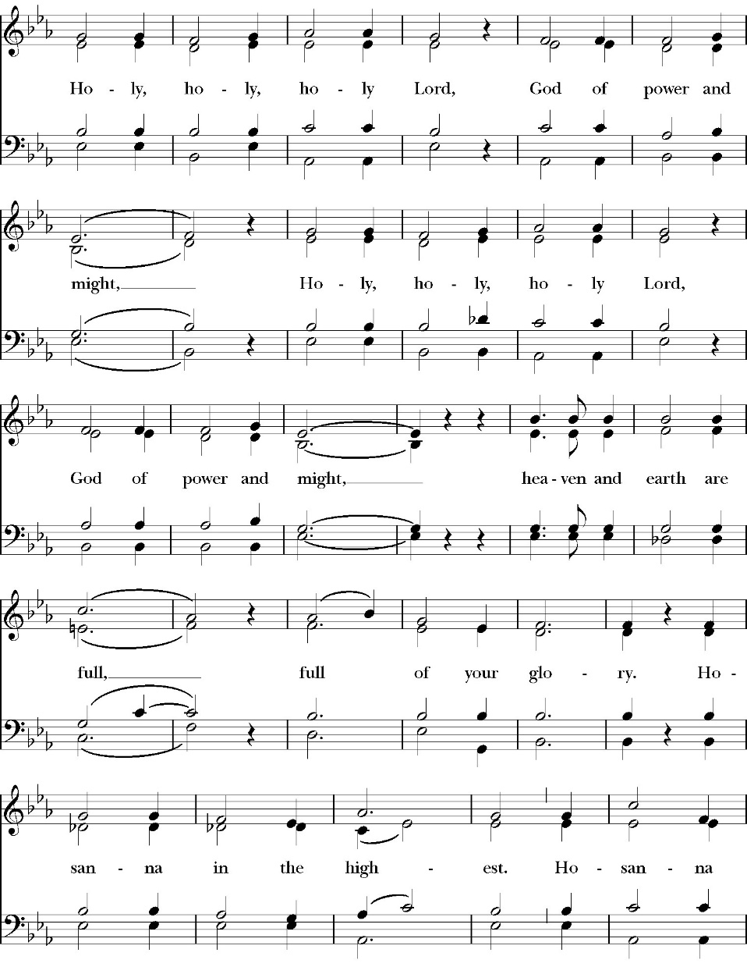
The Sanctus

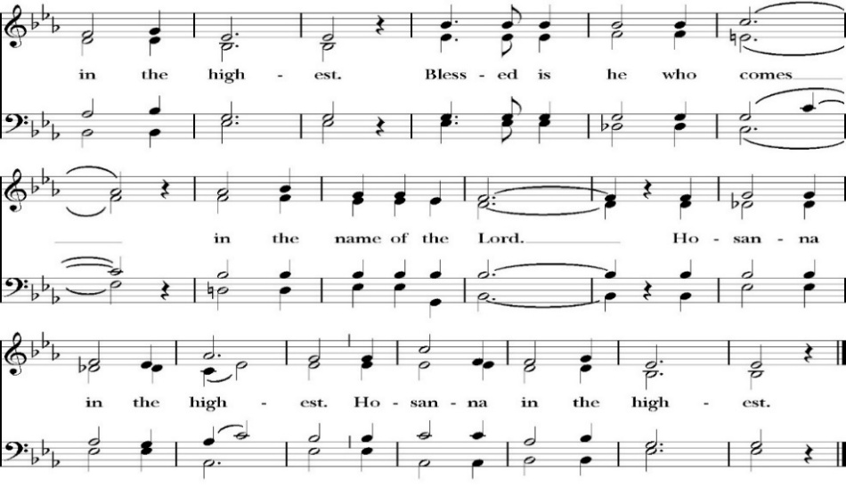
The People kneel or are seated if unable to kneel

All praise and glory is yours, O God our heavenly Father, for in your tender mercy, you gave your only Son Jesus Christ to suffer death upon the Cross for our redemption. He made there, by his one oblation of himself once offered, a full, perfect, and sufficient sacrifice, oblation, and satisfaction, for the sins of the whole world; and he instituted, and in his Holy Gospel commanded us to continue, a perpetual memory of his precious death and sacrifice, until his coming again.

So now, O merciful Father, in your great goodness, we ask you to bless and sanctify, with your Word and Holy Spirit, these gifts of bread and wine, that we, receiving them according to your Son our Savior Jesus Christ’s holy institution, in remembrance of his death and passion, may be partakers of his most blessed Body and Blood.

For on the night that he was betrayed, our Lord Jesus Christ took bread; and when he had given thanks, he broke it,* and gave it to his disciples, saying, “Take, eat; this is my Body, which is given for you: Do this in remembrance of me.”

Likewise, after supper, Jesus took the cup, and when he had given thanks, he gave it to them, saying, “Drink this, all of you; for this is my Blood of the New Covenant, which is shed for you, and for many, for the forgiveness of sins: Whenever you drink it, do this in remembrance of me.”

Therefore, O Lord and heavenly Father, according to the institution of your dearly beloved Son our Savior Jesus Christ, we your humble servants celebrate and make here before your divine Majesty, with these holy gifts, the memorial your Son commanded us to make; remembering his blessed passion and precious death, his mighty resurrection and glorious ascension, and his promise to come again.

And we earnestly desire your fatherly goodness mercifully to accept this, our sacrifice of praise and thanksgiving; asking you to grant that, by the merits and death of your Son Jesus Christ, and through faith in his Blood, we and your whole Church may obtain forgiveness of our sins, and all other benefits of his passion.
And here we offer and present to you, O Lord, ourselves, our souls and bodies, to be a reasonable, holy, and living sacrifice. We humbly pray that all who partake of this Holy Communion may worthily receive the most precious Body and Blood of your Son Jesus Christ, be filled with your grace and heavenly benediction, and be made one body with him, that he may dwell in us, and we in him.

And although we are unworthy, because of our many sins, to offer you any sacrifice, yet we ask you to accept this duty and service we owe, not weighing our merits, but pardoning our offenses, through Jesus Christ our Lord.

By him, and with him, and in him, in the unity of the Holy Spirit, all honor and glory is yours, Almighty Father, now and for ever. Amen.

And now, as our Savior Christ has taught us, we are bold to pray,

Our Father, who art in heaven,
hallowed be thy Name,
thy kingdom come,
thy will be done,
on earth as it is in heaven.
Give us this day our daily bread.
And forgive us our trespasses,
as we forgive those
who trespass against us.
And lead us not into temptation,
but deliver us from evil.
For thine is the kingdom,
and the power, and the glory,
for ever and ever. Amen.

The Fraction

Celebrant Alleluia. Christ our Passover is sacrificed for us.
People Therefore let us keep the feast. Alleluia.

The Prayer For Humble Access

We do not presume to come to this your table, O merciful Lord,
trusting in our own righteousness,
but in your abundant and great mercies.
We are not worthy so much as to gather up
the crumbs under your table;
but you are the same Lord
whose character is always to have mercy.
Grant us, therefore, gracious Lord,
so to eat the flesh of your dear Son Jesus Christ,
and to drink his blood,
that our sinful bodies may be made clean by his body,
and our souls washed through his most precious blood,
and that we may evermore dwell in him, and he in us.
Amen.

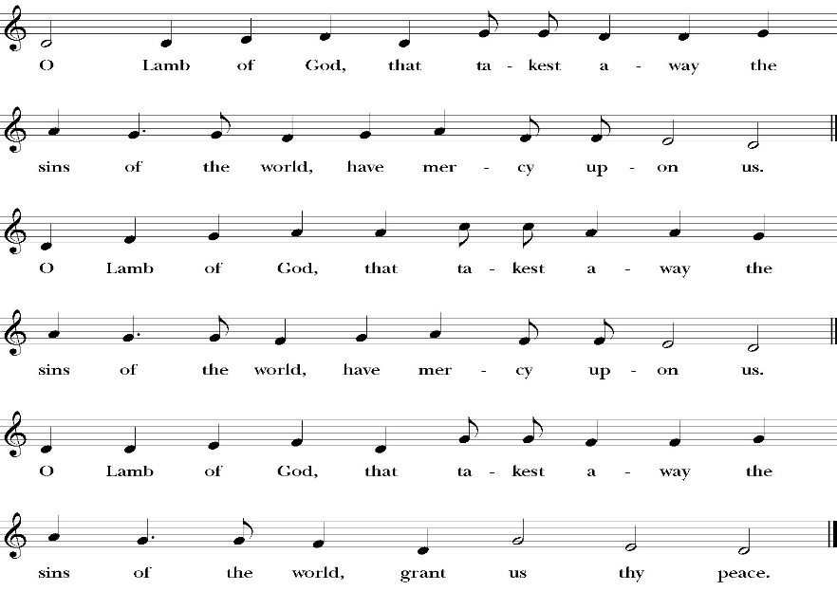
Agnus Dei

Behold the Lamb of God, behold him who takes away the sins of the world. Blessed are those who are invited to the marriage supper of the Lamb.
John 1:29; Revelation 19:9
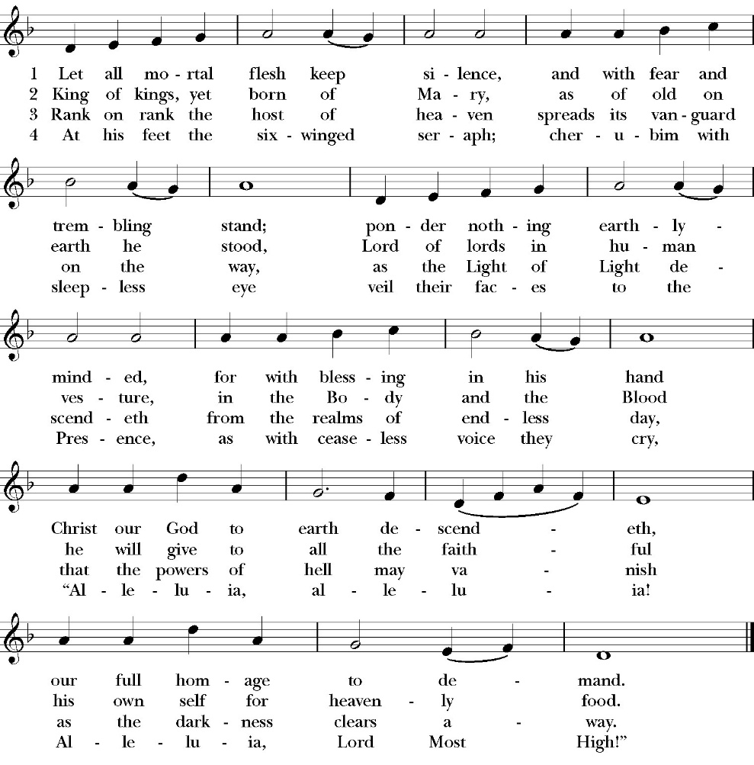
Communion Hymn: Let All Mortal Flesh Keep Silence

The Post Communion Prayer

Let us pray.

Almighty and everliving God,
we thank you for feeding us, in these holy mysteries,
with the spiritual food of the most precious Body and Blood
of your Son our Savior Jesus Christ;
and for assuring us, through this Sacrament, of your favor and
goodness towards us:
that we are true members of the mystical body of your Son,
the blessed company of all faithful people;
and are also heirs, through hope,
of your everlasting kingdom.
And we humbly ask you, heavenly Father,
to assist us with your grace,
that we may continue in that holy fellowship,
and do all the good works that you have prepared for us to
walk in;
through Jesus Christ our Lord,
to whom, with you and the Holy Spirit,
be all honor and glory, now and for ever. Amen.

The Blessing

The peace of God, which passes all understanding, keep your hearts
and minds in the knowledge and love of God, and of his Son Jesus
Christ our Lord; and the blessing of God Almighty, the Father, the
Son, and the Holy Spirit, be among you, and remain with you always.

Closing Hymn: Christ for the World We Sing!

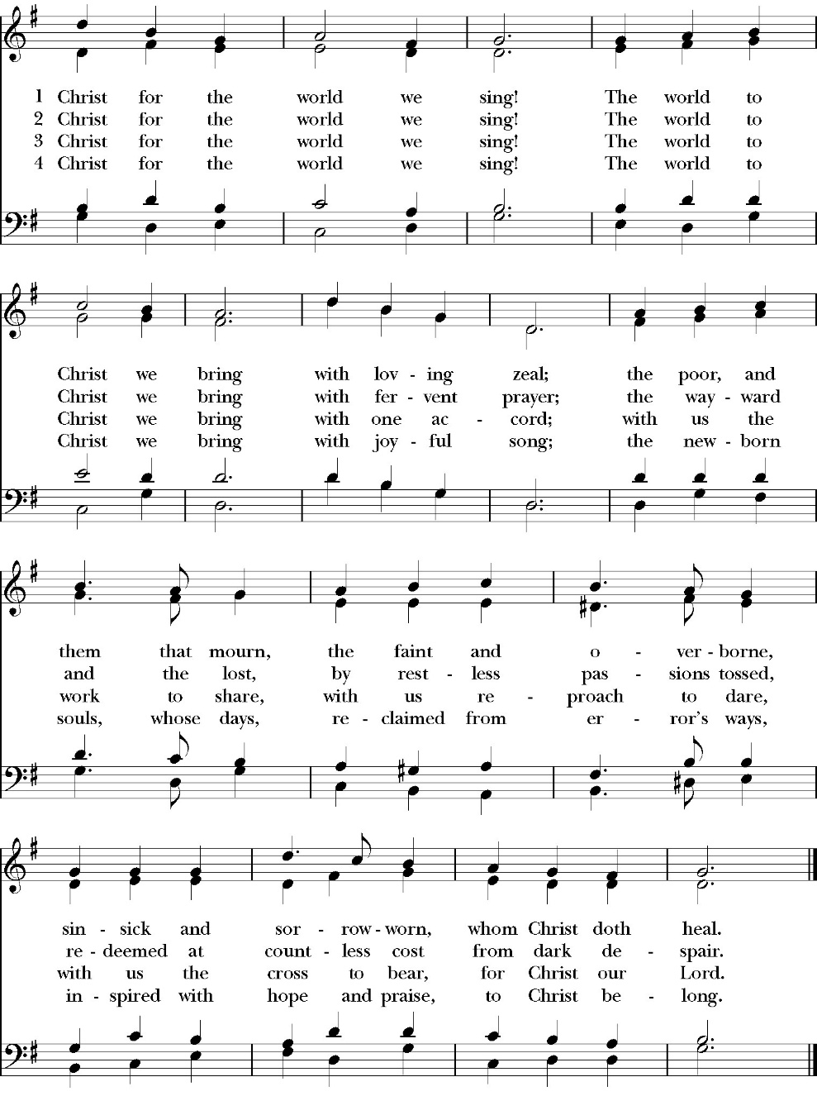

Deacon Alleluia, Alleluia. Go in peace to love and serve the Lord.
People Thanks be to God. Alleluia, Alleluia.
St. Paul’s Parish Calendar
Sunday, November 21 – Sunday December 28

SUNDAY, December 21 – Fourth Sunday in Advent
9:20 AM Choir Practice, Music Room
10:30 AM Children’s Sunday School, Chapel
10:30 AM Christmas Pageant
10:30 AM Holy Eucharist, Church
4:00 PM- 6:00 PM Christmas Caroling, Meet at Church

MONDAY, December 22

TUESDAY, December 23

WEDNESDAY, December 24 – Christmas Eve
5:00 PM Holy Eucharist, Church
11:00 PM Holy Eucharist, Church

THURSDAY, December 25 – Christmas Day
10:30 AM Holy Eucharist, Church

FRIDAY, December 26

SATURDAY, December 27

SUNDAY, December 28 – First Sunday of Christmas
9:20 AM Choir Practice, Music Room
10:30 AM Children’s Sunday School, Chapel
10:30 AM Holy Eucharist, Church

Church Office Hours
Monday-Thursday 8:00 AM-4:00 PM

Church Office Closed
Wednesday, December 24 at 12:00PM
Thursday, December 25
Wednesday, December 31 at 12:00PM
Thursday, January 1

Announcements

Christmas Caroling to Shut-Ins
Sunday, December 21, 4:00PM-6:00PM, Meet at Church
All church members are invited to join us for caroling to members of our church who are shut into their own homes. We gather at the church for cookies and hot cocoa and then travel in our own cars to four locations. This takes about two hours, but is a fun and joyful time for everyone. Routes will be distributed at the church.

Visalia Emergency Aid Food Barrel
For many years, St. Paul’s supported the ministry of Visalia Emergency Aid by housing a food barrel. We are renewing this ministry and invite members to bring food on Sunday mornings to place into the food barrel and support the VEA feeding ministries.

Nominations for Vestry Class of 2029
The Vestry is the governing board of St. Paul’s Anglican Church. Every year, four confirmed members of the church are elected to serve on the vestry for a three-year term. The vestry has three primary leadership functions. The vestry serves as the fiduciary leaders of the church, ensures that all administrative tasks of the church are functioning well, and assists the rector in leading the spiritual life of the church. If you are interested in serving on the vestry, desire to nominate a confirmed member of the church to serve on the vestry, or just want to learn more, please speak with Fr. Rob Longbottom or the three members of our vestry nominating committee. These people are Mark Morales, Rosemary Reeder, and Lydia Castaneda. Election of new vestry members will be held at the Annual Meeting on Sunday, February 1.

Year-End Giving at St. Paul’s Anglican Church
All financial giving that will be recorded for 2025 must be turned into the church office by Wednesday, December 31. The financial books for 2025 will be closed at 3 PM on Monday, January 5.

Spring Rummage Sale 2026
We will be collecting gently used items on Wednesday, March 4, and Thursday, March 5, from 9 AM to 4 PM. The actual sale begins on Friday, March 6, from 8 AM to 4 PM concluding on Saturday, March 7, from 8 AM to 2 PM. If you have any questions, please call Mary Murray 559-799-6973.
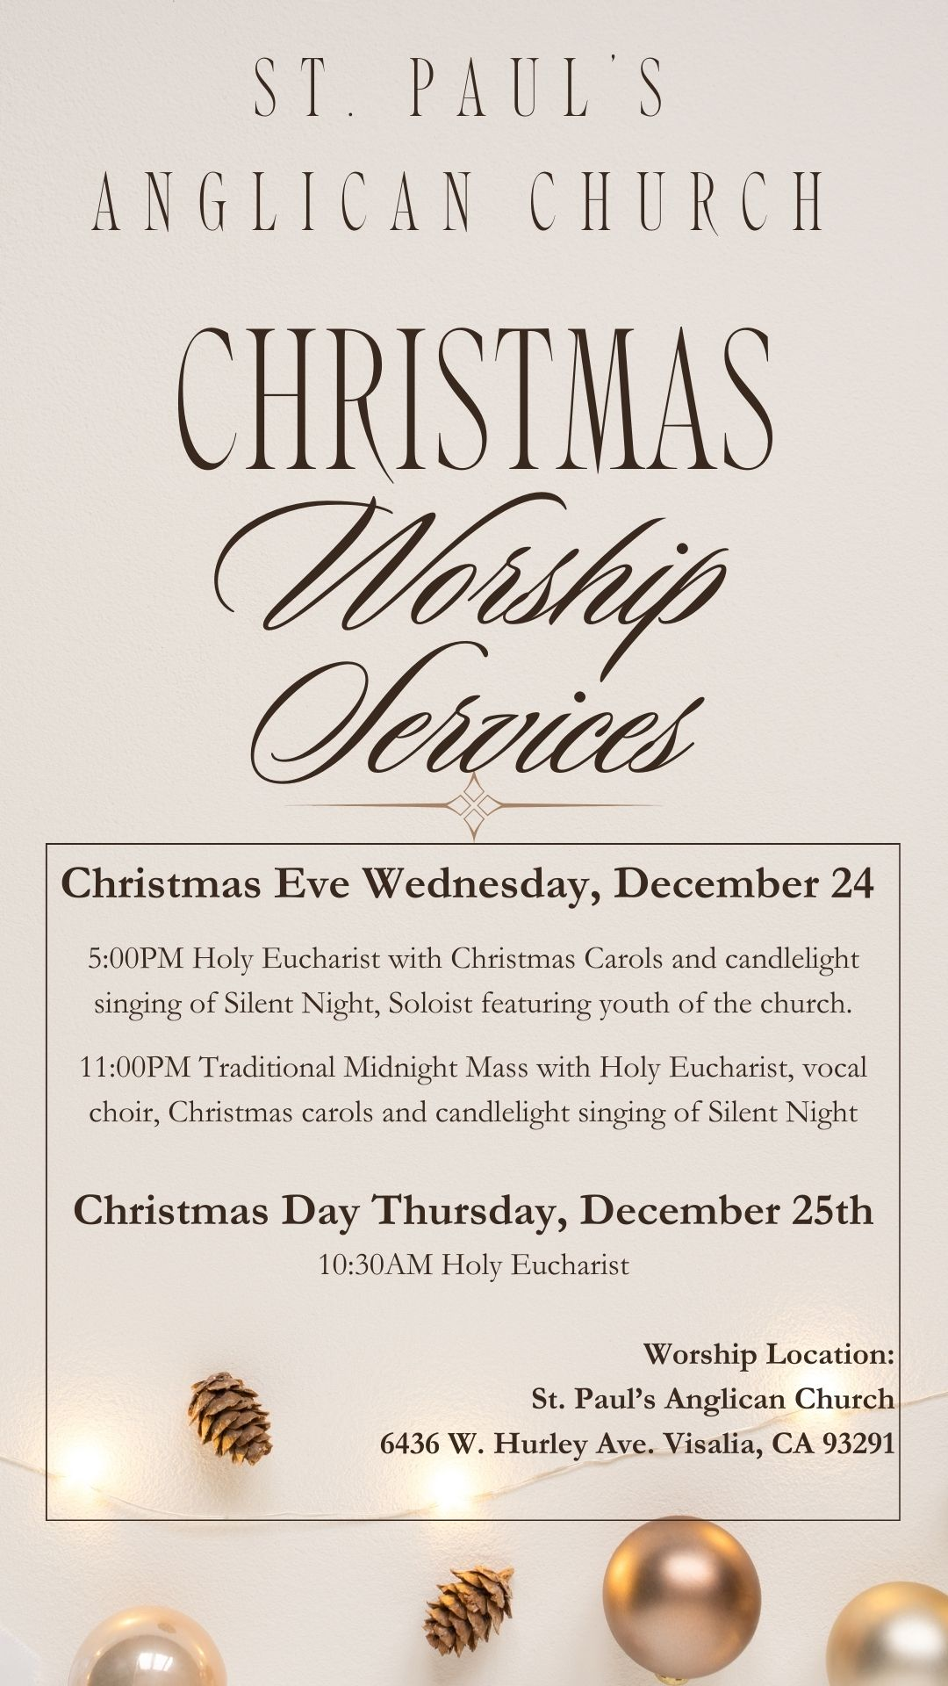
St. Paul’s Anglican Church
Parish Office
6436 W. Hurley Ave
Visalia, California 93291
559-732-4821
Office Hours: 8:00 – 4:00
Monday – Thursday

Worship: Sundays at 10:30AM
Livestream: Link at spvisalia.com
and on our Facebook page
Please be advised that this service is being recorded for broadcast
and/or archival purposes. By attending, you consent
to the inclusion of your likeness in these recordings.

St. Paul’s Clergy and Staff
The Rev. Robert Longbottom, Rector
rector@spvisalia.com
(559)802-2928
The Rev. John Iseman, Pastoral Associate for Family Ministries
family@spvisalia.com
The Rev. Kashy Rowland-Smith, Deacon
kashyrs@aol.com
Antoinette Horsting, Parish Administrator
bookkeeper@spvisalia.com
Marguerite Crownover, Organist and Accompanist
Cynthia Culp, Choral Director
Jackie Iseman, Nursery Coordinator
Shane Motl, Sexton

St. Paul’s is a Member Church of
the Anglican Diocese of San Joaquin
The Rt. Rev. Eric V. Menees, Bishop

Next Week’s Lessons
Isaiah 61:10-62:5
Psalm 147:12-20
Galatians 3:23-4:7
John 1:1-18

