St. Paul’s Anglican Church
Visalia, California

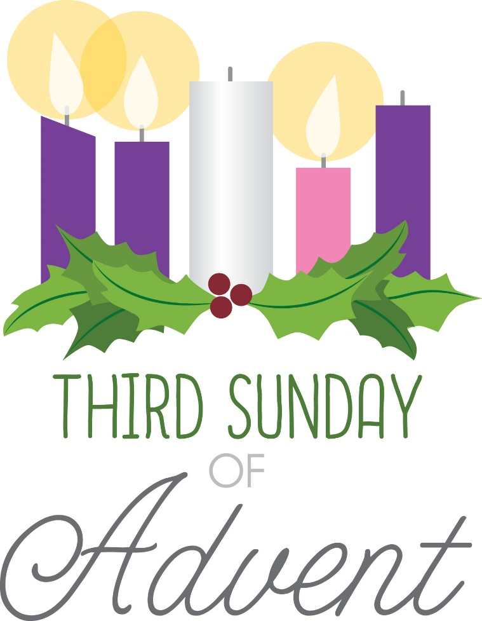

Third Sunday in Advent
December 14, 2025
10:30 A.M

Welcome!

St. Paul’s Anglican Church extends a warm welcome to all visitors and newcomers, whether worshiping in person or at home via livestream.

Visitors’ Guide

St. Paul’s Church is a parish in the Diocese of San Joaquin of the Anglican Church in North America, which includes both Catholic and Protestant traditions. We accept Jesus Christ as Savior, and we promise to follow him as Lord. We believe in One God,

- the Father who created us and all things,
- the Son who redeems us from sin and death,
- the Holy Spirit who renews and sanctifies us.

We believe the Holy Scriptures to be the Word of God and to contain all things necessary for salvation, and we accept the Apostles’ and Nicene Creeds as essential beliefs of the Christian faith.

Holy Communion is open to all baptized Christians who have examined their lives, repented of their sins, and desire to live
in love and charity with all people.

Those not desiring to receive Holy Communion, and those who have not been baptized into the Christian faith, are invited to cross their arms across their chest, and a blessing will be given instead.

Visitors are invited to sign the guest book at the entrance table and introduce themselves to the clergy following the service.

The Holy Eucharist

Prelude: “Dear Christians, One and All, Rejoice” Leavitt
Hymn: #56 – “O Come, O Come Emmauel” (verse 5&6)
The Lighting of the Advent Candle Liturgy p. 4
Opening Hymn: #59 – “Hark! A Thrilling Voice is Sounding” p. 5
Acclamation p. 6
The Collect for Purity p. 6
Summary of the Law p. 6
Trisagion p. 6
Gloria p. 7
Collect of the Day p. 8
Lesson: Isaiah 35:1-10 p. 8
Gradual: Psalm 146 p. 9
Epistle: James 5:7-20 p. 10
Sequence Hymn: #76 – “On Jordan’s Bank the Baptist’s Cry” p. 11
Gospel: Matthew 11:2-19 p. 11
Sermon: Rev Robert Longbottom
Nicene Creed p. 13
Prayers of the People p. 14
Confession and Absolution p. 16
The Comfortable Words p. 17
The Peace p. 17
The Offertory “Let There Be Peace on Earth” Bell Choir
The Eucharistic Liturgy Anglican Standard Text p. 18
Sanctus p. 19
The Lord’s Prayer p. 21
The Fraction p. 21
Prayer for Humble Access p. 22
Agnus Dei p. 22
Communion Hymn: #72 – “Hark! The Glad Sound!” p. 23
Post Communion Prayer p. 24
Blessing p. 24
Closing Hymn: #438 – “Tell Out My Soul” p. 25
Dismissal p. 25
Postlude: “The Advent of Our God” Powell

Hymnal #56: O Come, O Come Emmanuel (verses 5 & 6)

LIGHTING THE THIRD CANDLE
THE CANDLE OF JOY

John the Baptist

Leader: Light and peace, in Jesus Christ our Lord

All: Thanks be to God

Leader: Today is the Third Sunday of Advent and we will light the Candle of Joy.

Last Sunday we lit the Candle of Peace. We light it and the Candle of Hope again as we remember Jesus, born in Bethlehem, our hope and our peace.

(A person lights the Candles of Hope and Peace)

Today we light the Third Candle of Advent, the Candle of Joy. In their old age, God gave to Zechariah and Elisabeth a son called John. John spoke to the people bravely in the desert denying his own comforts and prepared to die for what he believed. He did this because he cared for people and wanted them to repent and find God’s forgiveness. John found joy in the knowledge that Jesus’ presence in the world would give joy to people who had none before. He healed them and gave them hope and peace when they believed in him. From hope and peace grows joy. We light the Candle of Joy to remind us that when Jesus is born in us we have joy and that through him there will be everlasting joy on earth.

(A person lights the third Candle, the Candle of Joy)

Joy is like a light shining in a dark place. As we look at the light of this candle, we celebrate the joy we have in Christ.

Leader: Let us pray

All: Lord God, your witness John the Baptist grew up strong in spirit and prepared people for the coming of the Lord. He also had the joy of knowing his Savior. Thank you God for the joy you give us. Help us to be joyful witnesses and spread the good news of your son Jesus. As Christmas draws closer day by day, help us to be ready to welcome him. We ask it in the name of the one who was born in Bethlehem. Amen.

Opening Hymn: Hark! A Thrilling Voice is Sounding
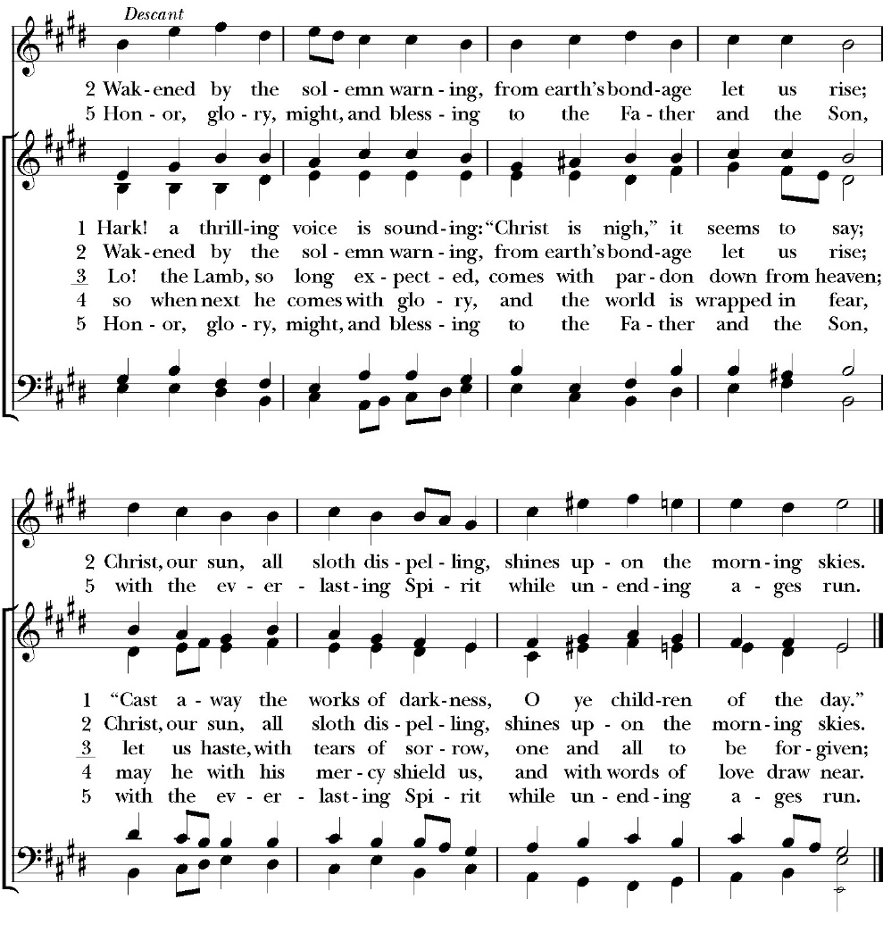

Opening Sentences

Celebrant For unto us a child is born
People Unto us a son is given.

Collect for Purity

Almighty God, to you all hearts are open, all desires known, and from you no secrets are hid: Cleanse the thoughts of our hearts by the inspiration of your Holy Spirit, that we may perfectly love you, and worthily magnify your holy Name; through Christ our Lord. Amen.

Summary of the law

Celebrant says
Hear what our Lord Jesus Christ says: You shall love the Lord your
God with all your heart and with all your soul and with all your mind.
This is the first and great commandment. And the second is like it:
You shall love your neighbor as yourself. On these two
commandments depend all the Law and the Prophets.

Trisagion
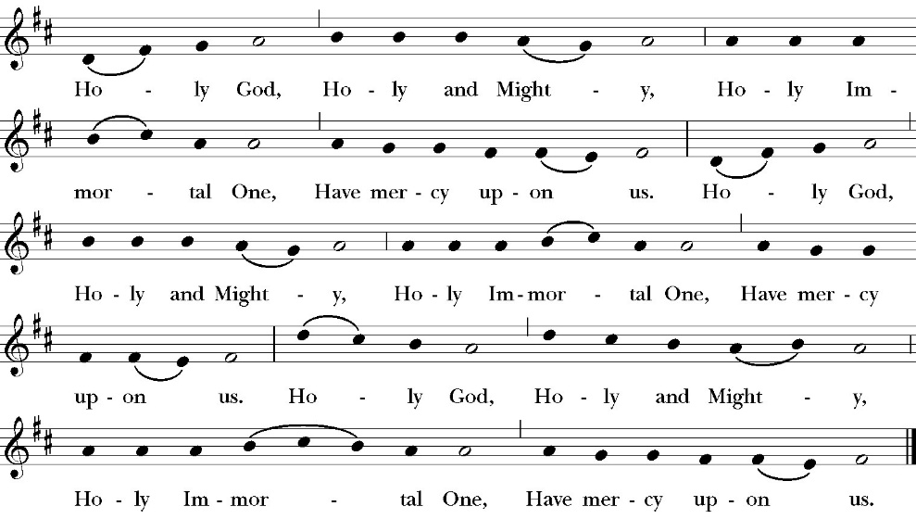
The Gloria

Officiant The Lord be with You.
People And with your spirit.
Officiant Let us pray:

The Collect of the Day
O Lord Jesus Christ, you sent your messengers the prophets to preach repentance and prepare the way for our salvation: Grant that the ministers and stewards of your mysteries may likewise make ready your way, by turning the hearts of the disobedient toward the wisdom of the just, that at your second coming to judge the world, we may be found a people acceptable in your sight; for with the Father and the Holy Spirit you live and reign, one God, now and for ever. Amen.

Lesson: Isaiah 35:1-10
The wilderness and the dry land shall be glad; the desert shall rejoice and blossom like the crocus; 2 it shall blossom abundantly and rejoice with joy and singing. The glory of Lebanon shall be given to it, the majesty of Carmel and Sharon. They shall see the glory of the LORD, the majesty of our God.

3 Strengthen the weak hands, and make firm the feeble knees. 4 Say to those who have an anxious heart, “Be strong; fear not! Behold, your God will come with vengeance, with the recompense of God. He will come and save you.”

5 Then the eyes of the blind shall be opened, and the ears of the deaf unstopped;

6 then shall the lame man leap like a deer, and the tongue of the mute sing for joy. For waters break forth in the wilderness, and streams in the desert; 7 the burning sand shall become a pool, and the thirsty ground springs of water; in the haunt of jackals, where they lie down, the grass shall become reeds and rushes.

8 And a highway shall be there, and it shall be called the Way of Holiness; the unclean shall not pass over it. It shall belong to those who walk on the way; even if they are fools, they shall not go astray. 9 No lion shall be there, nor shall any ravenous beast come up on it; they shall not be found there, but the redeemed shall walk there. 10 And the ransomed of the LORD shall return and
come to Zion with singing; everlasting joy shall be upon their heads; they shall obtain gladness and joy, and sorrow and sighing shall flee away.

Reader The Word of the Lord
People Thanks be to God

Gradual Psalm 146
1 Praise the LORD, O my soul; *
while I live I will praise the LORD.
2 Indeed, as long as I have my being, *
I will sing praises unto my God.
3 Put not your trust in princes, nor in any child of man, *
for there is no help in them.
4 For when one breathes his last, he shall return again to the earth, * and in that day all his thoughts perish.
5 Blessed is the one who has the God of Jacob for his help *
and whose hope is in the LORD his God,
6 Who made heaven and earth, the sea, and all that is therein; *
who keeps his promise for ever;
7 Who does right to those who suffer wrong; *
and who feeds the hungry.
8 The LORD sets prisoners free; *
the LORD gives sight to the blind.
9 The LORD helps those who have fallen; *
the LORD loves the righteous.
10 The LORD cares for the strangers in the land; he defends the fatherless and widow; *
but the way of the ungodly he makes crooked.
11 The LORD shall be King for evermore, *
even your God, O Zion, throughout all generations. Praise the LORD.

Glory be to the Father, and to the Son, and to the Holy Spirit;
as it was in the beginning, is now, and ever shall be, world
without end. Amen

Epistle: James 5:7-20
Be patient, therefore, brothers, until the coming of the Lord. See how the farmer waits for the precious fruit of the earth, being patient about it, until it receives the early and the late rains. 8 You also, be patient. Establish your hearts, for the coming of the Lord is at hand. 9 Do not grumble against one another, brothers, so that you may not be judged; behold, the Judge is standing at the door. 10 As an example of suffering and patience, brothers, take the prophets who spoke in the name of the Lord. 11 Behold, we consider those blessed who remained steadfast. You have heard of the steadfastness of Job, and you have seen the purpose of the Lord, how the Lord is compassionate and merciful.

12 But above all, my brothers, do not swear, either by heaven or by earth or by any other oath, but let your “yes” be yes and your “no” be no, so that you may not fall under condemnation.

13 Is anyone among you suffering? Let him pray. Is anyone cheerful? Let him sing praise. 14 Is anyone among you sick? Let him call for the elders of the church, and let them pray over him, anointing him with oil in the name of the Lord. 15 And the prayer of faith will save the one who is sick, and the Lord will raise him up. And if he has committed sins, he will be forgiven. 16 Therefore, confess your sins to one another and pray for one another, that you may be healed. The prayer of a righteous person has great power as it is working. 17 Elijah was a man with a nature like ours, and he prayed fervently that it might not rain, and for three years and six months it did not rain on the earth. 18 Then he prayed again, and heaven gave rain, and the earth bore its fruit.

19 My brothers, if anyone among you wanders from the truth and someone brings him back, 20 let him know that whoever brings back a sinner from his wandering will save his soul from death and will cover a multitude of sins.

Reader The Word of the Lord
People Thanks be to God

Sequence Hymn: On Jordan’s Bank the Baptist’s Cry
(vs. 1-3 before Gospel, vs. 4-5 after)
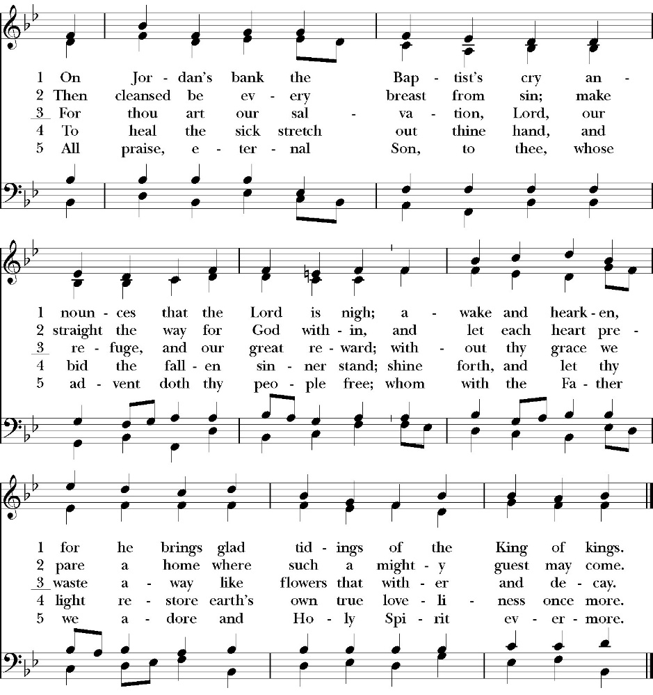

Clergy The Holy Gospel of Our Lord Jesus Christ, according to
St. Matthew
People Glory to you, Lord Christ

Gospel: Matthew 11:2-19
Now when John heard in prison about the deeds of the Christ, he sent word by his disciples 3 and said to him, “Are you the one who is to come, or shall we look for another?” 4 And Jesus answered them, “Go and tell John what you hear and see: 5 the blind receive their sight and the lame walk, lepers are cleansed and the deaf hear, and the dead are raised up, and the poor have good news preached to them. 6 And blessed is the one who is not offended by me.”
7 As they went away, Jesus began to speak to the crowds concerning John: “What did you go out into the wilderness to see? A reed shaken by the wind?

8 What then did you go out to see? A man dressed in soft clothing? Behold, those who wear soft clothing are in kings' houses. 9 What then did you go out to see? A prophet? Yes, I tell you, and more than a prophet. 10 This is he of whom it is written,

“‘Behold, I send my messenger before your face, who will prepare your way before you.’

11 Truly, I say to you, among those born of women there has arisen no one greater than John the Baptist. Yet the one who is least in the kingdom of heaven is greater than he. 12 From the days of John the Baptist until now the kingdom of heaven has suffered violence, and the violent take it by force. 13 For all the Prophets and the Law prophesied until John, 14 and if you are willing to accept it, he is Elijah who is to come. 15 He who has ears to hear, let him hear.

16 “But to what shall I compare this generation? It is like children sitting in the marketplaces and calling to their playmates, 17 ‘We played the flute for you, and you did not dance; we sang a dirge, and you did not mourn.’

18 For John came neither eating nor drinking, and they say, ‘He has a demon.’

19 The Son of Man came eating and drinking, and they say, ‘Look at him! A glutton and a drunkard, a friend of tax collectors and sinners!’ Yet wisdom is justified by her deeds.”

Deacon The Gospel of the Lord
People Praise to you, Lord Christ

Sermon
Rev. Robert Longbottom

The Nicene Creed

We believe in one God,
the Father, the Almighty,
maker of heaven and earth,
of all that is, visible and invisible.
We believe in one Lord, Jesus Christ,
the only-begotten Son of God,
eternally begotten of the Father,
God from God, Light from Light,
true God from true God,
begotten, not made,
of one Being with the Father.
through him all things were made.
For us and for our salvation he came down from heaven:
was incarnate from the Holy Spirit and the Virgin Mary,
and was made man.
For our sake he was crucified under Pontius Pilate;
he suffered death and was buried.
On the third day he rose again in accordance with the
Scriptures;
he ascended into heaven
and is seated at the right hand of the Father.
He will come again in glory to judge the living and the dead,
and his kingdom will have no end.
We believe in the Holy Spirit, the Lord, the giver of life,
who proceeds from the Father [and the Son],
who with the Father and the Son is worshiped and glorified.
who has spoken through the Prophets.
We believe in one holy catholic and apostolic Church.
We acknowledge one Baptism for the forgiveness of sins.
We look for the resurrection of the dead,
and the life of the world to come. Amen.

The Prayers of the People

Let us pray for the Church and for the world.

Almighty and everliving God, we are taught by your holy Word to offer prayers and supplications and to give thanks for all people. We humbly ask you mercifully to receive our prayers. Inspire continually the universal Church with the spirit of truth, unity, and concord; and grant that all who confess your holy Name may agree in the truth of your holy Word, and live in unity and godly love.

Silence

Reader Lord, in your mercy:
People Hear our prayer.

We pray that you will lead the nations of the world in the way of righteousness; and so guide and direct their leaders, especially Donald our President and Gavin our Governor, that your people may enjoy the blessings of freedom and peace. Grant that our leaders may impartially administer justice, uphold integrity and truth, restrain wickedness and vice, and protect true religion and virtue.

Silence

Reader Lord, in your mercy:
People Hear our prayer.

For Stephen, our Archbishop, and Eric, our Bishop, and for all the clergy and people of our Diocese and Congregation.

Silence

Reader Lord, in your mercy:
People Hear our prayer.

Prosper, we pray, all those who proclaim the Gospel of your kingdom throughout the world, and strengthen us to fulfill your great commission, making disciples of all nations, baptizing them and teaching them to obey all that you have commanded.

Silence

Reader Lord, in your mercy:
People Hear our prayer.
In the St. Paul’s cycle of prayer, we pray for our Sunday morning worship and welcoming ministries. We pray for the Altar Guild, our Lay Eucharistic Ministers, our Lectors, and our Acolytes. We pray for our music ministry and the musicians and vocalists. We pray for our ushers, greeters, and prayer table ministries.

Silence

Reader Lord, in your mercy:
People Hear our prayer.

In the ACNA Cycle of Prayer, today we pray for the Provincial Office, Lee Hilts, Treasurer, and his wife, Sarah, and The Rev. Kirk Patterson, Controller, and his wife, Tricia.

Silence

Reader Lord, in your mercy:
People Hear our prayer.

We ask you in your goodness, O Lord, to comfort and sustain all who in this transitory life are in trouble, sorrow, need, sickness, or any other adversity [especially _____________]. We also pray for all who are currently serving in our armed forces, law enforcement and serving as first responders.

Silence

Reader Lord, in your mercy:
People Hear our prayer.

We remember before you all your servants who have departed this life in your faith and fear, [especially _____________,] that your will for them may be fulfilled; and we ask you to give us grace to follow the good examples of St. Paul and all your saints, that we may share with them in your heavenly kingdom.

Silence

Reader Lord, in your mercy:
People Hear our prayer.

Celebrant:

Heavenly Father, grant these our prayers for the sake of Jesus Christ, our only Mediator and Advocate, who lives and reigns with you in the unity of the Holy Spirit, one God, now and for ever. Amen.

The confession and absolution of sin

The Deacon or other person appointed says the following

All who truly and earnestly repent of your sins, and seek to live in
love and charity with your neighbors, and intend to lead the new life, following the commandments of God, and walking in his holy ways: draw near with faith and make your humble confession to Almighty God.

Almighty God, Father of our Lord Jesus Christ,
maker and judge of us all:
We acknowledge and lament our many sins and offenses,
which we have committed by thought, word, and deed
against your divine majesty,
provoking most justly your righteous anger against us.
We are deeply sorry for these our transgressions;
the burden of them is more than we can bear.
Have mercy upon us,
Have mercy upon us, most merciful Father;
for your Son our Lord Jesus Christ’s sake,
forgive us all that is past;
and grant that we may evermore serve and please you in
newness of life, to the honor and glory of your Name;
through Jesus Christ our Lord. Amen.

A Deacon remains kneeling and prays

Grant to your faithful people, merciful Lord, pardon and peace; that we may be cleansed from all our sins, and serve you with a quiet mind; through Jesus Christ our Lord. Amen.

the comfortable words

The Celebrant may then say one or more of the following sentences, first saying

Hear the Word of God to all who truly turn to him.

The saying is trustworthy and deserving of full acceptance, that Christ Jesus came into the world to save sinners.
-1 Timothy 1:15

the peace

Celebrant The Peace of the Lord be always with you.
People And with your spirit.

Offertory
Let There Be Peace on Earth -Bell Choir
By: Sy Miller and Jill Jackson

The Doxology
(Verse 3 only)

The Offertory

Celebrant All things come from you, O Lord,
People And of your own have we given you.

The Eucharistic Liturgy

Celebrant The Lord be with you.
People And with your spirit.
Celebrant Lift up your hearts.
People We lift them up to the Lord.
Celebrant Let us give thanks to the Lord our God.
People It is right to give him thanks and praise.

It is right, our duty and our joy, always and everywhere to give thanks to you, Father Almighty, Creator of heaven and earth.

Because you sent your beloved Son to redeem us from sin and death, and to make us heirs in him of everlasting life; that when he shall
come again in power and great glory to judge the world, we may without shame or fear rejoice to behold his appearing.

Therefore, we praise you, joining our voices with angels and archangels and with all the company of heaven, who forever sing this hymn to proclaim the glory of your Name:

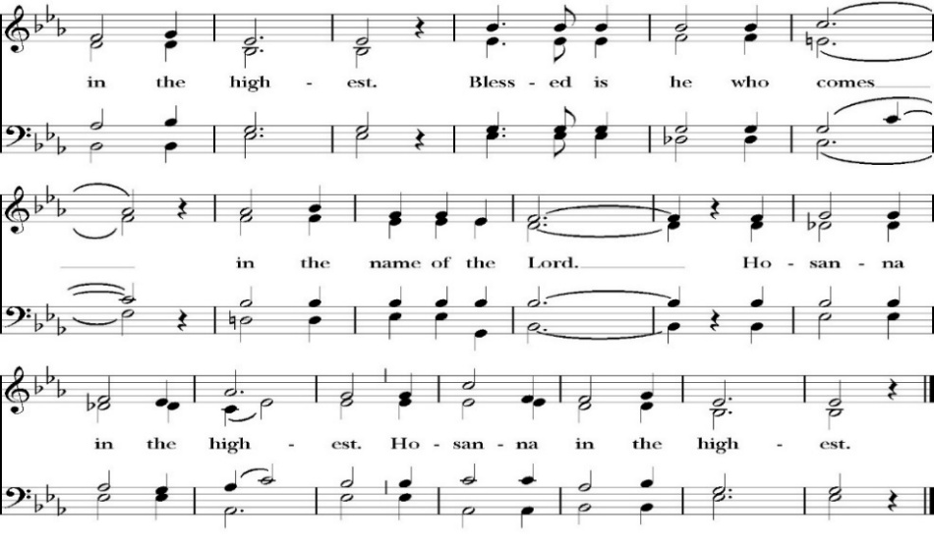
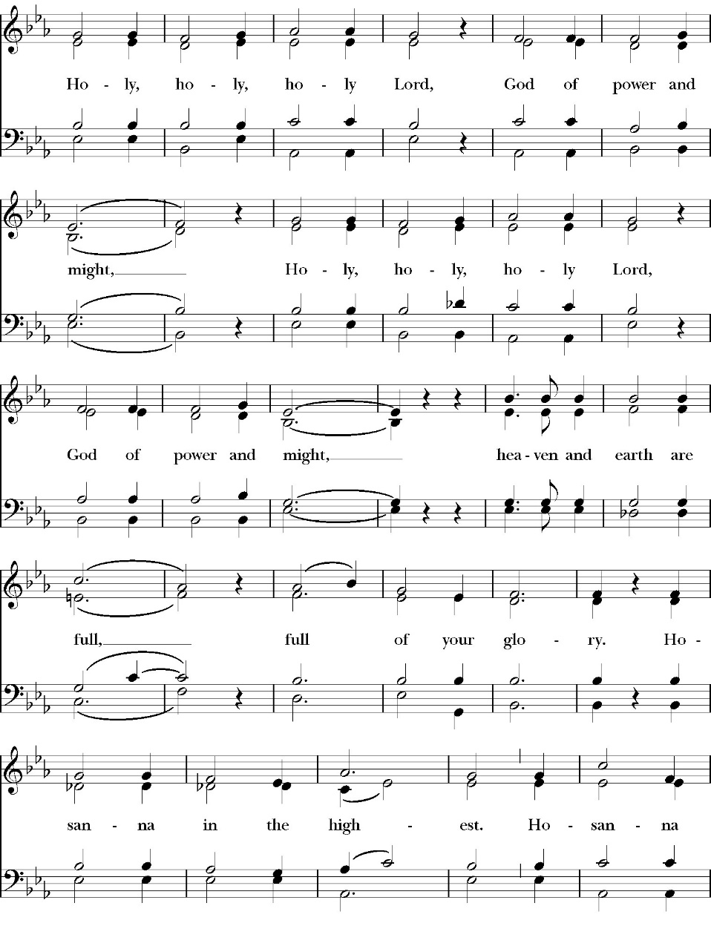
The Sanctus
The People kneel or are seated if unable to kneel

All praise and glory is yours, O God our heavenly Father, for in your tender mercy, you gave your only Son Jesus Christ to suffer death upon the Cross for our redemption. He made there, by his one oblation of himself once offered, a full, perfect, and sufficient sacrifice, oblation, and satisfaction, for the sins of the whole world; and he instituted, and in his Holy Gospel commanded us to continue, a perpetual memory of his precious death and sacrifice, until his coming again.

So now, O merciful Father, in your great goodness, we ask you to bless and sanctify, with your Word and Holy Spirit, these gifts of bread and wine, that we, receiving them according to your Son our Savior Jesus Christ’s holy institution, in remembrance of his death and passion, may be partakers of his most blessed Body and Blood.

For on the night that he was betrayed, our Lord Jesus Christ took bread; and when he had given thanks, he broke it,* and gave it to his disciples, saying, “Take, eat; this is my Body, which is given for you: Do this in remembrance of me.”

Likewise, after supper, Jesus took the cup, and when he had given thanks, he gave it to them, saying, “Drink this, all of you; for this is my Blood of the New Covenant, which is shed for you, and for many, for the forgiveness of sins: Whenever you drink it, do this in remembrance of me.”

Therefore, O Lord and heavenly Father, according to the institution of your dearly beloved Son our Savior Jesus Christ, we your humble servants celebrate and make here before your divine Majesty, with these holy gifts, the memorial your Son commanded us to make; remembering his blessed passion and precious death, his mighty resurrection and glorious ascension, and his promise to come again.

And we earnestly desire your fatherly goodness mercifully to accept this, our sacrifice of praise and thanksgiving; asking you to grant that, by the merits and death of your Son Jesus Christ, and through faith in his Blood, we and your whole Church may obtain forgiveness of our sins, and all other benefits of his passion.
And here we offer and present to you, O Lord, ourselves, our souls and bodies, to be a reasonable, holy, and living sacrifice. We humbly pray that all who partake of this Holy Communion may worthily receive the most precious Body and Blood of your Son Jesus Christ, be filled with your grace and heavenly benediction, and be made one body with him, that he may dwell in us, and we in him.

And although we are unworthy, because of our many sins, to offer you any sacrifice, yet we ask you to accept this duty and service we owe, not weighing our merits, but pardoning our offenses, through Jesus Christ our Lord.

By him, and with him, and in him, in the unity of the Holy Spirit, all honor and glory is yours, Almighty Father, now and for ever. Amen.

And now, as our Savior Christ has taught us, we are bold to pray,

Our Father, who art in heaven,
hallowed be thy Name,
thy kingdom come,
thy will be done,
on earth as it is in heaven.
Give us this day our daily bread.
And forgive us our trespasses,
as we forgive those
who trespass against us.
And lead us not into temptation,
but deliver us from evil.
For thine is the kingdom,
and the power, and the glory,
for ever and ever. Amen.

The Fraction

Celebrant Alleluia. Christ our Passover is sacrificed for us.
People Therefore let us keep the feast. Alleluia.

The Prayer For Humble Access

We do not presume to come to this your table, O merciful Lord,
trusting in our own righteousness,
but in your abundant and great mercies.
We are not worthy so much as to gather up
the crumbs under your table;
but you are the same Lord
whose character is always to have mercy.
Grant us, therefore, gracious Lord,
so to eat the flesh of your dear Son Jesus Christ,
and to drink his blood,
that our sinful bodies may be made clean by his body,
and our souls washed through his most precious blood,
and that we may evermore dwell in him, and he in us.
Amen.

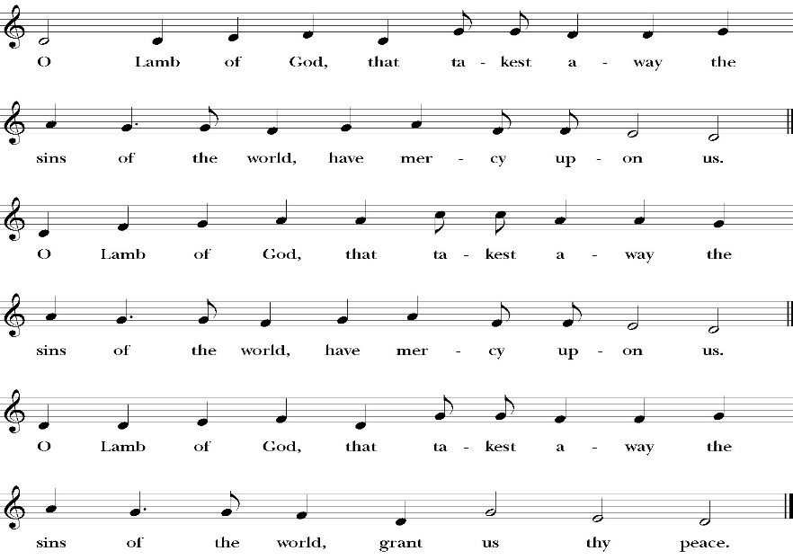
Agnus Dei

Behold the Lamb of God, behold him who takes away the sins of the world. Blessed are those who are invited to the marriage supper of the Lamb.
John 1:29; Revelation 19:9
Communion Hymn: Hark! The Glad Sound!

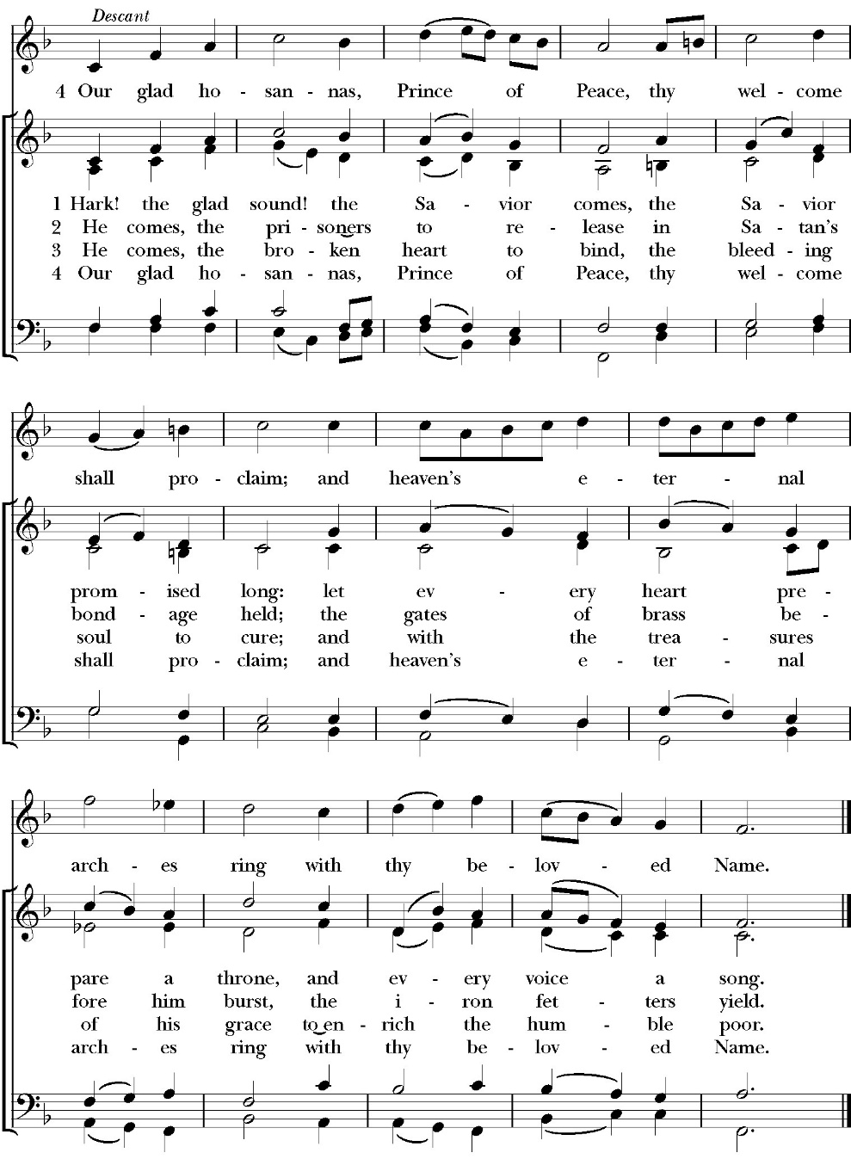

The Post Communion Prayer

Let us pray.

Almighty and everliving God,
we thank you for feeding us, in these holy mysteries,
with the spiritual food of the most precious Body and Blood
of your Son our Savior Jesus Christ;
and for assuring us, through this Sacrament, of your favor and
goodness towards us:
that we are true members of the mystical body of your Son,
the blessed company of all faithful people;
and are also heirs, through hope,
of your everlasting kingdom.
And we humbly ask you, heavenly Father,
to assist us with your grace,
that we may continue in that holy fellowship,
and do all the good works that you have prepared for us to
walk in;
through Jesus Christ our Lord,
to whom, with you and the Holy Spirit,
be all honor and glory, now and for ever. Amen.

The Blessing

The peace of God, which passes all understanding, keep your hearts
and minds in the knowledge and love of God, and of his Son Jesus
Christ our Lord; and the blessing of God Almighty, the Father, the
Son, and the Holy Spirit, be among you, and remain with you always.

Closing Hymn: Tell Out My Soul
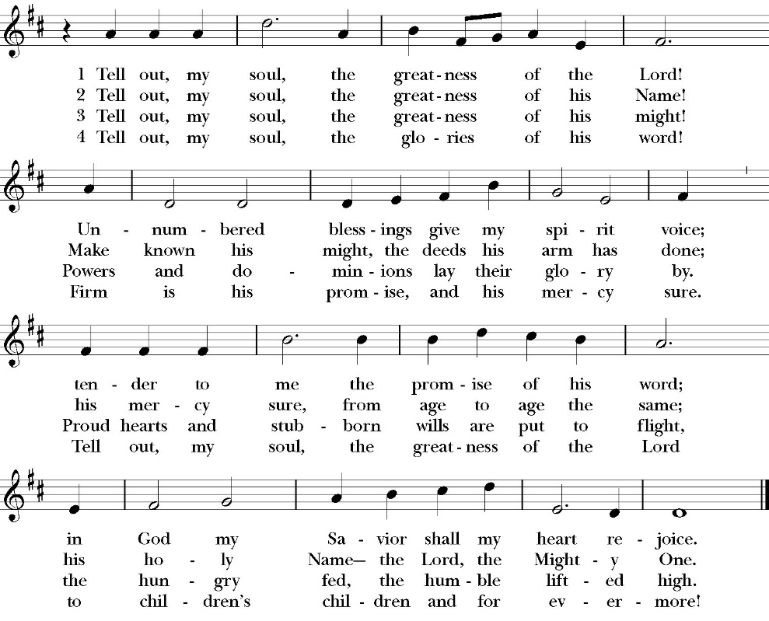

Deacon Alleluia, Alleluia. Go in peace to love and serve the Lord.
People Thanks be to God. Alleluia, Alleluia.
St. Paul’s Parish Calendar
Sunday, November 14 – Sunday December 21

SUNDAY, December 14 – Third Sunday in Advent
9:20 AM Bell Choir Practice, Music Room
10:30 AM Children’s Sunday School, Chapel
10:30 AM Holy Eucharist, Church
11:30 AM Congregational Blessing of Judy Ramirez Niche, Chapel

MONDAY, December 15

TUESDAY, December 16
6:00 PM Bell Choir Rehearsal, Music Room

WEDNESDAY, December 17
9:30 AM Morning Prayer, Chapel
10:15 AM Bible Study, Conference Room
7:00 PM Choir Practice, Chapel

THURSDAY, December 18

FRIDAY, December 19
6:30 AM Men’s Bible Study, Valhalla Restaurant

SATURDAY, December 20

SUNDAY, December 21 – Fourth Sunday in Advent
9:20 AM Choir Practice, Music Room
10:30 AM Children’s Sunday School, Chapel
10:30 AM Christmas Pageant
10:30 AM Holy Eucharist, Church
4:00 PM- 6:00 PM Christmas Caroling,

Church Office Hours
Monday-Thursday 8:00 AM-4:00 PM

Announcements

Christmas Pageant Rehearsals Every Sunday during Church.
Christmas Pageant is Sunday, December 21, during 10:30AM worship service
All children and youth of St. Paul’s are invited to participate in this year’s Christmas pageant. Rehearsals will be on Sunday mornings during Sunday School time. The Christmas pageant will be on Sunday, December 21, during the 10:30 worship service. If you have any questions, please reach out to our pageant director Mrs. Jennifer Hennagin at (661)332-7275.

Congregational Blessing of Judy Ramirez Niche
in the St. Paul’s Columbarium
Sunday, December 14, after the Sunday morning service.
Judy Ramirez’s ashes have been placed in the St. Paul’s Columbarium. All friends of Judy are invited to gather together after the Sunday morning worship service for a blessing over her niche in the St. Paul’s Columbarium.

St. Paul’s School Christmas choir concert
Monday, December 15, 7:00PM, St. Paul’s Church
St. Paul’s School choirs will be hosting their annual Christmas concert at S.t Paul’s Church on Monday, December 15, 7pm. St. Paul’s School Choir is led by Mr. Mark Alberstein. This is always a joyful concert. Let us all come out and support the ministry and students of St. Paul’s school and enjoy wonderful singing.

Christmas Gifts for St. Jude’s Family
Return by Wednesday, December 17
All gifts for the St. Jude’s family are asked to be returned to the church narthex or church office by Wednesday, December 17th. If all the ornaments were gone before you got a chance to select one, gift cards to Galaxy Theatre and Domino’s pizza have been suggested for the children.

Visalia Emergency Aid Food Barrel
For many years, St. Paul’s supported the ministry of Visalia Emergency Aid by housing a food barrel. We are renewing this ministry and invite members to bring food on Sunday mornings to place into the food barrel and support the VEA feeding ministries
Christmas Caroling to Shut-ins
Sunday, December 21, 4:00PM-6:00PM
Every year, a group from St. Paul’s travels to the homes or care facilities to sing Christmas carols to four members of our church who are in need of a Christmas blessing. We will gather at the church at 4:00PM, get our itinerary and finish by 6:00PM. All are welcome to join us. Hot cocoa and cookies will be provided for all.

Advent Daily Devotions Available at The Prayer Table
Advent is a season of preparation for the return of Jesus in glorious majesty. This year we once again offer the daily Advent devotional produced by Trinity Anglican Seminary. This year the daily devotional focuses on the Psalms from the daily lectionary of the Book of Common Prayer. The devotionals are available on the prayer table in the Narthex of the church.

Nominations for Vestry Class of 2029
The Vestry is the governing board of St. Paul’s Anglican Church. Every year, four confirmed members of the church are elected to serve on the vestry for a three-year term. The vestry has three primary leadership functions. The vestry serves as the fiduciary leaders of the church, ensures that all administrative tasks of the church are functioning well, and assists the rector in leading the spiritual life of the church. If you are interested in serving on the vestry, desire to nominate a confirmed member of the church to serve on the vestry, or just want to learn more, please speak with Fr. Rob Longbottom or the three members of our vestry nominating committee. These people are Mark Morales, Rosemary Reader, and Lydia Castaneda. Election of new vestry members will be held at the Annual Meeting on Sunday, February 1.

Year End Giving at St. Paul’s Anglican Church
All financial giving that will be recorded for 2025 must be turned into the church office by Wednesday, December 31. The financial books for 2025 will be closed at 3pm on Monday, January 5.

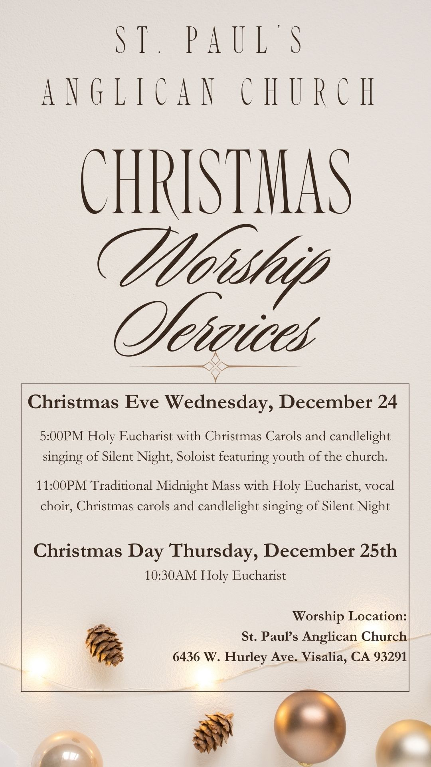

St. Paul’s Anglican Church
Parish Office
6436 W. Hurley Ave
Visalia, California 93291
559-732-4821
Office Hours: 8:00 – 4:00
Monday – Thursday

Worship: Sundays at 10:30AM
Livestream: Link at spvisalia.com
and on our Facebook page
Please be advised that this service is being recorded for broadcast
and/or archival purposes. By attending, you consent
to the inclusion of your likeness in these recordings.

St. Paul’s Clergy and Staff
The Rev. Robert Longbottom, Rector
rector@spvisalia.com
(559)802-2928
The Rev. John Iseman, Pastoral Associate for Family Ministries
family@spvisalia.com
The Rev. Kashy Rowland-Smith, Deacon
kashyrs@aol.com
Antoinette Horsting, Parish Administrator
bookkeeper@spvisalia.com
Marguerite Crownover, Organist and Accompanist
Cynthia Culp, Choral Director
Jackie Iseman, Nursery Coordinator
Shane Motl, Sexton

St. Paul’s is a member church of the
Anglican Diocese of San Joaquin
The Rt. Rev. Eric V. Menees, Bishop

Altar Flowers
The flowers at the altar are given to the Glory of God,
by Franco and Kathy Bernardi, in celebration of
their fifty-ninth wedding anniversary

