St. Paul’s Anglican Church
Visalia, California

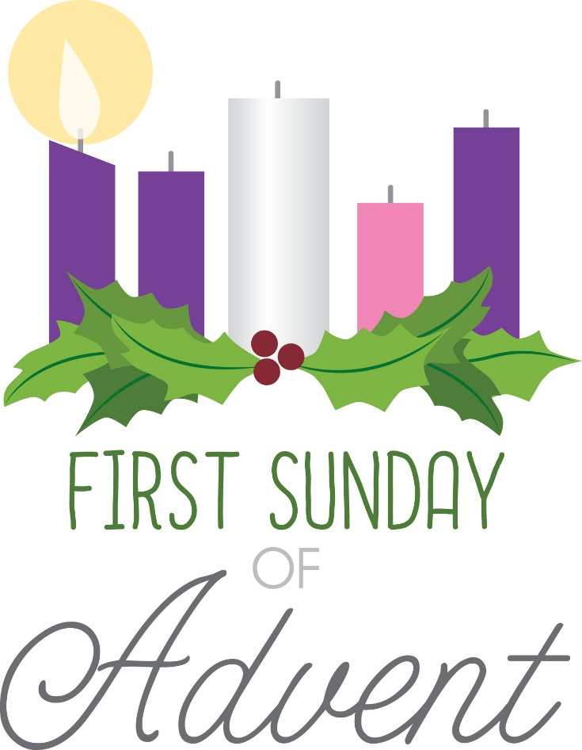

First Sunday in Advent
November 30, 2025
10:30 A.M

Welcome!

St. Paul’s Anglican Church extends a warm welcome to all visitors and newcomers, whether worshiping in person or at home via livestream.

Visitors’ Guide

St. Paul’s Church is a parish in the Diocese of San Joaquin of the Anglican Church in North America, which includes both Catholic and Protestant traditions. We accept Jesus Christ as Savior, and we promise to follow him as Lord. We believe in One God,

- the Father who created us and all things,
- the Son who redeems us from sin and death,
- the Holy Spirit who renews and sanctifies us.

We believe the Holy Scriptures to be the Word of God and to contain all things necessary for salvation, and we accept the Apostles’ and Nicene Creeds as essential beliefs of the Christian faith.

Holy Communion is open to all baptized Christians who have examined their lives, repented of their sins, and desire to live
in love and charity with all people.

Those not desiring to receive Holy Communion, and those who have not been baptized into the Christian faith, are invited to cross their arms across their chest, and a blessing will be given instead.

Visitors are invited to sign the guest book at the entrance table and introduce themselves to the clergy following the service.

The Holy Eucharist

Prelude: “Lord Jesus Christ, Turn Thou to Us” Walther
Hymn: #56 – “O Come, O Come Emmauel” (verse 1&2)
The Lighting of the Advent Candle Liturgy p. 4
Opening Hymn: #56 – “Come, Thou Long Expected Jesus” p. 5
Acclamation p. 5
The Collect for Purity p. 5
Summary of the Law p. 6
Trisagion p. 6
Gloria p. 7
Collect of the Day p. 8
Lesson: Isaiah 2:1-5 p. 8
Gradual: Psalm 122 p. 8
Epistle: Romans 13:8-14 p. 9
Sequence Hymn: #61 – “Sleepers Awake!” p. 10
Gospel: Matthew 24:29-44 p. 12
Sermon: Rev John Iseman
Nicene Creed p. 13
Prayers of the People p. 14
Confession and Absolution p. 16
The Comfortable Words p. 17
The Peace p. 17
The Offertory: “Christ, Whose Glory Fills the Sky” Choir
The Eucharistic Liturgy Anglican Standard Text p. 18
Sanctus p. 19
The Lord’s Prayer p. 21
Prayer for Humble Access p. 21
Agnus Dei p. 22
Communion Hymn: #60 – “Creator of the Stars of Night” p. 23
Post communion Prayer p. 24
Blessing p. 24
Closing Hymn: #542 – “Christ is the World’s True Light” p. 25
Dismissal p. 25
Postlude: “From Heaven Above to Earth I Come” Pachelbel

LIGHTING THE FIRST CANDLE
THE CANDLE OF HOPE

Hymnal #56: O Come, O Come Emmanuel (verses 1 & 2)

The Patriarchs, Abraham,
the Old Testament Ancestors of Jesus

Leader: Light and peace, in Jesus Christ our Lord.

All: Thanks be to God

Leader: Today is the First Sunday of Advent, in which we recall the hope we have in Christ. God told Abraham that through him all the nations of the world would be blessed, because he trusted and put his hope in God. The Old Testament spoke of the coming of Christ, of how a Savior would be born, a king in the line of King David. He would rule the world wisely and bless all the nations. We, too, believe in God’s promise to send Jesus again to this world to establish his kingdom upon the earth.

The first candle is lit.

Hope is like a light shining in a dark place. As we look at the light of the candle, we celebrate the hope we have in Jesus Christ.

Leader: Let us pray.

God of Abraham and Sarah and all the patriarchs of old, you are our Father, too. Your love is revealed to us in Jesus Christ, Son of God, and Son of David. Help us in preparing to celebrate his birth, to make our hearts ready, and to place our hope in you. Help us today and every day to worship you, to hear your word, and to do your will by sharing your hope with others. We ask it in the name of the one who was born in Bethlehem. Amen.

Opening Hymn: Come, Thou Long Expected Jesus
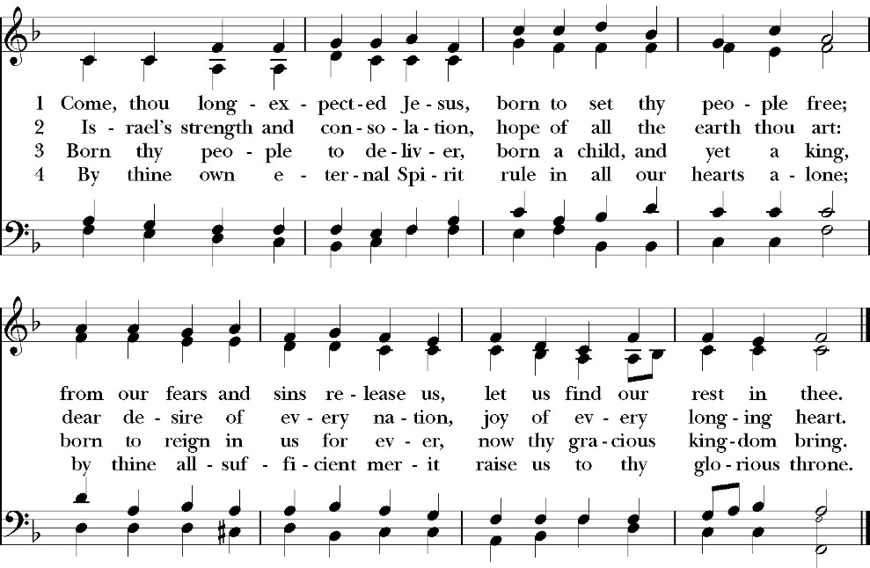

Opening Sentences

Celebrant For unto us a child is born
People Unto us a son is given.

Collect for Purity

Stir up, O Lord, the wills of your faithful people, that bringing
forth in abundance the fruit of good works, they may be
abundantly rewarded when our Savior Jesus Christ comes to
restore all things; who lives and reigns with you and the Holy
Spirit, one God, for ever and ever. Amen.

Summary of the law

Celebrant says
Hear what our Lord Jesus Christ says: You shall love the Lord your
God with all your heart and with all your soul and with all your mind.
This is the first and great commandment. And the second is like it:
You shall love your neighbor as yourself. On these two
commandments depend all the Law and the Prophets.

Trisagion
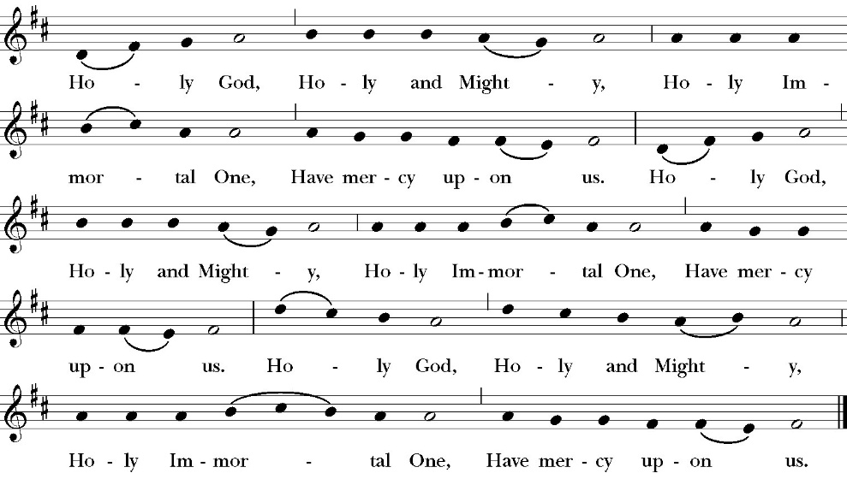

The Gloria

Officiant The Lord be with You.
People And with your spirit.
Officiant Let us pray:

The Collect of the Day
Almighty God, give us grace to cast away the works of darkness, and put on the armor of light, now in the time of this mortal life in which your Son Jesus Christ came to visit us in great humility; that in the last day, when he shall come again in his glorious majesty to judge both the living and the dead, we may rise to the life immortal; through him who lives and reigns with you and the Holy Spirit, one God, now and for ever. Amen.

Lesson: Isaiah 2:1-5
The word that Isaiah the son of Amoz saw concerning Judah and Jerusalem. 2 It shall come to pass in the latter days that the mountain of the house of the LORD shall be established as the highest of the mountains, and shall be lifted up above the hills; and all the nations shall flow to it, 3 and many peoples shall come, and say: “Come, let us go up to the mountain of the LORD, to the house of the God of Jacob, that he may teach us his ways and that we may walk in his paths.” For out of Zion shall go forth the law, and the word of the LORD from Jerusalem. 4 He shall judge between the nations, and shall decide disputes for many peoples; and they shall beat their swords into plowshares, and their spears into pruning hooks; nation shall not lift up sword against nation, neither shall they learn war anymore. 5 O house of Jacob, come, let us walk in the light of the LORD.

Reader The Word of the Lord
People Thanks be to God

Gradual: Psalm 122
1 I was glad when they said unto me, *
“We will go into the house of the LORD.”
2 Now our feet are standing *
within your gates, O Jerusalem.
3 Jerusalem is built as a city *
that is at unity in itself.

4 For there the tribes go up, even the tribes of the LORD, *
as was decreed for Israel, to give thanks unto the Name of the
LORD.
5 For there is the throne of judgment, *
even the throne of the house of David.
6 O pray for the peace of Jerusalem; *
they shall prosper that love you.
7 Peace be within your walls *
and plenteousness within your palaces.
8 For my brethren and companions’ sakes, *
I will wish you prosperity.
9 Indeed, because of the house of the LORD our God, *
I will seek to do you good.
Glory be to the Father, and to the Son, and to the Holy Spirit;
as it was in the beginning, is now, and ever shall be, world
without end. Amen
Epistle: Romans 13:8-14
Owe no one anything, except to love each other, for the one who 3 loves another has fulfilled the law. 9 For the commandments, “You shall not commit adultery, You shall not murder, You shall not steal, You shall not covet,” and any other commandment, are summed up in this word: “You shall love your neighbor as yourself.” 10 Love does no wrong to a neighbor; therefore love is the fulfilling of the law. 11 Besides this you know the time, that the hour has come for you to wake from sleep. For salvation is nearer to us now than when we first believed. 12 The night is far gone; the day is at hand. So then let us cast off the works of darkness and put on the armor of light. 13 Let us walk properly as in the daytime, not in orgies and drunkenness, not in sexual immorality and sensuality, not in quarreling and jealousy. 14 But put on the Lord Jesus Christ, and make no provision for the flesh, to gratify its desires.

Reader The Word of the Lord
People Thanks be to God

Sequence Hymn: Sleepers Awake
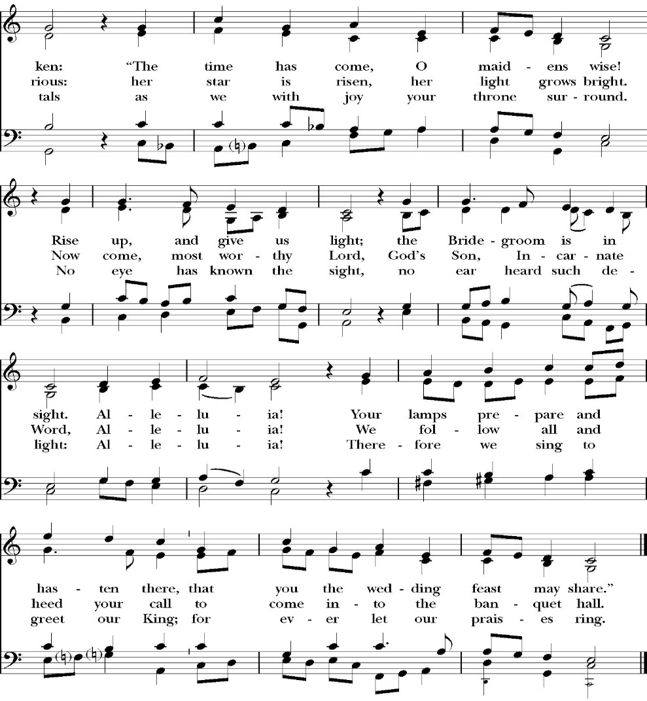
(vs. 1-2 before Gospel, vs. 3 after)

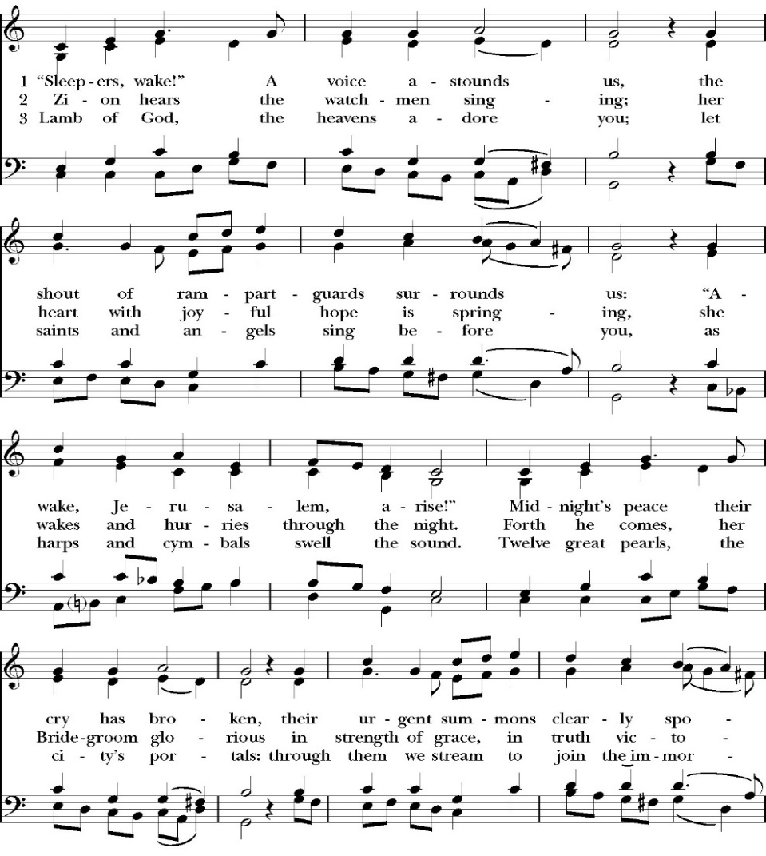

Clergy The Holy Gospel of Our Lord Jesus Christ, according to
St. Matthew
People Glory to you, Lord Christ

Gospel: Matthew 24:29-44

“Immediately after the tribulation of those days the sun will be darkened, and the moon will not give its light, and the stars will fall from heaven, and the powers of the heavens will be shaken. 30 Then will appear in heaven the sign of the Son of Man, and then all the tribes of the earth will mourn, and they will see the Son of Man coming on the clouds of heaven with power and great glory. 31 And he will send out his angels with a loud trumpet call, and they will gather his elect from the four winds, from one end of heaven to the other.

32 “From the fig tree learn its lesson: as soon as its branch becomes tender and puts out its leaves, you know that summer is near. 33 So also, when you see all these things, you know that he is near, at the very gates. 34 Truly, I say to you, this generation will not pass away until all these things take place. 35 Heaven and earth will pass away, but my words will not pass away.

36 “But concerning that day and hour no one knows, not even the angels of heaven, nor the Son, but the Father only. 37 For as were the days of Noah, so will be the coming of the Son of Man. 38 For as in those days before the flood they were eating and drinking, marrying and giving in marriage, until the day when Noah entered the ark, 39 and they were unaware until the flood came and swept them all away, so will be the coming of the Son of Man. 40 Then two men will be in the field; one will be taken and one left. 41 Two women will be grinding at the mill; one will be taken and one left. 42 Therefore, stay awake, for you do not know on what day your Lord is coming. 43 But know this, that if the master of the house had known in what part of the night the thief was coming, he would have stayed awake and would not have let his house be broken into. 44 Therefore you also must be ready, for the Son of Man is coming at an hour you do not expect.

Deacon The Gospel of the Lord
People Glory to you Lord Christ
Sermon
Rev. John Iseman

The Nicene Creed

We believe in one God,
the Father, the Almighty,
maker of heaven and earth,
of all that is, visible and invisible.
We believe in one Lord, Jesus Christ,
the only-begotten Son of God,
eternally begotten of the Father,
God from God, Light from Light,
true God from true God,
begotten, not made,
of one Being with the Father.
through him all things were made.
For us and for our salvation he came down from heaven:
was incarnate from the Holy Spirit and the Virgin Mary,
and was made man.
For our sake he was crucified under Pontius Pilate;
he suffered death and was buried.
On the third day he rose again in accordance with the
Scriptures;
he ascended into heaven
and is seated at the right hand of the Father.
He will come again in glory to judge the living and the dead,
and his kingdom will have no end.
We believe in the Holy Spirit, the Lord, the giver of life,
who proceeds from the Father [and the Son],
who with the Father and the Son is worshiped and glorified.
who has spoken through the Prophets.
We believe in one holy catholic and apostolic Church.
We acknowledge one Baptism for the forgiveness of sins.
We look for the resurrection of the dead,
and the life of the world to come. Amen.

The Prayers of the People

Let us pray for the Church and for the world.

Almighty and everliving God, we are taught by your holy Word to offer prayers and supplications and to give thanks for all people. We humbly ask you mercifully to receive our prayers. Inspire continually the universal Church with the spirit of truth, unity, and concord; and grant that all who confess your holy Name may agree in the truth of your holy Word, and live in unity and godly love.

Silence

Reader Lord, in your mercy:
People Hear our prayer.

We pray that you will lead the nations of the world in the way of righteousness; and so guide and direct their leaders, especially Donald our President and Gavin our Governor, that your people may enjoy the blessings of freedom and peace. Grant that our leaders may impartially administer justice, uphold integrity and truth, restrain wickedness and vice, and protect true religion and virtue.

Silence

Reader Lord, in your mercy:
People Hear our prayer.

For Stephen, our Archbishop, and Eric, our Bishop, and for all the clergy and people of our Diocese and Congregation.

Silence

Reader Lord, in your mercy:
People Hear our prayer.

Prosper, we pray, all those who proclaim the Gospel of your kingdom throughout the world, and strengthen us to fulfill your great commission, making disciples of all nations, baptizing them and teaching them to obey all that you have commanded.

Silence

Reader Lord, in your mercy:
People Hear our prayer.
In the St. Paul’s cycle of prayer, we pray for our Bishop Eric Menees, the Ministries of the Anglican Diocese of San Joaquin and its churches, for the Anglican Church in North America and its dioceses, for the Global Anglican Futures Conference, for the Worldwide Anglican Communion and all their provinces, diocese and churches.

Silence

Reader Lord, in your mercy:
People Hear our prayer.

In the ACNA Cycle of Prayer, today we pray for the Anglican Province of the Indian Ocean and The Most Rev. James Wong, Archbishop, and his wife, Doreen.

Silence

Reader Lord, in your mercy:
People Hear our prayer.

We ask you in your goodness, O Lord, to comfort and sustain all who in this transitory life are in trouble, sorrow, need, sickness, or any other adversity [especially _____________]. We also pray for all who are currently serving in our armed forces, law enforcement and serving as first responders.

Silence

Reader Lord, in your mercy:
People Hear our prayer.

We remember before you all your servants who have departed this life in your faith and fear, [especially _____________,] that your will for them may be fulfilled; and we ask you to give us grace to follow the good examples of St. Paul and all your saints, that we may share with them in your heavenly kingdom.

Silence

Reader Lord, in your mercy:
People Hear our prayer.

Celebrant:

Heavenly Father, grant these our prayers for the sake of Jesus Christ, our only Mediator and Advocate, who lives and reigns with you in the unity of the Holy Spirit, one God, now and for ever. Amen.

The confession and absolution of sin

The Deacon or other person appointed says the following

All who truly and earnestly repent of your sins, and seek to live in
love and charity with your neighbors, and intend to lead the new life, following the commandments of God, and walking in his holy ways: draw near with faith and make your humble confession to Almighty God.

Almighty God, Father of our Lord Jesus Christ,
maker and judge of us all:
We acknowledge and lament our many sins and offenses,
which we have committed by thought, word, and deed
against your divine majesty,
provoking most justly your righteous anger against us.
We are deeply sorry for these our transgressions;
the burden of them is more than we can bear.
Have mercy upon us,
Have mercy upon us, most merciful Father;
for your Son our Lord Jesus Christ’s sake,
forgive us all that is past;
and grant that we may evermore serve and please you in
newness of life, to the honor and glory of your Name;
through Jesus Christ our Lord. Amen.

A Deacon remains kneeling and prays

Grant to your faithful people, merciful Lord, pardon and peace; that we may be cleansed from all our sins, and serve you with a quiet mind; through Jesus Christ our Lord. Amen.

the comfortable words

The Celebrant may then say one or more of the following sentences, first saying

Hear the Word of God to all who truly turn to him.

The saying is trustworthy and deserving of full acceptance, that Christ Jesus came into the world to save sinners.
-1 Timothy 1:15

the peace

Celebrant The Peace of the Lord be always with you.
People And with your spirit.

Offertory Anthem
Christ, Whose Glory Fills the Sky, Choir

The Doxology
(Verse 3 only)
The Offertory

Celebrant All things come from you, O Lord,
People And of your own have we given you.

The Eucharistic Liturgy

Celebrant The Lord be with you.
People And with your spirit.
Celebrant Lift up your hearts.
People We lift them up to the Lord.
Celebrant Let us give thanks to the Lord our God.
People It is right to give him thanks and praise.

It is right, our duty and our joy, always and everywhere to give thanks to you, Father Almighty, Creator of heaven and earth.

Because you sent your beloved Son to redeem us from sin and death, and to make us heirs in him of everlasting life; that when he shall
come again in power and great glory to judge the world, we may without shame or fear rejoice to behold his appearing.

Therefore, we praise you, joining our voices with angels and archangels and with all the company of heaven, who forever sing this hymn to proclaim the glory of your Name:

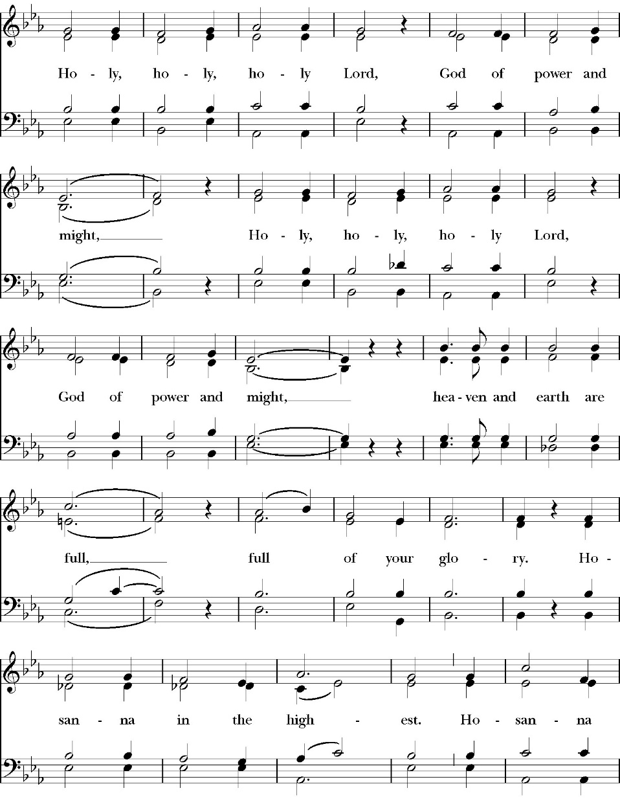
The Sanctus

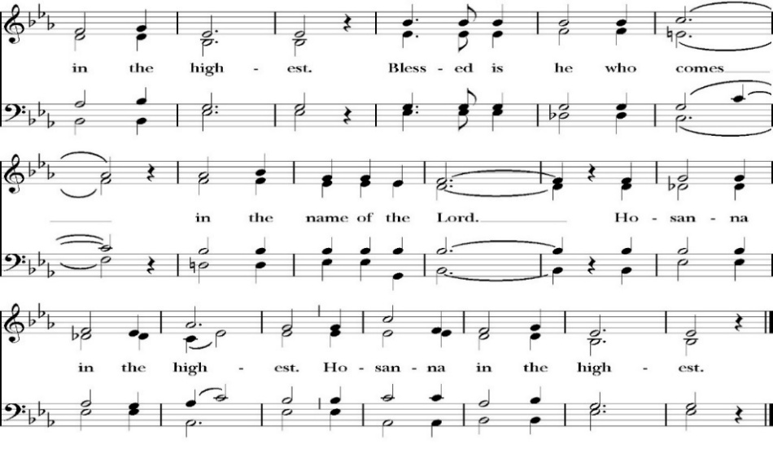
All praise and glory is yours, O God our heavenly Father, for in your tender mercy, you gave your only Son Jesus Christ to suffer death upon the Cross for our redemption. He made there, by his one oblation of himself once offered, a full, perfect, and sufficient sacrifice, oblation, and satisfaction, for the sins of the whole world; and he instituted, and in his Holy Gospel commanded us to continue, a perpetual memory of his precious death and sacrifice, until his coming again.

And here we offer and present to you, O Lord, ourselves, our souls and bodies, to be a reasonable, holy, and living sacrifice. We humbly pray that all who partake of this Holy Communion may worthily receive the most precious Body and Blood of your Son Jesus Christ, be filled with your grace and heavenly benediction, and be made one body with him, that he may dwell in us, and we in him.

And although we are unworthy, because of our many sins, to offer you any sacrifice, yet we ask you to accept this duty and service we owe, not weighing our merits, but pardoning our offenses, through Jesus Christ our Lord.

By him, and with him, and in him, in the unity of the Holy Spirit, all honor and glory is yours, Almighty Father, now and for ever. Amen.

And now, as our Savior Christ has taught us, we are bold to pray,

Our Father, who art in heaven,
hallowed be thy Name,
thy kingdom come,
thy will be done,
on earth as it is in heaven.
Give us this day our daily bread.
And forgive us our trespasses,
as we forgive those
who trespass against us.
And lead us not into temptation,
but deliver us from evil.
For thine is the kingdom,
and the power, and the glory,
for ever and ever. Amen.

The Prayer For Humble Access

We do not presume to come to this your table, O merciful Lord,
trusting in our own righteousness,
but in your abundant and great mercies.
We are not worthy so much as to gather up
the crumbs under your table;
but you are the same Lord
whose character is always to have mercy.
Grant us, therefore, gracious Lord,
so to eat the flesh of your dear Son Jesus Christ,
and to drink his blood,
that our sinful bodies may be made clean by his body,
and our souls washed through his most precious blood,
and that we may evermore dwell in him, and he in us.
Amen.

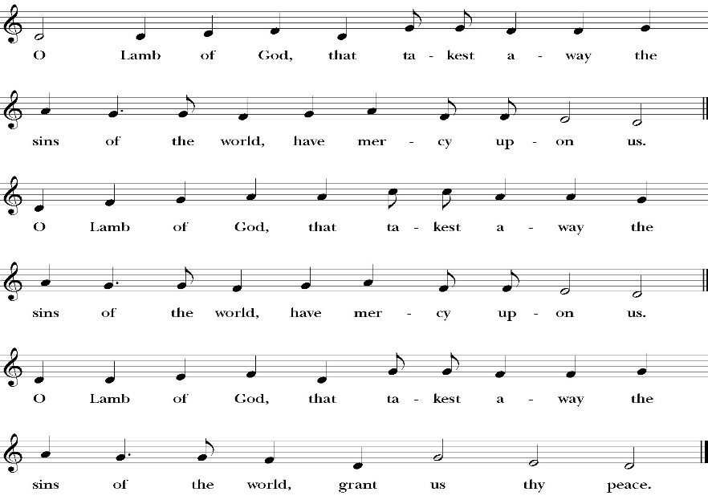
Agnus Dei

Behold the Lamb of God, behold him who takes away the sins of the world. Blessed are those who are invited to the marriage supper of the Lamb.
John 1:29; Revelation 19:9

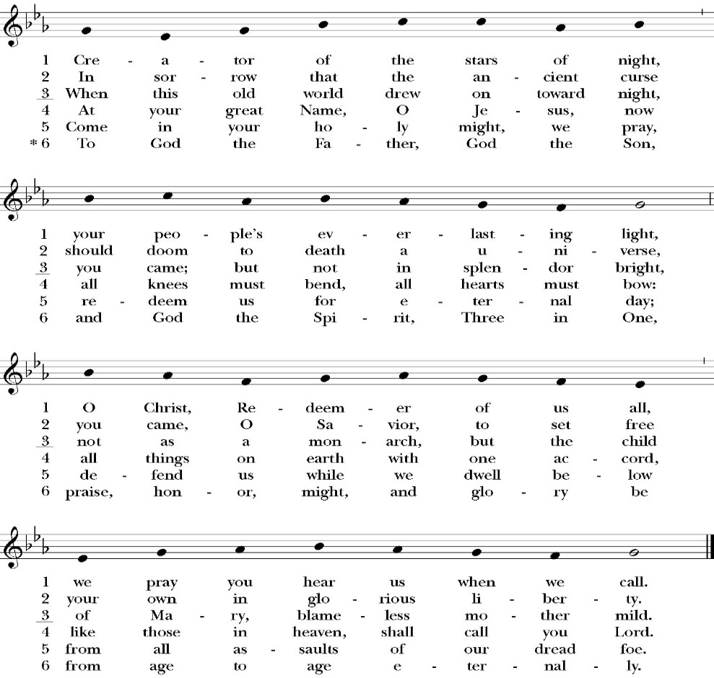
Communion Hymn: Creator of the Stars of Night

The Post Communion Prayer

Let us pray.

Almighty and everliving God,
we thank you for feeding us, in these holy mysteries,
with the spiritual food of the most precious Body and Blood
of your Son our Savior Jesus Christ;
and for assuring us, through this Sacrament, of your favor and
goodness towards us:
that we are true members of the mystical body of your Son,
the blessed company of all faithful people;
and are also heirs, through hope,
of your everlasting kingdom.
And we humbly ask you, heavenly Father,
to assist us with your grace,
that we may continue in that holy fellowship,
and do all the good works that you have prepared for us to
walk in;
through Jesus Christ our Lord,
to whom, with you and the Holy Spirit,
be all honor and glory, now and for ever. Amen.

The Blessing

The peace of God, which passes all understanding, keep your hearts
and minds in the knowledge and love of God, and of his Son Jesus
Christ our Lord; and the blessing of God Almighty, the Father, the
Son, and the Holy Spirit, be among you, and remain with you always.

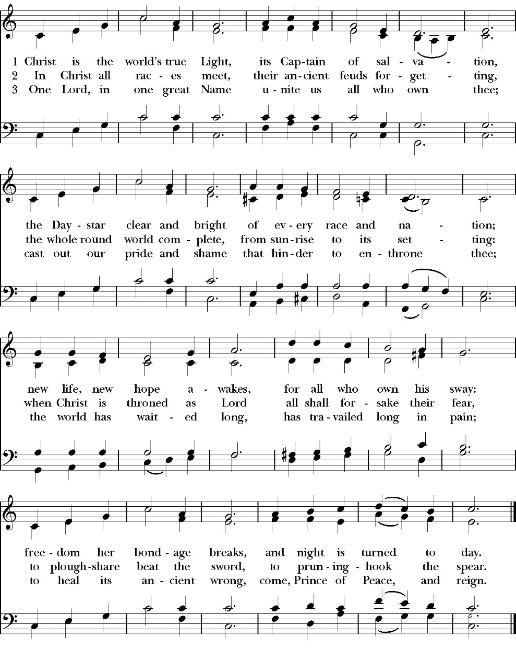
Closing Hymn: Christ is the World’s True Light

Celebrant Go in peace to love and serve the Lord.
People Thanks be to God.
St. Paul’s Parish Calendar
Sunday, November 30 – Sunday December 7

SUNDAY, November 30 – First Sunday in Advent
9:30 AM Choir Practice, Music Room
10:30 AM Children’s Sunday School,
Pre-K – 1st Grade, Sunday School Room.
2nd -6th Grade, Youth Room
10:30 AM Holy Eucharist, Church

MONDAY, December 1

TUESDAY, December 2
6:00 PM Bell Choir Rehearsal, Music Room

WEDNESDAY, December 3
9:30 AM Holy Eucharist, Church
10:15 AM Bible Study, Conference Room
7:00 PM Choir Practice, Chapel

THURSDAY, December 4

FRIDAY, December 5
6:30 AM Men’s Bible Study, Valhalla Restaurant

SATURDAY, December 6

SUNDAY, December 7 – Second Sunday in Advent
9:30 AM Choir Practice, Music Room
10:30 AM Children’s Sunday School,
Pre-K – 1st Grade, Sunday School Room.
2nd -6th Grade, Youth Room
10:30 AM Holy Eucharist, Church

Church Office Hours
Monday-Thursday 8:00 AM-4:00 PM

Announcements

Christmas Pageant Rehearsals every Sunday during church.
Christmas Pageant is Sunday, December 21, during 10:30AM worship service
All children and youth of St. Paul’s are invited to participate in this year’s Christmas pageant. Rehearsals will be on Sunday mornings during Sunday School time. The Christmas pageant will be on Sunday, December 21, during the 10:30 worship service. If you have any questions, please reach out to our pageant director Mrs. Jennifer Hennagin at (661)332-7275.

.
St. Jude’s Christmas Family and Angel Tree Ministry
Beginning Sunday, November 23, be on the lookout for the St. Jude’s Angel Tree in the narthex of the church. Every year, St. Paul’s partners with St. Jude’s and Fr. Jim Rouse to support a family that is striving towards self-sufficiency by giving them presents at Christmas. The Angel Tree will be adorned with ornaments that have Christmas gift needs for every member of the family. There are many “useful” gift needs such as clothes and personal supplies. However, there are also some fun gifts that the family members have asked for in order to have a joyful and blessed Christmas. If you have any questions, please reach out to our Angel Tree coordinator Wendy Johns. Call the church office and we can provide her with contact information. Christmas gifts must be rapped and tag must be attached.

Advent Daily Devotions Available at The Prayer Table
Advent is a season of preparation for the return of Jesus in glorious majesty. This year we once again offer the daily Advent devotional produced by Trinity Anglican Seminary. This year the daily devotional focuses on the Psalms from the daily lectionary of the Book of Common Prayer. The devotionals are available on the prayer table in the Narthex of the church.

Visalia Emergency Aid Food Barrel
For many years, St. Paul’s supported the ministry of Visalia Emergency Aid by housing a food barrel. We are renewing this ministry and invite members to bring food on Sunday mornings to place into the food barrel and support the VEA feeding ministries.

Wreaths Across America, December 13, 9:00 AM
Visalia Cemetery
This year, National Wreaths Across America Day will be held on Saturday, December 13, 2025. St. Paul’s will be joining the more than two million volunteers and supporters who will gather to remember, honor, and teach at more than 5,200 participating locations in all 50 states, at sea and abroad. St. Paul’s Church has volunteered to help place a wreath at the grave of each veteran in the Visalia Cemetery as we have for many years. It is reported that over 4,000 veterans are buried at just this one cemetery and placing a wreath is a gift of gratitude for someone who served our country so we can be free.

People may sponsor wreaths specific to the Visalia Cemetery by going to the following web site:
https://www.wreathsacrossamerica.org/
Learn about Wreaths Across America's Mission to Remember, Honor and Teach

Advent Candles for Advent Wreaths Available
Advent begins the Sunday after Thanksgiving. Advent Candles are available and will be in the Narthex, James Hall and the church office. These resources are free, but donations are accepted.

Christmas Eve and Christmas Morning Worship

Christmas Eve, Wednesday, December 24
5PM Holy Eucharist with carols, candlelight singing of Silent Night and a solo from children, youth and adults.
11PM Midnight Mass with Choir, carols, musical anthems and candlelight singing of Silent Night

Christmas Morning, Thursday, December 25
10:30AM Holy Eucharist, A simple Christmas morning Holy Eucharist

Friday December 5th, from 4:30pm - 7:30pm, we will host an event called "Parents' Night Out". During this event, the church will provide the children of the church from nursery age through high school with Christmas themed fun activities and crafts, including dinner and a movie. This way parents can have a night to finish Christmas shopping or just enjoy a night out! There is no set fee for this event, but there is a suggested donation of $5 per child to help offset costs. You may make the donation when you drop off your child. We do not want the cost to stop any family from taking advantage of this program so please do not let the suggested donation deter you from signing up! If you have any questions please contact Deacon John at family@spvisalia.com.


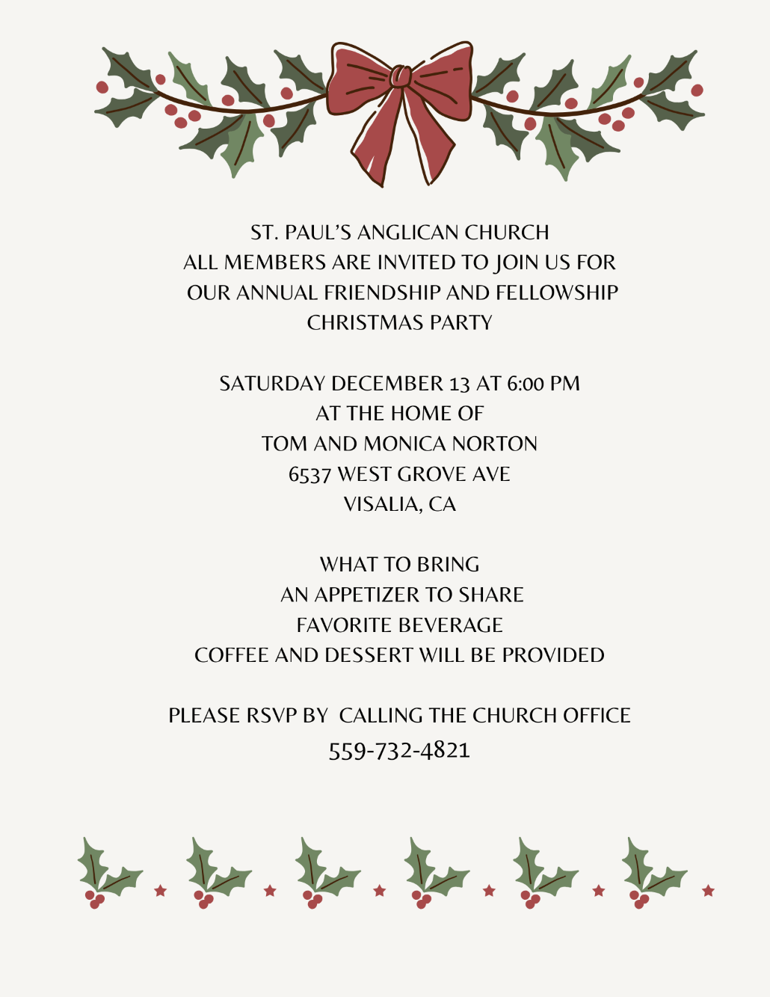

St. Paul’s Anglican Church
Parish Office
6436 W. Hurley Ave
Visalia, California 93291
559-732-4821
Office Hours: 8:00 – 4:00
Monday – Thursday

Worship: Sundays at 10:30AM
In person: St. Paul’s Anglican Church
Livestream: Link at spvisalia.com
and on our Facebook page
Please be advised that this service is being recorded for broadcast
and/or archival purposes. By attending, you consent
to the inclusion of your likeness in these recordings.

St. Paul’s Clergy and Staff
The Rev. Robert Longbottom, Rector
rector@spvisalia.com
(559)802-2928
The Rev. John Iseman, Pastoral Associate for Family Ministries
family@spvisalia.com
The Rev. Kashy Rowland-Smith, Deacon
kashyrs@aol.com
Antoinette Horsting, Parish Administrator
bookkeeper@spvisalia.com
Marguerite Crownover, Organist and Accompanist
Cynthia Culp, Choral Director
Jackie Iseman, Nursery Coordinator
Shane Motl, Sexton

Next Week’s Lessons
Isaiah 11:1-10
Psalm 72
Romans 15:1-13
Matthew 3:1-12

