ST. PAUL’S
ANGLICAN CHURCH
VISALIA, CALIFORNIA

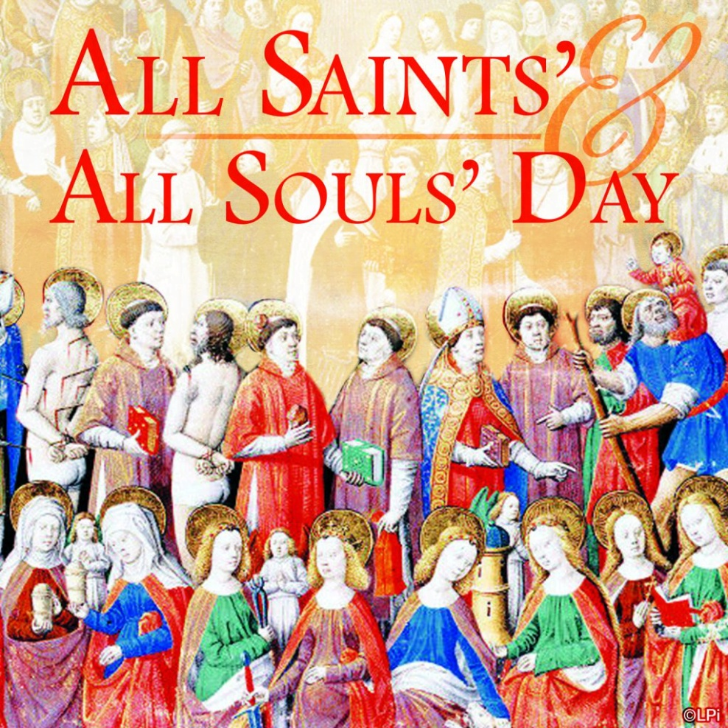

All Saints’ Sunday
November 2, 2025
10:30 A.M

Welcome!

St. Paul’s Anglican Church extends a warm welcome to all visitors and newcomers, whether worshiping in person or at home via livestream.

Visitors’ Guide

St. Paul’s Church is a parish in the Diocese of San Joaquin of the Anglican Church in North America, which includes both Catholic and Protestant traditions. We accept Jesus Christ as Savior, and we promise to follow him as Lord. We believe in One God,

- the Father who created us and all things,
- the Son who redeems us from sin and death,
- the Holy Spirit who renews and sanctifies us.

We believe the Holy Scriptures to be the Word of God and to contain all things necessary for salvation, and we accept the Apostles’ and Nicene Creeds as essential beliefs of the Christian faith.

All followers of Jesus who are baptized in the name of the Trinity are invited to receive Holy Communion. If for whatever reason you feel you cannot receive communion, we invite you to come forward to receive a blessing. Please indicate you’d like a blessing by crossing your arms. All people are welcome at the Altar of the Lord.

Visitors are invited to sign the guest book at the entrance table and introduce themselves to the clergy following the service.

The Holy Eucharist

Prelude: “Prelude and Fugue” Buxtehude
Opening Hymn: #287 – “For All the Saints” p. 4
Opening Acclamation p. 6
The Collect for Purity p. 6
Summary of the Law p. 6
Kyrie p. 6
Gloria p. 7
Collect of the Day p. 8
Lesson: Revelation 7 :9-17 p. 8
Gradual: Psalm 149 p. 9
Epistle: Ephesians 1:11-23 p. 9
Sequence Hymn: #293 – “I Sing a Song of the Saints of God” p. 11
Gospel: Luke 6:20-36 p. 11
Homily: The Rev. John Iseman
Nicene Creed p. 13
Prayers of the People p. 14
The Peace p. 17
Offertory; Marguerite Crownover Organ
The Offertory p. 17
Sursum Corda p. 18
Sanctus p. 18
The Lord’s Prayer p. 20
Fraction p. 20
Prayer for Humble Access p. 21
Agnus Dei p. 21
Communion Hymn: #656 – “Blessed Are the Pure in Heart” p. 22
Post Communion Prayer p. 22
Blessing p. 23
Closing Hymn: #618 – “Ye Watchers and Ye Holy Ones” p. 23
Dismissal p. 23
Postlude: “Chaconne” Buxtehude

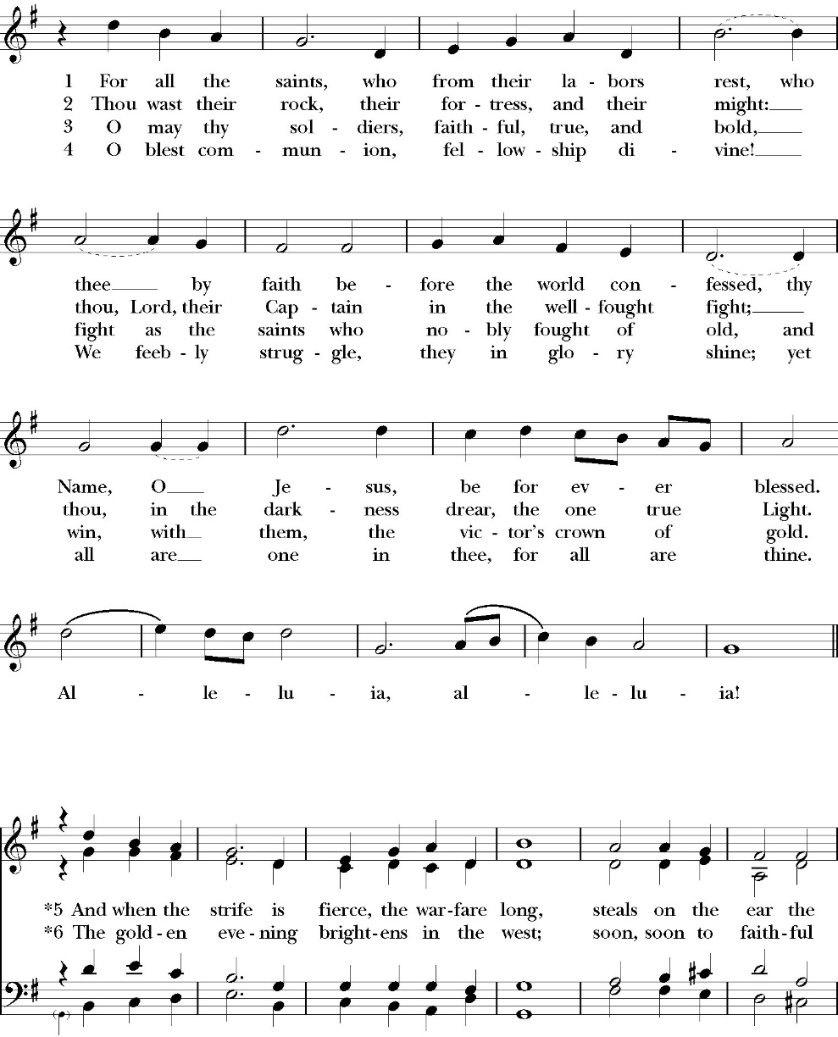
Opening Hymn: For All the Saints

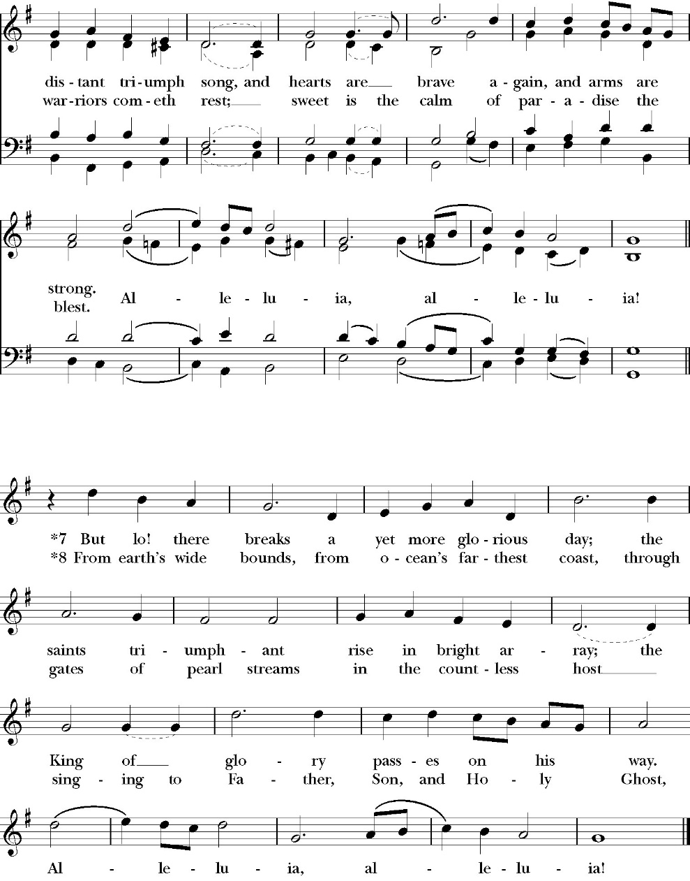

Opening Acclamation

Celebrant Blessed be God: the Father, the Son, and the Holy Spirit. People And blessed be his kingdom, now and for ever.
Amen.

Collect for Purity

People: Almighty God, to you all hearts are open, all desires
known, and from you no secrets are hid: Cleanse the thoughts of our hearts by the inspiration of your Holy Spirit, that we may perfectly love you, and worthily magnify your holy Name; through Christ our Lord. Amen.

Summary of the law

Celebrant: Hear what our Lord Jesus Christ says: You shall love the Lord your God with all your heart and with all your soul
and with all your mind. This is the first and great commandment. And the second is like it: You shall love your neighbor as yourself. On these two commandments depend all the Law and the Prophets.

The Kyrie
Gloria

Celebrant The Lord be with you.
People And with your spirit.
Celebrant Let us pray.

The Collect of the Day
almighty God, you have knit together your elect in one communion and fellowship in the mystical body of your Son Christ our Lord: Give us grace so to follow your blessed saints in all virtuous and godly living, that we may come to those ineffable joys that you have prepared for those who truly love you; through Jesus Christ our Lord; who with you and the Holy Spirit lives and reigns, one God, in glory everlasting. Amen.

Lesson: Revelation 7:9-17
After this I looked, and behold, a great multitude that no one could number, from every nation, from all tribes and peoples and languages, standing before the throne and before the Lamb, clothed in white robes, with palm branches in their hands, 10 and crying out with a loud voice, “Salvation belongs to our God who sits on the throne, and to the Lamb!” 11 And all the angels were standing around the throne and around the elders and the four living creatures, and they fell on their faces before the throne and worshiped God, 12 saying, “Amen! Blessing and glory and wisdom and thanksgiving and honor and power and might be to our God forever and ever! Amen.”

13 Then one of the elders addressed me, saying, “Who are these, clothed in white robes, and from where have they come?” 14 I said to him, “Sir, you know.” And he said to me, “These are the ones coming out of the great tribulation. They have washed their robes and made them white in the blood of the Lamb.

15 “Therefore they are before the throne of God, and serve him day and night in his temple; and he who sits on the throne will shelter them with his presence.

16 They shall hunger no more, neither thirst anymore; the sun shall not strike them, nor any scorching heat. 17 For the Lamb in the midst of the throne will be their shepherd, and he will guide them to springs of living water, and God will wipe away every tear from their eyes.”
Reader: The Word of the Lord
People: Thanks be to God

Gradual: Psalm 149
1 Praise the Lord. O sing unto the LORD a new song; *
let the congregation of the faithful praise him.
2 Let Israel rejoice in the one who made him, *
and let the children of Zion be joyful in their King.
3 Let them praise his Name in the dance; *
let them sing praises unto him with timbrel and harp.
4 For the LORD has pleasure in his people *
and gives victory to those who are oppressed.
5 Let the faithful be joyful with glory; *
let them rejoice upon their beds.
6 Let the praises of God be in their mouth *
and a two-edged sword in their hands,
7 To inflict vengeance on the nations *
and to rebuke the peoples,
8 To bind their kings in chains *
and their nobles with links of iron,
9 That they may execute judgment upon them, as it is written; *
such honor have all his faithful. Praise the Lord.

Glory be to the Father, and to the Son, and to the Holy Spirit;
as it was in the beginning, is now, and ever shall be, world without end. Amen

Epistle: Ephesians 1:11-23
In him we have obtained an inheritance, having been predestined according to the purpose of him who works all things according to the counsel of his will,

12 so that we who were the first to hope in Christ might be to the praise of his glory. 13 In him you also, when you heard the word of truth, the gospel of your salvation, and believed in him, were sealed with the promised Holy Spirit, 14 who is the guarantee of our inheritance until we acquire possession of it, to the praise of his glory.

15 For this reason, because I have heard of your faith in the Lord Jesus and your love toward all the saints, 16 I do not cease to give thanks for you, remembering you in my prayers, 17 that the God of our Lord Jesus Christ, the Father of glory, may give you the Spirit of wisdom and of revelation in the knowledge of him,

18 having the eyes of your hearts enlightened, that you may know what is the hope to which he has called you, what are the riches of his glorious inheritance in the saints, 19 and what is the immeasurable greatness of his power toward us who believe, according to the working of his great might 20 that he worked in Christ when he raised him from the dead and seated him at his right hand in the heavenly places, 21 far above all rule and authority and power and dominion, and above every name that is named, not only in this age but also in the one to come. 22 And he put all things under his feet and gave him as head over all things to the church, 23 which is his body, the fullness of him who fills all in all.
Reader: The Word of the Lord
People: Thanks be to God

Sequence Hymn: I Sing a Song of the Saint of God
(Verse 1-2 before Gospel and verse 3 after)
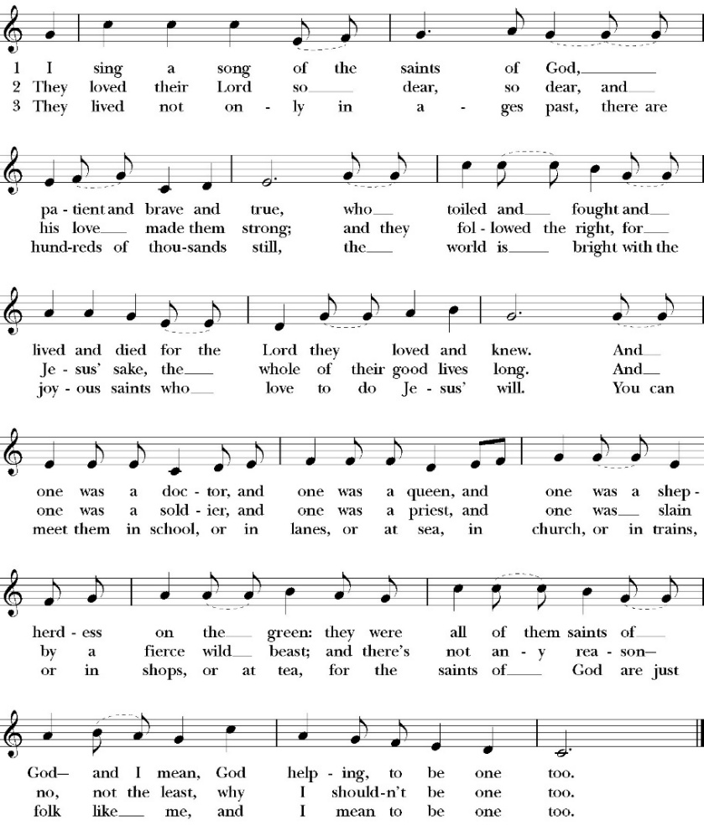

Clergy: The Holy Gospel of Our Lord Jesus Christ,
according to St. Luke
People: Glory to you, Lord God

Gospel: Luke 6:20-36
And he lifted up his eyes on his disciples, and said: “Blessed are you who are poor, for yours is the kingdom of God. 21 “Blessed are you who are hungry now, for you shall be satisfied. “Blessed are you who weep now, for you shall laugh.
22 “Blessed are you when people hate you and when they exclude you and revile you and spurn your name as evil, on account of the Son of Man! 23 Rejoice in that day, and leap for joy, for behold, your reward is great in heaven; for so their fathers did to the prophets.

24 “But woe to you who are rich, for you have received your consolation.25“Woe to you who are full now, for you shall be hungry. “Woe to you who laugh now, for you shall mourn and weep. 26 “Woe to you, when all people speak well of you, for so their fathers did to the false prophets.

27 “But I say to you who hear, Love your enemies, do good to those who hate you, 28 bless those who curse you, pray for those who abuse you. 29 To one who strikes you on the cheek, offer the other also, and from one who takes away your cloak do not withhold your tunic either. 30 Give to everyone who begs from you, and from one who takes away your goods do not demand them back. 31 And as you wish that others would do to you, do so to them.

32 “If you love those who love you, what benefit is that to you? For even sinners love those who love them. 33 And if you do good to those who do good to you, what benefit is that to you? For even sinners do the same. 34 And if you lend to those from whom you expect to receive, what credit is that to you? Even sinners lend to sinners, to get back the same amount. 35 But love your enemies, and do good, and lend, expecting nothing in return, and your reward will be great, and you will be sons of the Most High, for he is kind to the ungrateful and the evil.

36 Be merciful, even as your Father is merciful.

Clergy: The Gospel of the Lord
People: Praise to you, Lord Christ

Sermon
The Rev. john iseman

The Nicene Creed

The people stand

We believe in one God,
the Father, the Almighty,
maker of heaven and earth,
of all that is, visible and invisible.

We believe in one Lord, Jesus Christ,
the only-begotten Son of God,
eternally begotten of the Father,
God from God, Light from Light,
true God from true God,
begotten, not made,
of one Being with the Father.
through him all things were made.
For us and for our salvation he came down from heaven:
was incarnate from the Holy Spirit and the Virgin Mary,
and was made man.
For our sake he was crucified under Pontius Pilate;
he suffered death and was buried.
On the third day he rose again in accordance with the
Scriptures;
he ascended into heaven
and is seated at the right hand of the Father.
He will come again in glory to judge the living and the dead,
and his kingdom will have no end.
We believe in the Holy Spirit, the Lord, the giver of life,
who proceeds from the Father and the Son,
who with the Father and the Son is worshiped and glorified.
who has spoken through the Prophets.
We believe in one holy catholic and apostolic Church.
We acknowledge one Baptism for the forgiveness of sins.
We look for the resurrection of the dead,
and the life of the world to come. Amen.

The Prayers of the People
The People kneel or are seated if unable to kneel
The Deacon or other person appointed says these prayers. Reader pauses after each bidding, and the people may add petitions, either silently or aloud.
Let us pray for the Church and for the world, saying,
“Hear our prayer.”

For the peace of the whole world, and for the well-being and unity of the people of God.

Reader Lord, in your mercy:
People Hear our prayer.

For Stephen, our Archbishop, and Eric, our Bishop, and for all the clergy and people of our Diocese and Congregation.

Reader Lord, in your mercy:
People Hear our prayer.

For all those who proclaim the Gospel at home and abroad; and for all who teach and disciple others.

Reader Lord, in your mercy:
People Hear our prayer.

For our brothers and sisters in Christ who are persecuted for their faith.

Reader Lord, in your mercy:
People Hear our prayer.

For our nation, for those in authority, and for all in public service especially Donald our President and Gavin our Governor.

Reader Lord, in your mercy:
People Hear our prayer.

In the St. Paul’s cycle of prayer, we pray for all ministries to children, youth and families both in our church and through our church into the community around us. We pray for Sunday Funday, Sunday School, Youth Group and. We pray for all our family ministry volunteers. We pray for the children and youth you have given to our care and for their formation in the Christian faith. We pray for all children and youth to whom we are reaching out with the Good News of Jesus Christ.

Reader Lord, in your mercy:
People Hear our prayer.

In the ACNA Cycle of Prayer, today we pray for the Anglican Province of Papua New Guinea and The Rt. Rev. Nathan Ingen, Acting Archbishop, and his wife, Jesicah.

Reader Lord, in your mercy:
People Hear our prayer.

For all those who are in trouble, sorrow, need, sickness, or any other adversity [especially _____________].

Reader Lord, in your mercy:
People Hear our prayer.

Prayers for All Soul’s to be read by the celebrant

Dear Friends: It was our Lord Jesus himself who said, “Come to me, all who labor and are heavy laden, and I will give you rest.” Let us pray, then, for our brothers and sisters who have passed away this past year, that they may rest from their labors, and enter into God’s eternal Sabbath rest. We pray especially for those buried from our church in the past two years: Barry Gambini, Janice Thornton, The Rev. Randle Lewis, Larry Wilds, Judy Ramirez, Noreen Seibenaler, The Rev. Canon Richard James, Rebecca Doe, Nancy Daglish, Joyleen Pat Hodde and for all we now name either silently or aloud.

Silence is kept

The Celebrant concludes with a reading and the following prayers

But we do not want you to be uninformed, brothers and sisters, about those who are asleep, that you may not grieve as others do who have no hope. For since we believe that Jesus died and rose again, even so, through Jesus, God will bring with him those who have fallen asleep. For this we declare to you by a word from the Lord, that we who are alive, who are left until the coming of the Lord, will not precede those who have fallen asleep.
-1 Thessalonians 4:13-15

O God, who by the glorious resurrection of your Son Jesus Christ destroyed death and brought life and immortality to light: Grant that your servants whom we have named, being raised with Christ, may know the strength of his presence and rejoice in his eternal glory; who with you and the Holy Spirit lives and reigns, one God, for ever and ever. Amen.

Most merciful God, whose wisdom is beyond our understanding: deal graciously with those who mourn. Surround them with your love, that they may not be overwhelmed by their loss, but have confidence in your goodness, and strength to meet the days to come; through Jesus Christ our Lord. Amen.

The Confession and Absolution

Deacon Let us humbly confess our sins to Almighty God.

Most merciful God,
we confess that we have sinned against you
in thought, word and deed,
by what we have done, and by what we have left undone.
We have not loved you with our whole heart;
we have not loved our neighbors as ourselves.
We are truly sorry and we humbly repent.
For the sake of your Son Jesus Christ,
have mercy on us and forgive us;
that we may delight in your will, and walk in your ways,
to the glory of your Name. Amen.

Almighty God, our heavenly Father, who in his great mercy has
promised forgiveness of sins to all those who sincerely repent and
with true faith turn to him, have mercy upon you, pardon and deliver
you from all your sins, confirm and strengthen you in all goodness,
and bring you to everlasting life; through Jesus Christ our Lord.
Amen.

The Peace
Celebrant The Peace of the Lord be always with you.
People And with your spirit.

Offertory Anthem
Marguerite Crownover, Organ

The Doxology
(Verse 3 only)

Offertory

Celebrant All things come from you, O Lord,
People And of your own have we given you.

The Eucharistic Liturgy

Celebrant The Lord be with you.
People And with your spirit.
Celebrant Lift up your hearts.
People We lift them up to the Lord.
Celebrant Let us give thanks to the Lord our God.
People It is right to give him thanks and praise.

It is right, our duty and our joy, always and everywhere to give thanks to you, Father Almighty, Creator of heaven and earth.
Through Jesus Christ our Lord, who on the first day of the week overcame death and the grave, and by his glorious resurrection opened to us the way of everlasting life.

Therefore, we praise you, joining our voices with Angels and Archangels and with all the company of heaven, who for ever sing this hymn to proclaim the glory of your Name:

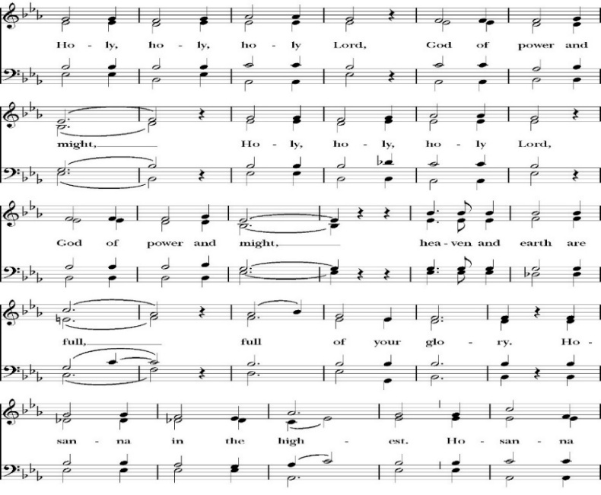
Sanctus
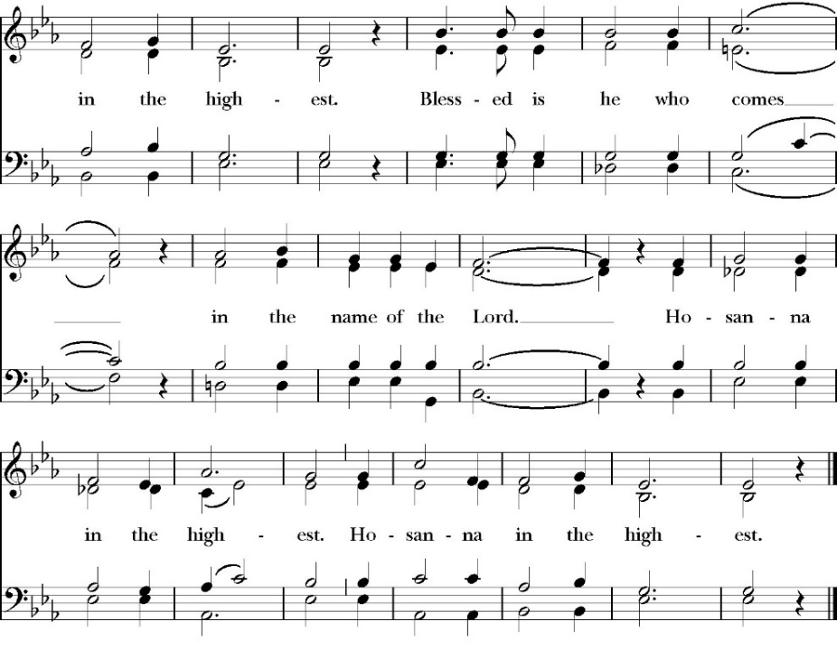
The People kneel or are seated if unable to kneel

Holy and gracious Father: In your infinite love you made us for yourself; and when we had sinned against you and become subject to evil and death, you, in your mercy, sent your only Son Jesus Christ
into the world for our salvation. By the Holy Spirit and the Virgin Mary he became flesh and dwelt among us. In obedience to your will, he stretched out his arms upon the Cross and offered himself once for all, that by his suffering and death we might be saved. By his resurrection he broke the bonds of death, trampling Hell and Satan under his feet. As our great high priest, he ascended to your right hand in glory, that we might come with confidence before the throne of grace.

On the night that he was betrayed, our Lord Jesus Christ took bread; and when he had given thanks, he broke it,* and gave it to his disciples, saying, “Take, eat; this is my Body, which is given for you: Do this in remembrance of me.”

Likewise, after supper, Jesus took the cup, and when he had given thanks, he gave it to them, saying, “Drink this, all of you; for this is my Blood of the New Covenant, which is shed for you, and for many, for the forgiveness of sins: Whenever you drink it, do this in remembrance of me.”

Therefore we proclaim the mystery of faith:
Christ has died.
Christ is risen.
Christ will come again.

We celebrate the memorial of our redemption, O Father, in this sacrifice of praise and thanksgiving, and we offer you these gifts.

Sanctify them by your Word and Holy Spirit to be for your people the Body and Blood of your Son Jesus Christ. Sanctify us also, that we may worthily receive this holy Sacrament, and be made one body with him, that he may dwell in us and we in him. In the fullness of time, put all things in subjection under your Christ, and bring us with all your saints into the joy of your heavenly kingdom, where we shall see our Lord face to face.

All this we ask through your Son Jesus Christ: By him, and with him, and in him, in the unity of the Holy Spirit, all honor and glory is yours, Almighty Father, now and for ever. Amen

And now, as our Savior Christ has taught us, we are bold to pray,

Our Father, who art in heaven,
hallowed be thy Name,
thy kingdom come,
thy will be done,
on earth as it is in heaven.
Give us this day our daily bread.
And forgive us our trespasses,
as we forgive those
who trespass against us.
And lead us not into temptation,
but deliver us from evil.
For thine is the kingdom,
and the power, and the glory,
for ever and ever. Amen

Fraction
Celebrant Alleluia! Christ our Passover is sacrificed for us.
People Therefore let us keep the feast. Alleluia!

The Prayer for Humble Access

We do not presume to come to this your table, O merciful Lord,
trusting in our own righteousness,
but in your abundant and great mercies.
We are not worthy so much as to gather up
the crumbs under your table;
but you are the same Lord
whose character is always to have mercy.
Grant us, therefore, gracious Lord,
so to eat the flesh of your dear Son Jesus Christ,
and to drink his blood,
that our sinful bodies may be made clean by his body,
and our souls washed through his most precious blood,
and that we may evermore dwell in him, and he in us.
Amen
Agnus Dei

The Ministration of Communion
The gifts of God for the People of God. Take them in remembrance that Christ died for you and feed on him in your hearts by faith, with thanksgiving.
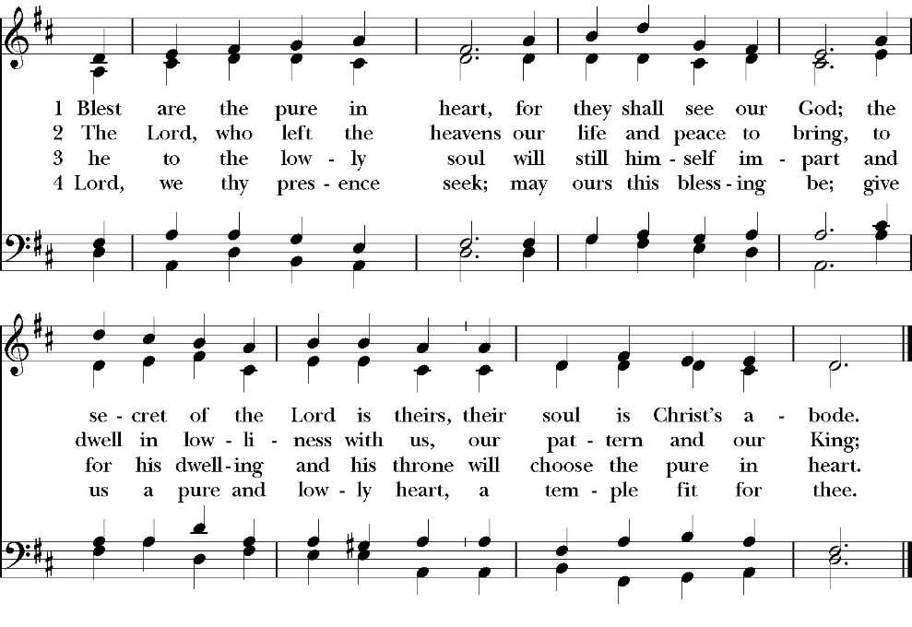
Communion Hymn Praise Blessed Are the Pure in Heart

The Post Communion Prayer

The People kneel or are seated if unable to kneel

Let us pray.

Heavenly Father,
We thank you for feeding us with the spiritual food
of the most precious Body and Blood
of your Son our Savior Jesus Christ;
and for assuring us in these holy mysteries
that we are living members of the body of your Son,
and heirs of your eternal Kingdom.
And now, Father, send us out to do the work you have
given us to do,
to love and serve you as faithful witnesses of Christ our
Lord.
To him, to you, and to the Holy Spirit,
be honor and glory, now and for ever. Amen.

The Blessing

The peace of God, which passes all understanding, keep your hearts and minds in the knowledge and love of God, and of his Son Jesus Christ our Lord; and the blessing of God Almighty, the Father, the Son, and the Holy Spirit, be among you, and remain with you always. Amen.

Closing Hymn: Ye Watchers and Ye Holy Ones
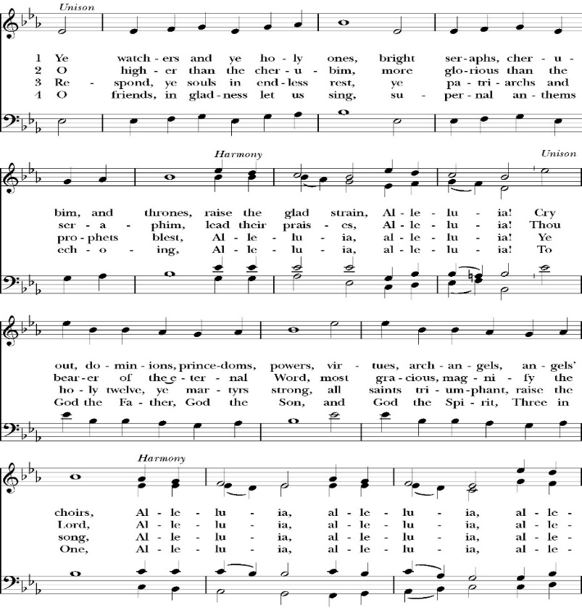

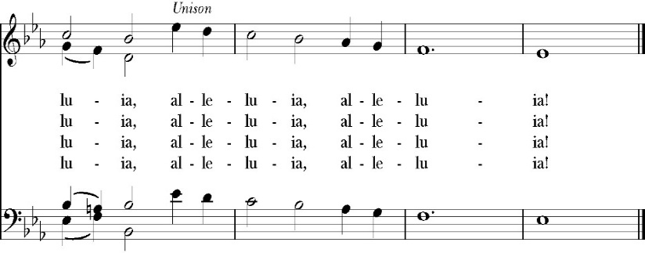

Deacon Alleluia, Alleluia! Let us go forth in the name of Christ.
People Thanks be to God. Alleluia! Alleluia!

St. Paul’s Parish Calendar
Sunday, October 26 to Sunday, November 2

SUNDAY, November 2 – All Saint Day
9:30 AM Choir Practice, Music Room
10:30 AM Children’s Sunday School,
Pre-K – 1st Grade, Sunday School Room.
2nd -6th Grade, Youth Room
10:30 AM Holy Eucharist, Church

MONDAY, November 3
6:30 PM Women’s Bible Study, Conference Room

TUESDAY, November 4
6:00 PM Bell Choir Rehearsal, Music Room

WEDNESDAY, November 5
9:30 AM Holy Eucharist, Chapel
10:15 AM Bible Study, Conference Room
5:00PM Community, Practicing the Way 5PM Class
6:00 PM Dinner, James Hall
6:45 PM Evening Program for all ages
7:00 PM Choir Rehearsal, Chapel

THURSDAY, November 6

FRIDAY, November 7
6:30 AM Men’s Bible Study, Valhalla Restaurant

SATURDAY, November 8

SUNDAY, November 9 – Twenty-second Sunday after Pentecost
9:30 AM Choir Practice, Music Room
10:30 AM Children’s Sunday School,
Pre-K – 1st Grade, Sunday School Room.
2nd -6th Grade, Youth Room
10:30 AM Holy Baptism and Holy Eucharist, Church

Church Office Hours
Monday-Thursday 8:00 AM-4:00 PM

Announcements

Operation Christmas Child. Coordinator: Mark Morales
Operation Christmas Child is a ministry of Samaritan’s Purse in which local churches help fill special shoe boxes with toiletries and a small Christmas gift for needy children around the world. Shoe boxes with supplies and gifts need to be completed by November 16 to get into the hands of needy children by Christmas. Our Operation Christmas Child outreach coordinator is Mark Morales. He will be making announcements in church and is available to answer any questions on Sunday mornings at church.

Baptism of Cillian Blake Schneemann, November 9
On August 13, Blake and Madelynn Schemman welcomed Cillian Blake into the world. Join us on Sunday, November 9, for his baptism and welcome into the household of God.

Forum on the Reordering of the Anglican Communion, Sunday, November 9th after Church, Main Church
All members and friends of St. Paul’s are invited to join us for a forum on the reordering of the Anglican Communion. On October 3 the appointment of Bishop of London Dame Sarah Mullally as the new Archbishop of Canterbury was announced. On October 16th, the Global Anglican Futures Conference (GAFCON) responded to this appointment with a declaration that the provinces, dioceses and bishops that align themselves with the conference would begin the permanent reordering of the Anglican Communion. Our forum will be an opportunity for attendees to better understand the content of the current call for the reordering of the Anglican Communion, how the ACNA and St. Paul’s have been connected to the issues and challenges of the Anglican Communion since 2008 and how the reordering of the Anglican Communion might affect the ACNA, the Anglican Diocese of San Joaquin and St. Paul’s Anglican Church.

A Food Bank for Hurley Families
The next Neighborhood Market to benefit students at Hurley School will be Friday November 14 from 2:30 to 3:30 at St Paul’s Church parking lot. If you are interested in helping that day, please contact Sue Nyberg. My home phone number is 559-733-8244.
Thanksgiving Eucharist, Wednesday, November 26, 9:30 AM, Main Church
All members of St. Paul’s are welcome to join us for a Thanksgiving Holy Eucharist. The Thanksgiving Eucharist will be at the normal Wednesday Holy Eucharist time and will use the Proper’s and readings for the Feast Day of Thanksgiving.

Thanksgiving Offering to go to St. Jude’s ministry led by Fr. Jim Rouse
Every Thanksgiving we invite members and friends of St. Paul’s to consider giving a Thanksgiving offering in gratitude for the blessings and work of Christ in their lives. This offering goes directly to the ministry of St. Judes founded by Fr. Jim Rouse who is the priest in charge at St. John’s Porterville. Every year St. Paul’s partners with Fr. Jim Rouse to support a St. Jude’s family that is striving to reach self-sustainability. This is the same family that we support with Christmas gifts through our Angel tree ministry.

St. Judes Christmas Family and Angel Tree Ministry
Beginning Sunday, November 23 be on the lookout for the St. Jude’s angel tree in the Narthex of the church. Every year St. Paul’s partners with St. Jude’s and Fr. Jim rouse to support a family that is striving towards self-sufficiency with presents at Christmas. The angel tree will be adorned with ornaments that have Christmas gift needs for every member of the family. There are many ‘useful gift needs’ such as clothes and personal supplies. However, there are also some fun gifts that the family members have asked for in order to have joyful and blessed Christmas. If you have any questions, please reach out to our Angel tree coordinator Wendy Johns. Call the church office and we can provide her with contact information.

Visalia Emergency Aid Race Against Hunger, Thanksgiving Day, November 27
St. Paul’s partners with Visalia Emergency Aid to serve hurley elementary families through our neighborhood food market. To help support the work, join your Rector and his family in running or walking in the Visalia Emergency Aid Race Against Hunger this Thanksgiving morning. All funds raised go straight to our food pantry programs, ensuring that local households in need are connected with the food resources they require. You can register online by going to the Race Against Hunger website at www.visaliaturkeytrot.com/Race/TurkeyTrotVisalia/Page/Register.


Menu November 5


Mediterranean Lemon Grilled Chicken


Rice Pilaf


Butternut Squash


Rolls & Butter


Dessert: Lemon Bars


Kid's Menu Chicken Nuggets

St. Paul’s Anglican Church
Parish Office
6436 W. Hurley Ave
Visalia, California 93291
559-732-4821
Office Hours: 8:00 – 4:00
Monday – Thursday

Worship: Sundays at 10:30AM
In person: St. Paul’s Anglican Church
Livestream: Link at spvisalia.com
and on our Facebook page
Please be advised that this service is being recorded for broadcast
and/or archival purposes. By attending, you consent
to the inclusion of your likeness in these recordings.

St. Paul’s Clergy and Staff
The Rev. Robert Longbottom, Rector
rector@spvisalia.com
(559)802-2928
The Rev. John Iseman, Pastoral Associate for Family Ministries
family@spvisalia.com
The Rev. Kashy Rowland-Smith, Deacon
kashyrs@aol.com
Antoinette Horsting, Parish Administrator
bookkeeper@spvisalia.com
Marguerite Crownover, Organist and Accompanist
Cynthia Culp, Choral Director
Jackie Iseman, Nursery Coordinator
Shane Motl, Sexton

Next Week’s Lessons
Job 19:23-27a
Psalm 17
2 Thessalonians 2:13-3:5
Luke 20:27-38

