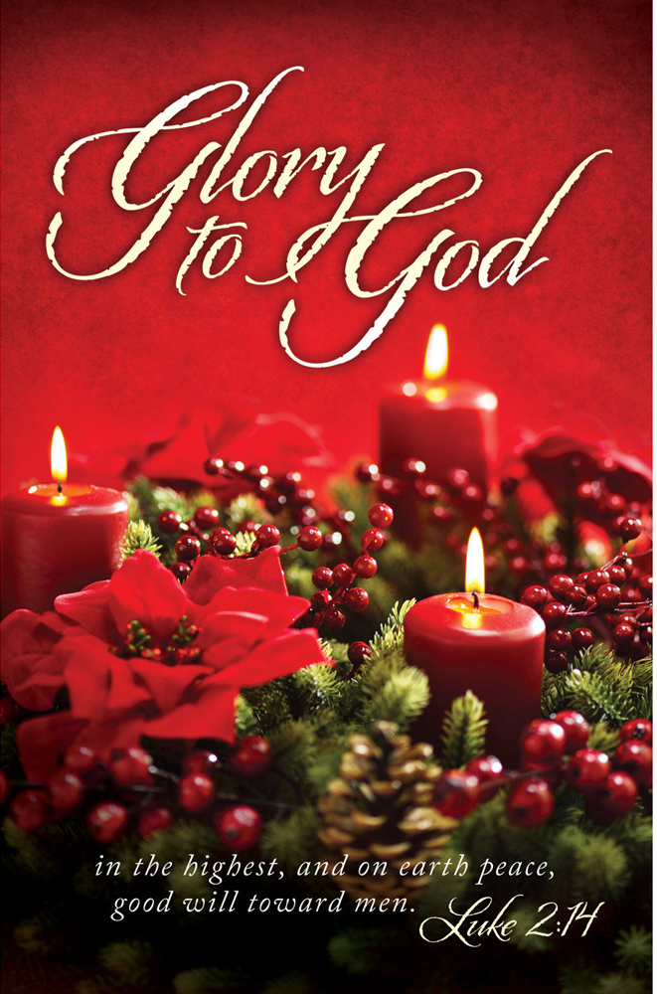

Christmas Eve
December 24, 2025

11:00 PM

The Holy Eucharist

Prelude: “Star of Bethlehem” John Williams
Lighting of the Christ Candle p. 3
Opening Hymn: #83 - “O Come, All Ye Faithful” p. 4
Acclamation p. 5
The Collect for Purity p. 5
Summary of the Law p. 5
Kyrie p. 5
Song of Praise: Hymn# 96 “Angels We Have Heard on High” p. 6
Collect of the Day p. 7
Lesson: Isaiah 9:1-7 p. 7
Gradual: Psalm 96 p. 8
Epistle: Titus 2:11-14 p. 9
Sequence Hymn: #87- “Hark! the Herald Angels Sing” p. 10
Gospel: Luke 2:1-20 p. 11
Sermon: Fr. Robert Longbottom p. 12
Nicene Creed p. 12
Prayers of the People p. 13
Confession and Absolution p. 13
The Peace p. 14
Anthem: “Candlelight Carol” SPC
The Offertory p. 15
Sanctus p. 16
The Lord’s Prayer p. 18
Prayer for Humble Access p. 19
Agnus Dei p. 19
Communion Hymns:
Hymn #109 – “The First Nowell” p. 20
Hymn #115 – “What Child Is This?” p. 22
Post communion Prayer p. 23
Candlelight Hymn: #111 - “Silent Night, Holy Night” p. 24
Blessing p. 25
Closing Hymn: #100 - “Joy to the World” p. 25
Dismissal p. 26
Postlude: “It Came Upon a Midnight Clear Richard Willis

THE LIGHTING OF THE CHRIST CANDLE

Leader: Light and peace, in Jesus Christ our Lord

All: Thanks be to God

Leader: Tonight we light again the candles of hope, peace, love and joy.

(Each candle will be lit as the reader speaks)

First Candle: We speak of hope – because God keeps his promises to us

Second Candle: We work for peace – because Jesus is the ‘Prince of Peace’ and he calls his children to work for peace in his name

Third Candle: We show love – because Jesus gave everything for us and led us to know the forgiveness of God

Fourth Candle: We share joy – because the Holy Spirit fills our hearts and minds with the presence of God

Last Candle: Now we light our last candle to remember the birth of our Lord and Savior Jesus Christ. As the prophets promised so long ago, you have come to us once again; and with the shepherds, we are filled with wonder and amazement.

(The Christ Candle is lit)

Lord, you come as a tiny, fragile baby; yet we know that you are God and you are with us. May the flame of this candle remind us that you are the light of the world and that if we follow you, we will never walk in darkness, but will have the true light of life.

All: Come, Lord Jesus, come. Amen

Opening Hymn: O Come, all Ye Faithful

The Acclamation

Celebrant For unto us a child is born,
People Unto us a son is given.

The Collect for Purity

Almighty God, to you all hearts are open, all desires
known, and from you no secrets are hid: Cleanse the thoughts
of our hearts by the inspiration of your Holy Spirit, that we
may perfectly love you, and worthily magnify your holy Name.
through Christ our Lord. Amen.

The Summary of the law

Hear what our Lord Jesus Christ says: You shall love the Lord your God with all your heart and with all your soul and with all your mind. This is the first and great commandment. And the second is like it: You shall love your neighbor as yourself. On these two commandments depend all the Law and the Prophets.

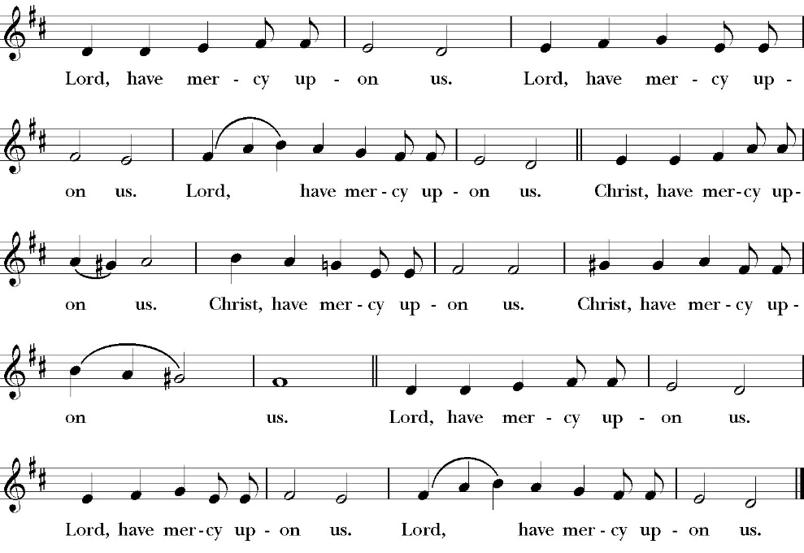
The Kyrie
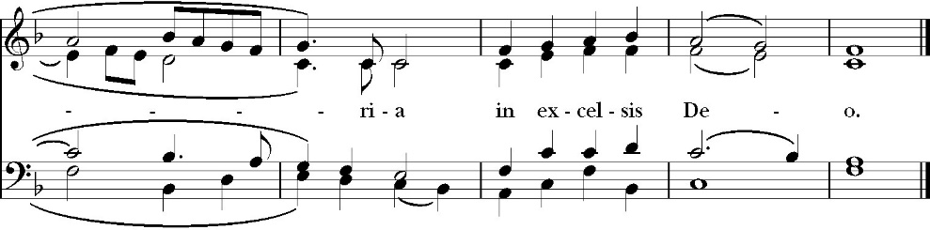
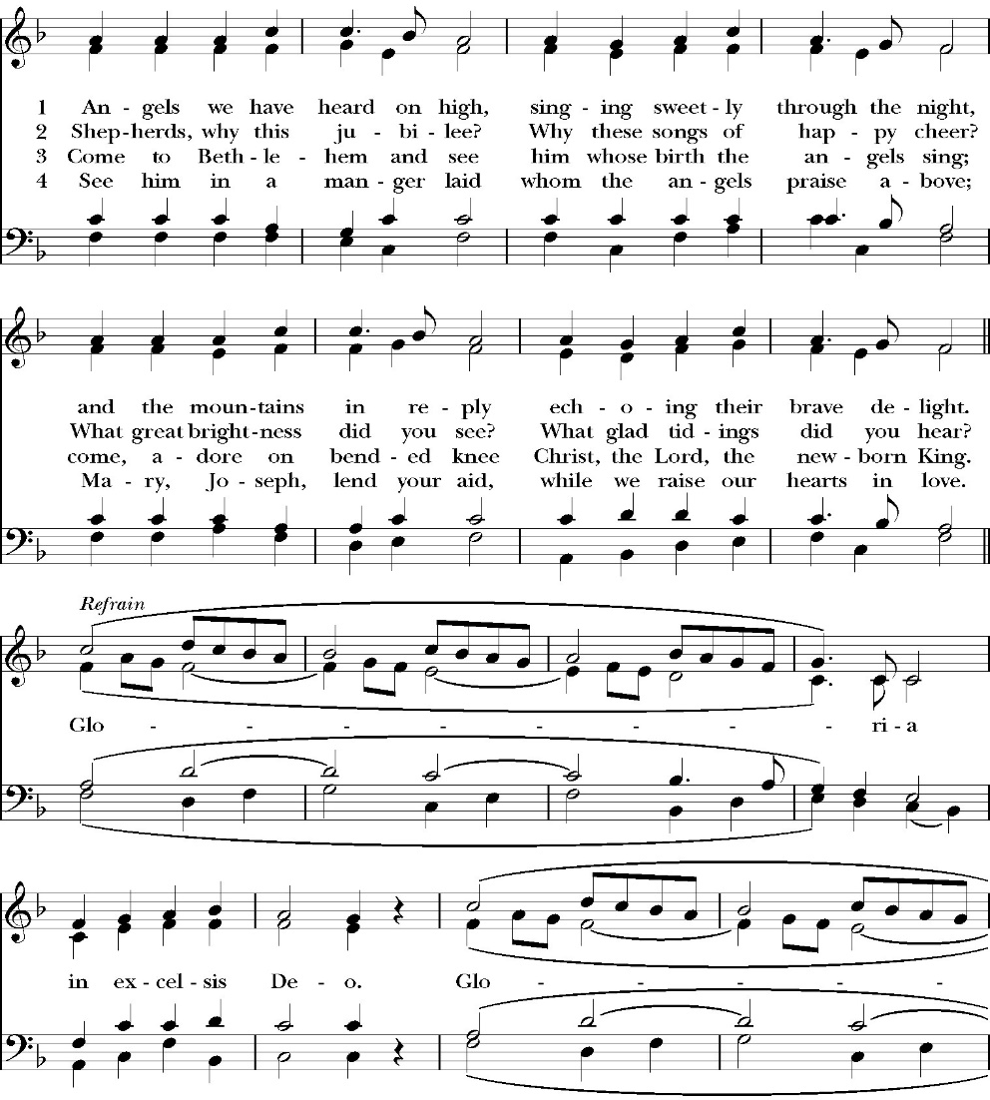
Song of Praise: Angels We Have Heard on High

Officiant The Lord be with You.
People And with your spirit.
Officiant Let us pray:

The Collect of the Day

O God, you have caused this holy night to shine with the brightness
of the true Light: Grant that we, who have known the mystery of that
Light on earth, may also enjoy him perfectly in heaven; where with you and the Holy Spirit he lives and reigns, one God, in glory everlasting. Amen.

Lesson: Isaiah 9:1-7
But there will be no gloom for her who was in anguish. In the former time he brought into contempt the land of Zebulun and the land of Naphtali, but in the latter time he has made glorious the way of the sea, the land beyond the Jordan, Galilee of the nations.
² The people who walked in darkness
have seen a great light;
those who dwelt in a land of deep darkness,
on them has light shone.
³ You have multiplied the nation;
you have increased its joy;
they rejoice before you
as with joy at the harvest,
as they are glad when they divide the spoil.
⁴ For the yoke of his burden,
and the staff for his shoulder,
the rod of his oppressor,
you have broken as on the day of Midian.
⁵ For every boot of the tramping warrior in battle tumult
and every garment rolled in blood
will be burned as fuel for the fire.
⁶ For to us a child is born,
to us a son is given;
and the government shall be upon his shoulder,
and his name shall be called
Wonderful Counselor, Mighty God,
Everlasting Father, Prince of Peace.
⁷ Of the increase of his government and of peace
there will be no end,
on the throne of David and over his kingdom,
to establish it and to uphold it
with justice and with righteousness
from this time forth and forevermore.
The zeal of the Lord of hosts will do this.
Reader The Word of the Lord
People Thanks be to God

Gradual: Psalm 96
1 O sing unto the Lord a new song; *
sing unto the Lord, all the whole earth.
2 Sing unto the Lord and praise his Name; *
tell of his salvation from day to day.
3 Declare his honor to the nations, *
and his wonders to all peoples.

4 For the Lord is great, and highly to be praised; *
he is more to be feared than all gods.
5 As for all the gods of the nations, they are but idols; *
but it is the Lord who made the heavens.
6 Glory and majesty are before him; *
power and honor are in his sanctuary.

7 Ascribe unto the Lord, O you families of the peoples, *
ascribe unto the Lord worship and power.
8 Ascribe unto the Lord the honor due unto his Name; *
bring offerings and come into his courts.
9 O worship the Lord in the beauty of holiness; *
let the whole earth stand in awe of him.
10 Tell it out among the nations, “The Lord is King; *

it is he who has made the world so firm that it cannot be moved; he shall judge the peoples righteously.”

11 Let the heavens rejoice, and let the earth be glad; *
let the sea make a noise, and all that is therein.

12 Let the field be joyful, and all that is in it; *
then shall all the trees of the wood rejoice before the Lord.

13 For he comes, for he comes to judge the earth, *
and with righteousness to judge the world, and the peoples with
his truth.

Glory be to the Father, and to the Son, and to the Holy Spirit;
as it was in the beginning, is now, and ever shall be, world without end. Amen

Epistle: Titus 2:11-14
¹¹ For the grace of God has appeared, bringing salvation for all people, ¹² training us to renounce ungodliness and worldly passions, and to live self-controlled, upright, and godly lives in the present age, ¹³ waiting for our blessed hope, the appearing of the glory of our great God and Savior Jesus Christ, ¹⁴ who gave himself for us to redeem us from all lawlessness and to purify for himself a people for his own possession who are zealous for good works.

Reader The Word of the Lord
People Thanks be to God

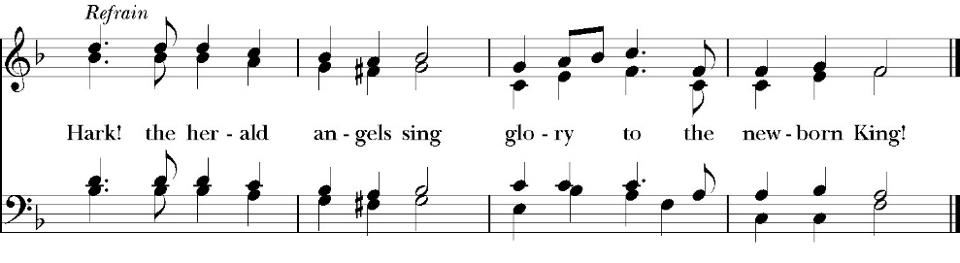
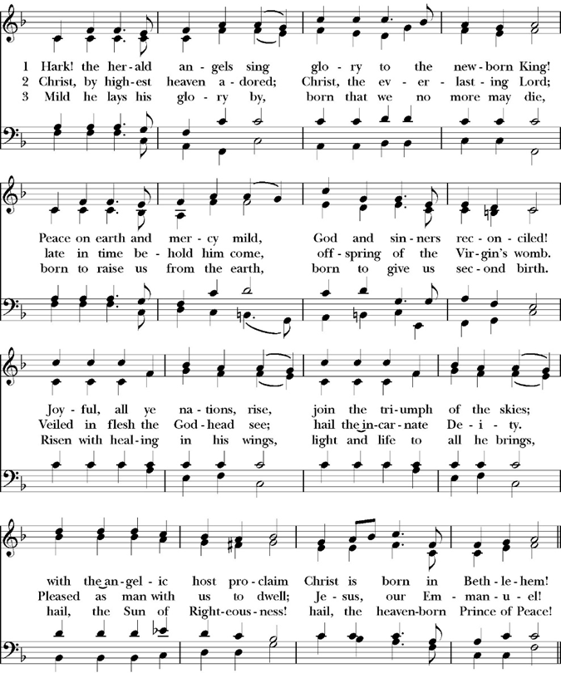
Sequence Hymn: Hark! The Herald Angels Sing

Clergy The Gospel of the Lord, according to St. Luke.
People Glory to you, Lord Christ.

Gospel: Luke 2:1-20
In those days a decree went out from Caesar Augustus that all the world should be registered. ² This was the first registration when Quirinius was governor of Syria. ³ And all went to be registered, each to his own town. ⁴ And Joseph also went up from Galilee, from the town of Nazareth to Judea, to the city of David, which is called Bethlehem, because he was of the house and lineage of David, ⁵ to be registered with Mary, his betrothed, who was with child. ⁶ And while they were there, the time came for her to give birth. ⁷ And she gave birth to her firstborn son and wrapped him in swaddling cloths and laid him in a manger, because there was no place for them in the inn.

⁸ And in the same region there were shepherds out in the field, keeping watch over their flock by night. ⁹ And an angel of the Lord appeared to them, and the glory of the Lord shone around them, and they were filled with great fear. ¹⁰ And the angel said to them, “Fear not, for behold, I bring you good news of great joy that will be for all the people. ¹¹ For unto you is born this day in the city of David a Savior, who is Christ the Lord. ¹² And this will be a sign for you: you will find a baby wrapped in swaddling cloths and lying in a manger.” ¹³ And suddenly there was with the angel a multitude of the heavenly host praising God and saying,
¹⁴ “Glory to God in the highest,
and on earth peace among those with whom he is pleased!”
¹⁵ When the angels went away from them into heaven, the shepherds said to one another, “Let us go over to Bethlehem and see this thing that has happened, which the Lord has made known to us.” ¹⁶ And they went with haste and found Mary and Joseph, and the baby lying in a manger. ¹⁷ And when they saw it, they made known the saying that had been told them concerning this child. ¹⁸ And all who heard it wondered at what the shepherds told them. ¹⁹ But Mary treasured up all these things, pondering them in her heart. ²⁰ And the shepherds returned, glorifying and praising God for all they had heard and seen, as it had been told them.
Clergy The Gospel of the Lord
People Praise to you, Lord Christ.

Homily
the rev. rob longbottom

The Nicene Creed

We believe in one God,
the Father, the Almighty,
maker of heaven and earth,
of all that is, visible and invisible.
We believe in one Lord, Jesus Christ,
the only-begotten Son of God,
eternally begotten of the Father,
God from God, Light from Light,
true God from true God,
begotten, not made,
of one Being with the Father.
through him all things were made.
For us and for our salvation he came down from heaven:
was incarnate from the Holy Spirit and the Virgin Mary,
and was made man.
For our sake he was crucified under Pontius Pilate;
he suffered death and was buried.
On the third day he rose again in accordance with the
Scriptures;
he ascended into heaven
and is seated at the right hand of the Father.
He will come again in glory to judge the living and the dead,
and his kingdom will have no end.
We believe in the Holy Spirit, the Lord, the giver of life,
who proceeds from the Father [and the Son],
who with the Father and the Son is worshiped and glorified.
who has spoken through the Prophets.
We believe in one holy catholic and apostolic Church.
We acknowledge one Baptism for the forgiveness of sins.
We look for the resurrection of the dead,
and the life of the world to come. Amen.
The Prayers of the People

Leader Let us pray for the Church and for the world, saying, “hear our prayer.”
For the peace of the whole world, and for the well-being and unity of the people of God.
Lord, in your mercy:
People Hear our prayer.

Leader For Stephen, our Archbishop, and Eric, our Bishop, Fr. Rob, Deacon John Iseman, Deacon Kashy Rowland-Smith and for all the clergy and people of our Diocese and Congregation.
Lord, in your mercy:
People Hear our prayer.

Leader For all those who proclaim the Gospel at home and abroad; and for all who teach and disciple others.
Lord, in your mercy:
People Hear our prayer.

Leader For our brothers and sisters in Christ who are persecuted for their faith.
Lord, in your mercy:
People Hear our prayer.

Leader For our nation, for those in authority, and for all in public service especially Donald our president, and Gavin our Governor.
Lord, in your mercy:
People Hear our prayer.

Celebrant: On this eve of the birth of our Lord and Savior Jesus Christ, we pray for our world and pray against the darkness which attempts to distort and destroy the works of God. We pray that the light and presence of Jesus Christ be in every corner of the world and in every heart. May we who have seen his coming and worship his majesty share boldly our faith that Jesus is the Messiah, the savior of the world. Amen.
The Confession and Absolution

Deacon: Let us humbly confess our sins to Almighty God.

Most merciful God,
we confess that we have sinned against you
in thought, word and deed,
by what we have done, and by what we have left undone.
We have not loved you with our whole heart;
we have not loved our neighbors as ourselves.
We are truly sorry and we humbly repent.
For the sake of your Son Jesus Christ,
have mercy on us and forgive us;
that we may delight in your will, and walk in your ways,
to the glory of your Name. Amen.

Almighty God, our heavenly Father, who in his great mercy has
promised forgiveness of sins to all those who sincerely repent and
with true faith turn to him, have mercy upon you, pardon and deliver
you from all your sins, confirm and strengthen you in all goodness,
and bring you to everlasting life; through Jesus Christ our Lord.
Amen.

Come to me, all who labor and are heavy laden, and I will give you
rest. Matthew 11:28

Celebrant The Peace of the Lord be always with you.
People And with your spirit.

Anthem
Candlelight Carol
By John Rutter

The Offertory

Celebrant All things come from you, O Lord,
People And of your own have we given you.

The Eucharistic Liturgy

Celebrant The Lord be with you.
People And with your spirit.
Celebrant Lift up your hearts.
People We lift them up to the Lord.
Celebrant Let us give thanks to the Lord our God.
People It is right to give him thanks and praise.

It is right, our duty and our joy, always and everywhere to give thanks to you, Father Almighty, Creator of heaven and earth.

Because you gave Jesus Christ, your only Son, to be born for us; who,
by the Holy Spirit and the Virgin Mary his mother, was made truly
man, yet without the stain of sin, that we might be cleansed from sin
and given the right to become your children.

Therefore we praise you, joining our voices with angels and archangels and with all the company of heaven, who forever sing this hymn to proclaim the glory of your Name:

The Sanctus
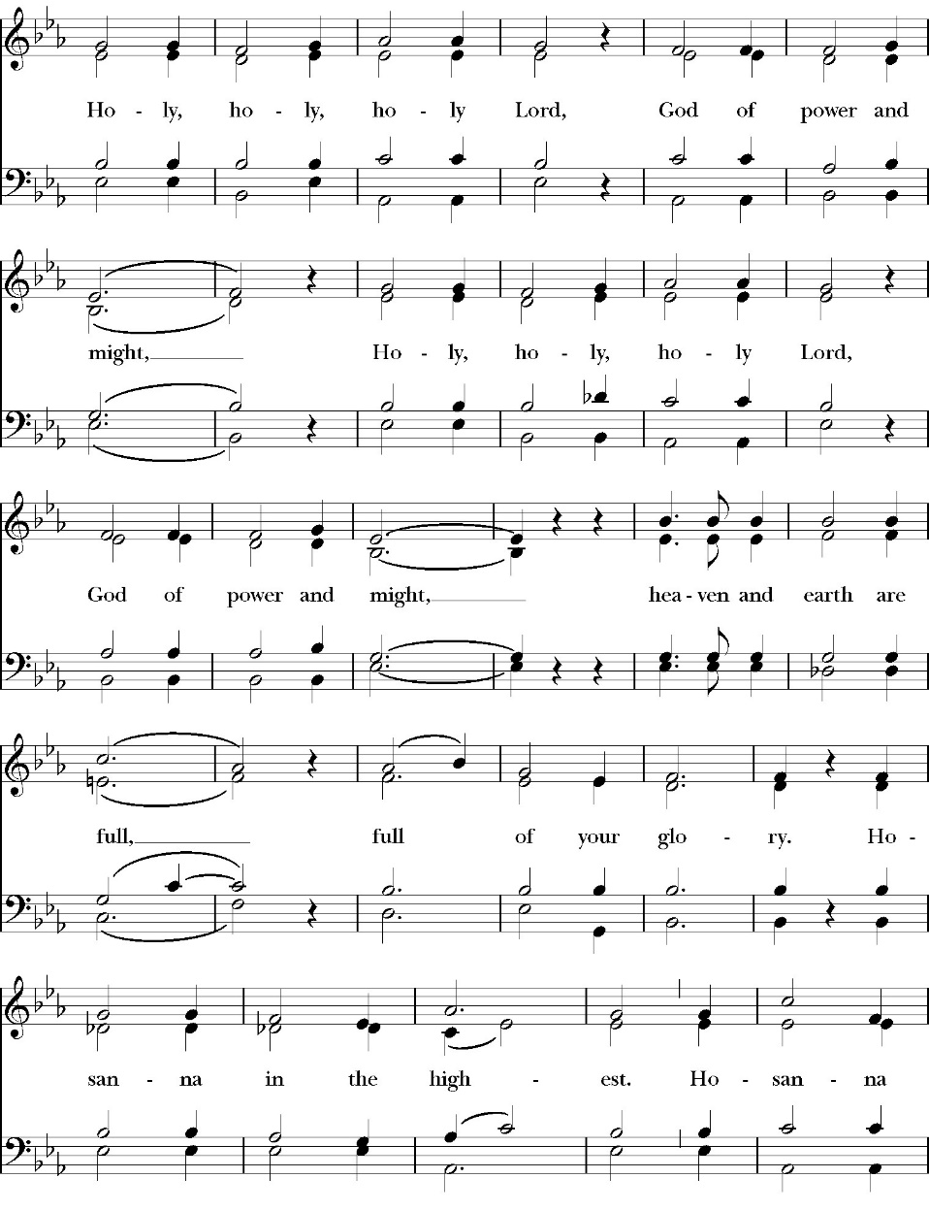

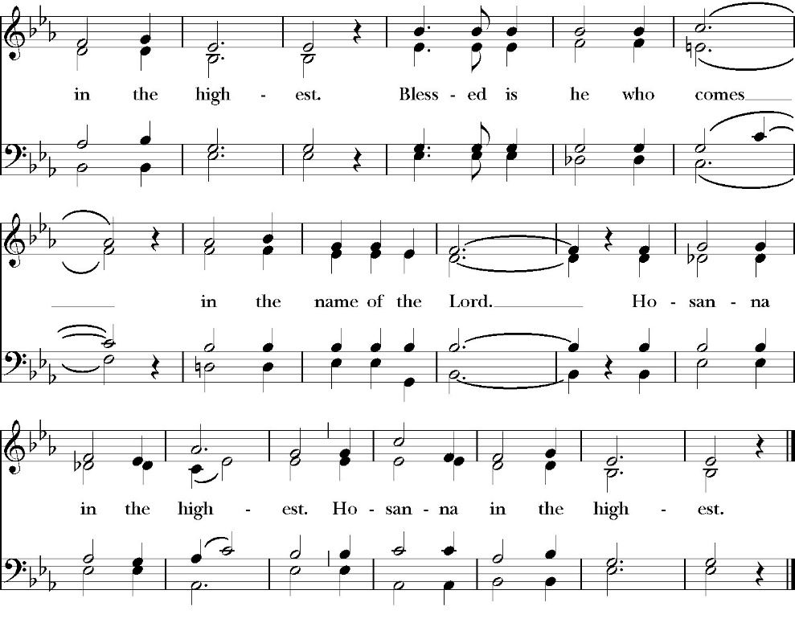
Holy and gracious Father: In your infinite love you made us for yourself; and when we had sinned against you and become subject to evil and death, you, in your mercy, sent your only Son Jesus Christ into the world for our salvation. By the Holy Spirit and the Virgin Mary he became flesh and dwelt among us. In obedience to your will, he stretched out his arms upon the Cross and offered himself once for all, that by his suffering and death we might be saved. By his resurrection he broke the bonds of death, trampling Hell and Satan under his feet. As our great high priest, he ascended to your right hand in glory, that we might come with confidence before the throne of grace.

On the night that he was betrayed, our Lord Jesus Christ took bread; and when he had given thanks, he broke it, * and gave it to his disciples, saying, “Take, eat; this is my Body, which is given for you: Do this in remembrance of me.”

Likewise, after supper, Jesus took the cup, and when he had given thanks, he gave it to them, saying, “Drink this, all of you; for this is my Blood of the New Covenant, which is shed for you, and for many, for the forgiveness of sins: Whenever you drink it, do this in remembrance of me.”
Therefore we proclaim the mystery of faith:

Christ has died.
Christ is risen.
Christ will come again.

We celebrate the memorial of our redemption, O Father, in this sacrifice of praise and thanksgiving, and we offer you these gifts.

Sanctify them by your Word and Holy Spirit to be for your people the Body and Blood of your Son Jesus Christ. Sanctify us also, that we may worthily receive this holy Sacrament, and be made one body with him, that he may dwell in us and we in him. In the fullness of time, put all things in subjection under your Christ, and bring us with all your saints into the joy of your heavenly kingdom, where we shall see our Lord face to face.

All this we ask through your Son Jesus Christ: By him, and with him, and in him, in the unity of the Holy Spirit, all honor and glory is yours, Almighty Father, now and for ever. Amen.

And now, as our Savior Christ has taught us, we are bold to pray,

Our Father, who art in heaven,
hallowed be thy Name,
thy kingdom come,
thy will be done,
on earth as it is in heaven.
Give us this day our daily bread.
And forgive us our trespasses,
as we forgive those
who trespass against us.
And lead us not into temptation,
but deliver us from evil.
For thine is the kingdom,
and the power, and the glory,
for ever and ever. Amen.

Celebrant Alleluia! Christ our Passover is sacrificed for us.
People Therefore let us keep the feast. Alleluia!

The Prayer For Humble Access

We do not presume to come to this your table, O merciful Lord,
trusting in our own righteousness,
but in your abundant and great mercies.
We are not worthy so much as to gather up
the crumbs under your table;
but you are the same Lord
whose character is always to have mercy.
Grant us, therefore, gracious Lord,
so to eat the flesh of your dear Son Jesus Christ,
and to drink his blood,
that our sinful bodies may be made clean by his body,
and our souls washed through his most precious blood,
and that we may evermore dwell in him, and he in us.
Amen.

Agnus Dei

The Ministration of Communion

The gifts of God for the People of God. Take them in remembrance that Christ died for you and feed on him in your hearts by faith, with thanksgiving. Jesu

The First Nowell

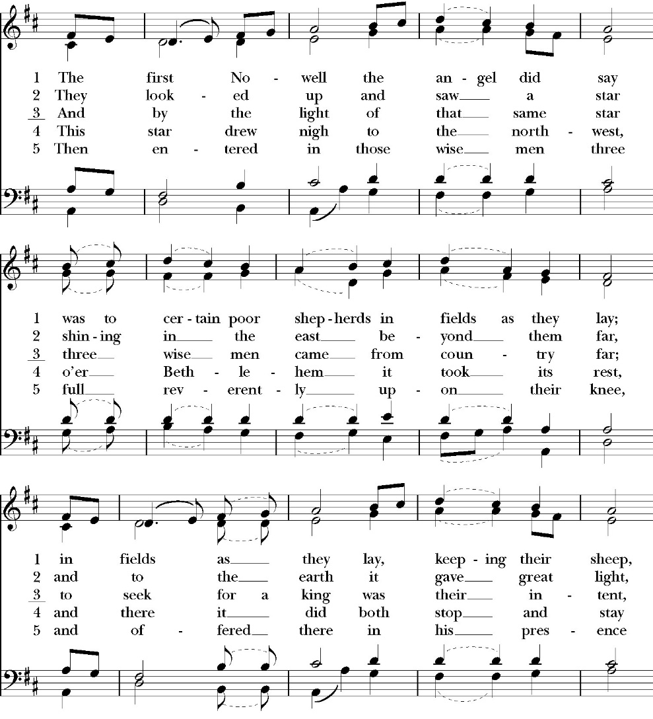

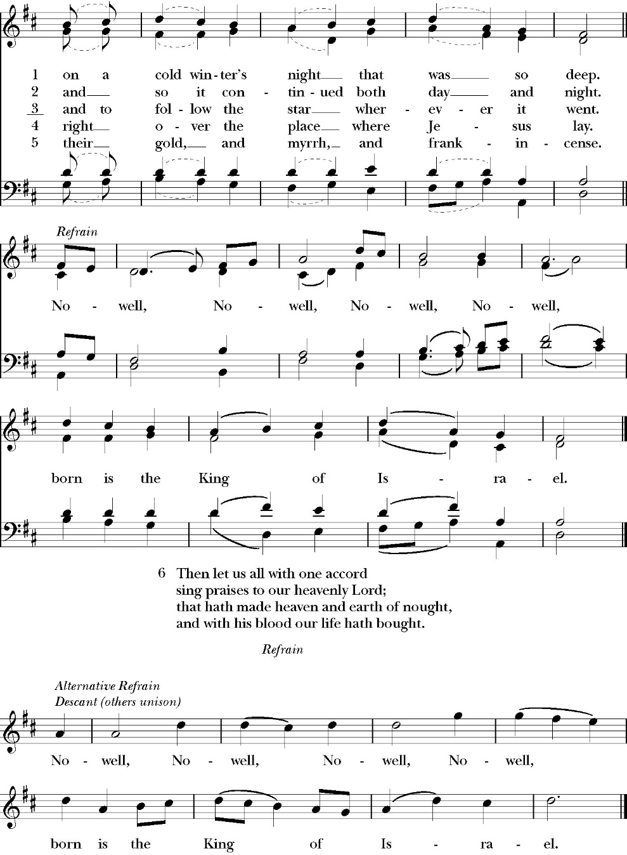

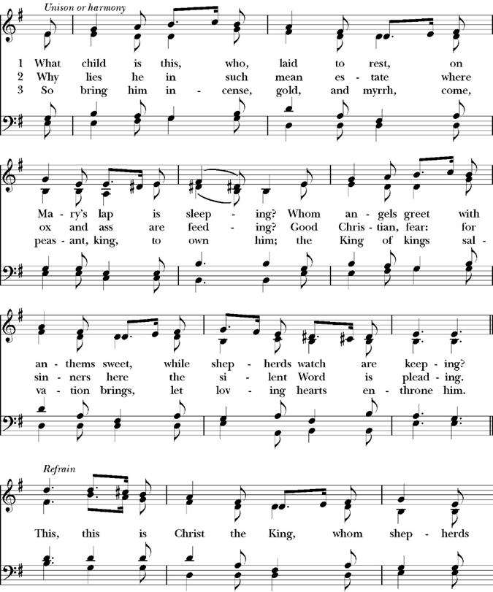
What Child Is This?

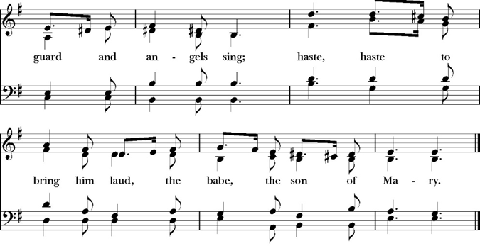

The Post Communion Prayer

Let us pray.

Heavenly Father,
We thank you for feeding us with the spiritual food
of the most precious Body and Blood
of your Son our Savior Jesus Christ;
and for assuring us in these holy mysteries
that we are living members of the body of your Son,
and heirs of your eternal Kingdom.
And now, Father, send us out to do the work you have
given us to do,
to love and serve you as faithful witnesses of Christ our
Lord.
To him, to you, and to the Holy Spirit,
be honor and glory, now and for ever. Amen.

Candlelight Hymn: Silent Night, Holy Night

Words: Isaac Watts
Music: Antioch, George Frideric Handel

The Blessing

The peace of God, which passes all understanding, keep your hearts
and minds in the knowledge and love of God, and of his Son Jesus
Christ our Lord; and the blessing of God Almighty, the Father, the
Son, and the Holy Spirit, be among you, and remain with you always.
Amen.

Closing Hymn: Joy to the World
(Hymn#100)

Celebrant Alleluia! Alleluia! Let us go forth in the Name of Christ.
People Thanks be to God. Alleluia! Alleluia!

Ministers and Musicians for the service

Celebrant: The Rev. Robert Longbottom
Deacon: The Rev. John Iseman
Deacon: Kashy Rowland-Smith
Lay Eucharistic Minister: Jim Doe
Chalice Bearer: Jenny Siwek

Acolytes:
Rose Longbottom, Penny Longbottom, Ziggy Longbottom

Musicians for the service
Choir Director: Cyndi Culp: Choir Director
Organist/Pianist: Marguerite Crownover
Viola: Karli Leal

Ushers:
Glen Catalina and Justin Qualls

St. Paul’s Anglican Church
Parish Office
6436 W. Hurley Ave
Visalia, California 93291
559-732-4821
Office Hours: 8:00 – 4:00
Monday – Thursday

Worship: Sundays at 10:30AM
Livestream: Link at spvisalia.com
and on our Facebook page
Please be advised that this service is being recorded for broadcast
and/or archival purposes. By attending, you consent
to the inclusion of your likeness in these recordings.

St. Paul’s Clergy and Staff
The Rev. Robert Longbottom, Rector
rector@spvisalia.com
(559)802-2928
The Rev. John Iseman, Pastoral Associate for Family Ministries
family@spvisalia.com
The Rev. Kashy Rowland-Smith, Deacon
kashyrs@aol.com
Antoinette Horsting, Parish Administrator
bookkeeper@spvisalia.com
Marguerite Crownover, Organist and Accompanist
Cynthia Culp, Choral Director
Jackie Iseman, Nursery Coordinator
Shane Motl, Sexton

St. Paul’s is a Member Church of
the Anglican Diocese of San Joaquin
The Rt. Rev. Eric V. Menees, Bishop

