ST. PAUL’S
ANGLICAN CHURCH
VISALIA, CALIFORNIA



Christ the King Sunday
November 23, 2025
10:30 A.M

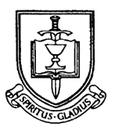

Welcome!

St. Paul’s Anglican Church extends a warm welcome to all visitors and newcomers, whether worshiping in person or at home via livestream.

Visitors’ Guide

St. Paul’s Church is a parish in the Diocese of San Joaquin of the Anglican Church in North America, which includes both Catholic and Protestant traditions. We accept Jesus Christ as Savior, and we promise to follow him as Lord. We believe in One God,

- the Father who created us and all things,
- the Son who redeems us from sin and death,
- the Holy Spirit who renews and sanctifies us.

We believe the Holy Scriptures to be the Word of God and to contain all things necessary for salvation, and we accept the Apostles’ and Nicene Creeds as essential beliefs of the Christian faith.

All followers of Jesus who are baptized in the name of the Trinity are invited to receive Holy Communion. If for whatever reason you feel you cannot receive communion, we invite you to come forward to receive a blessing. Please indicate you’d like a blessing by crossing your arms. All people are welcome at the Altar of the Lord.

Visitors are invited to sign the guest book at the entrance table and introduce themselves to the clergy following the service.

The Holy Eucharist

Prelude: “Fanfare” Lemmens
Opening Hymn: #494 – “Crown Him with Many Crowns” p. 4
Opening Acclamation p. 6
The Collect for Purity p. 6
Summary of the Law p. 6
Kyrie p. 6
Gloria p. 7
Collect of the Day p. 8
Lesson: Jeremiah 23 :1-6 p. 8
Gradual: Psalm 46 p. 9
Epistle: Colossians 1:11-20 p. 9
Sequence Hymn: #711 – “Seek Ye First” p. 10
Gospel: Luke 23:35-43 p. 11
Homily: The Rev. Robert Longbottom
Nicene Creed p. 11
Prayers of the People p. 12
The Peace p. 15
Offertory: -
The Offertory p. 15
Sursum Corda p. 16
Sanctus p. 17
The Lord’s Prayer p. 19
Fraction p. 19
Prayer for Humble Access p. 19
Agnus Dei p. 20
Communion: Hymn: “Above All” p. 21
Post Communion Prayer p. 23
Blessing p. 24
Closing Hymn: #450 – “All Hail the Power of Jesus’ Name” p. 24
Dismissal p. 25
Postlude: “Improvisation on “Miles Lane” Whitney

Opening Hymn: Crown Him with Many Crown

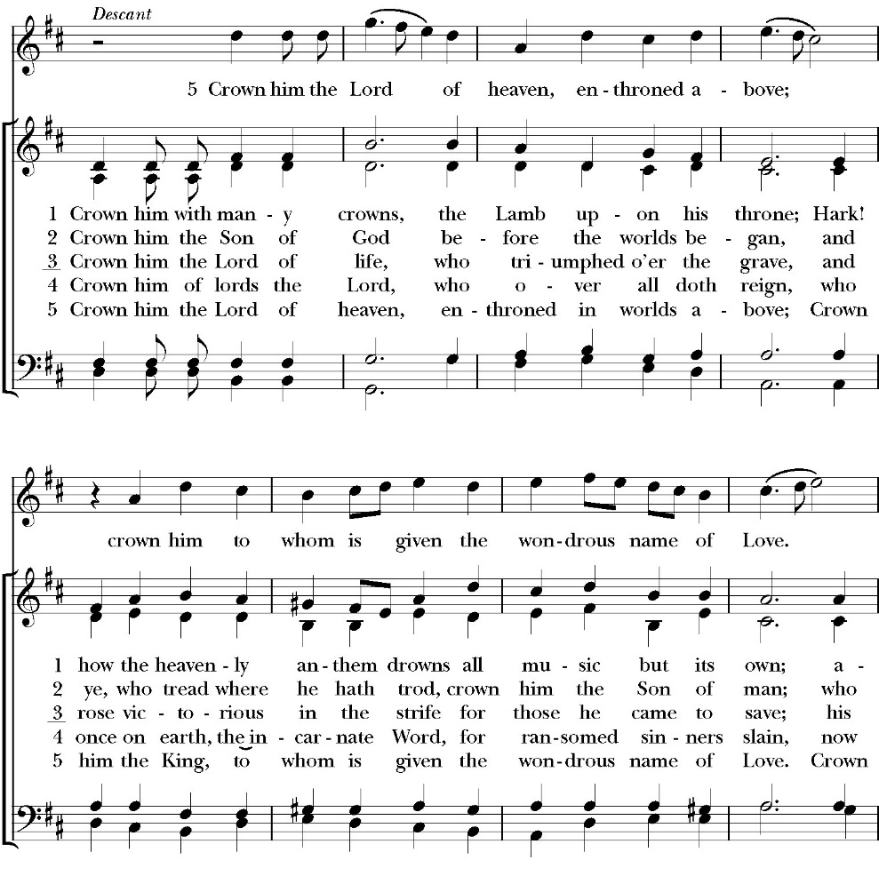

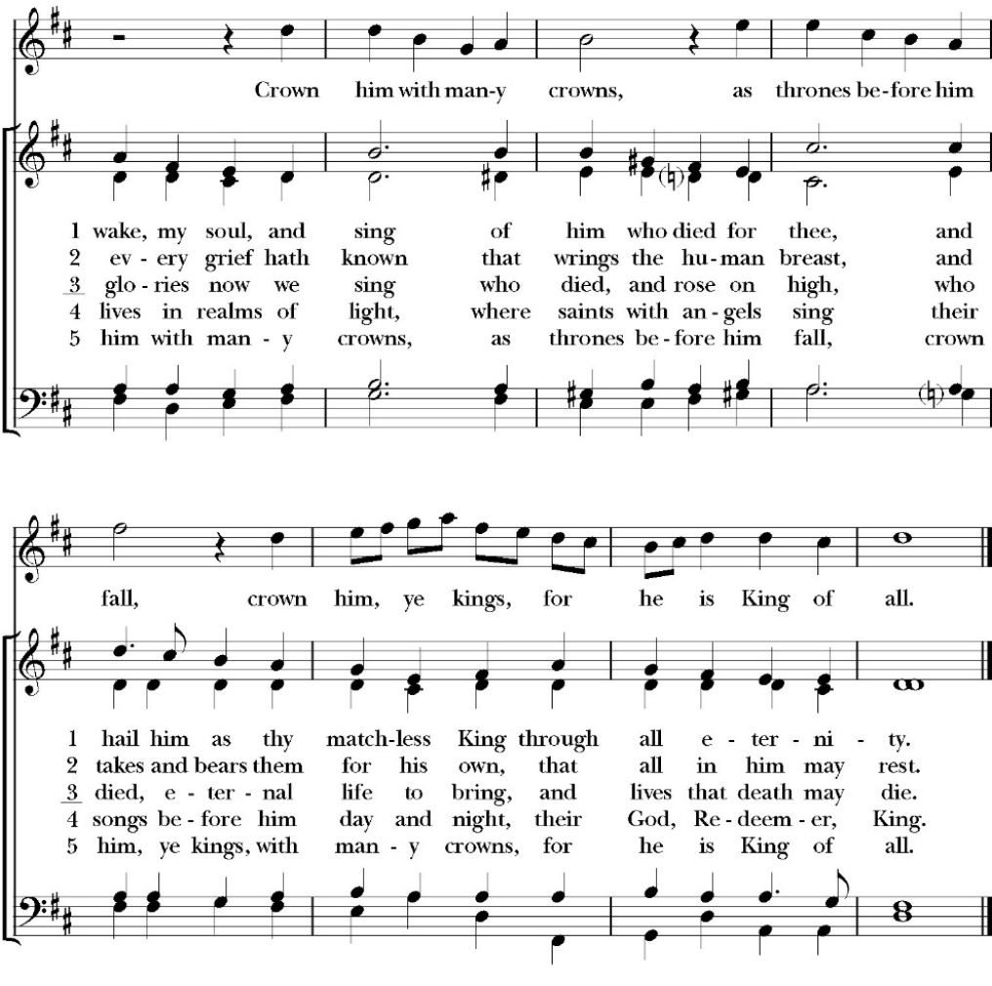

Opening Acclamation

Celebrant Worthy is the Lord our God,
People To receive glory and honor and power.

Collect for Purity

All: Almighty God, to you all hearts are open, all desires known, and from you no secrets are hid: Cleanse the thoughts of our hearts by the inspiration of your Holy Spirit, that we may perfectly love you, and worthily magnify your holy Name; through Christ our Lord. Amen.

Summary of the law

Celebrant: Hear what our Lord Jesus Christ says: You shall love the Lord your God with all your heart and with all your soul
and with all your mind. This is the first and great commandment. And the second is like it: You shall love your neighbor as yourself. On these two commandments depend all the Law and the Prophets.

The Kyrie

Gloria

Celebrant The Lord be with you.
People And with your spirit.
Celebrant Let us pray.

The Collect of the Day

Almighty and everlasting God, whose will it is to restore all things in your well-beloved Son, the King of kings and Lord of lords: Mercifully grant that the peoples of the earth, divided and enslaved by sin, may be freed and brought together under his most gracious rule; who lives and reigns with you and the Holy Spirit, one God, now and for ever. Amen.

Lesson: Jeremiah 23:1-6
“Woe to the shepherds who destroy and scatter the sheep of my pasture!” declares the LORD. 2 Therefore thus says the LORD, the God of Israel, concerning the shepherds who care for my people: “You have scattered my flock and have driven them away, and you have not attended to them. Behold, I will attend to you for your evil deeds, declares the LORD. 3 Then I will gather the remnant of my flock out of all the countries where I have driven them, and I will bring them back to their fold, and they shall be fruitful and multiply. 4 I will set shepherds over them who will care for them, and they shall fear no more, nor be dismayed, neither shall any be missing, declares the LORD.

5 “Behold, the days are coming, declares the LORD, when I will raise up for David a righteous Branch, and he shall reign as king and deal wisely, and shall execute justice and righteousness in the land. 6 In his days Judah will be saved, and Israel will dwell securely. And this is the name by which he will be called: ‘The LORD is our righteousness.’

Reader: The Word of the Lord
People: Thanks be to God

Gradual: Psalm 46
1 God is our refuge and strength, *
a very present help in trouble.
2 Therefore we will not fear, though the earth be moved, *
and though the hills be carried into the midst of the sea;
3 Though its waters rage and swell, *
and though the mountains shake at its tempest.
4 There is a river whose streams make glad the city of God, *
the holy dwelling place of the Most High.
5 God is in the midst of her; therefore she shall not be moved. *
God shall help her at the break of day.
6 The nations are in an uproar, and the kingdoms are moved, *
but God has lifted his voice, and the earth shall melt away.
7 The LORD of hosts is with us; *
the God of Jacob is our refuge.
8 O come and behold the works of the LORD, *
what devastations he has brought upon the earth.
9 He makes wars to cease in all the world; *
he breaks the bow, and shatters the spear, and burns the chariots in the fire.
10 “Be still then and know that I am God; *
I will be exalted among the nations, and I will be exalted in the earth.”
11 The LORD of hosts is with us; *
the God of Jacob is our refuge.

Glory be to the Father, and to the Son, and to the Holy Spirit;
as it was in the beginning, is now, and ever shall be, world without end. Amen

Epistle Colossians 1:11-20
Being strengthened with all power, according to his glorious might, for all endurance and patience with joy; 12 giving thanks to the Father, who has qualified you to share in the inheritance of the saints in light. 13 He has delivered us from the domain of darkness and transferred us to the kingdom of his beloved Son,

14 in whom we have redemption, the forgiveness of sins.
15 He is the image of the invisible God, the firstborn of all creation. 16 For by him all things were created, in heaven and on earth, visible and invisible, whether thrones or dominions or rulers or authorities—all things were created through him and for him. 17 And he is before all things, and in him all things hold together. 18 And he is the head of the body, the church. He is the beginning, the firstborn from the dead, that in everything he might be preeminent. 19 For in him all the fullness of God was pleased to dwell, 20 and through him to reconcile to himself all things, whether on earth or in heaven, making peace by the blood of his cross.

Reader: The Word of the Lord
People: Thanks be to God

Sequence Hymn: Seek Ye First
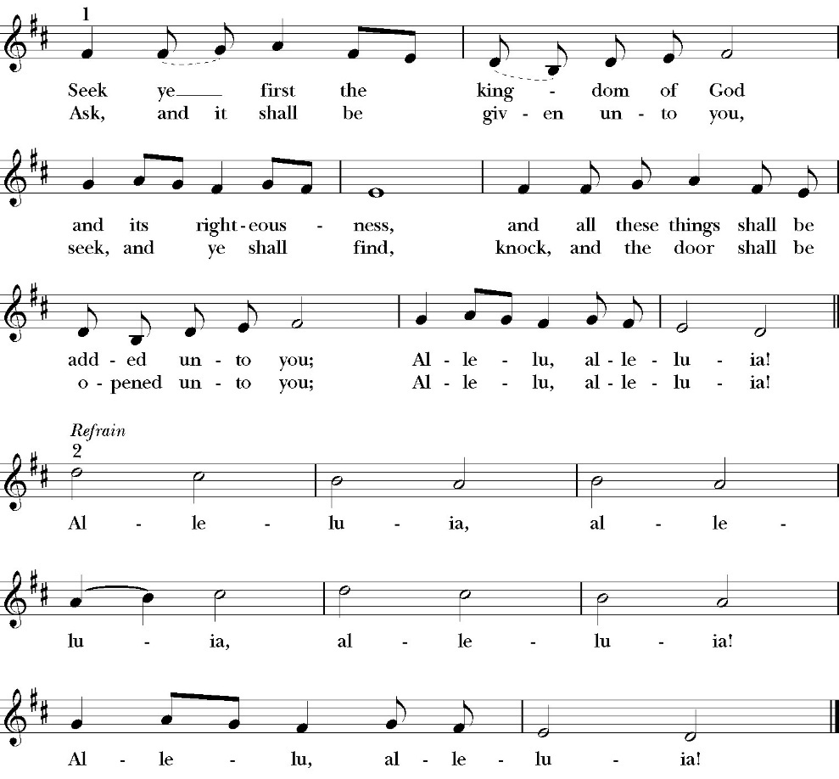
(Verse 1 before Gospel and verse 2 after)

Clergy: The Holy Gospel of Our Lord Jesus Christ,
according to St. Luke
People: Glory to you, Lord God

Gospel Luke 23:35-43
And the people stood by, watching, but the rulers scoffed at him, saying, “He saved others; let him save himself, if he is the Christ of God, his Chosen One!” 36 The soldiers also mocked him, coming up and offering him sour wine 37 and saying, “If you are the King of the Jews, save yourself!” 38 There was also an inscription over him, “This is the King of the Jews.”

39 One of the criminals who were hanged railed at him, saying, “Are you not the Christ? Save yourself and us!” 40 But the other rebuked him, saying, “Do you not fear God, since you are under the same sentence of condemnation? 41 And we indeed justly, for we are receiving the due reward of our deeds; but this man has done nothing wrong.” 42 And he said, “Jesus, remember me when you come into your kingdom.” 43 And he said to him, “Truly, I say to you, today you will be with me in paradise.”

Clergy: The Gospel of the Lord
People: Praise to you, Lord Christ

Sermon
The Rev. Robert Longbottom

The Nicene Creed

The people stand

We believe in one God,
the Father, the Almighty,
maker of heaven and earth,
of all that is, visible and invisible.
We believe in one Lord, Jesus Christ,
the only-begotten Son of God,
eternally begotten of the Father,
God from God, Light from Light,
true God from true God,
begotten, not made,
of one Being with the Father.
through him all things were made.
For us and for our salvation he came down from heaven:
was incarnate from the Holy Spirit and the Virgin Mary,
and was made man.
For our sake he was crucified under Pontius Pilate;
he suffered death and was buried.
On the third day he rose again in accordance with the
Scriptures;
he ascended into heaven
and is seated at the right hand of the Father.
He will come again in glory to judge the living and the dead,
and his kingdom will have no end.
We believe in the Holy Spirit, the Lord, the giver of life,
who proceeds from the Father and the Son,
who with the Father and the Son is worshiped and glorified.
who has spoken through the Prophets.
We believe in one holy catholic and apostolic Church.
We acknowledge one Baptism for the forgiveness of sins.
We look for the resurrection of the dead,
and the life of the world to come. Amen.

The Prayers of the People
The People kneel or are seated if unable to kneel
The Deacon or other person appointed says these prayers. Reader pauses after each bidding, and the people may add petitions, either silently or aloud.
Let us pray for the Church and for the world, saying,
“Hear our prayer.”

For the peace of the whole world, and for the well-being and unity of the people of God.

Reader Lord, in your mercy:
People Hear our prayer.
For Stephen, our Archbishop, and Eric, our Bishop, and for all the clergy and people of our Diocese and Congregation.

Reader Lord, in your mercy:
People Hear our prayer.

For all those who proclaim the Gospel at home and abroad; and for all who teach and disciple others.

Reader Lord, in your mercy:
People Hear our prayer.

For our brothers and sisters in Christ who are persecuted for their faith.

Reader Lord, in your mercy:
People Hear our prayer.

For our nation, for those in authority, and for all in public service especially Donald our President and Gavin our Governor.

Reader Lord, in your mercy:
People Hear our prayer.

In the St. Paul’s cycle of prayer, we pray for all ministries of Christian education, discipleship and bible study. We pray that through word and deed we might grow closer to the heart and life of Jesus through our study, prayer, fellowship and mission.

Reader Lord, in your mercy:
People Hear our prayer.

In the ACNA Cycle of Prayer, today we pray for the Anglican Diocese of the Great Lakes, Bishop Mark Engel and his wife, Terri; Bishop Allen Kannapell and his wife, Lisa; and Bishop Roger Ames and his wife, Gretsie.

Reader Lord, in your mercy:
People Hear our prayer.
For all those who are in trouble, sorrow, need, sickness, or any other adversity [especially _____________].

Reader Lord, in your mercy:
People Hear our prayer.

For all those who have departed this life in the certain hope of the resurrection, [especially ______,] in thanksgiving let us pray.

Reader Lord, in your mercy:
People Hear our prayer.

Celebrant says a concluding prayer

Heavenly Father, grant these our prayers for the sake of Jesus Christ, our only Mediator and Advocate, who lives and reigns with you in the unity of the Holy Spirit, one God, now and for ever. Amen.

The Confession and Absolution

Deacon Let us humbly confess our sins to Almighty God.

Most merciful God,
we confess that we have sinned against you
in thought, word and deed,
by what we have done, and by what we have left undone.
We have not loved you with our whole heart;
we have not loved our neighbors as ourselves.
We are truly sorry and we humbly repent.
For the sake of your Son Jesus Christ,
have mercy on us and forgive us;
that we may delight in your will, and walk in your ways,
to the glory of your Name. Amen.

Almighty God, our heavenly Father, who in his great mercy has
promised forgiveness of sins to all those who sincerely repent and
with true faith turn to him, have mercy upon you, pardon and deliver
you from all your sins, confirm and strengthen you in all goodness,
and bring you to everlasting life; through Jesus Christ our Lord.
Amen.
the comfortable words
Celebrant Hear the Word of God to all who truly turn to him.

The saying is trustworthy and deserving of full acceptance, that Christ Jesus came into the world to save sinners.
-1 Timothy 1:15

If anyone sins, we have an advocate with the Father, Jesus Christ the righteous. He is the propitiation for our sins, and not for ours only, but also for the sins of the whole world.
-1 John 2:1-2t
The Peace

Celebrant The Peace of the Lord be always with you.
People And with your spirit.

Offertory Anthem

The Doxology
(Verse 3 only)

Offertory

Celebrant All things come from you, O Lord,
People And of your own have we given you.

The Eucharistic Liturgy

Celebrating The Lord be with you.
People And with your spirit.
Celebrant Lift up your hearts.
People We lift them up to the Lord.
Celebrant Let us give thanks to the Lord our God.
People It is right to give him thanks and praise.

It is right, our duty and our joy, always and everywhere to give thanks to you, Father Almighty, Creator of heaven and earth.
Through Jesus Christ our Lord, who on the first day of the week overcame death and the grave, and by his glorious resurrection opened to us the way of everlasting life.

Therefore, we praise you, joining our voices with Angels and Archangels and with all the company of heaven, who for ever sing this hymn to proclaim the glory of your Name:

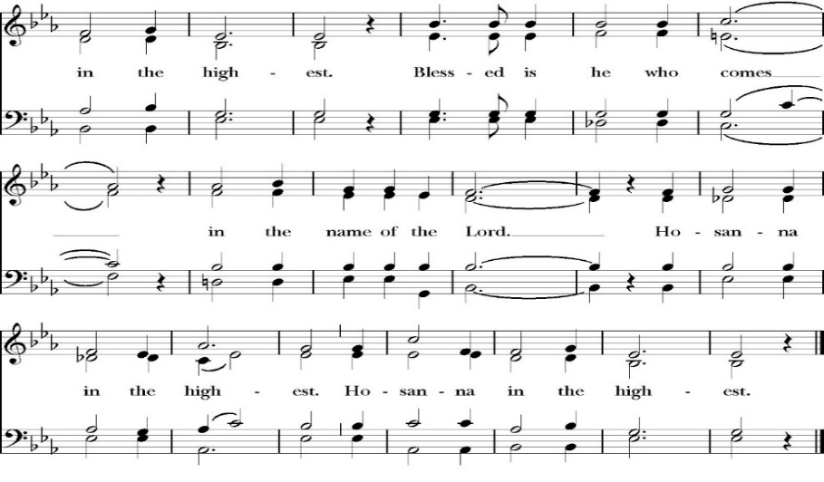
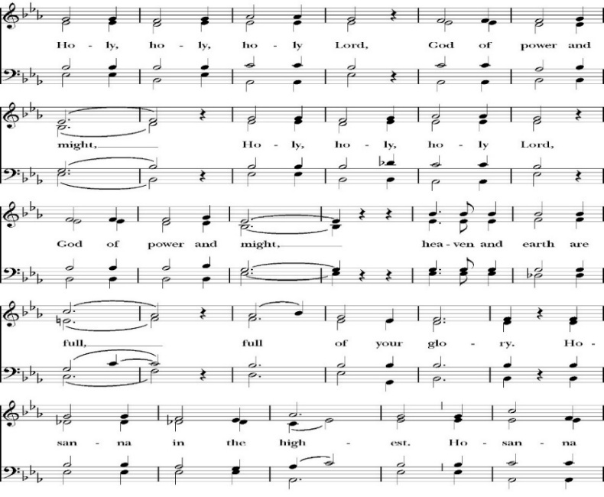
Sanctus

The People kneel or are seated if unable to kneel

Holy and gracious Father: In your infinite love you made us for yourself; and when we had sinned against you and become subject to evil and death, you, in your mercy, sent your only Son Jesus Christ
into the world for our salvation. By the Holy Spirit and the Virgin Mary he became flesh and dwelt among us. In obedience to your will, he stretched out his arms upon the Cross and offered himself once for all, that by his suffering and death we might be saved. By his resurrection he broke the bonds of death, trampling Hell and Satan under his feet. As our great high priest, he ascended to your right hand in glory, that we might come with confidence before the throne of grace.

On the night that he was betrayed, our Lord Jesus Christ took bread; and when he had given thanks, he broke it,* and gave it to his disciples, saying, “Take, eat; this is my Body, which is given for you: Do this in remembrance of me.”

Likewise, after supper, Jesus took the cup, and when he had given thanks, he gave it to them, saying, “Drink this, all of you; for this is my Blood of the New Covenant, which is shed for you, and for many, for the forgiveness of sins: Whenever you drink it, do this in remembrance of me.”

Therefore we proclaim the mystery of faith:

Christ has died.
Christ is risen.
Christ will come again.

We celebrate the memorial of our redemption, O Father, in this sacrifice of praise and thanksgiving, and we offer you these gifts.

Sanctify them by your Word and Holy Spirit to be for your people the Body and Blood of your Son Jesus Christ. Sanctify us also, that we may worthily receive this holy Sacrament, and be made one body with him, that he may dwell in us and we in him. In the fullness of time, put all things in subjection under your Christ, and bring us with all your saints into the joy of your heavenly kingdom, where we shall see our Lord face to face.
All this we ask through your Son Jesus Christ: By him, and with him, and in him, in the unity of the Holy Spirit, all honor and glory is yours, Almighty Father, now and for ever. Amen

And now, as our Savior Christ has taught us, we are bold to pray,

Our Father, who art in heaven,
hallowed be thy Name,
thy kingdom come,
thy will be done,
on earth as it is in heaven.
Give us this day our daily bread.
And forgive us our trespasses,
as we forgive those
who trespass against us.
And lead us not into temptation,
but deliver us from evil.
For thine is the kingdom,
and the power, and the glory,
for ever and ever. Amen

Fraction
Celebrant Alleluia! Christ our Passover is sacrificed for us.
People Therefore let us keep the feast. Alleluia!

The Prayer for Humble Access
We do not presume to come to this your table, O merciful Lord,
trusting in our own righteousness,
but in your abundant and great mercies.
We are not worthy so much as to gather up
the crumbs under your table;
but you are the same Lord
whose character is always to have mercy.
Grant us, therefore, gracious Lord,
so to eat the flesh of your dear Son Jesus Christ,
and to drink his blood,
that our sinful bodies may be made clean by his body,
and our souls washed through his most precious blood,
and that we may evermore dwell in him, and he in us.
Amen
Agnus Dei

The Ministration of Communion

The gifts of God for the People of God. Take them in remembrance that Christ died for you and feed on him in your hearts by faith, with thanksgiving.

Communion Hymn: Above All
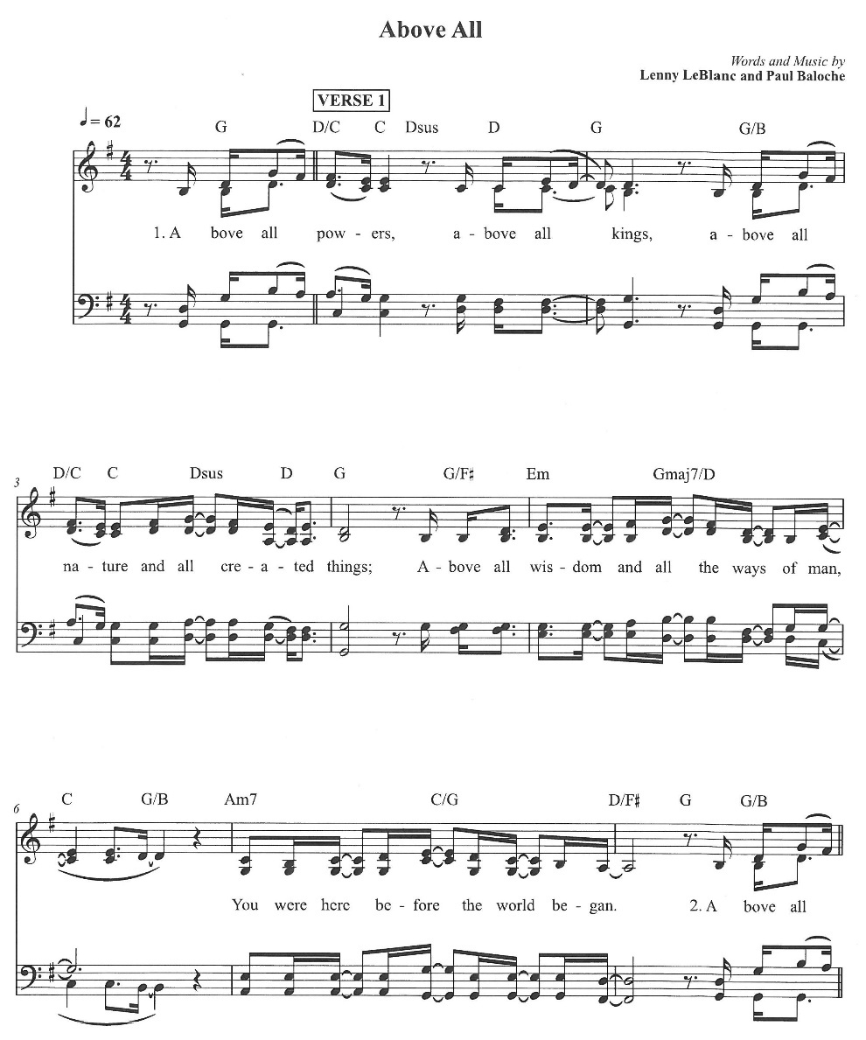

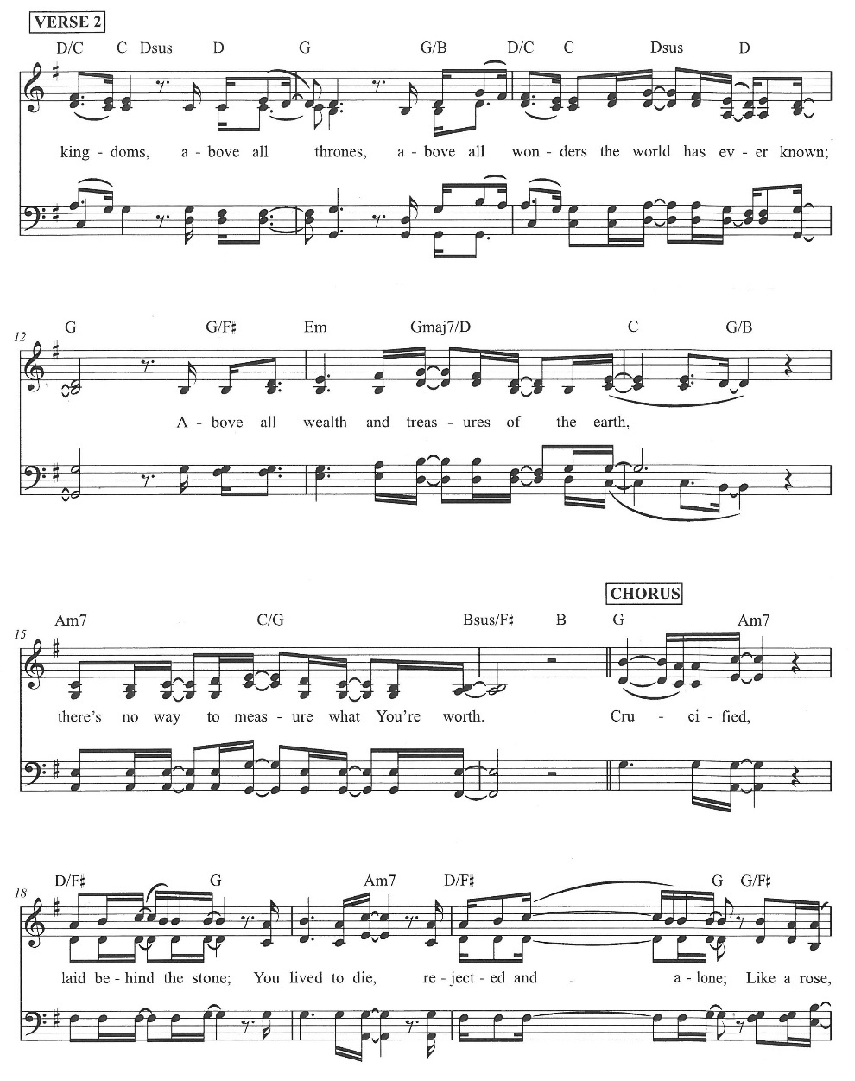

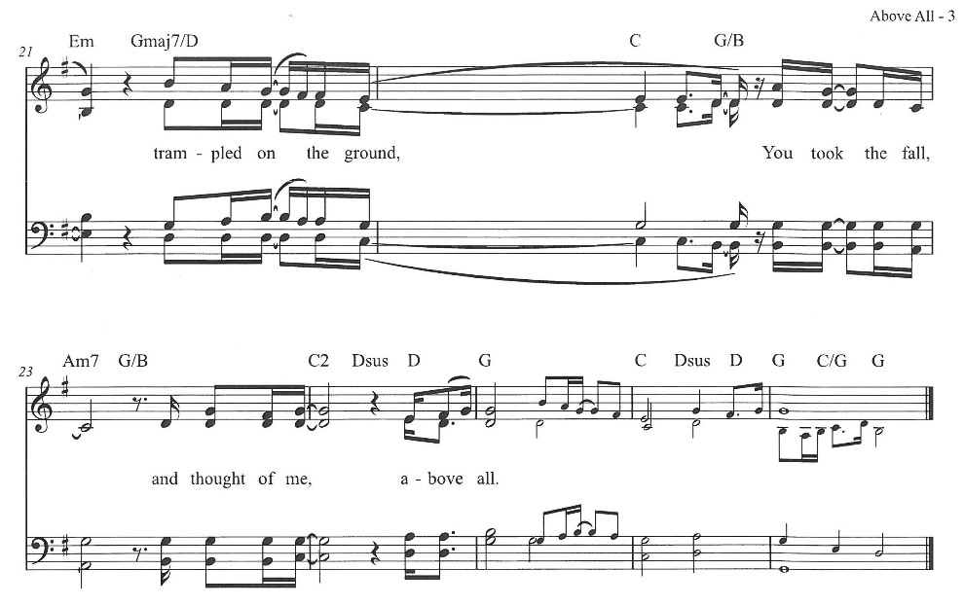
The Post Communion Prayer

The People kneel or are seated if unable to kneel

Let us pray.

Heavenly Father,
We thank you for feeding us with the spiritual food
of the most precious Body and Blood
of your Son our Savior Jesus Christ;
and for assuring us in these holy mysteries
that we are living members of the body of your Son,
and heirs of your eternal Kingdom.
And now, Father, send us out to do the work you have
given us to do,
to love and serve you as faithful witnesses of Christ our
Lord.
To him, to you, and to the Holy Spirit,
be honor and glory, now and for ever. Amen.
The Blessing

The peace of God, which passes all understanding, keep your hearts and minds in the knowledge and love of God, and of his Son Jesus Christ our Lord; and the blessing of God Almighty, the Father, the Son, and the Holy Spirit, be among you, and remain with you always. Amen.

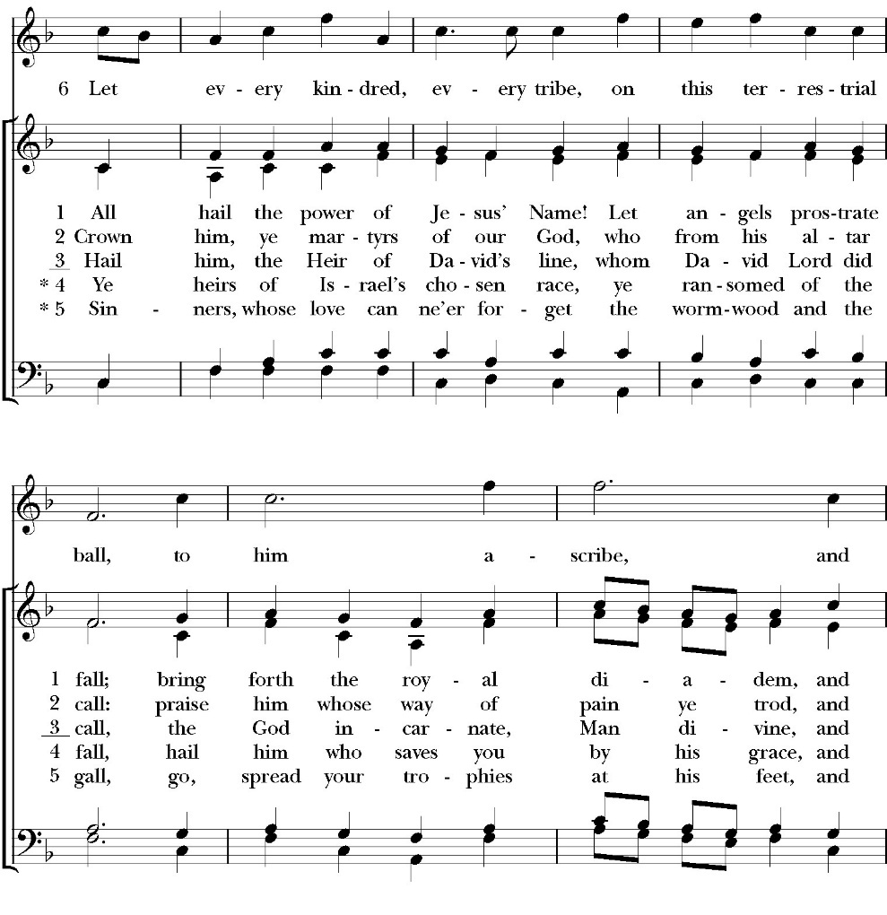
Closing Hymn: All Hail the Power of Jesus’ Name

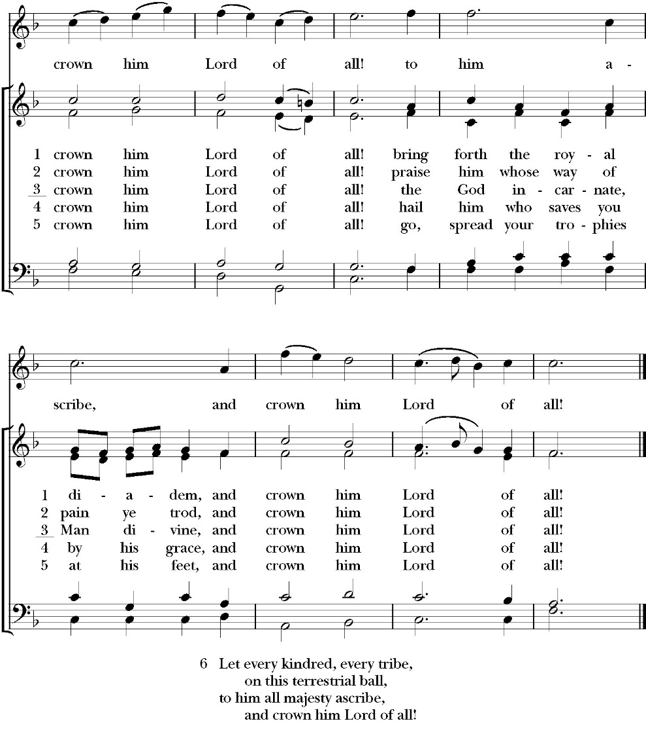

Deacon Alleluia, Alleluia! Let us go forth in the name of Christ.
People Thanks be to God. Alleluia! Alleluia!

St. Paul’s Parish Calendar
Sunday, November 23 – Sunday November 30

SUNDAY, November 23 – Christ the King
9:30 AM Choir Practice, Music Room
10:30 AM Children’s Sunday School,
Pre-K – 1st Grade, Sunday School Room.
2nd -6th Grade, Youth Room
10:30 AM Holy Eucharist, Church

MONDAY, November 24

TUESDAY, November 25
6:00 PM No Bell Choir Rehearsal, Music Room

WEDNESDAY, November 26 – Office Closed
9:30 AM Thanksgiving Holy Eucharist, Church
10:15 AM No Wednesday Bible study

THURSDAY, November 27 – Office Closed

FRIDAY, November 28
6:30 AM No Men’s Bible Study, Valhalla Restaurant

SATURDAY, November 29

SUNDAY, November 30 – First Sunday of Advent
9:30 AM Choir Practice, Music Room
10:30 AM Children’s Sunday School,
Pre-K – 1st Grade, Sunday School Room.
2nd -6th Grade, Youth Room
10:30 AM Holy Eucharist, Church

Church Office Hours
Monday-Thursday 8:00 AM-4:00 PM

Church office closed for Thanksgiving November 26 & 27
Announcements

Time, Talent, and Treasure Stewardship Campaign
November 23, Ingathering Sunday
Every year in November, St. Paul’s Anglican Church invites members and friends of the congregation to prayerfully consider their financial giving for 2026. St. Paul’s is looking to fund an operating budget for 2026 of $480,000. Above and beyond this goal, we are hoping to fund additional special projects for the safety, security, enjoyment and blessing of everyone who comes onto our campus. We project these projects to be an additional $40,000.
If you have any questions regarding our annual stewardship campaign or our budget for 2026, please speak with our Rector Fr. Rob Longbottom, our Senior Warden Mrs. Catherine Francis, or any member of our church vestry.

Christmas Pageant Rehearsals every Sunday during church
Christmas Pageant is Sunday, December 21, during 10:30AM worship service
All children and youth of St. Paul’s are invited to participate in this year’s Christmas pageant. Rehearsals will be on Sunday mornings during Sunday School time. The Christmas pageant will be on Sunday, December 21, during the 10:30 worship service. If you have any questions, please reach out to our pageant director Mrs. Jennifer Hennagin at (661)332-7275.

Thanksgiving Eucharist, Wednesday, November 26, 9:30 AM, Main Church
All members of St. Paul’s are welcome to join us for a Thanksgiving Holy Eucharist. The Thanksgiving Eucharist will be at the normal Wednesday Holy Eucharist time
.
Thanksgiving Offering to go to St. Jude’s Ministry led by
Fr. Jim Rouse
Every Thanksgiving, we invite members and friends of St. Paul’s to consider giving a Thanksgiving offering in gratitude for the blessings and work of Christ in their lives. This offering goes directly to the ministry of St. Jude’s founded by Fr. Jim Rouse who is the priest-in -charge at St. John’s Porterville. Every year, St. Paul’s partners with Fr. Jim Rouse to support a St. Jude’s family that is striving to reach self-sustainability. This is the same family that we support with Christmas gifts through our Angel Tree ministry.
St. Jude’s Christmas Family and Angel Tree Ministry
Beginning Sunday, November 23, be on the lookout for the St. Jude’s Angel Tree in the narthex of the church. Every year, St. Paul’s partners with St. Jude’s and Fr. Jim Rouse to support a family that is striving towards self-sufficiency by giving them presents at Christmas. The Angel Tree will be adorned with ornaments that have Christmas gift needs for every member of the family. There are many “useful” gift needs such as clothes and personal supplies. However, there are also some fun gifts that the family members have asked for in order to have a joyful and blessed Christmas. If you have any questions, please reach out to our Angel Tree coordinator Wendy Johns. Call the church office and we can provide her with contact information.

Visalia Emergency Aid Race Against Hunger, Thanksgiving Day, November 27
St. Paul’s partners with Visalia Emergency Aid to serve Hurley Elementary families through our neighborhood food market. To help support the work, join your Rector and his family in running or walking in the Visalia Emergency Aid Race Against Hunger this Thanksgiving morning. All funds raised go straight to our food pantry programs, ensuring that local households in need are connected with the food resources they require. You can register online by going to the Race Against Hunger website at www.visaliaturkeytrot.com/Race/TurkeyTrotVisalia/Page/Register.

Visalia Emergency Aid Food Barrel
For many years, St. Paul’s supported the ministry of Visalia Emergency Aid by housing a food barrel. We are renewing this ministry and invite members to bring food on Sunday mornings to place into the food barrel and support the VEA feeding ministries.

Advent Daily Devotions Available at The Prayer Table
Advent is a season of preparation for the return of Jesus in glorious majesty. This year we once again offer the daily Advent devotional produced by Trinity Anglican Seminary. This year the daily devotional focuses on the Psalms from the daily lectionary of the Book of Common Prayer. The devotionals are available on the prayer table in the Narthex of the church.

Paint Night

Sunday, November 23, 4:30 PM, James Hall
The Monday Night Women’s Bible study group will be doing a paint night open for all on Sunday, November 23, at 4:30 in James Hall. Cost is $40 per painter which will include everything. Light snacks and beverages will be provided. If you would like to sign up or have any questions, please see Kayla Haas or contact her 559-799-2012.

Wreaths Across America, December 13, 9:00 AM
Visalia Cemetery
This year, National Wreaths Across America Day will be held on Saturday, December 13, 2025. St. Paul’s will be joining the more than two million volunteers and supporters who will gather to remember, honor, and teach at more than 5,200 participating locations in all 50 states, at sea and abroad. St. Paul’s Church has volunteered to help place a wreath at the grave of each veteran in the Visalia Cemetery as we have for many years. It is reported that over 4,000 veterans are buried at just this one cemetery and placing a wreath is a gift of gratitude for someone who served our country so we can be free.

People may sponsor wreaths specific to the Visalia Cemetery by going to the following web site:
https://www.wreathsacrossamerica.org/
Learn about Wreaths Across America's Mission to Remember, Honor and Teach

Advent Candles for Advent Wreaths Available
Advent begins the Sunday after Thanksgiving. Advent Candles are available and will be in the Narthex, James Hall, and the church office. These resources are free, but donations are accepted.
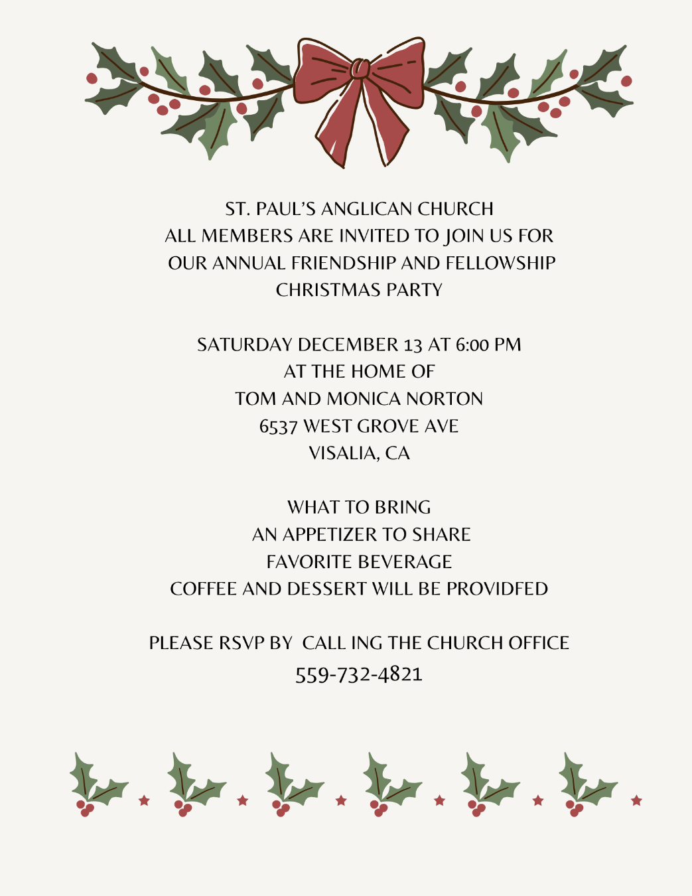

St. Paul’s Anglican Church
Parish Office
6436 W. Hurley Ave
Visalia, California 93291
559-732-4821
Office Hours: 8:00 – 4:00
Monday – Thursday

Worship: Sundays at 10:30AM
In person: St. Paul’s Anglican Church
Livestream: Link at spvisalia.com
and on our Facebook page
Please be advised that this service is being recorded for broadcast
and/or archival purposes. By attending, you consent
to the inclusion of your likeness in these recordings.

St. Paul’s Clergy and Staff
The Rev. Robert Longbottom, Rector
rector@spvisalia.com
(559)802-2928
The Rev. John Iseman, Pastoral Associate for Family Ministries
family@spvisalia.com
The Rev. Kashy Rowland-Smith, Deacon
kashyrs@aol.com
Antoinette Horsting, Parish Administrator
bookkeeper@spvisalia.com
Marguerite Crownover, Organist and Accompanist
Cynthia Culp, Choral Director
Jackie Iseman, Nursery Coordinator
Shane Motl, Sexton

Next Week’s Lessons
Isaiah 2:1-5
Psalm 122
Romans 13:8-14
Matthew 24:29-44

