Requiem Mass

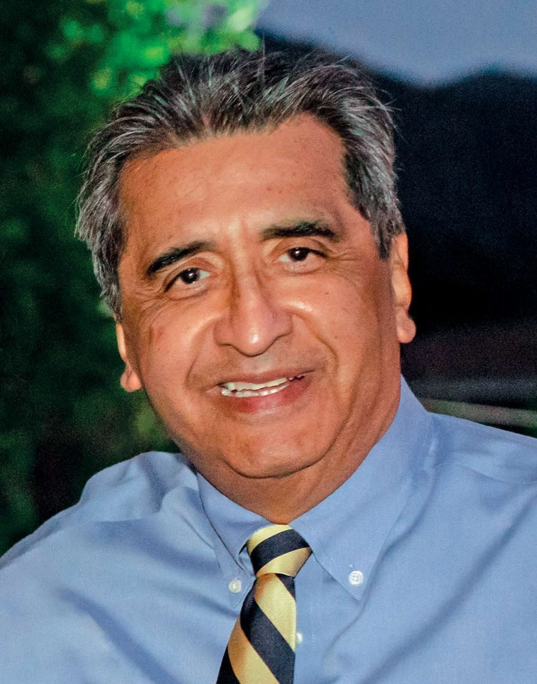
Reuben Christopher Garcia

November 15, 2025
10:30 A.M.

St. Paul’s Anglican Church Welcomes You!

St. Paul’s Anglican Church extends a warm welcome to all visitors and newcomers, whether worshiping in person or at home via livestream.

Visitors’ Guide

St. Paul’s Church is a parish in the Diocese of San Joaquin of the Anglican Church in North America, which includes both Catholic and Protestant traditions. We accept Jesus Christ as Savior, and we promise to follow him as Lord. We believe in One God,

- the Father who created us and all things,
- the Son who redeems us from sin and death,
- the Holy Spirit who renews and sanctifies us.

We believe the Holy Scriptures to be the Word of God and to contain all things necessary for salvation, and we accept the Apostles’ and Nicene Creeds as essential beliefs of the Christian faith.

Holy Communion is open to all baptized Christians who have examined their lives, repented of their sins, and desire to live
in love and charity with all people.

Those not desiring to receive Holy Communion, and those who have not been baptized into the Christian faith, are invited to cross their arms across their chest, and a blessing will be given instead.

Sunday Worship at St. Paul’s Anglican Church
is at 10:30 A.M.

Order of Service

Prelude:
Opening Sentences p. 4
Opening Hymn: Blessed Assurance p. 5
Lesson: Philippians 4:6-9 p. 6
Psalm 103 p. 6
Epistle: Romans 8:14-19, 34-35, 37-39 p. 8
Psalm 46 p. 9
Lesson: Revelation 7:9-17 p. 10
Sequence Hymn: Shout To the Lord p. 11
Gospel: Matthew 25:31-40 p. 12
Homily: The Rev. Robert Longbottom
Nicene Creed p. 13
Prayers of the People p. 14
The Peace p. 15
Offertory Hymn: It Is Well with My Soul p. 16
The Offertory Sentences p. 18
Sursum Corda p. 18
Sanctus p. 19
The Lord’s Prayer p. 22
Fraction p. 22
Prayer for Humble Access p. 22
Agnus Dei p. 23
Communion Hymns : Abide With Me, p. 24
I Come With Joy p. 25
In Christ Alone p. 26
Post Communion Prayer p. 27
Commendation p. 27
Closing Hymn: O For a Thousand Tongues to Sing p. 28
Obituary
Postlude:

The Opening Sentences

I am the resurrection and the life, says the Lord.
Whoever believes in me,
though he die, yet shall he live,
and everyone who lives and believes in me
shall never die. John 11:25-26

For I know that my Redeemer lives,
and at the last he will stand upon the earth.
And after my skin has been thus destroyed,
yet in my flesh I shall see God,
whom I shall see for myself,
and my eyes shall behold, and not another. Job 19:25-27

For none of us lives to himself,
and none of us dies to himself.
For if we live, we live to the Lord,
and if we die, we die to the Lord.
So then, whether we live or whether we die,
we are the Lord’s. Romans 14:7-9

For we brought nothing into the world,
and it is certain we carry nothing out.
The Lord gave, and the Lord has taken away;
blessed be the name of the Lord. 1 Timothy 6:7; Job 1:21

Blessed are the dead who die in the Lord;
Even so, says the Spirit,
for they rest from their labors. Revelation 14:13

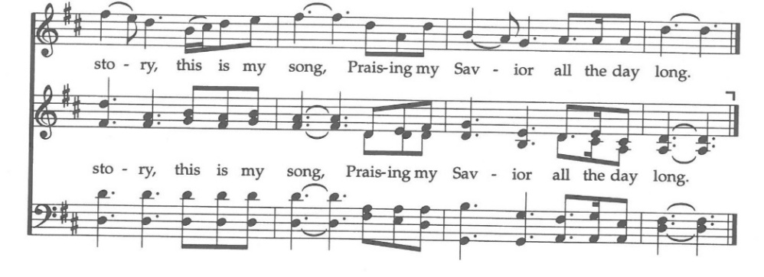
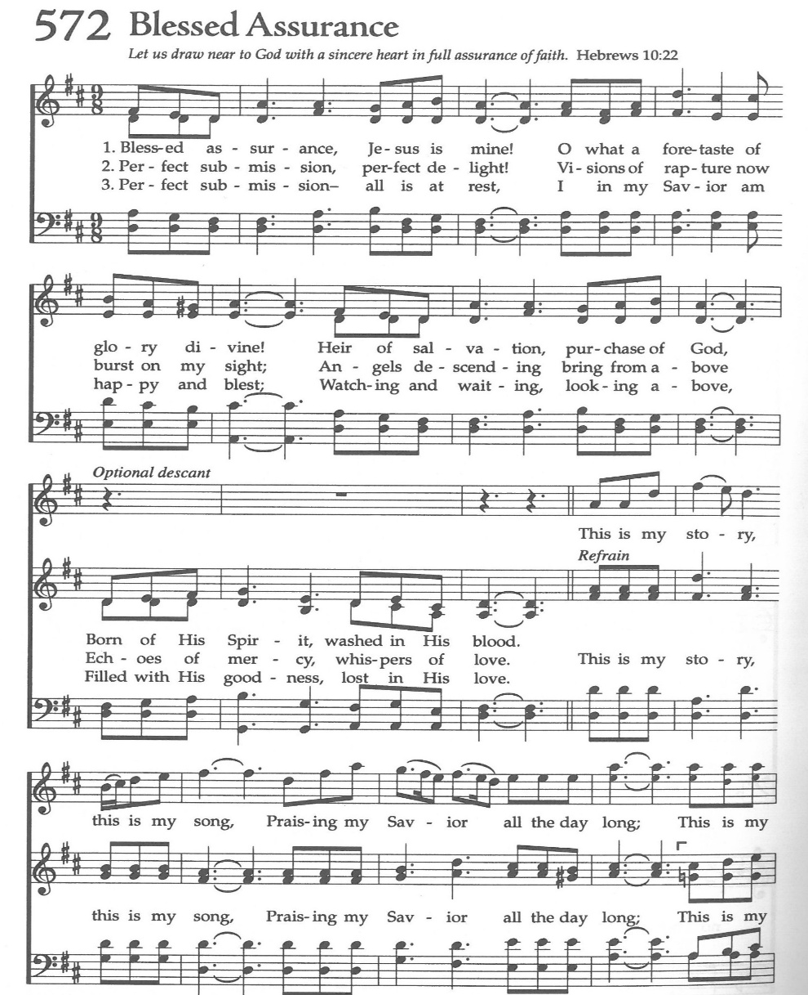
Opening Hymn: Blessed Assurance
Officiant: The Lord be with you.
People: And with your spirit.
Officiant: Let us pray.

O God, who by the glorious resurrection of your Son Jesus Christ
destroyed death and brought life and immortality to light: Grant that
your servant Reuben, being raised with Christ, may know the
strength of his presence and rejoice in his eternal glory; who with you
and the Holy Spirit lives and reigns, one God, for ever and ever.
Amen.
Philippians 4:6-9 Read by Kris Bratton
Reader: A Reading from Paul’s letter to the Philippians
⁶ Do not be anxious about anything, but in every situation, by prayer and petition, with thanksgiving, present your requests to God. ⁷ And the peace of God, which transcends all understanding, will guard your hearts and your minds in Christ Jesus.
⁸ Finally, brothers and sisters, whatever is true, whatever is noble, whatever is right, whatever is pure, whatever is lovely, whatever is admirable—if anything is excellent or praiseworthy—think about such things. ⁹ Whatever you have learned or received or heard from me, or seen in me—put it into practice. And the God of peace will be with you.
Reader: The Word of the Lord
People: Thanks be to God

Psalm Led by Ed Robinson
1 Praise the Lord, O my soul, *
and all that is within me, praise his holy Name.

2 Praise the Lord, O my soul, *
and forget not all his benefits:

3 Who forgives all your sin *
and heals all your infirmities,

4 Who saves your life from the pit *
and crowns you with mercy and loving-kindness,

5 Who satisfies you with good things, *
renewing your youth like an eagle’s.

6 The Lord executes righteousness and judgment *
for all those who are oppressed with wrong.

7 He showed his ways to Moses, *
his works to the children of Israel.

8 The Lord is full of compassion and mercy, *
long-suffering and of great goodness.

9 He will not always chide us, *
neither will he keep his anger for ever.

10 He has not dealt with us according to our sins, *
nor rewarded us according to our wickedness.

11 For as the heavens are high above the earth, *
so great is his mercy also toward those who fear him.

12 As far as the east is from the west, *
so far has he set our sins from us.

13 As a father pities his own children, *
so is the Lord merciful to those who fear him.

14 For he knows whereof we are made; *
he remembers that we are but dust.

15 The days of man are as grass; *
he flourishes as a flower of the field.

16 For as soon as the wind goes over it, it is gone, *
and its place shall know it no more.

17 But the merciful goodness of the Lord endures for ever and ever
upon those who fear him, *
and his righteousness upon children’s children,

18 Even upon those who keep his covenant *
and think upon his commandments to do them.

19 The Lord has prepared his throne in heaven, *
and his kingdom rules over all.

20 O praise the Lord, you angels of his, you that excel in strength, *
you that fulfill his commandment, and hearken unto the voice
of his words.

21 O praise the Lord, all you his hosts, *
you servants of his that do his pleasure.

22 O speak good of the Lord, all you works of his, in all places of his
dominion; *
praise the Lord, O my soul.

Glory be to the Father, and to the Son, and to the Holy Spirit;*
as it was in the beginning, is now, and ever shall be, world
without end. Amen

Romans 8:14-19, 34-35, 37-39 Read by Lydia Casteneda
Reader: A Reading from Paul’s letter to the Romans
All who are led by the Spirit of God are children of God. For you did not receive a spirit of slavery to fall back into fear, but you have received a spirit of adoption. When we cry, “Abba! Father!” it is that very Spirit bearing witness with our spirit that we are children of God, and if children, then heirs, heirs of God and joint heirs with Christ— if, in fact, we suffer with him so that we may also be glorified with him. I consider that the sufferings of this present time are not worth comparing with the glory about to be revealed to us. For the creation waits with eager longing for the revealing of the children of God;

Who is to condemn? It is Christ Jesus, who died, yes, who was raised, who is at the right hand of God, who indeed intercedes for us. Who will separate us from the love of Christ? Will hardship, or distress, or persecution, or famine, or nakedness, or peril, or sword?

No, in all these things we are more than conquerors through him who loved us. For I am convinced that neither death, nor life, nor angels, nor rulers, nor things present, nor things to come, nor powers, nor height, nor depth, nor anything else in all creation, will be able to separate us from the love of God in Christ Jesus our Lord.

Reader: The Word of the Lord
People: Thanks be to God

Psalm 46 Read by Kim Robinson

1 God is our refuge and strength, *
a very present help in trouble.

2 Therefore we will not fear, though the earth be moved, *
and though the hills be carried into the midst of the sea;

3 Though its waters rage and swell, *
and though the mountains shake at its tempest

4 There is a river whose streams make glad the city of God, *
the holy dwelling place of the Most High.

5 God is in the midst of her; therefore she shall not be moved. *
God shall help her at the break of day.

6 The nations are in an uproar, and the kingdoms are moved, *
but God has lifted his voice, and the earth shall melt away.

7 The Lord of hosts is with us; *
the God of Jacob is our refuge.

8 O come and behold the works of the Lord, *
what devastations he has brought upon the earth.

9 He makes wars to cease in all the world; *
he breaks the bow, and shatters the spear, and burns the
chariots in the fire.

10 “Be still then and know that I am God; *
I will be exalted among the nations, and I will be exalted in the earth.”

11 The Lord of hosts is with us; *
the God of Jacob is our refuge.

Glory be to the Father, and to the Son, and to the Holy Spirit;*
as it was in the beginning, is now, and ever shall be, world
without end. Amen
Revelation 7:9-17 Read by Joey Haas
Reader: A Reading from the Book of Revelation
After this I looked, and behold, a great multitude that no one could number, from every nation, from all tribes and peoples and languages, standing before the throne and before the Lamb, clothed in white robes, with palm branches in their hands, 10 and crying out with a loud voice, “Salvation belongs to our God who sits on the throne, and to the Lamb!” And all the angels were standing around the throne and around the elders and the four living creatures, and they fell on their faces before the throne and worshiped God, saying, “Amen! Blessing and glory and wisdom and thanksgiving and honor and power and might be to our God forever and ever! Amen.” Then one of the elders addressed me, saying, “Who are these, clothed in white robes, and from where have they come?” I said to him, “Sir, you know.” And he said to me, “These are the ones coming out of the great tribulation. They have washed their robes and made them white in the blood of the Lamb. “Therefore they are before the throne of God, and serve him day and night in his temple; and he who sits on the throne will shelter them with his presence. They shall hunger no more, neither thirst anymore; the sun shall not strike them, nor any scorching heat. For the Lamb in the midst of the throne will be their shepherd, and he will guide them to springs of living water, and God will wipe away every tear from their eyes.”

Reader: The word of the Lord.
People: Thanks be to God.

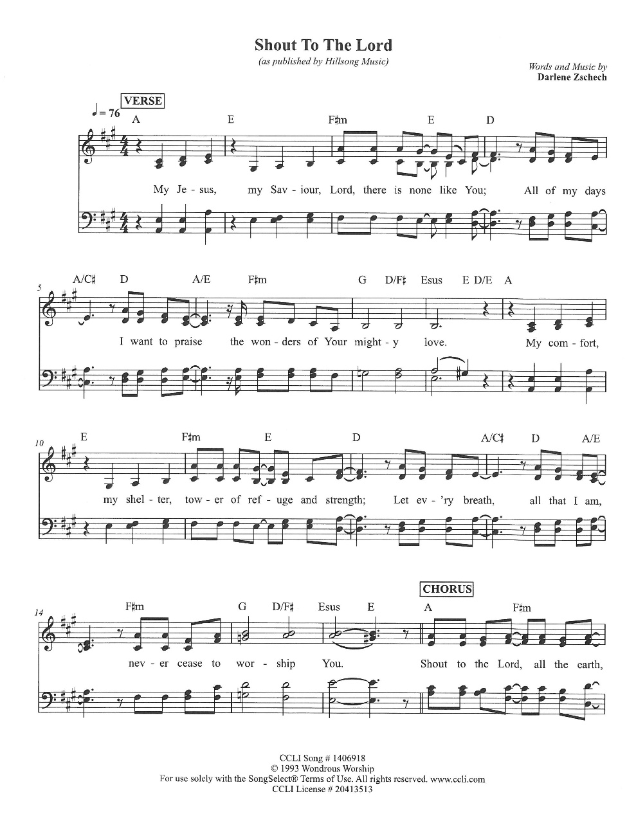
Congregational Hymn: Shout to the Lord

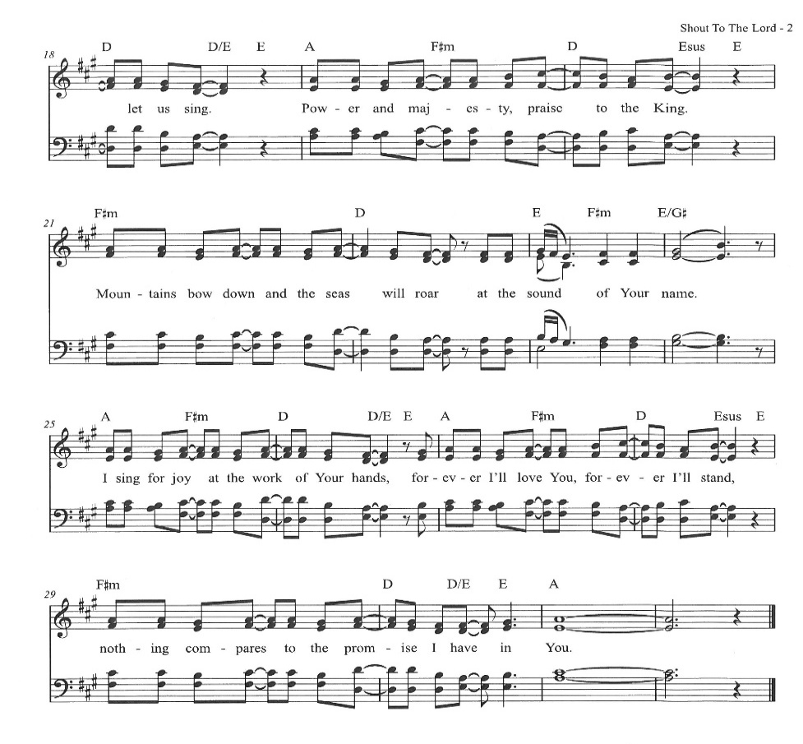
Gospel: Matthew 25:31-40 Read by The Rev. John Iseman

Clergy The Holy Gospel of Our Lord Jesus Christ, according to
St. Matthew
People Glory to you, Lord Christ

³¹ “When the Son of Man comes in his glory, and all the angels with him, then he will sit on his glorious throne. ³² Before him will be gathered all the nations, and he will separate people one from another as a shepherd separates the sheep from the goats. ³³ And he will place the sheep on his right, but the goats on the left. ³⁴ Then the King will say to those on his right, ‘Come, you who are blessed by my Father, inherit the kingdom prepared for you from the foundation of the world. ³⁵ For I was hungry and you gave me food, I was thirsty and you gave me drink, I was a stranger and you welcomed me, ³⁶ I was naked and you clothed me, I was sick and you visited me, I was in prison and you came to me.’ ³⁷ Then the righteous will answer him, saying, ‘Lord, when did we see you hungry and feed you, or thirsty and give you drink? ³⁸ And when did we see you a stranger and welcome you, or naked and clothe you? ³⁹ And when did we see you sick or in prison and visit you?’ ⁴⁰ And the King will answer them, ‘Truly, I say to you, as you did it to one of the least of these my brothers, you did it to me.’

Clergy The Gospel of the Lord
People Praise to you Lord Christ

Homily
The Rev. Robert Longbottom

The Apostles Creed

Officiant: Let us confess the Faith in the words of the Apostles’
Creed:

Officiant and People

I believe in God, the Father almighty,
creator of heaven and earth.
I believe in Jesus Christ, his only Son, our Lord.
He was conceived by the Holy Spirit
and born of the Virgin Mary.
He suffered under Pontius Pilate,
was crucified, died, and was buried.
He descended to the dead.
On the third day he rose again.
He ascended into heaven,
and is seated at the right hand of the Father.
He will come again to judge the living and the dead.
I believe in the Holy Spirit,
the holy catholic Church,
the communion of saints,
the forgiveness of sins,
the resurrection of the body,
and the life everlasting. Amen

The Prayers of the People
Led by Ed Robinson

Let us pray, saying, “Hear our prayer.”

Almighty God, you knit together your elect in one communion and fellowship, in the mystical body of your Son Jesus Christ our Lord: Grant, we pray, to your whole Church in heaven and on earth, your light and peace.

Reader Lord, in your mercy:
People Hear our prayer.

Grant that all who have been baptized into Christ’s death and resurrection may die to sin and rise to newness of life, that through the grave and gate of death we may pass with him to our joyful resurrection.
Reader Lord, in your mercy:
People Hear our prayer.

Grant to us who are still in our pilgrimage, and who walk as yet by faith, that your Holy Spirit may lead us in holiness and righteousness all our days.
Reader Lord, in your mercy:
People Hear our prayer.

Grant to your faithful people pardon and peace, that we may be cleansed from all our sins, and serve you in faithful obedience.

Reader Lord, in your mercy:
People Hear our prayer.

Grant to all who mourn a sure confidence in your fatherly care, that, casting their grief on you, they may know the consolation of your love.

Reader Lord, in your mercy:
People Hear our prayer.

Help us, we pray, in the midst of things we cannot understand, to believe and trust in the communion of saints, the forgiveness of sins, and the resurrection to life everlasting.

Reader Lord, in your mercy:
People Hear our prayer.

Grant us grace to entrust Reuben to your never-failing love; receive him into the arms of your mercy, and remember him according to the favor which you show to all your people.

Reader Lord, in your mercy:
People Hear our prayer.

Grant that, increasing in knowledge and love of you, he may go from strength to strength in the life of perfect service in your heavenly kingdom.

Reader Lord, in your mercy:
People Hear our prayer.

Celebrant Almighty God, grant us, with all who have died in the hope of the resurrection, the fullness of life in your eternal and ever-lasting glory, and, with all your saints, to receive the crown of life promised to all who share in the victory of your Son Jesus Christ, who lives and reigns with you and the Holy Spirit, one God, for ever and ever. Amen.

The Peace and Announcements

Celebrant The Peace of the Lord be always with you.
People And with your spirit.

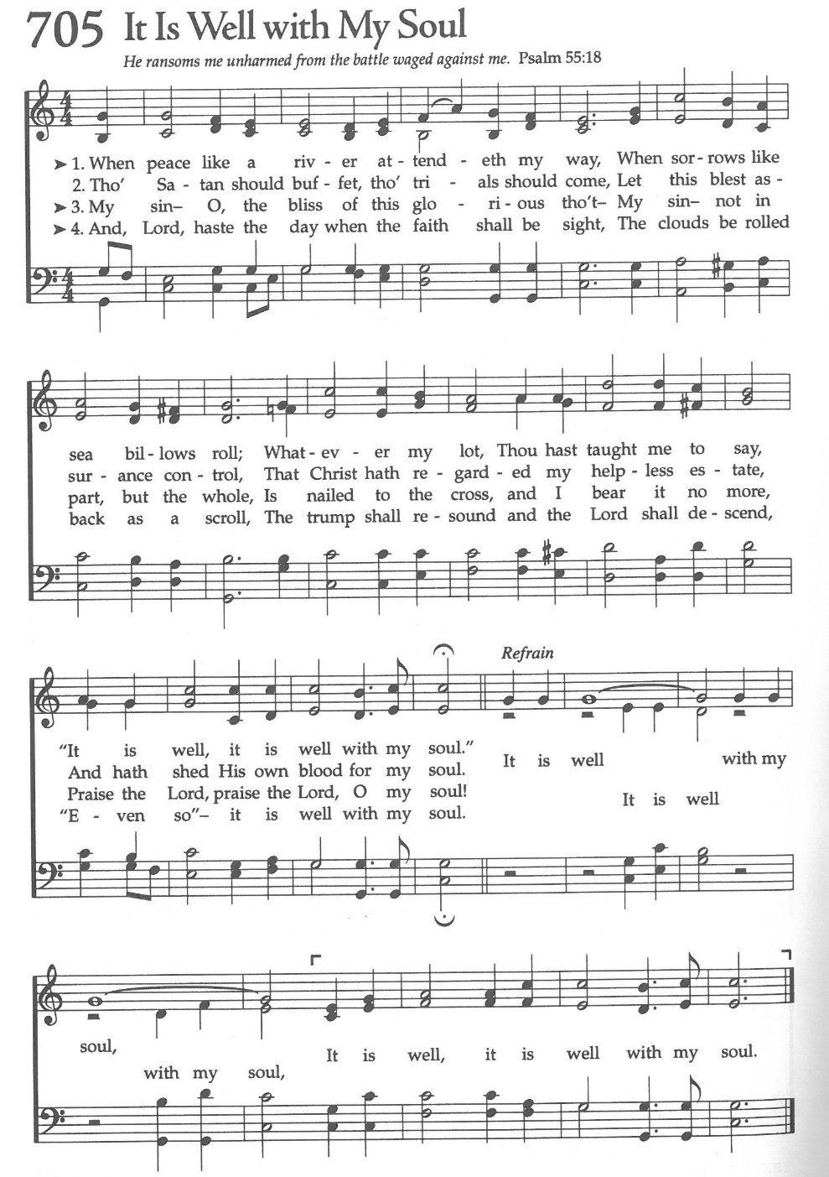
Offertory Anthem: It Is Well with My Soul

The Doxology
(Verse 3 only)

The Eucharistic Liturgy

Sursum Corda

The People remain standing. The Celebrant faces them and says

The Lord be with you.
People And with your spirit.
Celebrant Lift up your hearts.
People We lift them up to the Lord.
Celebrant Let us give thanks to the Lord our God.
People It is right to give him thanks and praise.

It is right, our duty and our joy, always and everywhere to give thanks to you, Father Almighty, Creator of heaven and earth.

Through Jesus Christ our Lord, who rose victorious from the dead and comforts us with the blessed hope of everlasting life. For to your faithful people, O Lord, life is changed, not ended; and when our mortal body lies in death, there is prepared for us a dwelling place eternal in the heavens.

Therefore, we praise you, joining our voices with Angels and Archangels and with all the company of heaven, who forever sing this hymn to proclaim the glory of your Name.

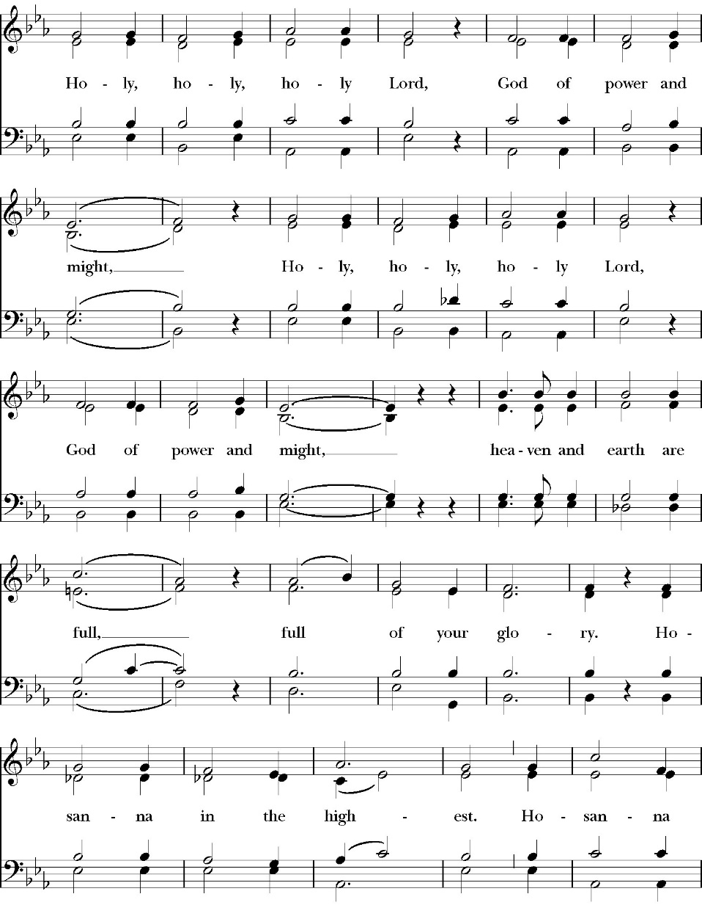
The Sanctus

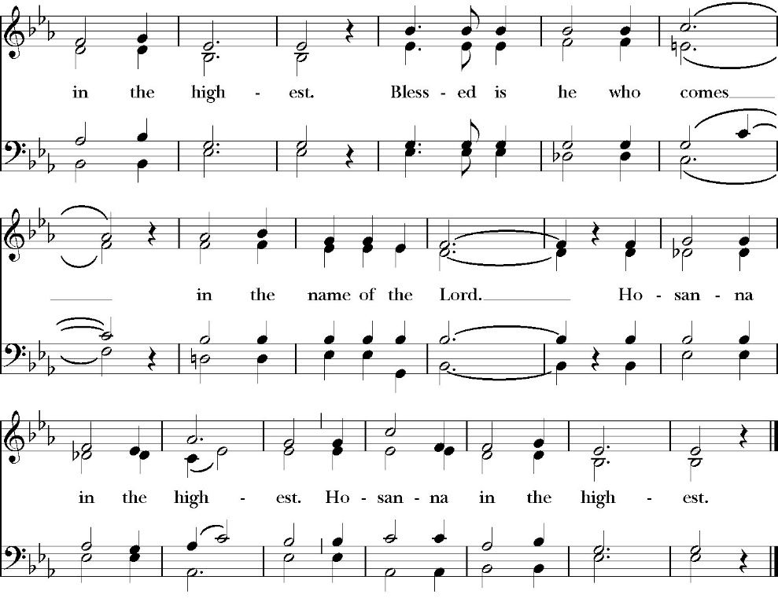
The Prayer of Consecration

Holy and gracious Father: In your infinite love you made us for yourself; and when we had sinned against you and become subject to evil and death, you, in your mercy, sent your only Son Jesus Christ into the world for our salvation. By the Holy Spirit and the Virgin Mary he became flesh and dwelt among us. In obedience to your will, he stretched out his arms upon the Cross and offered himself once for all, that by his suffering and death we might be saved. By his resurrection he broke the bonds of death, trampling Hell and Satan under his feet. As our great high priest, he ascended to your right hand in glory, that we might come with confidence before the throne of grace.

On the night that he was betrayed, our Lord Jesus Christ took bread; and when he had given thanks, he broke it,* and gave it to his disciples, saying, “Take, eat; this is my Body, which is given for you: Do this in remembrance of me.”

Likewise, after supper, Jesus took the cup, and when he had given thanks, he gave it to them, saying, “Drink this, all of you; for this is my Blood of the New Covenant, which is shed for you, and for many, for the forgiveness of sins: Whenever you drink it, do this in remembrance of me.”

Therefore we proclaim the mystery of faith:

Celebrant and People

Christ has died.
Christ is risen.
Christ will come again.

We celebrate the memorial of our redemption, O Father, in this sacrifice of praise and thanksgiving, and we offer you these gifts.

Sanctify them by your Word and Holy Spirit to be for your people the Body and Blood of your Son Jesus Christ. Sanctify us also, that we may worthily receive this holy Sacrament, and be made one body with him, that he may dwell in us and we in him. In the fullness of time, put all things in subjection under your Christ, and bring us with all your saints into the joy of your heavenly kingdom, where we shall see our Lord face to face.

All this we ask through your Son Jesus Christ: By him, and with him, and in him, in the unity of the Holy Spirit, all honor and glory is yours, Almighty Father, now and forever. Amen.

And now, as our Savior Christ has taught us, we are bold to pray,

Celebrant and people together pray

Our Father, who art in heaven,
hallowed be thy Name,
thy kingdom come,
thy will be done,
on earth as it is in heaven.
Give us this day our daily bread.
And forgive us our trespasses,
as we forgive those
who trespass against us.
And lead us not into temptation,
but deliver us from evil.
For thine is the kingdom,
and the power, and the glory,
for ever and ever. Amen.

Celebrant Alleluia! Christ our Passover is sacrificed for us.
People Therefore let us keep the feast. Alleluia!

We do not presume to come to this your table, O merciful Lord,
trusting in our own righteousness,
but in your abundant and great mercies.
We are not worthy so much as to gather up
the crumbs under your table;
but you are the same Lord
whose character is always to have mercy.
Grant us, therefore, gracious Lord,
so to eat the flesh of your dear Son Jesus Christ,
and to drink his blood,
that our sinful bodies may be made clean by his body,
and our souls washed through his most precious blood,
and that we may evermore dwell in him, and he in us. Amen.

The Agnus Dei

The Ministration of Communion

The gifts of God for the People of God. [Take them in remembrance that Christ died for you and feed on him in your hearts by faith, with thanksgiving.

All Baptized Christians regardless of denomination and who are walking in the Christian faith are welcome to recevie Holy Communion.

Communion Hymns

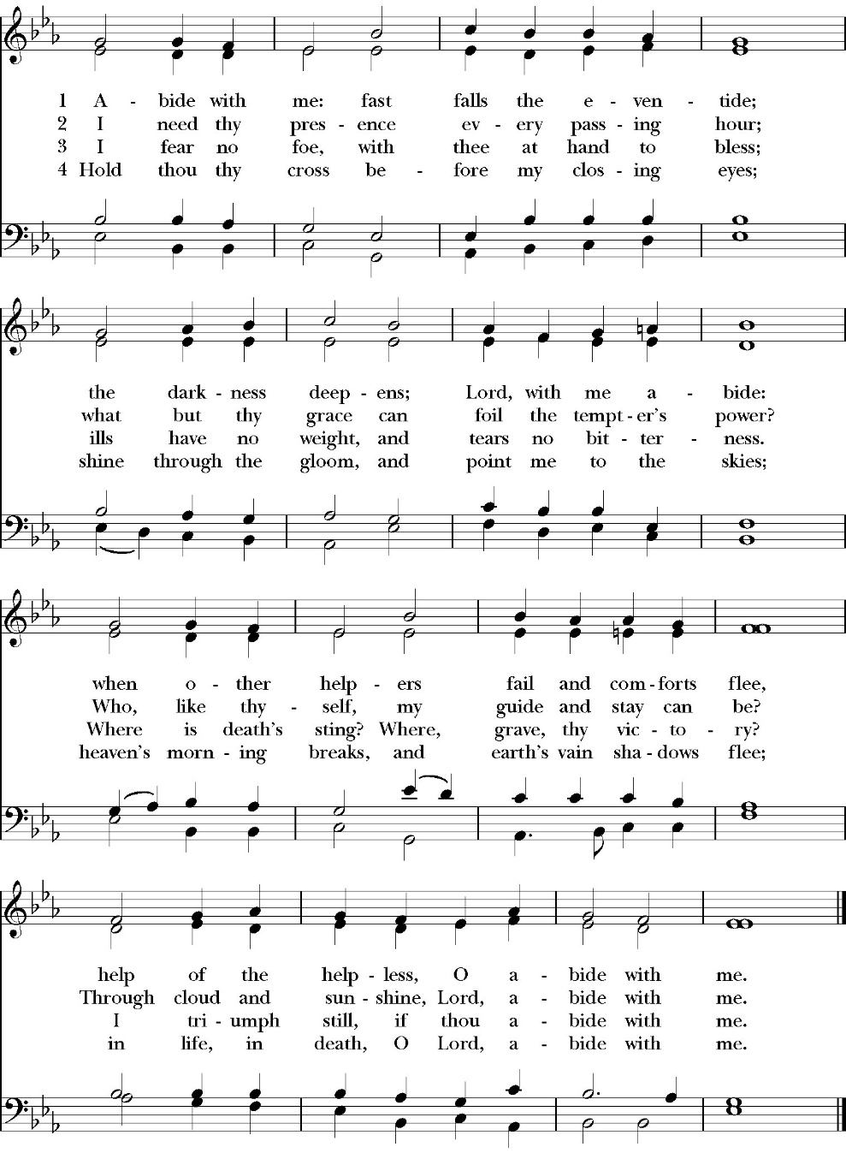
Abide with Me

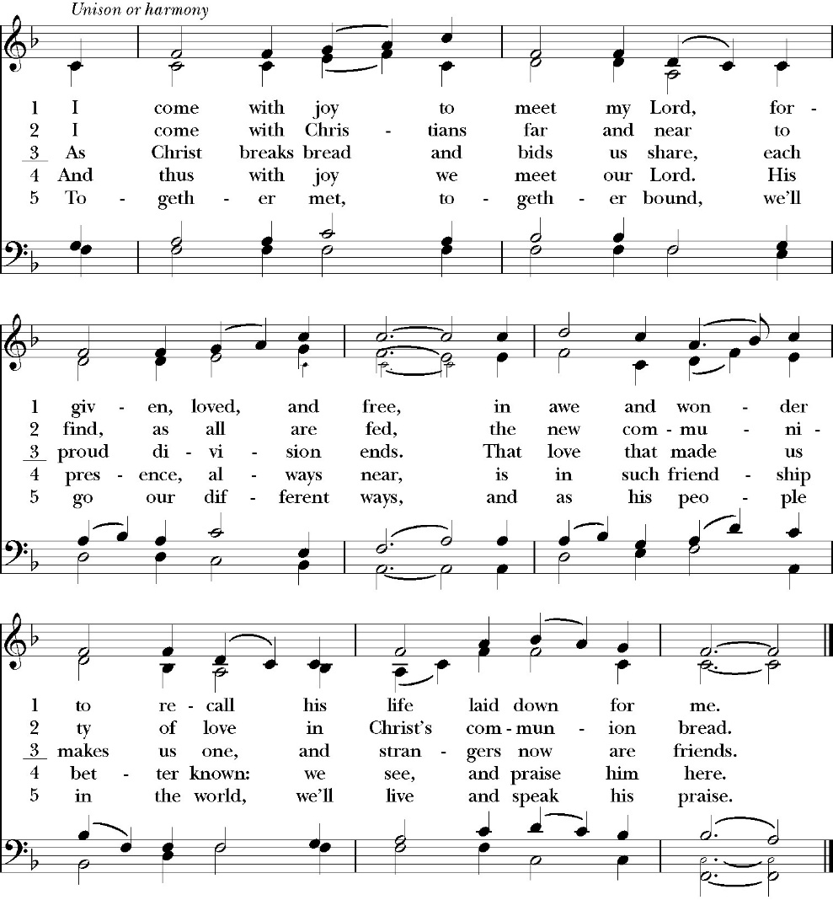
I come with Joy to meet my lord

In Christ Alone
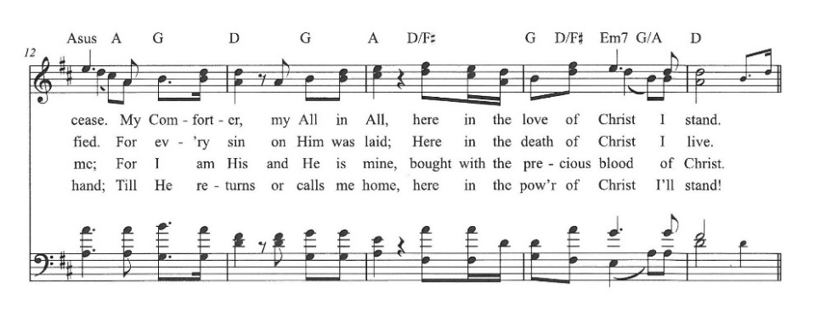
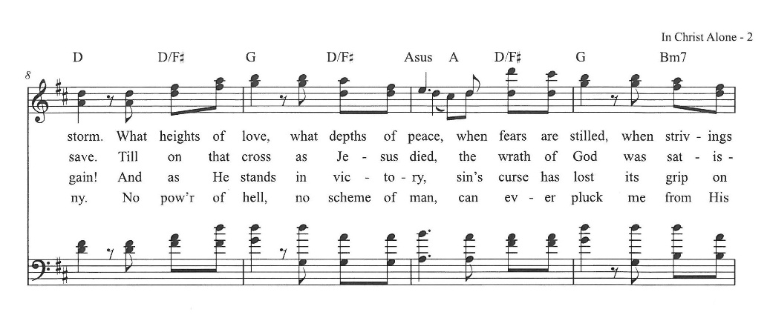
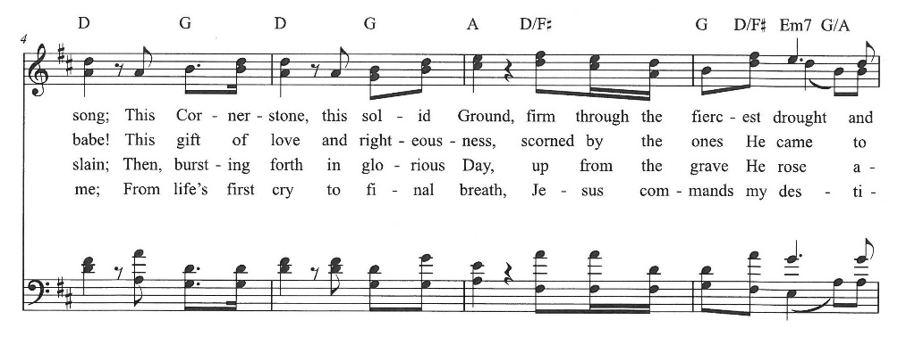
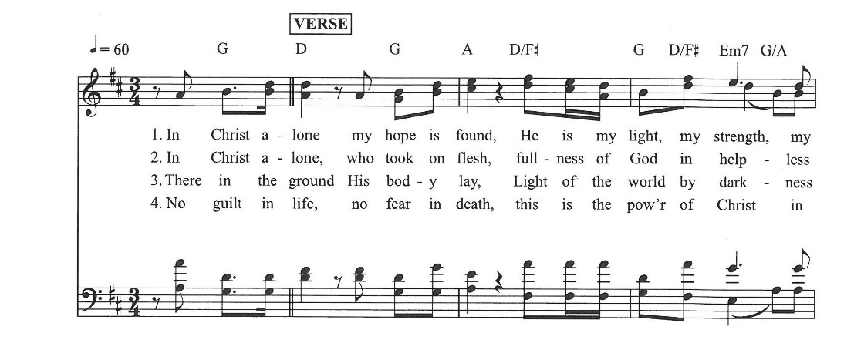
(Keith Getty & Stuart Townend)
The Post Communion Prayer

Let us pray.

Almighty God, we thank you that in your great love you have fed us with the spiritual food and drink of the Body and Blood of your Son Jesus Christ, and have given us a foretaste of your heavenly banquet. Grant that this Sacrament may be to us a comfort in affliction, and a pledge of our inheritance in that kingdom where there is no death, neither sorrow nor crying, but the fullness of joy with all your saints; through Jesus Christ our Savior. Amen.

The Commendation

Officiant Give rest, O Christ, to your servant with your saints,
All Where sorrow and pain are no more, neither sighing,
but life everlasting.
Officiant You only are immortal, the creator and maker of mankind; and we are mortal, formed of the earth, and to earth shall we return. For so did you decree, saying, “You are dust, and to dust you shall return.” All of us go down to the dust; yet even at the grave we make our song:
Alleluia, alleluia, alleluia.
All Give rest, O Christ, to your servant with your saints, where sorrow and pain are no more, neither sighing, but life everlasting.

Officiant Into your hands, O merciful Savior, we commend your servant Reuben. Acknowledge, we humbly beseech you, a sheep of your own fold, a lamb of your own flock, a sinner of your own redeeming. Receive him into the arms of your mercy, into the blessed rest of everlasting peace, and into the glorious company of the saints in light. Amen.

Officiant Alleluia, alleluia. Let us go forth in the Name of Christ.
All Thanks be to God. Alleluia, alleluia

Closing Hymn: O for a thousand tongues to sing
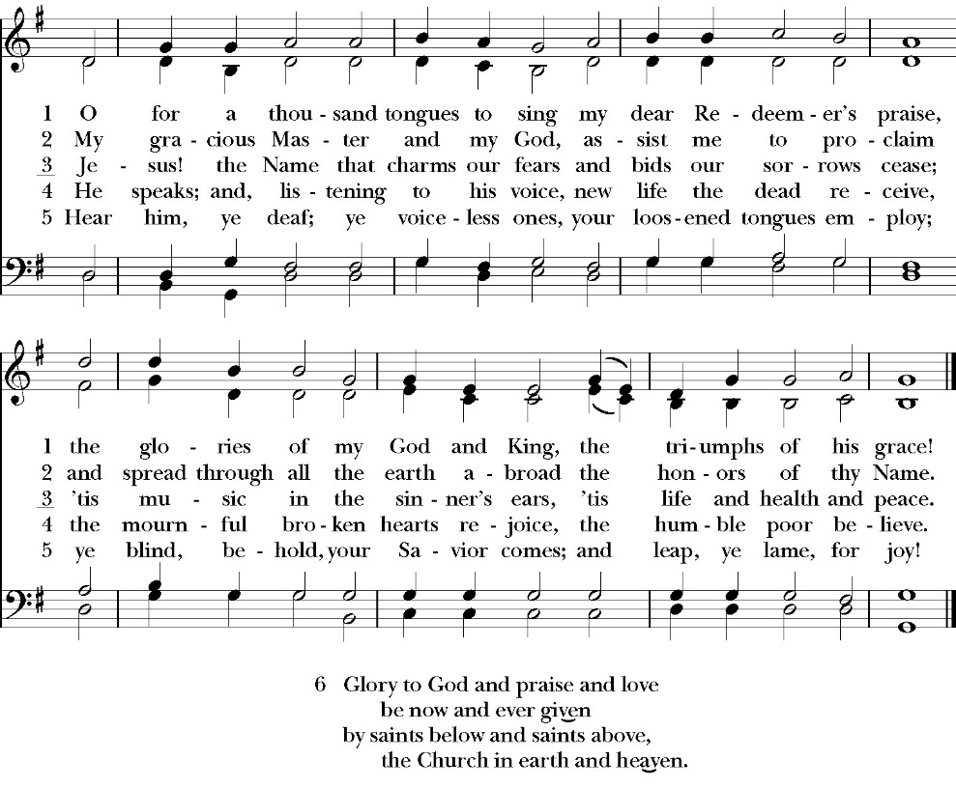

Reuben Garcia Obituary
October 15, 1954-October 15, 2025

God’s heavenly angels took Reuben (Bobo) Christopher Garcia home on October 15, 2025 at age 71. He was a loving husband, brother, uncle, and friend that will be deeply missed by all who knew him.

Reuben was born on October 15, 1954 in Hanford, CA to Apolonio and Eva Garcia. He attended Lincoln Elementary, Woodrow Wilson Junior High, and Hanford High School. Reuben graduated from Fresno State with a bachelor’s degree in Food Science. He practiced his degree as he worked as a quality assurance specialist for food and beverage companies for over 50 years in Tulare/Fresno County. In addition to his work, Reuben was also involved in the Visalia Rotary Club and as a member of the Visalia Arts Council.

Reuben was a devoted Christian who cherished the teaching of Jesus and was a faithful congregate to his church. Over the years, he enjoyed being an altar boy, a junior warden, an usher, and involving himself with many other church activities. During family gatherings, Reuben would always pull out his Bible after dinner to read a passage from the book of Psalms. Reuben’s joy in the Lord shone through in his loving actions and his willingness to serve others.

As a young boy, Reuben cherished the times he spent with his parents Apolonio and Eva. His mother, Eva, was a stay-at-home mom and one of Reuben’s favorite past times was listening to music with her. These moments sparked his passion for all different types of music and grew his interest in the arts. Reuben’s father, Apolonio, worked as an independent truck driver that delivered produce and other commodities. Some of Reuben’s favorite memories were the times he was able to join his father and his brothers on deliveries in the work truck.

Reuben loved spending time with his wife, Margie, of 21 years. Their favorite things to do together were working in their yard and traveling to the central coast where they walked the beach, went wine tasting, and enjoyed dinners together at their favorite restaurant, The Sea Chest. Reuben also enjoyed spending time with extended family on birthday’s, Thanksgiving, and Christmas. His nieces and nephews always cherished the moments when they got to hang out with their Tio Reuben. In addition to spending time with family, one of Reuben’s favorite hobbies was sports. When he was younger, he was a part of a group of friends that loved to play sports together and called themselves the “city tramps”. Reuben also appreciated watching sports, especially baseball. He always rooted for the San Francisco Giants!

Reuben was preceded in death by his parents Apolonio and Eva (Hinojosa) Garcia, his brothers Apolonio Jr., Ricky, Tommy, and Ralph, as well as his sisters Eleanor and Anita. Reuben is survived by his loving wife Margie, his sister Virginia and husband Bill, his brother Robert and wife Cora, and his sister Sally and husband Dana, and his sister in law Cindy(Ralph's wife). Reuben will be deeply missed by his wife, siblings, nephews, nieces, cousins, and friends. Reuben will be remembered for his kindness, generosity, caring heart, and love for all who knew him. You will be missed our dear Reuben. Thank you for sharing your love with us!!!

“And to those who have no might, He increases strength. Even the youths shall faint and be weary, and the young men shall utterly fall, but those who wait on the Lord shall renew their strength; they shall mount up with wings like eagles, they shall run and not be weary, they shall walk and not faint.” Isaiah 40:29-31

A memorial service will be held at 10:30 a.m. on Saturday, November 15, 2025 at St. Paul’s Anglican Church, 6436 West Hurley Ave, Visalia CA 93291 (559) 732-4821.

In lieu of flowers donations may be made in memory of Reuben Garcia to St. Paul’s Anglican church children’s ministries or The American Cancer Society.

St. Paul’s Anglican Church
6436 West Hurley Avenue
Visalia, California 93291

Worship: Sundays at 10:30 A.M.
Livestream: Link at spvisalia.com/media
and on our Facebook an YouTube pages

St. Paul’s Clergy and Staff
The Rt. Rev. Eric V. Meness, Bishop
The Rev. Robert Longbottom, Rector
rector@spvisalia.com
The Rev. John Iseman, Pastoral Associate for Family Ministries
family@spvisalia.com
The Rev. Kashy Rowland-Smith, Deacon
Antoinette Horsting, Bookkeeper
bookkeeper@spvisalia.com
Cyndi Culp, Vocal Choral Director
Marguerite Crownover, Organist/Accompanist
Jackie Iseman, Nursery Coordinator
Shane Motl, Sexton

Ministers of the service:

Officiant: The Rev. Robert J D. Longbottom
Assisting: The Rev. John Iseman
Lay Eucharistic Minister: Mr. Ed Robinson
Chalice Bearers: Lydia Castenada
Readers: Ed Robinson, Kris Bratton,
Lydia Castaneda, Kim Robinson

Organist: Marguerite Crownover

