ST. PAUL’S
ANGLICAN CHURCH
VISALIA, CALIFORNIA

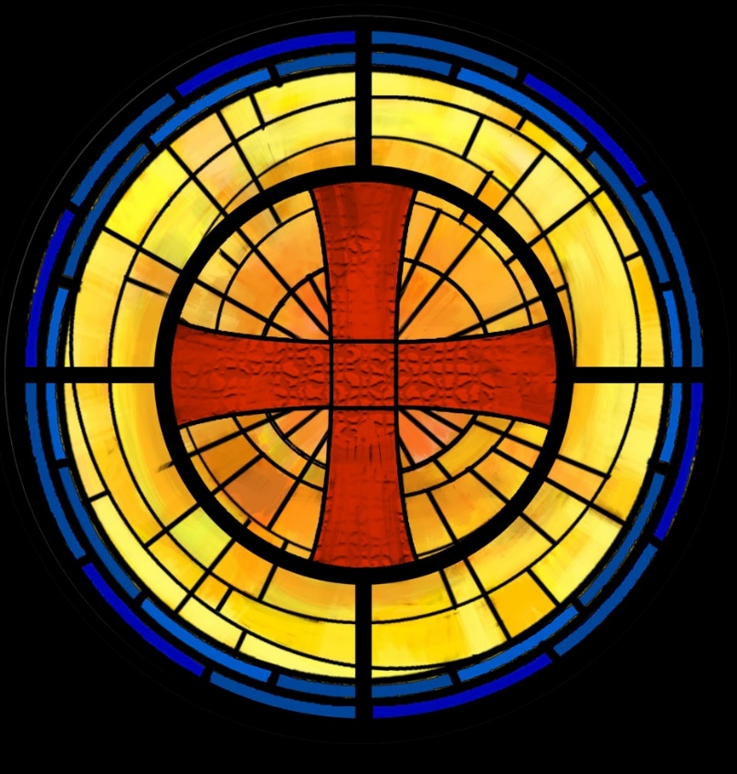

Twentieth Sunday after Pentecost
October 26, 2025
10:30 A.M

Welcome!

St. Paul’s Anglican Church extends a warm welcome to all visitors and newcomers, whether worshiping in person or at home via livestream.

Visitors’ Guide

St. Paul’s Church is a parish in the Diocese of San Joaquin of the Anglican Church in North America, which includes both Catholic and Protestant traditions. We accept Jesus Christ as Savior, and we promise to follow him as Lord. We believe in One God,

- the Father who created us and all things,
- the Son who redeems us from sin and death,
- the Holy Spirit who renews and sanctifies us.

We believe the Holy Scriptures to be the Word of God and to contain all things necessary for salvation, and we accept the Apostles’ and Nicene Creeds as essential beliefs of the Christian faith.

All followers of Jesus who are baptized in the name of the Trinity are invited to receive Holy Communion. If for whatever reason you feel you cannot receive communion, we invite you to come forward to receive a blessing. Please indicate you’d like a blessing by crossing your arms. All people are welcome at the Altar of the Lord.

Visitors are invited to sign the guest book at the entrance table and introduce themselves to the clergy following the service.

The Holy Eucharist

Prelude: “Prelude and Fugue in E Minor” Bach
Opening Hymn: #398 – “I Sing the Almighty Power of God” p. 4
Opening Acclamation p. 5
The Collect for Purity p. 5
Summary of the Law p. 5
Kyrie p. 5
Gloria p. 6
Collect of the Day p. 7
Lesson: Jeremiah 14 :1-10, 19-22 p. 7
Gradual: Psalm 84 p. 8
Epistle: 2 Timothy 4:6-18 p. 9
Sequence Hymn: #656 – “Blest Are the Pure in Heart” p. 10
Gospel: Luke 18:9-14 p. 10
Homily: The Rev. Robert Longbottom
Nicene Creed p. 11
Prayers of the People p. 12
The Peace p. 14
Offertory: “Above All” Choir
The Offertory p. 15
Sursum Corda p. 15
Sanctus p. 16
The Lord’s Prayer p. 18
Fraction p. 19
Prayer for Humble Access p. 19
Agnus Dei p. 19
Communion: Praise Song – “Better Is One Day” p. 20
Post Communion Prayer p. 24
Blessing p. 24
Closing Hymn: #620 – “Jerusalem, My Happy Home” p. 25
Dismissal p. 25
Postlude: “Rejoice Ye Pure in Heart” Hobby

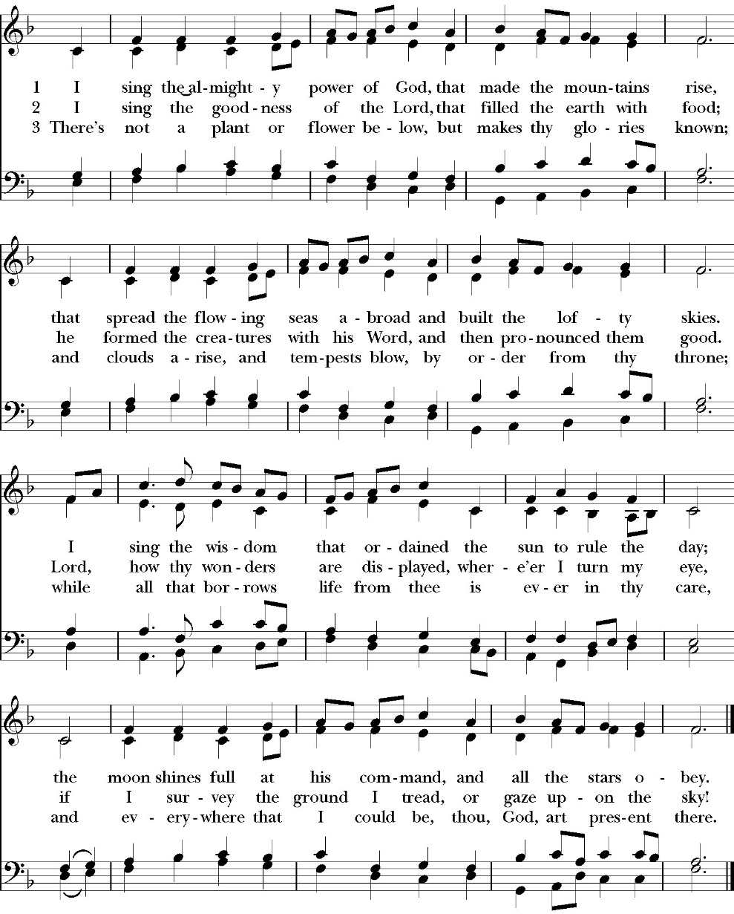
Opening Hymn: I Sing the Almighty Power of God

Opening Acclamation

Celebrant Blessed be God: the Father, the Son, and the Holy Spirit. People And blessed be his kingdom, now and for ever.
Amen.

Collect for Purity

People: Almighty God, to you all hearts are open, all desires
known, and from you no secrets are hid: Cleanse the thoughts of our hearts by the inspiration of your Holy Spirit, that we may perfectly love you, and worthily magnify your holy Name; through Christ our Lord. Amen.

Summary of the law

Celebrant: Hear what our Lord Jesus Christ says: You shall love the Lord your God with all your heart and with all your soul
and with all your mind. This is the first and great commandment. And the second is like it: You shall love your neighbor as yourself. On these two commandments depend all the Law and the Prophets.

The Kyrie
Gloria

Celebrant The Lord be with you.
People And with your spirit.
Celebrant Let us pray.

The Collect of the Day

Almighty and everlasting God, you govern all things both in heaven and on earth: Mercifully hear the supplications of your people, and in our time grant us your peace; through Jesus Christ our Lord, who lives and reigns with you and the Holy Spirit, one God, for ever and ever. Amen.

Lesson: Jeremiah 14:1-10,19-22

The word of the LORD that came to Jeremiah concerning the drought:

2 “Judah mourns, and her gates languish; her people lament on the ground, and the cry of Jerusalem goes up. 3 Her nobles send their servants for water; they come to the cisterns; they find no water; they return with their vessels empty; they are ashamed and confounded and cover their heads. 4 Because of the ground that is dismayed, since there is no rain on the land, the farmers are ashamed; they cover their heads.

5 Even the doe in the field forsakes her newborn fawn because there is no grass. 6 The wild donkeys stand on the bare heights; they pant for air like jackals; their eyes fail because there is no vegetation.

7 “Though our iniquities testify against us, act, O LORD, for your name’s sake; for our backslidings are many; we have sinned against you. 8 O you hope of Israel, its savior in time of trouble, why should you be like a stranger in the land, like a traveler who turns aside to tarry for a night? 9 Why should you be like a man confused, like a mighty warrior who cannot save? Yet you, O LORD, are in the midst of us, and we are called by your name; do not leave us.”

10 Thus says the LORD concerning this people: “They have loved to wander thus; they have not restrained their feet; therefore the LORD does not accept them; now he will remember their iniquity and punish their sins.”

19 Have you utterly rejected Judah? Does your soul loathe Zion? Why have you struck us down so that there is no healing for us? We looked for peace, but no good came; for a time of healing, but behold, terror.

20 We acknowledge our wickedness, O LORD, and the iniquity of our fathers, for we have sinned against you. 21 Do not spurn us, for your name’s sake; do not dishonor your glorious throne; remember and do not break your covenant with us. 22 Are there any among the false gods of the nations that can bring rain? Or can the heavens give showers? Are you not he, O LORD our God? We set our hope on you, for you do all these things.

Reader: The Word of the Lord
People: Thanks be to God

Gradual: Psalm 84
1How lovely are your dwellings, *
O LORD God of hosts!
2 My soul has a desire and longing to enter into the courts of the LORD; *
my heart and my flesh rejoice in the living God.
3 Indeed, the sparrow has found her a house, and the swallow a nest where she may lay her young, *
even your altars, O LORD of hosts, my King and my God.
4 Blessed are they who dwell in your house; *
they will be always praising you.
5 Blessed is the one whose strength is in you, *
in whose heart are your ways,
6 Who going through the valley of misery uses it for a well; *
indeed, the early rains fill the pools with water.
7 They will go from strength to strength, *
and the God of gods shall be seen by them in Zion.
8 O LORD God of hosts, hear my prayer; *
hearken, O God of Jacob.
9 Behold, O God, our defender, *
and look upon the face of your Anointed.
10 For one day in your courts *
is better than a thousand;

11 I would rather be a door-keeper in the house of my God *
than dwell in the tents of ungodliness.
12 For the LORD God is a light and defense; *
the LORD will give grace and honor, and no good thing shall he withhold from those who live a godly life.
13 O LORD God of hosts, *
blessed is the one who puts his trust in you.

Glory be to the Father, and to the Son, and to the Holy Spirit;
as it was in the beginning, is now, and ever shall be, world without end. Amen

Epistle: 2 Timothy 4:6-18
For I am already being poured out as a drink offering, and the time of my departure has come. 7 I have fought the good fight, I have finished the race, I have kept the faith. 8 Henceforth there is laid up for me the crown of righteousness, which the Lord, the righteous judge, will award to me on that day, and not only to me but also to all who have loved his appearing.

9 Do your best to come to me soon. 10 For Demas, in love with this present world, has deserted me and gone to Thessalonica. Crescens has gone to Galatia, Titus to Dalmatia. 11 Luke alone is with me. Get Mark and bring him with you, for he is very useful to me for ministry. 12 Tychicus I have sent to Ephesus. 13 When you come, bring the cloak that I left with Carpus at Troas, also the books, and above all the parchments. 14 Alexander the coppersmith did me great harm; the Lord will repay him according to his deeds. 15 Beware of him yourself, for he strongly opposed our message. 16 At my first defense no one came to stand by me, but all deserted me. May it not be charged against them! 17 But the Lord stood by me and strengthened me, so that through me the message might be fully proclaimed and all the Gentiles might hear it. So I was rescued from the lion's mouth. 18 The Lord will rescue me from every evil deed and bring me safely into his heavenly kingdom. To him be the glory forever and ever. Amen.

Reader: The Word of the Lord
People: Thanks be to God

Sequence Hymn: Blest Are the Pure in Heart
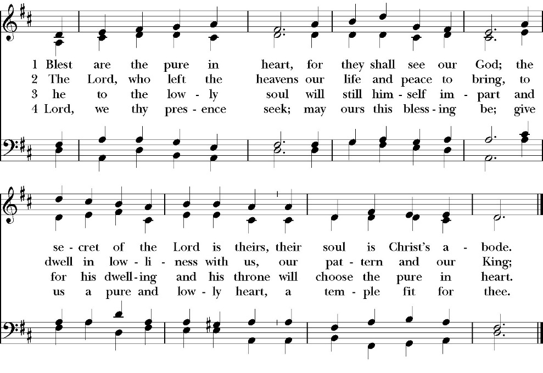
(Verse 1-3 before Gospel and verse 4 after)

Clergy: The Holy Gospel of Our Lord Jesus Christ,
according to St. Luke
People: Glory to you, Lord God

Gospel: Luke 18:9-14
He also told this parable to some who trusted in themselves that they were righteous, and treated others with contempt: 10 “Two men went up into the temple to pray, one a Pharisee and the other a tax collector.

11 The Pharisee, standing by himself, prayed thus: ‘God, I thank you that I am not like other men, extortioners, unjust, adulterers, or even like this tax collector. 12 I fast twice a week; I give tithes of all that I get.’ 13 But the tax collector, standing far off, would not even lift up his eyes to heaven, but beat his breast, saying, ‘God, be merciful to me, a sinner!’ 14 I tell you, this man went down to his house justified, rather than the other. For everyone who exalts himself will be humbled, but the one who humbles himself will be exalted.”

Clergy: The Gospel of the Lord
People: Praise to you, Lord Christ
Sermon
The Rev. Robert Longbottom

The Nicene Creed

The people stand

We believe in one God,
the Father, the Almighty,
maker of heaven and earth,
of all that is, visible and invisible.
We believe in one Lord, Jesus Christ,
the only-begotten Son of God,
eternally begotten of the Father,
God from God, Light from Light,
true God from true God,
begotten, not made,
of one Being with the Father.
through him all things were made.
For us and for our salvation he came down from heaven:
was incarnate from the Holy Spirit and the Virgin Mary,
and was made man.
For our sake he was crucified under Pontius Pilate;
he suffered death and was buried.
On the third day he rose again in accordance with the
Scriptures;
he ascended into heaven
and is seated at the right hand of the Father.
He will come again in glory to judge the living and the dead,
and his kingdom will have no end.
We believe in the Holy Spirit, the Lord, the giver of life,
who proceeds from the Father and the Son,
who with the Father and the Son is worshiped and glorified.
who has spoken through the Prophets.
We believe in one holy catholic and apostolic Church.
We acknowledge one Baptism for the forgiveness of sins.
We look for the resurrection of the dead,
and the life of the world to come. Amen.

The Prayers of the People
The People kneel or are seated if unable to kneel
The Deacon or other person appointed says these prayers. Reader pauses after each bidding, and the people may add petitions, either silently or aloud.
Let us pray for the Church and for the world, saying,
“Hear our prayer.”

For the peace of the whole world, and for the well-being and unity of the people of God.

Reader Lord, in your mercy:
People Hear our prayer.

For Stephen, our Archbishop, and Eric, our Bishop, and for all the clergy and people of our Diocese and Congregation.

Reader Lord, in your mercy:
People Hear our prayer.

For all those who proclaim the Gospel at home and abroad; and for all who teach and disciple others.

Reader Lord, in your mercy:
People Hear our prayer.

For our brothers and sisters in Christ who are persecuted for their faith.

Reader Lord, in your mercy:
People Hear our prayer.

For our nation, for those in authority, and for all in public service especially Donald our President and Gavin our Governor.

Reader Lord, in your mercy:
People Hear our prayer.

In the St. Paul’s cycle of prayer, we pray for our Sunday morning worship and welcoming ministries. We pray for the Altar Guild, our Lay Eucharistic Ministers, our Lectors, and our Acolytes. We pray for our music ministry and the musicians and vocalists. We pray for our ushers, greeters, and prayer table ministries.

Reader Lord, in your mercy:
People Hear our prayer.

In the ACNA Cycle of Prayer, today we pray for the Diocese of Fort Worth, Bishop Ryan Reed, his wife, Kathy; and Bishop William Wantland.

Reader Lord, in your mercy:
People Hear our prayer.

For all those who are in trouble, sorrow, need, sickness, or any other adversity [especially _____________].

Reader Lord, in your mercy:
People Hear our prayer.

For all those who have departed this life in the certain hope of the resurrection, [especially ______,] in thanksgiving let us pray.

Reader Lord, in your mercy:
People Hear our prayer.

A Prayer for the ACNA (BCP pg.647)

O God, by your grace you have called us in the Anglican Church in North America to be a good and godly fellowship of faith. Bless our Bishops, and other clergy, and all our people. Grant that your Word may be truly preached and truly heard, your Sacraments faithfully administered and faithfully received. By your Spirit, fashion our lives according to the example of your Son, and grant that we may show the power of your love to all among whom we live; through Jesus Christ our Lord. Amen.

Celebrant says a concluding prayer

Heavenly Father, grant these our prayers for the sake of Jesus Christ, our only Mediator and Advocate, who lives and reigns with you in the unity of the Holy Spirit, one God, now and for ever. Amen.

The Confession and Absolution

Deacon Let us humbly confess our sins to Almighty God.

Most merciful God,
we confess that we have sinned against you
in thought, word and deed,
by what we have done, and by what we have left undone.
We have not loved you with our whole heart;
we have not loved our neighbors as ourselves.
We are truly sorry and we humbly repent.
For the sake of your Son Jesus Christ,
have mercy on us and forgive us;
that we may delight in your will, and walk in your ways,
to the glory of your Name. Amen.

Almighty God, our heavenly Father, who in his great mercy has
promised forgiveness of sins to all those who sincerely repent and
with true faith turn to him, have mercy upon you, pardon and deliver
you from all your sins, confirm and strengthen you in all goodness,
and bring you to everlasting life; through Jesus Christ our Lord.
Amen.

The Peace

Celebrant The Peace of the Lord be always with you.
People And with your spirit.

Offertory Anthem
Above all - Choir

The Doxology
(Verse 3 only)

Offertory

Celebrant All things come from you, O Lord,
People And of your own have we given you.

The Eucharistic Liturgy

Celebrant The Lord be with you.
People And with your spirit.
Celebrant Lift up your hearts.
People We lift them up to the Lord.
Celebrant Let us give thanks to the Lord our God.
People It is right to give him thanks and praise.

It is right, our duty and our joy, always and everywhere to give thanks to you, Father Almighty, Creator of heaven and earth.
Through Jesus Christ our Lord, who on the first day of the week overcame death and the grave, and by his glorious resurrection opened to us the way of everlasting life.

Therefore, we praise you, joining our voices with Angels and Archangels and with all the company of heaven, who for ever sing this hymn to proclaim the glory of your Name:

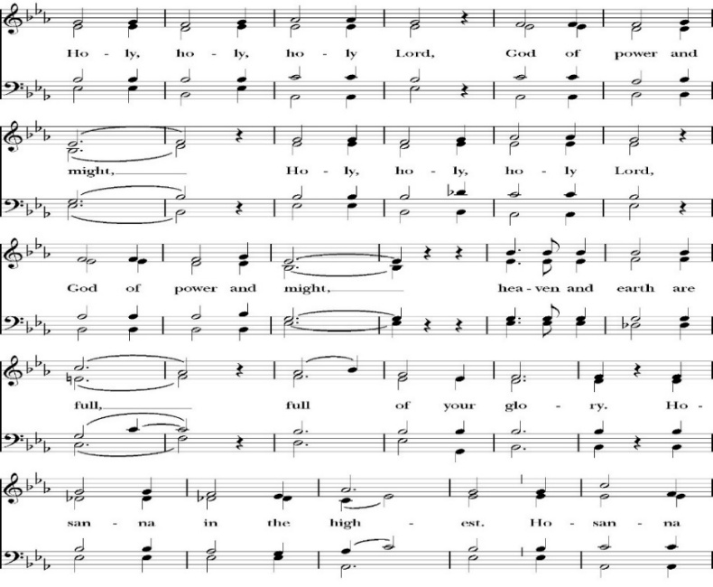
Sanctus

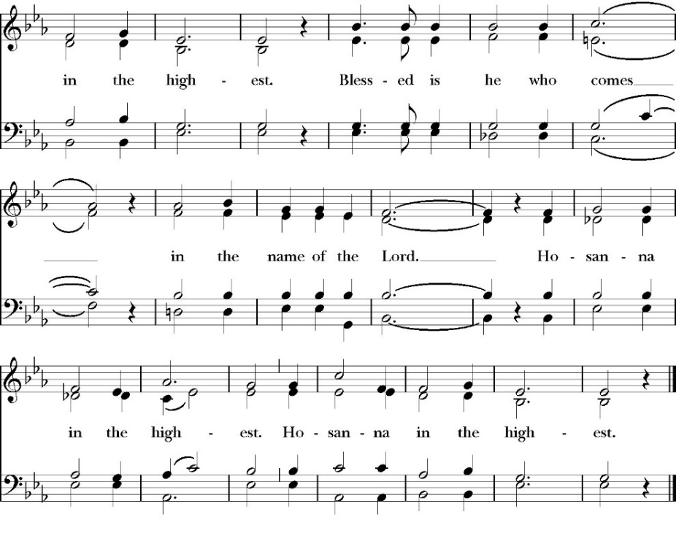
The People kneel or are seated if unable to kneel

Holy and gracious Father: In your infinite love you made us for yourself; and when we had sinned against you and become subject to evil and death, you, in your mercy, sent your only Son Jesus Christ
into the world for our salvation. By the Holy Spirit and the Virgin Mary he became flesh and dwelt among us. In obedience to your will, he stretched out his arms upon the Cross and offered himself once for all, that by his suffering and death we might be saved. By his resurrection he broke the bonds of death, trampling Hell and Satan under his feet. As our great high priest, he ascended to your right hand in glory, that we might come with confidence before the throne of grace.

On the night that he was betrayed, our Lord Jesus Christ took bread; and when he had given thanks, he broke it,* and gave it to his disciples, saying, “Take, eat; this is my Body, which is given for you: Do this in remembrance of me.”

Likewise, after supper, Jesus took the cup, and when he had given thanks, he gave it to them, saying, “Drink this, all of you; for this is my Blood of the New Covenant, which is shed for you, and for many, for the forgiveness of sins: Whenever you drink it, do this in remembrance of me.”

Therefore we proclaim the mystery of faith:

Christ has died.
Christ is risen.
Christ will come again.

We celebrate the memorial of our redemption, O Father, in this sacrifice of praise and thanksgiving, and we offer you these gifts.

Sanctify them by your Word and Holy Spirit to be for your people the Body and Blood of your Son Jesus Christ. Sanctify us also, that we may worthily receive this holy Sacrament, and be made one body with him, that he may dwell in us and we in him. In the fullness of time, put all things in subjection under your Christ, and bring us with all your saints into the joy of your heavenly kingdom, where we shall see our Lord face to face.

All this we ask through your Son Jesus Christ: By him, and with him, and in him, in the unity of the Holy Spirit, all honor and glory is yours, Almighty Father, now and for ever. Amen

And now, as our Savior Christ has taught us, we are bold to pray,

Our Father, who art in heaven,
hallowed be thy Name,
thy kingdom come,
thy will be done,
on earth as it is in heaven.
Give us this day our daily bread.
And forgive us our trespasses,
as we forgive those
who trespass against us.
And lead us not into temptation,
but deliver us from evil.
For thine is the kingdom,
and the power, and the glory,
for ever and ever. Amen

Fraction
Celebrant Alleluia! Christ our Passover is sacrificed for us.
People Therefore let us keep the feast. Alleluia!

The Prayer for Humble Access

We do not presume to come to this your table, O merciful Lord,
trusting in our own righteousness,
but in your abundant and great mercies.
We are not worthy so much as to gather up
the crumbs under your table;
but you are the same Lord
whose character is always to have mercy.
Grant us, therefore, gracious Lord,
so to eat the flesh of your dear Son Jesus Christ,
and to drink his blood,
that our sinful bodies may be made clean by his body,
and our souls washed through his most precious blood,
and that we may evermore dwell in him, and he in us.
Amen
Agnus Dei
The Ministration of Communion

The gifts of God for the People of God. Take them in remembrance that Christ died for you and feed on him in your hearts by faith, with thanksgiving.

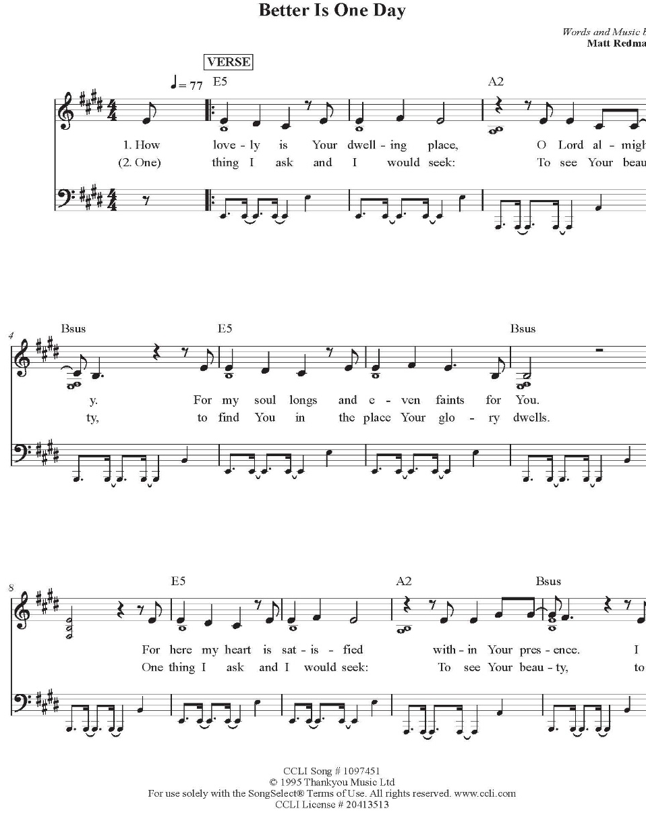
Communion Hymn Praise Song: Better Is One Day

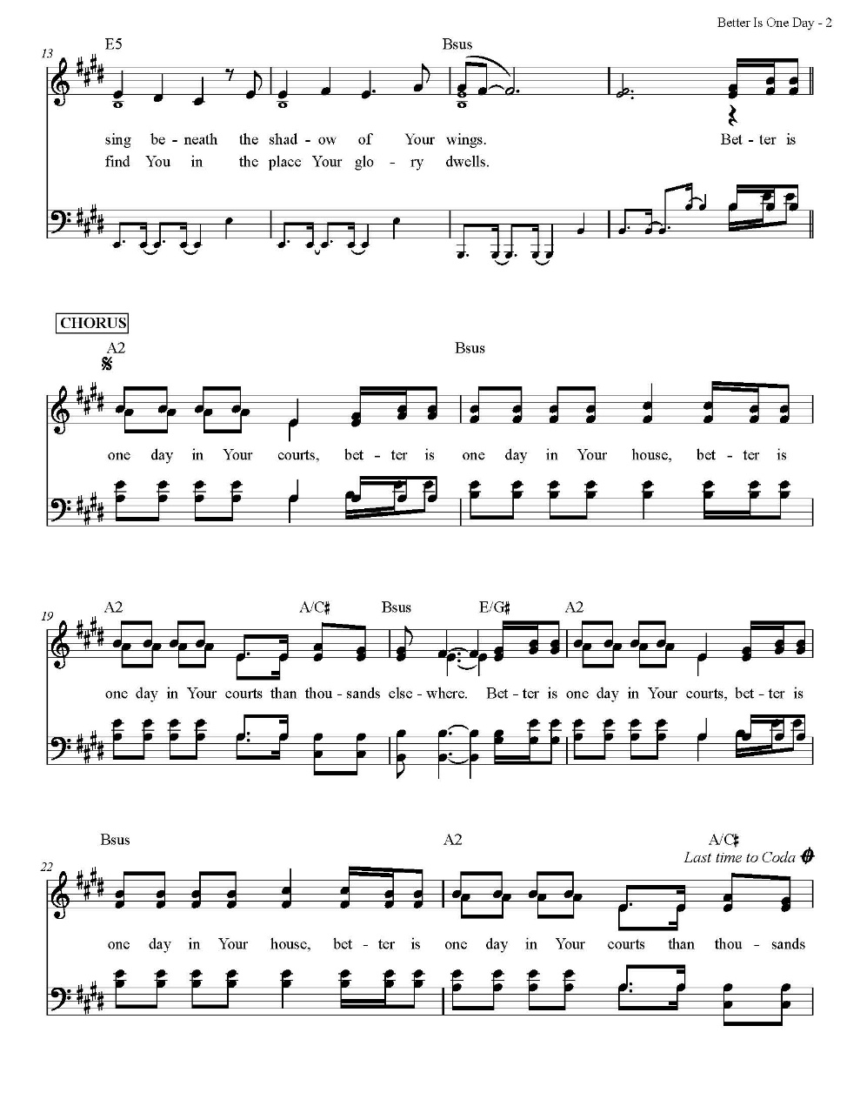

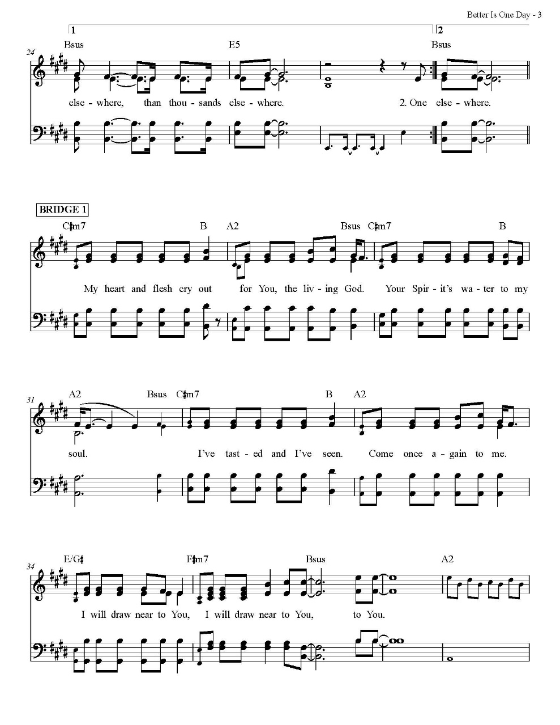

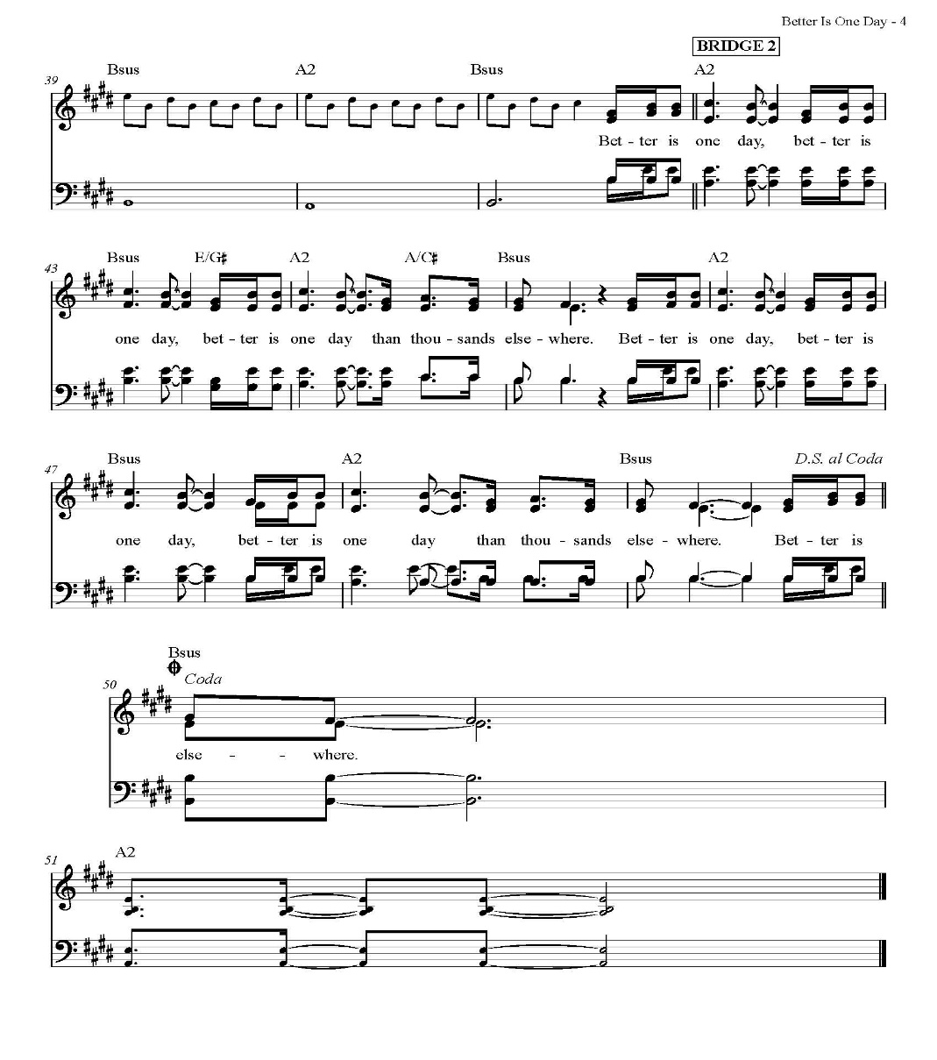

The Post Communion Prayer

The People kneel or are seated if unable to kneel

Let us pray.

Heavenly Father,
We thank you for feeding us with the spiritual food
of the most precious Body and Blood
of your Son our Savior Jesus Christ;
and for assuring us in these holy mysteries
that we are living members of the body of your Son,
and heirs of your eternal Kingdom.
And now, Father, send us out to do the work you have
given us to do,
to love and serve you as faithful witnesses of Christ our
Lord.
To him, to you, and to the Holy Spirit,
be honor and glory, now and for ever. Amen.

The Blessing

The peace of God, which passes all understanding, keep your hearts and minds in the knowledge and love of God, and of his Son Jesus Christ our Lord; and the blessing of God Almighty, the Father, the Son, and the Holy Spirit, be among you, and remain with you always. Amen.

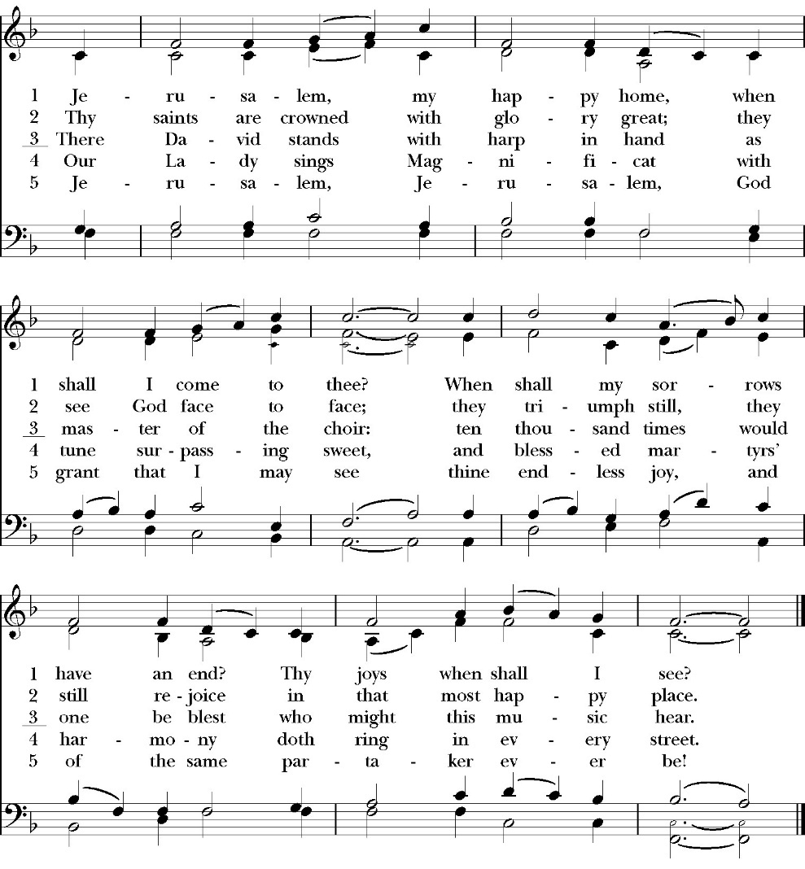
Closing Hymn: Jerusalem, My Happy Home

Deacon Alleluia, Alleluia! Let us go forth in the name of Christ.
People Thanks be to God. Alleluia! Alleluia!

St. Paul’s Parish Calendar
Sunday, October 26 to Sunday, November 2

SUNDAY, October 26 – Twentieth Sunday after Pentecost
9:15 AM Sunday Funday, Youth Room
9:15 AM Sunday Morning Class, Conference Room
9:30 AM Choir Practice, Music Room
10:30 AM Children’s Sunday School,
Pre-K – 1st Grade, Sunday School Room.
2nd -6th Grade, Youth Room
10:30 AM Holy Eucharist, Church
4:00 – 6:00 PM Trunk or Treat, Church Parking Lot
6:00 – 7:00 PM Family Dinner, James Hall

MONDAY, October 27

TUESDAY, October 28
6:00 PM Bell Choir Rehearsal, Music Room

WEDNESDAY, October 29
9:30 AM Holy Eucharist, Chapel
10:15 AM Bible Study, Conference Room
5:00PM Community, Practicing the Way 5PM Class
6:00 PM Dinner, James Hall
6:45 PM Evening Program for all ages
7:00 PM Choir Rehearsal, Chapel

THURSDAY, October 30

FRIDAY, October 31
6:30 AM Men’s Bible Study, Valhalla Restaurant

SATURDAY, November 1

SUNDAY, November 2 – All Saint Day
9:30 AM Choir Practice, Music Room
10:30 AM Children’s Sunday School,
Pre-K – 1st Grade, Sunday School Room.
2nd -6th Grade, Youth Room
10:30 AM Holy Eucharist, Church

Church Office Hours
Monday-Thursday 8:00 AM-4:00 PM

Announcements

Operation Christmas Child. Coordinator: Mark Morales
Operation Christmas Child is a ministry of Samaritan’s Purse in which local churches help fill special shoe boxes with toiletries and a small Christmas gift for needy children around the world. Shoe boxes with supplies and gifts need to be completed by November 16 to get into the hands of needy children by Christmas. Our Operation Christmas Child outreach coordinator is Mark Morales. He will be making announcements in church and is available to answer any questions on Sunday mornings at church.

Trunk or Treat, Today Sunday, October 26, 4:00-6:00PM
Our Trunk-R-Treat will be on Sunday 10/26 from 4:00pm to 6:00pm. After the Trunk-R-Treat is over we will have a simple "family dinner" in the fellowship hall with some fun table games. The dinner will be from 6:00pm to 7:00pm. We are not having any special theme for the trunks this year, just the same parameters as usual, so we should keep our decorations positive and not have anything too dark and spooky. Right now, our focus is on signing up volunteers for trunks, supervising the parish hall, and running our minute-to-win-it games. Please contact Deacon John, family@spvisalia.com, if you would like to sign up to serve or if you would like to do a trunk! Also, be sure to spread the word!

Daylight Savings is next Sunday, November 2
Do not forget to turn back your clocks on Saturday evening,
November 1. If you forget you will be at church an hour early.
Coffee will be available for all the early birds.

Baptism of Cillian Blake Schneemann, November 9
On August 13, Blake and Madelynn Schemman welcomed Cillian Blake into the world. Join us on Sunday, November 9, for his baptism and welcome into the household of God.

Forum on the reordering of the Anglican Communion, Sunday, November 9, after church, Main Church
All members and friends of St. Paul’s are invited to join us for a forum on the reordering of the Anglican Communion. On October 3, the appointment of Bishop of London Dame Sarah Mullally as the new Archbishop of Canterbury was announced. On October 16, the Global Anglican Futures Conference (GAFCON) responded to this appointment with a declaration that the provinces, dioceses and bishops that align themselves with the conference would begin the permanent reordering of the Anglican Communion. Our forum will be an opportunity for attendees to better understand the content of the current call for the reordering of the Anglican Communion, how the ACNA and St. Paul’s have been connected to the issues and challenges of the Anglican Communion since 2008, and how the reordering of the Anglican Communion might affect the ACNA, the Anglican Diocese of San Joaquin, and St. Paul’s Anglican Church.

Reuben Garcia Funeral, Saturday, November 15, 10:30am
All friends of Reuben Garcia are invited to join us to celebrate his life in the resurrection of Jesus Christ. The service will begin at 10:30AM with a lunch reception to follow in James Hall. In lieu of flowers Reuben’s wife Margie has asked that donations be made to support the children’s play structure project in the church courtyard.



Fall Wonderful Wednesday Program
Every Wednesday through November 19

5:00PM Building Community as Spiritual practice with John Mark Comer (Afternoon Session)
(October 15, 29, November 12)
Holy Eucharist with praise music
(October 8, 22, November 5, 19)
6:00PM Dinner
6:45PM Evening program with all ages
Children’s Program led by Fr. Rob and Deacon Kashy
- Songs, lessons and crafts
Adult Program: Building Community as
Spiritual practice with John Mark Comer
(Evening session)
Classes with teaching and small groups on the 1st, 3rd, 5th, 7th Weeks.
Worship, prayer time and small groups on
the 2nd, 4th, 6th and 8th weeks
7:00PM Choir

St. Paul’s Anglican Church
Parish Office
6436 W. Hurley Ave
Visalia, California 93291
559-732-4821
Office Hours: 8:00 – 4:00
Monday – Thursday

Worship: Sundays at 10:30AM
In person: St. Paul’s Anglican Church
Livestream: Link at spvisalia.com
and on our Facebook page
Please be advised that this service is being recorded for broadcast
and/or archival purposes. By attending, you consent
to the inclusion of your likeness in these recordings.

St. Paul’s Clergy and Staff
The Rev. Robert Longbottom, Rector
rector@spvisalia.com
(559)802-2928
The Rev. John Iseman, Pastoral Associate for Family Ministries
family@spvisalia.com
The Rev. Kashy Rowland-Smith, Deacon
kashyrs@aol.com
Antoinette Horsting, Parish Administrator
bookkeeper@spvisalia.com
Marguerite Crownover, Organist and Accompanist
Cynthia Culp, Choral Director
Jackie Iseman, Nursery Coordinator
Shane Motl, Sexton

Next Week’s Lessons
Revelation 7:9-17
Psalm 149
Ephesians 1:11-23
Luke 6:20-36

Altar Flowers
The flowers at the altar are given to the Glory of God
by Anne MacDonald in memory of her parents
Cecil and Eunice Luckin and in thanksgiving for her family.

