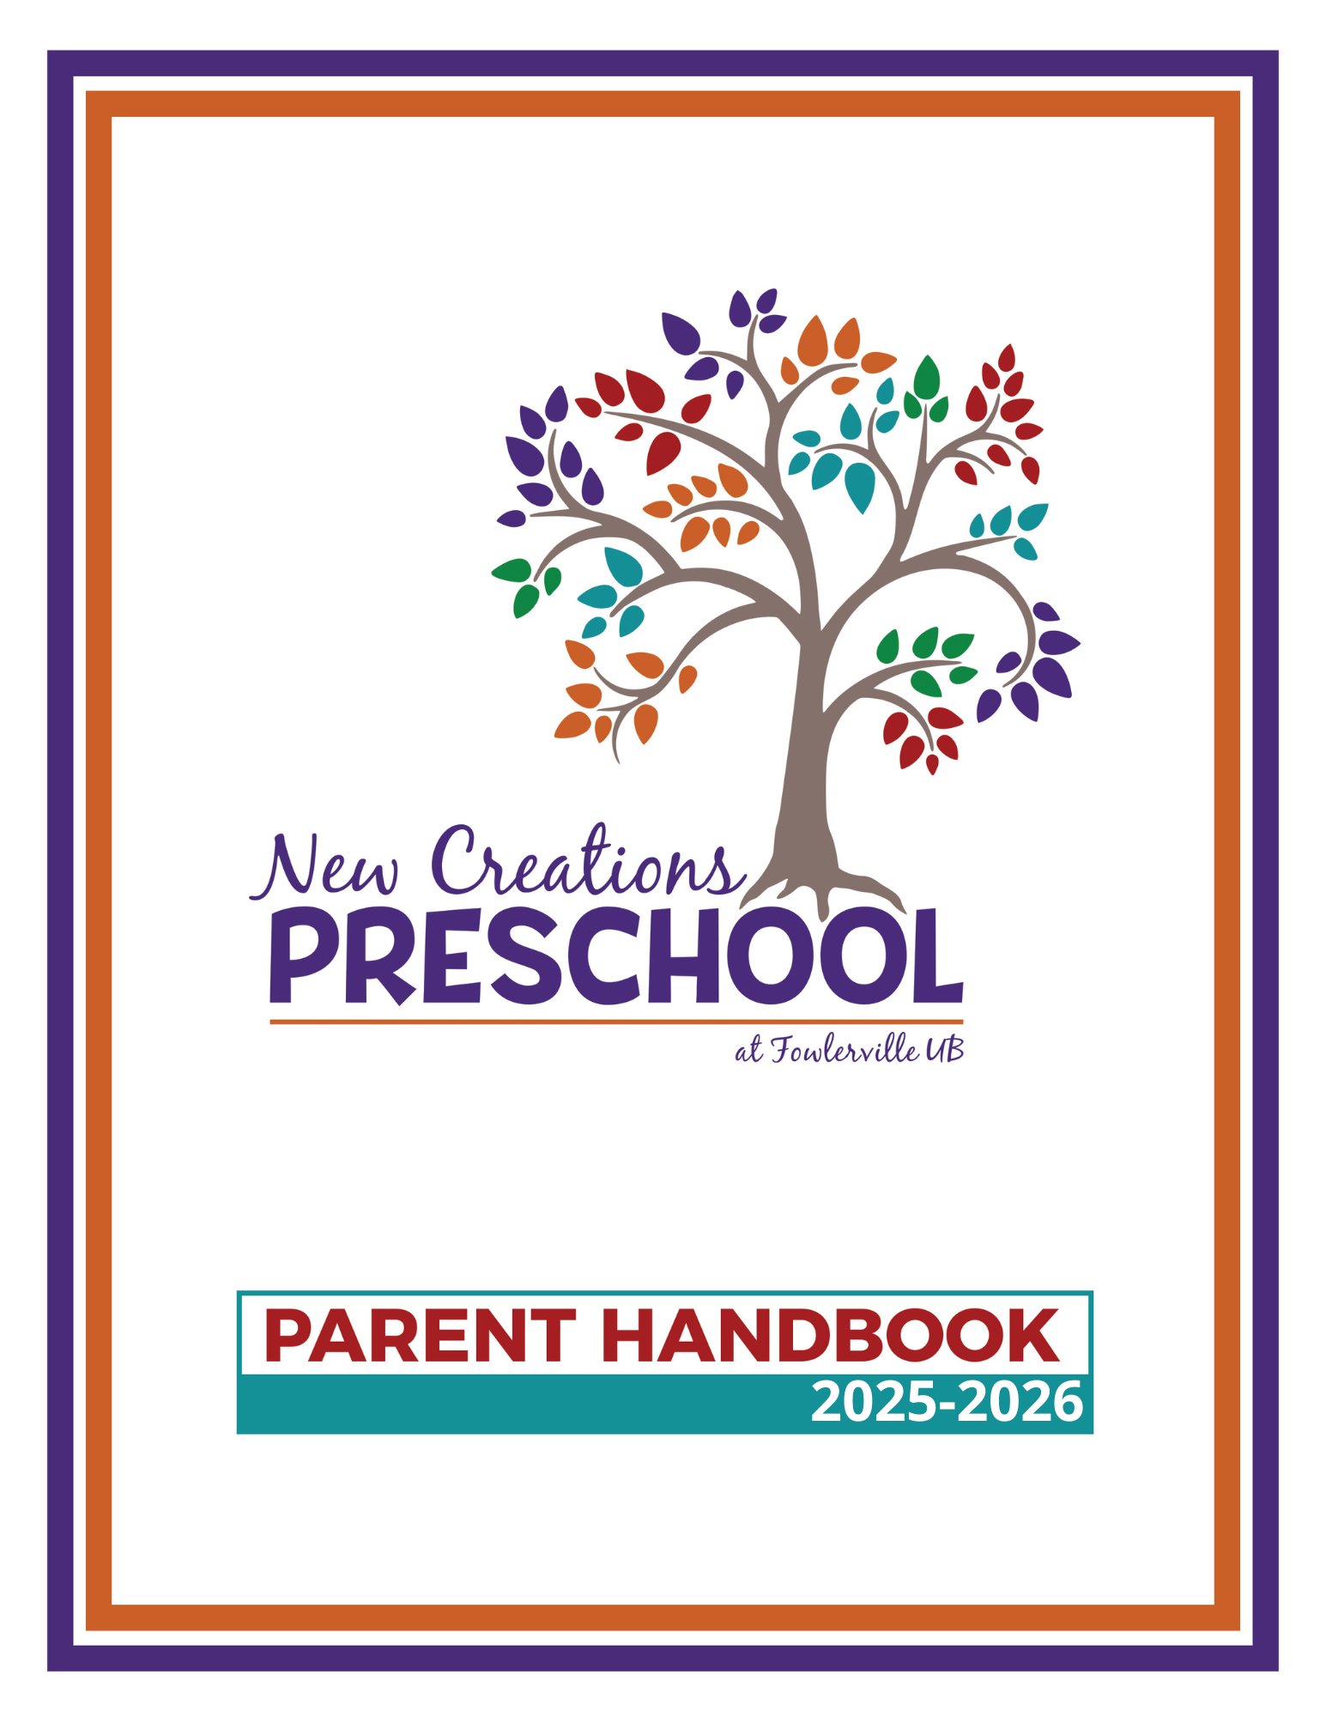
Welcome to New Creations Preschool!
New Creations Preschool was founded in 1992, with the mission to encourage children to learn about God’s creation and His love for them, while also preparing them with everything needed for future success in kindergarten and beyond.
We will provide an atmosphere in which children can:
- Relate lovingly toward others.
- Experience success and build self-esteem.
- Cooperate in groups of children and adults.
- Acquire self-control.
- Accept responsibility.
- Acquire skills appropriate for pre-school children.

Christian Atmosphere
One of the most obvious distinctions of our preschool is the Christian atmosphere we strive to maintain. Throughout the school year the children will learn many stories from the Bible, beginning with Creation and going through Jesus’ birth, life and death, and resurrection. The children will learn about prayer and the Bible in fun interactive ways.
We stress the importance of loving and caring for others. We also strive to communicate through our words, actions, hugs and affection, the truth that God loves them, and that Jesus is a loving, caring friend.
While we are a self-supporting outreach ministry of the Fowlerville United Brethren in Christ Church, we do not attempt to teach children what the UB denomination believes but focus our efforts on telling the good news about what Jesus did for us. We have no requirements that parents be affiliated with our church.

Admission Policy
Children will be accepted on a first come-first served basis. We follow the Michigan State Public School Guidelines for enrollment and do not discriminate based on race, gender, religion, or national origin. Children must be at least 3 by September 1, of the current school year, and fully potty-trained.
Class Size
New Creations Preschool is fully licensed by the Michigan Department of Social Services Child Care Licensing Division. Our maximum class size is 19.

Curriculum
We provide a program that allows children to develop in all five areas of preschool development, including: cognitive, creative, social, emotional, and physical.
Each day includes circle time with songs, finger plays, books, calendar time, as well as opportunities for the children to speak in front of the group. They have opportunities to sharpen listening skills, take turns talking, and other opportunities important to group dynamics.
We use theme-based teaching, with themes included in the monthly calendar. They will have opportunities each day to use their creativity with free art as well as teacher directed art. They will explore a variety of art media including different types of paint, markers, crayons, pencils, glue, and playdough. They will be provided with opportunities to learn proper scissor skills, as well as writing. Math, Science, Library, and Physical Education are also a part of our daily curriculum.
They will also be provided free choice play time when social and emotional skills are rehearsed and preformed. Children learn to share, take turns, assume roles, and negotiate. Many valuable skills are learned during this time, and it is an essential component of a structured preschool program.

Free Messaging Service-Class Dojo
All families are required to sign up for our free messaging service, Class Dojo on your cell phone. This will be used for teachers to communicate with you throughout the school year. You will also be able to message the administrator and your child’s teachers directly. We can help you set this up during our open house and during the first week of preschool.

Tuition Policy
A $40 non-refundable registration fee is due each school year.
Tuition is calculated at an annual rate and divided into 9 equal payments for the corresponding school year. This annual rate can be paid in one lump sum at the beginning of the school year, or a parent/guardian can choose to pay in nine monthly installments (September through May). See below for tuition rates. If you select the monthly payment option, payments are due on the 1st of each month September-May. Payments can be made by cash or check by placing your payment in the black payment box located on the wall as you exit the preschool hallway, or by credit, debit, or ACH with your bank account/routing number. Checks should be made out to Fowlerville UB Church. Please include the child’s name in the memo line.
If you are paying with cash, please place cash inside the provided envelope and write your child’s name on the front of the envelope. You will receive an email/text message each month with your bill with a link to pay with credit/debit/ACH. Paying by credit/debit/ACH instructions are included in the text/email. You can also set up automatic recurring payments through the payment link as well. If you select payment with credit/debit card there will be a 2.8% financing fee added to your bill. If you select payment by ACH to your bank account a 1% fee will be added to your bill. There will not be any financing fees for cash or check. Industry standard is to pay with credit/debit, so those financing fees have already been added to your bill. If you are not paying with that method, please contact Lyndsey Lovejoy (contact info below) and let her know your desired method so the fee can be updated.
If you have two or more children enrolled in the program in the same school year, the 2nd child will receive a 25% discount and the 3rd child will receive a 50% discount on their tuition. Please contact the Business Office for specific discounted rate amounts.
If a payment is not received by the fifteenth (15th) of the month a $15.00 late fee will be assessed on the account. If payment is still not received by the thirtieth (30th) of the month, an additional $20.00 late fee will be added to your bill.
By the fifteenth (15th) of the month following the second missed payment, your child’s placement will be suspended until arrangements are made to pay the delinquent balance. If balance is not paid or arrangements not made to pay balance by the thirtieth (30th), your child’s placement in our preschool will be terminated. No future placement of student or their siblings in our program will be accepted until all delinquent payments have been paid in full.
The church is more than willing to work with a family who is experiencing a family crisis or hardship that has affected their ability to pay in a timely manner. If you find yourself unable to pay tuition on time, we encourage you to contact the Business Office to discuss payment options.
In the case of the May payment, failure to pay or make arrangements for payment by the tenth (15th) of that month, will result in preschool placement suspension (students will not be permitted back in the classroom until a payment plan is made) and a hold will be placed on any future registration for student or siblings in our program until the debt is paid in full.
Monthly Tuition Rates
2 full days $225
3 full days $315
4 full days $400
2 half days $140
3 half days $195
4 half days $250
For payment arrangements or questions, please contact our Business Office and speak to Lyndsey Lovejoy at (517)223-9490 or by email at lyndsey@fowlervilleub.org.

School Closings
New Creations will follow the Fowlerville Community School calendar for major holidays and weather- related closings only. New Creations will close for electrical issues only if the church is without power or heat. There are instances when the public schools are without power, but the church still has electricity, such as when the closing is not related to the weather. Teacher professional days, half days, and conferences held at the district level will not affect our schedule. Please be sure to check the monthly calendar posted outside of the classroom and sent home via the teacher.
In case of a weather-related closing, New Creations will not be listed on the closing lists, but Fowlerville Community Schools will. Parents will be notified via text message and Class Dojo.

Schedule of Operation 2025-2026
(Subject to Change)
August 27 - Wednesday Meet the Teachers/Open House, 6-7:30 pm
September 2 - Tuesday First day of School
November 5 & 6 Picture Days
November 11 - Tuesday No School- Professional Staff Development
November 26-28 No School- Thanksgiving Break
December 18 - Thursday ½ day-Christmas program
December 22 - January 2 Christmas Break
January 5 - Monday School Resumes
January 19 - Monday No School
February 16 & 17 No School
March 27 – April 3. Spring Break
April 6 - Monday No School- Easter Monday (This is an NCP day that differs from the FCS calendar)
April 7- Tuesday School Resumes
May 21- Thursday Last day of School- Graduation- ½ day

Contact Information
New Creations Preschool (Church Office) (517) 223-9490
Cool Critters Lead Teacher- Jaima Zub: Class Dojo
Administrator- Tammy DeRuyver: tammy@fowlervilleub.org
Farm Friends Lead Teacher- Debbie Lang: Class Dojo

Clothing
Please make sure the clothing you send your child to school in is easy for them to take on/off in order to use the restroom. One-piece outfits or belts can be very challenging to a preschooler.
Be sure to have a change of clothing, including socks and underwear in your child’s backpack each day.
During the winter months, all children must have a warm coat, snow pants, boots, mittens and dry shoes to be worn in the classroom. Please label every item with your child’s name.
All shoes must be slip-on or Velcro-type. No laces please.

Meals & Snacks
Lunches, for full day children, are to be brought to school every day, and should include a drink. Please be sure that lunches are clearly labeled with your child’s name and are packed so that refrigeration is not required, as space is limited. Also keep in mind that we cannot heat up food items for your child. We stress the importance of healthy choices, so please be sure to include healthy food in your child’s lunch. Easy open containers are very helpful as well.
Afternoon snacks should be included daily in your child’s lunch. We will encourage them to save one item in their lunch for this purpose. We will not be providing the afternoon snack.
Birthday treats are welcome. (Please let us know ahead of time.)
Filled Water Bottles should be brought in daily for your child. Make sure they are labeled with your child’s name and left in their cubby or backpack side pocket.

Health/Illness Policy
All children enrolled at New Creations must have a current health form and proof of immunization on file prior to attending. If your child attended New Creations last year, you do not need to turn in another health form. (Please notify us of any changes). If you are exempt from the required immunizations, a Medical Contraindication Form (waiver) must be on file with the State of Michigan.
Any medication required to be given to your child, while in care must be accompanied by a medication authorization form, which can be filled out before leaving your child. This includes any OTC medications. Epi-pens, asthma medication, etc. must be accompanied by a physicians note. All medication must be in original container with the name of your child clearly visible, along with specific instructions for use.
The Health Department regulations prohibit the admittance of any child exhibiting any of the following symptoms into childcare settings:
  - Fever (100 degrees or higher) – Child must be fever free for 24 hours without the aid of medication.
  - Diarrhea - Child must be symptom free for 24 hours without the aid of medication.
  - Vomiting - Child must be symptom free for 24 hours without the aid of medication.
  - Runny nose with colored discharge - Check with your doctor and provide a doctors note to return.
  - Rash - Check with your doctor and provide a doctors note to return.
  - Discharge from eyes or ears - Check with your doctor and provide a doctors note to return.
  - Lice - Child must be treated, and ALL nits removed before returning to care.
  - Communicable diseases: chicken pox, measles, conjunctivitis (pink eye), Covid, etc. - Child may return when the incubation period has passed, and the child is well enough to resume daily activities. The Health Department requires all centers to provide an update of any communicable illnesses causing an absence from school. We ask that when your child is sick, you let us know as soon as possible.
We reserve the right to refuse care of your child if we feel he/she puts others at a risk of contracting an illness. Should your child become sick while in our care, you will be called and will be expected to make arrangements for him/her to be picked up as soon as possible (no more than ONE HOUR from time of call). He/she will be kept comfortable and separate from other children until you arrive.

Environmental Health Procedures
Hand Washing:
Hands of children and staff are washed frequently throughout the day using the 5-Step method. Hands are always washed:
- After using the bathroom.
- Before and after food prep/consumption.
- After nose wiping, etc.
5-Step Method:
- Wet hands under running water.
- Apply soap.
- Rub hands together, including the tops/bottoms/fingers for at least 20 seconds.
- Rinse hands under running water.
- Dry hands using a paper towel disposed of after use.

Handling Children’s Bodily Fluid:
If blood or blood-containing materials enter a child’s eye, nose, or mouth or an opening in their skin, our staff will take the following procedures to prevent illness or injury outlined by the American Heart Association:

Cleaning and Sanitizing of Affected Surfaces after a Bodily Fluid Incident:
- Staff will put on personal protective equipment.
- Clean surface with approved surface cleaner.
- Dispose of things used to clean the surface in appropriate containers.
- Wash hands/clean yourself.
- Fill out appropriate paperwork.

Bloodborne Pathogens and Exposure Control Plan
- A staff member will immediately put on protective equipment per the Bloodborne Pathogens training guidelines. The second employee will ensure the other children are safe.
- Immediately wash the child’s hands, and any skin that came into contact with blood, very well with soap and large amounts of water.
- If the material has splashed in their eyes, nose, or the inside of their mouth, these areas will be rinsed with lots of water.
- A staff member will complete an incident report.
- Parent/guardian will be contacted and informed of the incident.
- The parent will determine if their child should see a healthcare professional for evaluation.

Controlling the Spread of a Communicable Disease:
If a communicable disease is suspected or is diagnosed in a childcare setting, the following recommendations for handling communicable diseases will be promptly taken:
- The director is responsible for notifying the Livingston County Health Department and our licensing consultant.
- Parents are to be notified that it is suspected that their child may have a communicable disease and will need to come and pick up their child.
- If a parent informs us that their child has a communicable disease, then the returning of the child requires a written permission slip from the doctor.
- The director is to report to all of the parents of children attending New Creations when there has been an outbreak and how it is being handled. In addition, the director will be responsible for reviewing all the student’s immunization records, and the parents of those children not immunized will be notified. It will be the parent’s decision to decide if their child should attend at their own risk of exposure.
- Sanitation procedures must be strictly followed, and extra precautions taken in food handling, dish washing, and hand washing by staff and children; as well as general cleanliness of toys in the environment.
- The director will compile information pertaining to the specific disease, and the symptoms upon confirmation from the ill child’s parents to be distributed to all student’s families.

Important Telephone Numbers for Your Convenience:
Poison Control: 800-222-1222
Community Mental Health Services: 800-615-1245
Children’s Protective Services: 517-546-8668
LESA: 517-546-5550
DHS: 800-942-4357
Michigan Parent Help Line: 800-942-4357
Child Help USA, National Abuse Hotline: 800-4-A-CHILD
Mental Health Hotline 866-903-3787

Emergency Procedures
Fire:
In the event of a fire, all persons in the building will be evacuated through the nearest exit and will proceed to the pre-established meeting place. A call will be made to 911 once all the children are safe. Children will be kept safe and calm until help arrives and the situation is under control. Parents will be notified as soon as possible using Text & Class Dojo. Fire drills will be practiced quarterly, and documentation of those dates are posted in the classroom for parents to review.
Tornado:
Should the weather become threatening, all persons in the classroom/building will proceed to the designated tornado shelter until the threatening weather has passed. Tornado drills will be practiced twice a year, and documentation of those dates are posted in the classroom.
Flood:
Should a flood occur, all persons in the classroom & building will proceed to the highest point of the building (the attic) until such time as help arrives.
Incident/Accident/Medical Emergency:
The child will be attended to immediately and assessed for care. If needed, 911 will be called first and then the parent. If 911 is not required, the parent will be notified immediately, and arrangements will be made as to further medical attention needed. Emergency adult supervision will be provided for all other children should the child need to be transported to the hospital. (Please note that the nearest hospital is St. Joseph Mercy Livingston where your child will be taken unless otherwise required or requested on emergency card.) In the event of any other building issue, we will evacuate to our pre-established safe area. Parents will be notified immediately using our flocknote text messaging system and/or the Class Dojo app.
Power Outage
Should a power outage occur during school hours, our emergency lights will be utilized to guide children to safety and parents will be notified to pick children up.
Field Trips
Parents are responsible for transporting their child(ren) to and from the destination and are required to remain in attendance with the child(ren), unless otherwise specified. Smoking, drinking and drugs, are prohibited at all times while children are present. Parents are expected to help maintain order and protect the safety of all children at all times.
Rest Time
A mandatory rest/nap time will be given daily for all children at New Creations. Children are not required to sleep but are encouraged to rest quietly. Each child will have a clean safe cot for resting and are encouraged to bring a small pillow and blanket from home. One small stuffed animal may be brought as well. These items must fit in a bag that you provide and must be washed often. The teacher will play restful music, and may allow books, or a quiet activity at this time.

Discipline
Discipline at New Creations Preschool is maintained by:
- Providing a disciplined environment. Teachers take responsibility to ensure that each day is carefully planned, providing free play along with structured activities. In planning activities, consideration is given to the age of the child, the length of their attention span, and the level of ability. Interesting activities, a neatly arranged classroom, and a well-planned program are all part of providing a disciplined environment.
- Providing encouragement and praise. These are the most important tools we use in helping a child grow toward self-disciplined behavior.
- Repairing wrongdoing. Teaching children to ask for forgiveness when needed frees the offended child from resentment and the offending child from guilt.
- Disciplinary action. When a child has not responded to verbal correction or redirection, it may be necessary to use some mild disciplinary action or restraint to prevent the child from hurting other persons or property. Typically, the child will be asked to sit apart from the group for a specific length of time as a result of their disruptive behavior. After a short period of time, the child has usually regained control and is ready to rejoin the group.
The following forms of punishment will NEVER be used:
- Hitting, shaking, biting, pinching, or inflicting a form of corporal punishment.
- Restricting a child’s movement by binding or tying.
- Inflicting mental or emotional punishment, such as: humiliating, shaming or threatening a child.
- Depriving a child of a snack, rest or necessary toilet use.
- Confining a child in an enclosed area such as a closet, locked room, box or similar cubicle.

Grievance Policy
We recognize our responsibility to be responsive to your needs and concerns, and pledge to take care of them to the best of our ability. In matters pertaining to your child in the classroom, we encourage you to first, schedule a conference with the teacher in the hope of resolving the issue at that level. Should that route prove unsatisfactory, you are urged to secondly, seek the administrator’s assistance. Under no circumstance will we at New Creations condone behavior from staff, students or volunteers that is contrary to our philosophy or the general well being of our members and children.

Changes to Policies/Contract
Changes to the policies and/or contract may be made as needed with any changes taking effect two weeks after notification. All policies, forms, consents, and contracts will be reviewed annually, and new contracts will be required each school year.
Should emergency information, phone numbers/addresses, health issues, immunizations, etc. change, it must be given to New Creations in writing and will be kept in your child’s file.

Please sign and date both forms upon enrollment at New Creations Preschool and return to your child’s teacher on the first day of class:

Child’s name _______________________________________ Age _______________
Child’s name _______________________________________ Age _______________
Child’s name _______________________________________ Age _______________

Policy Handbook Receipt
By signing the following, I acknowledge that I have received the handbook and have read and accept the policies herein:
Parent/Guardian Signature: ______________________________________________ Parent/Guardian Printed: _________________________________ Date___________
Parent/Guardian Signature: ______________________________________________ Parent/Guardian Printed: _________________________________ Date___________

Photo/Press Release
_____ I hereby give my permission for my child/children’s photo to be used in the media (New Creations website/Facebook, newspapers, crafts, etc.) I understand that no last names will be used in identifying any child at any time.
Parent/Guardian signature: ______________________________ Date: ___________
______ I do not wish my child’s photo to be used in any manner pertaining to the media.
Parent/Guardian Signature: ______________________________ Date: ___________

Class Dojo Messaging
______ I have signed up to receive Class Dojo notifications from New Creations.
Parent/Guardian Signature: ______________________________ Date: ___________
Playground Equipment
I am aware that my child will be playing on the playground equipment in the enclosed outdoor area of the church. I am also aware that while the equipment has been approved by DHS licensing, it may or may not meet the requirements stated in the Handbook for Public Playground Safety.
Parent/Guardian Signature: ______________________________ Date: ___________

Parent Notification of the Licensing Notebook
(Child Care Organizations Act, 1973 Public Act 116)
Michigan Department of Human Services
All child care centers must maintain a licensing notebook which includes all licensing inspection reports, special investigation reports and all related corrective action plans (CAP). The notebook must include all reports issued and CAPs developed on and after May 27, 2010 until the license is closed.
• This center maintains a licensing notebook of all licensing inspection reports, special investigation reports and all related corrective action plans.
• The notebook will be available to parents for review during regular business hours.
• Licensing inspection and special investigation reports from at least the past two years are available on the Bureau of Children and Adult Licensing website at www.michigan.gov/michildcare.
- All teachers/subs/volunteers have been FULLY background checked.
I have read the above statement issued by New Creations Preschool.
Child(ren)’s Name(s) ____________________________________________________
Parent Name__________________________________________________________
Parent Signature ______________________________________ Date ____________

