All Saints’ Sunday

We affectionately remember these members and give thanks for all the contributions they made to our lives, to the church and to the world.
There will be an arrangement of white roses representing each of
our 10 deceased members.

Pat Faggart
David Rose
Martha Johnson
David Parker
Jim Lutz
Claudia Lutz
Frankie C. Hicks
Eula Crews
Terry Brown
Eleanor Cloyd

The Sanctuary Flowers are given to the glory of God and in loving memory of Mae M. Blair by her daughter, Marilyn Jack, and in memory of all the other loved ones who have joined the Church Triumphant since last All Saints’ Day.

Rev. David Lee, Pastor
Dr. Tammy Bass, Director of Discipleship
Caroline Scism, Director of Children Ministries
Danny Buckner, Director of Music Ministries

200 East Marion Street
Shelby, NC 28150
704-487-6336
http://cumcshelby.org


Please scan the QR code to the left and fill out the connect card to let us know you are worshipping with us and how we can connect you to our ministries.

The Worship of God

November 2, 2025 ________ 10:00am

Welcome and Announcements
Passing the Peace

Prelude Partita on “All the River” arr. Spong
Libby Alexander, organ

*Opening Hymn #702 Sing with All the Saints in Glory
(st. 1,2, & 4)

Moments with Children Lynn Carter

Offertory Hymn of Promise arr. Carter
Libby Alexander, organ
*Doxology #95
Praise God, from whom all blessings flow;
Praise him, all creatures here below;
Praise him above, ye heavenly host;
Praise Father, Son, and Holy Ghost. Amen

Recognition of Saints

Special Music In This Very Room arr. Hayes
Libby Alexander, piano
In this very room there’s quite enough love for one like me,
and in this very room there’s quite enough joy for one like me,
and there’s quite enough hope and quite enough power
to chase away any gloom.
For Jesus, Lord Jesus, is in this very room.

Prayers of the People
Ever living God, this day revives in us memories of loved ones who are no more. What happiness we shared when they walked among us. What joy, when, loving and being loved, we lived our lives together.
Their memory is a blessing for ever.

Months or years may have passed, and still we feel near to them. Our hearts yearn for them. Though the bitter grief has softened, a duller pain abides; for the place where once they stood is empty now. The links of life are broken, but the links of love and longing cannot break.
Their souls are bound up in ours forever.

We see them now with the eye of memory, their faults forgiven, their virtues grown larger. So does goodness live, and weakness fade from sight. We remember them with gratitude and bless their names.
Their memory is a blessing forever.

And we remember as well the members who but yesterday were part of our congregation and community. To all who cared for us
and labored for all people, we pay tribute. May we prove worthy of
carrying on the tradition of our faith, for now the task is ours.
Their souls are bound up in ours forever.
We give you thanks that they now live and reign with you. As a great crowd of witnesses, they surround us with their blessings, and offer you hymns of praise and thanksgiving.
They are alive for ever more. Amen.

We pray all of this in the One who taught us to pray:
Our Father, who art in heaven, hallowed be thy name.
Thy Kingdom come, thy will be done
on earth as it is in heaven.
Give us this day our daily bread.
And forgive us our trespasses,
as we forgive those who trespass against us.
And lead us not into temptation, but deliver us from evil.
For thine is the kingdom, and the power, and the glory,
forever. Amen

*Congregational Hymn #707 Hymn of Promise
(Please feel free to bring your Remembrance Card
and place it in the basket in front of the altar as we sing the hymn)

Lighting the Remembrance Candle

Sermon When Grace Looks Up Rev. Keith Brown

Anthem Welcome arr. Miller
Chancel Choir

*Hymn #709 Come, Let Us Join Our Friends Above
(st. 1,2, & 4)

*Benediction

*Chiming the Trinity

*Postlude Festival on “Sine Nomine” arr. Aber
Libby Alexander, organ

*Please stand if able
Welcome! Welcome! Welcome!
Visitors are invited to visit the Welcome Table for a free gift and additional information about Central United Methodist Church.
We are glad you are here!
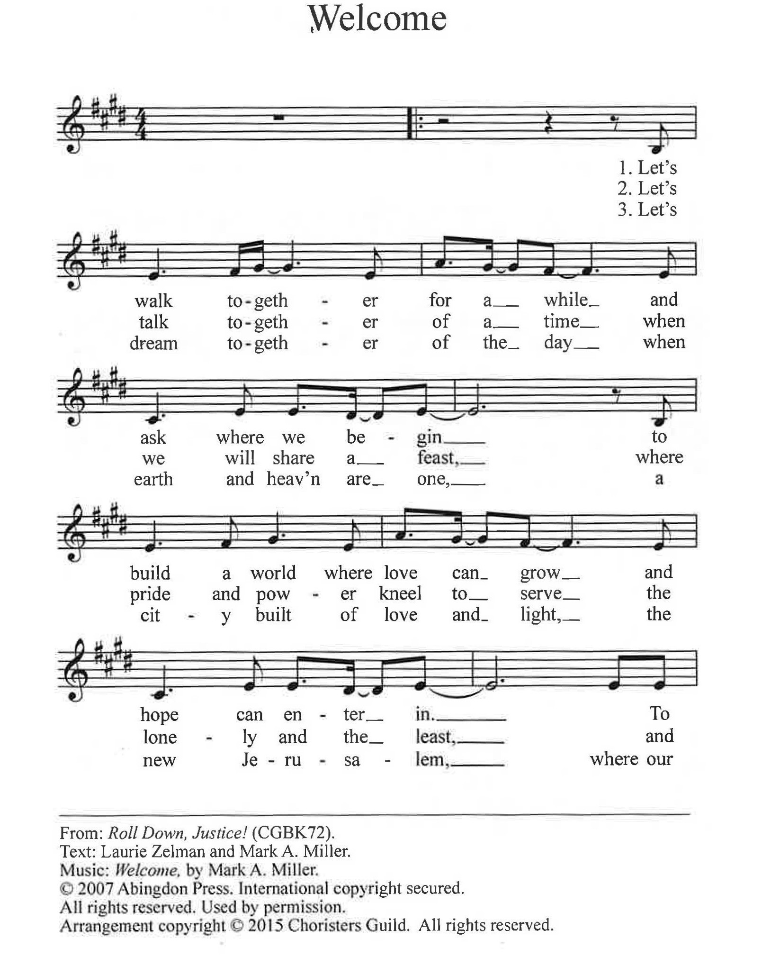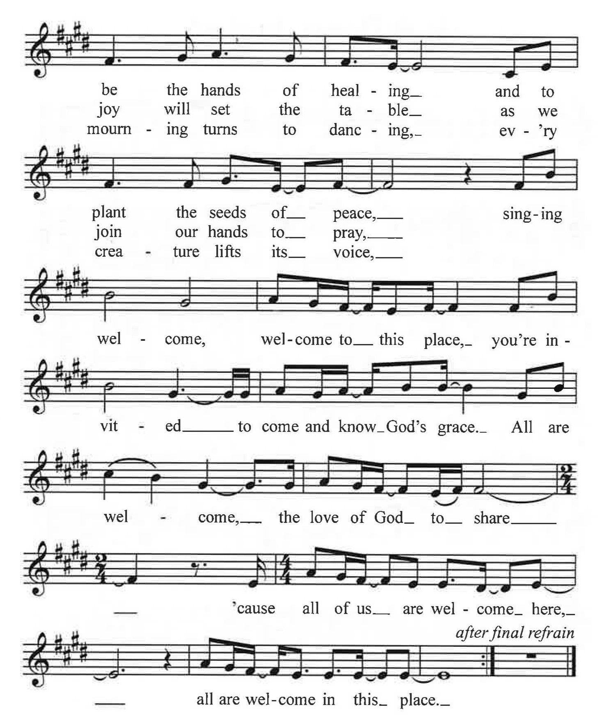

Remembrance Cards
If you have lost a loved one and would like them to be remembered today, please write their name(s) on the enclosed card. As you go up to receive the communion elements, we invite you to bring your remembrance card and place it in the basket on the table at the altar rail.
Prayer Concerns
For this week please pray for the following:
*All of those recovering or suffering from medical issues, physical and emotional.
Ricky Shell
Mike Richardson Kimberlyn Floyd
Mark Elliott (Stroke) Sandra Raynor and Family
Ollie Anthony
Steve & Becky Hill (loss of grandson- Sheilds Fletcher)
Leena Wray “Mom and Pop” Plunner
Deborah Martin (Stephen Agers sister-Cancer recover)
Allison Bustillo Chinchilla (Crest graduate self-deported after ICE detainment) Frank Richardson
Sarah Queen
Victims of Long COVID
Other:
Military & First Responders Western NC
End of Violence & Violent Rhetoric Breast Cancer Research
Our Homeless Community Division of our country
Wars in Ukraine, Gaza, and Sudan
Victims of extreme weather and wildfires
Those Grieving
The family of Becky Smith
The family of Rev. Dr. Jung Kee Lee

Connect with us!
Use this QR Code for a direct link to all things CUMC. Get easy access to online giving options, connect cards letting us know you were in worship (in person or online), updated bulletins, newsletters and more!

Ministry Needs
Below is a list of volunteer and donation needs for some of our ministries:
Backpack Ministry: For November: Individual packs of Grits/Oatmeal
Open Table: Bottled Water

Lake Junaluska Retreat Registration Is Open!
Registration for the retreat is still open. The pricing has been updated to the regular rate for the rooms and meal packages, but it is not too late to join in on this experience! Please visit cumcshelby.org/church-wide-retreat to register online or come to the office and we can get you all set!
A Note from Stewardship

As of October 26, 47 pledge cards were submitted from the 200 letters that were mailed. If you have made your giving estimate for 2026, thank you. If you have not, the Finance and Stewardship Committees encourage you to make your giving estimate by turning in your estimate card in the next few Sundays, mail it to the Church office, or bring it to the office between 9:00 am and 2:00 pm Monday-Friday. You can set up a recurring gift online at any time. Please be in prayer for our church as we work toward funding our mission and programs for 2026.
Wednesday Night Bible Study
The Wednesday night study "Everyone Must Eat" with Pastor David and Laura Lombardi is being postponed due to scheduling conflicts! Please be on the look out for the new dates!

Feeding Kids Cleveland County Thanksgiving Meal
Feeding Kids Cleveland County is having their annual Thanksgiving meal at the Bobby Bell pavilion on Saturday, November 22nd at 4:00 p.m. CUMC is invited to participate by volunteering to help with the event (table decorations, serving food, or making a dessert) or by eating the meal with our neighbors. Sign ups will begin November 1. If you are interested please contact Denise Sieges at (704)609-6184 or denisesieges@gmail.com

Operation Christmas Child
Nov. 9
Kids and Adults please help us in packing 100 shoeboxes for children who are in need of hearing the gospel! All the gifts will be supplied we just need you. It is a great introduction to missionary work. It will take place in the Fellowship Hall after the service. Hope to see you there!

Fall Discipleship Opportunities

Saturday Morning Men’s Bible Study
8am, Saturday Mornings before Open Table.
CUMC Room E210
Starting on Sept. 20th and meets the 1st and 3rd Saturdays of the month.
The Book of Matthew
Daytime Ladies’ Bible Study- Thrive
Thursdays starting Sept. 18th at 9:30
Conference room
Evening Ladies’ Bible Study- Way of Wisdom
Mondays at 6:30pm, rotates locations
Starting September 8
Disciple Class
The Disciple class will be starting back with the study of Colossians on Tuesdays from 3-5:30pm in the conference room. If you are interested, contact Rob Laney.

Central UMC Ministry Opportunities
This QR code will take you to a comprehensive list of opportunities to be involved and serve at Central. Check out the list! You will be proud of all that Central does to make a difference in people’s lives! Find a place to serve! As you find your place to serve, help new people find the information and a place to plug in! Together we shine the bright light of Christ!

Central UMC is a Safe Sanctuaries church. Please be sure that your children are always accompanied by a parent or responsible adult caregiver including if and when they need to use the restroom during service. We appreciate your assistance as we strive to ensure the safety of all.
Restrooms are located outside the right-hand side of the sanctuary, as you look at the chancel area.
Childcare is available for infants and preschool aged children. Our nursery staff awaits you in room E105 (pre-school age) and E204 (infants).
Hearing devices are available for those who need them.
Large print Bibles & Hymnals are available for those who need them. The Ushers are at each door and will happily assist you with any of these.
SERMON NOTES

Sermon Notes
____________________________________________________________
____________________________________________________________
___________________________________________________________
____________________________________________________________
___________________________________________________________
____________________________________________________________
____________________________________________________________
_________________________________________________________________________________________________________________________________________________________________________________________________________________________________________________________________________________________________________________________________________________________________________________________________________________________________________________________________________________________________________________________________________________________________________________________________________________________________________________________________________________________________________________________________________________________________________________________________________________________________________________________________________________________________

