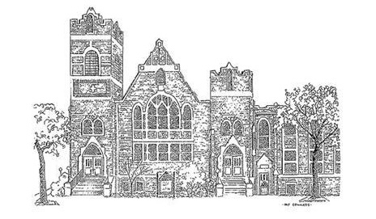

Central United Methodist Church
Our Mission:
To make disciples of Christ who WORSHIP God,
GROW in their faith and SERVE in the church and world.

Rev. David Lee, Pastor
Dr. Tammy Bass, Director of Discipleship
Caroline Scism, Director of Children Ministries
Danny Buckner, Director of Music Ministries
Katie Bowers, Director of Youth Ministries

200 East Marion Street
Shelby, NC 28150
704-487-6336
http://cumcshelby.org


Please scan the QR code to the left and fill out the connect card to let us know you are worshipping with us and how we can connect you to our ministries.

The Worship of God

November 9, 2025 10:00am

Welcome and Announcements

Passing of the Peace

Prelude Four Chorale Miniatures on
“For the Beauty of the Earth” arr. Burkhardt
Libby Alexander, organ

*Congregational Song Here I Am to Worship

Morning Prayer

The Lord’s Prayer
Our Father, who art in heaven, hallowed be thy name.
Thy Kingdom come, thy will be done
on earth as it is in heaven.
Give us this day our daily bread.
And forgive us our trespasses,
as we forgive those who trespass against us.
And lead us not into temptation, but deliver us from evil.
For thine is the kingdom, and the power, and the glory, forever.

Children’s Message Emily Ousley
Stewardship Moment Will Mabry & John Lattimore
Offertory I Want to Be a Christian arr. McDonald
Libby Alexander, organ
Doxology #95
Praise God, from whom all blessings flow;
praise him, all creatures here below;
praise him above, ye heavenly host;
praise Father, Son, and Holy Ghost. Amen.

Congregational Song How Great Is Our God

Scripture Luke 20: 27-38

Sermon The God of the Living Rev. Jerrianne Pyles

*Congregational Song He Leadeth Me

*Benediction

*Chiming the Trinity

*Postlude Recessional on St. Anne arr. Young
Libby Alexander, organ

*Please stand if able
Welcome! Welcome! Welcome!
Visitors are invited to visit the Welcome Table for a free gift and additional information about Central United Methodist Church. We are glad you are here!

Prayer Concerns
For this week please pray for the following:
*All of those recovering or suffering from medical issues, physical and emotional.
Ricky Shell
Mike Richardson Kimberlyn Floyd
Mark Elliott (Stroke) Sandra Raynor and Family
Ollie Anthony
Steve & Becky Hill (loss of grandson- Sheilds Fletcher)
Leena Wray “Mom and Pop” Plunner
Deborah Martin (Stephen Agers sister-Cancer recover)
Allison Bustillo Chinchilla (Crest graduate self-deported after ICE detainment)
Frank Richardson Roger Davis
Sarah Queen
Victims of Long COVID
Other:
Military & First Responders Western NC
End of Violence & Violent Rhetoric Breast Cancer Research
Our Homeless Community Division of our country
Wars in Ukraine, Gaza, and Sudan
Victims of extreme weather and wildfires
Those Grieving
The family of Becky Smith
The family of Rev. Dr. Jung Kee Lee

Connect with us!
Use this QR Code for a direct link to all things CUMC. Get easy access to online giving options, connect cards letting us know you were in worship (in person or online), updated bulletins, newsletters and more!

Ministry Needs
Below is a list of volunteer and donation needs for some of our ministries:
Backpack Ministry: For November: Individual packs of grits/oatmeal
Open Table: Bottled Water

Operation Christmas Child
Join us today immediately after the service in the Fellowship Hall to help us in packing 100 shoeboxes for children who are in need of hearing the gospel!

Lake Junaluska Retreat Registration Is Still Open!

The registration for the church wide retreat is open! Please fill out your registration card and return it to the office so you don’t miss out on this experience. We do offer the registration ONLINE! Visit cumcshelby.org/church-wide-retreat and complete the form. You can also pay online using the same page and following the link at the bottom.

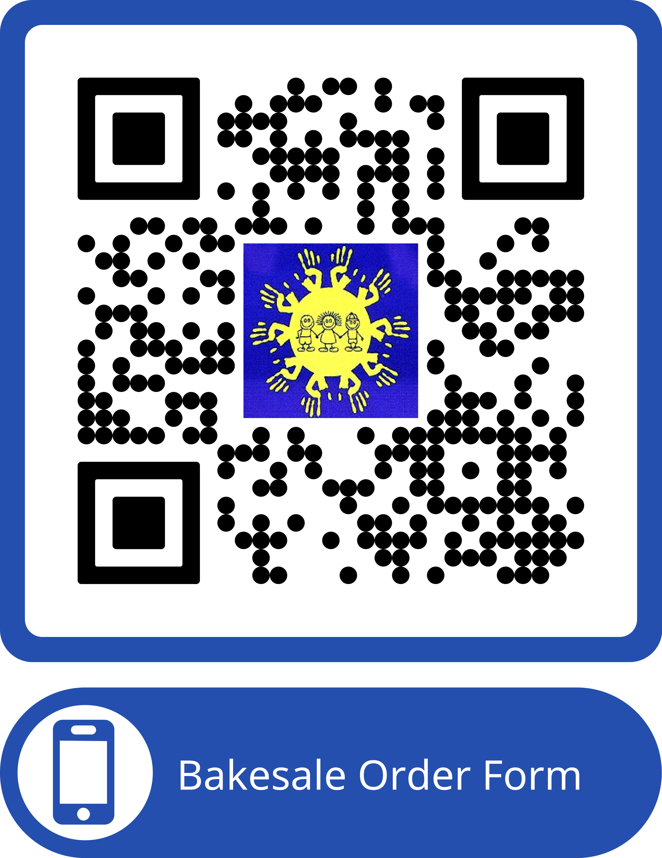
Kids Place Fundraiser
Pre-orders for pecan pies and large loaf pumpkin bread are due by November 20th. Scan the QR code order! Other yummy desserts will be available to purchase on November 23rd as well. Thanks to our wonderful WinGs group!

Youth Group
Youth will go downstairs to the fellowship hall to pack shoeboxes for a few minutes and then will grab lunch after church (please bring money). Then we will help Boy Scout Troup 104 by passing out fliers for their “Scouting for Food” initiative. We will meet in the church parking lot near the playground at 12:30 and should be done around 3:30pm. NO YOUTH THIS EVENING.
Youth Lock In
Youth will be having a "Lock In" and spending the night at church. Please arrive Friday at 6pm. We will be learning more about how food insecurity impacts Cleveland County. The youth are inviting all church members to "Skip a meal and Donate a meal." Instead of going out to eat one night as a family, please consider donating the money you would have spent to help feeding ministries in Cleveland County. Youth will be collecting money as people exit the worship service on Sunday, November 16. Come prepared with cash or checks. Thanks for sharing!
Confirmation Retreat
Anyone planning on attending the confirmation retreat March 13-15th, please provide a $50 deposit to the office and let Katie know your T-shirt size by Monday 11/17.
Mission Trip
The Youth will be heading to Kansas City for a mission trip in July 2026 and visiting Adam Hamilton's church while we are there as well. We will be flying out Saturday, July 18th and returning either Friday, July 24th or Saturday, July 25th. This is open to all current youth, anyone currently in 5th grade and their families. We need to send in an initial deposit of $100 per person to hold our spot and will be fundraising over the next several months to keep the out of pocket expenses as low as possible. Please turn your $100 deposit into the office by Sunday, November 16th and let Katie know if you have any questions.
If you would like to help feed our youth, please use the link below to sign up for a meal. We would love to have you stay to eat with us and get to know the youth better.
https://www.signupgenius.com/go/10C0B49A4AB23A1FFC70-58244224-2025

Feeding Kids Cleveland County Thanksgiving Meal
The sign up link is LIVE! Feeding Kids Cleveland County is having their annual Thanksgiving meal at the Bobby Bell pavilion on Saturday, November 22nd at 4:00 p.m. CUMC is invited to participate by volunteering to help with the event (table decorations, serving food, or making a dessert) or by eating the meal with our neighbors. If you are interested please contact Denise Sieges at (704)609-6184 or denisesieges@gmail.com
https://www.feedingkidscc.org/cttm

Fall Discipleship Opportunities

Saturday Morning Men’s Bible Study
8am, Saturday Mornings before Open Table.
CUMC Room E210
Starting on Sept. 20th and meets the 1st and 3rd Saturdays of the month.
The Book of Matthew
Have you wondered about the nature of the Kingdom of Heaven? Good thing to wonder! Matthew’s gospel pulls back the curtain and says, “Thanks for asking, here it is.”
Taught by Dr. Tim Sieges, retired Director of Wycliffe Counseling Ministries

Daytime Ladies’ Bible Study
Thursdays starting Sept. 18th at 9:30
Conference room
Thrive by Jen Cowart is a 6 week study of the book of James, a letter written about enduring hardships, lifting up six characteristics of mature Christians. From endurance and humility to controlling our words, Jen helps participants find the divine and the practical in living faithfully.

Evening Ladies’ Bible Study
Mondays at 6:30pm, rotates locations
Starting September 8
Way of Wisdom is an 8 week study through Proverbs, written by 6 amazing authors. The study covers themes like our words, relationships, family, work and living with a wise heart. For more information and the meeting location, text Jillian at 870-688-9692.
Central UMC Ministry Opportunity
This QR code will take you to a comprehensive list of opportunities to be involved and serve at Central. Check out the list! You will be proud of all that Central does to make a difference in people’s lives! Find a place to serve! As you find your place to serve, help new people find the information and a place to plug in! Together we shine the bright light of Christ!

Central UMC is a Safe Sanctuaries church. Please be sure that your
Children are always accompanied by a parent or responsible adult caregiver including if and when they need to use the restroom during service. We appreciate your assistance as we strive to ensure the safety of all.
Restrooms are located outside the right-hand side of the sanctuary, as
you look at the chancel area.
Childcare is available for infants and preschool aged children. Our
nursery staff awaits you in room E105 (pre-school age) and E204 (infants).
Hearing devices are available for those who need them.
Large print Bibles & Hymnals are available for those who need them.
SERMON NOTES

The Ushers are at each door and will happily assist you with any of these.
Sermon Notes
____________________________________________________________
____________________________________________________________
___________________________________________________________
____________________________________________________________
___________________________________________________________
____________________________________________________________
____________________________________________________________
_________________________________________________________________________________________________________________________________________________________________________________________________________________________________________________________________________________________________________________________________________________________________________________________________________________________________________________________________________________________________________________________________________________________________________________________________________________________________________________________________________________________________________________________________________________________________________________________________________________________________________________________________________________________________

