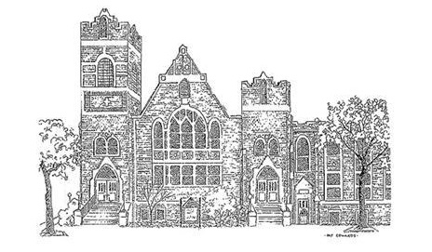

Central United Methodist Church
Our Mission:
To make disciples of Christ who WORSHIP God,
GROW in their faith and SERVE in the church and world.

Rev. David Lee, Pastor
Dr. Tammy Bass, Director of Discipleship
Caroline Scism, Director of Children Ministries
Danny Buckner, Director of Music Ministries
Katie Bowers, Director of Youth Ministries

200 East Marion Street
Shelby, NC 28150
704-487-6336
http://cumcshelby.org


Please scan the QR code to the left and fill out the connect card to let us know you are worshipping with us and how we can connect you to our ministries.

The Worship of God

November 30, 2025 10:00am

Welcome and Announcements

Passing of the Peace

Prelude O Come, O Come, Emmanuel arr. Hopson
Libby Alexander, organ

*Congregational Song Come, Thou Long Expected Jesus

Lighting the Advent Wreath
First Reader: The prophet Isaiah calls to us from the past to imagine the future
when God’s reign will be fully realized and recognized throughout creation. When that time comes, God “shall judge between the nations and shall arbitrate for many peoples; they shall beat their swords into plowshares and their spears into pruning hooks; nation shall not lift up sword against nation; neither shall they learn war any more” (Isaiah 2:4).

All: Today, we choose to live in hope, believing that the time of God’s reign has come and is coming among us.

Second Reader: We light this candle of hope as a sign of our promise to follow the Light as we answer God’s call to transform our hope into reality today and in the days to come.
(Light the first candle of the Advent wreath.)

Morning Prayer

The Lord’s Prayer
Our Father, who art in heaven, hallowed be thy name.
Thy Kingdom come, thy will be done
on earth as it is in heaven.
Give us this day our daily bread.
And forgive us our trespasses,
as we forgive those who trespass against us.
And lead us not into temptation, but deliver us from evil.
For thine is the kingdom, and the power, and the glory, forever.

Children’s Message Lynn Carter

Offertory Of the Father’s Love Begotten arr. Gawthrop
Libby Alexander, organ

Doxology #95
Praise God, from whom all blessings flow;
praise him, all creatures here below;
praise him above, ye heavenly host;
praise Father, Son, and Holy Ghost. Amen.

Anthem Down to the River to Pray arr. Curry Quartet: Jennifer Buckner, Emma Buckner,
Perry Anthony, and Danny Buckner

As I went down in the river to pray studying about that good old way
And who shall wear the starry crown? Good Lord, show me the way!
O sisters let's go down, let's go down, come on down.
Come on sisters let's go down, down to the river to pray.

As I went down in the river to pray studying about that good old way
And who shall wear the robe and crown? Good Lord, show me the way!
O brothers let's go down, let's go down, come on down.
Come on brothers let's go down, down to the river to pray.

As I went down in the river to pray studying about that good old way
And who shall wear the starry crown? Good Lord, show me the way!
O fathers let's go down, let's go down, come on down.
O fathers let's go down, down to the river to pray.

As I went down in the river to pray studying about that good old way
And who shall wear the robe and crown? Good Lord, show me the way!
O mothers let's go down, come on down. Don’t-cha wanna go down?
Come on mothers let's go down, down to the river to pray.

As I went down in the river to pray studying about that good old way
And who shall wear the starry crown? Good Lord, show me the way!
O sinners let's go down, let's go down, come on down.
O sinners let's go down, down to the river to pray.

Scripture Mark 1: 1-8

Sermon Prepare the Way of The Lord Rev. David Lee

*Congregational Song Hail to the Lord’s Anointed

*Benediction

*Chiming the Trinity

*Postlude Lift Up Your Heads arr. Cherwien
Libby Alexander, organ

*Please stand if able
Altar Design- God’s Message of HOPE--- Psalm 23. Thank you to Central’s staff for sharing their Nativity animals.

Welcome! Welcome! Welcome!
Visitors are invited to visit the Welcome Table for a free gift and additional information about Central United Methodist Church. We are glad you are here!

Prayer Concerns
For this week please pray for the following:
*All of those recovering or suffering from medical issues, physical and emotional.
Ricky Shell
Mike Richardson Kimberlyn Floyd
Mark Elliott (Stroke) Sandra Raynor and Family
Ollie Anthony
Steve & Becky Hill (loss of grandson- Sheilds Fletcher)
Leena Wray “Mom and Pop” Plunner
Deborah Martin (Stephen Agers sister-Cancer recover)
Allison Bustillo Chinchilla (Crest graduate self-deported after ICE detainment)
Frank Richardson Roger Davis
Gerald Lamonte Jennings (Cancer)
Ashley Allison Roger Lewis (Heart Surgery)
Jeannie Hamrick Aurora Lewis (Spinal Surgery)
Victims of Long COVID
Other:
Military & First Responders Western NC
End of Violence & Violent Rhetoric Breast Cancer Research
Our Homeless Community Division of our country
Wars in Ukraine, Gaza, and Sudan
Victims of extreme weather and wildfires
Those Grieving
Connect with us!
Use this QR Code for a direct link to all things CUMC. Get easy access to online giving options, connect cards letting us know you were in worship (in person or online), updated bulletins, newsletters and more!

Ministry Needs
Below is a list of volunteer and donation needs for some of our ministries:
Backpack Ministry: For November: Individual Packs of Grits/Oatmeal
Open Table: Bottled Water

Youth Group
No Youth 11/30

Youth Mission Trip
If you haven't paid your deposit for the Youth Mission Trip to Kansas City, please do so this week or reach out to Katie.

It’s Not Too Late!!
Lake Junaluska Retreat Registration Is Still Open!

The registration for the church wide retreat is open! Please fill out your registration card and return it to the office so you don’t miss out on this experience. We do offer the registration ONLINE! Visit cumcshelby.org/church-wide-retreat and complete the form. You can also pay online using the same page and following the link at the bottom.

Sanctuary Decorating
Monday 12/1 at 10am
Come and decorate the sanctuary and tree with us for Christmas. Please let Tammy know if you can help.

Meal Train for the Youngs
Welcome Marigold Young! Help Casey and Rebekah adjust to life at home with Goldie. Sign up on the Meal Train link to bring a meal:
https://mealtrain.com/d00943

Fall Discipleship Opportunities

Saturday Morning Men’s Bible Study
8am, Saturday Mornings before Open Table.
CUMC Room E210
Starting on Sept. 20th and m
eets the 1st and 3rd Saturdays of the month.
The Book of Matthew
Have you wondered about the nature of the Kingdom of Heaven? Good thing to wonder! Matthew’s gospel pulls back the curtain and says, “Thanks for asking, here it is.”
Taught by Dr. Tim Sieges, retired Director of Wycliffe Counseling Ministries
Daytime Ladies’ Bible Study
Thursdays starting Sept. 18th at 9:30
Conference room
This is a 4 week advent study titled “ A child is born” and written Amy-Jill Levine. If interested, contact Jessica Talbert
Disciple Class
The Disciple class will be starting back with the study of Colossians on Tuesdays from 3-5:30pm in the conference room. If you are interested, contact Rob Laney.


Stewardship Update: 11/24/25
Thanks to everyone who has made your pledge/estimate of giving for 2026. We have received 59 cards with a total of $542,072 pledged.

Our goal continues to have 100 cards supporting a budget of $801,000 to support the Mission of our church, “To make disciples of Christ, who WORSHIP God, GROW in their faith, and SERVE in the church and world”. In unity we serve and give to fulfill our mission.

If you have questions regarding Stewardship, feel free to call or come to the church office. I can be reached at 704-472-4568 or email jblattimore@hotmail.com.

John Lattimore
Stewardship Chair

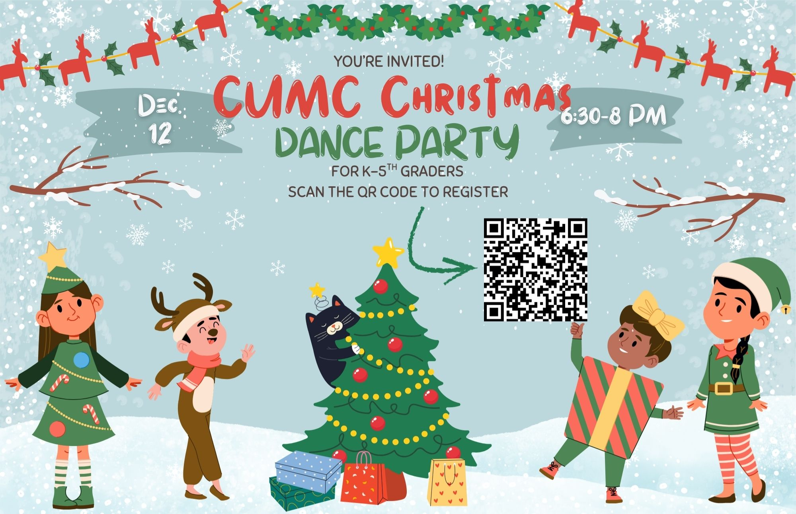

Central UMC Ministry Opportunity
This QR code will take you to a comprehensive list of opportunities to be involved and serve at Central. Check out the list! You will be proud of all that Central does to make a difference in people’s lives! Find a place to serve! As you find your place to serve, help new people find the information and a place to plug in! Together we shine the bright light of Christ!

Central UMC is a Safe Sanctuaries church. Please be sure that your
Children are always accompanied by a parent or responsible adult caregiver including if and when they need to use the restroom during service. We appreciate your assistance as we strive to ensure the safety of all.
Restrooms are located outside the right-hand side of the sanctuary, as
you look at the chancel area.
Childcare is available for infants and preschool aged children. Our
nursery staff awaits you in room E105.
Hearing devices are available for those who need them.
Large print Bibles & Hymnals are available for those who need them.
SERMON NOTES

The Ushers are at each door and will happily assist you with any of these.
Sermon Notes
____________________________________________________________
____________________________________________________________
___________________________________________________________
____________________________________________________________
___________________________________________________________
____________________________________________________________
____________________________________________________________
_________________________________________________________________________________________________________________________________________________________________________________________________________________________________________________________________________________________________________________________________________________________________________________________________________________________________________________________________________________________________________________________________________________________________________________________________________________________________________________________________________________________________________________________________________________________________________________________________________________________________________________________________________________________________

