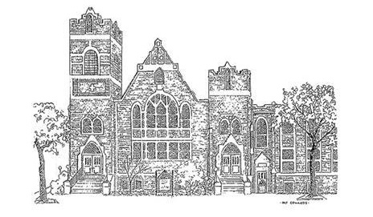

Central United Methodist Church
Our Mission:
To make disciples of Christ who WORSHIP God,
GROW in their faith and SERVE in the church and world.

Rev. David Lee, Pastor
Dr. Tammy Bass, Director of Discipleship
Caroline Scism, Director of Children Ministries
Danny Buckner, Director of Music Ministries
Katie Bowers, Director of Youth Ministries

200 East Marion Street
Shelby, NC 28150
704-487-6336
http://cumcshelby.org


Please scan the QR code to the left and fill out the connect card to let us know you are worshipping with us and how we can connect you to our ministries.

The Worship of God

November 16, 2025 10:00am

Welcome and Announcements

Passing of the Peace

Prelude Come Thou Fount of Every Blessing arr. Payne
Libby Alexander, organ

*Congregational Song Gather Us In

Morning Prayer

The Lord’s Prayer
Our Father, who art in heaven, hallowed be thy name.
Thy Kingdom come, thy will be done
on earth as it is in heaven.
Give us this day our daily bread.
And forgive us our trespasses,
as we forgive those who trespass against us.
And lead us not into temptation, but deliver us from evil.
For thine is the kingdom, and the power, and the glory, forever.

Children’s Message Caroline Scism

Offertory Be Thou My Vision arr. Lau
Libby Alexander, organ
Doxology #95
Praise God, from whom all blessings flow;
praise him, all creatures here below;
praise him above, ye heavenly host;
praise Father, Son, and Holy Ghost. Amen.

Anthem Where Cross the Crowded arr. Miller
Ways of Life
Chancel Choir
Hallelujah!
Where cross the crowded ways of life,
where sound the cries of clan and race,
above the noise of selfish strife,
we hear your voice, O God of grace.
Hallelujah!
In haunts of wretchedness and need,
on shadowed thresholds fraught with fears,
from paths where hide the lures of greed,
we catch the vision of your tears.

Till all the world shall learn your love,
and follow where your feet have trod,
till, shining from your heaven above,
shall come the city of our God!
Hallelujah!
The cup of water given for you
still holds the freshness of your grace;
yet long these multitudes to view
the sweet compassion of your face.
O Master, from the mountainside
make haste to heal these hearts of pain;
among these restless throngs abide;
O tread the city's streets again.
Hallelujah!

Scripture John 11

Sermon Grief, Gratitude and Community Rev. David Lee

*Congregational Song Amazing Grace

*Benediction

*Chiming the Trinity

*Postlude Go Make of All Disciples arr. House
Praise Ensemble Instrumentalists

*Please stand if able
The Altar Design honors CUMC for its many acts of kindness and deeds of caring for others at this season of Thanksgiving and during the year.
Matthew 7-20: By their fruit you will recognize them.

Welcome! Welcome! Welcome!
Visitors are invited to visit the Welcome Table for a free gift and additional information about Central United Methodist Church. We are glad you are here!

Prayer Concerns
For this week please pray for the following:
*All of those recovering or suffering from medical issues, physical and emotional.
Ricky Shell
Mike Richardson Kimberlyn Floyd
Mark Elliott (Stroke) Sandra Raynor and Family
Ollie Anthony
Steve & Becky Hill (loss of grandson- Sheilds Fletcher)
Leena Wray “Mom and Pop” Plunner
Deborah Martin (Stephen Agers sister-Cancer recover)
Allison Bustillo Chinchilla (Crest graduate self-deported after ICE detainment)
Frank Richardson Roger Davis
Sarah Queen
Victims of Long COVID
Other:
Military & First Responders Western NC
End of Violence & Violent Rhetoric Breast Cancer Research
Our Homeless Community Division of our country
Wars in Ukraine, Gaza, and Sudan
Victims of extreme weather and wildfires
Those Grieving
The family of Becky Smith
The family of Rev. Dr. Jung Kee Lee

Connect with us!
Use this QR Code for a direct link to all things CUMC. Get easy access to online giving options, connect cards letting us know you were in worship (in person or online), updated bulletins, newsletters and more!

Ministry Needs
Below is a list of volunteer and donation needs for some of our ministries:
Backpack Ministry: For November: Individual packs of grits/oatmeal
Open Table: Bottled Water

Lake Junaluska Retreat Registration Is Still Open!

The registration for the church wide retreat is open! Please fill out your registration card and return it to the office so you don’t miss out on this experience. We do offer the registration ONLINE! Visit cumcshelby.org/church-wide-retreat and complete the form. You can also pay online using the same page and following the link at the bottom.

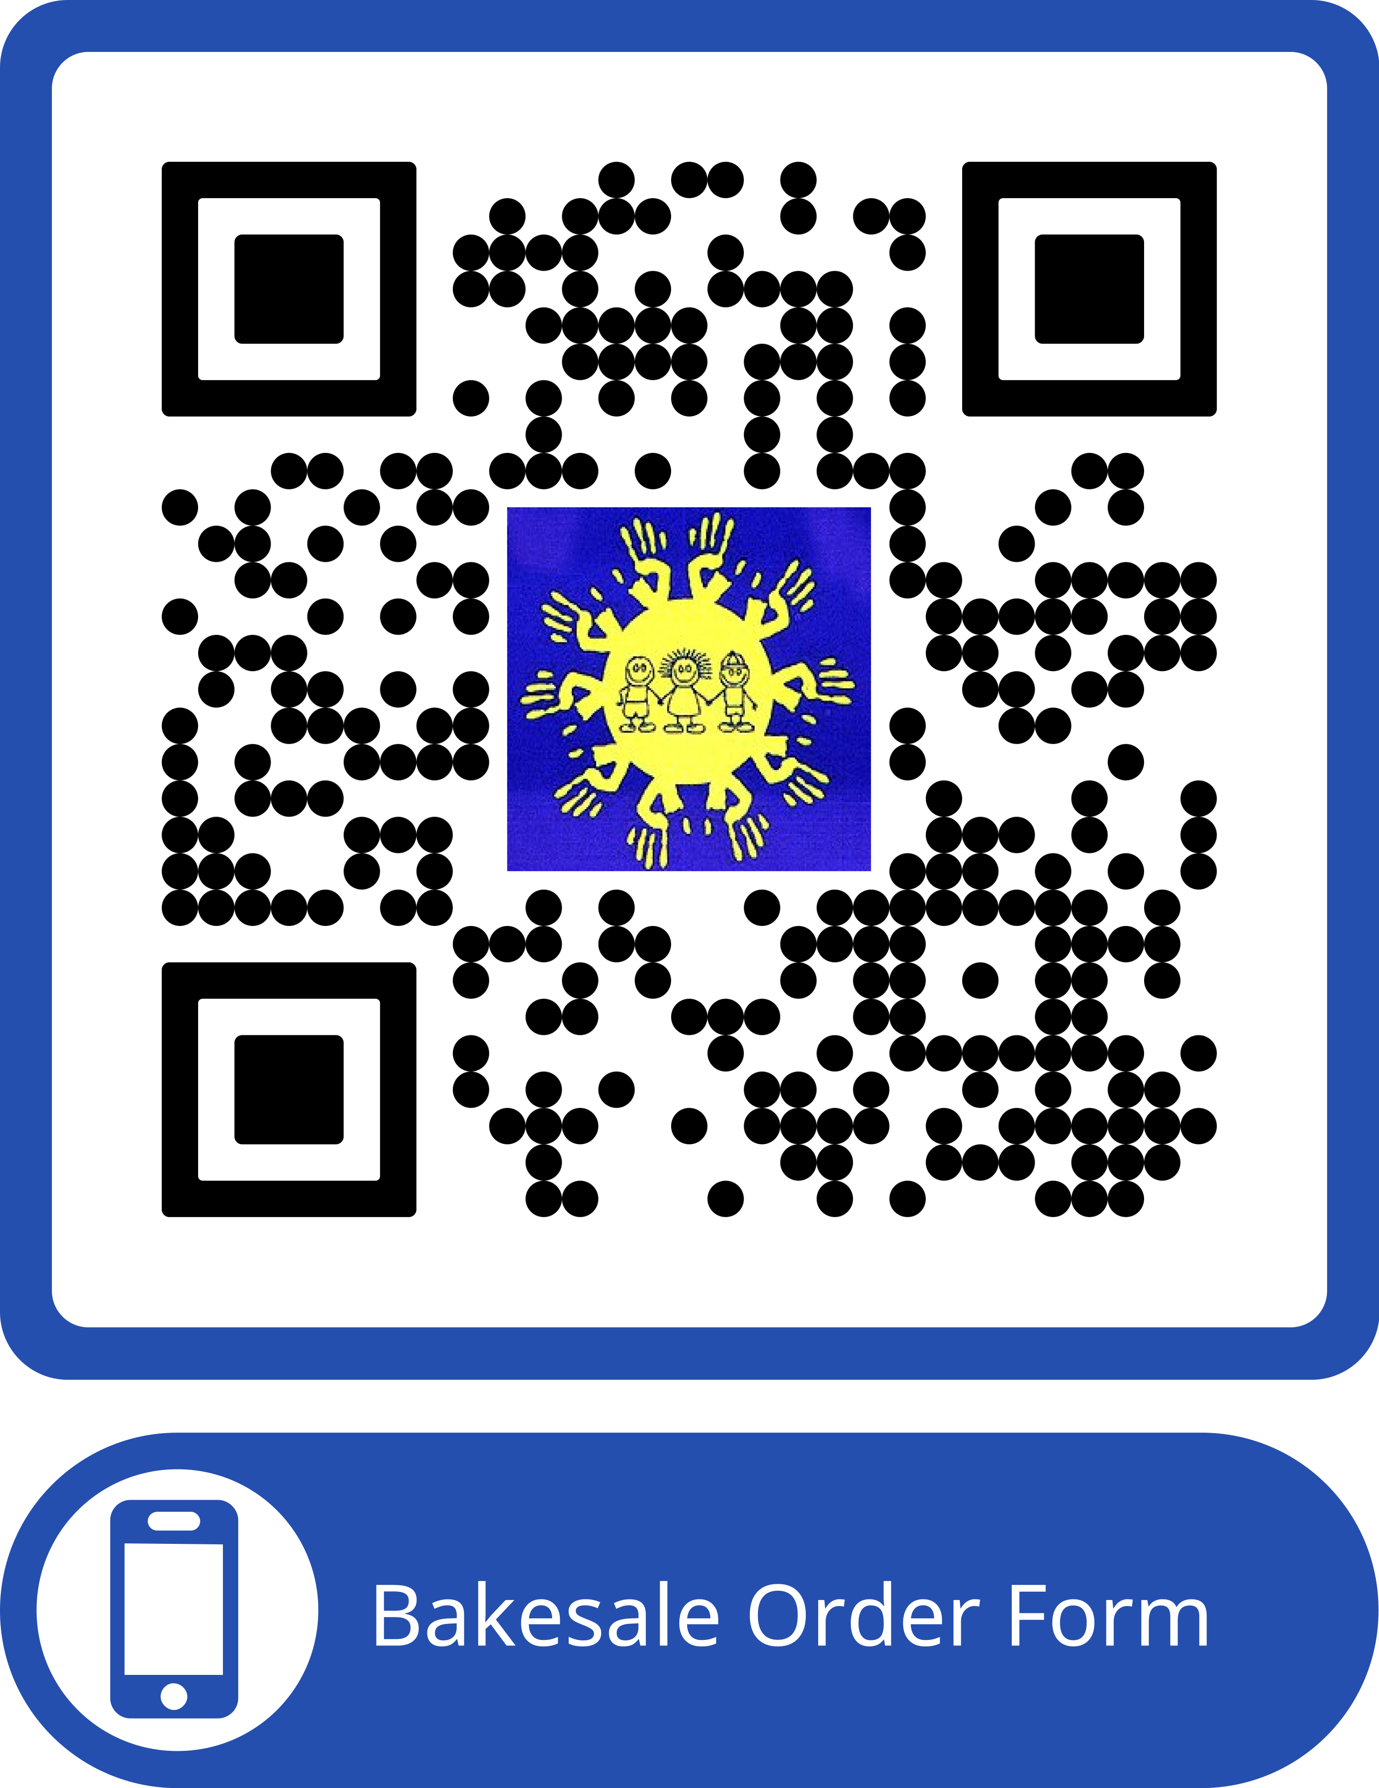
Kids Place Fundraiser
Pre-orders for pecan pies and large loaf pumpkin bread are due by November 20th. Scan the QR code order! Other yummy desserts will be available to purchase on November 23rd as well. Thanks to our wonderful WinGs group!

Blood Drive
Tuesday, November 18 from 2-6:30pm in the fellowship hall. This is the season of giving, so please plan to donate blood next week. Your donation can save up to 3 lives. If you give on the 18 th, you get a free pair of PAC-MAN socks.

Sanctuary Decorating
Monday 12/1 at 10am
Come and decorate the sanctuary and tree with us for Christmas. Please let Tammy know if you can help.

Time for WinGs!!
Everyone is welcome! Bring a friend!
This is a program you do not want to miss!
Our guest on Wednesday 11/19 @ 10am
is Mary Ann LaSelva. She will share her experiences from her recent journey on the CAMINO DE SANTIAGO. This is an 800 kilometer Pilgrimage from St Jean Pied du Port (in France) to Santiago, Spain. That is 497 MILES folks!
Join us for fellowship, information and inspiration.
See you there!

Youth Lock In
Please remember to "Skip a meal and Donate a meal" this week by skipping going out to eat one night and instead bringing the money you would have spent to church on Sunday. Youth will be by the doors after the service collecting donations to help food insecurity in our community.

Confirmation Retreat
Please remember to turn your deposits in for the confirmation retreat ($50 - retreat March 13-15) and the mission trip ($100 - July 18-24) by Monday 11/17. Please note in the memo line what the deposit is for to help our finance committee. Katie also needs to know tshirt size for anyone going on the confirmation retreat.

Mission Trip
The Youth will be heading to Kansas City for a mission trip in July 2026 and visiting Adam Hamilton's church while we are there as well. We will be flying out Saturday, July 18th and returning either Friday, July 24th or Saturday, July 25th. This is open to all current youth, anyone currently in 5th grade and their families. We need to send in an initial deposit of $100 per person to hold our spot and will be fundraising over the next several months to keep the out of pocket expenses as low as possible. Please turn your $100 deposit into the office by Sunday, November 16th and let Katie know if you have any questions.

Feeding Kids Cleveland County Thanksgiving Meal
Feeding Kids Cleveland County is having their annual Thanksgiving meal at the Bobby Bell pavilion on Saturday, November 22nd at 4:00 p.m. CUMC is invited to participate by volunteering to help with the event (table decorations, serving food, or making a dessert) or by eating the meal with our neighbors. Sign ups will begin November 1. If you are interested please contact Denise Sieges at (704)609-6184 or denisesieges@gmail.com

Stewardship Update:
Through Monday, November 10, 50 estimate of Giving Cards have been turned in, total $478,372. We are halfway to our goal of 100 cards. Our budget for 2025 is $801,000.00; our 2026 budget is to be determined. All pledges are greatly appreciated.
John Lattimore
Stewardship Chair

Fall Discipleship Opportunities

Saturday Morning Men’s Bible Study
8am, Saturday Mornings before Open Table.
CUMC Room E210
Starting on Sept. 20th and meets the 1st and 3rd Saturdays of the month.
The Book of Matthew
Have you wondered about the nature of the Kingdom of Heaven? Good thing to wonder! Matthew’s gospel pulls back the curtain and says, “Thanks for asking, here it is.”
Taught by Dr. Tim Sieges, retired Director of Wycliffe Counseling Ministries

Daytime Ladies’ Bible Study
Thursdays starting Sept. 18th at 9:30
Conference room
This is a 4 week advent study titled “ A child is born” and written Amy-Jill Levine. If interested, contact Jessica Talbert
Disciple Class
The Disciple class will be starting back with the study of Colossians on Tuesdays from 3-5:30pm in the conference room. If you are interested,



Central UMC Ministry Opportunity
This QR code will take you to a comprehensive list of opportunities to be involved and serve at Central. Check out the list! You will be proud of all that Central does to make a difference in people’s lives! Find a place to serve! As you find your place to serve, help new people find the information and a place to plug in! Together we shine the bright light of Christ!

Central UMC is a Safe Sanctuaries church. Please be sure that your
Children are always accompanied by a parent or responsible adult caregiver including if and when they need to use the restroom during service. We appreciate your assistance as we strive to ensure the safety of all.
Restrooms are located outside the right-hand side of the sanctuary, as
you look at the chancel area.
Childcare is available for infants and preschool aged children. Our
nursery staff awaits you in room E105(pre-school age) and E204 (infants).
Hearing devices are available for those who need them.
Large print Bibles & Hymnals are available for those who need them.
SERMON NOTES

The Ushers are at each door and will happily assist you with any of these.
Sermon Notes
____________________________________________________________
____________________________________________________________
___________________________________________________________
____________________________________________________________
___________________________________________________________
____________________________________________________________
____________________________________________________________
_________________________________________________________________________________________________________________________________________________________________________________________________________________________________________________________________________________________________________________________________________________________________________________________________________________________________________________________________________________________________________________________________________________________________________________________________________________________________________________________________________________________________________________________________________________________________________________________________________________________________________________________________________________________________

