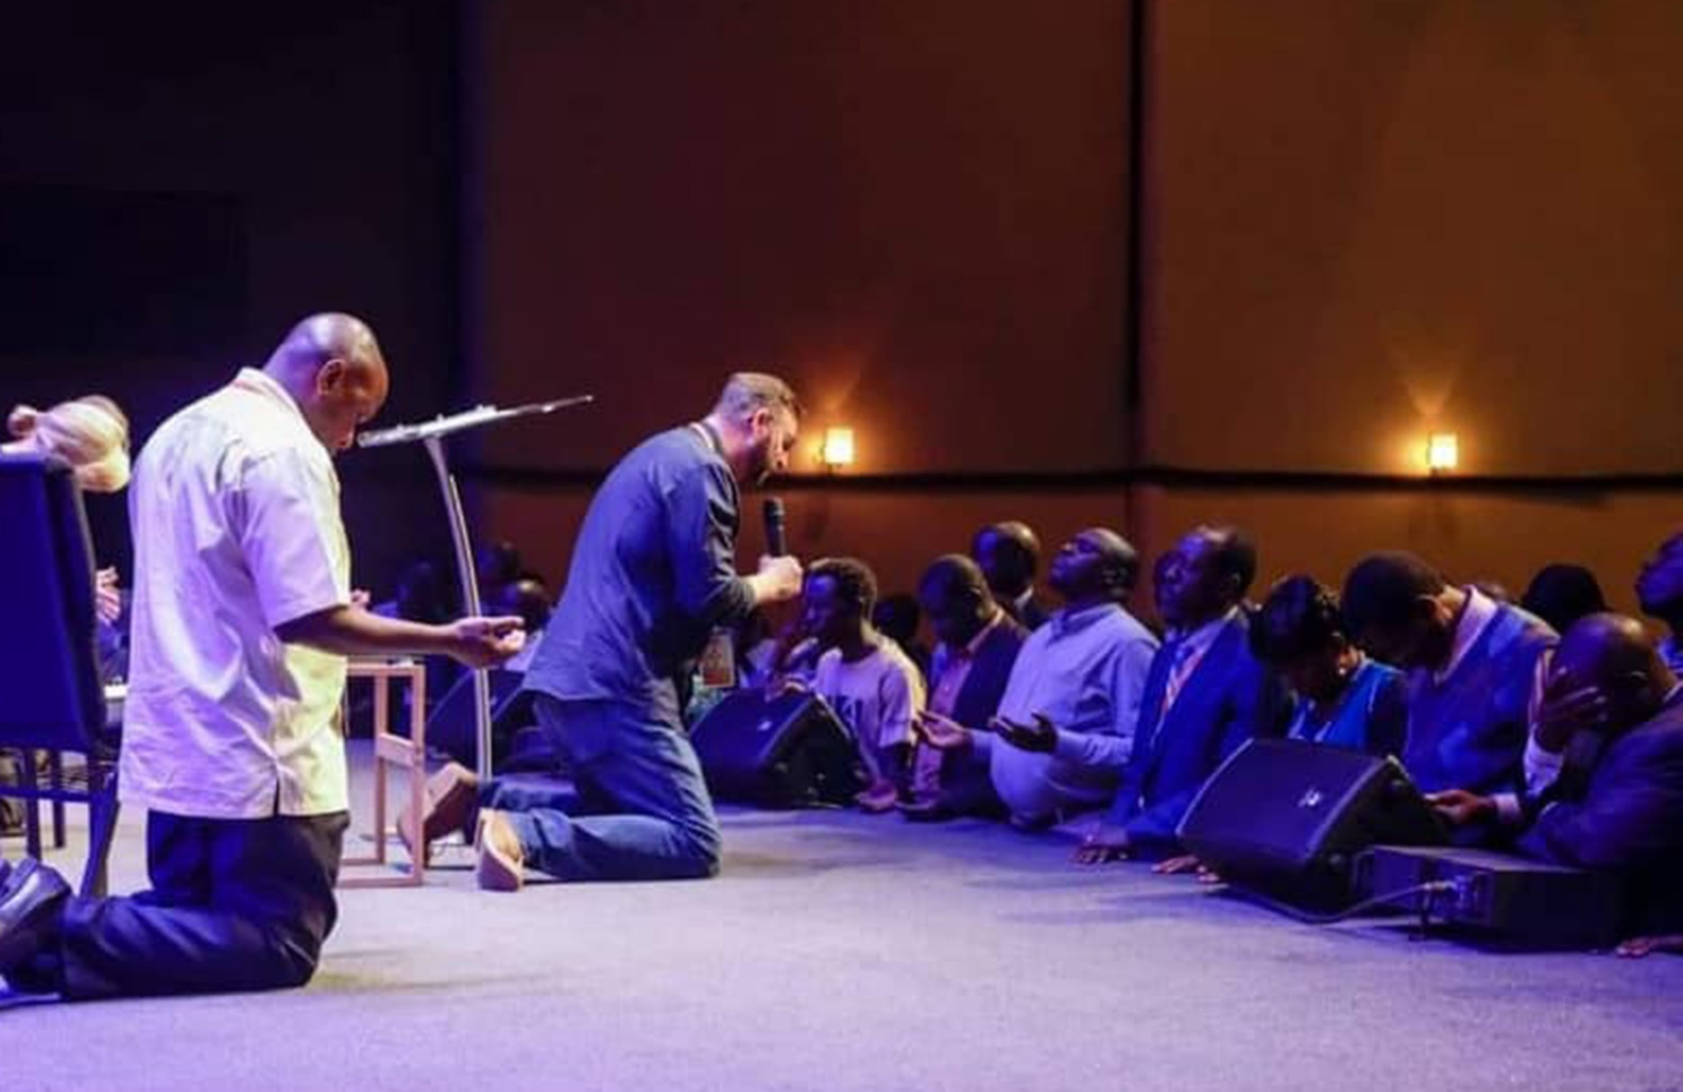

Facilitator  
Guide

Jim Cowart  
Senior Pastor

Preach a Sermon,

Give a Testimony &

Lead a Public Prayer

HOW TO

*How to   
Preach A Sermon,   
Give a Testimony &   
Lead a Public Prayer*by  
Jim Cowart

Inspired by Saddleback Church’s   
*Preaching for Life Change*

Contributions by   
*Andy Stanley*

Harvest Church  
3322 US HWY 41N  
Byron, GA 31008

478.923.8822

www.HarvestChurch4u.org

June 2025

PAGE 2

**21**

Praying In Public

**12**

The 8 Questions of Preaching

**10**

It’s All About Application

**09**

The 5-Sentence Sermon

A Testimony

**07**

A Simple Structure for Sermons & Personal  
Testimonies

ME  WE  GOD  YOU  WE

**04**

Preaching for People   
Who aren’t Preachers

PAGE 3

**Table of contents**

Preaching For People Who Aren’t Preachers

The religious community probably looked upon the first 12 disciples Jesus chose, as an unlikely and dubious group. There was not a Pharisee (the best of the best) or a Priest among them. This group was made up largely of salt-of-the-earth,   
guy-next-door type men, who were   
local businessmen.

But God used them to change the world anyway.

I believe God can use me, and you, too.

Now, let me clarify at the beginning, that   
I don’t believe everyone should quit their job and become a Pastor or Evangelist. Ephesians 4 teaches us that God has set aside and specifically gifted some people for offices in the Body of Christ.

“So Christ Himself gave the apostles, the prophets, the evangelists, the pastors and teachers, to equip His people for works of service, so that the body of Christ may be built up until we all reach unity in the faith and in the knowledge of the Son of God and become mature, attaining to the whole measure of the fullness of Christ.” Ephesians 4:11-13 (NIV)

This seminar is not about that.

This seminar is about…well, let me explain it this way.



PAGE 4



Professional Race Car Drivers drive at 200 miles per hour around a track, sometimes only feet or inches from a wall or another car. I can’t do that; and, you probably shouldn’t try it either. But I can drive to the grocery store, or to work, or to church, or to see a ball game - all by myself! And you probably can too. The point is: I’m not a professional driver and never will be. I can’t do what they do. But I can drive.

Ok, here’s another one. Think of these heroes - Firemen. They have special training and special equipment. They can put out fires and save people in situations that would probably prove disastrous to us. I can’t do that. But I can blow out a candle.

I suppose I could get to the grocery store faster at 200 miles per hour; but there just aren’t that many Race Car Drivers out there to cart us all around. So, we learned how to drive. I suppose I could call a Fireman over to blow out the scented candles Jen has around the house; but if   
I did, they’d probably turn the firehose on me to teach me a lesson.



PAGE 5

“God loves us! Our sin separates us from God; but He made a way to save us. God sent His son Jesus to the rescue. Jesus willingly died on the cross as a sacrifice for our sins. When we repent and believe in Jesus, we accept His sacrifice for us and we’re made right with God. When we follow Jesus, we are forgiven and adopted into His family. God is with us and helps us in this life; and He’s preparing a great   
place for us in heaven after this life. God loves us!”

Preach:

preCH / verb:   
share good news

PAGE 4

Here’s a great short sermon

Let me give you some scriptures for the basis of this seminar.

|  |  |  |
| --- | --- | --- |
| Romans 10:13-14 (NLT) | 2 Corinthians 5:18-20 (NLT) | Revelation 12:10-11 (NLT) |
| “For everyone who calls on the name of the Lord will be saved. But how can they call on Him to save them unless they believe in Him? And how can they believe in Him if they have never heard about Him? And how can they hear about Him unless someone tells them?” | “…And God has given us this task of reconciling people to Him. For God was in Christ, reconciling the world to Himself, no longer counting people’s sins against them. And He gave us this wonderful message of reconciliation. So we are Christ’s ambassadors; God is making His appeal through us. We speak for Christ when we plead, ‘Come back to God!’” | “…For the accuser of our brothers and sisters has been thrown down to earth — the one who accuses them before our God day and night. And they have defeated him by the blood of the Lamb and by their testimony. And they did not love their lives so much that they were afraid to die.” |

This is important!   
Soooooooo, how do we do it?



PAGE 6

PAGE 6

**PAGE 4 I**

From

Andy Stanley

A Simple Structure   
Me  We  God  You  We

ME

Personal   
Story

Maybe a light, humorous story about the general topic

Self-deprecating - don’t make yourself out to be a   
“better-than-you” hero

People will relate to your failures more than your successes,  
at least at this point

This is the reason for the sermon

Touches on a problem, pain, or need in the listener’s life

A problem everyone can relate to

Shared  
Felt Need

WE

GOD

SCRIPTURE &   
PRINCIPLE

This is what God says, from His word, about the problem or pain

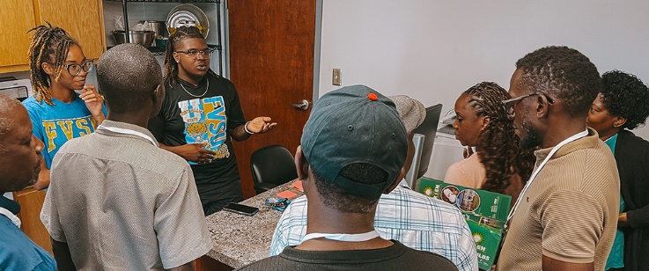

Paint a word picture of how life can be better if we actively seek   
God and apply His word in our daily lives and relationships

WE

PREFERRED  
FUTURE

YOU

APPLICATION

Action steps to put into practice based on what God says to do

Shorter is more memorable (1,2,3…not 1-27 steps)

Make it a verb - something to *do*, not just something to think about

PAGE 7

**PAGE 4 I**

**PAGE 4 I**



When I’m writing a sermon, I usually start with a **shared felt need** (We) or a **scripture** (God). Fill in the grid: Me, We, God,   
You, Me

Here’s an example of how I developed a sermon using this structure.

Problem   
(We - Shared Felt Need)

Christians are being very negative on social media. This is a bad testimony to unbelievers and harmful words are tearing people down. Stress seems to be bringing out the worst in some.

Scriptural Principle   
(God - Scripture)

“Therefore I, a prisoner for serving the Lord, beg you to lead a life worthy of your calling, for you have been called by God.”  
 Ephesians 4:1 (NLT)

We are called by God. So we need to live   
a life worthy of that calling. What does that look like; and, how do we do that?



|  |  |
| --- | --- |
| ME  Personal Story | * Story of personal stress * Slip into negativity and criticizing |
| WE  shared felt need | * Stress and fatigue tend to bring out the negative in us * Examples:  There’s a better way |
| GOD  scripture | * There’s a better way: Ephesians 4:1 |
| YOU  aCTION StEPS | * How can we *do* Ephesians 4:1 and live a life worthy of our calling?  1. Make a serious commitment to Jesus. Don’t *just* attend church 2. Grow more like Jesus (intentional steps: read the Bible, pray, obey commands) 3. Be more intentional about doing good deeds to help others |
| WE  PREFERRED FUTURE | * Benefits of living a life worthy of calling * Fruit of Spirit – love, joy, peace… |

PAGE 8

The 5-Sentence Sermon  
A Testimony

|  |  |
| --- | --- |
| ME  Personal Story | Just the other day I snapped at Jen for no apparent reason. I think I’ve been struggling lately; and, it just sneaks up on me sometimes |
| WE  shared felt need | I’ve noticed a lot of criticizing and complaining coming from my friends, too - especially on social media. So I guess I’m not the only one having a tough time |
| GOD  scripture | * I was reading the Bible the other day and came across Ephesians 4:1   “Therefore I, a prisoner for serving the Lord, beg you to lead a life worthy of your calling, for you have been called by God.” Ephesians 4:1 (NLT) |
| YOU  aCTION StEPS | I’ve been thinking about this verse a lot and asking God to show me *how* to live a life worthy of my calling  What I’m doing: I’m trying to give Jen a compliment every day |
| WE  PREFERRED FUTURE | I’m still working on it; but I think God is really helping me. And, I feel better already |

PAGE 9

PAGE 9

**I PAGE 5**

it’s all about application

God’s Purpose for the Bible



The purpose of the Bible is

___________________!

All scripture is given by inspiration of God and is profitable for:

⬥ Doctrine  Reproof  Correction  
⬥ Instruction in Righteousness

“That the man of God may be perfect thoroughly furnished unto all good works.”   
 2 Timothy 3:16-17 (KJV)

⬥ For  For  For  For*…So that!*

“The Word of God is not to teach us to prattle or be eloquent and subtle…It is to reform our lives so that we desire to serve God, to give ourselves entirely   
to Him, and to conform ourselves to   
His good will.” John Calvin

“The Bible was not given to increase our knowledge but to change our lives.” D. L. Moody

PAGE 10

PAGE 10



God’s Purpose for Leaders

“[Christ] gave some to be apostles, some to   
be prophets, some to be evangelists, and some to be pastors and teachers, to prepare God’s people for works of service, so that the body of Christ may be built up until we all reach unity in the faith and in the knowledge of the Son of God and become mature, attaining to the whole measure of the fullness of Christ.”  
 Ephesians 4:11-13 (NIV)

“The purpose of my instruction is that all   
the Christians there would be filled with   
love that comes from a pure heart, a clear conscience, and sincere faith. But some teachers have missed this whole point.   
They have turned away from these things   
and spend their time arguing and talking foolishness.” 1 Timothy 1:5-6 (NLT)

“We preach Christ to each person, using all wisdom to warn and to teach everyone, in order to bring each one into God’s presence   
as a mature person in Christ.”   
 Colossians 1:28 (NCV)

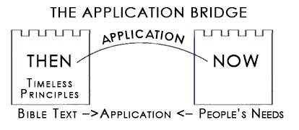

God’s Purpose   
for preachers

We are to be   
___________________.

.

How does   
“Life Change” happen?

___________________!

“If people are not sharing their faith in your church, if they’re not having a quiet time, if they’re not living godly lives, then you need to change your style of preaching. You are obviously not seeing lives changed through the Word of God. So what is the problem? The problem isn’t the Word! The problem is your preaching style!”  
 Bruce Wilkinson,   
 author of Prayer of Jabez

PAGE 11

“My word will not return void.” Isaiah 55:11 (NLT)

THE 8 QUESTIONS OF PREACHING

1. To whom will  
 I ________________?

"Whatever a person is like,   
I try to find common ground with him so he will let me tell him about Christ and let Christ save him. I do this to get the Gospel to them..."   
1 Corinthians 9:22-23 (LB)

"[Speak] only what is   
helpful for building others up according to their needs, that it may benefit those who listen.”   
 Ephesians 4:29 (NLT)

2. What does the Bible say about _________________?

“All scripture is inspired by God and is useful for teaching the faith and correcting error, for resetting the direction of a man’s life and training him in good living.”   
 2 Timothy 3:16 (Ph)

“[Jesus] He has appointed Me to preach Good News to the poor; He has sent Me to heal the broken-hearted and to announce that captives shall be released, and the blind shall see, that the downtrodden shall be freed from their oppressors, and that God is ready to give blessings to all who come to Him.” Luke 4:18-19/  
 Isaiah 6:1-2 (LB)

We don’t have   
to *make*   
the Bible relevant.   
It *is* !   
But we do have to _____________  
its relevance by   
_______________ it   
to today’s needs

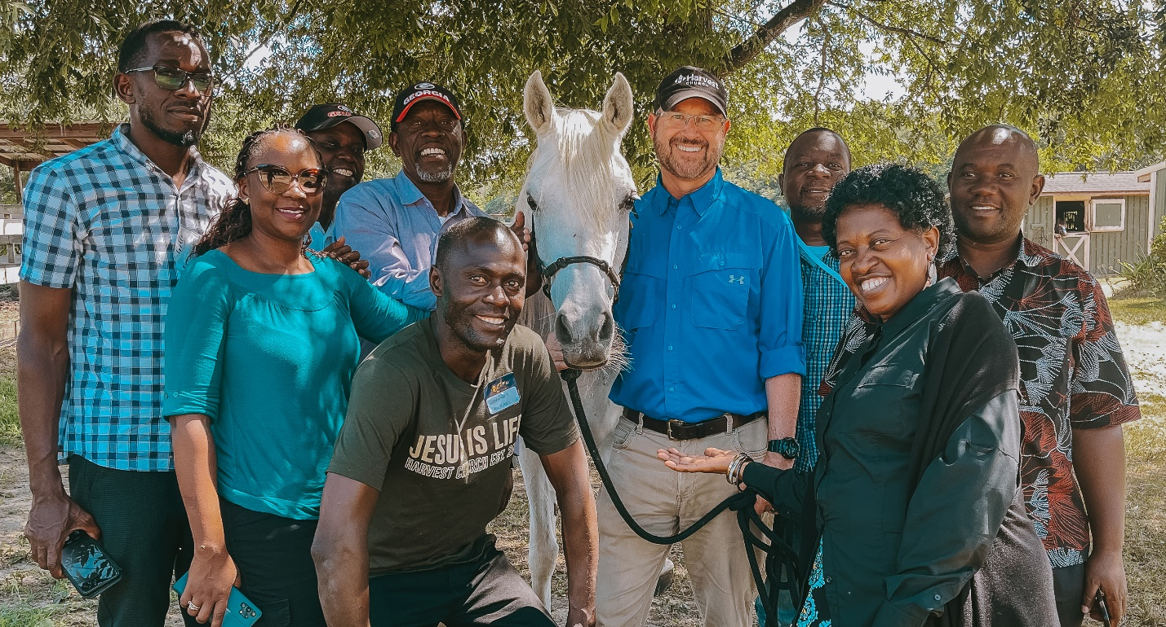

PAGE 12

3. What is the most _________________ way to say it?

If the *goal*   
of preaching is “changed lives,”   
then,  
_________________  
is the   
*primary task*   
of preaching!

“Don’t only hear the message, but put it into practice, otherwise you are merely deluding yourselves.”   
 James 1:22 (Ph)

“[Jesus]…Now go and do likewise.” Luke 10:37 (NLT)

“You must tell them the sort of character which should spring from sound teaching.”   
 Titus 2:1 (Ph)

“It is for you, then, to preach the behavior which goes with healthy doctrine.”   
 Titus 2:1 (NLT)



How to make your Preaching more Practical

We need less “______________” preaching   
and more “_______________” preaching!

show them   
_____________

“[Jesus]...teach them to DO everything I have commanded you...” Matthew 28:20 (NLT)

tell them ____________

PAGE 13

“The wise person teaches others how to live.” Proverbs 11:20 (NCV)

“He wrote to teach his people how to live – how to act in every circumstance.”   
 Proverbs 1:2 (LB)

“The words of Peter moved them deeply, and they said to him… ‘What should we do?’”  
 Acts 2:37 (LB)

Always aim for A  
___________________

4. What is the most _____________ way to say it?

Negative sermons fill a church with  
___________________  
Jesus never tried to convert anyone   
with an  
___________________  
Our basic message to the unchurched:   
___________________

“A wise, mature person is known for his understanding. The more pleasant his words,  
 the more persuasive he is.”  
 Proverbs 16:21 (GN)



Is the message good news?

Does my title imply Good news?

“Do not use harmful words in talking but only helpful words, the kind that build up...”   
 Ephesians 4:29a (GN)

When Preparing a Message Ask:

PAGE 14

5. What is the most ___________________way to say it?

“A word of encouragement does wonders!”   
 Proverbs 12:25 (LB)

“Everything that was written in the past was written   
to teach us, so that through endurance and the encouragement of the Scriptures, we might have hope.”  
 Romans 15:4 (NIV)

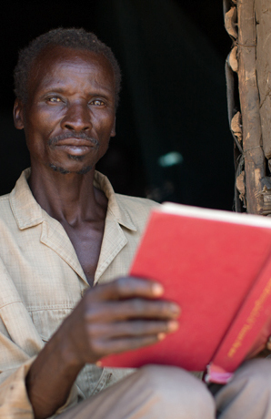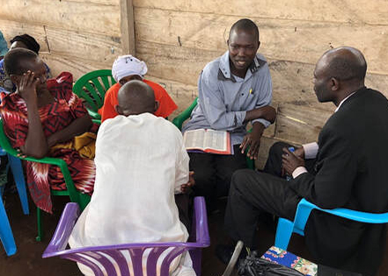

Key to   
Encouragement:  
Don’t just tell it like   
*it is.*Tell it like it   
_______________!

To have their faith reinforced

To have their hope renewed

To have their love restored

PAGE 15

Three Fundamental Needs of People

Jesus taught profound truths in   
_________________

“When I came to you, it was not with any show of oratory or philosophy, but simply to tell you what God has guaranteed.”  
 1 Corinthians 2:1 (JBP)

“My preaching was very plain, not with a lot of oratory...”  
 1 Corinthians 2:4 (LB)

“Your speech should be unaffected and logical so that your opponents may feel ashamed at finding nothing in which   
to pick holes.” Titus 2:8 (Ph)

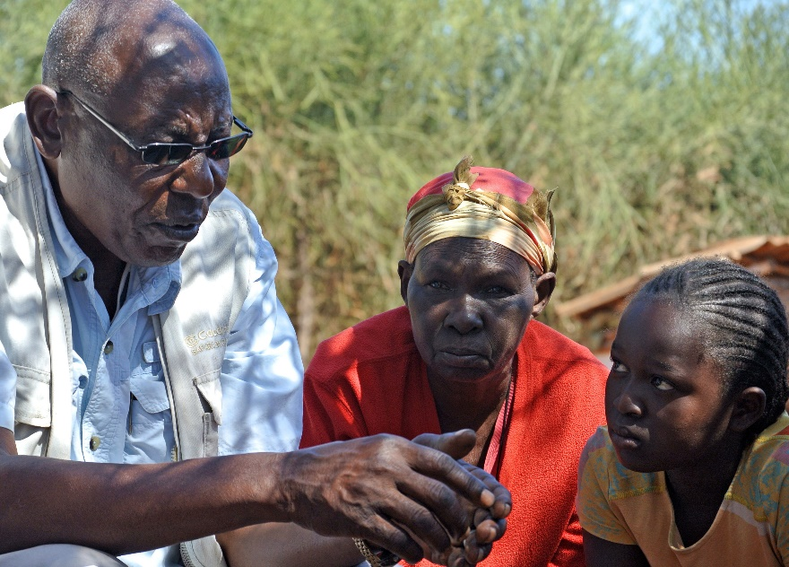

“I fear…[Satan] will corrupt you from the simplicity that is in Christ.”   
 2 Corinthians 11:3 (KJV)

Simple   
doesn’t mean   
________________!

“...the common people heard Him gladly.”  
 Mark 12:37 (KJV)

“You don’t really understand something   
unless you can explain it in a simple way.”   
 Albert Einstein

PAGE 16

6. What is the _______________ way to say it?

**PAGE 6 I**

how to simplify your messages

Keep your outline __________________

03

Avoid using   
___________________

02

Condense the message into a __________________

01

Put a __________in   
each point!

05

Make your applications the ____________________________

04





7. What is the most   
_________________ way   
to say it?

“We have spoken frankly to you, we have opened our hearts wide.” 2 Corinthians 6:11 (GN)

“We were delighted to share with you, not only the gospel of God but our own lives as well.”   
 1 Thessalonians 2:8 (NIV)

PAGE 17

**I PAGE 7**

“I want you to know about the hard times we went through in Asia.   
We were nearly crushed and overwhelmed and feared we would never live through it.”  
 2 Corinthians 1:8 (NLT)

Honestly share your_______________

01

how to preach with impact

Honestly share where you are ___________________

02



Ask the Holy Spirit to speak through you

“[Jesus] And when you are brought to trial in the synagogues and before rulers and   
authorities, don’t worry about how to defend yourself or what to say, for the   
Holy Spirit will teach you at that time what needs to be said.” Luke 12:11-12 (NLT)

“Our gospel came to you...with   
deep conviction.”   
 1 Thessalonians 1:5a (NLT)

PAGE 18

“Be wise in the way you act toward unbelievers...your speech should always   
be pleasant and interesting...”   
 Colossians 4:5-6 (GN)

“When wise people speak, they make knowledge attractive.”   
 Proverbs 15:2 (GN)

"For the Preacher was not only a wise man but a good teacher; he not only taught what he knew to the people, but taught them  
in an interesting manner."  
 Ecclesiastes 12:10 (LB)

8. What is the most __________________ way to say it?

Share what you are ___________________

04

03

"When we brought you the Good News, it was not just meaningless chatter to you; no, you listened with great interest. What we told you produced a powerful effect upon you…you know how our very lives were further proof to you of the truth of our message.” 1 Thessalonians 1:5 (LB)

In today’s culture,   
dull preaching is   
__________________!



humor ___________people

humor makes ___________________________more palatable

humor creates

_______________________

“Talk to [unbelievers] agreeably and with a flavor of wit, and try to fit your answers to the needs of each one.” Colossians 4:6 (JB)

“The large crowd listened to Jesus with delight.” Mark 12:37 (NIV)

“Jesus constantly used these illustrations when speaking to the crowds.   
In fact...He never spoke to them without at least one illustration.”  
 Matthew 13:34-35 (NLT)

benefits of humor

use  
___________________

How to keep it interesting

Vary your  
_______________

Never Make A Point Without a __________

tell   
__________________

PAGE 19

#1 Factor   
in  
Communication:  
_____________!

Key to Effective, Persuasive Preaching:  
__________________________!

PAGE 20



Opportunities

* Retirement Homes
* Small Groups
* Civic Clubs
* Small Churches
* Social Media

“…Always be prepared to give an answer to everyone who asks you to give the reason for the hope that you have. But do this with gentleness and respect…”   
 1 Peter 3:15 (NLT)

“Concentrate...on being a workman with nothing to be ashamed of, and who knows how to use the Word of Truth to the best advantage.” 2 Timothy 2:15 (Ph)

“If I have no love, my speech is no more than a noisy gong or a clanging bell.”   
 1 Corinthians. 13:1 (GN)

PRAYING IN PUBLIC

PAGE 21

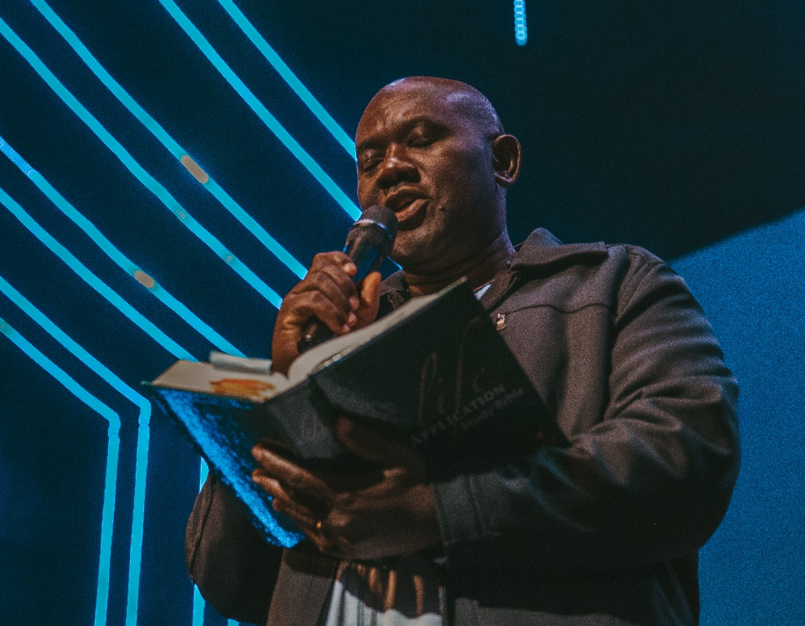

Talk to God but let the audience listen in.

01

“[Jesus] You always hear Me, but I said it out loud for the sake of all these people standing here, so that they will believe You sent Me.”   
 John 11:42 (NLT)

“{Jesus] When you pray, don’t babble on and on as the Gentiles do. They think their prayers are answered merely by repeating their words again and again.” Matthew 6:7 (NLT)

Be brief.

04

Use your own words. Don’t try to impress God or the people listening.

02

“When you pray, don’t be like the hypocrites who love to pray publicly on street corners and in the synagogues where everyone can see them.”   
 Matthew 6:6 (NLT)

A Simple Pattern (P.A.T.)

03

**P**raise God for who He is

**A**sk Him for help

**T**hank Him for what He   
 has done and will do

Write it out and practice

05

NOTES

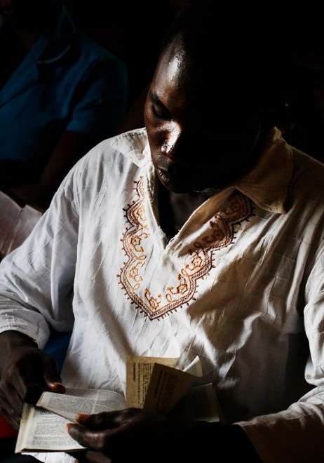

_____________________  
_____________________  
_____________________  
_____________________  
_____________________  
_____________________  
_____________________  
_____________________  
_____________________  
________________________________________  
________________________________________  
________________________________________  
________________________________________  
________________________________________  
________________________________________  
________________________________________  
________________________________________  
________________________________________  
________________________________________  
________________________________________  
________________________________________

PAGE 22

PAGE 23

|  |  |  |  |
| --- | --- | --- | --- |
| Pg | Answer | Pg | Answer |
| 10  11    12  13  14  15  16  17 | Life Change  Application  Bridge Builders  Be preaching  Their needs  Show  Applying  Practical  Application  Specific action  Why  How  Ought-to  How-to  Positive  Negative people  Angry Message  Good news  Encouraging  Can be  Simplest  Simple ways  Shallow  Single sentence  Religious terminology  Short and simple  Points of your outline  Verb  Personal | 18  19    20 | Own struggles  Making progress  Currently learning  Interesting  Inexcusable Delivery  Picture  Stories  Humor  Relaxes  Uncomfortable truths  Positive emotions  Love your people deeply  Likeability |

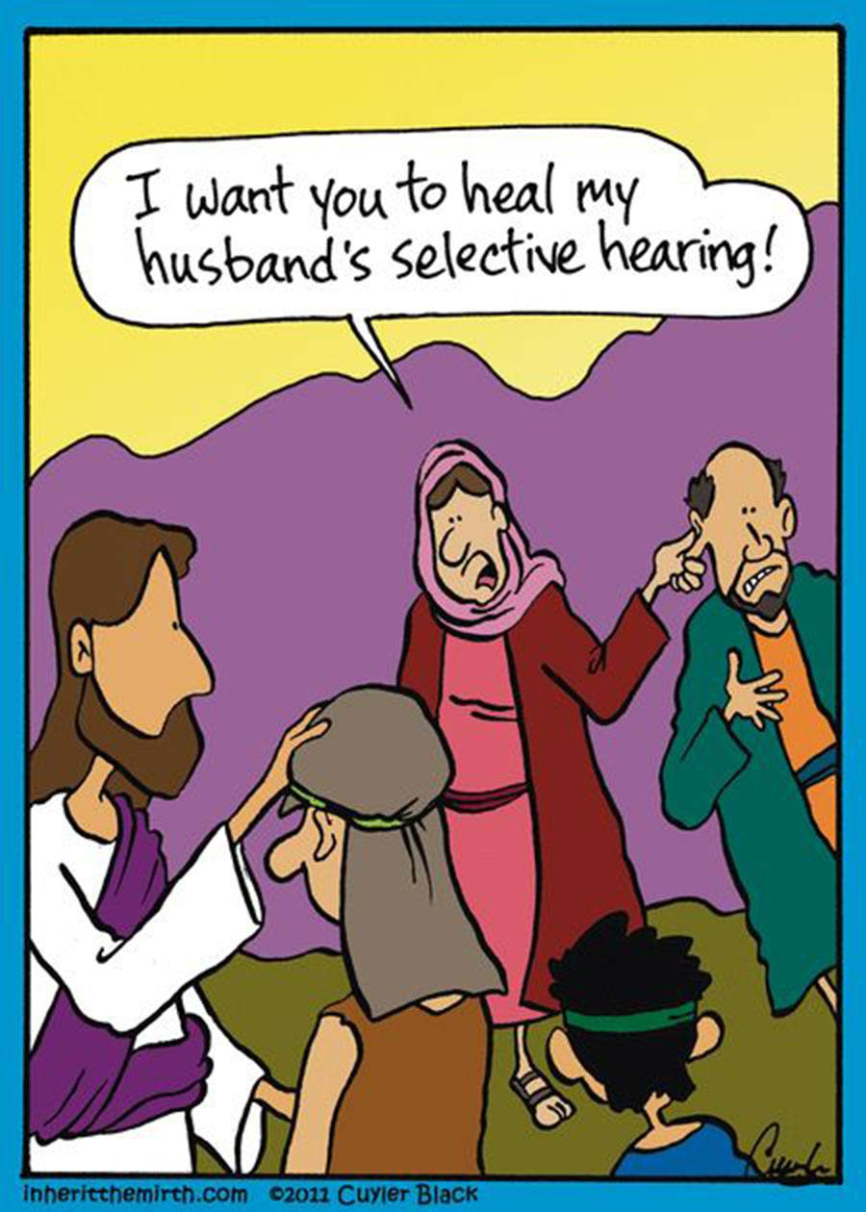

Answer Key





3322 US HWY 41N | Byron, GA 31008 | 478.923.8822  
www.HarvestChurch4u.org

Preach a Sermon,

Give a Testimony &

Lead a Public Prayer

HOW TO

Jim Cowart  
Senior Pastor