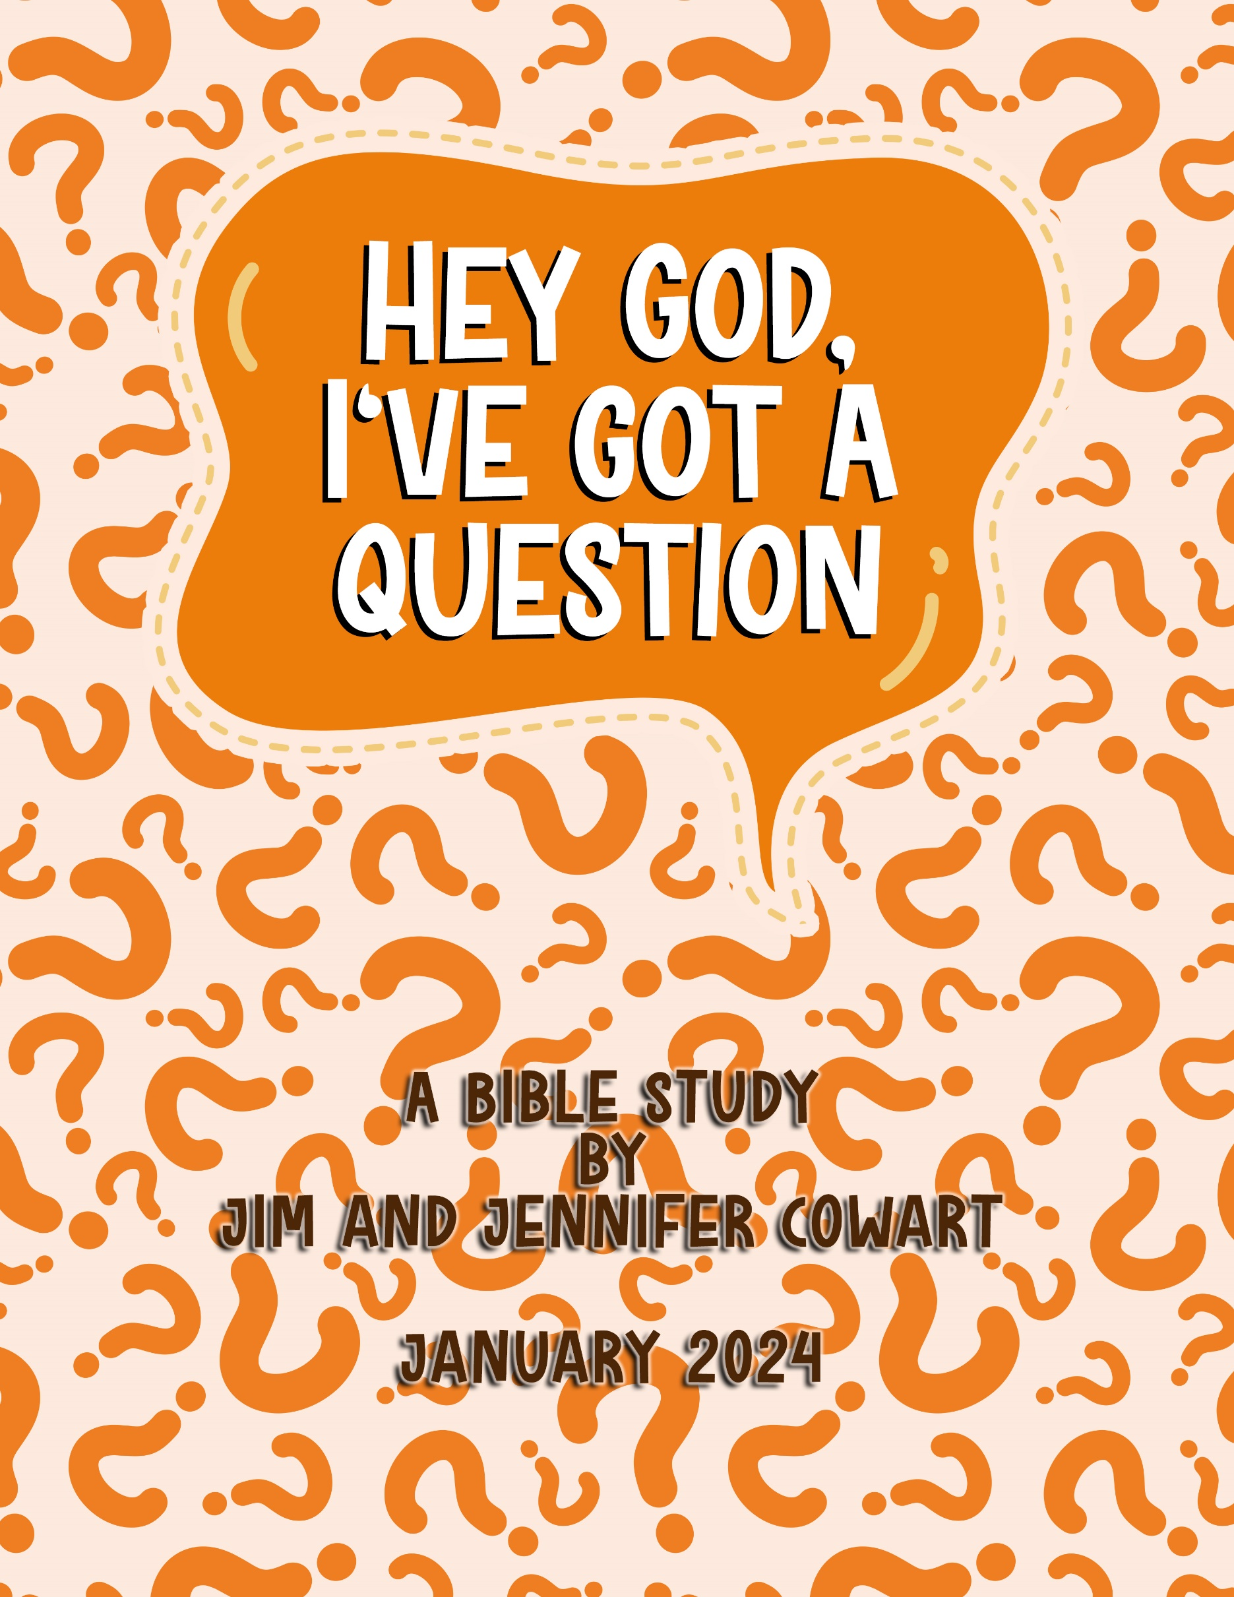

Welcome to

We’re so glad you decided to join us for our new series: *Hey God, I Have a Question.* Each of us has had (or will have) questions about our faith in God and His word. The good news is that our questions don’t scare our God. In fact, He enjoys them because they draw us closer to Him as we do the “good work” of searching for answers, clarity and understanding.

During this five-week Bible Study, you’ll have many opportunities to: examine the scriptures, share your discoveries and experiences. Hopefully you will both learn from each other and build lasting relationships with people in your group.

We are excited to see what Jesus has in store for you and your group over the next few weeks. And, we are praying that you will experience Him in fresh and relevant ways as a result of the time and effort you put into this opportunity.

Blessings,

Jim and Jennifer Cowart

Hey God, I Have a Question | a Bible Study | by Jim and Jennifer Cowart

a ministry of Harvest Church | 3322 US Hwy 41N, Byron, GA 31008

478.923.8822 | www.harvestchurch4u.org

Week 1:   
Is God real?

Opener

Have group members introduce themselves briefly: name, immediate family, one interest. Then, ask:

* What role did God have in your family growing up?
* Has church been a regular part of your life?

Activity

It’s impossible to prove or disprove anything, even the existence of God. But, we ***can*** point to the reliability of things.

For example, how would you prove to someone that you attended Harvest Church? Try this activity as a group.

* It would be hard to prove. But you could produce evidence that leads to a reliable verdict; evidence that indicates that you did indeed attend Harvest.

That’s what this study is meant to do. Offer thought provoking evidence to help people come to a reliable conclusion that God is who scripture says He is.

* What do you think holds most people back from believing in God?
* What do you think holds most people back from living for God? Is there is a difference in believing in God and living for Him?

Read

“Not everyone who says to Me, ‘Lord, Lord,’ will enter the kingdom of heaven, but the one who does the will of My Father who is in heaven. On that day many will say to Me, ‘Lord, Lord, did we not prophesy in Your name, and cast out demons in Your name, and do many mighty works in Your name?’ And then will I declare to them, ‘I never knew you; depart from Me, you workers of lawlessness.’ Matthew 7:21-23

Have someone sum up what this passage means?

Book Work:

In reading through *The God Questions* – it points to five things that lead us to consider God’s existence:

* The Universe
* The Creator – Pepsi Can Analogy
* Our Sense of Morality
* Jesus
* Personal Experience

Sum up what each of these five predictors mean. You may want to encourage group members to highlight portions of the book as they read each week.

* Which of the above five have been most meaningful to you?
* Which is hardest for you to find credible?
* If you do believe in God, what brought you to that conclusion?
* If you are not a believer, what questions and doubts do you have?
* What role does God play in your life right now?

Pray

How can we pray for one another?

Prepare

For next week, read chapter two of *The God Questions*.

Week 2:   
Is the Bible True?

Opener

Have group members introduce themselves briefly with their name and, if they have one, a favorite Bible story.

* What role did the Bible play in your family when you were growing up?
* How well would you say you know scripture?

Activity

If your group is up for it, write down Bible characters or stories on slips of paper. Have volunteers draw one and act it out to see if others can guess who it is. You may want to split the group into teams and do this as a fun competition. (Need a kick start? How about “David & Goliath,” “Daniel in the Lion’s Den,” Shadrach, Meshach and Abednego in the Fiery Furnace,” “Jesus and the Woman at the Well,” “Peter Trying to Walk on Water to Jesus,” “Jesus Healing a Blind Man” …you get the idea.)

The Bible was written by about 40 different authors. That writing was done in a 1500-year time span. Yet, from beginning to end, with all the various people, stories, and authors there is one theme of scripture – ***God’s passionate pursuit of a prodigal people.***

If your group is Bible savvy ask:

* How do you see this theme played out in Genesis?
* How do you see it played out after the flood?
* How do you see it played out through Jesus?
* Where else do you see it played out? Revelation, Prodigal Son, nation of Israel, etc.

Book Work:

* What exactly is a Bible translation? (See page 33 of *The God Questions.*) – How does this impact its integrity?
* Take a look at the chart on page 37. How does this impact the Bible’s reliability for you?
* In reading about evidence from science, archeology and prophecy (pages 39 – 49), how does this impact the credibility of scripture?

Read:

Have someone read Psalm 119:1-16.

* What promises and premises are held in this passage about God’s word?

Have someone read 2 Timothy 3:16-17.

* What is the purpose of scripture?
* How much time do you spend in God’s word weekly?
* What role do you see scripture playing in most Christians’ lives today?
* What role does it play in your life, personally?

Pray:

Ask how you can pray for one another’s faith.

Prepare:

For next week, read chapter 3 of *The God Questions*.

Week 3:   
Do all Roads lead to Heaven?

Opener:

Have group members share their name, and one of the most beautiful places they’ve ever visited.

Heaven is described as a beautiful place paved with streets of gold, gates of pearl and the presence of God bringing joy and peace. It’s probably fair to say that we cannot even imagine how wonderful heaven will be. No matter where you’ve been on earth it is just a glimpse of what God has in store for his children.

* What is the difference in a child of God and a creation of God?

Read

“God decided in advance to adopt us into His own family by bringing us to Himself through Jesus Christ. This is what He wanted to do, and it gave Him great pleasure.” Ephesians 1:4-5

“Jesus answered, ‘I am the way and the truth and the life. No one comes to the Father except through Me.’” John 14:6

“For God so loved the world that He gave His one and only Son, that whoever believes in Him shall not perish but have eternal life. For God did not send His Son into the world to condemn the world, but to save the world through Him.” John 3:16

* What do these passages tell us about God’s plan – about His passionate pursuit of prodigal people?

Some claim that Christianity is too exclusive, too narrow. Yet, it’s available to all. But there are specific instructions about how to get to heaven. It’s through a personal surrendered relationship with Jesus.

* Do you see anywhere in scripture that allows another path to heaven?

Book Work

* What stuck out to you while reading chapter 3: *Do all Roads Lead to Heaven*?
* How is Christianity fundamentally different to all religions?   
  (Answer: It’s not based on rules, but on relationship).
* What do you believe most of your friends believe about who Jesus is?
* What do you think is an effective way to share Christ with those who do not yet know Him?

Activity

This week’s activity is for ***after*** group. Ask group members to think of someone in their life who does not have a personal relationship with Jesus. What steps could they take, or begin taking, this week, to help that person(s) join God’s family. Share your ideas.

You may also want to share past experiences that you observed were not effective in sharing faith in Christ.

Pray

As you close read Romans 10:14-15 and then pray for courage to be sharers of God’s truth:

“And how can they hear about Him unless someone tells them? And how will anyone go and tell them without being sent? That is why the Scriptures say, ‘How beautiful are the feet of messengers who bring good news!’”   
 Romans 10:14-15

Prepare

Read Chapter 4 for next week’s group discussion.

Week 4:   
How can a good God   
allow suffering?

Opener

Share names, if needed; and, then ask if anyone is willing to share a particularly tough time they’ve been through in life.

* We all face hard times in life. When yours is hard, even tragic, how do you tend to respond?
* How do hard times affect your relationship with God?
* It’s been said, that when facing difficulties some people get **bitter** while others get **better**. What do you think the primary difference is?

Book Work:

What thoughts did you have from your reading this week?

* On page 75 in *The God Questions*, we read, “*To understand where suffering comes from, you have to understand free will.”* Discuss how free will plays into the suffering we face in this world.
* How would you respond to someone who says, *If there is a good God why does He allow so many bad things on earth?*

Read

What do these passages teach us about God and His attitude toward suffering on earth?

“For we do not have a high priest who is unable to empathize with our weaknesses, but we have One [Jesus] who has been tempted in every way, just as we are—yet He did not sin.” Hebrews 4:14- 16

“We can rejoice too, when we run into problems and trials, for we know that they are good for us, they help us to endure. And endurance develops strength of character.” Romans 5:3

“Even though Jesus was God’s Son, He learned obedience in the things He suffered.” Hebrews 5:8

“The Lord is close to the brokenhearted, and He saves those whose spirits have been crushed. People who do what is right may have many problems, but the Lord will solve them all.” Psalm 34:18-19

It’s interesting that God is often blamed for the hard things we experience, but we don’t give Him enough credit for the blessings. Has this ever been true in your life?

Activity

Can be done in group or later.

Write down 3 of the toughest moments of your life.

* Can you look back and see God at work in those moments?
* How did your attitude in those times affect the outcome?
* Did you draw closer to God; or did you find yourself distant?
* What will you do differently the next time life is challenging?

Pray

Ask how you can pray for group members. Specifically, are there hurts that they have blamed God for that they are ready to release today?

Prepare

No reading this week! But you may want to plan something fun for when this study ends. One more session to go!

Week 5:   
Why aren’t you answering   
my prayer?

Opener

If needed, share names; then, share something that you’ve prayed for that God answered in the way you hoped.

* What is the purpose of prayer?   
  (Answer: To know God, communicate with Him, be in relationship with Him and live out His will.)

On a scale of 1-10 where would you rate your prayer life?

1 2 3 4 5 6 7 8 9 10

* How can you move closer to a 10?

Read:

“And I will do whatever you ask in My name, so that the Father may be glorified in the Son. You may ask for anything in My name, and I will do it.”   
 John 14:13-14

There are some promises and premises in this verse.

* What premises do you see?
* What promises are there to be claimed?
* How have you seen people get this verse twisted?

Read the following passages and look for potential barriers in our prayer life?

1 Peter 3:7

1 John 5:14-15

Mark 11:24-25

Matthew 5:23-24

Matthew 7:9-11

God isn’t a genie in a bottle. He isn’t Santa Claus waiting for your wish list. He is a Heavenly Father wanting to be close to you and to see you prosper. He does not grant prayers that conflict with His will or His word. With that in mind, know that sometimes His answers to our prayers are:

*“Yes – that sounds awesome!”*

*“No – that is outside of my will for you.”*

*“Later – now is not the right timing.”*

*“Later – you need to get some stuff straight first.”*

* Can you look back on life and see that something you prayed for was not in your best interest? It’s in those moments God is protecting us from ourselves. Can anyone share one of those moments?
* Is there an area of your life that could be hindering your prayers? (Vulnerable question!)
* Has there ever been a time that it just felt like God was not hearing your prayers? How did you get through it?

Activity

Give each person an index card to write down prayer requests and then exchange with someone (of the same gender). Pray, actively, for one another this week; and, then check in with each other to see what God may be up to.

Pray

Smaller groups – take time to pray for each person individually

Larger groups – break into smaller groups and pray for each other specifically

Prepare

What’s next for your group? Church Study on Generosity? Or contact church for a curriculum



NOTES

Prayer Requests



Additional Resources 

Want to dig deeper into questions about the Christian Faith? Here are some great authors and books to consider:

Lee Strobel

* + Is God Real?
  + The Case for Christ
  + The Case for Faith
  + The Case for the Creator

Josh and Sean McDowell

* + Evidence that Demands a Verdict
  + Evidence for Jesus

Hal Seed

* + The God Questions
  + Bible Questions: Shedding Light on the World’s Most Important Book

Timothy Keller

* + The Reason for God

C. S. Lewis

* + Mere Christianity
  + The Problem of Pain
  + The Four Loves