**Standard “Gifts” Passages**

**1 Corinthians 12**

**Romans 12:6-8**

**While you can’t necessarily judge the importance of a subject by the number of times it’s mentioned in the scripture, it's hard to ignore this:**

* At least **150+ explicit mentions of spiritual gifts** via mention, explanation, or direction
* An additional **60+ narrative depictions** of them in action

**The Spiritual Gifts are mentioned way too much to be peripheral.**

**IDENTIFYING Gifts: (Not ranked or in specific order)**

1. Word of Wisdom
2. Word of Knowledge
3. Faith
4. Gifts of Healings
5. Effecting of miracles
6. Prophecy
7. Distinguishing (discerning) of Spirits
8. Kinds of Tongues
9. Interpretation of Tongues
10. Helps
11. Administration
12. Service
13. Teaching
14. Exhortation
15. Giving
16. Leadership
17. Mercy

**I’ve heard cases made for:**

Deliverance

Intercession

Dream/vision interpretation

Celibacy

Hospitality

***Cessationism is the school of thought that particular “sign” gifts ceased with the closing of the canon or the disappearance of the Apostles.***

*Under Cessationism, the highlighted gifts “don't happen” or rarely happen:*

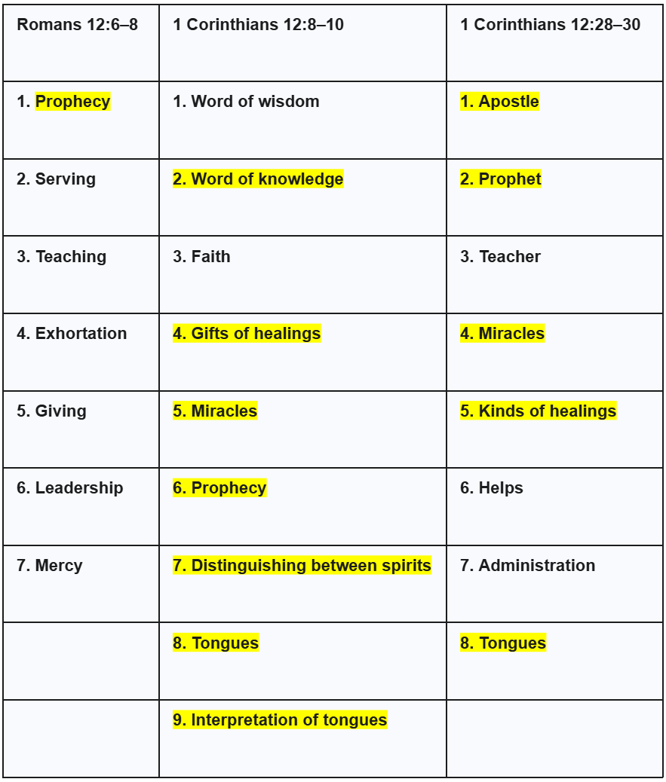

***These are not “natural” gifts or personality traits, although there may be some overlap.***

**Keep in mind, Variety of Gifts, Variety of Effects!!!!**

**1 Corinthians 12:4 - 6** - *4 “Now there are varieties of gifts, but the same Spirit.*

*5 And there are varieties of ministries, and the same Lord.*

***6 There are varieties of effects, but the same God who works all things in all [persons.]***

**12:6 There are varieties of effects [ἐνέργημα enérgēma, en-erg'-ay-mah;]**

* Energema - outcome, effective operation, working, energizings ("operations"), focusing on the results of God's "energy" (power)

Romans 12:6 - “Since we have gifts **that differ** according to the grace given to us, each of us is to exercise them accordingly: if prophecy, **[f]according to the proportion** of his faith;”

* Various degrees of ability, confidence, operation, etc.

**There is room for growth!**

1 Timothy 4:14-15 - 14 **Do not neglect** the spiritual gift within you, which was bestowed on you through prophetic utterance with the laying on of hands by the [a]presbytery.15 Take pains with these things; be absorbed in them, so that your **progress** will be evident to all.

**Every Christian will be gifted in some way. There’s no such thing as a “giftless” Christian. Even if it’s “just” one.**

* Many "gifts" and "varieties of service" and "varieties of activities" that "it is the same God who empowers them all in **everyone"** - From 1 Corinthians 12:4-6

**When you see the gifts truly in operation, you actively *encounter* the Holy Spirit.**

*“4 Now there are varieties of gifts, but the same Spirit. 5 And there are varieties of ministries, and the same Lord. 6 There are varieties of effects, but the same God who works all things in all persons. 7 But to each one is given the* ***manifestation of the Spirit*** *for the common good.* - **1 Corinthians 12:4-7**

The Holy Spirit, who is invisible, is made manifest by specific outworkings of grace.

**It’s for the BODY!**

12:7 -But to each one is given the manifestation of the Spirit **for the common good.**

* 1 Corinthians 14:12 So also you, since you are zealous of [h]spiritual gifts, seek to abound for the **edification of the church.**

**The Variety is God’s Idea, and We Need it All**

**As HE SEES FIT**

1 Corinthians 12:18 *But now God has placed the members, each one of them, in the body,* ***just as He desired.*** *19 If they were all* ***one member****,* ***where would the body be****? 20 But now there are many members, but one body.*

**We Need ALL the Gifts**

**1 Corinthians 12:15-17, 21-27**

**DESIRE**

*“12:31 But earnestly desire the greater gifts(Charisma).”*

Earnestly - zēloō:

**BLB:**

1. to burn with zeal
   1. to be heated or to boil with envy, hatred, anger
      1. in a good sense, to be zealous in the pursuit of good
   2. to desire earnestly, pursue
      1. to desire one earnestly, to strive after, busy one's self about him
      2. to exert one's self for one (that he may not be torn from me)
      3. to be the object of the zeal of others, to be zealously sought after
   3. to envy

**Day 1**

**Read 1 Corinthians 12:4-7**

This passage of scripture makes it clear that there will be varieties of gifts expressed in the body, along with varying levels of effectiveness and breakthrough. One of the issues we run into when exploring gifts is that some gifts are put in a more “glamorous” light, or are highlighted more by whoever is teaching them, because of what that teacher operates in. It’s no wonder people can feel “less than” whenever God regularly uses them in one of the ways deemed less “important.” I’m here to tell you that every gift matters and that God loves the variety, because it was His idea!  
  
What we fail to emphasize when we make gifts seem more glamorous at the expense of others is that in the operation of every gift is a manifestation of the Spirit. Many ministries, many gifts, but the same Lord, same Spirit, same God who works in everyone! And the gifts aren’t badges of honor or stamps of approval, but they are for the common good. Simply celebrate the ways God uses you and seek to grow in them. We need it all!

**Have you identified any gifts that God works through you regularly? What are they? If not, which gifts do you naturally feel drawn to?**

**Why do you think God designed the church to function this way, where there is such a variety of giftings and effects?**

**In class, we explored the idea that a “variety of effects” suggests room for growth in how one operates in the gifts. If you wanted to grow in the gifts, what are a few (3-4) practical things you could do?**

**Have you ever seen someone operate in a gifting effectively? Describe what it was like and what the benefit was.**

**Day 2**

**Read 1 Corinthians 12:4-7 (Again)**

Yes, we are reading the same verses from yesterday. There’s just too much goodness in these verses to only spend one day on them. Verse six made it clear that it is God working in *everyone.* What this suggests is that no believer is excluded. Put another way, there’s no such thing as an ungifted Christian. Every single believer has been given the Holy Spirit, and the Holy Spirit wants to use every believer to express Himself through the gifts. You have spiritual gifts; it’s just a matter of discerning how God uses you.

It’s helpful for me to think of the gifts, not as “things,” but as different revelations of Him. These are not things we possess, but ways the Holy Spirit uses us to manifest Himself. Manifesting (in the biblical sense, not in the new age sense) looks like the invisible Holy Spirit making Himself visible by working through believers. When you see the gifts in action, truly working, you are actually seeing Him!

**Do you struggle with believing that God has gifted you and wants to use you? Why or why not?**

**Seeing that the gifts are manifestations of the Holy Spirit Himself, what do you think about how some places severely limit the operation of the gifts? Or say many of them “don’t happen” anymore?**

**Is there any gift that makes you uncomfortable or that you’re scared to embrace? Why or why not?**

**What do you feel is the most important takeaway from these verses over the last two days? Explain.**

**Day 3**

**Read 1 Corinthians 12:8-11**

Here in these verses, we begin to get different examples of gifts, followed by the phrase “through the same Spirit.” It seems that God is really trying to get our attention here, especially after verses 4-7. No matter how many gifts there are, or how unique they are, they all come through the Spirit. The value is not in the uniqueness of the gift, or even what it produces, but in the source of the gift. The Holy Spirit is the treasure.

There are nine different gifts listed in these few verses. Each of them is unique in its own way. One of my personal favorites is healing. There’s nothing like when God moves on a person’s body and they are changed in a few moments. I love all these gifts, though, and have seen them all in action. It’s important that we learn how to celebrate and recognize each one. Take a moment to explore what each gift looks like today.

**What is your understanding of prophecy? Have you seen it in operation before? What’s your gut reaction to the general idea of it?**

**Have you ever seen or known someone who was healed through prayer? What was it like? If not, do you struggle with believing it can happen? Have you prayed for anyone for healing?**

**One of the gifts listed here is the distinguishing or discernment of spirits. This suggests that we will encounter more spirits than just the Holy Spirit sometimes. Does this thought make you feel anxious? How do you envision this gift at work? Have you ever experienced something other than the Holy Spirit?**

**In verse 11, Paul reminds us that “one and the same Spirit works all these things, distributing to each one individually just as He wills.” How does this shape how you see the gifts?**

**Day 4**

**Read 1 Corinthians 12:14-26**

Paul makes it clear here that we are meant, as believers, to be interdependent on one another in the Body of Christ. Not independent. Not dependent. We all need each other. That means every time we gather, we work to ensure every member is included, and every member knows they are valuable. This is not just a command for function, but the command here is clearly stated as coming from a “care” for one another. The intended result is that there would be no division in the Body.

When one member suffers, the whole body does. When one member is honored, the whole Body is supposed to rejoice with them. I love that Paul puts this verse in the context of all the different gifts listed. Because of our human desire for significance, when we see someone else honored, or maybe operating in their gifting with measurable fruit, sometimes we may get jealous or wonder if our place matters. This chunk of verses smashes all of that. There’s room for everyone at the table, and we should feel it when one of our members is hurting and celebrate when one is thriving.

**Verse 15 says, "If the foot says, 'Because I am not a hand, I am not a part of the body,' it is not for this reason any the less a part of the body." How can you relate this to feelings of inadequacy or comparison within the Church? How would you encourage others who may feel "less than" because their role seems less visible or essential?**

**Verse 18 says, "But now God has placed the members, each one of them, in the body, just as He desired." How does this verse affect the way you view your place in the body of Christ? How does this help you trust Him?**

**How do you personally contribute to the unity of the body of Christ? How can you grow in embracing others' gifts and roles in the Church?**

**If you were in charge of the church, what are some ways you would make sure this chunk of verses was true about your church?**

**Day 5**

**Read Romans 12:3-8**

What an incredible chapter Romans 12 really is. It gets at the heart of some of the same concepts we have tackled over the last few days. First of all, Paul reminds every believer to not think more highly of themselves than they ought. Maybe you’ve experienced this, or maybe not; but I’ll tell you, the longer you operate in the gifts with some effectiveness, the temptation slips in to think you’re something special. That thought must be dealt a death blow regularly. Remember, they are called spiritual “gifts,” not spiritual badges of honor. A gift is given to you…for free. If it’s not free, it’s not a gift.  
  
We then have another chunk of gifts listed. A good portion of these gifts fall into the “non-glamorous” category we’ve discussed before. Yet every single one of them is valuable! Notice again that it says “each one of us” is to operate in our gifts accordingly. Every Christian is to operate in the Gifts. Thank God for all the people He has gifted in these ways. Without some of these gifts, nothing would ever get done!

**Romans 12:3 gives us a stark warning. How can you guard against pride in your spiritual gifts? Reflect on a time when you may have overestimated yourself. How can you keep a humble perspective as you use your gifts?**

**In verse 6, Paul says that we have "gifts that differ according to the grace given to us." How does knowing that these gifts are operations *of* grace, entirely given *by* grace help you embrace them? Guard against pride?**

**In Romans 12:7, Paul speaks to those with the gift of service. How do you see the gift of service in action within our church? In what ways is it more than just doing necessary tasks in the church?**

**How have you benefited from the gift of teaching in your life? Reflect on a time when a teaching brought understanding at an unusual level for you.**

**Day 6**

**Read 1 Corinthians 12:31, 1 Timothy 4:14-15**

In these verses we are instructed to eagerly desire the gifts, obviously not for our own sake, but for the sake of building up the body of Christ. We are encouraged not to neglect this pursuit. As someone who has pursued these gifts my entire adult life, even I at times have become complacent and neglectful in my pursuit of them. This ought to never be the case.  
  
Not only are we instructed not to neglect these gifts, but in 1 Timothy 4, Paul instructs us to take pains with them and be absorbed in them! Not just “don’t neglect,” but actively pursue! When we do this, we actually progress in the gifts. And it will be evident, according to verse 15. Let this week be a reminder to you that the gifts are not just a subtle add-on, a peripheral part of your life as a believer. They are to never be neglected, but pursued the rest of your days!

**What does it mean to "earnestly desire" spiritual gifts? How do you distinguish between a healthy desire for gifts and selfish ambition? How can you cultivate this desire in your life?**

**What are some reasons you might become complacent in the pursuit of spiritual gifts? How can you guard against complacency and remain locked in on your pursuit of the gifts?**

**The gifts are not “a subtle add-on” or “peripheral” but are central. Does this challenge your current life in the spiritual gifts? Have you treated your spiritual gifts as secondary? How?**

**What are your most important takeaways from this week?**