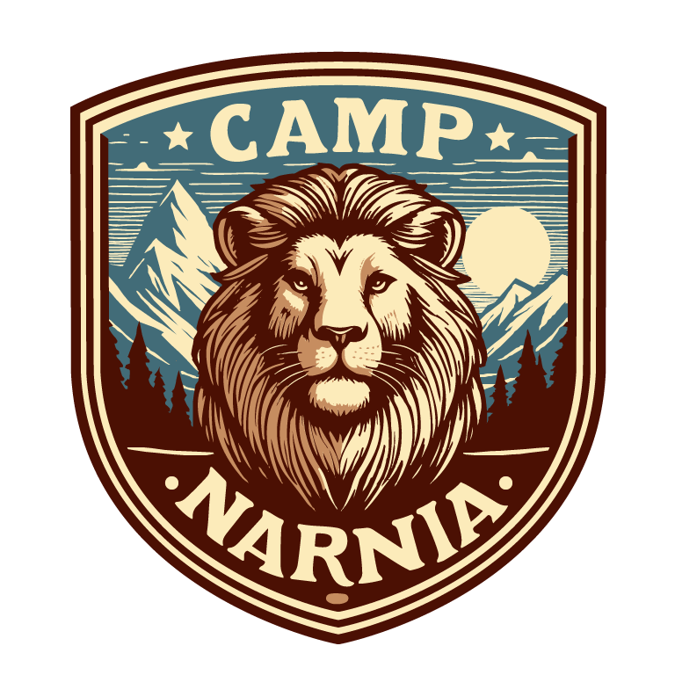
Camp Narnia 2025
Registration and Release
Christ Covenant Reformed Church
4420 East Road; Chesapeake VA 23321
Every Saturday in July ▪ 9am-12pm

Child’s Name: ___________________________________________ Age: ____________________
Parent(s) Name(s): __ ______________________________________________________________
Street Address: _ ____________________________City/State/Zip_____________ ___________
Home phone: ________________________________ Cell Phone: __________________________
Email: _ ____________________________________ Shirt Size: ______________________ ______
In case of emergency, contact: ______________________________________________________
Allergies (list medications, foods, etc): _______________________________________________

I (we), the parent(s) or guardian(s) of __________________________________, a minor, do hereby authorize adult volunteers and staff of Covenant Heritage Reformed Church as agents, to consent to any medical or surgical care deemed advisable by any accredited physician or surgeon in an approved emergency clinic or hospital. I further release from any liability Covenant Heritage Reformed Church any of its ministries or leaders in the event of an accident during Camp Narnia and any of the Camp Narnia activities.

Signature of parent/guardian: ________________________________________________________

Please turn in registration by June 13th to be guaranteed a spot and shirt for Camp Narnia. Registration is $10/ per child which includes the shirt.

For any questions or concerns, please contact Carey Peacock: 318-547-3091

