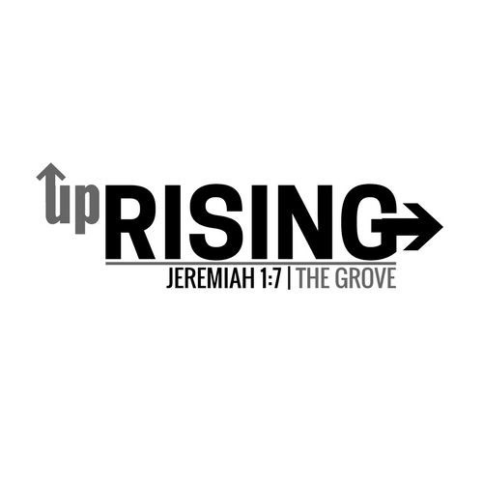
Waiver and Release Form
All Participants MUST have this general release and indemnification of claims completed and turned in to Joshua Newton upon arrival at this event. This form must be completed and notarized for all participants. The last day to have your form notarized in the Pine Grove Church office is Wednesday, December 17th.

Please review, complete, sign and notarize.

Camp location: North Florida Christian Camp (Keystone Heights, FL)

Camp Dates: 12/29/25 to 01/01/2026

Name of participant: ___________________________________________
Gender of Participant: Male Female; Participant age: ____ DOB: ___/___/___

Please indicate what describes the participant best: Camper Adult leader

Name of Parent/ Guardian (please print): _______________________________

Cell phone number of parent/ Guardian: (____) ___________________________

Secondary Emergency Contact Number: ( ____) __________________________
Allergies or Dietary restrictions: _______________________________________
Assumption of Risk: I am aware of the risk associated by or with participation in this camp. I voluntarily assume full responsibility for any risk of loss, property damage or personal injury, including death that may result from participation in camp activities.
Photography/Video Acknowledgment: Throughout the event there may be photographs and video taken for marketing and promotional purposes.
I acknowledge that and grant permission for such media to be used in promotional materials.
Release and Indemnity: I acknowledge and agree that I or my agents hold harmless, release forever, and agree not to sue Pine Grove Baptist Church of Trenton, Florida, it’s leadership, agents, venues, locations, community partners, volunteers, sponsors from any and all claims or demands related to personal injury, sickness, and even death, as well as any property damage or related expenses, incurred by my participation or my minor child during any event that Pine Grove Baptist Church attends. In the event of medical need, I understand that the authorized agent of the church is responsible for care and decisions related to medical needs including, but not limited to medical consent, care, transportation, and communication with the home church and family. Any and all medical expenses that could be incurred if medical care is needed are my sole responsibility and I release liability and understand that I or my minor child participate in any and all activity at will.
Understanding: I acknowledge that I have read and understand this waiver/release and all its terms. My signature below represents that understanding and I freely relinquish legal rights, I have had the opportunity to obtain any and all counsel if needed and that by my signature, I understand and accept this agreement in full. Furthermore, it is understood that a copy of this form is considered as authentic and binding as the original.
Complete and sign below (participants who are minors per your state law require Parent/Guardian signature)
This portion MUST be signed in front of a Notary
I am a: Parent/Guardian Event attendee who is 18 or older

Signature of Parent/ Guardian: _________________________________

Signature of Event Attendee: ____________________________________

Date: _____/_____/_____

Notary Acknowledgment: The state of ______ ___County of___ ___________ on ____________ before me,
____________________________, Notary Public, personally appeared_________________________ who proved to me on the basis of satisfactory evidence to be the person(s) whose name(s) is/are subscribed to the within instrument and acknowledged to me that he/ she/they executed the same in his/her/their authorized capacity(ies), and that by his/her/their signature(s) on the instrument the person(s) or the entity upon behalf of which the person(s) acted, executed the instrument.
Witness my hand and official seal.
Notary signature: ______________________________ My commission expires:___/___/___

