**Leader Overview**

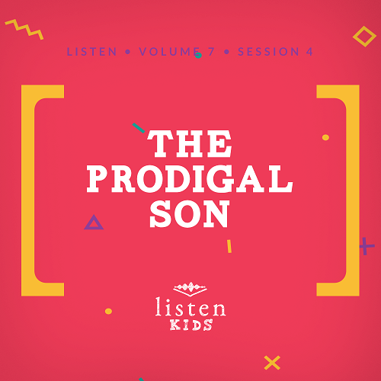

*In* Listen*, kids will explore amazing truths from God’s Word, the Bible. In this session, kids will learn how to forgive others from God’s example and a familiar parable. God offers forgiveness to us over and over when we sin against Him, and He expects the same forgiveness from us when others hurt us*.

**Bible Lesson**

The Parable of the Prodigal Son

Luke 15:11–32

**Faith Fact**

God forgives me.

**Faith Verse**

John 14:6 (NLT)

Jesus told him, “I am the way, the truth, and the life. No one can come to the Father except through me.”

**Preparing for the Session**

**Leader Preparation Time: 20–25 Minutes**

|  |
| --- |
| ***You Will Need***  ***Large Group***   * *Bible* * *Worship songs (Song suggestions: “Zeal” by The Belonging Co; “Chain Reaction” by River Valley Worship; “The Blessing” by Elevation; “Way Maker” by Leeland)* * *For groups not using a phone or tablet only, add:*   *• Projector or TV*  *• Laptop*  *•* ***Rules Video*** *or* ***Slide***  *•* ***Faith Fact Slide***  *•* ***Faith Verse Video*** *or* ***Slide***  *•* ***Bible Lesson Slide 1***  *•* ***Bible Lesson Video A***  *•* ***Bible Lesson Video B***   * *10–20 dark-colored balloons* * *Dollar bills or play money* * *Backpack* * *Robe* * *Ring* * *Sandals*   ***Small Group***   * *Bibles, one per kid* * ***Small Group Faith Verse Review****, one per group* * ***Small Group Activity Page****, one per kid* * *Dirty pennies, one per kid* * *Large bowl of water, one per group* * *Small bowls, one per kid* * *White vinegar, ¼ cup per kid* * *Salt, 1 teaspoon per kid* * *¼ cup measuring cup, one or two per group* * *1 teaspoon measuring spoon, one or two per group* * *Disposable spoons, one per kid* * *Paper towels for clean up* * *Scissors* * *Crayons, pencils, or markers*   *To access the Bible Engagement Project library from a computer, visit* [App.BibleEngagementProject.com](http://App.BibleEngagementProject.com). |
| ***Getting Ready***  ***Large Group***   * *Download videos and slides if needed.* * *Select worship song(s) and have them ready to play.* * *Blow up the balloons, leaving some empty and placing money in some.*   ***Small Group***   * *Print the* ***Small Group Faith Verse Review****, one per group.* * *Cut apart the bills with verse segments.* * *Print copies of the* ***Small Group Activity Page****, one per kid.* * *Collect enough dirty pennies so each kid can have one.* * *Fill a large bowl with water for each group.* |

**Large Group**

**30 Minutes**

*See what’s needed at the beginning of the session.*

**Introduction**

Who is excited to be here? *(Group response)* We should always be excited and thankful to gather together. So far, we have talked about Jesus’ birth, His healings, and His teachings. This time we are focusing on the fact that **God forgives me**. We’ll see this told through a story, or parable, that Jesus told.

Maybe you didn’t know that you need to be forgiven. Here’s a quick question for everyone that will help clear things up. Who in here has sinned or done something that they know they shouldn’t have done? *(Group response)* Every hand in the room should be up because we have all sinned. That’s why we need to be forgiven.

Today’s Faith Fact gets right to the point and reminds us of God’s forgiveness.

• *Show the* ***Faith Fact Slide***.

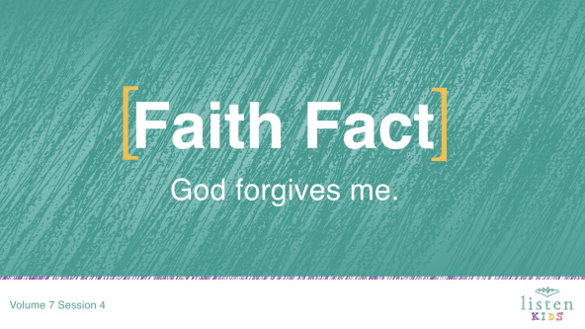

Say the Faith Fact with me and pretend to give yourself a giant hug while you say it. **God forgives me.** Great job everyone!

**Rules Review (Optional)**

Maybe you know all the rules. Who can run up to me first and tell me all the rules as quickly as possible? *(Allow time for kids to respond.)* That was so fast, I’m not sure I even heard the rules! Let’s watch this video to make sure we know all of them.

• *Play* ***Rules Video***.

**Game**

**Out of Cash**

|  |
| --- |
| ***You Will Need***   * *10–20 dark colored balloons* * *Dollar bills or play money*   ***Getting Ready***   * *Blow up the balloons, leaving some empty and placing money in some.* |

In today’s Bible story, we’ll hear about someone who spent all of his money and didn’t have any more. We don’t want to be like him. The player can pop a balloon. If there’s money inside, the player gets to keep the money. If the balloon is empty, the player is out of cash and has to give back everything he’s collected. Who’s ready to play?

• *Choose one kid to play at a time*.

• *Allow the kid to keep popping balloons until an empty balloon is popped or the kid decides to keep the money and not risk popping another balloon*.

• *Keep reminding the kids that if they pop an empty balloon, then any cash they have must be returned*.

• *Let kids take turns until you run out of balloons*.

• *Option: Use play money in the balloons. At the end of the game, let kids exchange their play money for candy or a prize*.

Great job! Some of you made great choices, and some of you just missed out. Aren’t you thankful that when we make bad choices that God is quick to forgive us when we ask?

I’m thankful for so many things, but I’m most thankful for God’s forgiveness. If we didn’t have His forgiveness, we would be lost and separated from Him forever. God’s forgiveness comes up a lot in our singing because we need to be reminded to thank God for it every day.

**Worship**

Use today’s time of worship to thank and praise God for forgiving your sins. God’s forgiveness is one of the reasons He deserves our worship even when we don’t feel like worshipping Him. Let’s sing and thank Him for His forgiveness.

• *Lead the kids in singing one or two praise songs. See suggestions at the beginning of the session*.

**Bible Lesson**

Thanks for worshipping God with all your heart today. Now, let’s pray and ask God to speak to us in a new way about forgiving others.

**Prayer**

|  |
| --- |
| Dear God, thank You for forgiving us even though we don’t deserve it. Help us to remember that we are forgiven and that we should forgive others in the same way. Amen. |

**Video Intro**

Before we get started with the Bible story, let’s check in with the Challenge Accepted team and see what they’re up to!

• *Play* ***Bible Lesson Video A***.

Now that challenge sounds like fun! Would you accept that challenge? *(Group response)* Let’s go to today’s Bible story now.

**Bible Story**

If you have your Bible, turn to Luke 15:11–32. (*Allow time for the kids to find the passage in their Bibles.)*

Our Bible story today is one of three parables Jesus taught that shows how much God wants to bring people close to Him. Those parables are about a lost sheep, a lost coin, and a lost son. Today’s story is the best known of the three parables, the Parable of the Lost Son.

You may have heard this parable called the Parable of the Prodigal Son. *Prodigal* describes someone who spends money freely and wastefully, and this guy certainly did that. Who knows what a parable is? *(Allow responses.)* A parable is a story Jesus told that had a spiritual meaning. Jesus told parables to teach people valuable lessons about how God wanted us to live.

Let’s look at this well-known parable and find something new God wants to teach us today. Before we read it together, I need a volunteer to be the star of our Bible story today and play the lost son.

• *Choose a kid to come up to the front and stand next to you. He or she will act out the story as it is read from the Bible*.

I think we are ready! Let’s begin reading together.

• *Read Luke 15:11–12.*

• *Give the volunteer a stack of play cash*.

There was a man who had two sons. Can you imagine asking your parents for the money you would inherit when they die? You want to use it so you can move away and live without them. Could you do that? *(Group response)* This man’s younger son did that, and the dad agreed to give him the money.

What about the older brother? Well, he stayed at home with his dad and worked in the fields. What do you think the younger son did with all this money? *(Group response)* Let’s read and find out.

• *Read Luke 15:13.*

• *Give the volunteer a backpack and have him walk around the room*.

After a while, the young man was in big trouble. He had wasted all of his money and had nothing left. The Bible doesn’t tell us, but he may have been so proud and stubborn that he wouldn’t go home and tell his dad what he had done.

• *Take the money from the volunteer*.

Let’s read what the young man decided to do next.

• *Read Luke 15:15–16.*

• *Have the volunteer pretend to feed pigs. Then, he should act hungry and lick his lips as he looks at the imaginary food in his hand*.

• *Read Luke 15:17–19.*

The Bible tells us that the young man finally came to his senses. He knew that his dad’s hired servants were eating better than he was. He thought that if he apologized to his dad then maybe his dad would take him back as a servant. He felt that he has lost the right to be his son. Let’s read what happened next.

• *Read Luke 15:20–21.*

• *High-five the volunteer*.

The father forgave his son! He didn’t just accept him back as a servant like the son expected. The father called his servants and told them to prepare for a party to celebrate his son who had returned. The father told his servants to bring the finest robe for his son. He told them to bring a ring for his son’s finger and sandals for his feet. He even ordered the servants to cook their best meal for the son.

• *Put a robe on the volunteer. Give him a ring and sandals*.

• *Show* ***Bible Lesson Slide 1***.

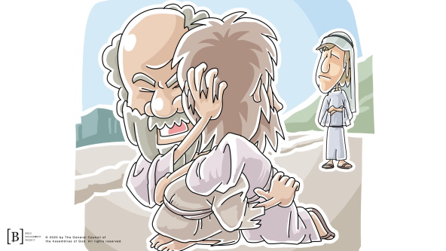

The younger son, the lost son, messed up big time. He asked for his inheritance money early and wasted it all. Now, he was back, and his father didn’t even expect him to apologize. Dad just accepted his son back with open arms and gave him a bunch of gifts and a party.

Remember that older brother from the beginning of the story who stayed home with his dad? How do you think he felt? *(Allow responses.)*

The older brother was out working in the fields when his brother came home. When the older brother came home, he could hear the party going on. Let’s pretend we are at the party! *(Lead the kids in cheering and making lots of noise.)* The older brother asked what was going on, and one of the servants told him they were celebrating his brother’s return. The older brother was so angry he wouldn’t even attend the party. He felt like his brother didn’t deserve his father’s forgiveness.

His dad’s response is found in verses 31–32. Let’s read what he said.

• *Read Luke 15:31–32.*

• *Lead the kids in clapping for the volunteer while he heads back to his seat*.

**Teaching Time**

Who do you think the father in the parable represents? *(Group response)* The father is God. The lost son is anyone who doesn’t know God or has turned away from doing what God wants. God is ready and willing to forgive anyone even if it’s the last day they are alive if they will just ask. God’s forgiveness is the same for everyone no matter how many good or bad things they have done.

We have to be careful not to become like the older brother. He didn’t understand why his father would forgive his younger brother and then give him gifts and a party. He resented his brother and was angry with his dad for forgiving him. The older son didn’t understand the joy his father had that his lost son had returned. Just like the father in this story, God wants us to share in the joy when someone comes back to Him. No matter how long ago you became a Christian, God forgave you, and He expects you to forgive others, too. It doesn’t matter how many times someone hurts us, we still need to forgive them. That might not seem fair, but God does that for us every time we sin and then ask Him to forgive us.

**Faith Verse**

That’s why our Faith Verse is so important to remember. Our sin is the reason Jesus had to come to earth. He is the only way for us to receive the forgiveness of the Father. Let’s say the verse and do the actions together.

• *Play* ***Faith Verse Video***.

John 14:6 (NLT)

Jesus told him, “I am the way, the truth, and the life. No one can come to the Father except through me.”

We can all receive God’s forgiveness through Jesus today.

**Prayer and Response**

*Consider playing a worship song softly in the background while kids pray*.

Close your eyes and allow God to help you remember times when people may have hurt you. Did you really forgive them or are you holding onto unforgiveness and bitterness toward them? Unforgiveness hurts us so much more than it hurts the person we are unwilling to forgive. The Bible tells us that God won’t forgive us if we don’t forgive others. If you thought of someone you haven’t forgiven, stop and forgive them right now.

• *Give kids time to pray. Then introduce the worship song. This could play in the background while kids pray or could be a worship song to sing together*.

**Worship Song**

*Play a worship song*.

**Video Wrap-Up**

Before we go to our small group activities, let’s see how the Challenge Accepted team did with today’s challenge.

• *Play* ***Bible Lesson Video B***.

I love our Challenge Accepted videos. Be sure to take time this week to do the challenge they gave us. It fits perfectly with our Faith Fact. Are you ready to say our Faith Fact one more time?

• *Show the* ***Faith Fact Slide***.



Say it with me. **God forgives me**. God’s forgiveness is the most valuable thing we can ever receive. Remember to thank Him for His forgiveness every day this week. See you next time!

• *Dismiss kids to Small Group time or to go home if your group time ends here*.

**Small Group**

**30 Minutes**

*This section can be done in conjunction with the large group, or on its own if you do small groups with your kids. During Small Group time, the goal is to connect the kids with the Word of God and to each other. All activities are led by the small group leader.*

**Group Connection**

**Clean Up Your Change**

|  |
| --- |
| ***You Will Need***   * *Dirty pennies, one per kid* * *Large bowl of water, one per group* * *Small bowls, one per kid* * *White vinegar, ¼ cup per kid* * *Salt, 1 teaspoon per kid* * *¼ cup measuring cups, one or two per group* * *1 teaspoon measuring spoons, one or two per group* * *Disposable spoons, one per kid* * *Paper towels for clean up*   ***Getting Ready***   * *Collet dirty pennies, one per kid.* * *Fill a large bowl with water for each group.* |

I’ve given each of you a dirty penny. It might look like it can never be cleaned up, but we are going to do it today. This activity is a great reminder of how God “cleans up” our lives when we ask Him for forgiveness. When He forgives us, He removes our sin and our heart and life are clean like these pennies.

• *Give each kid a dirty penny, small bowl, and a spoon*.

• *Have each kid add ¼ cup of vinegar and 1 teaspoon of salt to their bowl. Help younger kids as needed*.

• *Tell kids to stir the mixture well until the salt has dissolved*.

Now, drop your penny into your bowl. In just a few seconds, you can take it out and wash it in the large bowl of water.

• *Have kids take their pennies out and place them in the large bowl of water*.

• *Kids can clean any excess dirt off their penny in the large bowl of water*.

You can take home your penny as a reminder of what God does for us when He forgives us for the wrong things we have done. He takes us from being dirty, covered with sin, to being clean and free from sin.

**Bible Lesson Recap**

|  |
| --- |
| ***You Will Need***   * *Bible, one per kid*   *No prep needed for this activity.* |

**Bible Story Review:** **Luke 15:11–32**

Last time, we heard that Jesus was an amazing teacher and storyteller. One of His favorite ways to teach His followers was through parables. Parables are stories that represent spiritual truths. Jesus taught with parables because people could understand and relate to the stories, which helped them to understand spiritual truths.

There are many parables found in the four Gospels. Today’s Bible story is one of the more well-known parables told by Jesus. You may have heard it called the Parable of the Lost, or Prodigal, Son. Let’s review this familiar parable together.

• *Divide the Bible reading into smaller chunks for kids to read aloud*.

What is one thing that you remember about our Bible story?

**Faith Fact**

Jesus taught the people that parable to remind them of how God’s forgiveness works. God’s forgiveness is not limited by time and cannot be earned by doing a bunch of good things. That’s why our Faith Fact is so important to remember.

• *Show the* ***Faith Fact Slide***.



Say it with me: **God forgives me**.

**Group Discussion**

*Feel free to use all or just a few questions as a jumping-off place for good discussion. Questions marked with * are designed for more conversation. Adjust the questions based on the age or maturity of your group. Typically, older kids will be able to dive a little deeper than younger ones*.

**Questions**

What job did the prodigal son take when he ran out of money?

What did the father do for the prodigal son that showed he was forgiven?

Do you think it is easy to forgive others? Why or why not?

Have you ever not been forgiven?

* How does it make you feel when you know someone hasn’t forgiven you?

Have you ever chosen not to forgive someone?

* How does it make you feel when you choose not to forgive?

* Why do you think God tells us to forgive others?

* When you forgive someone, does that mean you have to stay friends with them? Why or why not?

Is there someone you need to apologize to or forgive right now?

**Application and Response**

We can all agree that we are thankful for God’s forgiveness. That part of the story is what we would love to focus on. However, Jesus was teaching us about more than God’s forgiveness through His parable. Jesus wanted us to realize that God forgives us, and He expects us to forgive others, too. The older son struggled with forgiving his younger brother. If you are struggling with unforgiveness, you need to ask God to help you forgive.

**Make It a Habit**

*Select a simple visual reminder of the session’s Faith Fact*.

Remember our Faith Fact today? Let’s say it together: **God forgives me.** I want you to look for some coins around your house or in your car this week. Dig around in the couch cushions or look under the seats in your parent’s car until you find some.

One of the other parables Jesus taught was the Parable of the Lost Coin. In the parable, a woman lost one of her ten coins. But, she didn’t stop looking for it until she found it. When you look at your coins, remember that God cares about you so much that even though there are over seven billion other people on the earth right now He will always look for you if you are lost. He will forgive you when you do something wrong.

**Prayer**

Let’s pray and ask God to help us. Repeat this prayer after me.

|  |
| --- |
| Dear God, thank You for the reminder that I can be forgiven. Please forgive me for the times when I held onto unforgiveness and bitterness. Help me to be like the father in the parable and to forgive others when they hurt me. Amen. |

**Faith Verse Review**

|  |
| --- |
| ***You Will Need***   * ***Small Group Faith Verse Review****, one per group* * *Scissors*   ***Getting Ready***   * *Print the* ***Small Group Faith Verse Review****, one per group.* * *Cut apart the bills with verse segments.* |

Our Faith Verse for today is John 14:6. It reminds us that Jesus made a way for us to come to the Father and receive His forgiveness. Let’s say the Faith Verse and do the actions for the verse together.

• *Show the* ***Faith Verse Slide***.

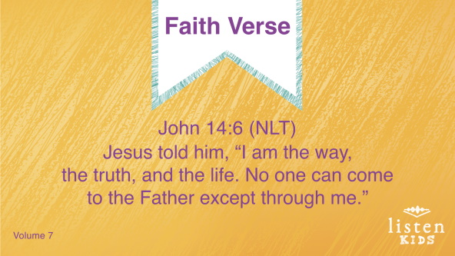

John 14:6 (NLT)

Jesus told him, “I am the way, the truth, and the life. No one can come to the Father except through me.”

**Faith Verse Fun**

**Money Verse**

Let’s review the Faith Verse together a few more times.

John 14:6 (NLT)

Jesus told him, “I am the way, the truth, and the life. No one can come to the Father except through me.”

Have you ever wanted to have a bunch of money and just throw it up in the air? *(Group response)* We are going to do that today. We’re going to divide into two teams and have each team stand in a circle. Then, I’ll throw a bunch of play money in the air in the center of each circle. The Faith Verse is in phrases on the play money. The first team to get the verse in the correct order wins. Are you ready to play?

• *Play again as time allows*.

**Creative Activity**

**The Prodigal Son Returns**

|  |
| --- |
| ***You Will Need***   * ***Small Group Activity Page****, one per kid* * *Crayons, pencils, or markers*   ***Getting Ready***   * *Print copies of the* ***Small Group Activity Page****, one per kid.* |

Today, we learned that God’s forgiveness is always there for us while we’re alive. Jesus taught us that God the Father is always ready with open arms to welcome us home, just like the father in the story we heard today. The father in the Bible story forgave his son and welcomed him home.See if you can complete this maze and help the son return home to his dad.

**Prayer**

|  |
| --- |
| Dear God, thank You for cleaning my heart and my life by forgiving my sins. Help me to remember to thank You for that every single day. I love You. Amen. |

**Faith Fact Recap**

• *Display the* ***Faith Fact Slide*** *as parents are coming into the room*.

• *Maximize the time you have with your kids so that parents see what their kids have learned. Have the kids repeat the Faith Fact and then dismiss them to their parents*.

• *Show the* ***Faith Fact Slide***.



Remember today’s Faith Fact and take a few moments to thank God for it each day. **God forgives me**.

**Dismissal**

• *Send home a clean penny with each kid*.

• *Send home the* ***Small Group Activity Page***.

• *Remind parents that there are* ***Family Devotions*** *available on the app to do with their kid*.

• *Tell everyone the date and time for the next session*.