**Leader Overview**

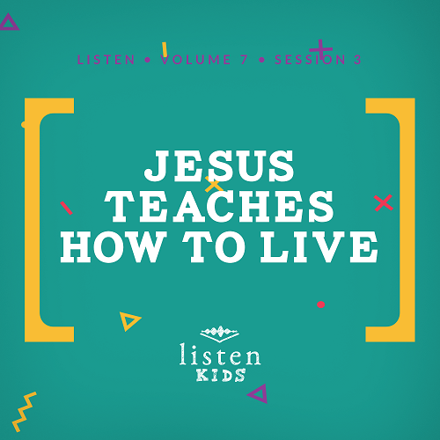

*In* Listen*, kids will explore amazing truths from God’s Word, the Bible. In this session, kids will learn from the best Teacher ever, Jesus. He taught His disciples many valuable lessons that are still important for us today. His Sermon on the Mount is a great example of His incredible teaching*.

**Bible Lesson**

The Beatitudes

Matthew 5:1–10

**Faith Fact**

Jesus teaches me.

**Faith Verse**

John 14:6(NLT)

Jesus told him, “I am the way, the truth, and the life. No one can come to the Father except through me.”

**Preparing for the Session**

**Leader Preparation Time: 20–25 Minutes**

|  |
| --- |
| ***You Will Need***  ***Large Group***   * *Bible* * *Worship songs (Song suggestions: “Zeal” by The Belonging Co; “Chain Reaction” by River Valley Worship; “The Blessing” by Elevation Worship; “Way Maker” by Leeland)* * *For groups not using a phone or tablet only, add:*   *• Projector or TV*  *• Laptop*  *•* ***Rules Video*** *or* ***Slide***  *•* ***Faith Fact Slide***  *•* ***Faith Verse Video*** *or* ***Slide***  *•* ***Bible Lesson Video A***  *•* ***Bible Lesson Video B***  *•* ***Bible Lesson Slide 1***   * *4 buckets* * *10 small balls that fit easily in the buckets* * *White board or chalkboard* * *Dry erase markers or chalk*   ***Small Group***   * ***Small Group Activity Page****, one per kid* * *Crayons or markers*   *To access the Bible Engagement Project library from a computer, visit* [App.BibleEngagementProject.com](http://App.BibleEngagementProject.com). |
| ***Getting Ready***  ***Large Group***   * *Download videos and slides if needed.* * *Select worship song(s) and have them ready to play.* * *Place five balls each in two of the buckets. Place the other two empty buckets at an equal distance from where you plan to have the kids stand to throw the balls.*   ***Small Group***   * *Print copies of the* ***Small Group Activity Page****, one per kid.* |

**Large Group**

**30 Minutes**

*See what’s needed at the beginning of the session.*

**Introduction**

How is everyone today? *(Group response)* It’s always a great day when we get to come together and learn about God. We are continuing to learn about Jesus, and this time we are going to learn from Him. What do I mean by that? Well, today we are focusing on how Jesus teaches us. What is your favorite subject in school? *(Allow responses.)*

That’s great, but none of those are what Jesus taught. Jesus taught His disciples and us through His Word about how to live. You couldn’t ask for a better teacher than Jesus. We can’t possibly learn everything Jesus taught today, but we will focus on the beginning of one His most famous teachings, the Sermon on the Mount.

Before we go any further, let’s learn today’s Faith Fact, which is **Jesus teaches me**.

• *Show the* ***Faith Fact Slide***.

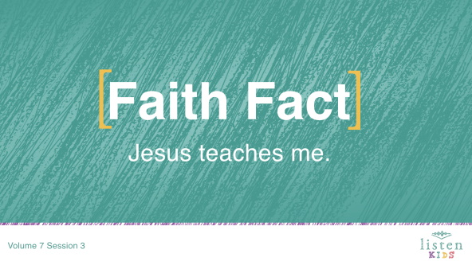

Say the Faith Fact with me and move your finger like you are telling someone what to do while you say it. **Jesus teaches me**. Great job everyone!

**Rules Review (Optional)**

It’s time to review the rules. Who can tell me all of the rules? Rules help us have fun and listen to what God is wanting to tell us today.

• *Choose one kid to respond and tell you the rules. Ask for another kid to help if he or she can’t remember all of them*.

• *Play* ***Rules Video***.

**Game**

**Count Your Blessings**

|  |
| --- |
| ***You Will Need***   * *4 buckets* * *10 small balls that fit easily in the buckets*   ***Getting Ready***   * *Place five balls each in two of the buckets. Place the other two empty buckets at an equal distance from where you plan to have the kids stand to throw the balls.* |

When you have trouble sleeping at night, some people say to count sheep. I suggest you try counting your blessings instead. Blessings are the good things in your life that God has given you.

We are going to play a game that will help us count our blessings. We need four of you to play on two-person teams. One of you will name a blessing in your life and the other team member will throw the ball into the bucket. Each team will have five chances to name a blessing and get a ball in their team’s bucket. The team with the most balls in the bucket at the end of the game wins.

• *Choose one kid on each team to come up with blessings and the other kid will be the thrower*.

• *The team with the most balls in their bucket wins*.

• *Encourage the rest of the kids to participate by yelling out blessings and cheering for the teams*.

• *Options: Have the kids take turns naming a blessing and throwing the ball or have the kid that names the blessing throw the ball and take turns*.

We have so many blessings in our lives if we really think about it. Where do our blessings come from? *(Allow responses.)* They all come from God. That’s a great reason to worship Him.

**Worship**

We can thank God for His blessings while we worship. Let’s do that together right now. Are you ready? *(Group response)* Let’s sing our worship now.

• *Lead the kids in singing one or two praise songs. See suggestions at the beginning of the session*.

**Bible Lesson**

|  |
| --- |
| ***You Will Need***   * *White board or chalk board* * *Dry erase markers or chalk*   *No prep needed for this activity.* |

That was an amazing time of worship. Let’s all bow our heads and ask God to teach us something new today in our Bible story.

**Prayer**

|  |
| --- |
| Dear God, thank You for all the blessings You have given to us. Help us to learn how to live a better life for You from Jesus’ teachings. Amen. |

**Video Intro**

Before we get started with the Bible story, let’s check in with the Challenge Accepted team and see what they’re up to.

• *Play* ***Bible Lesson Video A***.

Now that’s an interesting challenge! Would you want to try that challenge? *(Group response)* I wonder how that challenge connects to our Bible story today. Well, we’ll find out later.

**Bible Story**

If you have your Bible with you, turn to Matthew 5:1–12. *(Allow time for the kids to find the passage in their Bible.)*

Last time, we heard about Jesus’ miracles and the healing of the woman who reached out and touched His robe. Jesus wasn’t just known as a healer; He was also a respected teacher. As a teacher, Jesus helped God’s people to better understand who God is and how they should live their lives in service of Him.

There were many teachers in Israel at this time. These teachers belonged to different groups who believed different things about how people should live for God. The teachers had rules for their followers and helped them understand the Scriptures. They were respected and full of knowledge.

When Jesus came, He didn’t fit perfectly into any particular group. He spoke in ways that confused and amazed people. He often told stories, called parables, to help people understand His teachings. Sometimes His teaching challenged people, and at other times, it made people angry. Jesus only taught people the truth no matter how difficult it was for people to hear.

One of Jesus’ most famous teachings is often called the Beatitudes. This teaching is a part of a longer teaching we call the Sermon on the Mount. You know the teaching is going to take some time because Jesus sat down. Today, we are only covering the beginning of this teaching.

• *Show the* ***Bible Lesson Slide 1.***

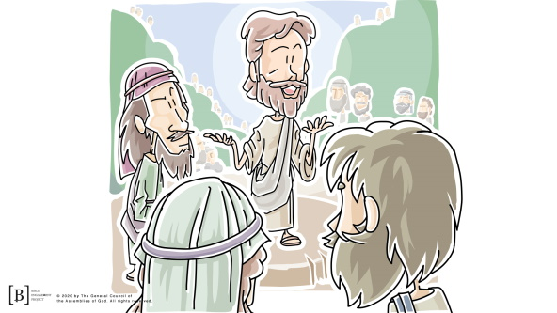

In this teaching, Jesus gave God’s people a new way of thinking. He gave a list of the kinds of people that others would expect to be in last place in life. Then, He surprised everyone by saying that these were people God would bless. Jesus was describing the kind of person that others may push away, but God would bring close to Him.

As I read Jesus’ teaching, listen for the people Jesus says will be blessed. Then, I’m going to ask you for the types of people so I can write them on the whiteboard.

• *Read Matthew 5:3–10.*

Let’s list off everyone who is mentioned in the passage who will be blessed according to this teaching of Jesus.

• *As the kids list off people who will be blessed, write them on the white board*.

• Those who are poor and realize their need for God

• Those who mourn

• Those who are humble

• Those who hunger and thirst for justice

• Those who are merciful

• Those whose hearts are pure

• Those who work for peace

• Those who are persecuted for doing right

• *Read the passage slowly a second time, if needed, to check their list*.

Wow! That’s a long list! Look at all those types of people. If I were to tell you that all those people are blessed, what would you think? *(Group response)* Do all those kinds of people have anything in common? *(Group response)* Would you consider these people to be blessed? *(Group response)* Why? *(Allow responses.)*

Did any of the people mentioned in Jesus’ list surprise you? *(Allow responses.)* Think about it! Jesus didn’t say God blesses if you are already successful, make lots of money, are good looking, or are well-known. He even listed things we might think are negative in the list of people God will bless.

The people listening to Jesus must have been confused. Some of the people they thought God would punish would instead be blessed by Him. And some of the people they thought God would bless would not be blessed.

Let’s read some more to find out what Jesus said next.

• *Read Matthew 5:12*.

Jesus explained that life might be full of poverty, pain, mourning, humility, persecution, and putting others first. Life would be challenging. But as they followed God’s way, their reward would be to be part of God’s kingdom in heaven. They knew that this is the greatest reward they could ever receive.

**Teaching Time**

God wants us to think about our future with Him in heaven and not just our lives here on earth. Do you think that’s easy or hard to do? *(Allow responses.)* That’s not always easy. Our life on earth is what we are currently living. There are things we see or hear every single day that go against God’s way. We have to choose to change our focus and think the way God wants us to think.

We need to keep our focus on things God wants instead of what is right in front of us. Jesus ended His teaching in the Sermon on the Mount with a story about wise and foolish builders in Matthew 7:24–27. Jesus told those who were listening that to be wise meant that they chose to listen to and obey His teachings and to be foolish meant that they chose not to listen and obey.

Matthew 7:28 says that when Jesus finished His teaching the crowds were amazed. They knew He was different and taught with real authority, the authority He had received from God. Jesus was the best teacher anyone could ever ask for, and we can still learn from Him today. He teaches us in God’s Word, the Bible, how we should live. We need to read the Bible and obey His teachings.

**Faith Verse**

That’s why our Faith Verse is so important to remember. Jesus is the only way, but He is also the truth. He wants us to learn the truth from His teachings and apply it to our lives every single day. Let’s say the verse and do the actions together.

• *Play* ***Faith Verse Video****.*

John 14:6 (NLT)

Jesus told him, “I am the way, the truth, and the life. No one can come to the Father except through me.”

Let’s all be like the wise builder in Jesus’ parable and listen to His teachings and obey them.

**Prayer and Response**

*Consider playing a worship song softly in the background while kids pray*.

Let’s take a moment to just sit and listen to God. We don’t just sit and listen as often as we should. We usually spend most of our time with God talking and asking Him to do things for us. God also wants us to take time to listen to what He wants to say to us. Whisper this simple question, “God, what do You want to teach me?” Then, just sit and listen for a minute. Allow God to speak something new to you.

• *Give kids time to pray. Then introduce the worship song. This could play in the background while kids pray or could be a worship song to sing together*.

**Worship Song**

*Play a worship song*.

**Video Wrap-Up**

Before we go to our small group activities, let’s see how that challenge worked out for the Challenge Accepted team.

• *Play* ***Bible Lesson Video B***.

I love the way they challenge us to live our life for Jesus. Are you ready to say our Faith Fact one more time?

• *Show the* ***Faith Fact Slide***.



Say it with me. **Jesus teaches me**. I’m so thankful that we can read what Jesus taught thousands of years later and that it is still so helpful and workable in our lives. Thanks for joining us for our service today, and I hope we see you back next time.

• *Dismiss kids to Small Group time or to go home if your group time ends here*.

**Small Group**

**30 Minutes**

*This section can be done in conjunction with the large group or on its own if you do small groups with your kids. During Small Group time, the goal is to connect the kids with the Word of God and to each other. All activities are led by the small group leader.*

**Group Connection**

**Blessed or Stressed?**

*No prep is needed for this activity*.

Are you blessed or stressed? *(Group response)* Different situations and activities may cause stress for one person and be exciting for another person. I am going to read different things you might have to do. If you feel “blessed” or good while doing the activity, raise your hand. If you feel “stressed” or bad while doing the activity, put your face in your hands. Let’s play.

• *For each activity, kids will choose if they would be blessed or stressed by it*.

• *Ask the kids what they like or dislike about each activity*.

• *If you have time ask them to tell you some of the blessings God has given them in their life*.

*Blessed or Stressed Activities*

• *Cleaning your room*

• *Going on a bike ride*

• *Swimming in the ocean*

• *Riding on a roller coaster*

• *Mowing the lawn*

• *Going on a tall water slide*

• *Washing the dishes*

• *Organizing your closet*

• *Meeting new people*

• *Going to a party*

• *Singing in public*

• *Playing basketball with friends*

• *Being called on to speak in class*

Lots of things can make us feel blessed or even stressed. Can you think of any other activities that make you feel stressed? *(Allow responses.)*

Often, behind the things that make us feel stressed, like cleaning our rooms or mowing the lawn, there are actually blessings. For instance, God has really blessed us if we have a house to live in, a bedroom to sleep in, and a yard to play in. Jesus wants us to see God’s blessings even in difficult and stressful situations.

**Bible Lesson Recap**

|  |
| --- |
| ***You Will Need***   * *Bible, one per kid*   *No prep needed for this activity.* |

**Bible Story Review: Matthew 5:1–10**

Jesus is an amazing teacher and storyteller. Why do you think crowds of people followed Him and gathered to hear Him teach? The Beatitudes, which we heard about today, are the beginning of one of the longest recorded teachings of Jesus in the Bible.

The people in the crowd who heard Jesus’ teachings were amazed. They probably had heard many teachers in the temple or their local synagogue before, but none of those men were quite like Jesus. The people could tell that there was something different and special about Jesus’ teaching, and they couldn’t get enough of it. Let’s read the beginning of His teaching from the Sermon on the Mount together.

• *Divide the Bible reading into smaller chunks for volunteers to read aloud*.

What is one thing that you remember about our Bible story?

**Faith Fact**

Jesus didn’t just teach His disciples and the crowds in the Bible. Jesus is still teaching us today through God’s Word, the Bible. That’s why our Faith Fact is so important to remember.

• *Show the* ***Faith Fact Slide***.



Say it with me: **Jesus teaches me**. It’s so simple to say, but important for us to remember!

**Group Discussion**

*Feel free to use all or just a few questions as a jumping-off place for good discussion. Questions marked with * are designed for more conversation. Adjust the questions based on the age or maturity of your group. Typically, older kids will be able to dive a little deeper than younger ones*.

**Questions**

What were some of the groups of people that God blesses?

What is something that stresses you out?

* What is something that used to stress you out but doesn’t anymore?

Which of the Beatitudes do you relate to the most? *(Read through the Beatitudes in Matthew 5:3–10 if needed.)*

Who is someone in your life who is a blessing to you?

What is something God has blessed you with?

What is something God has blessed your whole family with?

* How can you bless someone else?

* How can you pass on God’s blessings to others?

How can you focus on your blessings?

How can you become less stressed and more blessed?

**Application and Response**

Jesus’ teaching in the Bible wasn’t just for those people who sat down on the mountain to hear Him teach. There is a reason why His Sermon on the Mount is recorded in the Bible. God knew that the words and ideas in Jesus’ teaching would be read for thousands of years. He made sure that the teaching would still be helpful and relevant for us today. Jesus was a timeless teacher.

**Make It a Habit**

*Select a simple visual reminder of the session’s Faith Fact*.

Remember our Faith Fact today? Let’s say it together: **Jesus teaches me**. Each day this week, go outside and look for something new. It can be in nature or just something that you never noticed before. Thank God that He is always creating new things and growing the things that are already there. Ask God to teach you something new and grow you this week.

What should we use to remember?

• *Make notes of what the kids share*.

**Prayer**

Let’s pray and ask God to help us. Repeat this prayer after me.

|  |
| --- |
| Dear God, thank You for continuing to teach me new things from Your Word. Please forgive me for the times when I didn’t pay attention to Your teaching. Help me to know Your Word so I can know how to live. Amen. |

**Faith Verse Review**

*No prep is needed for this activity*.

Our Faith Verse for today is John 14:6. It reminds us that Jesus not only taught the truth but also is the truth. There isn’t a better Teacher for us to learn from than Jesus. Let’s say the Faith Verse and do the actions for the verse together.

• *Show the* ***Faith Verse Slide***.

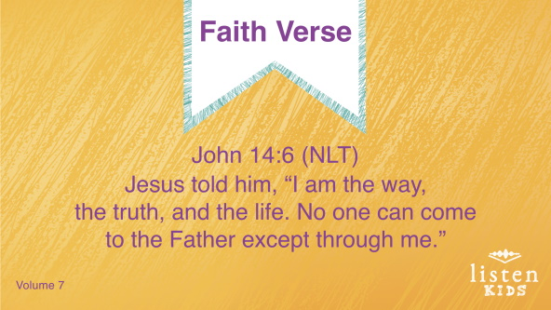

John 14:6 (NLT)

Jesus told him, “I am the way, the truth, and the life. No one can come to the Father except through me.”

**Faith Verse Fun**

**New Teacher**

Let’s go over the Faith Verse together as a group a couple times. Remember to say it as loud as possible so all the other small groups can hear you!

John 14:6 (NLT)

Jesus told him, “I am the way, the truth, and the life. No one can come to the Father except through me.”

Now, I have a question for you, but you have to answer it honestly. Have you ever wanted to be the teacher or thought you could teach better than your teacher? *(Group response)* This is your chance to be the teacher. I need a volunteer to be our new teacher, and you can teach the verse to the group any way you like.

• *Choose a kid and allow them to lead the verse. Let other kids one at a time take turns being the teacher*.

**Creative Activity**

**Jesus Teaches Me**

|  |
| --- |
| ***You Will Need***   * ***Small Group Activity Page****, one per kid* * *Crayons or markers*   ***Getting Ready***   * *Print copies of the* ***Small Group Activity Page****, one per kid.* |

Isn’t it great that we have Jesus to teach us? He went before us to show us how to live a godly, faithful life that is pleasing to God. Jesus taught people like these shown on our Activity Page, and He continues to teach all of us today. Let’s color this page and talk about ways Jesus has taught us.

**Prayer**

|  |
| --- |
| Dear God, thank You for all the blessings You have given us. Help us to remember our blessings and count them when we lose focus and worry about things we don’t have or things we want. Amen. |

**Faith Fact Recap**

• *Display the* ***Faith Fact Slide*** *as parents are coming into the room.*

• *Maximize the time you have with your kids, so that parents see what their kids have learned. Have the kids repeat the Faith Fact, and then dismiss them to their parents.*

I know you won’t forget our Faith Fact today. It’s only three words! **Jesus teaches me**. Take that reminder with you until we meet next time.

• *Show the* ***Faith Fact Slide***.



Say it with me now. **Jesus teaches me**. Great job!

**Dismissal**

• *Send home the* ***Small Group Activity Page***.

• *Remind parents that there are* ***Family Devotions*** *available on the app to do with their kid*.

• *Tell everyone the date and time for the next session*.