**Leader Overview**

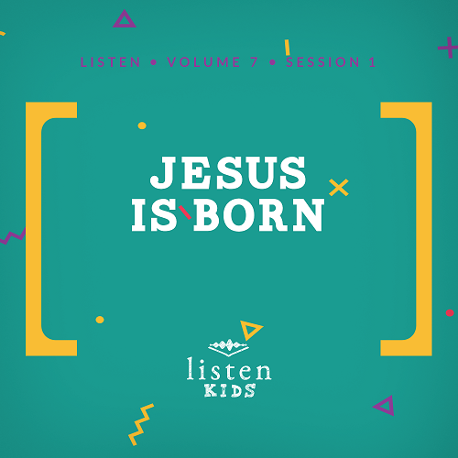

*In* Listen*, kids will explore amazing truths from God’s Word, the Bible. In this session, kids will learn that there are many promises of God found in the Bible. God keeps all of His promises to us. They will learn about one of the most important promises of God and how He fulfilled that promise by sending Jesus*.

**Bible Lesson**

Jesus Is Promised

Matthew 1:21–23

Simeon Meets the Messiah

Luke 2:25–32

**Faith Fact**

God gave me Jesus.

**Faith Verse**

John 14:6(NLT)

Jesus told him, “I am the way, the truth, and the life. No one can come to the Father except through me.”

**Preparing for the Session**

**Leader Preparation Time: 20–25 Minutes**

|  |
| --- |
| ***You Will Need***  ***Large Group***   * *Bible* * *Worship songs (Song suggestions: “Zeal” by The Belonging Co; “Chain Reaction” by River Valley Worship; “The Blessing” by Elevation Worship; “Way Maker” by Leeland)* * *For groups not using a phone or tablet only, add:*   *• Projector or TV*  *• Laptop*  *•* ***Rules Video*** *or* ***Slide***  *•* ***Large Group Game Slides 1–8***  *•* ***Faith Verse Video*** *or* ***Slide***  *•* ***Faith Fact Slide***  *•* ***Bible Lesson Video A***  *•* ***Bible Lesson Video B***  *•* ***Bible Lesson Slides 1–3***   * *Two wrapped gifts (See Getting Ready for details)*   ***Small Group***   * ***Small Group Activity Page****, one per kid* * ***Small Group Faith Verse*** *Review page, one per kid* * *Bibles, one per every one or two kids* * *Poster board, one per group* * *Marker, one per group* * *Crayons or markers* * *Pencils or pens, one per kid*   *To access the Bible Engagement Project library from a computer, visit* [App.BibleEngagementProject.com](http://App.BibleEngagementProject.com). |
| ***Getting Ready***  ***Large Group***   * *Download videos and slides if needed.* * *Select worship song(s) and have them ready to play.* * *Wrap two gifts. One should be wrapped neatly with nice paper. In this gift, there should be a less valuable item that will be given to a kid. The other gift should be wrapped messily with newspaper. In this gift there should be a more valuable gift for a kid.*   ***Small Group***   * *Print copies of* ***Small Group Activity Page****, one per kid.* * *Print copies of* ***Small Group Faith Verse Review*** *page, one per kid.* * *Write “Promises of God” at the top of each poster board in large print. Write the Scripture references underneath “Promises of God,” leaving space for the kids to write the promise of God in each Scripture.*   *Scripture References:*  *Exodus 20:12; Deuteronomy 31:8; 2 Chronicles 7:14; Psalm 34:17; Isaiah 40:29; Matthew 7:11; John 8:36; Romans 8:28; Philippians 4:19; James 1:5* |

**Large Group**

**30 Minutes**

*See what’s needed at the beginning of the session.*

**Introduction**

Hey kids! Who is ready to hear another Bible story? *(Group response)* I’m excited because we will be focusing on a very important person from the Bible for the next four sessions. In fact, He is the most important person who was born into this world. Can you guess who I might be talking about? *(Allow responses.)* That’s right! That person is Jesus. We are going back to the beginning of the story of Jesus’ time on earth. This happened even before He was born.

We will be taking a look at the promise God made to Joseph that Mary would have a very special baby. We will see how that promise of that gift was confirmed by another guy who knew God very well.

God made many promises to us in His Word, but the promise to send the gift of Jesus was one of the most important. Who knows why it was so important for Jesus to come to earth? *(Allow responses.)* He came so we could have a relationship with God by having our sins forgiven.

That’s why our Faith Fact is so important. It tells us that God kept His promise to us. Today’s Faith Fact is **God gave me Jesus**.

• *Show the* ***Faith Fact Slide***.

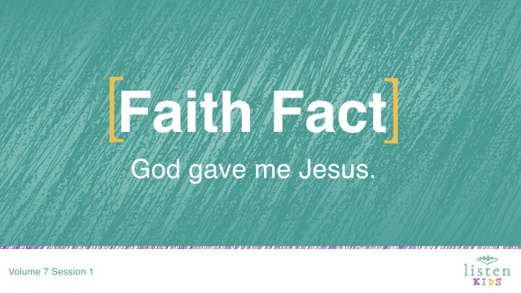

Let’s say the Faith Fact one more time as loudly as possible! **God gave me Jesus**. Great job!

**Rules Review (Optional)**

Before we go any further, let’s review our rules together. Does anyone already know them? *(Allow responses.)*

• *Play* ***Rules Video***.

**Game**

**Did God Say It?**

|  |
| --- |
| ***You Will Need***   * ***Large Group Game Slides 1–8***   *No prep needed for this activity.* |

Do you know some of God’s promises found in the Bible? *(Allow responses.)* Today, we will hear the story of God sending the gift of Jesus to fulfill promises from the Old Testament. Do you think you could tell a true promise of God from a fake one? *(Group response)* We will see just how well you know your promises of God in this game called, Did God Say It? For each round, a “promise of God” will come up on the screen. You will vote if you think it’s a promise of God or a fake promise.

If you think it’s a promise of God, jump up and down. If you think it’s a fake promise, kneel on the floor. Are you ready to play?

• *Show* ***Large Group Game Slide 1*** *and allow kids to choose if they think it is a promise God made in the Bible or not*.

• *Show remaining slides (2–8) in turn and repeat for each one*.

• *Promises of God*

• *I give power to the weak. (Isaiah 40:29)*

• *I give good gifts to those who ask. (Matthew 7:11)*

• *I will forgive you when you admit your sin. (1 John 1:9)*

*• I will never abandon you. (Hebrews 13:5)*

• *Fake Promises*

• *I will give you a trouble-free life*.

• *I will make everyone who follows Me rich*.

• *I will give all good people a comfortable life on earth*.

• *I will give you the answers to all your questions*.

Game time is always a good time, but you know what I love even more? Worship time! It’s time to get up on your feet and spend some time worshipping and singing to God. Let’s do it!

**Worship**

A great way to encounter God is through worship. We can become closer to Him and feel His presence when we take to time to worship Him. One way to do that is by singing.

• *Lead the kids in singing one or two praise songs. See suggestions at the beginning of the session*.

**Bible Lesson**

Worship time never disappoints! I’m so thankful for the time we get to spend in worship in God’s presence. Let’s take a moment to bow our heads and ask God to prepare our hearts and minds for what He wants us to hear in our Bible story today.

**Prayer**

|  |
| --- |
| Dear God, thank You for Your promises. We know that You would never make a promise that You wouldn’t keep. Help us to learn something new from this Bible story today. Amen. |

**Video Intro**

Before we get started with the Bible story, let’s check in with our Challenge Accepted team and see what they’re up to!

• *Play* ***Bible Lesson Video A****.*

Wow! Do you think you could win that challenge? *(Group response)* That’s an interesting way to lead into our Bible story today.

**Bible Story**

If you have your Bible here today, turn to Matthew 1:20–23. When you have found it, shout “Amen!” *(Allow time for kids to find the passage and respond.)*

• *Open the Bible to Matthew 1:20–23. Have Luke 2:25–32 marked and be ready to turn there later*.

Is there anything better than receiving a gift? *(Group response)* I love it when someone tells me they are going to get me a gift, and I have to wait. I get so excited imagining what that gift will be and what it will look like. So today, I want to surprise one of you with a gift.

• *Pick a kid to come to the front*.

Now, instead of just giving you a gift, I’m going to let you choose between two packages. I’ve got these two different gifts, and they look a little different. What are some things you notice are different about them both? *(Allow responses.)*

• *Show kids two similarly sized gifts*.

• *One gift should be very nicely wrapped with a less valuable item in it. For example, use a fun-sized candy or a dollar bill*.

• *The other gift should be poorly wrapped with newspaper with a more valuable item in it. For example, use a larger candy bar or a five dollar bill*.

Which gift do you think our volunteer should choose? *(Group response)* Take a moment to look at the gifts and think. Which gift have you chosen?

• *Allow selected kid to choose one of the gifts*.

Good choice! Why did you choose that gift? *(Allow response.)* That’s a great reason. Let’s open the gift and see what you got.

• *Have the kid open the gift, and you open the other one*.

*(Volunteer)*, what did you receive? *(Allow response.)* Oh, that’s great! Want to see what he or she could have received? *(Group response)*

• *Reveal what was in the gift that was not chosen and respond appropriately*.

• *Adjust your teaching if the volunteer chose the poorly wrapped gift*.

You might be wondering what gifts have to do with the Bible story today. Well, last time, we talked about a man named Nehemiah. Over four hundred years have passed, and there isn’t much in the Bible to explain what happened during that time. We do know though that God’s people were waiting because God had promised to send them a special gift.

Can you imagine waiting four hundred years for a gift? *(Group response)* Most of us can’t wait to open our presents on Christmas morning. At the time of today’s Bible story, God’s people were living under Roman rule. But they were waiting for God to fulfill His promise to send His gift, the Messiah, who would save them.

For those four hundred years, the Israelites had a lot of time to imagine what this Messiah would be like. Many thought He would be a warrior, a king, or someone born in an important family, but God had very different plans. The gift He gave His people looked very different from how they imagined.

One day during this waiting period, an angel appeared to a young woman named Mary, with special news. Mary was a regular girl in the small town of Nazareth. She was about to be married to Joseph, but her life was turned upside down by the angel’s news that she would become pregnant with a baby boy. The Baby would be the gift that everyone was waiting for.

• *Show the* ***Bible Lesson Slide 1***.

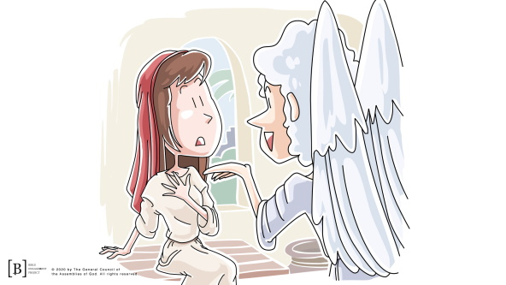

When Joseph heard this news, he was confused and scared about what people would think. He started making plans to cancel their wedding. Joseph didn’t realize that Mary’s child would be a special and very important baby.

As Joseph thought about what he might do, something amazing happened. Let’s read to find out more!

• *Read Matthew 1:20–23.*

Can you imagine how Joseph might have felt? Make the expression with your face you would have had if you were Joseph. *(Allow kids to make their expression.)* He must have been scared, shocked, and amazed all at the same time! The little Baby, growing inside Mary, was the fulfillment or answer for prophecies that had been made by the Old Testament prophets hundreds of years before.

As the story continued, Mary and Joseph had to travel to Bethlehem for a census to be counted by the Roman government. While there, it was time for the baby to be born. Jesus spent His first night sleeping in a manger, which is a trough that the animals would have eaten from.

Some people may have looked at that and thought that Jesus couldn’t be the promised gift from God, but others knew better. Angels appeared to some shepherds and told them that the Savior was born. The shepherds immediately visited Jesus to see God’s special gift.

• *Show the* ***Bible Lesson Slide 2***.

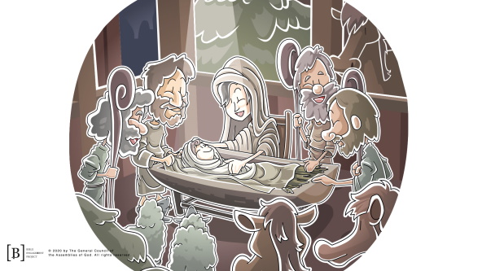

Let’s fast-forward to a few days after Jesus was born. Find Luke 2:27–32. When you find the spot, yell “Amen!” *(Allow time for kids to find the passage and respond.)*

In these verses, we read about a man named Simeon. He was a very old and devoted follower of God. He had waited his whole life to meet the promised Messiah.

The Holy Spirit had told Simeon that he would not die until he had seen the Messiah. That’s a pretty cool promise! Let’s read what happened next.

• *Read Luke 2:27–32.*

• *Show the* ***Bible Lesson Slide 3***.

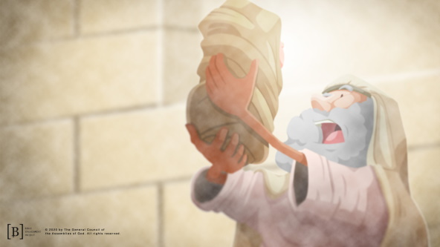

God kept His promise to Simeon! God told Simeon that he would have a chance to meet the Messiah before he died, and God revealed to Simeon that Jesus was the Messiah he had been waiting for.

**Teaching Time**

It’s so cool to see that God made those promises to Mary and Joseph, and Simeon and that He came through for them. Those are just two of the many promises God made that can be found in the Bible. God gave many prophecies through the Old Testament prophets that were fulfilled through Jesus’ life on earth. The same God who made those promises in the Bible and kept them is the same God we worship today.

People may have expected the promised gift from God to look or act differently, but Jesus was a much better gift than they could have ever expected.

The promises of God found in His Word were not just for the people in the Bible; they are for all of us as well. That’s why our Faith Fact is **God gave me Jesus**. Jesus came to help you and me. We can have a relationship with Him, and He can help us just like He helped others in the Bible.

**Faith Verse**

That’s why our Faith Verse is so important. It reminds us that Jesus is the only way to know God and receive His forgiveness and salvation. Let’s say the verse and learn the actions together.

• *Play* ***Faith Verse Video****.*

John 14:6 (NLT)

Jesus told him, “I am the way, the truth, and the life. No one can come to the Father except through me.”

That verse reminds us of how important it was and still is for us today that God kept His promise and gave us Jesus.

**Prayer and Response**

*Consider playing a worship song softly in the background while kids pray.*

Let’s take some time right now to thank God for His gift and promises. If God had not kept His promise of sending the gift of Jesus, our life and future would be very different. When Jesus grew up and eventually died on a cross, He took the punishment for all our sins. Because He was willing to die, we have the opportunity to live forever with Him. If you haven’t done so, take a moment to ask Jesus to come into your life and forgive your sins right now. Don’t let God’s promise and Jesus’ sacrifice go to waste!

• *Give kids time to pray. Then introduce the worship song. This could play in the background while kids pray or could be a worship song to sing together*.

**Worship Song**

*Play a worship song*.

**Video Wrap-Up**

Before we go to our small group activities, let’s see how the Challenge Accepted team managed their challenge.

• *Play* ***Bible Lesson Video B****.*

Let’s all accept the challenge that Dash gave us! This week, give someone a gift with a note telling them about the gift that God provided for all of us—Jesus. That perfectly fits our Faith Fact for today. Say it with me.

• *Show the* ***Faith Fact Slide***.



**God gave me Jesus**. I’m so thankful that He did. Thanks for joining us today.

• *Dismiss kids to Small Group time or to go home if your group time ends here.*

**Small Group**

**30 Minutes**

*This section can be done in conjunction with the large group or on its own if you do small groups with your kids. During Small Group time, the goal is to connect the kids with the Word of God and to each other. All activities are led by the small group leader.*

**Group Connection**

**Promises of God**

|  |
| --- |
| ***You Will Need***   * *Bibles, one for every one or two kids* * *Poster board, one per group* * *Marker, one per group*   ***Getting Ready***   * *Write “Promises of God” at the top of each poster board in large print. Write the Scripture references underneath “Promises of God,” leaving space for the kids to write the promise of God in each Scripture.*   *Scripture References:*  *Exodus 20:12; Deuteronomy 31:8; 2 Chronicles 7:14; Psalm 34:17; Isaiah 40:29; Matthew 7:11; John 8:36; Romans 8:28; Philippians 4:19; James 1:5* |

We are going to look up some amazing promises of God in our Bibles and write them on this poster board next to the Scripture reference. Everyone, grab a Bible and get ready to look up some verses.

• *Give each kid a Bible for this activity or pair kids up to work together to find the verses*.

• *For each round, give the kids a verse to look up. The first kid/pair to find the verse will jump up and read the verse for the group. For younger kids, have leaders help them find the verses and read them*.

• *The group should try to figure out what the promise from God is in each verse and write it on the poster board next to that reference*.

**Bible Lesson Recap**

|  |
| --- |
| ***You Will Need***   * *Bible, one per kid*   *No prep needed for this activity.* |

**Bible Story Review:** **Matthew 1:21–23; Luke 2:25–32**

Our Bible story is broken up into two completely different passages. Why? Because we will have the chance to read about two promises God made to two different people that were fulfilled by one Baby’s birth. Jesus was no ordinary baby. He was the fulfillment of many prophecies and promises that had been made to God’s people many years before. God kept His promise, as always, by sending the gift of Jesus to earth. Let’s read about it together.

• *Choose one kid to read Matthew 1:21–23 and another kid to read Luke 2:25–32.*

What is one thing that you remember about our Bible story?

**Faith Fact**

All of our Bible reading is a reminder to me of our Faith Fact.

• *Show the* ***Faith Fact Slide***.



Say it with me**. God gave me Jesus**.

**Group Discussion**

*Feel free to use all or just a few questions as a jumping-off place for good discussion. Questions marked with * are designed for more conversation. Adjust the questions based on the age or maturity of your group. Typically, older kids will be able to dive a little deeper than younger ones*.

**Questions**

What town was Jesus born in?

What promise did God make to Simeon?

Have you ever made a promise to someone before?

* Have you ever broken a promise you made to someone? What happened?

Has anyone ever made a promise to you and then broken the promise?

* How does it feel to have someone break a promise he or she made to you?

* What is your favorite promise from God? Why?

How are God’s promises different from promises that people make to you?

* Do you believe in God’s promises? Why or why not?

* How can you make sure you keep your promises?

**Application and Response**

God’s Word is filled with incredible promises of God. Grab your Bible and spend some time reading it every single day. If you are looking for promises, you will find God’s promises throughout the entire Bible. God has never made a promise He can’t keep.

**Make It a Habit**

*Select a simple visual reminder of the session’s Faith Fact*.

Remember our Faith Fact today? Let’s say it together. **God gave me Jesus**.

• *Have all the kids hold up their pinkies*.

Who has ever made a pinkie promise with a friend to do something? *(Group response)* God’s promises are so much bigger and better than any pinkie promise we could ever make. God promised to send His Son, Jesus, to earth to be our Savior, which is the greatest gift God could ever give us. God keeps all of His promises to us. Every time you look down and see your pinkie this week, think about the promises God has made to you and thank Him for always keeping them.

**Prayer**

Let’s pray and ask God to help us. Repeat this prayer after me.

|  |
| --- |
| Dear God, thank You for Your promises. Please forgive me when I make promises to others that I don’t keep. Help me to be more like You every day. Amen. |

**Faith Verse Review**

*No prep is needed for this activity*.

Our Faith Verse for today is John 14:6. It tells us that Jesus is the only way to God the Father. We cannot have a relationship with God or get to heaven without Jesus and the sacrifice He made for us. Let’s say the Faith Verse and do the actions together.

• *Show the* ***Faith Verse Slide***.

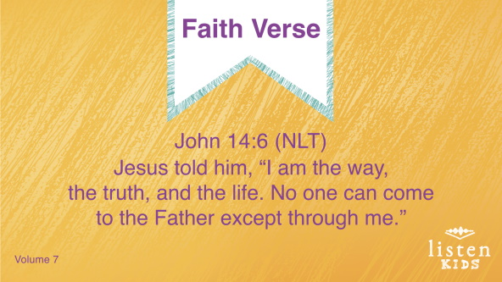

John 14:6 (NLT)

Jesus told him, “I am the way, the truth, and the life. No one can come to the Father except through me.”

**Faith Verse Fun**

**Picture It**

|  |
| --- |
| ***You Will Need***   * ***Small Group Faith Verse Review*** *page, one per kid* * *Pencils or pens, one per kid*   ***Getting Ready***   * *Print copies of* ***Small Group Faith Verse Review*** *page, one per kid.* |

Let’s take some time to work on the Faith Verse. Everyone will have a paper with the Faith Verse on it and a pencil. You will draw a picture for every word or draw one picture for the whole verse.

• *Give each kid a copy of the* ***Small Group Faith Verse Review*** *page and a pencil or a pen. Help them come up with ideas to draw*.

**Creative Activity**

|  |
| --- |
| ***You Will Need***   * ***Small Group Activity Page****, one per kid* * *Crayons or markers* * *Bible, one per every one or two kids*   ***Getting Ready***   * *Print copies of the* ***Small Group Activity Page****, one per kid.* |

Today, we learned that **God gave me Jesus**. He was placed in a manger after He was born. It may have looked like this one on our **Activity Page***.* Let’s color the picture of Joseph, Mary, and Baby Jesus. When you are finished, add in some animals you think were there with them.

**Prayer**

|  |
| --- |
| Dear God, thank You for giving us Your promises and sending Your Son, Jesus, to take the punishment for the wrong things we have done. We love You. Amen. |

**Faith Fact Recap**

• *Display the* ***Faith Fact Slide*** *as parents are coming into the room*.

• *Maximize the time you have with your kids so that parents see what their kids have learned. Have the kids repeat the Faith Fact and then dismiss them to their parents*.

One of the most important things to remember from today is our Faith Fact.

• *Show the* ***Faith Fact Slide***.



Let’s say it together: **God gave me Jesus**.

**Dismissal**

• *Send home the* ***Small Group Activity Page***.

• *Remind parents that there are* ***Family Devotions*** *available on the app to do with their kid*.

• *Tell everyone the date and time for the next session*.