Personal Devotion
Day 1
Engage
Read Luke 9:1–27.
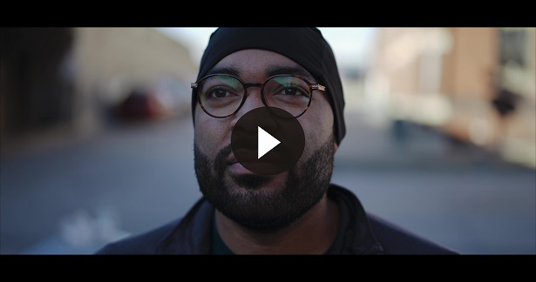
Consider
QUESTION
What were the two things Jesus told His disciples to do according to Luke 9:2?

QUESTION
What did Jesus tell His disciples to do in Luke 9:13?

QUESTION
What might these two verses suggest about what God calls His followers to do?

QUESTION
What three things must you be willing to do if you desire to be a follower of Jesus? (Luke 9:23)
Reflect
QUESTION
Taking up your cross is a way of describing sacrificing your desires to do what’s right. What might that look like in your life?
Activate
Write out Luke 9:25 on an index card or in your Bible. Make it a point to read it before going to bed each night this week.
Pray
Precious Lord, I praise You. You are good and faithful. You provide for me in so many ways. I can’t thank You enough. Help me to deny myself, take up my cross, and follow after You all the days of my life. Help me share about Your kingdom, pray for the sick, and feed the hungry. I pray that Your Church would rise up to be the Church the world needs in order to see You. I bless Your name. Amen.

Personal Devotion
Day 2
Engage
Read 2 Corinthians 4:1–18.
Consider
QUESTION
What does Satan do to the minds of those who don’t yet believe? (2 Corinthians 4:4)

QUESTION
In what four ways was Paul persecuted? (2 Corinthians 4:8–9)

QUESTION
What does Paul say is a positive outcome in our suffering? (2 Corinthians 4:10, 12)

QUESTION
What attitude does Paul reflect in 2 Corinthians 4:16–17?
Reflect
QUESTION
How does this chapter encourage you in your faith?

QUESTION
Has your attitude changed regarding being persecuted for your faith in Christ? How?
Activate
Take a moment to pray for greater strength and courage in your faith.
Pray
God, I ask You to show me the power of Your Word. May Your Word strengthen me in my faith. Help me to listen to the voice of the Holy Spirit as I read Your Word. Help me to hold firmly to what I believe about You and the validity of Your Word. Amen.

Personal Devotion
Day 3
Engage
Read 1 Peter 4:1–19.
Consider
QUESTION
What should your attitude be toward suffering because of Jesus Christ’s suffering?

QUESTION
What does Peter say not to be surprised about in 1 Peter 4:12?

QUESTION
What happens if you’re insulted according to 1 Peter 4:14?
Reflect
QUESTION
How does knowing Christ suffered for all believers give you the courage to face trials?
Activate
Talk to a pastor or youth leader about having strong faith even when suffering for Jesus. Ask them to pray for you to have faith to follow regardless of how others treat you.
Pray
Lord, help me be teachable and humble when I learn from others how to live through persecution. I also pray for others who are going through suffering right now. Please help them through the Holy Spirit. Also, give me greater boldness in my faith through Your Holy Spirit as well. In Your wonderful name. Amen.

Personal Devotion
Day 4
Engage
Read Romans 8:18–39.
Consider
QUESTION
What does the Holy Spirit do for you in times of weakness?

QUESTION
What does God cause to happen according to Romans 8:28? For whom?

QUESTION
Put Romans 8:35–37 in your own words.
Reflect
QUESTION
Have you ever felt separated from God’s love? How could reading Romans 8:38–39 be helpful when feeling this way?
Activate
Do your best to memorize Romans 8:38–39 this week. Write it out on a card to carry with you, or place someplace to see each day.
Pray
God, thank You for Your Holy Spirit who lives in those who have surrendered to Jesus. I ask You to baptize me in Your Spirit, empowering me to live and serve You. May those who feel separated from You be reminded that You never leave us alone. You are always with us. In Your Son’s name. Amen.

Personal Devotion
Day 5
Engage
Read John 15:1–27.
Consider
QUESTION
What is the result in your life if you remain in Christ? (John 15:5)

QUESTION
How do you remain in Christ? (John 15:10)

QUESTION
What can you be sure of since Jesus was persecuted? (John 15:20)
Reflect
QUESTION
Does knowing people hate Jesus without cause help you to grow closer to Him? Why or why not?
Activate
Pray John 15:12–13 for your life.
Pray
Gracious Father, guard my heart and mind against false teaching. Help me to love others and be willing to lay down my life as an act of love. Give me this kind of faith. I pray that those who hate You would turn from the false teachings they’ve heard and surrender their lives to You. Amen.

