Personal Devotion

Day 1

Engage
Read Romans 12:1–21.
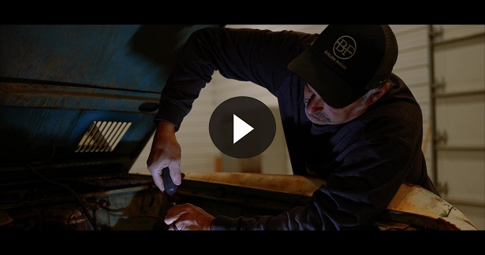
Consider
QUESTION
What does the passage tell us about how we change? (Romans 12:2)

QUESTION
What is one way we can see how much we have changed? (Romans 12:3)

Several challenges come in Romans 12:9–21. Living these out will show how Jesus has transformed us.
QUESTION
Which ones stand out to you? Why?
Reflect
QUESTION
Which characteristics from the list in Romans 12:9–21 are hardest for you? Why?
Activate
Choose one of the qualities listed in Romans 12:9–21, and work on making it a part of your life.
Pray
Father God, please help me to focus on these qualities in my life. I pray that You would help me be changed as I allow You to change my mind. I ask that as I read the Bible, my mind would be renewed, and that I would think differently about myself and others. I pray that I would see them as people loved by You. I want to start doing whatever I can to show love to them. Thank You. Amen.
Personal Devotion
Day 2
Engage
Read Acts 7:54–60, 8:1–3.
Consider
QUESTION
Based on this passage, how would you describe Saul to someone who didn’t know who he was?

QUESTION
What does Stephen’s response to persecution say about his character?

QUESTION
What does it say about Stephen’s relationship with Jesus?

QUESTION
Have you been bullied because of your faith in Jesus? If you haven’t experienced that, do you know someone who has?
Reflect
QUESTION
How do you respond to people who persecute you because you follow Jesus?

QUESTION
Is there anything about the way you treat people who mistreat you that you’d like to change? What is it?
Activate
If you’ve been persecuted for your faith, whether by another student, family member, or teacher, stop now to pray for them. Pray daily for them until your heart is free from their negative influence.
Pray
Lord, bless those who have done wrong to me because I follow You. Help me to reflect Jesus to them and not mirror back their bad behavior. Help me to love my enemies, to pray for those who persecute me. Help me to choose to bless others. I pray for those in the world being persecuted as well. Help them today and be near them. In Your mighty Name. Amen.
Personal Devotion
Day 3
Engage
Read 2 Corinthians 11:16–33.
Consider
QUESTION
What stands out to you regarding Paul’s commitment to Christ?

QUESTION
How does this passage show us the change that took place in Paul’s life from before he met Jesus to when he wrote these words?

QUESTION
What does Paul mean in the statement he makes in 2 Corinthians 11:30?

QUESTION
What’s one thing from this Bible passage that you can use in your life?
Reflect
QUESTION
How much are you willing to endure in order to advance the kingdom of God?
Activate
From today’s reading, underline in your Bible or write down a list of the hardships Paul endured. Make a few notes in the margins reflecting your commitment to follow Christ as a changed person.
Pray
Father, please give me the strength I need to endure any and all situations where my faith is on the line. Help me to boldly proclaim Your name, regardless of what I have to endure in this life. I also pray for Your Church, that every member would experience the change needed and courage to stand for You. Amen.
Personal Devotion
Day 4
Engage
Read John 3:1–21.
Consider
QUESTION
What do you know about Nicodemus from what you read?

QUESTION
What does Jesus tell him about seeing the kingdom of God? (John 3:3)

QUESTION
How would you explain John 3:20–21 in your own words?
Reflect
Read John 19:38–42.
QUESTION
What can we conclude about Nicodemus from reading these verses?
Activate
Memorize John 3:16.
Pray
Heavenly Father, I trust You. I believe in You. Please help me to demonstrate the change in my life to my family and friends. Also, help Your Church to not be afraid to approach You and to be about Your mission to see people’s lives changed. Amen.

Personal Devotion
Day 5
Engage
Read Luke 19:1–10.
Consider
QUESTION
What do you know about Zacchaeus from what you read?

QUESTION
What in this account tells you how much Zacchaeus changed as a result of meeting Jesus?

QUESTION
What does Luke 19:10 tell you about Jesus?
Reflect
QUESTION
Have you wronged anyone? If so, what can you do to make that situation right?
Activate
Take whatever action is needed to make things right with any person you have wronged.
Pray
Great Shepherd, help me to live right and not take advantage of others. Let others see that I truly am a changed person. Help me to step out in faith and, like Jesus, search for lost people. Help me to share the good news with them, so that they can be changed as well. Thank You. Amen.

