Personal Devotion
Day 1
Engage
Read Acts 2:36–47.
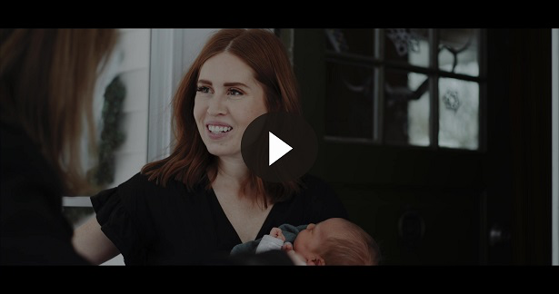
Consider
QUESTION
What was the core of Peter’s message to the crowd that made them want to respond? (Acts 2:38–40)

QUESTION
What were the main activities of the New Testament Church?

QUESTION
Which aspects from Acts 2:42–47 do you participate in or lead?
Reflect
QUESTION
What do you love best about your local church?
Activate
Write out the purposes of the Church in your Bible or a journal as a reminder of how God established His Church.
Pray
Holy Father, thank You for Your Church and how Jesus came to establish it as a way to reach the world with the gospel. I ask, as a part of Your Church, that You would help my life draw people to You and make them want to be a part of it. In Your amazing Name I pray. Amen.
Personal Devotion
Day 2
Engage
Read Colossians 1:15–29.
Consider
QUESTION
What does Colossians 1:18 tell us about Jesus and His relationship with the Church?

QUESTION
What has caused some people to be far away from God? (Colossians 1:21)

QUESTION
What does Paul say his responsibility is concerning the Church? (Colossians 1:24–26)
Reflect
QUESTION
How does this passage challenge you in serving the Church?
Activate
Make a list of a few ways you can serve in your local church.
Pray
Great Creator, I ask that Your Church would serve in greater ways than ever before and be a great light to those who are lost and without hope. May Your Church rise to the challenge of serving, giving, and worshipping You in greater ways. Help us to truly impact the world. And help me to learn to serve in greater ways to be a part of that impact. Amen.

Personal Devotion
Day 3
Engage
Read Hebrews 10:19–25.
Consider
QUESTION
What was one thing Jesus’ death accomplished for us according to Hebrews 10:22?

QUESTION
How is Hebrews 10:24–25 similar to the passage in Acts 2 that you read on Day 1?

QUESTION
Why do you believe the writer of Hebrews challenged us to continue to meet together?
Reflect
QUESTION
What are some ways you have motivated others to acts of love and good works?
Activate
Over the next several weeks, make it a point to actively participate in as many activities as you can when it comes to meeting together as your local church.
Pray
Mighty King, I ask You to help me to motivate others to love and good works. I pray the Church around the world would be strengthened to accomplish this as well. Help Your followers to see the value of the Church just as You do. In Jesus’ name. Amen.

Personal Devotion
Day 4
Engage
Read 1 Corinthians 12:12–31.
Consider
QUESTION
What does the writer, Paul, compare the Church to in 1 Corinthians 12:12?

QUESTION
What do these verses suggest about our role in the body of Christ?

QUESTION
What are some of the roles God has appointed in the Church? (1 Corinthians 12:28)

QUESTION
What is the challenge to each of us according to 1 Corinthians 12:31?
Reflect
QUESTION
What are your gifts that contribute to the body of Christ?

QUESTION
How can you use your gifts to help in your local church?
Activate
Ask God to show you the gifts you bring to the body of Christ, His Church. Consider taking a spiritual gifts test. Talk to your youth leader or pastor or search online for a spiritual gifts test.
Pray
Father God, please allow Your Holy Spirit to reveal to me any gifts You’ve given me for the building of the Church. I want to be an active member of the body of Christ and do my part to help. I also ask that believers everywhere would walk in their gifts so Your Church could grow and reach all people. In Christ’s name. Amen.

Personal Devotion
Day 5
Engage
Read Matthew 25:31–46.
Consider
In these verses, Jesus told a story to make a point about those God will invite into His kingdom. It tells us a lot about the kindness He expects us to show others.
QUESTION
Who does Jesus say inherits His kingdom? (Matthew 25:34–36)

QUESTION
What does Matthew 25:40 tell us about the kindness we show to others?

QUESTION
How does this passage give us insight into the role of the Church?
Reflect
QUESTION
What are you doing to serve the needs of people in your community?

QUESTION
How is your church serving in these areas?
Activate
Think of one way you can begin serving the least of these. Then take that step.
Pray
Father, help me to feed the poor, clothe those who need it, care for the sick, visit those in prison, and do what I can to make an impact for Your kingdom. Help me to realize this is a big part of what Your Church has been called to do. I ask for followers throughout the world that they would care for others in greater ways and make disciples. Help us to spread the gospel in word and deed, so all will hear and see You! Amen.

