Personal Devotion
Day 1
Engage
Read Acts 1:1–11.
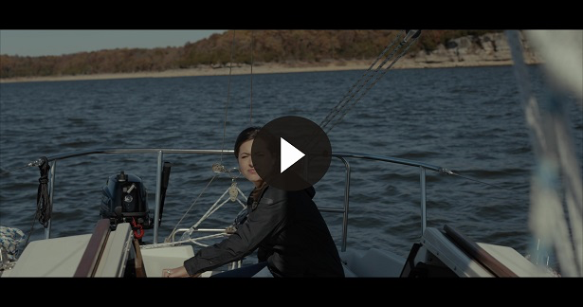
Consider
QUESTION
What was Jesus’ instruction to the disciples? (Acts 1:4)

QUESTION
Who did Jesus say would send the gift of the baptism in the Holy Spirit?

QUESTION
What did Jesus say is the outcome of receiving the Holy Spirit? (Acts 1:8)
Reflect
QUESTION
Are you relying on the Holy Spirit when it comes to living as a witness? How?
Activate
Find a Christian friend who you’re close to. Ask them if they see you as a witness for Jesus, and if so, how. If not, ask them why not. Listen without defending yourself, and then thank them for their honesty.
Pray
Father God, thank You for the promised Holy Spirit. I’m open to His work and help in my life. Please let me be the best witness for Jesus I can be! I pray this in the name of Jesus. Amen.
Personal Devotion
Day 2
Engage
Read Acts 11:1–18.
Consider
In these verses, the apostle Peter returned to Jerusalem from a ministry trip to Gentiles. (Gentile is a word that Jewish people use for people who are not Jewish.)
QUESTION
Why was Peter being criticized? (Acts 11:1–3)

QUESTION
What had the Holy Spirit told Peter to do?

QUESTION
What is one thing you saw in this passage that the Holy Spirit can do in our lives?
Reflect
QUESTION
Do you believe the Holy Spirit still speaks to us today? Why or why not?
Activate
Take a moment to ask Jesus to baptize you with the Holy Spirit. If you’re already baptized in the Holy Spirit, take time to pray in the Spirit (in tongues or your prayer language).
Pray
Father God, I ask for Your Holy Spirit to be ever present in my life every day. Help me to listen to You and obey as You give me direction. I also pray that Your Church would continue to learn to walk in the presence of the Holy Spirit daily. Amen.

Personal Devotion
Day 3
Engage
Read Acts 19:1–6.
Consider
QUESTION
Who did Paul encounter on the coast? (Acts 19:1)

QUESTION
What question did Paul ask, and what was their response?

QUESTION
What was the result of Paul laying his hands on the believers?
Reflect
QUESTION
Based on what you read, do you believe the baptism in the Holy Spirit is a separate act from salvation? Why or why not?
Activate
Find a pastor, teacher, or leader in your church, and ask him or her to share about their experience with the Holy Spirit.
Pray
God, thank You that the Holy Spirit is in my life. I want everything He has to offer to draw me closer to You. Help me to serve and live for You as the Holy Spirit gives me power. Amen.

Personal Devotion
Day 4
Engage
Read Galatians 5:16–26.
Consider
QUESTION
Why should we allow the Holy Spirit to guide our lives?

QUESTION
What is the result of following the sinful nature?

QUESTION
What fruit does the Holy Spirit produce in a Christian’s life?
Reflect
QUESTION
What sin are you struggling with that you need the Holy Spirit’s power to overcome?
Activate
Write out Galatians 5:22–23 on an index card, and place it on your mirror or refrigerator. Attempt to memorize it over the next several days.
Pray
Father God, thank You for living in me through the Holy Spirit and being willing to lead me in my everyday life. Help me to walk with You, listen to You, and be led by You, all while getting closer to You and growing more like Jesus. Help Your Church to walk in the fruit of the Spirit. Please help those struggling with sin to overcome it. Amen.

Personal Devotion
Day 5
Engage
Read Acts 4:1–31.
Consider
QUESTION
How did the Holy Spirit help Peter? (Acts 4:8)

QUESTION
What was the outcome of the prayer meeting in Acts 4:31?

QUESTION
What did the Holy Spirit empower them to do as a result of their prayer?
Reflect
QUESTION
How have you experienced the Holy Spirit over this past week as you’ve prayed and learned more about Him?

QUESTION
Does the Holy Spirit have permission to speak to you and lead you in any and all situations? Why or why not?
Activate
Take a moment to record in your Bible or journal some thoughts from spending the week listening to the voice of the Holy Spirit.
Pray
God, I ask for courage through the Holy Spirit to share Your Word with others. I pray that I would no longer be fearful to tell others of Your love, forgiveness, mercy, and judgment. I pray that my friends and church would walk in great boldness as well. Please let us see many people come to know Jesus as a result. Amen.

