Personal Devotion
Day 1
Engage
Read 1 Corinthians 15:12–26.
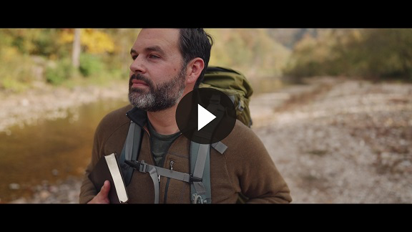
The apostle Paul had a vision of the resurrected Jesus. That vision changed the course of his life. He was transformed from someone who persecuted Christians to a key leader of Christians. Later in his life, he wrote a letter to a church in Corinth and addressed a false teaching happening in this young church. The false teaching was that there is no life after death.
QUESTION
What does the Resurrection have to do with our faith in Christ? (1 Corinthians 15:14, 17)

QUESTION
What does the Resurrection have to do with the forgiveness of sins? (1 Corinthians 15:17)

QUESTION
How did Paul explain the relationship between Adam and Jesus? (1 Corinthians 15:21–22)
Reflect
QUESTION
How does knowing that there is eternal life through Jesus give you hope?
Activate
Write in a journal or inside your Bible how the resurrection of Jesus gives you hope and strengthens your walk with Him now.

Pray
Faithful God, I know that death is a scary thought for many. I admit that I have uncertainties about death. Thank You that Jesus faced the final enemy of death in our place. And when Jesus rose from the dead, He ensured that all those who believe in Him would not be ultimately defeated by death. Help me to believe that truth and not lose my hope or joy in any circumstance. In Jesus’ name. Amen.

Personal Devotion
Day 2
Engage
Read John 11:17–44.
Consider
QUESTION
How many days had Lazarus been in the tomb when Jesus got there?

QUESTION
What did Jesus promise Martha in John 11:23?

QUESTION
Jesus knew that He was going to raise Lazarus from the dead. Why do you think He still wept?

QUESTION
What did Jesus do before He called Lazarus out of the tomb? (John 11:41–42)
Reflect
QUESTION
How does Jesus’ attitude toward death encourage you in your faith?
Activate
Reach out to a friend or family member who may believe that something in their life has died (for example, a relationship, future plans, inner peace, etc.). Ask them if you can pray for them that the resurrection power of Jesus will bring hope and encouragement to them in that area of their life.
Pray
Glorious God, thank You that Jesus has power over death. Thank You that He walks into the darkest moments of my life and brings both words of truth and a caring presence. Help me to believe His truth and receive His presence. In Jesus’ name. Amen.
Personal Devotion
Day 3
Engage
Read Matthew 28:1–20.
Consider
QUESTION
What did the angel say to the women at the tomb?

QUESTION
How did the religious leaders attempt to discredit the Resurrection? (Matthew 28:11–15)

QUESTION
What does the religious leaders’ attempt to lie about the Resurrection suggest about Jesus?

QUESTION
What were Jesus’ first words to His disciples following the Resurrection? (Matthew 28:18–20)
Reflect
QUESTION
Why do you believe the enemy tries to convince people Jesus didn’t rise from the dead?
Activate
Write out Matthew 28:19–20 and post it somewhere you will see it often. Read it often as a reminder of our mission as followers of Jesus.
Pray
Jesus, thank You that You are making all things new. Thank You for defeating death to give everyone the opportunity for life. Help me to fulfill the mission of making disciples and help Your Church grow in the power of Your Resurrection! In Your powerful name. Amen.
Personal Devotion
Day 4
Engage
Read Philippians 3:1–11.
Consider
QUESTION
What did Paul say he relied on in Philippians 3:3?

QUESTION
How did Paul view his accomplishments after encountering Christ? (Philippians 3:7–8)

QUESTION
What did Paul say about becoming righteous? (Philippians 3:9)

QUESTION
What four things did Paul say he wanted in Philippians 3:10?
Reflect
QUESTION
What daily habits are a part of your life to help you know Jesus better?
Activate
Write out your spiritual résumé. List on a piece of paper all your good behavior, good habits, and religious activities.
Then mark over it in big letters, “RIGHTEOUS IN CHRIST!” Hang that paper in your bedroom to remind you that it is not your good works that make you righteous in God’s eyes, but what Jesus accomplished through His life, death, and resurrection.
Pray
Jesus, thank You that You saved me even though I don’t deserve it. Thank You that I don’t have to impress You or earn Your mercy and grace. Help me to know that I can receive and rest in what You did in my place. Help me remember that I do good works because I’m saved, but good works do not save me. I pray for those who need to know this truth for their lives as well. In Your wonderful name. Amen.
Personal Devotion
Day 5
Engage
Read Romans 6:1–11.
Consider
QUESTION
What is the question Paul asked in Romans 6:1? How did he answer it in Romans 6:2?

QUESTION
In Romans 6:3–8, what powerful truths did Paul teach us about death and resurrection?

QUESTION
According to Romans 6:10–11, what did Christ’s death accomplish for us? How should we live in response?
Reflect
QUESTION
What are some areas of your life where you are learning to die to sin?

QUESTION
How you can live for the glory of God in your home, school, and workplace?
Activate
Put into action your ideas about bringing glory to God in your home, school, or workplace.
Pray
Father, thank You that I can be dead to sin and alive in Jesus! I know this is possible only because of what Jesus did for me, not anything I’ve done. Please allow the Holy Spirit to remind me of this truth whenever I’m tempted to fall back into slavery to sin. Remind me that I am one with Christ, united to Him, and hidden in Him! Let my identity be rooted in that relationship. In Jesus’ name. Amen.

