Personal Devotion
Day 1
Engage
Read Philippians 2:1–11.
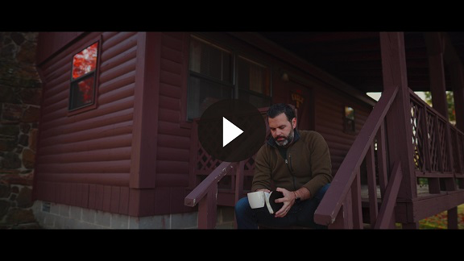
Consider
QUESTION
What three things does the apostle Paul say would make him happy? (Philippians 2:2)

QUESTION
How would you say Philippians 2:3–4 in your own words?

QUESTION
What are six things Paul recorded that Jesus did in Philippians 2:7–8?

QUESTION
What did God do for His Son Jesus following His death? (Philippians 2:9–11)
Reflect
QUESTION
What does it mean to have the same attitude that Jesus did?

QUESTION
What steps can you take to begin to walk in this attitude?
Activate
Take a moment to write out a few thoughts in your journal or Bible about the kind of attitude you want to have when it comes to serving and loving others.
Pray
God, please help me to obey the important work You have for me. Help me see that even the simple, mundane tasks of my day can be done to Your glory and for others’ good. Give me the grace and strength to love and serve You with all my heart and a willing mind. Amen.

Personal Devotion
Day 2
Engage
Read Mark 1:21–45.
Consider
QUESTION
What was the main thing Jesus did in Mark 1:21–28?

QUESTION
What was the main activity of Jesus in Mark 1:29–34?

QUESTION
Why did Jesus say He came in Mark 1:38?

QUESTION
What did Jesus feel toward the man with leprosy?
Reflect
QUESTION
What do the verses you read have to say about Jesus when it comes to serving?
Activate
Make a list of ways you can serve that are similar to how Jesus served in today’s Bible verses.
Pray
Wonderful God, You sent Jesus as a servant when I was still Your enemy. You didn’t come for me because I was good. You came for me because You are good. Help me to serve others the same way. I know I can’t love You without loving others. Thank You that the Holy Spirit helps me see others the way You do, and He gives me the grace to love and serve everyone. I pray this in the Name above all names. Amen.

Personal Devotion
Day 3
Engage
Read Hebrews 13:1–7.
Consider
QUESTION
Why should we show hospitality to strangers?

QUESTION
Who are two groups of people we are told to remember in Hebrews 13:3?

QUESTION
Why is it important that we remember the leaders who teach us the Word of God?
Reflect
QUESTION
What might following the good examples of our leaders’ faith look like?
Activate
Write a note or tell a leader you admire why you look up to their example of faith and how you see the heart of a servant in him or her.
Pray
Wonderful Savior, help me to love in word and action. I want to speak words of life and encouragement to others. Help me also to act in a way that considers others more important than myself. Thank You that You love us in word and action. You taught us important truths, but also laid down Your life. Help me to respond in worship by laying down my life for others. Amen.

Personal Devotion

Day 4

Engage
Read Matthew 23:1–11.
Consider
QUESTION
How does Jesus instruct the crowds to respond to the teaching of the religious leaders? (Matthew 23:3)

QUESTION
What is Jesus’ main problem with the religious leaders of His day? (Matthew 23:3–7)

Jesus isn’t necessarily taking issue with the titles these people had. He confronted their hearts that craved attention and status. He wants people to serve, not to be seen and noticed, but out of love.
QUESTION
In the kingdom of God, who is the greatest? (Matthew 23:11)

Reflect
QUESTION
What is the danger of serving in order to be seen and noticed?

QUESTION
Who is someone in your life that you can serve who can do nothing for you in return?

Activate
Think of one new way you can serve in your church. If you don’t currently serve, talk to a church leader about where you can serve. Commit to serving even if no one notices you or applauds you. Serve not to be served, but to bless others.
Pray
Father, I want to help others recognize that You are great—not me. Guard my heart against serving in order to be noticed. Help me to live my life knowing that You love me, not for the approval of others. Thank You that You accept me not based on my works, but based on the unchanging, undeserved work You did for me and others. Help us as Your Church to serve valiantly in Your kingdom. Amen.
Personal Devotion
Day 5
Engage
Read Romans 12:9–21.
Consider
QUESTION
In Romans 12:9–10, Paul gives six brief commands. What are they?

QUESTION
How does Paul say we should serve the Lord? (Romans 12:11)

QUESTION
What do you think it means to be eager to practice hospitality?

Look again at Romans 12:16–19. These verses address the way we are to live with people.
QUESTION
Which of those commands do you think is the most challenging for Christians? Why?
Reflect
QUESTION
What might serving the Lord enthusiastically look like in your life?

QUESTION
What are some wrong ways a person might serve the Lord?
Activate
Think of one way you can show hospitality to someone who isn’t a close friend. Choose one person and one action to do.
Pray
Father God, I admit that sometimes I don’t love others the way You want me to. Sometimes I judge others and think I am better than them. I struggle to live in peace with others. But I know that through Your grace, You can transform not just what I do, but why I do it. Give me Your motivation to serve and love others. I need You! Amen.

