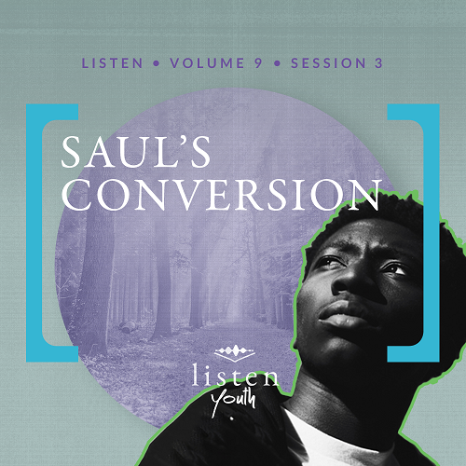Group Session
Small Group Study
Overview
It happened on the road to Damascus. Jesus changed a man from Tarsus—who persecuted Christians—into a believer who advanced the kingdom of God. Later known as the apostle Paul, he wrote much of the New Testament. As we encounter Jesus, He changes us into dedicated followers with a heart to make a difference for His kingdom.
You Will Need
- Baby pictures of group members
- Photos from group leaders (including yourself) as teenagers—the funnier, the better
Getting Ready
- Before this session, ask students to bring baby pictures to show the group.
- Insert photos of group leaders as teenagers into a digital slide show.
- First time leading Listen for Youth? Look here for the Facilitator Guide.

To access the Bible Engagement Project library from a computer, visit App.BibleEngagementProject.com.

Engage
Welcome
Thank everyone for being a part of the group, explaining that their participation greatly adds to the community. Especially give a huge welcome to guests.
QUESTION
What have you enjoyed most about being a part of our journey through the Bible together?
Opening Prayer
Prayer thoughts: Welcome God and His transforming work in people’s lives. Thank Him for changing each person who follows Him. Ask God to allow His Holy Spirit to help everyone understand the Scriptures and have the faith and courage to follow them.
Introduction
Today, we want to look at the story of one man whose life was drastically changed in an instant. He went from being someone who had a part in killing and imprisoning Christians to someone who wrote most of the books in the New Testament. We’ll see that the lives of people who have seriously said yes to Jesus are changed. The work of the Holy Spirit happens in greater ways in our life as He transforms us; we become a new creation. But on a fun note, here’s a question.
QUESTION
Have you ever known someone or seen someone famous who experienced dramatic physical changes? Maybe they had plastic surgery or muscled up for a role, and looked noticeably different after the change? Tell us about it.
Group Activity
Transformers
You Will Need
- Baby pictures of group members
- Photos from group leaders (including yourself) as teenagers—the funnier, the better
Getting Ready
- Before this session, ask students to bring baby pictures to show the group.
- Insert photos of group leaders as teenagers into a digital slide show.

Speaking of change, I hope you have pictures of yourselves as babies that you’re willing to share. Get those out and show them to a few people around you.
• Have students share their photos with people nearby.
Just for fun, let’s look at some other “before” photos. See if you can guess who they are.
• Show the pictures of the leaders.
People can change a lot, can’t they? Today’s Bible story comes from the Book of Acts and is about one of the most radically changed people in all the Bible.
Did You Know?
The Book of Acts is one of only five books in the New Testament categorized as history. Acts, along with the Gospels, lays out the historical account of Jesus’ life and the amazing results. All but one of the remaining books of the New Testament follow the format of ancient letters.

Let’s watch this video as you think about your favorite book of the Bible.

Watch
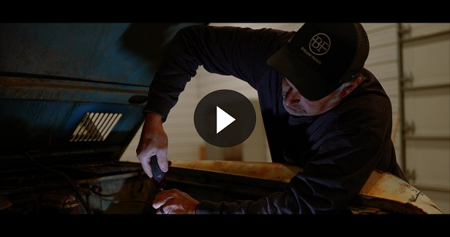
QUESTION
What stood out to you from this video?

Consider
Ensure each student has access to a Bible, preferably the same version.
People Change
QUESTION
What’s something you do differently today from when you were younger?

Today’s Bible account shows how Jesus radically changed a man named Saul in ways that would impact the Church from his day to ours. His direction and mission were so changed that as his focus shifted to ministering to the Greek-speaking world, he started going by the Greek version of his name—Paul. His testimony and New Testament teachings were so impactful that they’re still influencing believers today.
Jesus Challenged Saul
Read Acts 9:1–6.
Could you imagine getting called out in a more awkward way? While Saul was literally on the way to attack Jesus’ followers, Jesus Himself called Saul out. And if that wasn’t enough, Jesus confronted him in miraculous fashion.
QUESTION
What does Saul’s persecution of the followers of Jesus tell you about him?

QUESTION
How might you have responded had you heard Jesus audibly speak to you as He did to Saul?
Jesus Led Saul
Read Acts 9:7–9.
QUESTION
How do you think Saul felt? What could have been going through his mind?

Now put yourself in the sandals of one of the guys with Saul. Your fierce, well-respected leader has suddenly gone blind, and he’s leaning on you to guide him to Damascus. Then he tells you that Jesus, his former enemy, is the one who spoke to him.
QUESTION
What would be going through your mind?

QUESTION
This event left Saul physically blind. Would you call him spiritually blind before this? Why?

Saul wasn’t able to see who Jesus really was and that Christians were truly following God’s Son, Jesus. But meeting Jesus changed that for him.
Ananias Went to Saul
Read Acts 9:10–19.
We don’t really get any information about what was going on before this vision, but we do learn a few things about Ananias. We know that he was a Christian. We also know when he heard God’s voice, he recognized it was his Lord talking.
QUESTION
What do you think Ananias thought when the Lord asked him to go to Saul?

Saul was known to be an enemy of Jesus’ followers, so it’s not surprising that Ananias was hesitant about going to see Saul. Just imagine God telling you to share Jesus with the person in the world who you think hates Christians the most. It’s pretty scary stuff!
QUESTION
What might it say about Ananias that God asked him to be the one to help Saul?
God had a special plan for Saul. He also knew about Saul’s past and that not everyone would be lining up to talk to him about Jesus. This probably tells us that Ananias must have been a faithful follower and someone willing to obey God.
QUESTION
What was the result of Ananias doing what God told him to do?
God gave Ananias a job, and when Ananias took action, God was there to do His part. Not only was Ananias part of bringing Saul into God’s family (note that he called Saul “brother”), but he got to be part of God’s healing of Saul’s eyes.

Reflect
Jesus Changes People
Read Acts 9:20–22.
QUESTION
What does Acts 9:21 suggest about the transformation that took place in Saul’s life?

People listening to this executioner-turned-preacher must have been asking each other, “What just happened?” People saw that Saul’s focus had changed. He was no longer passionate about arresting Christians—he had become one of them!
QUESTION
What did Saul immediately begin doing following his transformation?

Saul didn’t wait to tell others about what he had learned about Jesus. Saul was changed, and he wanted to give other people the chance to come to Jesus as well.
QUESTION
What does this tell us about Jesus’ ability to change people?

Jesus Changes Us
QUESTION
Do you think someone who doesn’t experience a dramatic transformation, as Saul did, is any less a follower of Jesus? Why or why not?

Not everyone experiences a dramatic transformation like Saul did when they are saved. But every follower of Jesus should change for the better as we follow Him.
• Allow the following question to be optional. Be prepared to share your own examples too.
QUESTION
How has Jesus changed your life?

Jesus Changes the Unchangeable
Think of the person you feel is least likely to become a follower of Jesus.
QUESTION
Do you think Jesus is able to change them? Why or why not?

QUESTION
If God can change someone like Saul, what could that say about His ability to change the person you’re thinking of?

QUESTION
Why do you imagine Jesus chose to have such a dramatic encounter with Saul?

You’ll get some clues in some of the personal devotions this week. As you read through them, make sure you take a closer look at Saul’s life.
Digging Deeper (Optional)
The Tables Are Turned
Read Acts 9:23–30.
Not long after Jesus transformed his life, Saul began to preach boldly. As a result, Saul was now the one being hunted.
QUESTION
How was Saul initially received by believers?

QUESTION
Why do you think some people hate Christians?

QUESTION
Have you ever been in a situation where others hated you for your faith? What was this like, and what was your response?

Activate
• If you want to offer an opportunity to receive Jesus before breaking into groups, see the Salvation Opportunity below.
Saul shows us how important it is to invite Jesus into our life and share what He has done. We’re going to gather in groups of two or three people. If you’re comfortable, please share your testimony of how Jesus came into your life. You don’t have to share your story if you would rather not.
• Optional: Begin by sharing your salvation testimony briefly.
• Give each person one to two minutes to briefly share their salvation story.
Thanks for sharing. I realize you might not have surrendered your life to Jesus. You may still have some questions, and I’d be happy to talk with you.
Salvation Opportunity
Include this if you think there may be some in the group who do not have a personal relationship with Jesus.

After hearing how Jesus has changed Saul, maybe you’re ready to have a relationship with Jesus or realize you need to renew your relationship with Him.

Take a moment to acknowledge those who respond, and thank them for their desire to make things right between themselves and God. Pray with them now or after the group time is over. Following group time, talk more about where they are in their walk with God and how you might be able to help. Be sure to celebrate those who have surrendered to Jesus.
Conclusion
Before we wrap up, let’s stop and think about one person in our life who needs Jesus to save them.
• Give students a few moments to think about this.
Let’s pray for the person each of us thought of just now. God can reach them in His own way and in His own time. Let me challenge you to pray for that person this week with the awareness that if God can change you, He can change anyone!
Prayer
Heavenly Father, thank You that You change people through Your Son, Jesus, and the work of the Holy Spirit. Thank You that You are continually changing each of us. We ask for You to continue to encounter people with Your presence. Our desire is to see that all those who don’t know You would surrender their lives to You today. In the mighty name of Jesus. Amen.
Next time we’ll take a look at one of the most interesting prison breaks in the history of prison escapes. Come ready for another exciting account from the Bible.

