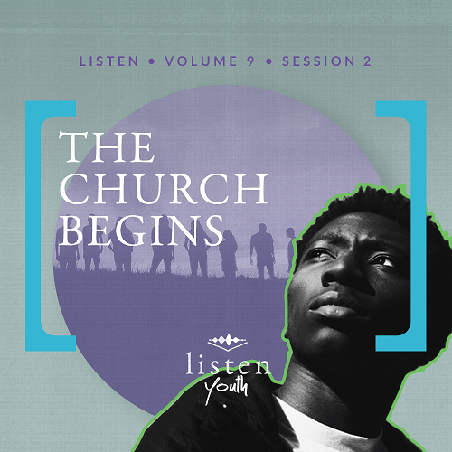Group Session
Small Group Study
Overview
What is the role of the Church as a whole, and what is our individual part both inside and outside the Church? In this session of Listen, we will see several functions of the Church and how it connects us to both God and other followers. We will also better understand why God chose the Church to be His instrument to help us reach people.
You Will Need
- Communion elements (bread or crackers and grape juice) for everyone in your group
- Additional snacks to be sure everyone in the group will get one
Getting Ready
- Ask students ahead of time to bring two of their favorite snacks (e.g., two candy bars, two bags of chips, etc.), telling them one will be shared.
- Prepare Communion elements for distribution.
- First time leading Listen for Youth? Look here for the Facilitator Guide.

To access the Bible Engagement Project library from a computer, visit App.BibleEngagementProject.com.

Engage
Welcome
Welcome everyone, making sure guests feel incredibly welcome. Thank everyone for coming.
Remember the personal devotions during the week. It’s a time for God to speak to us and for us to listen to Him.
Opening Prayer
Prayer thoughts: Take a moment to thank God for His Church and that He provided a place for us to meet other people, to hear more about Him, and serve in ministry. Ask that those who have never experienced the love of Christ and the relationships enjoyed at church will soon do so. Pray for families who don’t attend church in your community and that your church will be a light for the community.

Introduction
Today we’re going to talk about the role of the Church. That’s Church with a capital C, which means all followers of Jesus, not a physical building. So, for just a moment, throw out your own ideas of what the Church is about. We’re going to look at what God intended for the Church and see if that’s what’s actually happening. We’ll ask ourselves what the Church’s real purpose is, and how it impacts our lives. One of the things we seem to do a lot of in the church is eat. So, that leads me to a question.
QUESTION
What’s your favorite snack that you would share if you had an unlimited supply?
Group Activity
To Share or Not to Share
You Will Need:
- Snacks provided by the students
- Extra snacks for those who didn’t bring any

No prep is needed for this activity.

If you brought your favorite snack, thank you. Hang onto them for now. Earlier I asked you what snack you’d share if you had an unlimited supply. I’m going to turn that question around as we go into our discussion. Let’s say there is only one of your favorite snacks left, and you have it—the very last one! Cue the dramatic music: DUT-DUT-DUUUH!
You have a choice. You have to choose one of these options, or your snack will go bad: Walk two miles to eat it by yourself, or call two friends and share it.
QUESTION
Which would you do?

QUESTION
Why did you make that choice?

If you said share, it’s time to decide how much you’re going to be like the Early Church. You can choose to put one or both of your snacks in the middle.
• Allow time for students to participate.
Now, like the Early Church, we’re going to share. If you gave up all the snacks you brought or even if you didn’t bring one, choose a snack to enjoy.
• Allow students to select a snack and eat it.
Sharing is just one of the things God wants the Church to do. We’ll talk more about it later.
Did You Know?
The first time the word church shows up in our English Bible is in Matthew 16:18, spoken by Jesus.
Let’s watch today’s video and see what else we can find out about the Church.
Watch
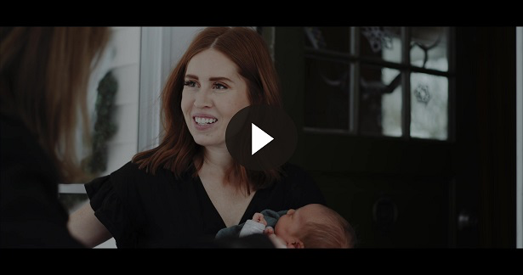
QUESTION
What caught your attention from this video?

Consider
Ensure each student has access to a Bible, preferably the same version.
Today’s Bible reading tells us a lot about the passion of the early followers of Jesus. The Church that they were becoming was focused on devotion to God, sharing with each other, and connecting with those who needed to hear Jesus’ message. It was the birth of something that would spread all over the world.
QUESTION
What do you believe the purpose of the Church is?

They Were Devoted
Read Acts 2:42–43.
These verses give us the first picture of the Church, the believers, right after God’s gift of the Holy Spirit. It shows how radically committed a person’s life can be to following Jesus. It also lays out some of the core parts of what happens when the Church gets together—teaching, fellowship, sharing, and prayer.
QUESTION
What does it mean to be devoted to something?

QUESTION
What are some of the things these early followers of Jesus devoted themselves to?

The Gift of Sharing
Read Acts 2:44–45.
A big part of the Church’s culture early on was sharing with one another. Those early believers seemed as committed to helping those in need as they were any of their other activities.
QUESTION
What did these believers share with each other?

QUESTION
How do you think this kind of sharing affected that community?

They Kept Growing
Read Acts 2:46–47.
As they continued to meet regularly, that community grew together with God at the center. Not only did people experience joy and generosity, the Church grew as well. Those are all great outcomes for the Church.
QUESTION
What activities do you see in these verses that the believers participated in?

QUESTION
Which of these things do you still see happening in our local church or community?

Reflect
God’s Plan for His Church
• Students may answer these questions with several ideas. Let them discuss together as it will give you an idea of how students currently view the Church as a whole as well as your local church.
QUESTION
Why do you think God chose the Church to fulfill His plan?

QUESTION
How do you imagine the activities of the Church mentioned in Acts 2:42–47 could impact a community?

There are so many great answers here. Worship changes the atmosphere. Giving impacts those in need in the community. Fellowship lets us encourage each other. Teaching gives us direction for purposeful living and shows us how to live with others. Serving helps remind us of what Jesus has done for us and how we are to serve others. The list could go on and on.
QUESTION
Which of these characteristics do you feel the Church best fulfills today?

QUESTION
Which do you feel the Church lacks most today?

QUESTION
Why do some people connect the word church with only a building and not the people who follow Jesus?

You and the Church
QUESTION
The Early Church focused on worship, fellowship, teaching, prayer, Communion, and giving. Which of these aspects of the Church has had the most impact on you personally? How?

QUESTION
Which aspect is hardest for you to get involved in personally? Why?

QUESTION
What’s one thing you’ve learned about the Church that you didn’t previously know or understand?
Digging Deeper (Optional)
The Holy Spirit Impacts the Church
Read Acts 2:14–18.
These verses were part of Peter’s sermon on the day the Holy Spirit first came to Jesus’ followers. The verses contain a prophecy that Peter said was fulfilled that day.
QUESTION
What kinds of people do these verses say the Holy Spirit would be poured out on?

QUESTION
Peter noted that the baptism in the Holy Spirit was predicted in God’s Word long before it happened. Why do you think he did that?

QUESTION
Have you heard of someone having a dream, prophecy, or vision from God? How do you think these gifts could be used to help the Church?

Activate
You Will Need
- Communion elements (bread or crackers and grape juice) for everyone in your group
Getting Ready
- Prepare Communion elements for distribution.

In just a moment, we’re going to participate in Communion together. Communion is something believers do to remember what Jesus did for us. If you’re not a believer and would like to be a part of this, now is the time to make Jesus your Savior.
Salvation Opportunity
Include this if you think there may be some in the group who do not have a personal relationship with Jesus.

If you’ve never surrendered your heart to Jesus or need to rededicate your life to Him, you can do that today.

Is there anyone here that we can pray for who doesn’t have a relationship with Jesus or wants to renew their relationship with Him?

Take a moment to acknowledge those who respond, and thank them for their desire to make things right between themselves and God. Pray with them now. Following group time, talk more about where they are in their walk with God and how you might be able to help.

Sharing Communion
Read 1 Corinthians 11:23–28.
- Pass out the bread or crackers and juice. Be sensitive to not force someone who doesn’t want to take the elements while also not attracting attention to them.
This passage tells us about the significance of the bread and the juice. They are a reminder of what Jesus did for you and me. As we take them together, examine your heart. Take time to make sure you’re right with God.
• Consider having a few students pray for the Church, your community, forgiveness of sins, healing, or any other needs.
Conclusion
Notice in our discussion today, I didn’t ask anything about the church building. Our Christianity should be lived out, whether in a church building or out in our community. Church is not limited to once-a-week attendance on Sundays. The church meets throughout the week in various capacities for worship, fellowship, prayer, serving, and giving. We do this to be strengthened and encouraged to live out the gospel during the week.
Let me encourage each of you to take part in that strengthening by spending a few minutes this week looking over the personal devotions.
Prayer
Mighty God, please pour out Your Holy Spirit on us in a fresh way this week. Help us to be the Church to a community who desperately needs You. Help us to worship, serve, give, and listen to You through Your Word and Spirit this week. Give us favor with our church body, school campus, and community, so we have opportunities to impact them. We ask these things in Your glorious name! Amen.
Next time, we’ll take a look at the radical conversion of a man who was considered one of the most religious guys in the Bible, yet he didn’t know Jesus in a personal way. He had a remarkable conversion. You don’t want to miss it!
Speaking of change, bring a picture of yourself as a baby, if you can, to show the rest of us.
• Prep for next time: Ask the leaders and church staff to provide photos of themselves as teenagers—the funnier the better. You may need extra prep time to get these ready to show the students if you have a large group.

