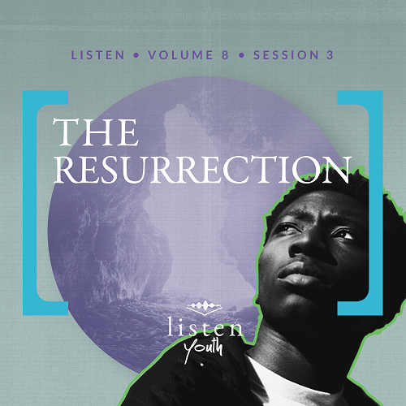Group Session
Small Group Study
Leader Overview
No event in history compares with Jesus’ resurrection from the grave. His defeat of death, hell, and the grave gives us hope. The future of believers is secure if we keep our faith in Him because nothing can separate us from His love, grace, and forgiveness.
You Will Need
- No prep is needed for this session.
Getting Ready
- First time leading Listen for Youth? Look here for the Facilitator Guide.

To access the Bible Engagement Project library from a computer, visit App.BibleEngagementProject.com.

Engage
Welcome
Take time to welcome everyone and thank them for coming.
Opening Prayer
Prayer thoughts: Thank God that even though Jesus came to die in our place, He was resurrected. Thank Him for forgiveness from every sin. Pray for strength to overcome things in our life that keep us from following Him. Pray for families of those students in attendance, for your church, for your community, and that all would hear the message of the gospel.
Introduction
This session, we’re continuing our journey through the Bible. It’s hard to believe we’ve already covered so many stories from God’s Word. Last time we looked at Jesus’ crucifixion and learned that He is our Savior. Today, we’ll be looking at the amazing event that happened just a few days later—the resurrection of Jesus from the dead!
QUESTION
What is the most amazing event you’ve ever witnessed? What was so amazing about it?
Did You Know?
Following Jesus’ resurrection, He appeared to more than five hundred witnesses. His appearance to people who would testify about what they saw was key to the beginnings of the Church.
Group Activity
Dinner for Four
Let’s begin with an activity. Imagine you’re throwing a dinner party, and you can invite one other person who is no longer living. The only exceptions are that it can’t be someone you personally knew or were related to.
QUESTION
Who would you invite, and why?

QUESTION
What is the first question you would ask?

This is obviously just a fantasy because we don’t just flippantly bring the dead back to life for a dinner party! But today, we’re going to learn that Jesus did the impossible. He came back from the dead.
Watch
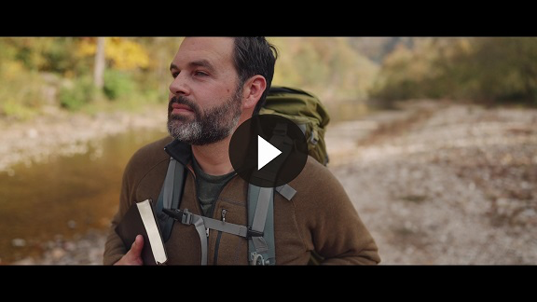
QUESTION
What did you like in this video?

Consider
Ensure each student has access to a Bible, preferably the same version.
Last time, we heard that Jesus is our Savior. On the cross, He offered forgiveness and gave the opportunity for salvation, changing the lives of many. His work on the cross continues to change lives today. But Jesus’ story didn’t end there. Jesus defeated death so He could give each of us the chance to live forever with Him.
It’s Empty!
Read Luke 24:1–4.
QUESTION
Why did the women go to the tomb of Jesus?

The women wanted to complete the burial process for Jesus, anointing His body with spices and oils. The burial practices of that time were quite different from today’s and included a second, final burial about a year later. The fragrant oils and spices were to help overcome the smell of decay at that later time.
QUESTION
What did they expect to find at the tomb, and what did they find?

They knew that a stone should be blocking the entrance. Another Gospel lets us know that they wondered who might move it and let them into the tomb. They also expected Jesus’ body to be there because He was dead—or so they thought. Instead, they found the stone rolled away and no body.
The Two Angels
Read Luke 24:5–8.
Later in this chapter, as well in other Gospels, we learn that the men in the dazzling robes were actually angels!
QUESTION
What amazing news did the angels tell the women?

QUESTION
How do you think the women felt about forgetting what Jesus said until the angels reminded them?

The Disciples’ Response
Read Luke 24:9–12.
QUESTION
How did most of the disciples respond to the women’s report?

QUESTION
Why do you think the disciples didn’t believe the women?

After seeing Jesus die, they might have thought the women were in shock or denial about Jesus’ death. They also may not have remembered either that Jesus had predicted this all along.
QUESTION
What was Peter’s response?

Reflect
Let’s consider the main idea for this session: Jesus defeated death. It looked like the enemy had won, and Jesus had been defeated by death. But the Resurrection means that Jesus overcame death and secured eternal life for you and me.
Fear of Death
QUESTION
What fears do you think the disciples had following Jesus’ death on the cross?

QUESTION
Death is consistently in the top three of people’s fears. Why do you think this?

QUESTION
What are some different ways people cope with the thought of their own death?

People react in a variety of ways to the thought of their own death. Some people work very hard to look young or be healthy, trying to stave off death. Some embrace it and build their life around it. Sadly, others may even end their own lives. Some try to ignore it, filling their lives with distractions. Some fear it and never live free.
QUESTION
What are some of your greatest fears connected to your death or someone else’s?

This Changes Everything
Read 1 Peter 1:3.
QUESTION
What does Jesus’ victory over death (His resurrection) mean for followers of Jesus?

QUESTION
How does the resurrection of Jesus separate Christianity from other religions?
While other religions may have some similarities with Christianity, no major religion’s leader has ever come back from the dead to live eternally. No other religion claims an empty tomb.
QUESTION
How does knowing Jesus defeated death at the Resurrection strengthen your relationship with Him?

QUESTION
What does Jesus’ resurrection suggest about God’s desire to have relationship with us?

Jesus defeated death, and that provided us both a meaningful life for now and eternal life for the future. He wants to be with us!
Digging Deeper (Optional)
Paul’s View on Death
Read Philippians 1:20–24.
QUESTION
According to Philippians 1:20, what did Paul want his life to produce?

QUESTION
What do you think he meant by saying that his death would be better for him than life?

As long as we live, we live to the glory of Jesus. We do not exist for our own purposes and plans; we exist for His! Jesus has given us life, so our worshipful response is to give it back. Yet when we die as Christians, we don’t lose. We gain because we’re another step closer to eternity with Him.
QUESTION
How is Paul’s view of death radically different than some of the world’s views?
Some view death as the end of existence. They believe there is nothing after this life. But Paul teaches that we have purpose. Others may view death as nothing but loss, but Paul teaches it is gain for those who are in Christ.

Activate
Today, we’ve talked about Jesus overcoming death. This truth has the power to fill our hearts with hope, even on our darkest day. One way we can live this truth out is through the way we respond to suffering and events that bring sadness. Let’s have a few of you share your response to these questions.
QUESTION
Do you have someone in your life who has lost hope or is struggling?

QUESTION
How can you be a good friend to them this week?
Conclusion
Jesus lived the life we should have lived. He died the death we should have died. But He was also raised to new life, and that gives us confidence that He has the power to cause you and me to experience improved life now and eternal life someday in His presence.
If Jesus defeated the greatest enemy, death, we can certainly find strength in Him to face lesser things like selfishness, sorrow, and sin. Perhaps you’re stuck in one of these. There is a way out. Jesus came to give new life, and He did this through His death and resurrection. If you’ve never surrendered your life to Him, why not choose to do it today?
Salvation Opportunity
Include this if you think there may be some in the group who do not have a personal relationship with Jesus.

Is there anyone here that we can pray for who doesn’t have a relationship with Jesus or wants to renew their relationship with Him?

Take a moment to acknowledge those who respond, and thank them for their desire to make things right between themselves and God. Pray with them now or after the group time is over. Following group time, talk more about where they are in their walk with God and how you might be able to help.
In a moment, we will close in prayer. As we do, let’s take a moment to pray for the individuals who surrendered their lives to Jesus.
Prayer
Risen Savior, thank You for overcoming death, hell, and the grave. Your victory over death gives us victory in life. There is nothing that can defeat us because of what You did! We pray for those who don’t know You and have never surrendered their lives to You. We ask that each of them would hear the gospel and respond by surrendering to You. In Your amazing name we pray. Amen!
Don’t forget about the daily devotions located on your app.
Next time we will listen to the incredible mission Jesus gave to all who follow Him. This mission includes us! We will consider what it means to make disciples as we wait for the return of Jesus.

