**Group Session**

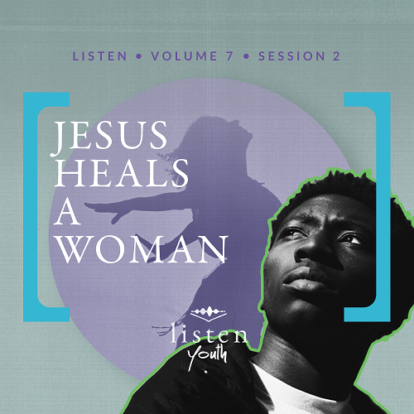

Small Group Study

**Leader Overview**

*Experience the God of the impossible through the healing ministry of Jesus. The Gospels are filled with numerous accounts of healing. The good news is that the healing Jesus offered in the Gospels remains available to us today. We can approach Jesus with confidence for healing, as we will see through today’s discussion.*

|  |
| --- |
| ***You Will Need***   * *Piece of paper and pen for each group of three to five students*   ***Getting Ready***   * ***First time leading* Listen *for Youth? Look here for the* Facilitator Guide***.* |

*To access the Bible Engagement Project library from a computer, visit*[***App.BibleEngagementProject.com***](http://App.BibleEngagementProject.com)*.*

**Engage**

**Welcome**

*Take this time to welcome everyone, introduce first-time guests, learn names, and thank everyone for coming.*

Don’t forget to take a look at the personal devotions during the week. It’s a time for God to speak to us and for us to listen to Him.

**Opening Prayer**

*Prayer thoughts: Thank the Lord that He came to earth to bring healing. Thank Him that He gave His life in order to make us whole. Pray for everyone present and their families. Pray for the schools represented by the students in your group as well.*

**Introduction**

One of the things we read about in the Gospels—Matthew, Mark, Luke, and John—are the miraculous healings that Jesus did for people from different backgrounds. Men, women, and children were healed, and the good news is that He stills heals people today.

Today, we’re going to read about a woman who was at the end of her rope and desperately needed healing. She went to Jesus for the solution. Before we get to her story, here’s an interesting fact that involves something Jesus quoted.

**Did You Know?**

|  |
| --- |
| The most quoted Old Testament verse in the New Testament is Leviticus 19:18. “Do not seek revenge or bear a grudge against a fellow Israelite, but love your neighbor as yourself. I am the LORD” (NLT). You will find this verse referenced by Jesus in both Matthew 22:37–39 and Mark 12:31. |

**Group Activity**

**It’s a Miracle**

|  |
| --- |
| ***You Will Need***   * *Piece of paper and pen for each group of three to five students*   *No prep is needed for this activity.* |

Today, we’ll continue to discover more about Jesus. Let’s see how much we already know as a group about the miracles He did. After we divide into teams, you’ll have about three minutes to write down as many of Jesus’ miracles as you can. The team who names the most miracles wins.

• *Break into groups of three to five students.*

• *Give each group paper and a pen.*

• *After about three minutes, collect the papers, and declare a winner.*

Although Jesus performed a few different types of miracles, today we’re going to talk about Jesus as our Healer. Let’s begin by watching this video.

**Watch**

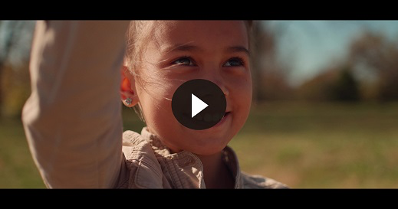

|  |
| --- |
| **QUESTION**  What caught your attention from this video? |

**Consider**

*Ensure each student has access to a Bible, preferably the same version.*

**Great Need**

Read Mark 5:21–26.

Jesus certainly drew a crowd! As He moved from place to place throughout the Galilee region of Israel, He was often followed by crowds. Many came to hear the wisdom of His teachings. But as word got out that He also performed miracles, many came with their need for His healing touch.

|  |
| --- |
| **QUESTION**  How long had this woman been suffering? |

|  |
| --- |
| **QUESTION**  What two things does it say the woman had tried in order to get better? |

|  |
| --- |
| **QUESTION**  What was the result of spending all her money to get well? |

Imagine this poor lady’s desperation. Can you imagine spending everything you have to get medical help and seeing no improvement? It was out of desperation that she came to Jesus.

**Great Faith**

Read Mark 5:27–31.

|  |
| --- |
| **QUESTION**  What did the woman hope would bring her healing? |

|  |
| --- |
| **QUESTION**  What was the result of her faith? |

|  |
| --- |
| **QUESTION**  How do you think she felt after Jesus asked about someone touching His robe? |

Though Jesus’ closest followers, the disciples, thought it was impossible to know who touched Him when being mobbed by a crowd, Jesus knew. This wasn’t just someone bumping into Him accidentally. It was intentional and something miraculous.

**Great Result**

Read Mark 5:32–34.

|  |
| --- |
| **QUESTION**  Why do you think Jesus kept looking for the person rather than letting it go? |

|  |
| --- |
| **QUESTION**  What did Jesus say brought about her healing? |

In a moment, this woman went from fear and trembling to peace and the absence of suffering. It’s such an amazing moment of change. And to top that off, Jesus credited her faith for what happened. The kindness and concern of Jesus just pours from this story!

**Reflect**

**Jesus and Wholeness**

There were aspects of this healing that went against cultural norms. First, a woman wasn’t permitted to touch a man in public. Second, someone with a blood disorder wasn’t allowed to touch anyone. But the woman took a risk and did both.

|  |
| --- |
| **QUESTION**  How does knowing this make this healing more remarkable? |

The woman not only pushed past the crowd in order to touch Jesus, but her need outweighed her care about what others thought.

|  |
| --- |
| **QUESTION**  What can we conclude about the life of the woman, knowing that she was not allowed to touch anyone during her twelve years of sickness? |

For twelve years, she very possibly had little to no embrace from family or friends. She came alone to Jesus, which is probably much like her life’s existence for those years.

|  |
| --- |
| **QUESTION**  How does Jesus address the woman’s wholeness in addition to her healing in Mark 5:34? |

**Jesus and Relationships**

|  |
| --- |
| **QUESTION**  What does this account of healing say about Jesus to you? |

Jesus cares for those whom others seem to have forgotten about. It can seem like He is in no hurry when it comes to our needs. Remember, He cares about both our physical and spiritual wholeness.

|  |
| --- |
| **QUESTION**  How would you define a person as being whole? |

|  |
| --- |
| **QUESTION**  What do you think the woman needed more: her physical healing or being made whole? Why? |

|  |
| --- |
| **QUESTION**  What’s more difficult: being sick or being alone? Why? |

**My Faith in Healing**

|  |
| --- |
| **QUESTION**  How does discussing this story strengthen your faith when it comes to healing? |

|  |
| --- |
| **QUESTION**  Would you be willing to pray with and for people in order to see them healed and whole? Why or why not? |

**Digging Deeper (Optional)**

**Listen Carefully**

Read Matthew 9:27–30.

|  |
| --- |
| **QUESTION**  Who was seeking healing in this passage? |

|  |
| --- |
| **QUESTION**  How did they show boldness in their faith in order to receive healing? |

|  |
| --- |
| **QUESTION**  What was the question Jesus asked the blind men? |

|  |
| --- |
| **QUESTION**  What did Jesus say would bring about the healing in their lives? |

|  |
| --- |
| **QUESTION**  If God still heals and does miracles today, how should that affect our daily lives as Jesus followers? |

**Activate**

Take time this week to pray for those who need physical healing or wholeness in their lives.

**Conclusion**

God not only wants us healed, but He wants us to be whole. He cares deeply about our physical and spiritual well-being. This is shown by the several accounts of Jesus healing throughout the New Testament. You’ll read about a few of these in the personal devotions this week.

|  |
| --- |
| **Salvation Opportunity**  *Include this if you think there may be some in the group who do not have a personal relationship with Jesus.*  **Perhaps you’ve never thought of Jesus as Healer or you’ve never thought much about Jesus at all. First, if you have never completely put your trust in God, I want to give you a chance to receive Jesus as your personal Savior.**  **Is there anyone here that we can pray for who doesn’t have a relationship with Jesus or wants to renew their relationship with Him?**  *Take a moment to acknowledge those who respond, and thank them for their desire to make things right between themselves and God. Pray with them now or after the group time is over. Following group time, talk more about where they are in their walk with God and how you might be able to help.* |

**Prayer**

I also want to take time to pray for anyone who needs healing. If you have a need that you want to ask Jesus to heal, we will pray and believe with you.

• *Add a time of personal prayer here if needed.*

Jesus, our Healer, thank You for the times You have healed us whether or not we realized You were doing so. We pray for those in our group today who are in need of healing. We pray for those around the world who are suffering from disease and sickness. We agree together in faith for Your healing and comfort to move on them. Amen.

Next time, we’ll take a close look at one of the greatest, if not the greatest, sermons ever preached. I’m looking forward to meeting again and hearing your thoughts on something we refer to as the Beatitudes. Going through this sermon will show us Jesus as our Teacher.