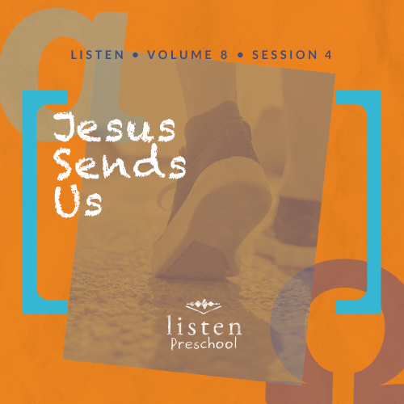Leader Overview
In this session, preschoolers discover: With Jesus, I can change the world. Learning to trust God and follow Him is a lifelong journey. Helping your preschoolers understand that when we obey Jesus, we can accomplish everything He wants us to is a good start. Jesus has a plan for each of us, and a piece of that plan is to proclaim the good news to those around us. If we begin to live out Jesus’ instructions for life, we can indeed change the world we touch.

Bible Lesson
The Great Commission
Matthew 28:16–20
Jesus’ Ascension
Acts 1:3–11
Faith Fact
With Jesus, I can change the world.
Faith Verse
Romans 5:8 (NLT)
But God showed his great love for us by sending Christ to die for us while we were still sinners.

Preparing for the Session
Leader Preparation Time: 20–25 Minutes
You Will Need
Preservice Activities
- Inflatable globe ball or beach ball drawn to look like a globe
- Permanent marker, optional
- Toasted oat ring cereal
Large Group
- Bible
- Worship songs (Song suggestions: “Jump into the Light” by Jana Alayra; “Friend of God” by Shout Praises Kids)
- For groups not using a phone or tablet only, add:
  - Projector or TV
  - Laptop
  - Rules Video or Slide
  - Faith Fact Sound video (bell ringing)
  - Faith Fact Slide
  - Faith Verse Slide
  - Bible Lesson Video A
  - Bible Lesson Video B
Small Group
- Small Group Activity Page, one per kid
- Small Group Creative Time, one per kid
- Crayons
- Inflatable globe ball or beach ball drawn to look like a globe
- Way to play music

To access the Bible Engagement Project library from a computer, visit App.BibleEngagementProject.com.
Getting Ready
Preservice Activities
- Set out toys and snacks.
- Inflate ball. If needed, use the permanent marker to draw the continents on the beach ball to resemble a globe.
Large Group
- Download videos and slides if needed.
- Select worship song(s) and have them ready to play.
Small Group
- Print the Small Group Activity Page, one per kid.
- Print the Small Group Creative Time, one per kid.

First time leading Listen for Preschool? Check out the Facilitator Guide.

Preservice Activities
See what’s needed at the beginning of the session.
Bible Story Warm-Up
As kids play with the globe ball, ask questions like these to introduce the Bible lesson.
Let’s bounce this globe ball to each other. Who remembers what happened to Jesus in our last Bible story? (Group response) Yes, Jesus rose from the tomb and defeated death. Did you know Jesus talked to His disciples after He rose from the tomb? What do you think Jesus told His disciples? (Allow responses.) Those are all good ideas.
What is on our ball? (Group response) You’re right. It is a picture of our world. Do you think Jesus wants us to tell all the people of the world about Him? (Group response) Yes, He does.
Today, we are going to hear about how Jesus told the disciples to go into all the world and tell others about Him. But, before they went, He wanted them to receive power from God’s Holy Spirit to help them. He wasn’t sending them out alone. With Jesus, I can change the world.
Snack
Ring-Shaped Cereal
As the kids eat, ask them these questions to get them thinking about the story they will hear today.
Have you ever seen a picture of the world or a globe?
If you could go anywhere in the world, where would you go?
Have you ever traveled anywhere for vacation or to visit family? Where have you gone?
Free Play
Any extra time can be spent playing with toys.
Transition
A few minutes before service begins, have kids make their way to the large group area and sit in their designated spots.

Large Group
25 Minutes
See what’s needed at the beginning of the session.

Introduction
Hi, kids! I am so excited that you have come today to learn about God. How can we learn about God? (Hold up the Bible.) That’s right we learn about God from His Word, the Bible. Each story in the Bible tells us something about God, and today, we are going to learn that With Jesus, I can change the world. Learning about how we can change the world around us with the good news about Jesus is super important.
If you are ready to start, put one hand on your head and one hand on your heart. Now, let’s clap our hands really loud one time and place them in our laps. Oh good! It looks like everyone is ready to begin.
Rules Review (Optional)
You look so amazing, sitting so tall with your hands on your laps. Before we begin, we have to go over just a few things to keep us all having fun. Let’s watch this video together.
• Play Rules Video.
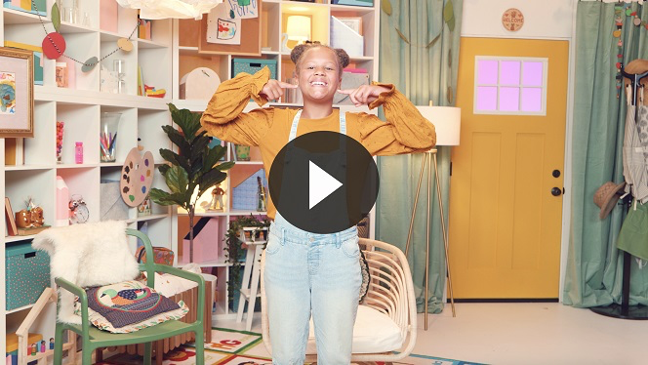
Each time we are together we learn something new. So let’s make sure we are listening so everybody can have a great time!

Bible Time
I love that each time we are together we get to learn something new about God and what He’s done for us. We learn these new things by reading from God’s Word, the Bible. (Hold up Bible.) It is important that we take time to see what the Bible tells us. Lizzy and her grandpa will help us with that. Let’s check in with them now.
• Play Bible Lesson Video A.
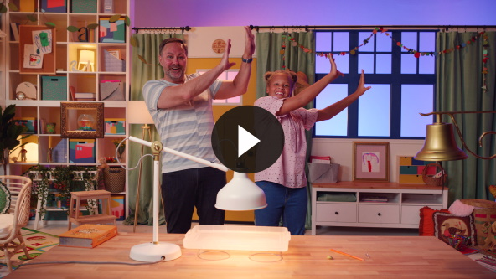
I love learning the Faith Verse with Lizzy. She always comes up with great actions. This verse is a great reminder of how much God loves us. He sent Jesus to die in our place so we can be saved and be with Him forever.
Faith Fact
Our Faith Fact helps me know what we are talking about today.
• Play Faith Fact Sound video (bell ringing).
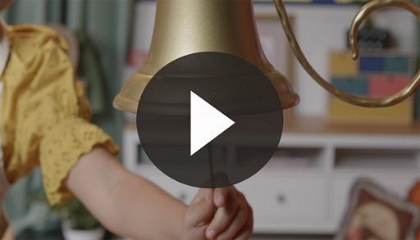
• Show the Faith Fact Slide.
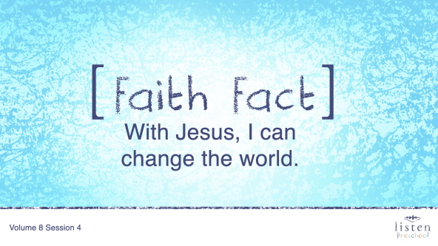
What does that sound mean? (Group response) That’s right, it means it’s time to say the Faith Fact. Can you say the Faith Fact with me on the count of three? 1, 2, 3. With Jesus, I can change the world.
That sounds pretty amazing. We can change the world if we have Jesus!

Worship
One of my favorite things to do is to sing and worship God. Are you ready to sing some songs and tell Him how much we love Him?
Praise
Are you glad God sent His Son? Jump up on your feet! (Group response)
Are you glad Jesus gave us the Holy Spirit? Give your neighbor a high five! (Group response)
Are you glad that With Jesus, I can change the world? Reach your hands to the sky! (Group response)
Who wants to thank God? (Group response)
Awesome! Let’s bow our heads and pray together.
Prayer
Dear God, thank You for sending Jesus to take the punishment for the things we’ve done wrong. Thank You that we can be saved by asking for Your forgiveness. Thank You for sending the Holy Spirit to help guide us. Thank You for being with us every day and helping us to change the world. We love You! Amen.
Sing
Okay, let’s raise our voices really loud and tell God just how much we love Him as we sing this song.
• Lead the kids in singing one or two songs. See suggestions at the beginning of the session.

Bible Time cont’d
I loved singing with you. Now it’s time to sit down so we can check back in with Lizzy and Grandpa!
• Play Bible Lesson Video B.
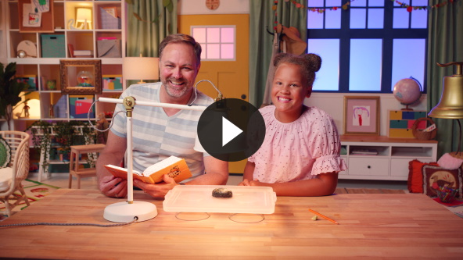
God loves each one of you so very much! But did you know that many people don’t know how much God loves them or that He sent Jesus for them. That’s why we should tell others around us and help to change the world.
Faith Verse
• Show the Faith Verse Slide.
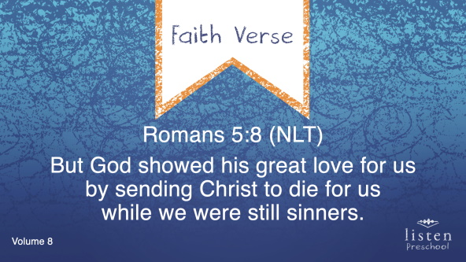
Who thinks they remember the Faith Verse we have been learning? Let’s all say it together and do the actions.
Romans 5:8 (NLT)
But God showed His great love for us by sending Christ to die for us while we were still sinners.
Great job! It’s so much fun learning God’s Word with you.
Response Time
Our Faith Verse reminds us that we have all made mistakes and that Jesus came to take away those mistakes. He came to save us so that we can have a relationship with God. With Jesus, we can change the world. The way we can change the world is by showing His love to other people like our friends and our family.
If you want to ask Jesus to help you change the world with Him, raise your hand for me. We’re going to pray together right now
• Pause to allow kids time to respond.
• Ask the kids to repeat after you.
Dear God, thank You for loving us so much that You sent Your only Son Jesus to take the punishment for the things we’ve done wrong. Because of what Jesus did, we can be saved! Help us to show Your love to other people so they can know You love them too. Amen.
Closing
Did you have fun today, kids? We’ve heard that With Jesus, I can change the world. We’ve worshipped God by praising, praying, singing, and learning our Faith Verse. You did such a good job.
• Play Faith Fact Sound video (bell ringing).
• Show the Faith Fact Slide.
Do you remember what we’re supposed to do? Let’s shout our Faith Fact now. With Jesus, I can change the world. Excellent job, friends.
Dismissal to Small Groups
Now it’s time to go to our circles where we will spend time with our very special small groups and our leaders.
• Dismiss the kids by groups.
Leader Tip: This can be done by assigning color teams or by age groups. Note that some young preschoolers may not know their age. Using a colored sticker, jersey, or wristband will help separate the kids and help identify their small groups.

Small Group
25 Minutes
See supplies and prep instructions at beginning of session or in each activity below.
Leader Tip: Small groups can alternate to each circle, or all groups can do each activity at the same time. If you choose to alternate, you will need at least one leader per circle.

Circle 1
Group Connection
Two Corners
No prep needed for this activity.
Goal: Kids will play a game and review the Bible story.
We are going to play Two Corners. This corner will be “yes,” and that corner will be “no.” I am going to ask you questions about our Bible story. If you think the answer is yes, run to this “yes” corner. (Point to “yes” corner.) If you think the answer is no, run to the “no” corner. (Point to the “no” corner.)
• Sample questions:
• Did Jesus come to save us? (Yes)
• Did Jesus say to obey Him only part of the time? (No)
• Did Jesus die on a cross? (Yes)
• Did Jesus say to tell only grownups about Him? (No)
• Did Jesus come back to life? (Yes)
• Did Jesus leave us alone until we get to heaven? (No)
• Did Jesus give us a job to do on earth? (Yes)
• Can we change the world with Jesus? (Yes)

Circle 2
Hands-On Learning
World Connect the Dots
You Will Need
- Small Group Activity Page, one per kid
- Crayons
Getting Ready
- Print copies of the Small Group Activity Page, one per kid.

Goal: Kids will do a connect the dot activity and review the Great Commission.
Today, we learned that with Jesus we can change the world. Right now, we’re going to connect the dots around the world. Jesus wants us to tell everyone in the world about Him. Who wants to tell people about Jesus? (Group response) Let’s connect the dots and color the world. While we do, we can think of people to tell about Jesus.
• Help any kids who have trouble connecting the dots.
• Play Faith Fact Sound video (bell ringing).
• Show the Faith Fact Slide.
• At some point during the activity, interrupt and practice the Faith Fact: With Jesus, I can change the world.

Circle 3
Feet-to-Floor Game Time
Where in the World?
You Will Need
- Inflatable globe ball or beach ball drawn to look like a globe (from Preservice Activities)
- Way to play music

No prep is needed for this activity.

Goal: Kids will be introduced to the size of the world and reminded to pray for people in the world to hear about Jesus and His love.
We are going to play a game called Where in the World? When the music starts, pass the globe ball to the kid sitting to your right. When the music stops, the kid holding the ball will look where your hands are. Wherever your hand is, we will pray for the people in that part of the world to hear about and know Jesus.
• Continue playing until every kid has a turn to hold the ball when the music stops.
• Everyone plays for the entire activity. The kids are not “out” when the ball stops with them.
• Play Faith Fact Sound video (bell ringing).
• Show the Faith Fact Slide.
• At some point during the activity, interrupt and practice the Faith Fact: With Jesus, I can change the world.

Circle 4
Creative Time
Whom Should You Tell?
You Will Need
- Small Group Creative Time, one per kid
- Crayons
Getting Ready
- Print copies of the Small Group Creative Time, one per kid.

Goal: Kids will color as they think about people they know who need to hear that Jesus loves them.
We are coloring this page that says, “Jesus loves you.” Who do you know that needs to hear those words? (Allow responses.) Yes, I’m sure our parents, grandparents, or brothers and sisters need to hear those words. Do you know someone who may not know Jesus, who seems sad, or who seems angry? (Group response) Think about that person as you color your page. Then, if you can, give your paper to that person this week.
• After the kids have finished coloring, help them to fold the page and remind them to give it to the person they thought about, if possible.
• During the activity, interrupt and practice the Faith Verse.
• Show the Faith Verse Slide.
Romans 5:8 (NLT)
But God showed his great love for us by sending Christ to die for us while we were still sinners.
Dismissal
• Remind the kids of the Faith Fact before they go home.
• Send home the Small Group Activity Page and Small Group Creative Time with each kid.
• Remind parents that there are Family Devotions available on the app to do with their kid.
• Tell everyone the date and time for the next session.

