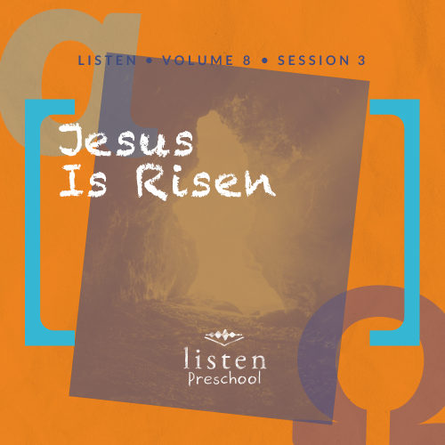Leader Overview
In this session, preschoolers discover that Jesus defeated death. Last time, they heard that Jesus died on the cross to be our Savior, which opened the door for us to have a closer relationship with God the Father. God gave the most precious person to Him to gain us back. This session’s message is another foundation stone of our Christian faith. Jesus died and rose again, which is how we can have eternal life with Him.

Bible Lesson
Jesus’ Resurrection
Luke 24:1–12
Faith Fact
Jesus defeated death.
Faith Verse
Romans 5:8 (NLT)
But God showed his great love for us by sending Christ to die for us while we were still sinners.

Preparing for the Session
Leader Preparation Time: 20–25 Minutes
You Will Need
Preservice Activities
- Different spices or oils (cinnamon, rosemary, lemon, eucalyptus are all strong smells)
- Cotton balls
- Plastic baggies
- Marker
- Index card
- Cinnamon graham crackers or cinnamon graham teddy bears
Large Group
- Bible
- Worship songs (Song suggestions: “Jump into the Light” by Jana Alayra; “Friend of God” by Shout Praises Kids)
- For groups not using a phone or tablet only, add:
  - Projector or TV
  - Laptop
  - Rules Video or Slide
  - Faith Fact Sound video (bell ringing)
  - Faith Fact Slide
  - Faith Verse Slide
  - Bible Lesson Video A
  - Bible Lesson Video B
Small Group
- Small Group Activity Page, one per kid
- Small Group Creative Time, one per 8 kids
- Several different types of stones in all sizes
- Container to hold stones
- Crayons or colored pencils
- Scissors
- Glue
- Large ball

To access the Bible Engagement Project library from a computer, visit App.BibleEngagementProject.com.
Getting Ready
Preservice Activities
- Set out toys and snacks.
- Put several drops of an oil on a cotton ball and place it or the dry spice in a plastic bag. Repeat for each oil or spice. Label each bag with a number.
- Make an answer sheet on the index card so you know which oil or spice is in which bag.
Large Group
- Download videos and slides if needed.
- Select worship song(s) and have them ready to play.
Small Group
- Print copies of the Small Group Activity Page, one per kid.
- Print copies of the Small Group Creative Time, one per 8 kids. Cut apart the boxes of angels.

First time leading Listen for Preschool? Check out the Facilitator Guide.

Preservice Activities
See what’s needed at the beginning of the session.
Bible Story Warm-Up
In this session, preschoolers will learn that Jesus defeated death. On the day Jesus rose from the grave, women were coming to the tomb with spices to anoint His body. As kids play with the toys, ask questions like these to introduce the Bible lesson.
Who remembers what happened to Jesus in our Bible lesson last time we were together?
Do you think Jesus stayed dead?
Do you know who the first person to learn about Jesus being alive again was?
Women came to Jesus’ tomb to get His body ready to be buried. They brought strong smelling spices and oils to rub on His body. I brought some spices and oils for you to smell. Then, you can guess what the spice is or what it reminds you of.
• Have the kids smell what’s in the first bag. Then, ask for one kid to say what it is. If he’s wrong or doesn’t know, ask someone else to guess.
• Repeat with the remaining bags.
• Depending on the spices chosen, you may need to help them with the answers.
Snack
Cinnamon Snack
As kids are eating the snack, share the following:
Our story from the Bible today starts with women bringing spices to Jesus’ tomb. Spices are things we put in food to make it taste better or put on food to make them last longer. Spices smell very strongly. The snack we are having today has a spice in it. Who can tell me what it is? (Group response) That’s right, it’s cinnamon.
Free Play
Any extra time can be spent playing with toys.
Transition
A few minutes before service begins have kids make their way to the large group area and sit in their designated spots.

Large Group
25 Minutes
See what’s needed at the beginning of the session.

Introduction
Hi, kids! Who is excited to learn about God today? How do we learn about God? (Hold up the Bible.) That’s right, one way we can learn about God is from His Word, the Bible. Each story in the Bible tells us something about God, and today, we are going to learn that Jesus defeated death.
Learning about how Jesus defeated death helps us understand that when we choose to make Jesus our Savior, we get to go to heaven when we die.
If you are ready to start our story look at me through your looking glass. (Make two circles with your hands and place them on top of each other. Then, hold them up to one eye like you are looking through a telescope.) Oh, good! It looks like everyone can see me through their looking glass, and we are ready to begin.
Rules Review (Optional)
You kids look so neat through my looking glass. Before we begin, we have to go over just a few things to keep us all having fun. Let’s watch this video together.
• Play Rules Video.
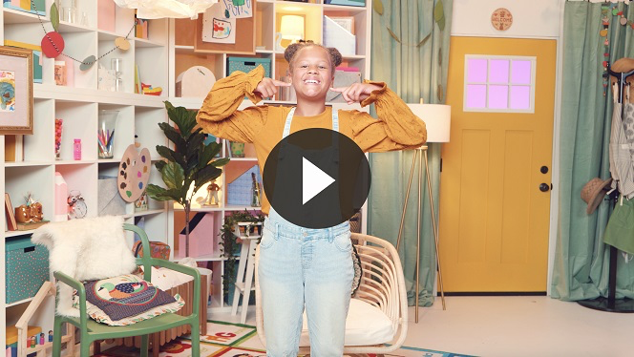
Each time we are together we learn something new. So let’s make sure we are listening so everybody can have a great time!

Bible Time
One of the most important things we do is learn about God from His Word, the Bible. (Hold up the Bible.) Let’s get ready to see what our friend Lizzy is up to today.
• Play Bible Lesson Video A.
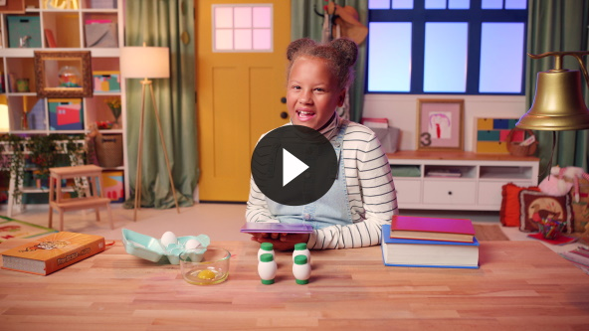
That was fun! You did a great job helping Lizzy solve all the clues. The three and the noise maker were each a clue to our Bible story. We learned that Jesus defeated death even when everyone, including the disciples, thought He was in the tomb forever.
Faith Fact
God gave His Son to die on the cross for a reason. God knew Jesus would defeat death so we could live with Him forever. That is the best news of all! That reminds me of our Faith Fact for today. Jesus defeated death.
• Play Faith Fact Sound video (bell ringing).
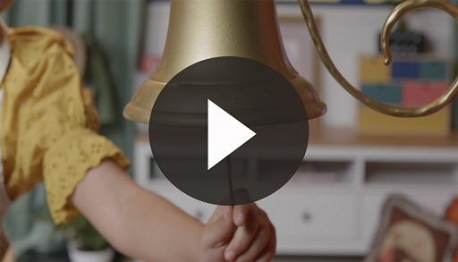
• Show the Faith Fact Slide.
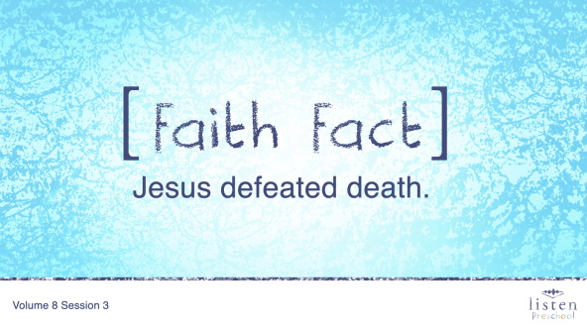
Wait! What does that sound mean? (Group response) That’s right, it means it’s time to say our Faith Fact. Let’s all say that together on the count of 3. Ready? 1, 2, 3. Jesus defeated death.
Oh, I think you can do it a little louder than that. Let’s try it again. Ready? 1, 2, 3. Jesus defeated death. Great job!

Worship
Hearing this story makes me even more excited to worship God through singing! Are you ready to jump up and sing some songs? Let’s stand up and get ready.
Praise
Are you glad God sent His Son? Wave your hands up high. (Group response)
Are you glad Jesus didn’t stay in the tomb? Wave your hands down low. (Group response)
Are you glad Jesus defeated death? Wave your hands up high. (Group response)
Who wants to thank God? Wave your hands down low. (Group response)
Prayer
Before we start to sing to God, let’s bow our heads and pray together.
Dear God, thank You for sending Jesus to defeat death. We are so thankful that one day we get to live with You forever. We love You. Amen.
Sing
One way to give God thanks is worshipping Him by singing.
• Lead the kids in singing one or two songs. See suggestions at the beginning of the session.

Bible Time cont’d
You did such a great job singing! You sounded like a great choir of singers. Let’s check back in with Lizzy.
• Play Bible Lesson Video B.
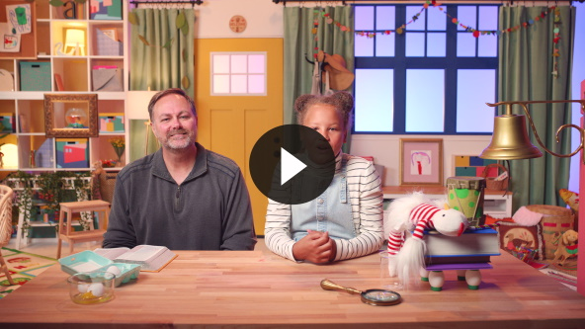
God loves each one of you so very much. When Jesus died and rose again, He did it for you and for me. Jesus was the sacrifice for our sins, which are the bad things we do. Jesus did it so we could be forgiven and could be with Him in heaven someday.
Faith Verse
Another way we can get closer to God is by reading His Word, the Bible, and learning the verses. Let’s check out our Faith Verse. We can say it and do the actions too!
• Show the Faith Verse Slide.
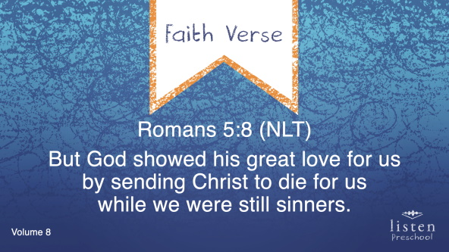
Romans 5:8 (NLT)
But God showed his great love for us by sending Christ to die for us while we were still sinners.
Response Time
Our Faith Verse reminds us that even when we mess up, Jesus still loves us. Last time we learned that God sent His Son to die for us. However, the best part is it didn’t stop there. Today, we learned that Jesus rose again and defeated death. He did it because He loves you so very much. Let’s spend some time in prayer. Repeat this prayer after me.
Dear God, thank You for loving me so much that You sent Your Son not just to die for me but also to defeat death. Help me to trust in You and Your love. Amen.
Closing
Did you have fun today, kids? We’ve heard all about how Jesus defeated death and rose again. We’ve worshipped God by singing and we’ve practiced our Faith Verse. Oh! My friends, do you hear that sound?
• Play Faith Fact Sound video (bell ringing).
• Show the Faith Fact Slide.
Do you remember what we’re supposed to do? Let’s shout our Faith Fact now. Jesus defeated death. Great job, friends!
Dismissal to Small Groups
Now it’s time to go to our circles where we will spend time with our very special small groups and our leaders.
• Dismiss the kids by groups.

Leader Tip: This can be done by assigning color teams or by age groups. Note that some young preschoolers may not know their age. Using a colored sticker, jersey, or wristband will help separate the kids and help identify their small groups.

Small Group
25 Minutes
See supplies and prep instructions at beginning of session or in each activity below.

Leader Tip: Small groups can alternate to each circle, or all groups can do each activity at the same time. If you choose to alternate, you will need at least one leader per circle.

Circle 1
Group Connection
The Stone
You Will Need
- Several different types of stones in all sizes
- Container to hold stones

No prep needed for this activity.

Goal: Kids will do a hands-on activity to help them understand the miracle that happened for a stone that large to be rolled away.
Everyone, come sit down over here. We are going to look at and hold these rocks. This is the smallest rock in the container. Pass it around so everyone gets to hold it.
• Ask these questions and allow kids to answer as the rocks are passed around.
• What does this rock look like?
• How does this rock feel?
• How heavy is this rock?
• Do you think you could move this rock if was in front of Jesus’s tomb?
• Next take out larger rocks. Ask the same questions to the kids.
• Have them compare the differences in the weight of the two rocks.
• Repeat these questions and comparisons as many times as you can with larger stones.
Well, those are all the rocks I have in my container. How big do you think the stone was that was in front of Jesus’ tomb? (Allow responses.) Imagine if the stone was as tall as the door to our room. Imagine if that stone was even wider than our door. How heavy do you think that would be? Do you think you could move that stone all by yourself?
Well, of course, we couldn’t move a stone that big. Today, we have machines that could move a big stone. but even today, a single person couln’t move that stone with just his arms. (Act like you are trying to pick up a big stone.) A stone that big in front of Jesus’ tomb had to be rolled away by an angel.
Let’s practice our Faith Verse a couple of times and do the actions Lizzy taught us. This verse reminds us that Jesus died for us before the stone was rolled away from the tomb.
• Show the Faith Verse Slide.
Romans 5:8 (NLT)
But God showed his great love for us by sending Christ to die for us while we were still sinners.

Circle 2
Hands-On Learning
The Tomb
You Will Need
- Small Group Activity Page, one per kid
- Crayons or colored pencils
Getting Ready
- Print copies of the Small Group Activity Page, one per kid.

Goal: Kids will review the Bible story by coloring a picture.
Kids, we are going to color this picture. What is this a picture of? (Group response) That’s right. It’s a tomb. Why do you think we’re coloring a tomb? (Group response) That’s right. We want to remember that Jesus didn’t stay there. He defeated death.
Who remembers what happened when the women arrived at the tomb? (Allow responses.) The stone had been moved by the angel, and the tomb was empty.
• At some point during the activity, interrupt and practice the Faith Fact: Jesus defeated death.
• Play Faith Fact Sound video (bell ringing).
• Show the Faith Fact Slide.
Let’s say the Faith Fact as quietly as we can. Jesus defeated death. Now shout it out as loudly as you can. Jesus defeated death. Awesome job!

Circle 3
Feet-to-Floor Game Time
Rolled Away
You Will Need
- Large ball

No prep needed for this activity.

Goal: Kids will play an active game to review the Faith Fact.
We are going to play a game called Rolled Away. Everyone needs to stand in a circle. I am going to roll the ball to someone. When the ball comes to you, shout the Faith Fact: Jesus defeated death. Then, roll the ball to someone else so they can shout the Faith Fact.
• Make sure every kid gets a chance to roll the ball.
• Show the Faith Fact Slide.

Circle 4
Creative Time
Angels Appear
You Will Need
- Small Group Activity Page, colored in Hands-On Learning
- Small Group Creative Time, one per 8 kids
- Crayons or colored pencils
- Scissors
- Glue
Getting Ready
- Print copies of the Small Group Creative Time, one page per 8 kids. Cut apart the boxes of angels.

Goal: Kids will do a craft to review the Bible story.
Here is your Activity Page that you colored earlier. Why did the women go to the tomb? (Allow responses.) That’s right, they had come with spices for Jesus’ body.
After they noticed the tomb was empty, what happened? (Group response) You’re right. Two angels appeared and told the women that Jesus was alive. Do you think the women were excited to hear that Jesus had defeated death? (Group response) I do, too! They rushed away to tell the disciples the good news. Let’s color these angels. Make sure their outfits are dazzling! Then, you can glue them on your page.
• Give each kid their Small Group Activity Page. Also give each kid a pair of angels.
• Allow kids to color their angels and glue them to the Activity Page. Help kids as needed.
Dismissal
• Remind the kids of the Faith Fact before they go home.
• Send home the Small Group Activity Page with each kid.
• Remind parents that there are Family Devotions available on the app to do with their kid.
• Tell everyone the date and time for the next session.

