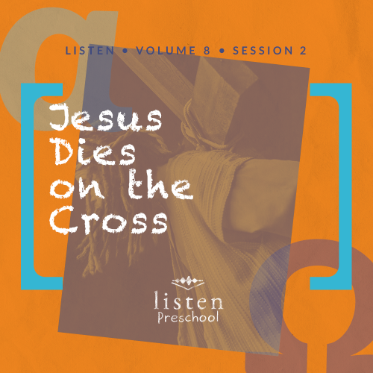Leader Overview
In this session, preschoolers will discover that Jesus is my Savior. This Bible lesson is one of the foundation stones of our Christian faith. Jesus died for us in our place. A few times in this Scripture passage it said for Jesus to “save Himself.” The Roman soldiers said it, and the second criminal said it. However, Jesus wasn’t there to be His own Savior; He was on the Cross to be our Savior. What He did that day defies human logic and tendency for self preservation. Jesus loves us so much that He willingly gave His life in our place, but we know the story doesn’t end there.
Make sure you tell the preschoolers that this is only the first part of Jesus’ story. Tell them that next time we will look at the Resurrection when Jesus came back to life. At this age, they need to know that Jesus did not stay dead.
Bible Lesson
Jesus’ Crucifixion
Luke 23:32–49
Faith Fact
Jesus is my Savior.
Faith Verse
Romans 5:8 (NLT)
But God showed his great love for us by sending Christ to die for us while we were still sinners.

Preparing for the Session
Leader Preparation Time: 20–25 Minutes
You Will Need
Preservice Activities
- Preservice Activity Page, four or five per group
- Single-hole punch
- Lengths of yarn
- Card stock
- Scissors
- Tape
- Pretzel sticks
Large Group
- Bible
- Worship songs (Song suggestions: “Jump into the Light” by Jana Alayra; “Friend of God” by Shout Praises Kids)
- For groups not using a phone or tablet only, add:
  - Projector or TV
  - Laptop
  - Rules Video or Slide
  - Faith Fact Slide
  - Faith Fact Sound video (bell ringing)
  - Faith Verse Slide
  - Bible Lesson Video A
  - Bible Lesson Video B
Small Group
- Small Group Activity Page, one per kid
- Small Group Group Connection, one set per group
- Card stock
- Scissors
- Crayons or colored pencils
- Craft sticks, two per kid
- Glue
- Watercolor paints
- Paint smocks or adult T-shirts, optional
- Marker

To access the Bible Engagement Project library from a computer, visit App.BibleEngagementProject.com.
Getting Ready
Preservice Activities
- Set out toys and snacks.
- Print copies of the Preservice Activity page, four or five per group.
- Punch holes as marked on the cross outline.
- Cut lengths of yarn long enough to thread through the shape.
- Wrap a piece of tape around one end of each length of yarn and tie a knot at the other end.
Large Group
- Download videos and slides if needed.
- Select worship song(s) and have them ready to play.
Small Group
- Print copies of the Small Group Activity Page, one per kid.
- Print the Small Group Group Connection on card stock, one set per group. Cut apart the cards.
- Make a sample by gluing craft sticks together to make a cross. Then take water colors and paint the cross.

First time leading Listen for Preschool? Check out the Facilitator Guide.

Preservice Activities
See what’s needed at the beginning of the session.
Bible Story Warm-Up
As the kids thread yarn on their cross, ask questions like these to introduce the lesson.
What is the shape we are sewing today?
Do you know what Bible story has a cross in it?
Do you know why Jesus went to the Cross?
Today, we will hear about how Jesus chose to die for us. Because of His sacrifice, we can have a relationship with God.
Snack
Pretzel Sticks
As kids are eating the snack, share the following:
Do any of you know what it means to be a Savior? A savior is someone who saves or rescues another person. Jesus saved us from sin when He died on the Cross. Can you make a cross like this with your pretzels? Because of Jesus’ sacrifice, one day we will get to be with Him forever.
Free Play
Any extra time can be spent playing with toys.
Transition
A few minutes before service begins, have kids make their way to the large group area and sit in their designated spots.

Large Group
25 Minutes
See what’s needed at the beginning of the session.

Introduction
Hi, kids! Who is excited to learn about God today? How can we learn about God? (Hold up the Bible.) That’s right we learn about God from His Word, the Bible. Each story in the Bible tells us something about God. Today, we will learn that Jesus is my Savior. The more we know about the Bible, the more we know how to live the way Jesus wants us to.
If you are ready to get started, look at me like you are looking through a window. (Hold up your hands on each side of your face like you are looking through a window). Can you see me through your window? I can see you through my window, and it looks like you’re ready.
Rules Review (Optional)
You are so much fun! Before we begin, we have to go over just a few things to keep us all together. Let’s watch this video now.
• Play Rules Video.
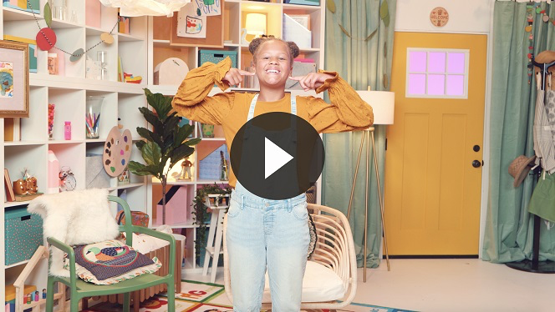
Each time we are together, we learn something new. So let’s make sure we are listening so everybody can have a great time.

Bible Time
It is so wonderful that every time we are together we get to learn something from God’s Word and have fun. It is important that we take time to see what the Bible tells us. Today, Lizzy and her grandpa will help us with that. Let’s check in with them now.
• Play Bible Lesson Video A.
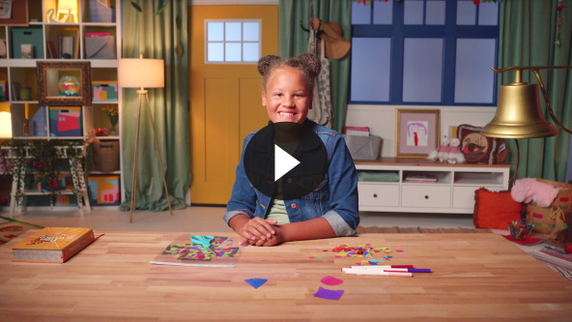
Wow! It’s so much fun seeing what Lizzy is up to.
Faith Fact
Every time we get together, we learn a new Faith Fact. Today, we will learn that Jesus is my Savior.
• Play Faith Fact Sound video (bell ringing).
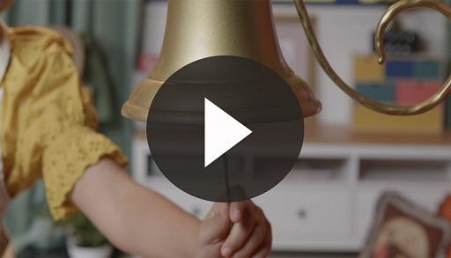
• Show the Faith Fact Slide.
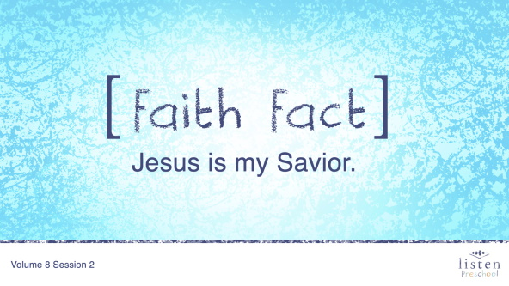
Can you say that with me on the count of 3? Ready? 1, 2, 3. Jesus is my Savior. Let’s shout out our Faith Fact one more time. Jesus is my Savior.

Worship
Let’s spend some time singing songs and thanking God for all He has done for us!
Praise
Are you glad God made you and me? Wave your hands up high. (Group response)
Are you glad God sent Jesus? Wave your hands down low. (Group response)
Are you glad Jesus is our Savior? Wave your hands up high. (Group response)
Who wants to thank God for giving His Son? Wave your hands down low. (Group response)
Prayer
Now let’s bow our heads to pray and open our hearts as we worship Jesus.
Dear God, thank You for giving us Your Son, Jesus. Thank You that He died on the Cross so we could live. Thank You that Jesus is our Savior. We love You! Amen.
Sing
One way to give God thanks is by worshipping Him with singing.
• Lead the kids in singing one or two songs. See suggestions at the beginning of the session.

Bible Time cont’d
You did a great job singing! I love worshipping with you. Let’s check back in with Lizzy and see what’s going on now.
• Play Bible Lesson Video B.
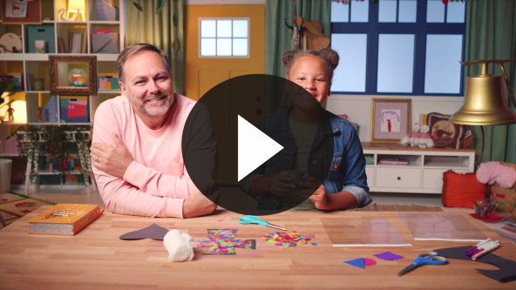
I love that God loved us so much that He sent His Son and that Jesus was willing to go to the Cross for our sins. When I ask Jesus to forgive me for the wrong things that I’ve done, Jesus is my Savior.
Faith Verse
Another way we worship God is by learning the Word of God, the Bible. (Hold up Bible.) Let’s work on our Faith Verse today.

• Show the Faith Verse Slide.
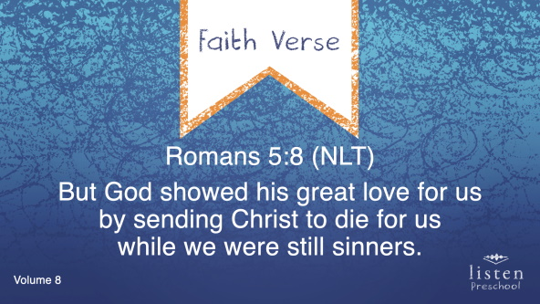
Romans 5:8 (NLT)
But God showed his great love for us by sending Christ to die for us while we were still sinners.
Isn’t it amazing how God loved us so much He sent His only Son to die for us. I’m so thankful He loves me that much!
Response Time
We’ve heard all about how much God loves us today. He loves us so much that He sent His Son, Jesus, to die for us. Jesus loves each one of you so much. Did you know there is nothing you could ever do to make Jesus stop loving you?
Maybe you have had fun learning today about Jesus being our Savior, but you have never asked Jesus to be your Savior. Do you know what that means? It means that He forgives all the things we have done wrong and that He helps us live for him.
If you want to ask Jesus to be your Savior today, join me in praying this prayer. Repeat this prayer after me.
Dear Jesus, please forgive me for the things that I have done wrong. I want to live for You and do what’s right. I love You. Amen.
Closing
Did you have fun today, kids? I know I did. We’ve heard all about how Jesus is my Savior. That is the best news ever.
• Play Faith Fact Sound video (bell ringing).
Did you hear that sound? (Group response) Do you know what we’re supposed to do? (Group response) That’s right!
• Show the Faith Fact Slide.
Let’s shout our Faith Fact now. Jesus is my Savior. Great job, friends!
Dismissal to Small Groups
Now it’s time to go to our circles where we will spend time with our very special small groups and our leaders.
• Dismiss the kids by groups.
Leader Tip: This can be done by assigning color teams or by age groups. Note that some young preschoolers may not know their age. Using a colored sticker, jersey, or wristband will help separate the kids and help identify their small groups.

Small Group
25 Minutes
See supplies and prep instructions at beginning of session or in each activity below.

Leader Tip: Small groups can alternate to each circle, or all groups can do each activity at the same time. If you choose to alternate, you will need at least one leader per circle.

Circle 1
Group Connection
Bible Story Matching
You Will Need
- Small Group Group Connection, one set per group
- Card stock
- Scissors
Getting Ready
- Print the Small Group Group Connection on card stock, one set per group. Cut apart the cards.

Goal: Kids will play a matching game and the leader will retell the Bible story when kids turn over matching cards.
Kids, let’s sit in a circle. We’re going to play a matching game. I have twelve cards, and these six cards match these six cards. Each of you will try to find a match by turning over two cards. If you flip over cards and they don’t match, that’s okay. You can wait for your next turn.
• Place the cards facedown in the center of the circle.
• If kids have trouble remembering where the cards are, help them.
• When a card is flipped, tell which part of the Bible story the card is showing.
• Soldier kneeling – The Roman soldier realized Jesus was being punished but hadn’t done anything wrong.
• Jesus and criminal on a cross – Jesus told the criminal that he would be with Jesus in paradise.
• Women crying – These women were friends of Jesus and they watched from a distance.
• Jesus and two criminals on crosses – Jesus was crucified with two other men.
• Soldiers laughing – The Roman soldiers laughed and made fun of Jesus.
• Sun – The light from the sun went away while Jesus was dying.
• Torn curtain – The curtain in the temple was torn from the top down when Jesus died.

Circle 2
Hands-On Learning
Color the Cross
You Will Need
- Small Group Activity Page, one per kid
- Crayons or colored pencils
Getting Ready
- Print copies of the Small Group Activity Page, one per kid.

Goal: Kids will color a picture that reviews the Bible lesson.
As we color our cross, each of you can tell a different part of our Bible story.
• Take turns letting each kid share something they remember about the Bible story.
• When you’ve reviewed the Bible story and the kids have colored the cross, practice the Faith Verse with actions a couple of times.
• Show the Faith Verse Slide.
Romans 5:8 (NLT)
But God showed his great love for us by sending Christ to die for us while we were still sinners.

Circle 3
Feet-to-Floor Game Time
Freeze Tag
No prep needed for this activity.
Goal: Kids will play an active game that helps them remember that Jesus is our Savior.
We are going to play the game Freeze Tag. We need one person to tag and one person to be the “Saver.” “Saver” sounds a lot like “Savior,” doesn’t it?
If you get tagged, you have to freeze where you are at. Then, the saver can save you by tagging you again. Who remembers why we call Jesus our Savior? (Group response) That’s right! He came to save us from sin. Let’s play. When you’re tagged, be sure to hold very still until your friend comes to save you.
• Option: Have the kids shout the Faith Fact when they are “saved.” Jesus is my Savior.

Circle 4
Creative Time
The Cross
You Will Need
- Craft sticks, two per kid plus extras
- Glue
- Watercolor paints
- Paint smocks or adult T-shirts, optional
- Marker
Getting Ready
- Make a sample by gluing craft sticks together to make a cross. Then take water colors and paint the cross.

Goal: Kids will make a craft that is a reminder that Jesus came to be our Savior.
Why did God send Jesus? (Allow responses.) Did Jesus do anything wrong and need to be punished by dying on the cross? (Allow responses.) Why did Jesus die on the cross? (Allow responses.)
Today, we will make a reminder that Jesus came to be our Savior. (Hold up the sample of the craft.) Let’s see how lovely you can make your cross.
• Hand out craft sticks to each kid.
• Help the kids glue the craft sticks to make a cross shape.
• Show the kids how to use watercolors to paint their wooden crosses.
• Let kids wear paint smocks or adult T-shirts to protect their clothing.
• At some point during the activity, interrupt and practice the Faith Fact: Jesus is my Savior.
• Play Faith Fact Sound video (bell ringing).
• Show the Faith Fact Slide.
Let’s say today’s Faith Fact one more time before we go home. Jesus is my Savior.
Dismissal
• Send home the Small Group Activity Page and the Creative Time cross with each kid.
• Remind parents that there are Family Devotions available on the app to do with their kid.
• Tell everyone the date and time for the next session.

