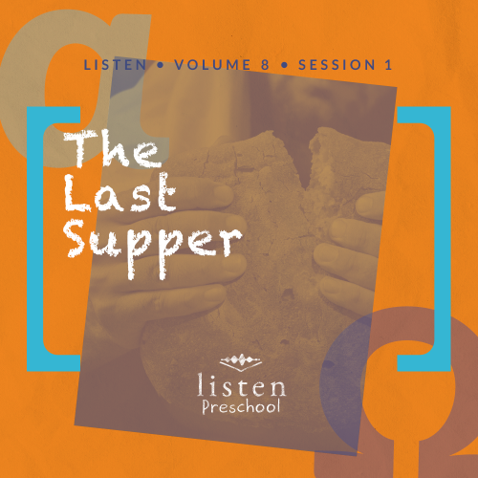Leader Overview
In this session, preschoolers discover that Jesus shows me how to live. As Christians, we have chosen to live our lives differently than the rest of the world. We don’t live by our own standards or the world’s standards. We live by following what the Bible has to say. Jesus was the perfect example of how to live a God-centered life here on earth. He was compassionate, kind, merciful, and slow to anger. He noticed the unnoticeable, and He loved the unlovable. We are to follow the example He set. By taking time to study our Bible and do what Jesus did, we can live the way He wants us to.
Bible Lesson
Jesus Washes the Disciples’ Feet
John 13:1–17
Faith Fact
Jesus shows me how to live.
Faith Verse
Romans 5:8 (NLT)
But God showed his great love for us by sending Christ to die for us while we were still sinners.

Preparing for the Session
Leader Preparation Time: 20–25 Minutes
You Will Need
Preservice Activities
- Tortillas
- Tub filled with soapy water
- Plastic dishes
- Rag/towel
Large Group
- Bible
- Worship songs (Song suggestions: “Jump into the Light” by Jana Alayra; “Friend of God” by Shout Praises Kids)
- For groups not using a phone or tablet only, add:
  - Projector or TV
  - Laptop
  - Rules Video or Slide
  - Faith Fact Sound video (bell ringing)
  - Faith Fact Slide
  - Faith Verse Slide
  - Bible Lesson Video A
  - Bible Lesson Video B
Small Group
- Small Group Activity Page, one per kid
- Crayons
- Markers
- Hula hoop

To access the Bible Engagement Project library from a computer, visit App.BibleEngagementProject.com.
Getting Ready
Preservice Activities
- Set out toys and snacks.
- Fill the plastic tub with warm soapy water. Place the plastic dishes and the towel next to the tub.
Large Group
- Download videos and slides if needed.
- Select worship song(s) and have them ready to play.
Small Group
- Print copies of the Small Group Activity Page, one per kid.
- Review the tune of “Three Blind Mice.”

First time leading Listen for Preschool? Check out the Facilitator Guide.

Preservice Activities
See what’s needed at the beginning of the session.
Bible Story Warm-Up
As the kids wash the dishes and dry them with a towel, ask questions like these to introduce the Bible story:
Have you ever watched a parent or grandparent do the dishes?
Have you ever helped your parent or grandparent do the dishes?
Did you feel good when you were helping?
Jesus was our example of how to live on earth. Since Jesus helped many people while He was here, what are ways you can help others?
Today, we will hear from the Bible that Jesus washed the feet of His disciples and was a servant to others. We will learn to follow His example because Jesus shows me how to live.
Snack
The Last Supper Feast
As kids are eating the snack, share the following:
In our story today, we will learn about a meal called Passover. Jesus and His disciples shared this meal together. This was a special meal the Jewish people ate to celebrate when Moses led the Israelites out of Egypt.
During this meal, they ate a special type of bread called unleavened bread. For our snack today, we are going to eat one type of unleavened bread. You may recognize this type of unleavened bread as a tortilla. See how flat it is? That’s because it doesn’t have any yeast or leaven in it like a regular loaf of bread.
Because Jesus and His disciples ate this special meal together just before He died, we call it the Last Supper.
Free Play
Any extra time can be spent playing with toys.
Transition
A few minutes before service begins, have kids make their way to the large group area and sit in their designated spots.

Large Group
25 Minutes
See what’s needed at the beginning of the session.

Introduction
Hi, kids! Who is excited to learn about God today? How do we learn about God? (Hold up the Bible.) That’s right! We learn about God from His Word, the Bible. Each story in the Bible tells us something about God. Today, we are going to learn that Jesus shows me how to live.
The more we know about the Bible, the more we know how to live the way Jesus wants us to. If you are ready to start our Bible story, look at me through your binoculars. (Make two circles with your hands and place them over your eyes like binoculars.) Oh good, it looks like everyone can see me through their binoculars so we are ready to begin.
Rules Review (Optional)
You are amazing binocular wearers! Before we begin, we have to go over just a few things to keep us all having fun. Let’s watch this video together.
• Play Rules Video.
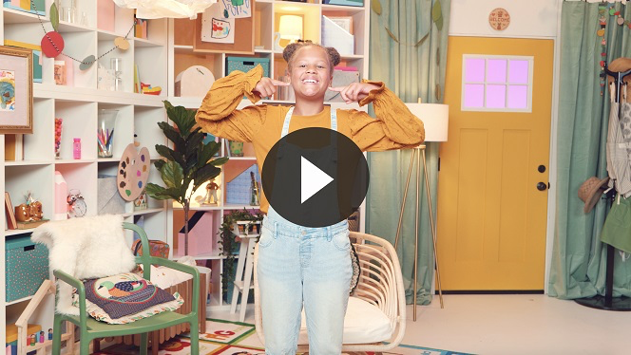
Each time we are together we learn something new. Let’s make sure we are listening so everybody can have a great time!

Bible Time
It is so amazing that every time we are together we get to learn something from God’s Word. It is important that we take time to see what the Bible tells us. Today, we will learn that Jesus shows me how to live. Lizzy and her grandpa will help us with that. Let’s check in with them now.
• Play Bible Lesson Video A.
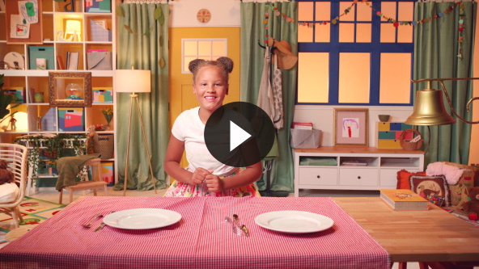
I love how you kids helped Lizzy figure out the clues. You are so smart! I am so thankful that we have the Bible and Jesus to show us how to live.
Faith Fact
Today, we’re talking about how Jesus shows me how to live. Even if we don’t know the right thing to do, we can go to the Bible and follow Jesus’ example. In fact, that is our Faith Fact today.
• Play Faith Fact Sound video (bell ringing).
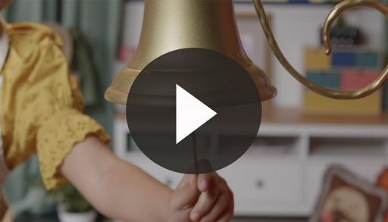
• Show the Faith Fact Slide.
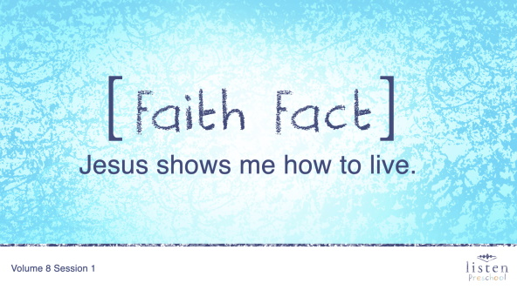
Perfect timing! Can you say that with me on the count of 3? Ready. 1, 2, 3. Jesus shows me how to live. You did a great job!

Worship
If you’re ready to worship, let’s jump up on our feet and get ready!
Praise
Are you glad God made you and me? Wave your hands up high. (Group response)
Are you glad God gave us the Bible? Wave your hands down low. (Group response)
Are you glad Jesus shows us how to live? Wave your hands up high. (Group response)
Who wants to thank God? Wave your hands down low. (Group response)
Prayer
Now let’s bow our heads and pray before we worship.
Dear God, thank You for sending Your Son, Jesus. Thank You for the example He gave us of how to treat others and how to live our lives. We love You! Amen.
Sing
One way to give God thanks is worshipping Him by singing.
• Lead the kids in singing one or two songs. See suggestions at the top of the session.

Bible Time cont’d
I know Jesus loved every second of hearing you sing to Him. Are you ready to check back in with Lizzy and see what’s going on? Let’s check it out.
• Play Bible Lesson Video B.
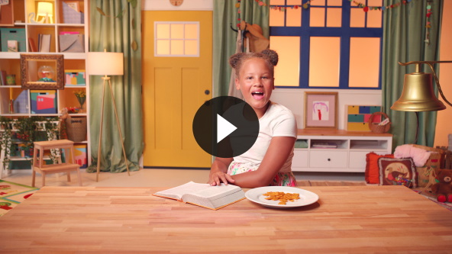
I love that God showed each of us how to live through the life of Jesus. He was our example of how to live for God here on earth. Jesus was loving and kind and a servant to others even though He was God.
Faith Verse
• Show the Faith Verse Slide.
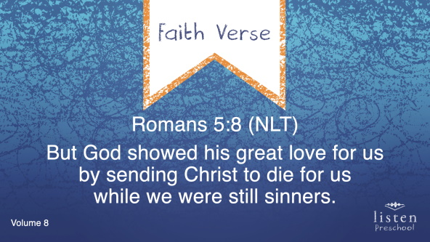
Another way we worship God is by reading and saying the Word of God. Let’s see what our Faith Verse is today. Let’s shout it out a couple of times with the actions.
Romans 5:8 (NLT)
But God showed his great love for us by sending Christ to die for us while we were still sinners.
• Try having kids start out loud and get softer as they say the verse. Then, have them do it the opposite way.
Response Time
Right now we’re going to take some time to pray. If you want Jesus to help teach you how to live, raise your hand. I want us all to pray together.
• Have the kids repeat after you as you pause after every few words.
Dear God, we are so thankful that You sent us Jesus to teach us how to live. Please help me know how to follow Him and follow Your Word. Help me to do my best to live for You. Amen.
Closing
Did you have fun today? We’ve heard how Jesus shows us how to live and how He was a servant to others. We’ve worshipped God by praising, praying, singing, and saying God’s Word. We’ve started to learn our new Faith Verse. Let’s continue to learn how to live like Jesus!
• Play Faith Fact Sound video (bell ringing).
• Show the Faith Fact Slide.
Do you remember what we’re supposed to do? Let’s say our Faith Fact now. Jesus shows me how to live.
Great job, friends!
Dismissal to Small Groups
Now it’s time to go to our circles where we will spend time in our very special small groups with our leaders.
• Dismiss the kids by groups.

Leader Tip: This can be done by assigning color teams or by age groups. Note that some young preschoolers may not know their age. Using a colored sticker, jersey, or wristband will help separate the kids and help identify their small groups.

Small Group
25 Minutes
See supplies and prep instructions at beginning of session or in each activity below.

Leader Tip: Small groups can alternate to each circle, or all groups can do each activity at the same time. If you choose to alternate, you will need at least one leader per circle.

Circle 1
Group Connection
Who Is Jesus and Who Am I?
No prep is needed for this activity.
Goal: Kids will review the characteristics of Jesus that they heard about in today’s Bible story.
Let’s sit in a circle and remember what we heard about Jesus. We’re going to start with the kid on my right, and you will say something positive about Jesus (who He is) that you remember from our story today. Then, you will say your name and tell us something positive about yourself.
• Example: Jesus is loving. My name is John, and I am nice to my brother.
• Examples of Jesus’ character: loving, caring, kind, a servant, a leader, etc. (You may have to give them some ideas depending on how old your group is.)
• Play Faith Fact Sound video (bell ringing).
• Show the Faith Fact Slide.
• During the activity, interrupt and practice the Faith Fact: Jesus shows me how to live.
Let’s say our Faith Fact together. Jesus show me how to live. Amazing job!

Circle 2
Hands-On Learning
Jesus Serving
You Will Need
- Small Group Activity Page, one per kid
- Crayons
Getting Ready
- Make copies of the Small Group Activity Page, one per kid.

Goal: Kids will color the picture of Jesus washing the disciples’ feet as they review the Bible story.
Let’s see what a good job you can do as you color the picture of Jesus washing the disciples’ feet.
• As the kids color the page, ask the following questions.
• Why did Jesus wash the disciples’ feet?
• What happened when Jesus started to wash the disciples’ feet?
• What was Jesus trying to teach the disciples?

Circle 3
Feet-to-Floor Game Time
Jesus Shows Me How to Live
You Will Need
- Hula hoop

No prep needed for this activity.

Goal: Kids will play an active game to reinforce that Jesus teaches us how to live.
Jesus teaches us how to live, and one thing He teaches us is that we are supposed to help others. We are going to play a game with this hula hoop. Everyone, get in a straight line and hold hands with the kids next to you. We will to work together to get this hula hoop from the start of the line to the end. I will hold the hula hoop, and each one of you will step through it without dropping your neighbors’ hands.
• Play Faith Fact Sound video (bell ringing).
• Show the Faith Fact Slide.
• At some point during the activity, interrupt and practice the Faith Fact: Jesus shows me how to live.

Circle 4
Creative Time
Learn a Song!
Getting Ready
- Review the tune of “Three Blind Mice.”

No prep needed for this activity.

Goal: Kids will learn a song that reinforces the Faith Fact.
Today we’re going to learn a song that will help us remember what we learned today. First, we will learn the words of the song. Then, we will learn the tune of the song. Just say the words aftter me. Are you ready?

Song Lyrics:

He washed their feet.
He washed their feet.
Jesus taught me.
Jesus taught me.
How to live my life for Him,
And serve each other with a grin.
Jesus teaches me how to live.
I love Him.
• Repeat song as many times as you need to for the kids to learn it or your time runs out.
Dismissal
• Remind the kids of the Faith Fact before they go home.
• Send home the Small Group Activity Page with each kid.
• Remind parents that there are Family Devotions available on the app to do with their kid.
• Tell everyone the date and time for the next session.

