**Leader Overview**

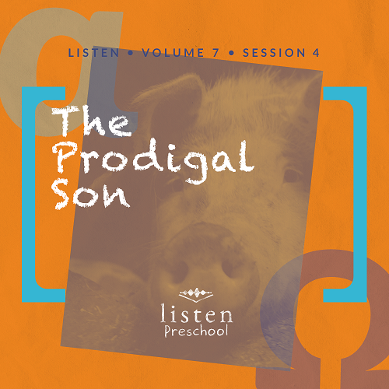

*In this session, preschoolers learn that God never stops loving us. Just as the father was excited to see his prodigal son return, God is always waiting for us with open arms. We can all be redeemed to a relationship with God our Father through His Son, Jesus*.

**Bible Lesson**

The Parable of the Prodigal Son

Luke 15:11–32

**Faith Fact**

God forgives me.

**Faith Verse**

John 14:6 (NLT)

Jesus told him, “I am the way, the truth, and the life. No one can come to the Father except through me.”

**Preparing for the Session**

**Leader Preparation Time: 20–25 Minutes**

|  |
| --- |
| ***You Will Need***  ***Preservice Activities***   * *Dirt pudding cups (chocolate pudding with crushed chocolate sandwich cookies on top, gummy worms, optional) (For those with chocolate allergies, you can make “sand” with vanilla pudding, vanilla sandwich cookies, and gummy fish.)* * *Spoons, one per kid* * *Farm animal toys*   ***Large Group***   * *Bible* * *Worship songs (Song suggestions: “Nothing Is Impossible” by Planetshakers; “God of the Impossible” by Everfound)* * *For groups not using a phone or tablet only, add:*   + *Projector or TV*   + *Laptop*   + ***Rules Video*** *or* ***Slide***   + ***Faith Fact Sound*** *video (bell ringing)*   + ***Faith Verse Slide***   + ***Faith Fact Slide***   + ***Bible Lesson Video A***   + ***Bible Lesson Video B***   ***Small Group***   * ***Small Group Activity Page****, one per kid* * ***Small Group Group Connection****, one per group* * *Brown ink pads, one per group* * *Wipes* * *Plastic tablecloths, one per table* * *Crayons* * *Carpet-safe tape* * *Various obstacles for the obstacle course (empty boxes, cones, jump ropes, etc.)* * *Toy house, toy pig, and coins/empty wallet* * *Other items that go along with the Bible story* * *Small paper bag*   *To access the Bible Engagement Project library from a computer, visit* [***App.BibleEngagementProject.com***](http://app.bibleengagementproject.com/)***.*** |
| ***Getting Ready***  ***Preservice Activities***   * *Set out toys and snacks.*   ***Large Group***   * *Download videos and slides if needed.* * *Select worship song(s) and have them ready to play.*   ***Small Group***   * *Print copies of the* ***Small Group Activity Page****, one per kid.* * *Cover the tables with the plastic tablecloths.* * *Print out and color the* ***Small Group Group Connection****, one per group.* * *Create a simple obstacle course with tape on the floor.*   ***First time leading* Listen *for Preschool? Check out* the Facilitator Guide.** |

**Preservice Activities**

*See what’s needed at the beginning of the session.*

**Bible Story Warm-Up**

Let’s pretend that we work on a farm and take care of these animals. *(Show the kids the farm animal toys).* In today’s Bible story, we are going to hear about a son who made some bad choices and ended up working on a pig farm.

Jesus loved teaching people by telling them stories of things they knew about. In today’s story, Jesus reminds us that God wants to forgive us.

*As kids play with the toys, ask questions like this to introduce the Bible story:*

Have you ever done something that was wrong?

When you realized you did something wrong, did you say you were sorry?

Did the person forgive you?

Did you know that God forgives you also?

If we ever do something wrong, we can ask God to forgive us. He never stops loving us, even when we do something wrong.

**Snack**

**Dirt Cups**

*As kids are eating the snack, share the following:*

Today, we are going to eat a treat that’s called dirt cups. It’s pudding with crushed chocolate cookies on top that look like dirt. Dirt reminds me of sin. When we do things we are not supposed to, it’s called sin. Sin makes us and God feel bad. Thankfully, Jesus died on the cross so that now, we can ask Jesus to forgive us whenever we sin.

Today, we are going to hear Jesus’s story about the Lost Son. The Lost Son left his family and got dirty with sin. His dad never stopped loving him and forgave his son when he came back home. God does the same thing for us when we tell Him we’re sorry. **God forgives me**.

**Free Play**

*Any extra time can be spent playing with toys*.

I’m so glad you came in time to play. Now let’s put away the toys and get ready to listen. It’s time to put on our listening ears!

**Transition**

*A few minutes before service begins, have the kids make their way to the large group area and sit in their designated spots*.

**Large Group**

**25 Minutes**

*See what’s needed at the beginning of the session.*

**Introduction**

Hi boys and girls. I’m so happy that you are here today. It’s good to see you. My name is _________. We are going to have a lot of fun. Today, we are going to hear a story from God’s Word—the Bible. *(Hold up the Bible.*) We are going to learn about the Lost Son.

**Rules Review (Optional)**

Let’s review our rules before we start. Here’s a video for us to watch.

• *Play* ***Rules Video***.

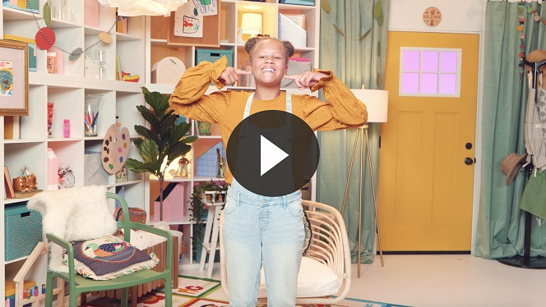

You are each doing such a great job of learning and following the rules!

**Bible Time**

Sometimes we all choose to do things that we aren’t supposed to. That’s called sin. But Jesus came to help us with our sin problem. I’m so thankful that Jesus died to forgive us of our sins and that God forgives us when we ask Him to. Let’s check on Lizzy and her grandpa. I know they have something special for us today.

• *Play* ***Bible Lesson Video A***.

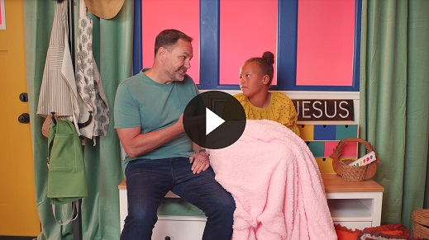

Uh-oh! Sounds like Lizzy and her mom had some problems. We’ll see later how things work out.

**Faith Fact**

• *Play* ***Faith Fact Sound*** *video (bell ringing)*.

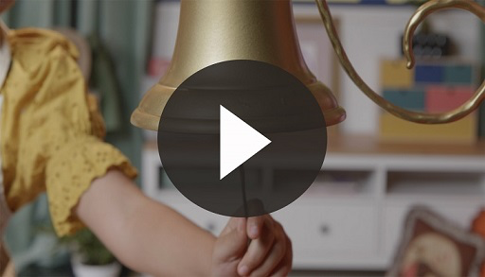

• *Show the* ***Faith Fact Slide***.

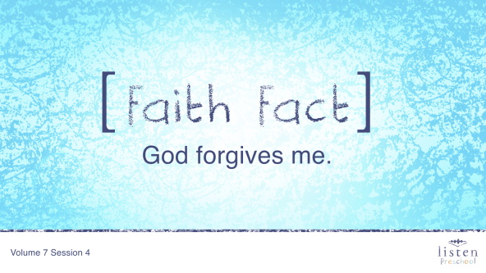

Did you hear that? *(Group response)* It was our Faith Fact bell. Our Faith Fact today is **God forgives me.** Can you say that with me on the count of 3? Ready? 1, 2, 3. **God forgives me.** Good job, everyone.

**Worship**

I’m so incredibly thankful that God forgives us. Are you thankful, too? If so let’s praise Him for His goodness and love and then we’ll pray.

**Praise**

Are you glad God forgives you? Wave your hands up high. *(Group response)*

Are you glad that God loves you? Wave your hands down low. *(Group response)*

Who wants to tell God thank You? Wave your hands up high. *(Group response)*

**Prayer**

Let’s bow our heads and pray.

|  |
| --- |
| Dear God, thank You so much for always loving me. Thank You for forgiving me when I ask. I love You. Amen. |

**Sing**

The more time we spend with God, the easier it is to listen to Him. Are you ready to spend some time worshipping Him by singing? Jump up on your feet.

• *Lead the kids in singing one or two songs. See suggestions at the beginning of the session*.

**Bible Time cont’d**

• *Play* ***Bible Lesson Video B***.

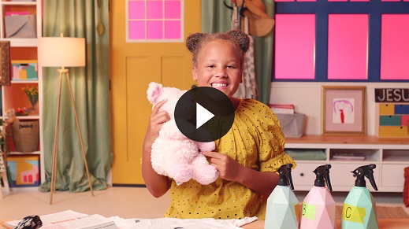

Great job, everyone. Well, I’m glad Lizzy is going to tell her mom that she’s sorry for the way she acted. Sounds like everything will work out fine. Let’s practice the Faith Verse. We’ll say it and do the actions.

**Faith Verse**

• *Show the* ***Faith Verse Slide***.

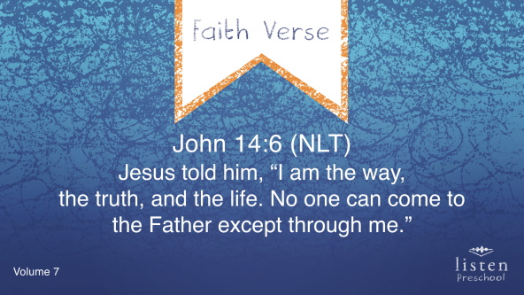

John 14:6 (NLT)

Jesus told him, “I am the way, the truth, and the life. No one can come to the Father except through me.”

Hasn’t this been such a great Faith Verse? Good job working on it, everyone.

**Response Time**

Today, we need to think about our own hearts. If you have done things you shouldn’t have done and have sin in your heart, then you can ask God to forgive you today. If you want to ask God to forgive you then raise your hand.

• *Pause to allow kids time to respond*.

Put your hands together and bow your heads. Repeat after me.

|  |
| --- |
| Dear God, please forgive me for all the sin in my heart. I love You, God. Thank You for forgiving me and always loving me. Amen. |

**Closing**

We have some fun activities planned for our small groups today. Let’s repeat the Faith Fact one more time before we move to our small groups.

• *Play* ***Faith Fact Sound*** *video (bell ringing)*.



• *Show the* ***Faith Fact Slide***.



Let’s say our Faith Fact now. **God forgives me**.

**Dismissal to Small Groups**

Now let’s head to our super fun small groups to spend more time with our friends and leaders.

• *Dismiss the kids by groups*.

**Small Group**

**25 Minutes**

*See supplies and prep instructions at beginning of session or in each activity below.*

|  |
| --- |
| ***Leader Tip****: Small groups can alternate to each circle, or all groups can do each activity at the same time. If you choose to alternate, you will need at least one leader per circle.* |

**Circle 1**

**Group Connection**

**Muddy Pigs**

|  |
| --- |
| ***You Will Need***   * ***Small Group Group Connection****, one per group* * *Brown ink pads, one per group* * *Wipes* * *Plastic tablecloths, one per table*   ***Getting Ready***   * *Print copies of the* ***Small Group Group Connection****, one per group.* * *Color the pigs and Prodigal Son before class.* |

**Goal:** Kids will review the Bible story to help them understand that sin makes us dirty but that God forgives us and cleans our sins away.

Today, we heard the story of the Prodigal or Lost Son. He took the money his dad gave him and wasted it all. He had nothing left and had to work with pigs. Just like pigs get dirty in the mud, the son got dirty with his sin. Later, He went home, and his father cleaned him up and forgave him. Our Heavenly Father, God, forgives us and washes our sins away when we ask Him to forgive us for the wrong things we’ve done. Let’s take turns using our fingerprints to create the mud and the dirt.

• *Have the kids take turns using the ink pad and their fingerprints to make the mud*.

• *Clean their hands with the wipes and remind them that God cleans away our sins when we ask Him to*.

• *During the activity, practice the Faith Fact.* **God forgives me**.

• *Play* ***Faith Fact Sound*** *video (bell ringing)*.



• *Show the* ***Faith Fact Slide***.



Let’s practice our Faith Fact. **God forgives me.** Great job!

**Circle 2**

**Hands-On Learning**

**The Lost Son Returns Home**

|  |
| --- |
| ***You Will Need***   * ***Small Group Activity Page****, one per kid* * *Crayons*   ***Getting Ready***   * *Print copies of the* ***Small Group Activity Page****, one per kid*. |

**Goal:** Kids will further review Jesus’ story of the Lost Son returning home.

Boys and girls, let’s color the picture as we review today’s Bible story. Who can tell me something from the story we heard today? *(Allow responses.)* That’s right. We heard the story of the Lost Son. When the son knew in his heart he had done something wrong, he went back home and asked his dad to forgive him for the wrong things he had done. Let’s help him find the right path home.

• *Hold up an activity page as you review the story*.

In the story, the dad represents God. The Lost Son stands for the people who choose to go their own way and do things they shouldn’t do.

When the Lost Son chose to go back home, did his dad welcome him? *(Group response)* Did he forgive his son for the wrong choices he had made? *(Group response)* Does God forgive us when we come to Him and tell Him we’re sorry for the wrong things we’ve done? You’re right! He is excited to forgive us and show us how much He loves us! He is always ready to forgive us.

One thing we could do now is say our Faith Verse. Saying Bible verses out loud helps us to think about what God wants us to do. Let’s say it together now and do the actions.

• *Show the* ***Faith Verse Slide***.



John 14:6 (NLT)

Jesus told him, “I am the way, the truth, and the life. No one can come to the Father except through me.”

**Circle 3**

**Feet-to-Floor Game Time**

**Road to Forgiveness**

|  |
| --- |
| ***You Will Need***   * *Carpet-safe tape* * *Various obstacles for the obstacle course (empty boxes, cones, jump ropes, etc.)*   ***Getting Ready***   * *Create a simple taped out obstacle course.* |

**Goal:** Kids will learn about asking for forgiveness as they complete a simple obstacle course.

This Bible story reminds us how much God cares about and loves each one of us. If we ask Him, God will forgive us. Sometimes it can be hard to say that we were wrong. Have you ever had a hard time saying you were sorry? *(Allow responses.)* Just like the Lost Son had to make the journey home, sometimes it can be a journey for us to admit that we were wrong and need to ask for forgiveness. Every time God forgives us, it gives us a chance to be better. We are going to do a fun obstacle course, and when you make it to the end, I want you to shout our Faith Fact. **God forgives me**.

• *Give each kid a chance to try the obstacle course*.

• *Repeat as time allows*.

**Circle 4**

**Creative Time**

**What’s in the Bag?**

|  |
| --- |
| ***You Will Need***   * *Toy house* * *Toy pig* * *Coins/empty wallet* * *Other items that go along with the Bible story* * *Small paper bag*   ***Getting Ready***   * *Put all items in the bag.* |

**Goal:** Kids will review the Bible story by playing a game.

We are going to play a guessing game. I am going to put an item in a bag and you will have to try and guess what that item is. When you guess the item, I will ask you how the item is connected to the Bible story.

• *If the kids aren’t sure how the items relate to the Bible story, then help them with the answer*.

• *House: The lost son returned home to his father and asked for forgiveness*.

• *Pig: The lost son’s sin made him dirty like the pigs he took care of*.

• *Coins/wallet: The lost son was greedy and spent everything his father gave him and ended up having nothing*.

• *Play* ***Faith Fact Sound*** *video (bell ringing)*.



• *Show the* ***Faith Fact Slide***.



Let’s say the Faith Fact one last time before we go home. **God forgives me.** Always remember those words!

**Dismissal**

• *Send home the* ***Small Group Activity Page*** *with each kid*.

• *Remind parents that there are* ***Family Devotions*** *available in the app to do with their kid*.

• *Tell everyone the date and time for the next session*.