**Leader Overview**

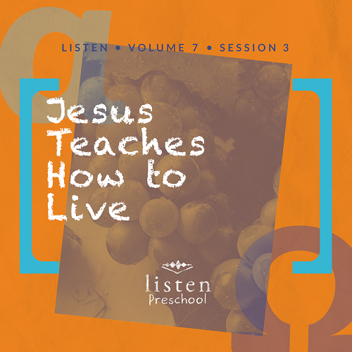

*In this session, preschoolers learn that Jesus was a great teacher. He taught His followers how to develop God’s character. We can still learn Jesus’ lessons from the Bible by studying His Word at home and by coming to church. Jesus teaches us*.

**Bible Lesson**

The Beatitudes

Matthew 5:1–10

**Faith Fact**

Jesus teaches me.

**Faith Verse**

John 14:6 (NLT)

Jesus told him, “I am the way, the truth, and the life. No one can come to the Father except through me.”

**Preparing for the Session**

**Leader Preparation Time: 20–25 Minutes**

|  |
| --- |
| **You Will Need**  ***Preservice Activities***   * *Honey graham crackers* * *Toys* * *School supplies (e.g., notebooks, folders, coloring books, crayons, rulers)*   ***Large Group***   * *Bible* * *Worship songs (Song suggestions: “Nothing Is Impossible” by Planetshakers; “God of the Impossible” by Everfound)* * *For groups not using a phone or tablet only, add:*   + *Projector or TV*   + *Laptop*   + ***Rules Video*** *or* ***Slide***   + ***Faith Fact Sound*** *video (bell ringing)*   + ***Faith Fact Slide***   + ***Faith Verse Slide***   + ***Bible Lesson Video A***   + ***Bible Lesson Video B***   ***Small Group***   * ***Small Group Activity Page 1****, one per kid* * ***Small Group Activity Page 2****, one column of bees per kid* * ***Small Group Creative Time****, one per kid plus one for a sample* * *Butcher paper or paper large enough for the group to draw on together* * *Crayons or markers* * *Glue sticks* * *Beach ball* * *Craft sticks, one per kid plus extras* * *Permanent marker*   *To access the Bible Engagement Project library from a computer, visit* [***App.BibleEngagementProject.com***](http://app.bibleengagementproject.com/)***.*** |
| ***Getting Ready***  ***Preservice Activities***   * *Set out toys and snacks.*   ***Large Group***   * *Download videos and slides if needed.* * *Select worship song(s) and have them ready to play.*   ***Small Group***   * *Cut out long sheets of paper, one per group.* * *Print copies of* ***Small Group Activity Page 1****, one per kid.* * *Print copies of* ***Small Group Activity Page 2****, and cut apart one column of eight bees per kid.* * *Print and cut out the bee on* ***Small Group Creative Time****, one per kid.* * *Write on several craft sticks using a permanent marker with one of the following: “Bee Pure in Heart,” “Bee Merciful,” or “Bee a Peacemaker.”* * *Create a sample bee to show kids.* * *Blow up the beach ball.*   ***First time leading* Listen *for Preschool? Check out* the Facilitator Guide.** |

**Preservice Activities**

*See what’s needed at the beginning of the session.*

**Bible Story Warm-Up**

*As kids play with the school supplies, ask questions like these to introduce the Bible story*.

When you go to preschool or daycare, who teaches you? What do they teach you?

Who teaches you at home? What do they teach you?

Who teaches you at church? What do they teach you?

The greatest teacher ever is Jesus. He teaches us all about God and how to be like Him.

Who goes to preschool? *(Group response)* Preschool is a fun place where we learn things like colors and shapes. Let’s play with these school supplies and pretend that we are in school. Who wants to be the teacher? *(Allow kids to play school.)*

**Snack**

**Honey Graham Crackers**

*As kids are eating the snack, share the following:*

One of the things Jesus taught us in the Bible is the Beatitudes. That’s a big word that means a blessing or something good that God wants to give us.

What animal does the BEE-atitudes sound like? Yes, bees. What do bees make? That’s right, honey. Let’s have a yummy snack of honey graham crackers.

**Free Play**

*Any extra time can be spent playing with toys and the school supplies*.

Good job, everyone! Let’s put away everything and get ready to listen. We’re going to hear about something important that Jesus wanted His friends to know!

**Transition**

*A few minutes before service begins, have the kids make their way to the large group area and sit in their designated spots*.

**Large Group**

**25 Minutes**

*See what’s needed at the beginning of the session.*

**Introduction**

Hi kids. It’s so good to see you. My name is _________. Today, we are going to have fun learning from God’s Word—the Bible. *(Hold up the Bible.)* Raise your hand if you love learning new things. I love to learn, too. When we are trying to learn something new, it helps to have a good teacher. The greatest teacher of all is Jesus.

**Rules Review (Optional)**

Let’s make sure we know our rules by watching this video.

• *Play* ***Rules Video***.

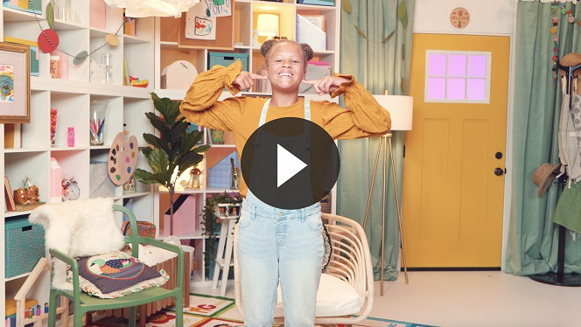

You are doing such a great job learning the rules! I’m so proud of you!

**Bible Time**

The Bible is full of so much for us to learn. Jesus taught His disciples and followers so many important lessons. Let’s check on Lizzy and her grandpa. I am sure they have a special story from God’s Word to tell us today.

• *Play* ***Bible Lesson Video A***.

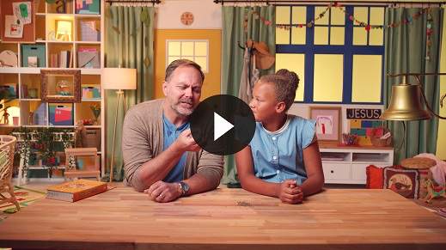

You did such a fantastic job helping Lizzy, boys and girls. Great job!

**Faith Fact**

• *Play* ***Faith Fact Sound*** *video (bell ringing)*.

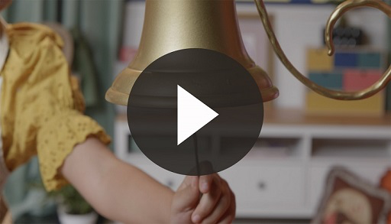

• *Show the* ***Faith Fact Slide***.

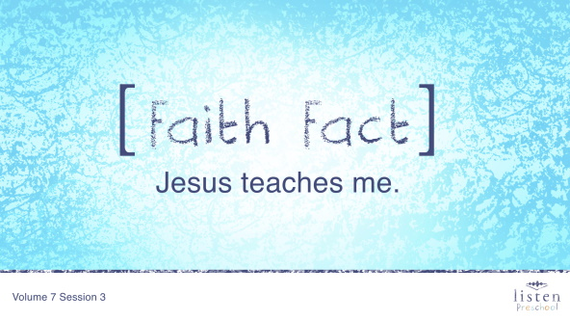

Wait! Was that the bell I heard? *(Group response)* It was the bell! The bell means it’s time to say our Faith Fact. Do you remember that Lizzy told us today’s Faith Fact? It’s **Jesus teaches me**. Let’s practice saying it together so that we can all remember it. Can you say it with me on the count of 3? Ready. 1, 2, 3. **Jesus teaches me**. Good job, everyone.

**Worship**

I’m so thankful that God gave us His Word so that we can learn important lessons like Jesus taught. He wants us have a heart that follows God to grow good things in our life. Let’s give God thanks for sending Jesus to teach us.

**Praise**

Are you glad Jesus teaches us? Wave your hands up high. *(Group response)*

Are you glad the Bible guides us? Wave your hands down low. *(Group response)*

Who wants to tell God thank You? Wave your hands up high. *(Group response)*

**Prayer**

Let’s bow our heads and pray.

|  |
| --- |
| Dear God, thank You so much for sending Jesus to teach us. We want to follow what He taught us. We love You. Amen. |

**Sing**

The more time we spend with God, the easier it is to listen to Him. Are you ready to spend some time singing and worshipping? Jump up on your feet.

• *Lead the kids in singing one or two songs. See suggestions at the top of the session*.

**Bible Time cont’d**

Worshipping God was so much fun. Who wants to see what Lizzy is doing now? *(Group response)*

• *Play* ***Bible Lesson Video B***.

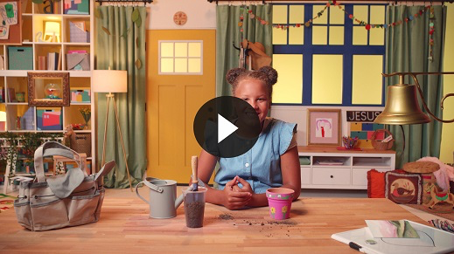

Wasn’t learning about things Jesus taught amazing? Now, let’s practice the Faith Verse. Today we’re going to work on the rest of the verse. Let’s say it now and do the actions.

**Faith Verse**

• *Show the* ***Faith Verse Slide***.

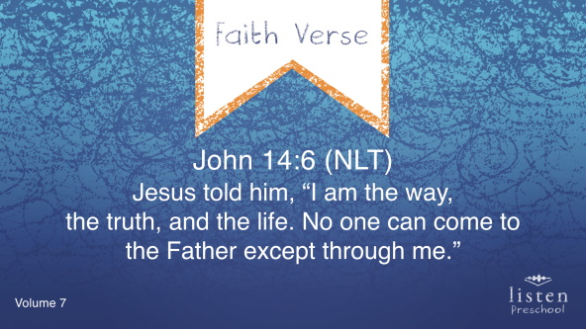

John 14:6 (NLT)

Jesus told him, “I am the way, the truth, and the life. No one can come to the Father except through me.”

Great job! You’re on your way to learning this verse.

**Response Time**

I hope we never stop learning from Jesus and His Word. Raise your hand if you would like to pray that Jesus will keep teaching you and that you will follow what Jesus taught in your life. Let’s pray right now. Put your hands together and bow your heads. Repeat after me.

|  |
| --- |
| Dear God, please help me learn everything that Jesus wants to teach to me. Help me to follow Him in my life. Amen. |

**Closing**

If you are ready for small groups yell, “Yea,” on the count of 3. Ready? 1, 2, 3. As we go to our small groups, let’s say today’s Faith Fact.

• *Play* ***Faith Fact Sound*** *video (bell ringing)*.



• *Show the* ***Faith Fact Slide***.



**Jesus teaches me**. That was awesome! Let’s do it again. **Jesus teaches me**.

**Dismissal to Small Groups**

Now let’s get ready so we can go have fun in our small groups with our leaders.

• *Dismiss the kids by groups*.

**Small Group**

**25 Minutes**

*See supplies and prep instructions at the beginning of the session or in each activity below.*

|  |
| --- |
| ***Leader Tip:*** *Small groups can alternate to each circle, or all groups can do each activity at the same time. If you choose to alternate, you will need at least one leader per circle.* |

**Circle 1**

**Group Connection**

**What Does Jesus Teach You?**

|  |
| --- |
| ***You Will Need***   * *Butcher paper or paper large enough for the group to draw on together* * *Crayons or markers*   ***Getting Ready***   * *Cut out long sheets of paper, one per group.* |

**Goal:** Kids will draw together things they learned about Jesus’ teaching of the Beatitudes.

In today’s story, we heard about the Beatitudes, God’s blessings for us when we do what He tells us to. In the Bible Jesus teaches us so much. We are going to take some time to draw things that Jesus teaches us. For example, I am going to draw myself praying because Jesus teaches me to pray. (*Divide into groups and help kids come up with things Jesus teaches us.)* Let’s all take time to share ways that Jesus teaches us.

• *Examples include Jesus teaches me to be kind, Jesus teaches me to give, Jesus teaches me to obey*.

**Circle 2**

**Hands-On Learning**

**Bee Blessed**

|  |
| --- |
| ***You Will Need***   * ***Small Group Activity Page 1****, one per kid* * ***Small Group Activity Page 2****, one column of eight bees per kid* * *Glue sticks* * *Crayons or markers*   ***Getting Ready***   * *Print copies of* ***Small Group Activity Page 1****, one per kid.* * *Print copies of* ***Small Group Activity Page 2****, one column of eight bees per kid.* * *Cut apart bees from* ***Small Group Activity Page 2****.* |

**Goal:** Kids will talk about the Beatitudes.

Kids, today we heard about Jesus teaching the Beatitudes. We learned that God blesses us when we are humble and merciful. We are going to create a beehive to remember what we have learned. We will color the beehive and glue these bees on our page. *(Show activity page.)* At the bottom, it says, “Bee Blessed.” We also learned that Jesus teaches us. Once you are finished with your beehive, try to follow the dots to write out the word *blessed*.

• *Use the time to review the Bible story*.

• *During the activity, interrupt and practice the Faith Fact*.

• *Play* ***Faith Fact Sound*** *video (bell ringing)*.



• *Show the* ***Faith Fact Slide***.



Let’s say our Faith Fact together: **Jesus teaches me**.

**Circle 3**

**Feet-to-Floor Game Time**

**Sharing Game**

|  |
| --- |
| ***You Will Need***   * *Beach ball*   ***Getting Ready***   * *Be sure the beach ball is full of air.* |

*NOTE: You may want to have small groups join together for this game*.

**Goal:** Kids will practice the Faith Verse as they play an active game.

Today, we learned that **Jesus teaches me**. When we learn something from Jesus, we should share it with others. Today, we learned about what Jesus taught His friends about following God’s directions.

Let’s practice sharing what we learned by playing a game. We are going to stand in a circle and pass the ball to each other. When the ball comes to the last kid, we will practice sharing our Faith Verse by saying it really loud.

• *You can also have them say each word of the Faith Verse as the ball is passed to each kid instead of saying it at the end*.

• *Show the* ***Faith Verse Slide***.



John 14:6 (NLT)

Jesus told him, “I am the way, the truth, and the life. No one can come to the Father except through me.”

**Circle 4**

**Creative Time**

**Beatitude Bees**

|  |
| --- |
| ***You Will Need***   * ***Small Group Creative Time****, one per kid plus an extra for a sample* * *Crayons* * *Glue sticks* * *Craft sticks, one per kid plus extras* * *Permanent marker*   ***Getting Ready***   * *Cut out* ***Small Group Creative Time****, one per kid.* * *Write on several craft sticks using a permanent marker one of the following: “Bee Pure in Heart,” “Bee Merciful,” or “Bee a Peacemaker.”* * *Create a sample bee to show kids.* |

**Goal:** Kids will hear more about what the Beatitudes mean.

Today, we heard about Jesus teaching His followers things God wants us to know. This was very special because Jesus was honoring people who may not feel very special. Beatitudes are blessings, and Jesus was teaching that these people are blessed. That means good things would happen to them.

I want everyone to pick one of these very special attitudes to be your focus this week. Here are the ones you can choose this week: “Bee Pure in Heart,” “Bee Merciful,” or “Bee a Peacemaker.”

You may be wondering what each of these beatitudes means. To “Bee Pure in Heart” is to be clean in your heart after asking Jesus to forgive your sins. To “Bee Merciful” is to be forgiving and nice to those who do not deserve it. To “Bee a Peacemaker” is to try to be at peace with everyone and to keep others from fighting.

All right, which beatitude do you choose for this week? Color your bee. I will give you a craft stick with your beatitude on it, and we will glue your bee to it.

• *Write each kid’s name on his or her bee*.

• *Help them glue the bees to the craft sticks*.

**Dismissal**

• *Remind the kids of the Faith Fact before they go home*.

• *Send home the* ***Small Group Activity Page*** *and* ***Small Group Creative Time*** *page with each kid*.

• *Remind parents that there are* ***Family Devotions*** *available on the app to do with their kid*.

• *Tell everyone the date and time for the next session*.