**Leader Overview**

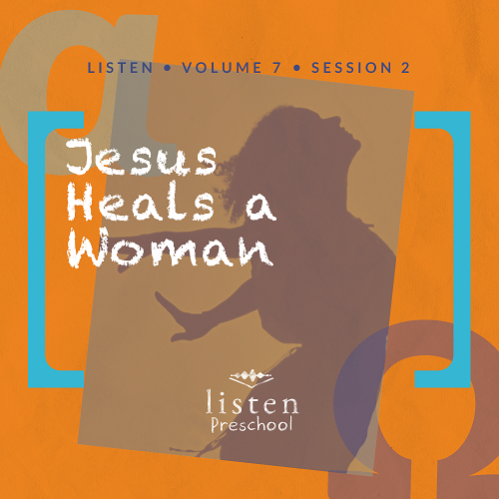

*In this session, preschoolers discover that Jesus healed the woman who suffered from constant bleeding. They will learn that nothing is impossible for God and that He still does miracles today*.

**Bible Lesson**

Jesus Heals a Woman

Mark 5:21–34

**Faith Fact**

Nothing is impossible for God.

**Faith Verse**

John 14:6 (NLT)

Jesus told him, “I am the way, the truth, and the life. No one can come to the Father except through me.”

**Preparing for the Session**

**Leader Preparation Time: 20–25 Minutes**

|  |
| --- |
| ***You Will Need***  ***Preservice Activities***   * *Doctor kit toy set* * *Jell-O cups* * *Spoons*   ***Large Group***   * *Bible* * *Worship songs (Song suggestions: “Nothing Is Impossible” by Planetshakers; “God of the Impossible” by Everfound)* * *For groups not using a phone or tablet only, add:*   + *Projector or TV*   + *Laptop*   + ***Rules Video*** *or* ***Slide***   + ***Faith Fact Sound*** *video (bell ringing)*   + ***Faith Verse Slide***   + ***Faith Fact Slide***   + ***Bible Lesson Video A***   + ***Bible Lesson Video B***   ***Small Group***   * ***Small Group Activity Page****, one per kid* * ***Small Group Creative Time****, one per group* * *Roll of toilet paper, one per group* * *Timer (optional)* * *Trash bag*   *To access the Bible Engagement Project library from a computer, visit* [***App.BibleEngagementProject.com***](http://app.bibleengagementproject.com/)***.*** |
| ***Getting Ready***  ***Preservice Activities***   * *Set out toys and snacks.*   ***Large Group***   * *Download videos and slides if needed.* * *Select worship song(s) and have them ready to play.*   ***Small Group***   * *Print copies of the* ***Small Group Activity Page****, one per kid.* * *Print copies of the* ***Small Group Creative Time****, one per group.*   ***First time leading* Listen *for Preschool? Check out* the Facilitator Guide.** |

**Preservice Activities**

*See what’s needed at the beginning of the session.*

**Bible Story Warm-Up**

*As kids play with the toys, introduce the Bible story*.

Have you ever been sick?

What helped you feel better? Rest? Soup? Medicine?

• *Show the doctor toy set to the kids*.

Who knows what this is? *(Allow response)* That’s right! This is a doctor’s kit. It has everything a doctor may need to help someone get better. Doctors help our bodies heal when they are sick with things like medicines and Band-Aids. Today, we are going to learn about someone who healed through touch. Who do you think that is? *(Allow response)* That’s right! Jesus. In today’s story, we are going to learn that **Nothing is impossible for God**.

**Snack**

**Jell-O Cups**

*As kids are eating the snack, share the following:*

Today, we are eating Jell-O. Many people eat Jell-O when they don’t feel well. What are some things you like to eat when you don’t feel well? *(Allow responses.)* Jesus can take our sickness away and make us all better.

**Free Play**

*Any extra time can be spent playing with toys*.

And now it’s time to put away our toys.

**Transition**

*A few minutes before service begins, have the kids make their way to the large group area and sit in their designated spots*.

**Large Group**

**25 Minutes**

*See what’s needed at the beginning of the session.*

**Introduction**

Hi, boys and girls. I’m so excited to see you! My name is _________. Today, we are going to hear a very special story from the Bible—God’s Word. *(Hold up the Bible.)* Raise your hand if you have ever been sick. Maybe you have had a cough or runny nose or tummy ache. I’ve been sick, too. It’s no fun being sick. God’s Son, Jesus, did many miracles.

What’s a miracle? It’s something that only Jesus can do. Jesus healed lots of sick people when He was here. He still heals people today when we ask Him to.

**Rules Review (Optional)**

Let’s review our rules by watching this video!

• *Play* ***Rules Video***.



I can’t wait to learn more about how Jesus heals!

**Bible Time**

Jesus is God’s Son, and nothing is impossible for Him, even making sick people better. Let’s check on Lizzy and her grandpa. I think we’ll hear more about this from Lizzy.

• *Play* ***Bible Lesson Video A***.

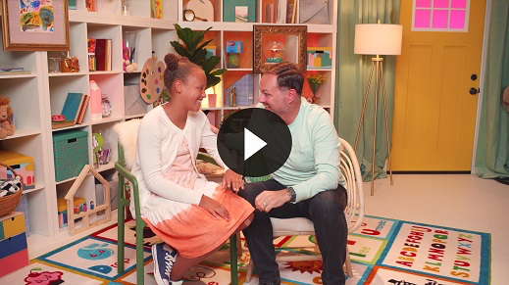

Great job! Thank you so much for helping Lizzy, boys and girls!

**Faith Fact**

• *Play* ***Faith Fact Sound*** *video (bell ringing)*.

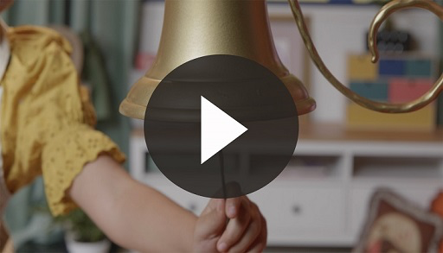

• *Show the* ***Faith Fact Slide***.



Did you hear the bell? The bell means it’s time to say our Faith Fact. Today’s Faith Fact is **Nothing is impossible for God**. Can you say that with me on the count of 3? Ready? 1, 2, 3. **Nothing is impossible for God**. Good job, everyone.

**Worship**

I love hearing that nothing is impossible for God! Let’s take a moment and thank Him for helping us and keeping us healthy.

**Praise**

Are you glad nothing is impossible for God? Wave your hands up high. *(Group response)*

Are you glad that Jesus heals? Wave your hands down low. *(Group response)*

Who wants to tell God thank You? Wave your hands up high. *(Group response)*

**Prayer**

Let’s bow our heads and pray.

|  |
| --- |
| Dear God, thank You for doing the impossible. Thank you for sending Jesus. Help me never forget that He heals us. Amen. |

**Sing**

The more time we spend with God, the easier it is to listen to Him. Are you ready to spend some time singing and worshipping? Jump up on your feet.

• *Lead the kids in singing one or two songs. See suggestions at the beginning of the session*.

**Bible Time cont’d**

I wonder how Lizzy’s knee is now. Let’s check back in with her!

• *Play* ***Bible Lesson Video B***.

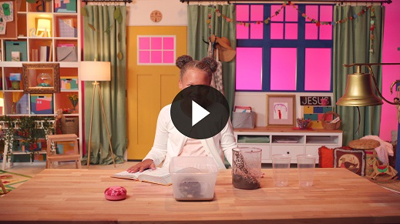

That Bible story was so amazing! Now if only there was a verse we could learn to help us remember that Jesus is the One who heals us. I think the Faith Verse we’ve been working on is perfect! Let’s review it.

**Faith Verse**

• *Show the* ***Faith Verse Slide***.

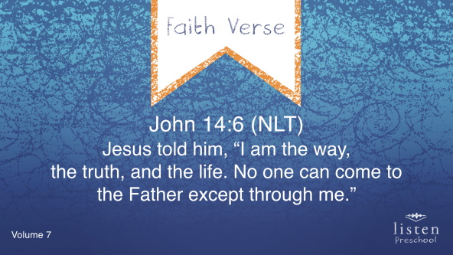

John 14:6 (NLT)

Jesus told him, “I am the way, the truth, and the life. No one can come to the Father except through me.”

Let’s keep working on learning this verse so that it will be in our hearts forever!

**Response Time**

Today was such a fun day. I loved learning that Jesus heals! How many of you are sick or know someone who needs Jesus to heal them? If that’s you, raise your hand. *(Allow kids time to respond.)*

Let’s pray right now and ask God to heal everyone who is sick. Put your hands together and bow your heads. Repeat after me.

|  |
| --- |
| Dear God, I know that You can do the impossible. I know that Jesus can heal the sick. Please heal me and everyone who is sick in Jesus’ name. Amen. |

**Closing**

Jump up and down if you’ve had fun today! If you are ready to have fun in small groups, say, “Yea,” and then sit back down. *(Group response)* As we go to small groups, don’t forget our Faith Fact.

• *Play* ***Faith Fact Sound*** *video (bell ringing)*.



• *Show the* ***Faith Fact Slide.***



Let’s say our Faith Fact now. **Nothing is impossible for God**.

**Dismissal to Small Groups**

Now it’s time to go to our circles where we will spend time in our very special small groups with our leaders.

• *Dismiss the kids by groups*.

|  |
| --- |
| ***Leader Tip:*** *This can be done by assigning color teams or by age groups. Note that some young preschoolers may not know their age. Using a colored sticker, jersey, or wristband will help separate the kids and help identify their small groups.* |

**Small Group**

**25 Minutes**

*See supplies and prep instructions at beginning of session or in each activity below.*

|  |
| --- |
| ***Leader Tip:*** *Small groups can alternate to each circle, or all groups can do each activity at the same time. If you choose to alternate, you will need at least one leader per circle.* |

**Circle 1**

**Group Connection**

**Toilet Paper Bandages**

|  |
| --- |
| ***You Will Need***   * *Roll of toilet paper, one per group* * *Timer (optional)* * *Trash bag*   *No prep is needed for this activity.* |

**Goal:** Kids will be reminded that Jesus heals and **Nothing is impossible for God**.

Have you ever hurt yourself? What helps you feel better? *(Group response)* If you are like me, bandages always help me feel better. Today, I’m going to pair you up, and you are going to pretend that your friend has an “owie” on his or her arm. You will have ten seconds to wrap your friend’s arm with the toilet paper.

• *Pair kids up with one kid wrapping the toilet paper around the other kid’s arm*.

• *Use a timer to count for ten seconds or have the kids count to ten. Adjust time as needed*.

• *Have the kids switch and make sure everyone gets a chance to play*.

• *Remind the kids that Jesus can heal us from owies and sicknesses*.

• *Use the trash bag to collect the used toilet paper*.

• *During the game, interrupt and practice the Faith Fact*.

• *Play* ***Faith Fact Sound*** *video (bell ringing)*.



• *Show the* ***Faith Fact Slide***.



Let’s say the Faith Fact all together. **Nothing is impossible for God**.

**Circle 2**

**Hands-On Learning**

**Jesus Healed the Woman Coloring Sheet**

|  |
| --- |
| ***You Will Need***   * ***Small Group Activity Page****, one per kid* * *Crayons*   ***Getting Ready***   * *Print copies of the* ***Small Group Activity Page****, one per kid.* |

**Goal:** Kids will reflect on the Bible story as they color a picture of the woman with a bleeding illness being healed by Jesus.

Boys and girls, who can remember today’s Bible story? *(Group response)* Who was very sick? *(Allow responses.)* That’s right. The woman. Who healed her? *(Group response)* Yes, Jesus healed her. Can Jesus heal us? *(Group response)* Yes, He can.

• *Hold up an activity page and ask kids about each person on it*.

• *Review the Bible story as the kids color the page*.

One thing we could do is say our Faith Verse. Saying Bible verses out loud helps us to think about what God wants us to do. Let’s say it together now.

• *Show the* ***Faith Verse Slide***.



• *Repeat the verse two times*.

John 14:6 (NLT)

Jesus told him, “I am the way, the truth, and the life. No one can come to the Father except through me.”

**Circle 3**

**Feet-to-Floor Game Time**

**Stop and Go**

*No prep is needed for this activity*.

*NOTE: You may want to have small groups join together for this game*.

**Goal:** Kids will realize that Jesus and His disciples stopped to find out who had been healed by touching Jesus.

Jesus was walking to help someone else when the sick woman touched His robe. He felt her touch Him, so He stopped to see who had reached out and touched Him.

We are going to play a game like Red Light, Green Light. We are going to practice walking and stopping like Jesus did. Everyone line up on this side of the room*.* When I say, “Go,” walk toward the other wall. *(Point to the other side of the room.)* When I say, “Stop,” you must stop. If you keep walking, then you have to go back to the wall and start over.

• *During the game, interrupt and practice the Faith Fact*.

• *Play* ***Faith Fact Sound*** *video (bell ringing)*.



• *Show the* ***Faith Fact Slide***.



Let’s all say the Faith Fact together. Nothing is impossible for God.

**Circle 4**

**Creative Time**

**Find Jesus**

|  |
| --- |
| ***You Will Need***   * ***Small Group Creative Time****, one per group*   ***Getting Ready***   * *Print copies of* ***Small Group Creative Time****, one per group.* * *Cut out the people.* |

**Goal:** Kids will review the Bible story as they play a game.

I love today’s Bible story! Have you ever been in a very crowded place? *(Group response)* It makes it hard to find who you are looking for. Jesus was being followed by a big crowd of people, so the sick woman had to move and squeeze past them to find Jesus. But, she knew that it would be worth it because she believed Jesus could heal her sickness.

We are going to try to find Jesus in the crowd. *(Hold up cards of people.)* This is Jesus, and these are some of the people who were following Him. We are going to lay the pictures facedown like this and then take turns trying to find Jesus. When you find Him, I want you to shout the Faith Fact: **Nothing is impossible for God**.

• *Depending on size of the groups, you may need to divide into smaller groups*.

• *As time allows, play again to find the healed woman in the crowd*.

**Dismissal**

• *Remind the kids of the Faith Fact before they go home*.

• *Send home the* ***Small Group Activity Page*** *with each kid*.

• *Remind parents that there are* ***Family Devotions*** *available on the app to do with their kid*.

• *Tell everyone the date and time for the next session.*