**Leader Overview**

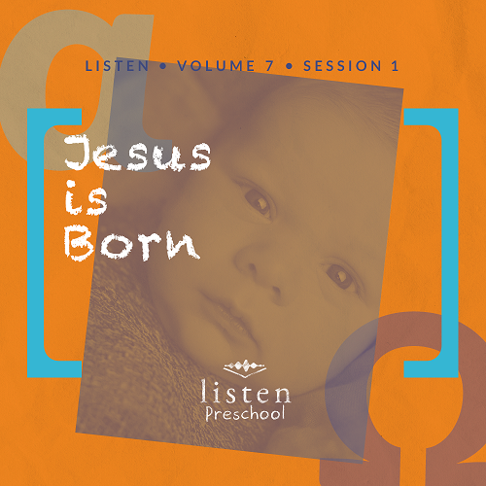

*In this session, we learn that God gave us the ultimate present, Jesus! Preschoolers will be reminded that God loves us and is always with us*.

**Bible Lesson**

Jesus Is Promised

Matthew 1:21–23

Simeon Meets the Messiah

Luke 2:25–32

**Faith Fact**

God gave me Jesus.

**Faith Verse**

John 14:6 (NLT)

Jesus told him, “I am the way, the truth, and the life. No one can come to the Father except through me.”

**Preparing for the Session**

**Leader Preparation Time: 20–25 Minutes**

|  |
| --- |
| ***You Will Need***  ***Preservice Activities***   * *Christmas cakes* * *Empty boxes of all sizes wrapped in wrapping paper (Paper does not need to be Christmas themed)*   ***Large Group***   * *Bible* * *Worship songs (Song suggestions: “Born Is the King” by Hillsong; “O Come, O Come, Emmanuel” by Bethel Music Kids)* * *For groups not using a phone or tablet only, add:*   + *Projector or TV*   + *Laptop*   + ***Rules Video*** *or* ***Slide***   + ***Faith Fact Sound*** *video (bell ringing)*   + ***Faith Fact Slide***   + ***Faith Verse Slide***   + ***Bible Lesson Video A***   + ***Bible Lesson Video B***   ***Small Group***   * ***Small Group Activity Page****, one per kid* * *Several wrapped boxes with lids or gift bags with tissue paper* * *Assorted items to place in the boxes or bags* * *Music and player (phone, stereo, etc.)* * *Crayons* * *Glitter, glue, construction paper, and wipes (optional)* * *Construction paper* * *Other craft supplies to decorate (optional)*   *To access the Bible Engagement Project library from a computer, visit* [***App.BibleEngagementProject.com***](http://app.bibleengagementproject.com/)***.*** |
| ***Getting Ready***  ***Preservice Activities***   * *Wrap empty boxes.* * *Set out toys and snacks.*   ***Large Group***   * *Download videos and slides if needed.* * *Select worship song(s) and have them ready to play.*   ***Small Group***   * *Print* ***Small Group Activity Page****, one per kid.* * *Place one item in each gift box or gift bag and either wrap the boxes and lids or place tissue paper in the bags.*   ***First time leading* Listen *for Preschool? Check out the* Facilitator Guide.** |

**Preservice Activities**

*See what’s needed at the beginning of the session.*

**Bible Story Warm-Up**

*As kids play with the toys, ask questions like this to introduce the Bible story:*

What was your favorite birthday or Christmas gift you got this year?

Look at all these presents! Let’s see who can stack them the highest. *(Allow kids to stack presents.)* Did you know that long ago, God gave us an amazing present to show how much He loves us? We are going to learn more about it later. What do you think He gave us?

**Snack**

**Mini Cakes**

*As kids are eating the snack, share the following:*

Usually, we have cake at parties. Do you know what else is usually at a party? *(Allow responses.)* That’s right; there are presents! We just talked about our favorite present we received this year.

Are you as excited as I am to know what present God gave us? He loves us so much that He gave us this special present to remind us that He is always with us. Isn’t that great?

**Free Play**

*Any extra time can be spent playing with toys*.

Good job, everyone! Let’s put away everything and get ready to listen. We have a very special story today!

**Transition**

*A few minutes before service begins, have kids make their way to the large group area and sit in their designated spots*.

**Large Group**

**25 Minutes**

*See what’s needed at the beginning of the session.*

**Introduction**

Hello, everyone! I’m so excited to be here with you today! My name is _________. Have you had fun so far today? *(Group response)* During this group time, we have been hearing about the Bible, which is God’s Word. *(Hold up the Bible.)*

Today, we are going to learn about how one of our favorite holidays started. Can you guess what holiday that is? *(Allow responses.)* That’s right; it’s Christmas! It’s all about Jesus’ birth, which we learn about from the Bible! If you’re ready to get started, say, “Oh yeah!” *(Group response)* Good job!

**Rules Review (Optional)**

Let’s watch this video together so that we can go over our rules!

• *Play* ***Rules Video***.

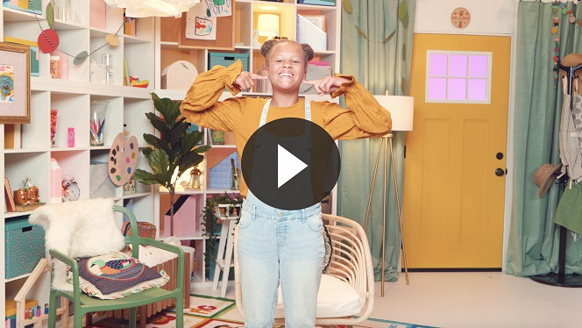

All right! I’m so excited for today’s Bible story!

**Bible Time**

The Bible teaches us about the greatest gift ever given to us—Jesus! He came to earth to help us. We’ll hear lots more about Jesus coming from Lizzy and her grandpa. Let’s see what they are up to!

• *Play* ***Bible Lesson Video A***.

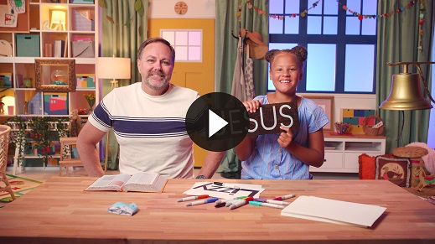

Kids, you did such a great job helping Lizzy! Thank you!

**Faith Fact**

• *Play* ***Faith Fact Sound*** *video (bell ringing)*.

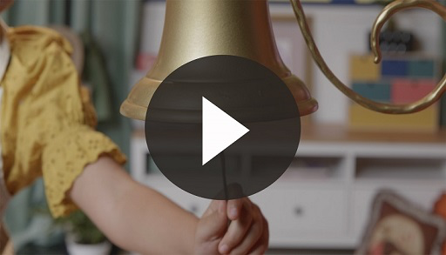

• *Show the* ***Faith Fact Slide***.

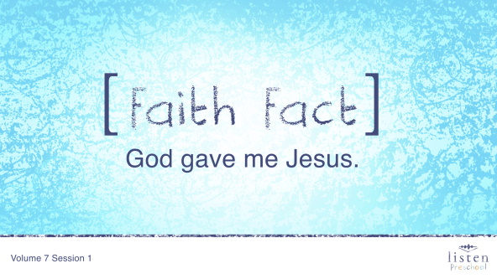

Remember, when we get together, we’re going to learn about God. Lizzy and Grandpa already introduced our Faith Fact for today. It is **God gave me Jesus**. Can you say that with me on the count of 3? Ready? 1, 2, 3. **God gave me Jesus.** Great job!

**Worship**

Jesus is the greatest gift we have ever been given because He came to show us how much God loves us and help us to know God. In fact, Jesus is so great that on His birthday, we give and receive gifts. It helps us remember that Jesus is the greatest gift of all.

If you want to tell God thank you for giving us Jesus, then raise your hands up and clap them together.

**Praise**

Are you glad God gave us Jesus? Wave your hands up high. *(Group response)*

Are you glad that Jesus loves you and me? Wave your hands down low. *(Group response)*

Who wants to tell God thank You? Wave your hands up high. *(Group response)*

**Prayer**

That was so amazing! Now it’s time to bow our heads and close our eyes. We are going to pray.

|  |
| --- |
| Dear God, thank You for giving us Jesus! He is the best gift of all! Amen. |

**Sing**

The more time we spend with God, the easier it is to listen to Him. Are you ready to spend time singing and worshipping? Jump up on your feet.

• *Lead the kids in singing one or two songs. See suggestions at the beginning of the session*.

**Bible Time cont’d**

Let’s see what Lizzy is doing now!

• *Play* ***Bible Lesson Video B***.

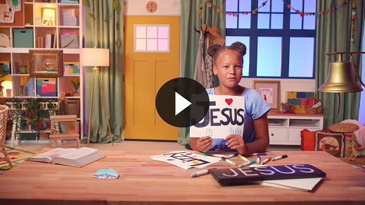

**Faith Verse**

Lizzy just taught us the first part of our Faith Verse! We are going to work on learning this verse so that we never forget it.

• *Show the* ***Faith Verse Slide***.

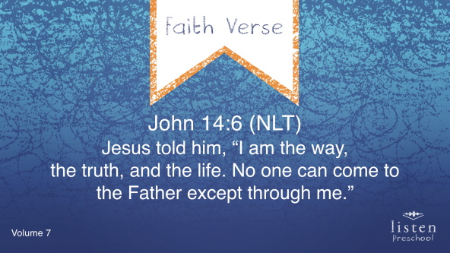

Let’s say it together.

John 14:6 (NLT)

Jesus told him, “I am the way, the truth, and the life. No one can come to the Father except through me.”

We’ll learn the rest of the verse later.

**Response Time**

Today, we heard all about Jesus’ birth and how God gave us Jesus. He is such a special gift to us all. Who wants to tell God thank You for sending Jesus?

• *Pause to allow kids time to respond*.

We’re going to pray together, so repeat this prayer after me.

|  |
| --- |
| Dear God, thank You so much for sending Jesus to be our gift. Help us to always remember how special He is and that Christmas is all about Jesus. Amen. |

**Closing**

Did you have fun today, kids? This was such a special day. I will always remember that Jesus is the best gift of all. I’m so glad that God gave us Jesus! Raise your hand if you loved the Bible story. *(Group response)* Raise your hand if you loved the Faith Verse. *(Group response)* Raise your hand if you loved the Faith Fact. *(Group response)*

• *Play* ***Faith Fact Sound*** *video (bell ringing)*.



• *Show the* ***Faith Fact Slide***.



Oh! Did you hear that sound? That means it’s time for us to say our Faith Fact. Let’s say our Faith Fact now. **God gave me Jesus**.

**Dismissal to Small Groups**

Now it’s time to go to our circles where we will get to spend time in our fun small groups with our leaders.

• *Dismiss the kids by groups*.

**Small Group**

**25 Minutes**

*See supplies and prep instructions at the beginning of the session or in each activity below.*

|  |
| --- |
| ***Leader Tip:*** *Small groups can alternate to each circle, or all groups can do each activity at the same time. If you choose to alternate, you will need at least one leader per circle.* |

**Circle 1**

**Group Connection**

**Guess the Gift**

|  |
| --- |
| ***You Will Need***   * *Several wrapped boxes with lids or gift bags with tissue paper* * *Assorted items to place in the boxes or bags*   ***Getting Ready***   * *Place one item in each gift box or gift bag and either wrap the boxes or place tissue paper in the bags.* |

**Goal:** Kids will associate how special gifts are with the fact that God gave us Jesus as the greatest gift of all.

Friends, I am so glad that you are here. What are these? *(Point to the gifts.)* That’s right, they are gifts! Do you like getting gifts? *(Group response)* Let’s try and guess what this gift is. *(Choose a gift, shake the package, and give clues as kids guess what’s inside. Finally, reveal the gift.)* This is such a good gift, but do you know what gift is even greater? It’s the gift God gave us—Jesus! Let’s play the game again.

• *Be sure to include a variety of items. It’s helpful to have items that make noise or have things that are familiar to the kids*.

• *Think of fun clues to help the kids guess*.

• *Encourage and validate each kid*.

• *If kids don’t guess the item after two or three clues, go ahead and reveal the item*.

• *Be sure to keep repeating that God gave us Jesus and that He is the greatest gift*.

• *During the game, interrupt and practice the Faith Fact.* ***God gave me Jesus***.

• *Play* ***Faith Fact Sound*** *video (bell ringing)*.



• *Show the* ***Faith Fact Slide***.



Let’s all say our Faith Fact. **God gave me Jesus**.

**Circle 2**

**Hands-On Learning**

**Angel and Joseph Coloring Sheet**

|  |
| --- |
| ***You Will Need***   * ***Small Group Activity Page****, one per kid* * *Crayons* * *Glitter, glue, construction paper, and wipes (optional)*   ***Getting Ready***   * *Print copies of the* ***Small Group Activity Page****, one per kid.* |

**Goal:** Kids will review the Bible story as they color a picture about the story.

Kids, we are going to color a picture that will help remind us of today’s story. Who is the man sleeping in this picture? *(Allow responses.)* That’s right! It’s Joseph. Who gave him a special message from God? *(Allow responses.)* That’s right! It was an angel. The angel appeared to Joseph in a dream and told him that Mary would have a baby who was to be named Jesus.

• *Hold up an activity page and ask the kids about each person on it to review the Bible story*.

• *If you choose to have the kids glitter the angel’s wings, put the glue inside the wings and have the kids spread it on the wings with their fingers. Place the picture on a piece of construction paper and help the kids shake the glitter onto the wings. Then, shake the extra glitter onto another piece of construction paper and use that glitter with the next kid’s picture before shaking from the container. You should be able to pour all extra glitter back into the container when finished. Have wipes for the kids to clean glue off their hands*.

**Circle 3**

**Feet-to-Floor Game Time**

**Pass the Gift**

|  |
| --- |
| ***You Will Need***   * *Small wrapped box* * *Music and player (phone, stereo, etc.)*   ***Getting Ready***   * *Use one of the boxes from the Preservice Activities or from the Small Group Group Connection.* * *Select music and make sure the music player is ready.* |

*NOTE: You may want to have small groups join together for this game*.

**Goal:** Kids will play a game to reinforce the Faith Fact.

Have you ever played Hot Potato? Today’s game is a lot like that.

Everyone stands in a circle. *(Pause for kids to move into a circle.)* We are going to use this gift because God gave us Jesus as the best gift of all. We will pass the gift to the next kid in the circle until the music stops. When the music stops, the kid with the gift will say the Faith Fact. **God gave me Jesus**.

• *Practice the Faith Fact a couple of times before starting the game*.

• *Stop the music so that different kids get a chance to answer*.

• *Show the* ***Faith Fact Slide***.



**Circle 4**

**Creative Time**

**Cards**

|  |
| --- |
| ***You Will Need***   * *Construction paper* * *Crayons* * *Other craft supplies to decorate (optional)*   *No prep needed for this activity.* |

**Goal:** Kids will do a craft so they can show others that God loves them by sharing what they heard today—**God gave me Jesus**.

We are going to show our families that God loves them by making cards for them. Just like God gave us Jesus as a gift, we can give the gift of a card to our families and tell them all we heard and talked about today.

• *Give each kid a sheet of construction paper. Help kids write their names on the paper*.

• *Encourage the kids to draw a picture that reminds them of today’s story*.

• *You can help them write the Faith Fact on their cards if they want*.

• *During the activity, practice the Faith Fact:* ***God gave me Jesus***.

• *Show the* ***Faith Fact Slide***.



**Dismissal**

• *Send home the* ***Small Group Activity Page*** *and cards with each kid*.

• *Remind parents that there are* ***Family Devotions*** *available on the app to do with their kid*.

• *Tell everyone the date and time for the next session*.