**Leader Overview**

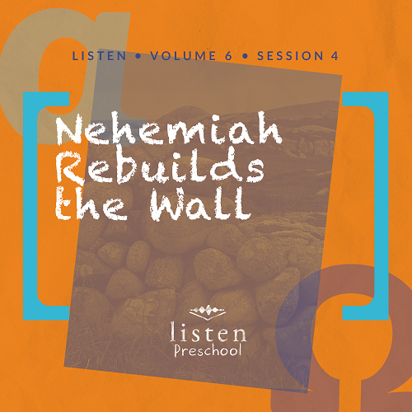

*In this session of* Listen*, preschoolers discover that* ***God wants me to trust Him****. We learn about Nehemiah and how he trusted God to help him rebuild the wall of Jerusalem. Even though Nehemiah was in another country and served in that country’s royal court, he still remained faithful to God. God gave Nehemiah favor as he served the king, and eventually, he was allowed to go back to Jerusalem and rebuild the wall. When we trust God, He makes a way that we do not see.* *Help your preschoolers understand that even when things aren’t going the way they think they should go, they can still trust God*.

**Bible Lesson**

Nehemiah Leads the People

Nehemiah 2:11–20

**Faith Fact**

God wants me to trust Him.

**Faith Verse**

2 Corinthians 5:7 (NLT)

For we live by believing and not by seeing.

**Preparing for the Session**

**Leader Preparation Time: 20–25 Minutes**

|  |
| --- |
| ***You Will Need***  ***Preservice Activities***   * *Blocks or building toys* * *Grape juice and crackers*   ***Large Group***   * *Bible* * *Worship songs (Song suggestions: “Jump Around” by KidSpring; “Faithful” by Gateway Kids Worship; “Jump into the Light” by Jana Alayra; “Ready Set Go” by Yancy & Little Praise Party)* * *For groups not using a phone or tablet only, add:*   + *Projector or TV*   + *Laptop*   + ***Rules Video*** *or* ***Slide***   + ***Faith Fact Sound*** *video (bell ringing)*   + ***Faith Verse Slide***   + ***Faith Fact Slide***   + ***Bible Lesson Video A***   + ***Bible Lesson Video B***   ***Small Group***   * ***Small Group Activity Page****, one per kid plus one for a sample* * ***Small Group Group Connection****, one per kid* * ***Small Group Creative*** *Time, one per kid* * *Black, gray, and brown construction paper* * *Scissors* * *Crayons* * *Glue sticks* * *Blindfold or bandana* * *Painter’s tape*   *To access the Bible Engagement Project library from a computer, visit* [***App.BibleEngagementProject.com***](http://app.bibleengagementproject.com/)***.*** |
| ***Getting Ready***  ***Preservice Activities***   * *Set out toys and blocks.* * *Set out crackers and grape juice.*   ***Large Group***   * *Download videos and slides if needed.* * *Select worship song(s) and have them ready to play.*   ***Small Group***   * *Print copies of the* ***Small Group Activity Page****, one per kid.* * *Cut rocks from construction paper for preschoolers who can’t use scissors.* * *Make a sample* ***Small Group Activity Page*** *with construction paper rocks.* * *Print the* ***Small Group Group Connection****, one per two kids.* * *Cut apart the bricks and give one to each kid.* * *Print copies of the* ***Small Group Creative Time*** *page, one per kid.* * *Create a circle on the floor using painter’s tape.*   ***First time leading* Listen *for Preschool? Check out* the Facilitator Guide.** |

**Preservice Activities**

*See what’s needed at the beginning of the session.*

**Bible Story Warm-Up**

*As kids play with the toys, introduce the Bible story*.

Today, we are going to hear about a man named Nehemiah. Because Nehemiah trusted God, God helped Nehemiah when the city had fallen apart and was in ruins. **God wants me to trust Him** like Nehemiah did.

When Nehemiah saw Jerusalem, the wall and the gates had been torn down like our blocks. Nehemiah and a bunch of helpers wanted to rebuild those walls. Let’s use these blocks and build a wall.

• *Set out blocks or building toys in a circle to represent Jerusalem’s walls in ruins*.

**Snack**

**Grape Juice and Crackers**

*As kids are eating the snack, share the following:*

Today, we will learn that **God wants me to trust Him**.

Have you ever had something happen that you didn’t understand?

How did you feel when that happened?

Does God care about us during those times?

Can we trust God?

**Free Play**

*Any extra time can be spent playing with toys.*

Good job, everyone! Let’s put the blocks and other toys away and get ready to listen. If you like stories about building things, you’ll really like today’s Bible story.

**Transition**

*A few minutes before service begins have kids make their way to the large group area and sit in their designated spots*.

**Large Group**

**25 Minutes**

*See what’s needed at the beginning of the session.*

**Introduction**

Hi, kids! My name is ___________. Are you excited to learn about God today? How do we learn about God? *(Hold up the Bible.)* That’s right we learn about God from the Bible.

Each story in the Bible tells us something about God. Today, we are going to learn that **God wants me to trust Him**. If you are ready to start our story, look at me with your giant telescope. *(Make two circles with your hands and place them both over one eye like you are using a telescope.)* I see lots of kids looking at me through their telescopes. Everyone must be ready!

**Rules Review**

Before we move ahead, we have to go over a few things to help us all have fun. Let’s watch this video together.

• *Play* ***Rules Video***

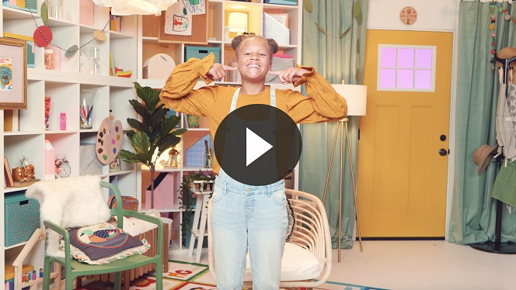

Whenever we are together, we can learn something new. Let’s be sure we are listening so everybody can have a great time!

**Bible Time**

When we meet, we hear a remarkable story from the Bible. We should listen to what the Bible tells us. Today, we are going to learn that **God wants me to trust Him** no matter what things may look like all around me. Today, Lizzy will tell us the Bible story that her grandpa told her. Let’s watch Lizzy now.

• *Play* ***Bible Lesson Video A***.

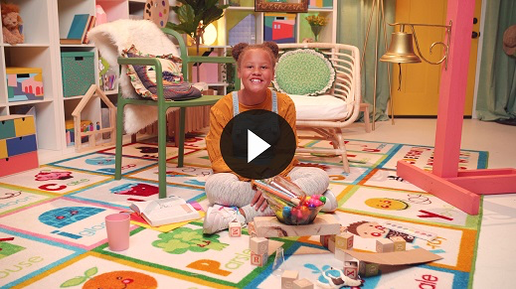

**Faith Fact**

That was incredible! You did a great job helping Lizzy solve all the clues. The cup and the horse were each a part of our Bible story. We learned that **God wants me to trust Him** no matter what things may look like all around us. Even when things seem to be falling apart, we can still trust God. That is great news!

• *Play* ***Faith Fact Sound*** *video (bell ringing)*.

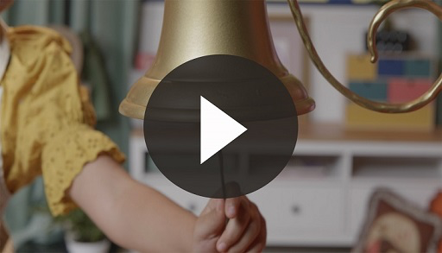

• *Show the* ***Faith Fact Slide.***

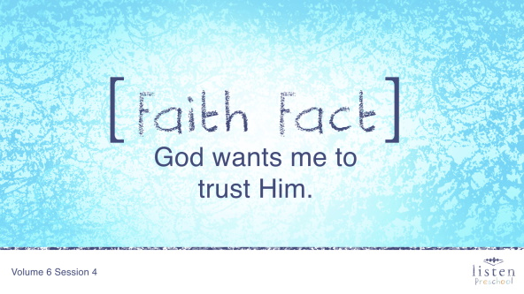

Perfect timing! Let’s shout out our Faith Fact. **God wants me to trust Him**.

**Worship**

Let’s spend some time singing songs and thanking God that we can always trust Him!

**Praise**

Are you glad God watches over us? Wave your hands up high. *(Group response)*

Are you glad God protects us? Wave your hands down low. *(Group response)*

Are you glad God wants you to trust Him? Wave your hands up high. *(Group response)*

Who wants to thank God? Wave your hands down low. *(Group response)*

**Prayer**

Now, let’s bow our heads and pray.

|  |
| --- |
| Dear God, thank You that no matter what is going on around me I can still trust that You have a plan for me. Help me to trust You with all things in my life. Amen. |

**Sing**

One way to worship God is by singing. Sing with me now.

• *Lead the kids in singing one or two songs. See suggestions at the top of the session*.

**Bible Time cont’d**

Another way we worship God is by hearing and saying words from the Bible. Let’s review our Faith Verse.

**Faith Verse**

• *Show the* ***Faith Verse Slide***.

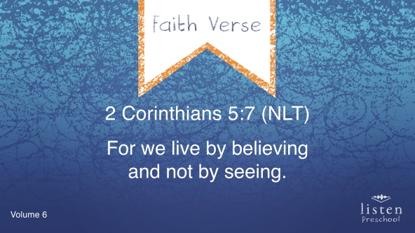

Let’s say it together.

2 Corinthians 5:7 (NLT)

For we live by believing and not by seeing.

Great job! Let’s check back in with Lizzy.

• *Play* ***Bible Lesson Video B***.

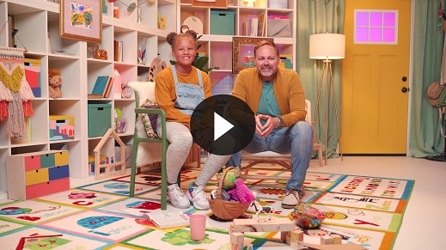

**Response Time**

I love that God showed us that we could trust Him. Sometimes we don’t always see how things are going to turn out, but **God wants us to trust Him** anyway. Is there anything you need help trusting God with? Let’s pray together!

• *Take time to hear the kids’ prayer requests and say a short prayer*.

• *If your group is large, ask for kids to raise their hands if they have a sick family member, a bump or bruise, sick or lost pet, etc. This gives all the kids a chance to participate*.

**Closing**

Did you have fun in *Listen* today, kids? We’ve heard that **God wants me to trust Him** in all kinds of things. We’ve worshipped God by praising, praying, and singing. We’ve learned our Faith Verse, too.

• *Play* ***Faith Fact Sound*** *video (bell ringing)*.



And what are we supposed to do when we hear that sound? *(Shout out the Faith Fact.)*

• *Show the* ***Faith Fact Slide.***



Let’s say our Faith Fact now. **God wants me to trust Him**.

Great job, friends!

**Dismissal to Small Groups**

Now it’s time to go to our circles where we will spend time with our very special small groups and our leaders.

• *Dismiss the kids by groups*.

|  |
| --- |
| ***Leader Tip****: This can be done by assigning color teams or by age groups. Note that some young preschoolers may not know their age. Using a colored sticker, jersey, or wristband will help separate the kids and help identify their small groups.* |

**Small Group**

**25 Minutes**

*See supplies and prep instructions at the beginning of the session or in each activity below.*

|  |
| --- |
| ***Leader Tip:*** *Small groups can alternate to each circle, or all groups can do each activity at the same time. If you choose to alternate, you will need at least one leader per circle.* |

**Circle 1**

**Group Connection**

**Remember to Trust**

|  |
| --- |
| ***You Will Need***   * ***Small Group Group Connection*** * *Crayons* * *Scissors*   ***Getting Ready***   * *Print copies of the* ***Small Group Group Connection****, one per two kids.* * *Cut apart the bricks and give one to each kid.* |

**Goal:** Kids make a reminder that Nehemiah trusted God to help him rebuild the walls.

Today, we are going to help Nehemiah rebuild the wall of Jerusalem. You each will get a brick to color and decorate. When you are finished, we are going to tape it to the wall to create our own brick wall.

• *While kids decorate their bricks, ask what things they can trust God to help them with.*

• *Write the kids’ names on their bricks*.

• *When session is over, either send bricks home or keep them up on the wall*.

• *Play* ***Faith Fact Sound*** *video (bell ringing)*.



• *Show the* ***Faith Fact Slide.***



Let’s say the Faith Fact together again. **God wants me to trust Him**.

That was great!

**Circle 2**

**Hands-On Learning**

**Jerusalem’s Walls**

|  |
| --- |
| ***You Will Need***   * ***Small Group Activity Page****, one per kid plus one for sample* * *Black, gray, and brown construction paper* * *Glue sticks* * *Crayons* * *Scissors*   ***Getting Ready***   * *Print copies of the* ***Small Group Activity Page****, one per kid.* * *Cut rocks from construction paper for preschoolers who can’t use scissors.* * *Make a sample* ***Small Group Activity Page*** *with construction paper rocks* |

**Goal:** Kids will color a scene of Nehemiah and a friend rebuilding the wall of Jerusalem to review the Bible story.

Was Nehemiah worried when he saw that the wall of Jerusalem had fallen down? *(Group response)* Let’s see how strong you can make the walls of Jerusalem. We are going to color our pictures. Then, we will cut out rocks from the construction paper to fill in the holes in the wall. You have glue sticks to glue the rocks to the wall. The great thing about rocks is they are all different sizes and shapes.

• *Put the construction paper, scissors, and glue sticks on the table or hand out the precut rocks.*

• *Show kids a sample of the completed Activity Page*.

• *Help the kids glue the rocks to their page to rebuild the wall*.

**Circle 3**

**Feet-to-Floor Game Time**

**Trust**

|  |
| --- |
| ***You Will Need***   * *Blindfold or bandana* * *Painter’s tape*   ***Getting Ready***   * *Create a circle or square on the floor using painter’s tape.* |

**Goal:** To help the kids trust your voice and the voices of the other kids in their small group even when they can’t see.

Do you remember our Faith Verse? Let’s all say it together!

• *Show the* ***Faith Verse Slide***.



2 Corinthians 5:7 (NLT)

For we live by believing and not by seeing.

We are going to play a game called Trust. One of you stand on this side of the room. Then, we’re going to cover that person’s eyes. One of the other kids will give that person another directions to get to the middle of our circle. Your friend will have to trust you to get to the circle.

• *Use the painter’s tape to make a circle on the floor*.

• *Help the kids give good directions like: “Take two steps forward” or “Move one step to the left.”*

• *Try to keep the other kids from yelling directions.*

• *Place the blindfolded kid near the taped circle. The goal is to help the kids trust when they can’t see, not to make it difficult.*

• *Play this game until every kid has a chance to participate*.

**Circle 4**

**Creative Time**

**Wall Inspection**

|  |
| --- |
| ***You Will Need***   * ***Small Group Creative Time****, one per kid* * *Crayons*   ***Getting Ready***   * *Print copies of the* ***Small Group Creative Time****, one per kid.* |

**Goal:** Kids will review the Bible story and Faith Fact by doing a craft.

Today, we heard how Nehemiah trusted God to help him rebuild the wall of Jerusalem. When he arrived in Jerusalem, he went out late at night to inspect the walls and check what needed to be repaired. He found things like broken walls, burnt gates, and rubble. Today, we are going to help Nehemiah find these things and more. Color the picture and see if you can find all of the images on the bottom of the page. When you find them in the picture, circle them.

• *Play* ***Faith Fact Sound*** *video (bell ringing)*.



• *Show the* ***Faith Fact Slide.***



Let’s say our Faith Fact. **God wants me to trust Him**.

Awesome job!

**Dismissal**

• *Send home the* ***Small Group Activity Page, Small Group Group Connection*** *page, and* ***Small Group Creative Time*** *page with each kid*.

• *Remind parents that there are* ***Family Devotions*** *available on the app to do with their kid*.

• *Tell everyone the date and time for the next session*.