**Leader Overview**

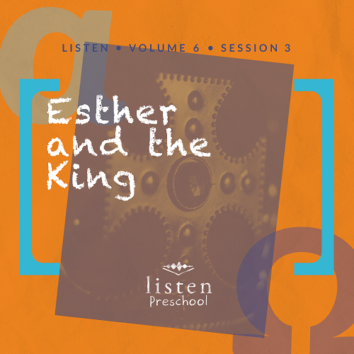

*In this session, preschoolers discover that* ***God knows what’s best****. Sometimes we don’t understand what is going on around us, or a situation comes up that we don’t have an answer to. Often, we think God has forgotten us or He isn’t concerned about our situation. However, we know from reading the Bible that God is aware of our situation and He knows what’s best even when we can’t see it*.

**Bible Lesson**

Esther and the King

Esther 4:10 to 5:4

**Faith Fact**

God knows what’s best.

**Faith Verse**

2 Corinthians 5:7 (NLT)

For we live by believing and not by seeing.

**Preparing for the Session**

**Leader Preparation Time: 20–25 Minutes**

|  |
| --- |
| ***You Will Need***  ***Preservice Activities***   * *Tablecloth* * *“Fancy” paper plates and cups* * *Centerpiece for snack table* * *Snack* * *Toys related to royalty (kings, queens, crowns, etc.)*   ***Large Group***   * *Bible* * *Worship songs (Song suggestions: “Jump Around” by KidSpring; “Faithful” by Gateway Kids Worship; “Jump into the Light” by Jana Alayra; “Ready Set Go” by Yancy & Little Praise Party)* * *For groups not using a phone or tablet only, add:*   + *Projector or TV*   + *Laptop*   + ***Rules Video*** *or* ***Slide***   + *Faith* ***Fact Sound*** *video (bell ringing)*   + ***Faith Verse Slide***   + ***Faith Fact Slide***   + ***Bible Lesson Video A***   + ***Bible Lesson Video B***   ***Small Group***   * ***Small Group Group Connection*** * ***Small Group Activity Page****, one per kid* * ***Small Group Creative Time****, one per kid plus one for sample craft* * *Crayons or markers* * *Items for an obstacle course* * *Rolled up paper (scroll) with Faith Fact written on it* * *Marker* * *Scissors* * *Tape or stapler* * *Glue sticks* * *Paper towel roll, one per kid, optional* * *Card stock, optional* * *Sticker jewels, optional* * *Aluminum, optional*   *To access the Bible Engagement Project library from a computer, visit* [***App.BibleEngagementProject.com***](http://app.bibleengagementproject.com/)***.*** |
| ***Getting Ready***  ***Preservice Activities***   * *Set out toys and snacks.*   ***Large Group***   * *Download videos and slides if needed.* * *Select worship song(s) and have them ready to play.*   ***Small Group***   * *Print the* ***Small Group Group Connection*** *and cut apart the photos.* * *Set up obstacle course from one side of the room to the other (cones, ropes, boxes, etc.).* * *Print the* ***Small Group Activity Page****, one per kid.* * *Print the* ***Small Group Creative Time****, one per kid plus one for sample craft.* * *Make a sample of the Creative Time craft before the session.*   ***First time leading* Listen *for Preschool? Check out* the Facilitator Guide.** |

**Preservice Activities**

*See what’s needed at the beginning of the session.*

**Bible Story Warm-Up**

*Welcome kids and show them the toys related to royalty. While kids are playing, introduce the Bible story*.

Today, we are going to hear about a young woman who became a queen. Her name was Esther. Do you ever pretend that you are a queen or a king? It is really fun. Part of a queen’s job is to take care of her people. In today’s story, we will hear how Esther helped her people by trusting that God knew what was best.

Do you always know how to do the right thing?

What happens when we do the wrong thing?

Does God know what’s best?

God helped Queen Esther do the right thing because **God knows what’s best**.

**Snack**

**Banquet**

*Set up today’s snack time like a banquet. Have the kids help you place a tablecloth over the snack table. Use “fancy” paper plates and cups for snack time. Put a centerpiece in the middle of the table. Choose your own snack option or provide fruit slices and bread. These would have been staples at a banquet in Bible times.*

Today, we are going to hear about a queen in the Bible who invited the king to a banquet.

**Free Play**

*Any extra time can be spent playing with toys.*

Good job, everyone! Let’s put away our toys and get ready to listen.

**Transition**

*A few minutes before service begins, have kids make their way to the large group area and sit in their designated spots*.

**Large Group**

**25 Minutes**

*See what’s needed at the beginning of the session.*

**Introduction**

Hi, kids! My name is ___________. Today is a special day because we are all together and get to hear a Bible story. Who is excited to learn about God today? How do we learn about God? *(Hold up the Bible.)* That’s right! We learn about God from the Bible.

Each story in the Bible tells us something about God, and today, we are going to learn that **God knows what’s best**. If you are ready to start our story, look at me through your binoculars. *(Make two circles with your hands and place them over your eyes like binoculars.)* Oh good! Now that everyone can see me through their binoculars, we are ready to begin.

**Rules Review (Optional)**

Before we begin, we need to go over a few things so we’re all having fun. Let’s watch this video together.

• *Play* ***Rules Video***

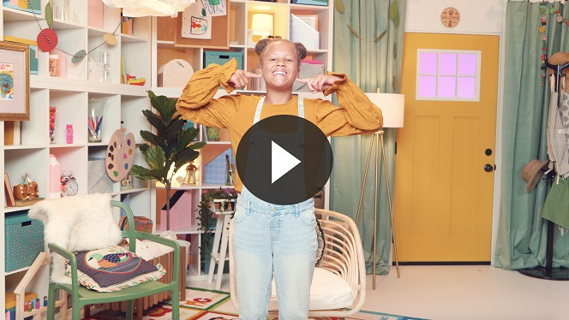

Each time we are together we learn something new. Let’s make sure we are listening so everybody can have a great time!

**Bible Time**

When we’re together, we get to hear something awesome from God’s Word. It is important that we take time to see what the Bible tells us. Today, we are going to learn that **God knows what’s best** no matter what. Lizzy and her grandpa will help us with that. Let’s check in with them now.

• *Play* ***Bible Lesson Video A***.

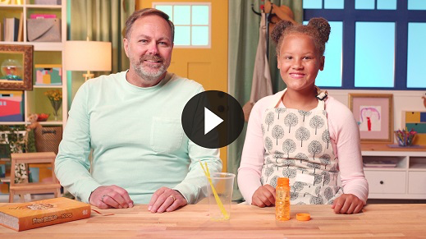

**Faith Fact**

That was fun! You did a great job helping Lizzy solve all the clues. The crown and the *X* were each a piece of our Bible story. We learned that **God knows what’s best** even when we don’t know what to do. Sometimes it is hard to do things that are uncomfortable or new to us, but we have to trust that **God knows what’s best**.

• *Play* ***Faith Fact Sound*** *video (bell ringing)*.

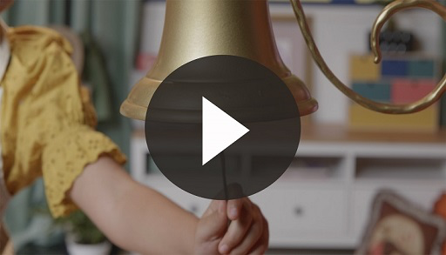

• *Show the* ***Faith Fact Slide.***

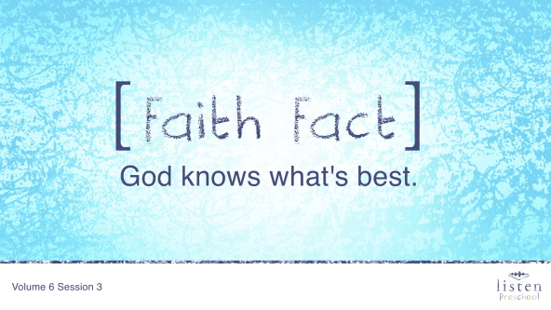

Perfect timing! Let’s shout out our Faith Fact. **God knows what’s best**.

**Worship**

Let’s spend some time singing songs and thanking God for knowing what’s best!

**Praise**

Are you glad God made you and me? Jump up high. *(Group response)*

Are you glad God loves you? Touch your toes down low. *(Group response)*

Are you glad God knows what’s best? Wave your hands up high. *(Group response)*

Who wants to thank God? Clap your hands. *(Group response)*

**Prayer**

Now let’s bow our heads and pray.

|  |
| --- |
| Dear God, thank You for loving me and for always knowing what is best. Thank You for helping me when I am worried or don’t know what to do. Thank You that I can trust You to know what’s best. Amen. |

**Sing**

Another way to praise God is to worship Him by singing.

• *Lead the kids in singing one or two songs. See suggestions at the top of the session*.

**Bible Time cont’d**

Let’s check back in with Lizzy again.

• *Play* ***Bible Lesson Video B***.

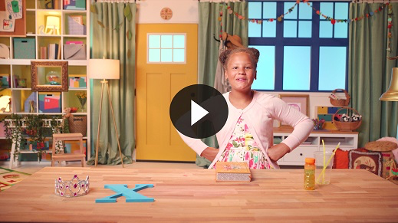

**Faith Verse**

Did you know that we worship God by saying words from the Bible? Let’s practice our Faith Verse together.

• *Show the* ***Faith Verse Slide***.

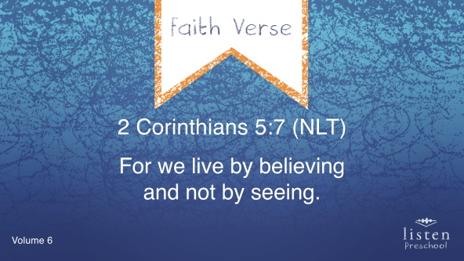

2 Corinthians 5:7 (NLT)

For we live by believing and not by seeing.

**Response Time**

I love that God showed us that if we believe His Word then He will take care of us. Even when we can’t see the right thing to do, we can believe that He knows what’s best. Is there something you need God’s help with today? Let’s pray together and ask Him because He knows what’s best!

• *Take time to hear the kids prayer requests and say a short prayer*.

• *If your group is large, you may ask for kids to raise their hands if they have a sick family member, a bump or bruise, sick or lost pet, etc. This gives all the kids a chance to participate*.

**Closing**

Did you have fun in *Listen* today, kids? We’ve heard all about how God knows what’s best no matter what is going on. We’ve worshipped God by praising, praying, and singing. We are practicing our Faith Verse, too. Just remember that God loves you!

• *Play* ***Faith Fact Sound*** *video (bell ringing)*.



• *Show the* ***Faith Fact Slide.***



Now, what are we supposed to do when we hear that sound? *(Shout out the Faith Fact.)* Let’s say our Faith Fact now. **God knows what’s best**.

Great job, friends!

**Dismissal to Small Groups**

Now it’s time to go to our circles where we will spend time with our very special small groups and our leaders.

• *Dismiss the kids by groups*.

|  |
| --- |
| ***Leader Tip****: This can be done by assigning color teams or by age groups. Note that some young preschoolers may not know their age. Using a colored sticker, jersey, or wristband will help separate the kids and help identify their small groups.* |

**Small Group**

**25 Minutes**

*See supplies and prep instructions at the beginning of the session or in each activity below.*

|  |
| --- |
| ***Leader Tip:*** *Small groups can alternate to each circle, or all groups can do each activity at the same time. If you choose to alternate, you will need at least one leader per circle.* |

**Circle 1**

**Group Connection**

**What’s Best?**

|  |
| --- |
| ***You Will Need***   * ***Small Group Group Connection***   ***Getting Ready***   * *Print the* ***Small Group Group Connection*** *and cut apart the photos*. |

**Goal:** Kids will play a fun, engaging game that reminds them of today’s Faith Fact.

We are going to play a game called What’s Best? Stand in a group in the middle of our area. I’m going to show you a picture of two different things, and you are going to choose which one you think is best. If you think the one on this side is best, stand on this side of me. If you think the item on the other side is best, stand on this side of me.

• *Many of the preschoolers won’t know their left from right, so you may just point to the side they can move to*.

Now, let’s pause to say the Faith Fact again.

• *Play* ***Faith Fact Sound*** *video (bell ringing)*.



• *Show the* ***Faith Fact Slide.***



**God knows what’s best.** That’s a great job!

**Circle 2**

**Hands-On Learning**

**Throne Room**

|  |
| --- |
| ***You Will Need***   * ***Small Group Activity Page****, one per kid* * *Crayons or markers*   ***Getting Ready***   * *Print copies of the* ***Small Group Activity Page****, one per kid.* |

**Goal:** Kids will color the throne room scene where Esther walked in to see the king to remind them that **God knows what’s best**.

When Esther first learned about what was about to happen to the Jewish people, what did she do? *(Group response)* Did she change her mind? *(Group response)* In the end, Esther put what she thought was best aside. She trusted that God knew what was best and would be with her. God protected Esther and saved her people!

Let’s see how beautifully you can color the king’s throne room.

**Circle 3**

**Feet-to-Floor Game Time**

**Deliver the Message**

|  |
| --- |
| ***You Will Need***   * *Items for an obstacle course (cones, ropes, boxes, etc.)* * *Rolled up paper (scroll) with Faith Verse written on it* * *Marker*   ***Getting Ready***   * *Set up obstacle course from one side of the room to the other.* |

**Goal:** Kids will review the story and practice the Faith Verse.

While Esther was living in the king’s palace her cousin Mordecai used messengers to deliver notes to her. Today, we have an important message to deliver to one of our leaders, but you have to get through these obstacles. Here is the message we need to deliver, but I am also going to whisper the message to you. When you complete the obstacle course, share the message with the leader.

• *Have a leader stand at the end of the obstacle course to receive the message*.

• *As each kid goes through the obstacle course, hand him or her the scroll*.

• *Encourage the kids to say the Faith Verse if they are able*.

• *After saying the Faith Verse to the leader, the kid should take the scroll back to the next kid in line for the obstacle course*.

• *Play until everyone has had a chance to go through the obstacle course*.

**Circle 4**

**Creative Time**

**Create Your Own Scepter**

|  |
| --- |
| ***You Will Need***   * ***Small Group Creative Time****, one per kid plus one for sample craft* * *Crayons* * *Scissors* * *Tape or stapler* * *Glue sticks* * *Paper towel roll, one per kid, optional* * *Card stock, optional* * *Sticker jewels, optional*   ***Getting Ready***   * *Print and cut out the scepter on the* ***Small Group Creative Time*** *page, one per kid plus one for sample craft.* * *Use either card stock rolled into a long tube or a paper towel roll. Tape or staple the scepter to the tube.* * *Create a sample craft. Color the scepter and cut it out. Glue it to either a card stock tube or the paper towel roll. Decorate with sticker jewels (optional).* |

**Goal:** Kids will review the Bible story as they complete a craft.

In today’s Bible story, we learned that Esther was asked to go before the king uninvited. She was scared because she knew that could get her into trouble. When she entered the room, the king held his scepter out to her. A scepter is a small staff that a king carries. It looks kind of like this. *(Show sample scepter.)*

When the king held out his scepter like this, it was a way of inviting that person into the room. Even though Esther wasn’t sure she would be invited into the room, she trusted that God knew what was best and would protect her. Because she trusted God, Esther had the courage to speak to the king and save her people.

We are going to make our own scepters to remind us that even when something seems scary, we can trust that **God knows what’s best**.

**Dismissal**

• *Remind the kids of the Faith Fact before they go home*.

• *Send home the* ***Small Group Activity Page*** *and* ***Small Group Creative Time*** *with each kid*.

• *Remind parents that there are* ***Family Devotions*** *available on the app to do with their kid*.

• *Tell everyone the date and time for the next session*.