**Leader Overview**



*In this session, preschoolers discover that God listens when they pray. Prayer can be a difficult concept for a preschooler to comprehend. Having a conversation with someone they can’t see or touch can seem foreign. God is always there with us. He is listening and communicating. He is just waiting for us to start the conversation. Help your preschoolers know that it doesn’t matter where they are, who they are, or what they are doing; God listens when they pray*.

**Bible Lesson**

Daniel in the Lions’ Den

Daniel 6:10–27

**Faith Fact**

God listens when I pray.

**Faith Verse**

2 Corinthians 5:7 (NLT)

For we live by believing and not by seeing.

**Preparing for the Session**

**Leader Preparation Time: 20–25 Minutes**

|  |
| --- |
| **You Will Need**  ***Preservice Activities***   * *Blankets or anything that can be used to make a lions’ den* * *Chairs* * *Stuffed lions and cats* * *Animal crackers*   ***Large Group***   * *Bible* * *Worship songs (Song suggestions: “Jump Around” by KidSpring; “Faithful” by Gateway Kids Worship; “Jump into the Light” by Jana Alayra; “Ready Set Go” by Yancy & Little Praise Party)* * *For groups not using a phone or tablet only, add:*   + *Projector or TV*   + *Laptop*   + ***Rules Video*** *or* ***Slide***   + ***Faith Fact Sound*** *video (bell ringing)*   + ***Faith Verse Slide***   + ***Faith Fact Slide***   + ***Bible Lesson Video A***   + ***Bible Lesson Video******B***   ***Small Group***   * ***Small Group Activity Page 1****, one per kid plus one for the sample* * ***Small Group Activity Page 2****, one per four kids plus sample* * *Crayons* * *Tape* * *Scissors* * *Items that are easy to guess what they are by touch* * *Bag that you can’t see through*   *To access the Bible Engagement Project library from a computer, visit* [***App.BibleEngagementProject.com***](http://app.bibleengagementproject.com/)***.*** |
| ***Getting Ready***  ***Preservice Activities***   * *Set out toys and snacks.* * *Create a lions’ den out of blankets and chairs.* * *Place toy lions and cats in the den.*   ***Large Group***   * *Download videos and slides if needed.* * *Select worship song(s) and have them ready to play.*   ***Small Group***   * *Print the* ***Small Group Activity Page 1****, one per kid plus one for the sample* * *Print the* ***Small Group Activity Page 2****, one per four kids plus sample* * *Cut out the lions on* ***Small Group Activity Page 2****.* * *Make a sample of the Activity Page. Cut apart the smiling lions. Color both pictures. Tape a smiling lion on top of the angry lion.*   ***First time leading* Listen *for Preschool? Check out* the Facilitator Guide.** |

**Preservice Activities**

*See what’s needed at the beginning of the session.*

**Bible Story Warm-Up**

*Welcome kids and invite them to check out the lions’ den. As kids play with the toys, ask questions like these to introduce the Bible story:*

What does it mean to pray?

Where do you normally pray?

Can God hear me when I pray?

**Snack**

**Animal Crackers**

*As kids are eating the snack, share the following:*

Today, we are learning about a man named Daniel who refused to stop praying. He knew how important it was to pray to God because **God listens when I pray**. Daniel ended up in a lions’ den filled with hungry lions! Do you think he was scared? *(Group response)* He may have been, but he still trusted God. Guess what? Daniel knew that God heard him when he prayed. Later, we will learn more.

**Free Play**

*Any extra time can be spent playing with toys.*

Good job, everyone! Let’s put everything away and get ready to listen. If you like stories about lions, you’ll really like today’s Bible story.

**Transition**

*A few minutes before service begins have kids make their way to the large group area and sit in their designated spots*.

**Large Group**

**25 Minutes**

*See what’s needed at the beginning of the session.*

**Introduction**

Hi, kids! My name is ___________. I am so excited to see you today. Who is excited to learn about God? How can we learn about God? *(Hold up the Bible.)* That’s right! We learn about God from His Word, the Bible.

Each story in the Bible tells us something about God. Today, we are going to learn that **God listens when I pray**. If you are ready to start, look at me with a giant telescope. *(Make two circles with your hands and place them both over one eye like you are using a telescope.)* I see lots of kids looking at me through their telescopes. Everyone must be ready.

**Rules Review (Optional)**

Before we begin, we have to go over a few things so we are all having fun. Let’s watch this video together.

• *Play* ***Rules Video***

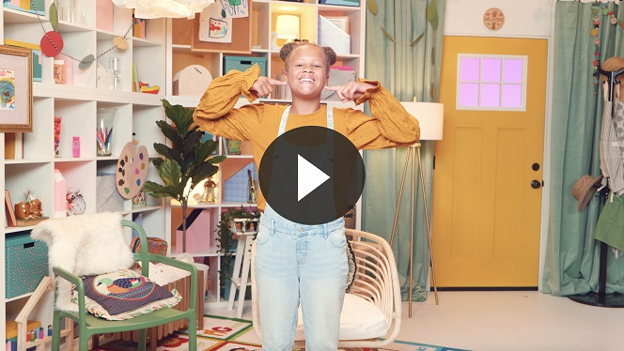

Each time we are together we learn something new. Let’s make sure we are listening so everybody can have a great time!

**Bible Time**

When we’re together, we can learn something fantastic from God’s Word. It’s important that we take time to see what the Bible is teaching us. Today, we are going to learn that **God listens when I pray** no matter where I’m at. Lizzy and her grandpa will help us with that. Let’s check in with them now.

• *Play* ***Bible Lesson Video A***.

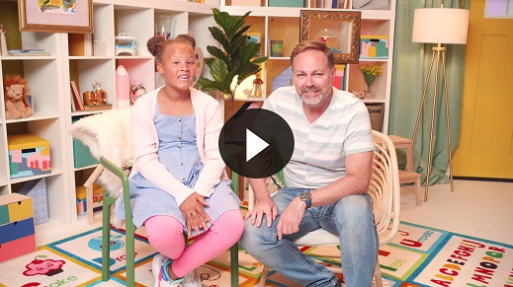

**Faith Fact**

You did a great job helping Lizzy and Grandpa say the Faith Verse with actions.

• *Play* ***Faith Fact Sound*** *video (bell ringing)*.

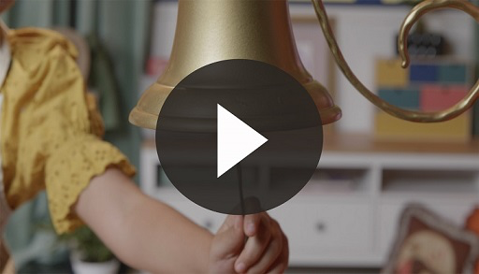

• *Show the* ***Faith Fact Slide.***

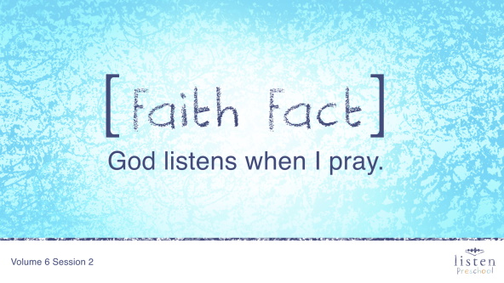

Let’s shout out our Faith Fact. **God listens when I pray**.

**Worship**

Let’s spend some time singing songs and thanking God for listening when we pray!

**Praise**

Are you glad God made you and me? Wave your hands up high. *(Group response)*

Are you glad God made our ears to listen? Wave your hands down low. *(Group response)*

Are you glad God has ears to listen? Wave your hands up high. *(Group response)*

Who wants to thank God for listening to our prayers? Wave your hands down low. *(Group response)*

**Prayer**

Now, let’s take time to pray and thank God for hearing us when we pray.

|  |
| --- |
| Dear God, thank You for always listening when we pray. No matter where we are or what is happening, You are still listening. Amen. |

**Sing**

One way to worship God is by singing.

• *Lead the kids in singing one or two songs. See suggestions at the top of the session*.

**Bible Time cont’d**

Another way we worship God is by learning and saying verses from the Word of God, the Bible. Let’s practice our Faith Verse.

**Faith Verse**

• *Show the* ***Faith Verse Slide***.

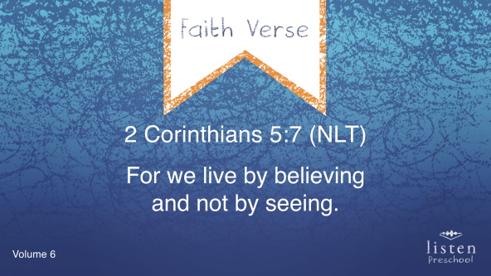

2 Corinthians 5:7 (NLT)

For we live by believing and not by seeing.

Great job! It is so great to know that we don’t always have to see things to believe them. We can’t see God, but we know that He is here. We know that He is listening when we pray. No matter where we are when we pray, God is listening. Let’s check back in with Lizzy.

• *Play* ***Bible Lesson Video B***.

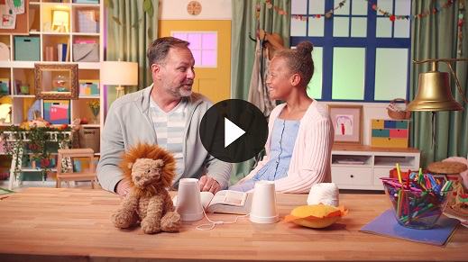

**Response Time**

Wow! Isn’t it amazing that God listens when we pray? God heard Daniel and protected him from those hungry lions. Did you hear what Lizzy said? Even though Daniel couldn’t see that God was listening to his prayer, he believed that God always heard him and would protect him. Is there something you need to ask God for today? Let’s all pray together because we know **God listens when I pray.**

• *Take time to listen to the kids’ prayer requests and say a short prayer*.

• *If your group is large, ask for kids to raise their hands if they have a sick family member, a bump or bruise, sick or lost pet, etc. This gives all the kids a chance to participate*.

**Closing**

Did you have fun in *Listen* today? We’ve heard all about how **God listens when I pray** no matter of where we are. We’ve worshipped God by praising, praying, and singing. We’re starting to remember our new Faith Verse. You’re incredible! Do you know why you’re incredible? You’re incredible because God loves each one of you!

• *Play* ***Faith Fact Sound*** *video (bell ringing)*.



Do you remember what we’re supposed to do when you hear that sound? *(Shout out the Faith Fact.)*

• *Show the* ***Faith Fact Slide.***



Let’s say our Faith Fact now. **God listens when I pray.** Great job, friends!

**Dismissal to Small Groups**

Now it’s time to go to our circles where we will spend time with our very special small groups and our leaders.

• *Dismiss the kids by groups*.

|  |
| --- |
| ***Leader Tip:*** *This can be done by assigning color teams or by age groups. Note that some young preschoolers may not know their age. Using a colored sticker, jersey, or wristband will help separate the kids and help identify their small groups.* |

**Small Group**

**25 Minutes**

*See supplies and prep instructions at the beginning of the session or in each activity below.*

|  |
| --- |
| ***Leader Tip****: Small groups can alternate to each circle, or all groups can do each activity at the same time. If you choose to alternate, you will need at least one leader per circle.* |

**Circle 1**

**Group Connection**

**Are You Listening?**

*No prep needed for this activity*.

**Goal:** To remind the kids that just like we listen to each other God listens to us.

We are going to play a game called Are You Listening? Choose a spot to stand so you are an arm’s length away from anyone else. *(Pause for kids to move.)* Now that you have chosen your spot, don’t move until it is your turn. I am going to whisper something in the ear of one of my friends. Then he or she walk to another friend and tell him or her what I said. We will play until everyone has been told the phrase. We will see if we can all listen well.

• *This game is similar to a game of Telephone, but the kids walk around to tell their friends*.

• *You may need to direct the kids to the next person.*

• *When the kids all tell you the phrase at the end, correct or not, emphasize that God always hears exactly what we pray.*

• *Remind the kids that* ***God listens when I pray.***

• *You can play this game several times depending on your time*.

• *If you have older preschoolers, they could choose the phrase to start the game. Example phrases: I will pray to God; God loves me; Daniel didn’t stop praying; Live by believing not seeing*.

**Circle 2**

**Hands-On Learning**

**Angry Lions**

|  |
| --- |
| ***You Will Need***   * ***Small Group Activity Page 1****, one per kid plus one for the sample* * ***Small Group Activity Page 2****, one per four kids plus sample* * *Crayons* * *Scissors* * *Tape*   ***Getting Ready***   * *Print copies of the* ***Small Group Activity Page 1****, one per kid.* * *Print copies of the* ***Small Group Activity Page 2****, one per four kids.* * *Cut apart the lions on* ***Small Group Activity Page 2****.* * *Make a sample of the Activity Page. Cut apart the smiling lions. Color both pictures. Tape a smiling lion on top of the angry lion.* |

**Goal:** Kids will review the Bible story when they color a scene of Daniel in the lions’ den.

Let’s see how colorful you can make Daniel in the lions’ den.

• *While the kids are coloring, ask the following questions and allow the kids to respond*.

• When Daniel prayed to God, did God listen?

• What happened when Daniel prayed?

• Has God ever answered your prayers?

• *Have the kids color both the* ***Small Group Activity Page 1*** *and the smiling lion from* ***Small Group Activity Page 2****.*

• *Help the kids tape the smiling lion over the angry one on their Activity Page.*

**Circle 3**

**Feet-to-Floor Game Time**

**Lions’ Den**

*No prep is needed for this activity*.

**Goal:** To remind kids God listens when we pray.

What did God do when Daniel was thrown in the lions’ den? *(Group response)* That’s right! He closed the lions’ mouths. Though Daniel may have been scared, he believed that God would protect him. I want all of you to pretend to be a ferocious lion and roar loud. *(Pause for kids to roar.)*

Wow! That was very ferocious! Now, I am going to stand over here, and when I turn with my back to you, start crawling and roaring toward me. When I turn to face you and say our Faith Fact, **God listens when I pray**, you have to freeze. If you move, you have to go back to the start and try again. Are you ready to play?

• *Allow kids who reach you first to take a turns at being the leader.*

**Circle 4**

**Creative Time**

**Guess the Item**

|  |
| --- |
| ***You Will Need***   * *Items that are easy to guess what they are by touch* * *Bag that you can’t see through*   *No prep is needed for this activity.* |

**Goal:** Kids will review the Faith Verse.

Who remembers our Faith Verse? Let’s practice saying it all together with the actions. Repeat after me.

• *Show the* ***Faith Verse Slide***.



2 Corinthians 5:7 (NLT)

For we live by believing and not by seeing.

Great job! We are going to play a fun game. I will put an item in this bag, and you will have to try and guess what it is just by touching it! I’m going to let several kids touch the item before I ask you what it is, so don’t say anything yet.

• *When putting each item in the bag, make sure not to show the item*.

• *Let several kids touch each item. If no one guesses the item, then allow a few more to touch it.*

You kids are good at guessing!

Even though we can’t see God, we know that He is there and listens when we pray. Remember to be like Daniel and pray to God believing that He hears you.

Before you leave for today, let’s say our Faith Fact one more time.

• *Play* ***Faith Fact Sound*** *video (bell ringing)*.



• *Show the* ***Faith Fact Slide.***



**God listens when I pray.** Great job, everyone!

**Dismissal**

• *Send home the* ***Small Group Activity Page 1*** *with each kid*.

• *Remind parents that there are* ***Family Devotions*** *available on the app to do with their kid*.

• *Tell everyone the date and time for the next session*.