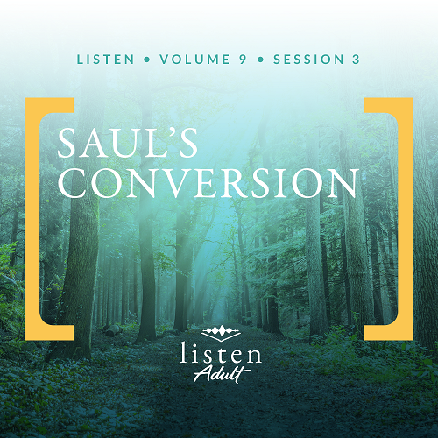Group Session
Small Group Study
Overview
In today’s session we’ll see the power of God radically transform a life. Saul, a devout Jew and student of the Scriptures, passionately opposed early Christians and their message that Jesus was the Messiah. However, Jesus had other plans for Saul. So Jesus appeared to Saul in a vision and declared Himself as Lord. From this moment forward, nothing about Saul’s life would ever be the same. The ability of God to transform a life can still be evidenced in us when we surrender to His lordship.

To access the Bible Engagement Project library from a computer, visit App.BibleEngagementProject.com.

Engage
QUESTION
As a kid, when you played a game where players chose teams, were you usually chosen first, in the middle, or last?
Being chosen matters to every one of us. And there is no one more important to be chosen by than God. But God doesn’t just stop at choosing us. Much like we’ll see in Saul’s life, He wants to change us too.
Watch
As we watch this video, consider this question:
QUESTION
Can you think of a time when God interrupted or challenged your plans? What happened?


Consider
Growing up David was a scrawny, puny child. Thankfully his size and stature did not affect much of life. But, when evening came and it was time for all the children to go out and play, his heart sank. He loved playing soccer with one of his older cousins and his friends. Unfortunately, David’s body didn’t support what his heart longed after. Every time his cousin would go out to play, David would plead his case to go along, hoping that the older kids would let him play with them.

You’re probably familiar with a similar scene. All the kids line up. Captains for each team systematically choose team members. There David stood in the line, the tiniest ten–year-old among towering teenagers, waiting to be chosen. One by one, everyone’s name was called. Then it was just David, standing alone. His cousin, in a show of familial affection, would usually motion to him and say, “Come on, you can be part of my team.” And David would run on the field, visibly smiling with uncontainable joy.

Most of us have felt the adrenaline rush that accompanies being picked. Remember being chosen for an award or winning a prize or, much more significantly, getting engaged? In fact, when important people choose us, the esteem and expectation of their choice irrevocably changes us. So imagine the change one experiences when Jesus, the most esteemed Person in all of history, chooses us!

QUESTION
What is one way being chosen by Jesus changes people?

What the Bible Says
God choosing you and me changes who we are. We become sons and daughters instead of orphans. We experience hope in the middle of pain. We have a purpose that goes beyond death, and we have a mission in Him while we live on earth. We are set apart because He chose us, and His choice changes us. And in today’s Bible account, we’ll look at someone who may seem like an unlikely choice by God—a man named Saul who was in absolute opposition to the message of Jesus.
Gospel Opposition
Read Acts 8:1–3.
The first biblical appearance of Saul of Tarsus introduces him at the martyrdom of an Early Church leader named Stephen (Acts 6:8 to 7:59). Some Jews who opposed Stephen recruited false witnesses to testify against him. They claimed that he spoke against God. Stephen responded to their accusations by using Scriptures and testifying about Jesus. The experts in the Law were publicly humiliated by this humble man who was empowered by the Holy Spirit.
Saul witnessed the testimony of Stephen. While Stephen was standing up for his faith, Saul took care of the coats of the men who stoned Stephen to death. As we read, Saul’s barrage of persecution against the Church was just beginning. He was dedicated to a purpose—ending the Church and those who stood with it.
QUESTION
Have you ever experienced someone standing up for their faith under hostile circumstances? How did their courage impact you?
Religious Passion
Read Acts 9:1–9.
Saul left the scene of Stephen’s stoning and began “going everywhere to destroy the church.” After some time, he headed to Damascus. Passion for his religion gripped his heart. Then God, whom Saul thought he was defending, reached out to him in an unexpected way. The resurrected Jesus spoke to Saul. God mercifully stopped Saul in his tracks.
In a moment, the one who proclaimed vengeance against Christians lay helplessly blinded on the ground. Saul’s human blindness matched his spiritual blindness. Just as he had to be led into the city by others, God would send believers who would help him grasp faith in Jesus.
QUESTION
Tell about a time when God was merciful to you by interrupting your plans or not answering a prayer in the way that you expected.
Unlikely Choice
Read Acts 9:10–19.
Can you imagine God asking you to go to the modern-day leader of a group that tortures and kills Christians in order to pray for his healing? Ananias needed a lot of courage to obey God’s command.
Verse 13 tells us that Saul’s past gave Ananias pause. But Ananias obeyed God. When he found Saul, Ananias didn’t treat him as an outsider, but called him “brother.” God’s acceptance was enough for Ananias to also accept Saul into God’s family.
QUESTION
What can we learn from Ananias’s example to welcome people with difficult histories into God’s family?
Gospel Passion
Read Acts 9:20–22.
Saul, the persecutor of Christians, was transformed into a champion of Christianity. His passion for religion was replaced with a passion for Jesus. His knowledge of the Law helped him use the Scriptures to prove Jesus is the Messiah. This man who had been molded by Jewish teachers and steeped in Jewish traditions now saw Jesus as the fulfillment of God’s promise to all people. Saul became a champion of the faith to the Gentiles and planter of multiple churches. Later called Paul, he still speaks God’s truth to us today as we read his writings in the New Testament.
QUESTION
What has been the greatest change in your life since you became a follower of Jesus?

Reflect
God changed Saul radically, but God didn’t waste Saul’s life experiences before his Damascus Road encounter. Many people became followers of Jesus because God made the unlikely choice of changing one man’s life.
God is still in the business of changing people. Like Saul, we are His unlikely choice to change the world, too.

Listen to God
The goal of Listen is not only to gain an understanding of God’s Word, but also to pause and listen to what God might want to say to us about what we have read and shared. Be silent for a few moments and reflect on the following questions. Choose the one that most resonates with what God is saying to you now. Then complete the others during Day 1 of your devotion time this week.
Personal Reflection Questions
Record your answers to the following questions in the space provided or in your personal journal.
QUESTION
All of us are unlikely choices. Reflecting on your history, think about what makes you an unlikely choice to be part of the kingdom of God. Spend a minute thanking God for choosing you.

QUESTION
Who has been an example of faith in your life? Whose legacy lives on in you?

QUESTION
Have you ever been in a situation where being identified as a Christian could negatively impact you? Did you hide your faith or let your faith be known?

QUESTION
Have you ever acted out of religious passion and later regretted any hurtful actions your passion may have caused you to do? What did you learn from this experience?
Our unchanging God is continuously working to change us into the image of His Son. But our desire to sin resists change.

QUESTION
What is one area in which God is working on changing you? How do you need to cooperate with the Holy Spirit for the needed change to happen?
Prayer Requests
Note any requests from the group and remember to pray for them during the week.
Before next time, continue to listen with the personal devotions.
Did You Know?
Saul was a Benjamite, born in the city of Tarsus. Because he was a Jew who was a Roman citizen, Saul spoke multiple languages. He studied in Jerusalem under a famous Pharisee, Gamaliel. His knowledge of the Jewish Scriptures would have been excellent. Saul may very well have had ambitions to sit in the Sanhedrin as his teacher did.

As part of that most important Jewish court, Gamaliel was honored by both the Pharisees and Sadducees of the Sanhedrin. When Peter and the other apostles were arrested for preaching the gospel, Gamaliel successfully persuaded the Sanhedrin to let them go (Acts 5:33–39).

