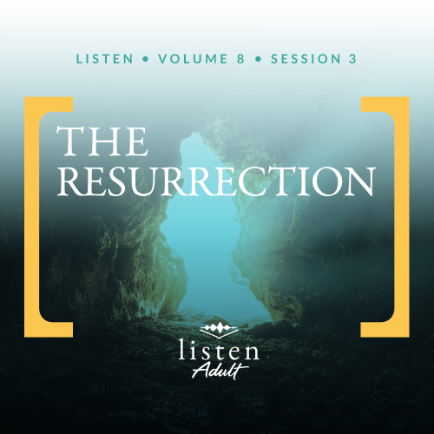Group Session
Small Group Study
Overview
As we saw in our last session, Jesus’ death gives us hope in the face of spiritual death. In Christ, we have new life! As we continue reading through the New Testament, we get a clearer picture of death’s eventual end. The apostle Paul wrote in 1 Corinthians 15:26 that the last enemy to be destroyed is death. The apostle John had an incredible vision of the end of time. In a memorable scene, he heard God say that there is no more death or sorrow or crying or pain. Someday even death will end. But what was the moment that secured Jesus’ victory over death? That’s what we’ll be talking about today.

To access the Bible Engagement Project library from a computer, visit App.BibleEngagementProject.com.

Engage
QUESTION
Which of the following is a greater source of fear for you and why: Spiders or snakes? Darkness or heights? Public speaking or flying?
Everyone faces fear sometimes, even Jesus’ disciples. Jesus did what He could to prepare them for His end-of-life events, and yet they were still caught off guard. Imagine if you, like them, didn’t know what was going to happen next. The leader they had followed was just crucified, and they were left alone and afraid. As we read about the events early on Resurrection Sunday, what would it have been like to be right there with Jesus’ followers?
Watch
As we watch this video, consider this question:
QUESTION
How has Jesus’ resurrection impacted you?

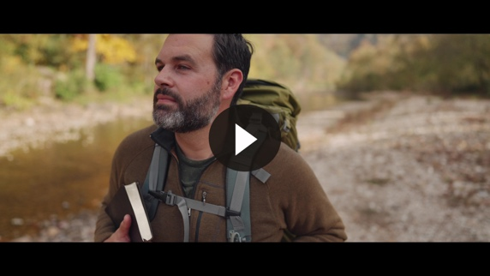

Consider
If you search online, you can find many lists of people’s greatest fears. While those lists may mention things like spiders, heights, and public speaking, it’s hard to find a list that doesn’t include death. For most people, great fear is attached to their own death and the death of those they love. The combination that makes death especially terrifying for some people is that it is both unavoidable and unknown. Death is a complete mystery to them, but Paul didn’t want it to be for believers. He exposed some of the mystery in 1 Thessalonians 4:13–14.

QUESTION
How should our view of death change if we believe it isn’t final—that eternity with or without God awaits?

What the Bible Says
The Bible is unrelentingly honest about death. We can’t pretend it isn’t real. We can’t ignore that death is a source of great pain and sorrow. In John 11, we see Jesus in tears after the death of His dear friend, Lazarus. Though He knew He was about to turn that funeral into a party, Jesus was still deeply moved.
The storyline of Scripture provides the reader with an explanation for the origin of death and also hope for life after death. In Genesis 3, Adam and Eve rebel and sin against God. This sin harms their relationship with God and each other—not to mention their relationship with creation. From that day forward death has been inevitable. We became destined for natural death and vulnerable to spiritual death.
The Women’s Discovery
Read Luke 24:1–3.
To understand the timing of this story, we need to understand the Sabbath law. Any work on the Sabbath was forbidden. Sabbath began at sundown on Friday and ended at sundown on Saturday. Jesus died in the middle of the afternoon on a Friday and was immediately buried before sundown. When the Sabbath ended on Saturday, it would have been dark. So, Sunday morning was the soonest the women could have returned to the tomb—and that’s what they did. The women went to the tomb expecting to complete the burial ceremony. They went expecting to find the body of Jesus, but that was not what they found.
QUESTION
As they waited from Friday to Sunday, Jesus’ followers must have felt overwhelmed with sadness, fear, despair, and confusion. Describe a time of waiting when you have experienced these emotions.

QUESTION
What do you do during times like that, so you don’t lose hope?
The Angel’s Message
Read Luke 24:4–8.
The women had the same response we find from others in Scripture anytime an angel shows up—they’re scared! But these two “men” have good news! First, the angels ask a question. It’s worth noting that the question the angels asked reveals the nature of humankind. We tend to look for life in the wrong places.
Next the angels make two life-changing exclamations to remind the women of Jesus’ teachings. The women needed this reminder to jolt them out of their uncertainty. Suddenly the women realize what’s happened: Jesus rose from the dead! Jesus is alive!
QUESTION
If you had been these women, what would you have done next?
The Disciples’ Response
Read Luke 24:9–12.
Excited, the women ran back to tell the disciples. Imagine how different their feelings were when they left Jesus’ tomb compared to when they approached His tomb! The good news of the Resurrection has the power to change our deep sadness into great joy.
The disciples couldn’t believe it. They had to see for themselves. Luke’s account focuses on Peter going to the tomb, but we know from John’s Gospel that John was with him. It’s interesting to note that upon seeing the empty tomb, Peter didn’t immediately move to belief; he moved to wonder.
QUESTION
What role has wonder played in your journey with Christ?

Reflect
We can’t underestimate how unexpected Jesus’ resurrection was to His followers. Despite His own predictions, not one of them expected this turn of events. The women did not go to see if He was alive; they went to complete the burial. They had to be reminded of Jesus’ own words before they believed. The disciples didn’t believe the women. Even after seeing the empty tomb, Peter left “wondering what had happened.”
And we shouldn’t blame them. Our old enemy—death—had an impressive winning record. Death didn’t lose … until that Sunday morning. Jesus defeated death! In the song “His Heart Beats,” singer-songwriter Andrew Peterson captures this moment perfectly. Check it out at https://www.youtube.com/watch?v=8unqeRdRj2o.

Listen to God
The goal of Listen is not only to gain an understanding of God’s Word, but also to pause and listen to what God our Creator might want to say to us about what we have read and shared. Be silent for a few moments and reflect on the following questions. Choose the one that most resonates with what God is saying to you now. Then complete the others during Day 1 of your devotion time this week.
Personal Reflection Questions
Record your answers to the following questions in the space provided or in your personal journal.
QUESTION
How has your search for Jesus surprised you? What have you learned about Jesus, His life, and His message that is different from what you once thought?

QUESTION
The women walked to the tomb with heavy hearts. What heaviness in your heart do you need to bring to Jesus today?

QUESTION
How has the resurrection of Jesus changed the way you live and the way you think about death?
QUESTION
Peter insisted on seeing for himself. Is there something that you need to do this week to take personal responsibility for your relationship with Jesus?

Prayer Requests
Note any requests from the group and remember to pray for them during the week.
Before next time, continue to listen with the personal devotions.
Did You Know?
The apostle Paul admitted that if the resurrection of Jesus Christ didn’t happen, we are hopeless, miserable people (1 Corinthians 15:19). In other words, the resurrection of Jesus Christ is either the greatest hope or the greatest hoax—there is no middle ground. The claims of Christ are too radical and the impact of Christ on history is too significant for us to not determine for ourselves: Did Jesus rise from the dead?

Stories exist of atheists who set out to disprove the Resurrection, knowing that if they could, it would unhinge the Christian faith. One of the most well-known examples of this is Lee Strobel. As a result of this journalist’s search, he ended up putting his faith in Jesus. You can read about this in his book The Case For Christ, or watch the movie based on his story by the same name.

