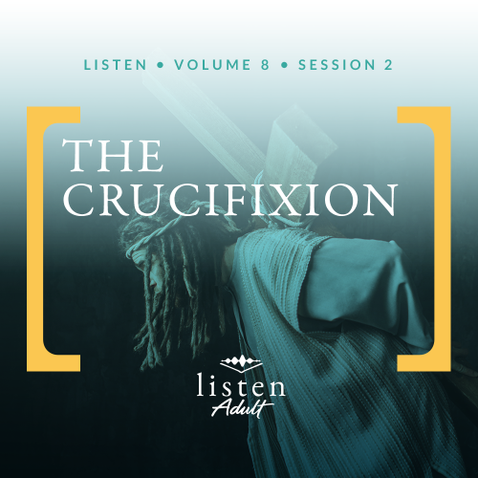Group Session
Small Group Study
Overview
Having predicted His death many times, Jesus knew the hour had finally come. His purpose for coming to earth is about to be accomplished. After the Passover meal, Jesus went to a garden to pray for the strength He needed to endure the unfair trials and horrific death that was before Him. This session continues as we look at Jesus’ resurrection next time.

To access the Bible Engagement Project library from a computer, visit App.BibleEngagementProject.com.

Engage
QUESTION
As a kid, did you ever save your money in order to get something special? Was it worth it?
The Jewish people had been waiting many years for the Messiah, and Jesus’ time was finally here. Jesus came to earth with one purpose—to die for the sin of humanity once and for all. As we explore these life-changing events that happened over two thousand years ago, pause and reflect on how Jesus’ death has impacted you.
Watch
As we watch this video, consider this question:
QUESTION
What does Jesus’ death mean to you?


Consider
Are you a person who gets caught up in a movie and just goes along for the ride? Or do you find yourself trying to figure out the plot twists?

Some movies keep you guessing until the end, and then reveal an ending that could not have been predicted. Others are predictable. But the best movies give clues that careful observers can pick up and piece together to predict the outcome.

Films filled with unexpected turns sometimes conclude by recounting how all the subtle clues fit together to deliver the seemingly unpredictable ending. Then careful observers can have hours of conversation, discussing how “it all makes sense now” in light of the known outcome.

QUESTION
What is one of the most creative plot twists you have ever seen in a movie?

What the Bible Says
The backdrop of events leading up to the Crucifixion had been carefully woven throughout Scripture. Predictions, shadows, and descriptions of a Savior began in Genesis 3:15 with God’s statement to the serpent that he would cause hostility and that Satan would strike the Savior’s heel while the Savior would simultaneously strike Satan in the head.
We can see Christ in the Book of Exodus as the Passover Lamb. We see Him in the poetry of King David as the Lord who will be king and priest (Psalm 110). The prophet Isaiah predicted a Servant who would carry the sins of us all, refuse to defend Himself, and then be unjustly condemned to die as a criminal.
But many in Israel did not understand the clues. Instead, as our human nature tends to do, they created an image in their minds of what they wanted their Messiah to be. The appearance of a deliverer would not have been unexpected. But for the careful observer, the evidence of a plot twist was scattered along the way. Instead of coming as a warrior who would overthrow an earthly kingdom, Jesus came as a humble servant. He chose to bring spiritual deliverance through the ultimate act of sacrificial love. This twist of events changed not only history, but the destiny of humanity forever.
Jesus, Our Lamb
Read Luke 23:32–34.
Under the Old Testament law, the blood of animals had to be shed over and over again to atone for peoples’ sins. This act for every single sin constantly reminded them of their guilt. But it pointed forward to the death of Jesus, whose blood could—in a single act—take away sin (Hebrews 10:4).
John the Baptist had previously proclaimed about Jesus that He took away the sins of the world (John 1:29). Now hanging from a cross with His blood dripping onto the soil below, Jesus did for us what no amount of previous sacrifices could ever do. He made a way to permanently erase our sin.
QUESTION
The fact that Jesus has pronounced us “not guilty” does not automatically remove our feelings of guilt over our past. How can guilt and shame keep us from living the life that Jesus died to give us?
Jesus, Our Savior
Read Luke 23:35–38.
Three times other people challenged Jesus to prove who He was by saving Himself. What the crowds, the soldiers, and the criminal did not understand was that He did not come to elevate Himself, but to save the world. Jesus came to display His power, not through acts of self-preservation, but through acts of selfless love. What some people might view as weakness was actually great sacrifice.
QUESTION
In what ways do you see people today trying to get Jesus to do what fits our desires rather than changing our desires to please Him?
Jesus, Our King
The sign above Him read, “This is the King of the Jews.” It was not unusual for the criminal to carry to his execution the charge for which he was being condemned (Luke 23:33–49). The Roman government could not have known the weight of truth carried in these words.
It had been prophesied that God would raise up a king for Israel from the line of King David. (Jeremiah 23:5–6; Luke 1:32–33). In an earthly kingdom, the death of the king often meant the end of the kingdom. But for God’s eternal kingdom, death was a key part of this never-ending kingdom.
QUESTION
Knowing that the worldview of God’s kingdom and earthly kingdoms are very different, what limitations can earthly government systems present for a Christian’s life?
Jesus, Our High Priest
Read Luke 23:39–49.
The curtain of the temple being torn down the middle is symbolic. The original curtain separated the more common areas of the temple from the Most Holy Place, reserved for the high priest. Though Luke doesn’t clearly explain the meaning of the torn veil, Hebrews 10:19–22 helps us understand its significance. Because of Jesus’ sacrificial work, every believer is empowered to have access to the presence of God.
God Himself did away with the old system. With Jesus’ sacrifice on the Cross, a new way has been opened up for us. Once and for all, Jesus became our great High Priest, who invites us to boldly approach Him for mercy and grace (Hebrews 4:14–16).
QUESTION
In what ways do we still tend to rely on others to go to God on our behalf rather than accessing Him directly?

Reflect
Read Hebrews 9:28.
Human history had been leading to this culminating moment. Christ our Savior came to be a sacrifice for our sins. He is now in heaven with God the Father. For those of us who accept Jesus’ sacrifice, He will be our Savior, eternal Priest, and King.

Listen to God
The goal of Listen is not only to gain an understanding of God’s Word, but also to pause and listen to what God our Creator might want to say to us about what we have read and shared. Be silent for a few moments and reflect on the following questions. Choose the one that most resonates with what God is saying to you now. Then complete the others during Day 1 of your devotion time this week.
Personal Reflection Questions
Record your answers to the following questions in the space provided or in your personal journal.
QUESTION
Examine your heart carefully. Have you adjusted your view of God in some areas of your life to please yourself, rather than adjusting your life to please God?

QUESTION
We discussed the limitations of earthly governing systems. Why is it more important to influence others for Jesus rather than for a political candidate or viewpoint?

QUESTION
Do you tend to ask others to pray on your behalf before you go to God for yourself? Why do you think you do this?

QUESTION
Have you struggled with guilt and shame over your past even though you know that Jesus shed His blood to remove your guilt? If so, who could you talk to this week to help you understand the freedom that Christ has offered you?
Prayer Requests
Note any requests from the group and remember to pray for them during the week.
Before next time, continue to listen with the personal devotions.
Did You Know?

The crucifixion Jesus endured was far from the original form of this barbaric method. Over time, different cultures and empires developed their own variations. While debate exists about who invented crucifixion, the earliest form was quite different than what typically comes to mind.

The roots of crucifixion are often attributed to kingdoms like the Assyrians and Babylonians who impaled enemies as a way of terrorizing those who opposed them. Though Egyptian Pharaohs did something similar, as noted in Genesis 40:19, it’s likely that the first historical record of an execution called crucifixion recounts the Persian king, Darius I, crucifying three thousand Babylonians around 519 BC. This method was moved further west by Alexander the Great, and it was eventually picked up by the Romans who some would say perfected it as a means of an extended and torturous death.

