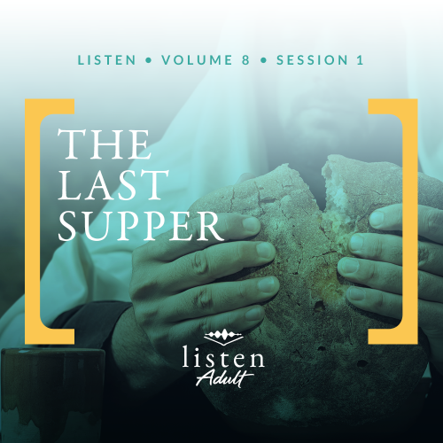Group Session
Small Group Study
Overview
This session is set in Jerusalem. It was Passover weekend, and many people had traveled to Jerusalem to celebrate. Jesus ate the Passover celebration meal with His disciples, which is sometimes referred to as the Last Supper. Jesus revealed that the time for His death had come. It will, in fact, happen the very next day. So during His final hours on earth, Jesus chose to teach His disciples one last lesson on humility and servanthood.

To access the Bible Engagement Project library from a computer, visit App.BibleEngagementProject.com.

Engage
QUESTION
Who is the most famous or most important person you have ever met?
In this session, we’ll see Jesus as both leader and servant. These contrasting roles confused His disciples. As His time on earth is nearing an end, Jesus left a lasting impression on those closest to Him.
Watch
As we watch this video, consider this question:
QUESTION
How has a leader impressed you through their humble actions?
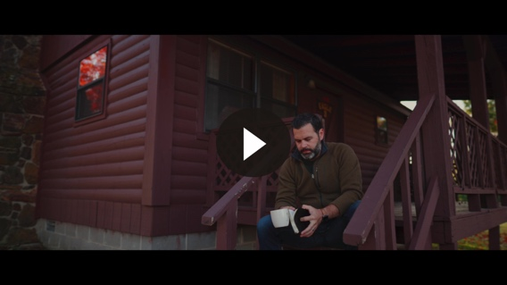

Consider
In high school sports and activities, some parents try hard to get in good with their kid’s coach. They may work hard to be the best booster club parents. Some may share their season tickets to a professional sporting event or loan out their new boat. Others may become friends with the coach and hang out with him on the weekends. They may do all of these things in hopes of garnering favor for their child athlete, cheerleader, or band member.

As the Bible says, there is nothing new under the sun (Ecclesiastes 1:9). In fact, we see a story in Matthew 20:20–23 of a mother who approached Jesus with much the same attitude as we see in helicopter parents today. She hoped to help her sons to get ahead in Jesus’ kingdom.

QUESTION
When you were younger, what dreams or goals did your parents have for you?

What the Bible Says
The mother of the brothers James and John came to Jesus to ask Him a favor. She wanted to ensure that her sons would have high positions in Jesus’ kingdom. However, she misunderstood the type of kingdom that Jesus would be establishing.
Jesus didn’t come to overthrow a human government and set up a temporary earthly kingdom. Rather, He came to establish an eternal Kingdom through His great love and sacrifice. Jesus explained, “Whoever wants to be a leader among you must be your servant, and whoever wants to be first among you must become your slave. For even the Son of Man came not to be served but to serve others and to give his life as a ransom for many” (Matthew 20:26–28).
A Model of Servanthood
Read John 13:1–5.
Taking off His outer garment most likely means that Jesus was wearing only a simple tunic. This would essentially be the clothing of a slave. Washing feet was the job of the lowest servant in the house.
This act was contrary to the culture of that time. The teacher should always be above his disciples. But here was Jesus posturing Himself as the servant of His disciples. Not only was this unexpected, but this change of roles would have also been very uncomfortable for them.
QUESTION
Have you ever participated in or observed someone washing another person’s feet? What was that experience like?

A Shadow of Things to Come
Read John 13:6–8.
Peter reacts impulsively from his human nature and understanding to keep Jesus in a place of honor. However, Jesus essentially said, “Trust me. This will all make sense later.” You see, humbling Himself as the lowest household servant was one thing. But being crucified like the worst of criminals would be far more humiliating.
Similarly, the love being shown by washing His closest friends’ feet was not even in the same ballpark as the love demonstrated by dying for the very ones who opposed Him.
QUESTION
Today we don’t usually wash another person’s feet. What other humbling acts of service like this do people sometimes choose to perform for those they love (babies, elderly or sick relatives, etc.)?
A Spiritual Cleansing
Read John 13:9–11.
Peter seemed to want all or nothing. At first, he didn’t want Jesus to wash his feet at all. Then he asked Jesus for a bath. Jesus took this opportunity to teach a spiritual truth. Cleaning the whole body would be characteristic of baptism—an act of conversion. Jesus was telling Peter that he was already one of His disciples.
On the other hand, priests regularly cleaned just their feet and hands before they entered the temple to serve. In the same way, we need to practice ongoing cleansing of our sins by repentance to purify our hearts and ready ourselves for God’s service.
QUESTION
What are other benefits of regular repentance as a spiritual discipline?
Follow My Example
Read John 13:12–17.
One of the main purposes of Jesus’ act of service was to give His disciples an example to follow. To this point Jesus’ disciples were much more concerned with which of them was the greatest (Matthew 18:1–4; 20:20–27).
Jesus had explained that to be the greatest, they must be willing to make themselves a slave to everyone (Mark 10:44). But often, an experience is much more memorable than words. So to make a lasting impression on the disciples this night, Jesus, the Creator of heaven and earth, lowered Himself to the level of a slave to demonstrate this truth. He is our ultimate example.
QUESTION
God set us in communities, so we could encourage and challenge one another. Do you know someone who is a great example of servanthood, and why would you choose that person?

Reflect
Satan himself was thrown down from heaven for craving the position that belonged to God alone (Isaiah 14:12–14). So, you can believe that he tempts us to want to be great as well. In fact, throughout the Gospels we see religious leaders desperately trying to maintain their status and positions. The disciples too argue about their ranking.
However, Jesus turned this paradigm on its head. The only One deserving of power and fame came to serve others. If we want to be great in the kingdom of God, we must humble ourselves to be the servant of all.

Listen to God
The goal of Listen is not only to gain an understanding of God’s Word, but also to pause and listen to what God our Creator might want to say to us about what we have read and shared. Be silent for a few moments and reflect on the following questions. Choose the one that most resonates with what God is saying to you now. Then complete the others during Day 1 of your devotion time this week.
Personal Reflection Questions
Record your answers to the following questions in the space provided or in your personal journal.
QUESTION
Is there something that God is calling you to do that you have been resisting because you feel it is “beneath” you?

QUESTION
We all make wrong choices, say unkind things, or have bad attitudes from time to time. Is the practice of repentance something that you engage in on a regular basis? Is there something that comes to mind that you need to repent of?

QUESTION
Repentance involves awareness, confession, and renouncing sins. Write down the area of sin you are struggling with the most right now (actions, words, attitudes). Be as specific as you need to be. Confess this aloud to the Lord in prayer and ask Him to help you surrender your will and submit to Him.

QUESTION
What could you do this week to practice the kind of servanthood that Jesus displayed?
Prayer Requests
Note any requests from the group and remember to pray for them during the week.
Before next time, continue to listen with the personal devotions.
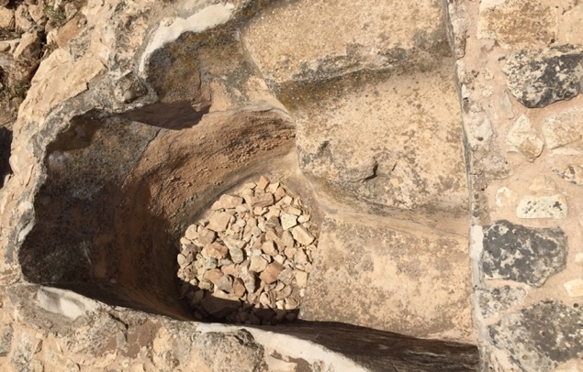
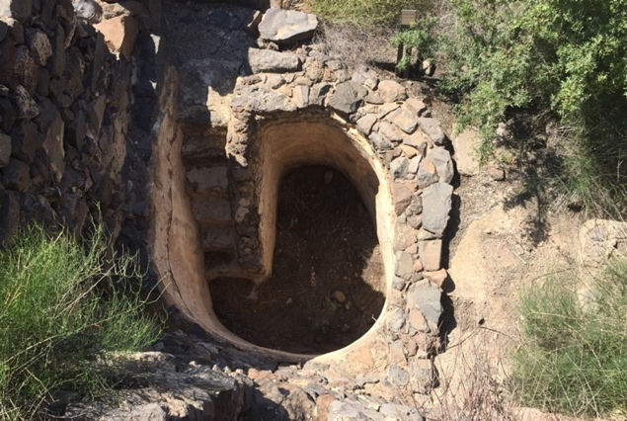
Did You Know?
During the Second Temple Period, when a person wanted to become a proselyte to Judaism, the individual needed to fulfill two conditions. They needed to undergo ritual immersion (baptism), and they needed to undergo circumcision. With this in mind, the disciples of Jesus would have been familiar with the practice of immersion as a sign of spiritual conversion.

Ritual cleansings (including baptisms) would take place in a mikveh. A mikveh is a pool constructed to certain specifications according to Jewish law. Mikvehs were then filled with water from a natural spring, from rain water or from a river fed by a natural spring (a.k.a. living water).

Mikveh in Yodefat, Israel Mikveh in Gamla, Israel

